Yohannes Ayele

module-1

assignment-1.2

Date: 6/2/24

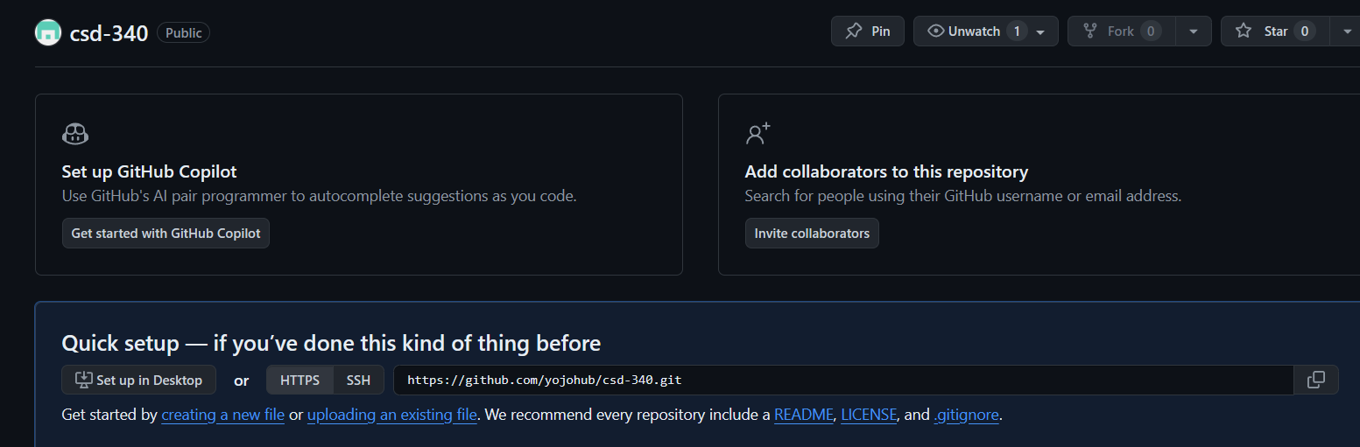

https://github.com/yojohub/csd-340.git

