# Azure Databricks

## Introduction

Azure Databricks is a cloud-based data analytics platform designed to provide a collaborative environment for big data and artificial intelligence (AI) workloads. It is a first-party Microsoft Azure service that integrates seamlessly with Azure services such as Azure Data Lake, Azure Synapse Analytics, Power BI, and more. Databricks combines the power of Apache Spark with the scalability and flexibility of cloud computing, making it an essential tool for organizations to process, analyze, and visualize large volumes of structured and unstructured data.

## Key Features

1. Unified Analytics Platform – Azure Databricks allows data engineers, data scientists, and business analysts to collaborate in a single workspace.  
2. Apache Spark-Based – It is built on Apache Spark, enabling large-scale data processing.  
3. AI and Machine Learning – Provides built-in libraries and integration with ML frameworks such as TensorFlow, PyTorch, and Scikit-learn.  
4. Seamless Azure Integration – Works smoothly with services like Azure Data Factory, Azure Blob Storage, Azure SQL Database, and Power BI.  
5. Autoscaling and Performance – Automatically scales clusters based on workload.  
6. Security and Compliance – Offers enterprise-grade security features like Azure Active Directory integration, role-based access, and compliance with industry standards.

## Architecture

The architecture of Azure Databricks consists of multiple layers designed to manage and analyze data effectively:  
  
- Workspace: A collaborative environment for teams to share notebooks and dashboards.  
- Clusters: Managed Spark clusters that process big data workloads.  
- Notebooks: Interactive documents for writing and executing code in multiple languages (Python, R, SQL, Scala).  
- Jobs: Scheduled or triggered tasks that run automated workflows.  
- Data Integration: Connectors for Azure storage, databases, and external data sources.  
  
The diagram below illustrates a simplified view of the Azure Databricks architecture:

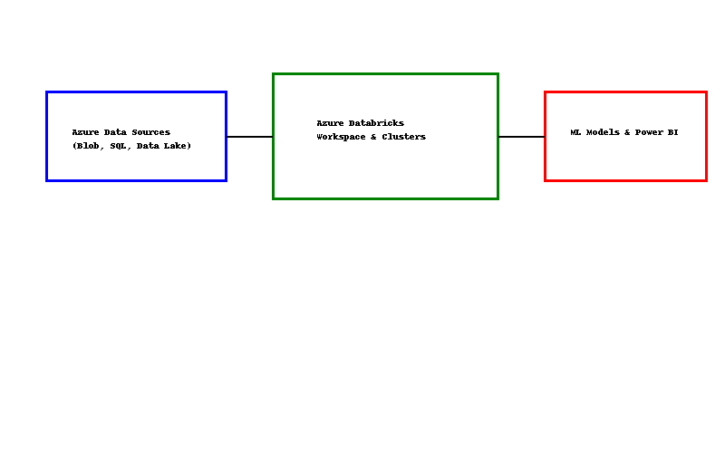

## Use Cases

1. Data Engineering: ETL pipelines to ingest, clean, and transform raw data into usable formats.  
2. Machine Learning: Model development, training, and deployment for predictive analytics.  
3. Business Intelligence: Integration with Power BI for visualization and reporting.  
4. Real-Time Analytics: Streaming analytics for IoT, finance, and operational monitoring.  
5. Genomics and Research: Large-scale data analysis in healthcare, life sciences, and academic research.

## Benefits of Azure Databricks

1. Scalability: Automatically adjusts resources to meet demand.  
2. Cost Efficiency: Pay-as-you-go model reduces infrastructure costs.  
3. Collaboration: Provides a unified workspace for multiple teams.  
4. Flexibility: Supports multiple programming languages and machine learning frameworks.  
5. Security: Meets enterprise-grade compliance and data protection standards.

## Extended Explanation

Azure Databricks empowers organizations by offering a modern, scalable analytics solution that can be tailored to business needs. Unlike traditional data platforms, Databricks unifies data engineering and data science teams, reducing silos and increasing productivity. Its ability to integrate seamlessly with existing Azure infrastructure means organizations can build end-to-end pipelines without worrying about data silos.  
  
For example, an e-commerce company can use Azure Databricks to capture transactional data in real-time, apply machine learning models to predict customer behavior, and send insights directly to Power BI dashboards for decision-makers. Similarly, healthcare providers can use it to analyze patient records, predict disease outbreaks, and optimize treatment plans based on historical data.  
  
In summary, Azure Databricks is not only a platform for big data analytics but also a strategic enabler for digital transformation.

## Conclusion

Azure Databricks is a powerful platform that simplifies big data processing and advanced analytics. By combining the strengths of Apache Spark with deep integration into the Azure ecosystem, it enables organizations to build scalable, secure, and collaborative data solutions. Its use cases span across industries, from finance to healthcare, making it an essential tool for driving data-driven decision-making and innovation.