3 - GenAI Version (Make Facts Witty):
~ In this stage, you will make those facts funny and engaging using Amazon Bedrock.
~ Amazon Bedrock allows you to use foundation models (like Anthropic Claude, AI21, etc.) directly from AWS without managing infrastructure.
~ This means you can enhance your cloud facts dynamically.
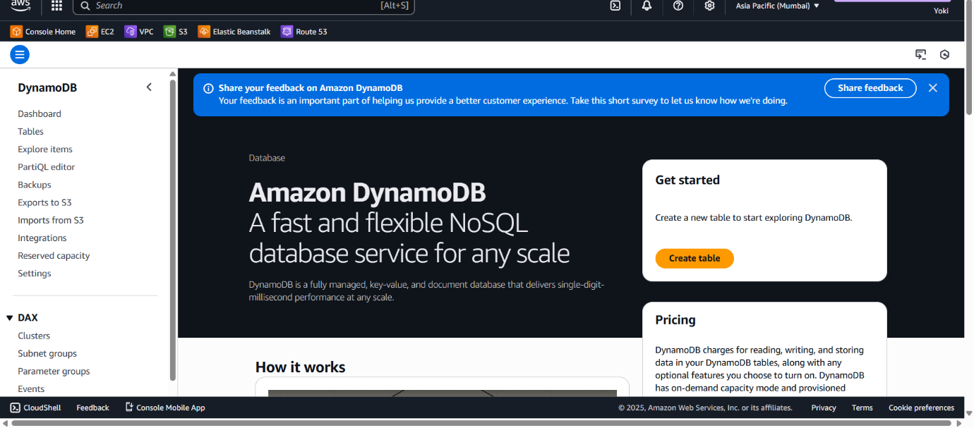

Step - 1: Request Model Access in Bedrock:
1. Go to the Amazon Bedrock Console in your region.
2. In the left menu, choose Model Catalog.
3. Find Anthropic Claude (e.g., Claude 3.5 Sonnet)
4. Click on Modify the model access button.
5. Select the Claude 3.5 Sonnet under Anthropic > Click Next > Submit.
~ After approval, go back to Model access page, verify if the status has changed from “Access required” → “Access granted”.
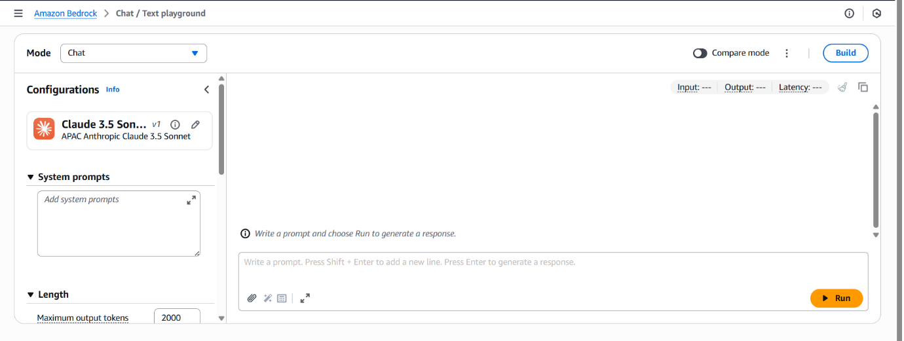

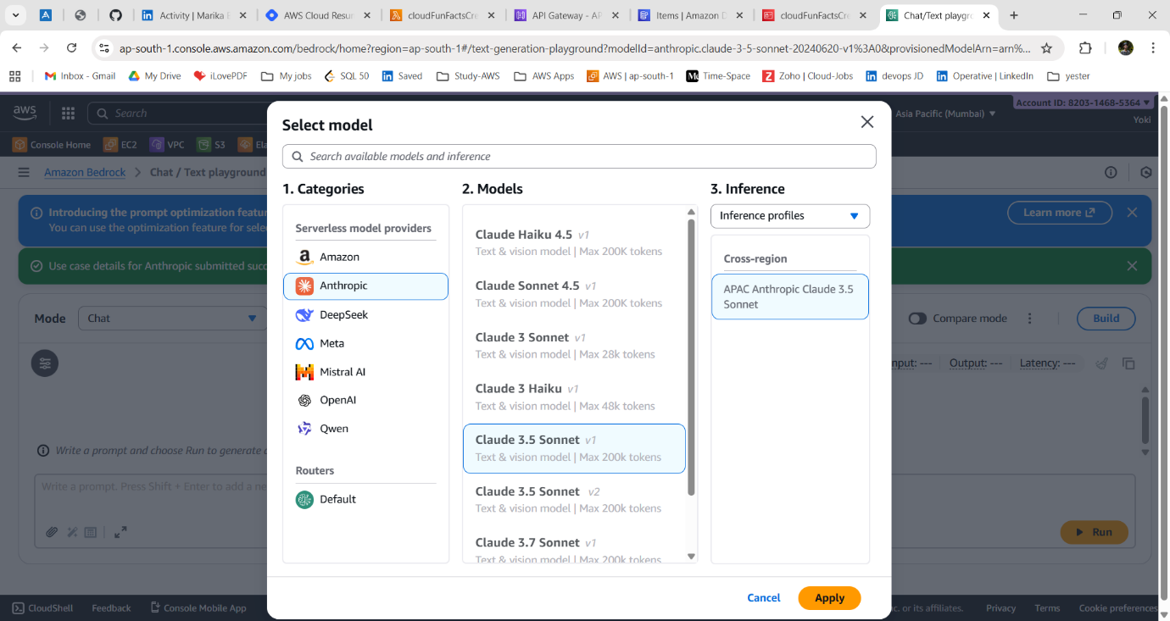

Step - 2: Update IAM Role:
1. Go to IAM Console → Roles.
2. Open the role attached to your Lambda function (CloudFunFactsRole).
3. Attach the policy: AmazonBedrockFullAccess (this allows your Lambda to call Bedrock models).
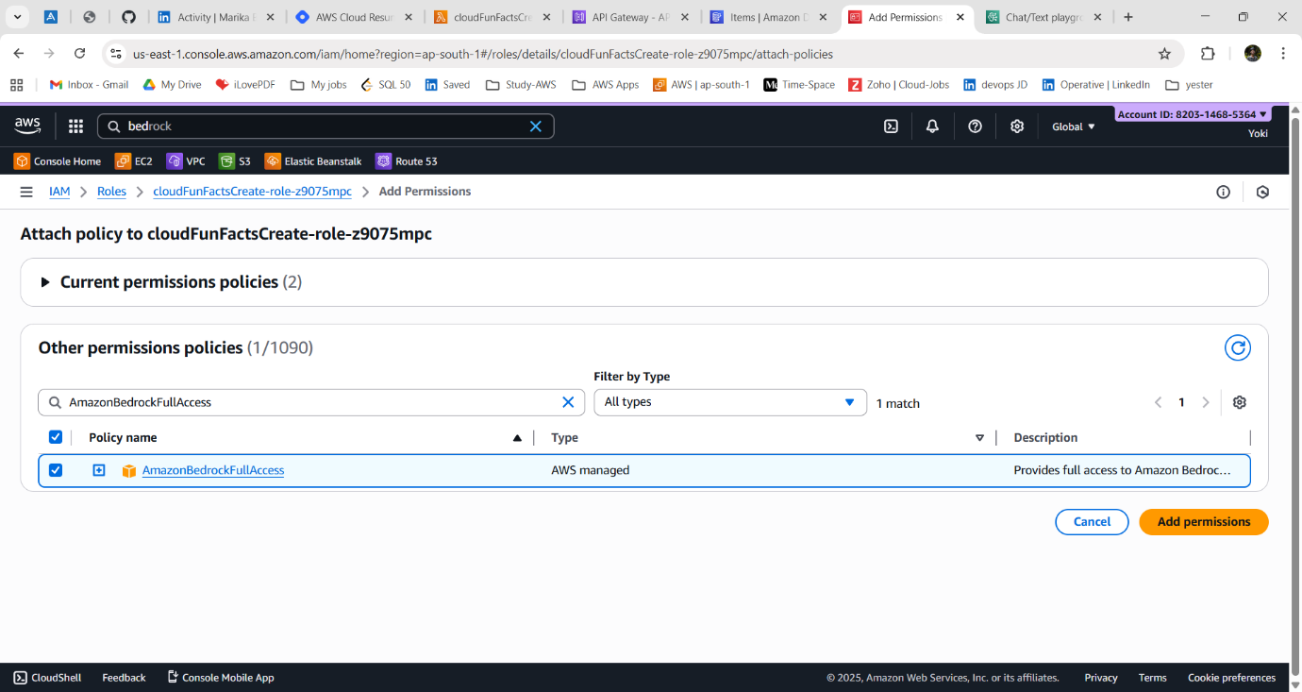

Step - 3: Update Lambda Code:
1. Replace your DynamoDB Lambda code with this:
Lambda updated code:
import boto3
import random
import json
# DynamoDB connection
dynamodb = boto3.resource("dynamodb")
table = dynamodb.Table("CloudFacts")
# Bedrock client
bedrock = boto3.client("bedrock-runtime")
def lambda_handler(event, context):
# Fetch all facts from DynamoDB
response = table.scan()
items = response.get("Items", [])

if not items:
return {
"statusCode": 200,
"headers": {
"Content-Type": "application/json",
"Access-Control-Allow-Origin": "*",
"Access-Control-Allow-Methods": "GET, OPTIONS",
"Access-Control-Allow-Headers": "Content-Type"
},
"body": json.dumps({"fact": "No facts available in DynamoDB."})
}

fact = random.choice(items)["FactText"]
# Messages for Claude 3.5 Sonnet
messages = [
{
"role": "user",
"content": f"Take this cloud computing fact and make it fun and engaging in 1-2 sentences maximum. Keep it short and witty: {fact}"
}
]
body = {
"anthropic_version": "bedrock-2023-05-31",
"max_tokens": 100,
"messages": messages,
"temperature": 0.7
}
try:
# Call Claude 3.5 Sonnet on Bedrock
resp = bedrock.invoke_model(
modelId="anthropic.claude-3-5-sonnet-20240620-v1:0",
body=json.dumps(body),
accept="application/json",
contentType="application/json"
)

# Parse response
result = json.loads(resp["body"].read())
witty_fact = ""

# Claude v3 response: look inside "content"
if "content" in result and result["content"]:
for block in result["content"]:
if block.get("type") == "text":
witty_fact = block["text"].strip()
break
# Fallback if empty or too long
if not witty_fact or len(witty_fact) > 300:
witty_fact = fact
except Exception as e:
print(f"Bedrock error: {e}")
witty_fact = fact
return {
"statusCode": 200,
"headers": {
"Content-Type": "application/json",
"Access-Control-Allow-Origin": "*",
"Access-Control-Allow-Methods": "GET, OPTIONS",
"Access-Control-Allow-Headers": "Content-Type"
},
"body": json.dumps({"fact": witty_fact})
}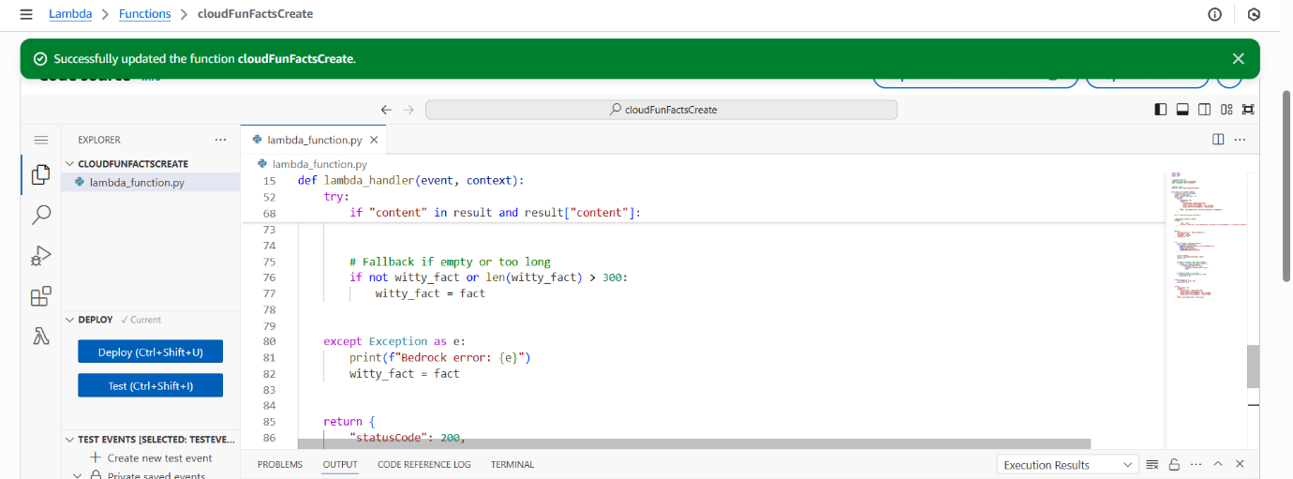
2. Click deploy to save the code.
3. Increase Lambda Timeout
Go to Configuration → General Configuration → Edit
4. Set Timeout to 15–30 seconds (or more if your model takes longer to respond)
5. Save changes

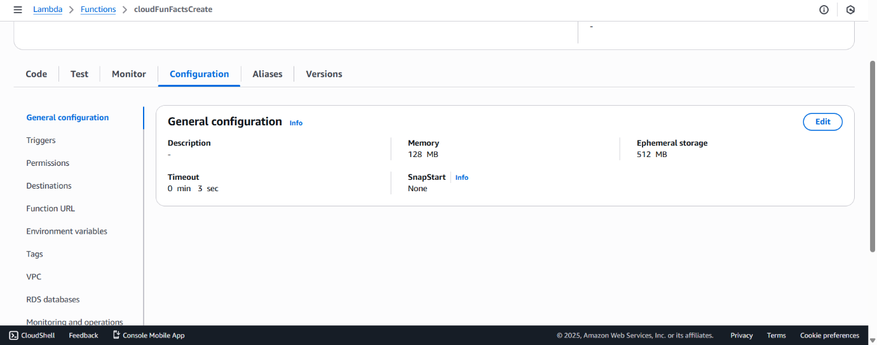

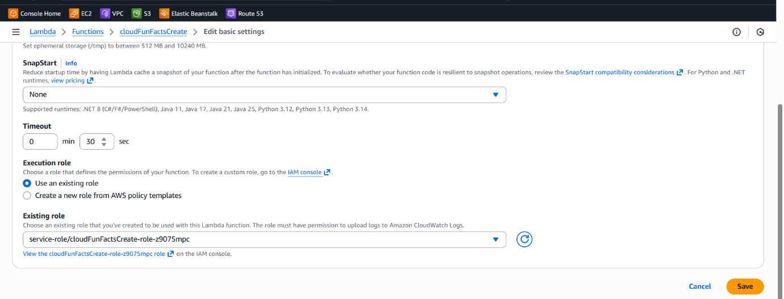
Step - 4: Test the GenAI-Powered Lambda:
1. Go to Lambda → Select your function → Test.
2. Run the function a few times.
3. Instead of plain facts, you’ll see playful AI-generated versions of the same facts.
Example:
----------
Input fact: “AWS S3 was launched in 2006.”
Output witty fact: “AWS S3 has been around since 2006, older than the first iPhone, and still storing your selfies!”

Step - 5: Test the API:
1. Go back to API Gateway.
2. Hit your endpoint:
Copy the URL (e.g., https://abcdedf.execute-api.ap-south -1.amazonaws.com).
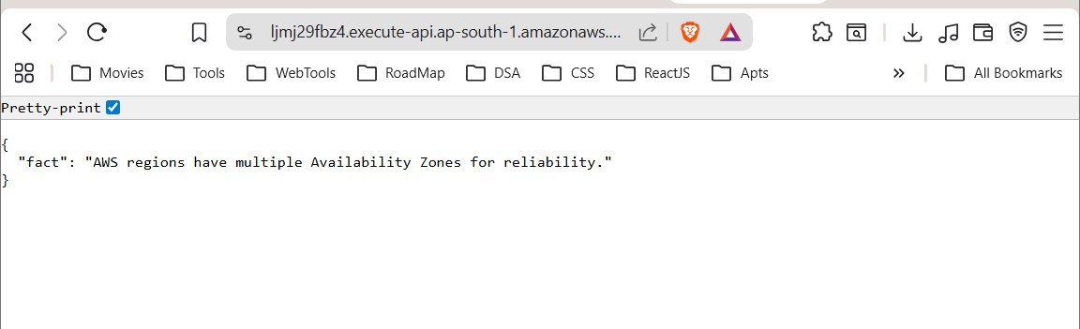

This time, the response should come as a witty fact from Bedrock.
Example:
{
"fact": "NASA uses AWS to store and share Mars mission data with the public."
}
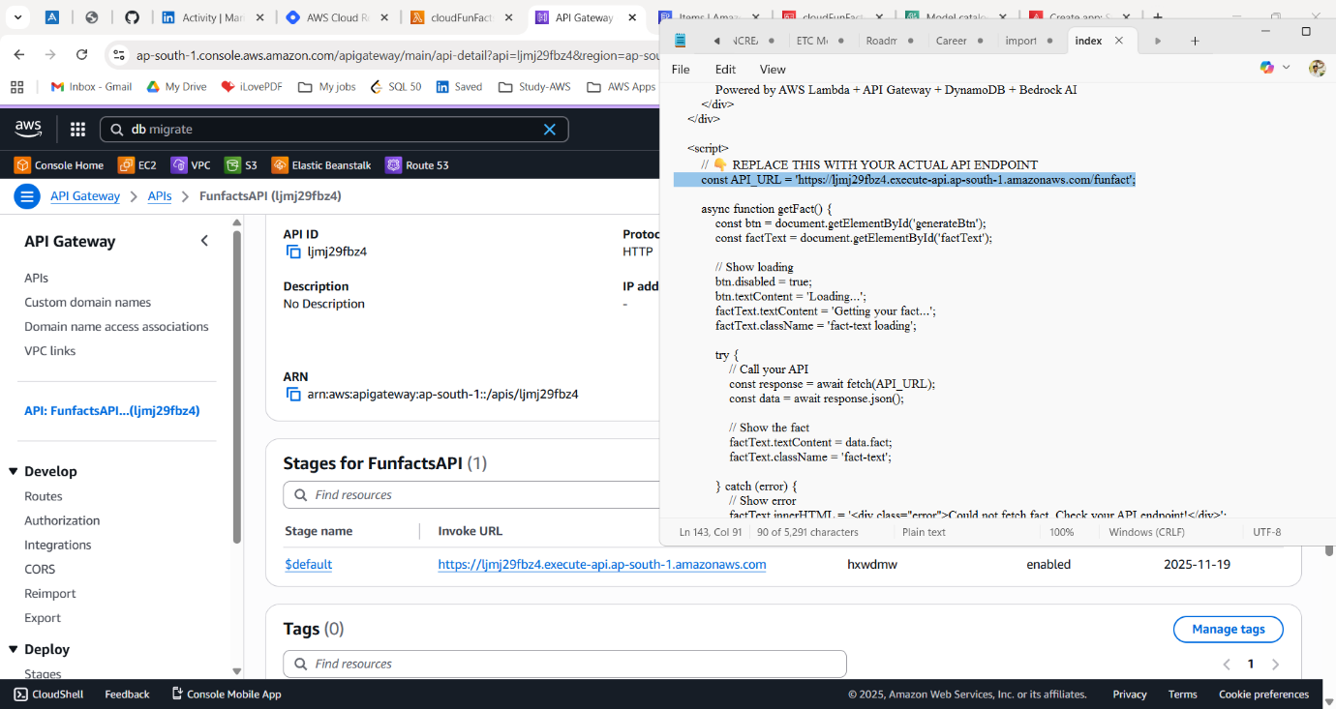
Outcome of Stage - 3:
At this point, you’ve just turned your Fun Facts API into a Generative AI-powered service
~ It creates an AI-generated version of this content where the facts stay accurate, but the delivery is clever, entertaining, or humorous.
DEPLOYING APPLICATION:
~ In the previous stages, we built a complete serverless API that evolved from hardcoded facts → database-driven → AI-enhanced. Now you'll create a beautiful web frontend so users can interact with your Cloud Fun Facts API through a browser.
1. Create frontend file:
Make `index.html` → paste the provided HTML/JS code → replace `API_URL` with your real API endpoint.
2. Get your API URL:
In API Gateway → Stages → default → copy the Invoke URL → ensure it ends with `/funfact`.
3. Enable CORS:
In API Gateway → CORS → allow your Amplify domain (or `*` for testing) → allow GET/OPTIONS → save.
4. Deploy to AWS Amplify:
Go to AWS Amplify → Host web app → “Deploy without Git” → upload a ZIP containing `index.html`.
5. Test the app:
Open the Amplify URL → click “Generate Fun Fact” → confirm it loads facts from your API.
