2 - Database Version (DynamoDB + Lambda)
~ In this 2nd stage, you will store cloud fun facts in a DynamoDB Table and fetch data dynamically.
~ This makes your API flexible, scalable, and production-ready.
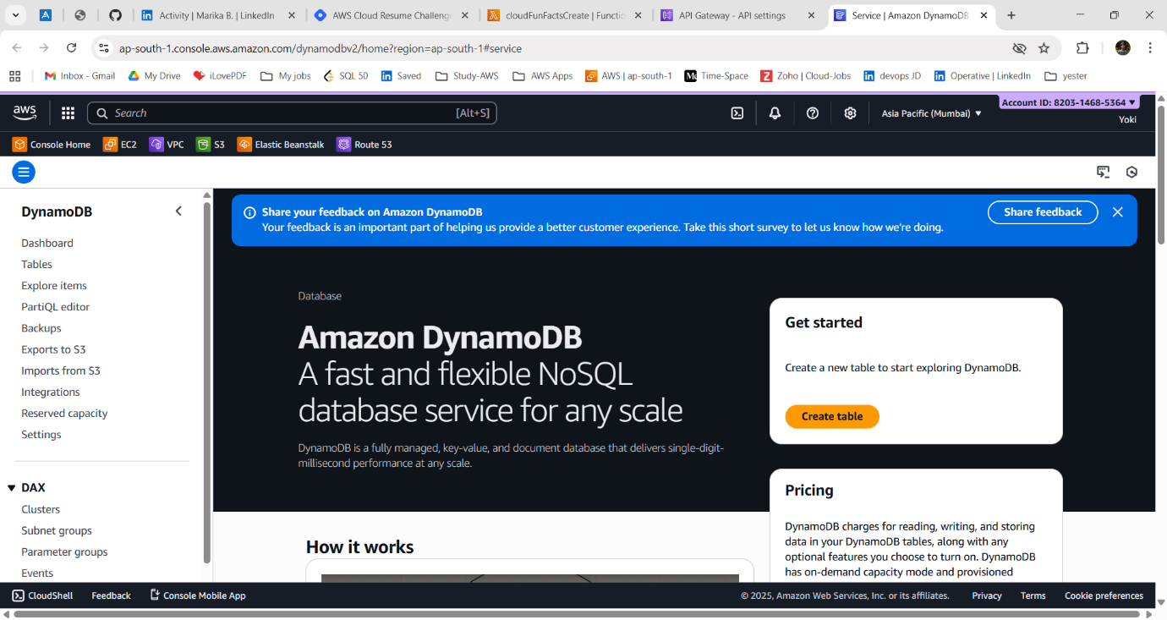
Step - 1: Create DynamoDB Table:
1. Go to AWS Management Console → Search for DynamoDB.
2. click “Create Table”
3. give table details.
Table name: CloudFacts
Partition key: FactID - (String)
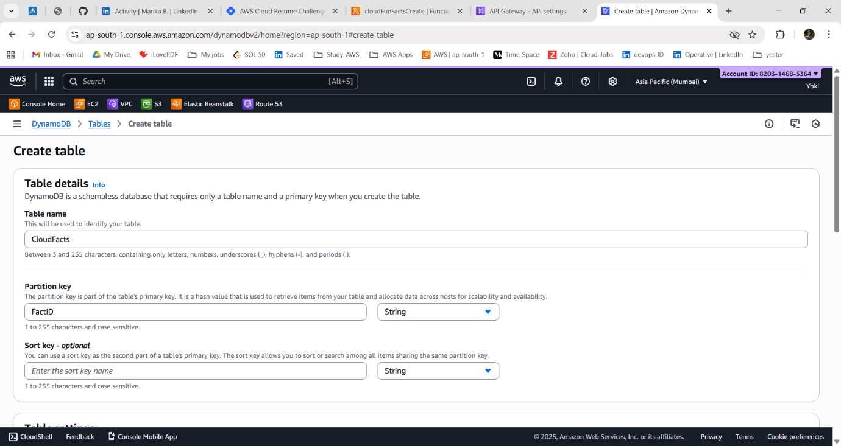
~ Leave other settings default (on-demand capacity is fine for this project).
👉 What’s happening here?
- DynamoDB is AWS’s NoSQL database - super fast, serverless, and fully managed.
- We’re creating a table where each fact has:
FactID → unique identifier (like 1, 2, 3)
FactText → the actual fun fact string.

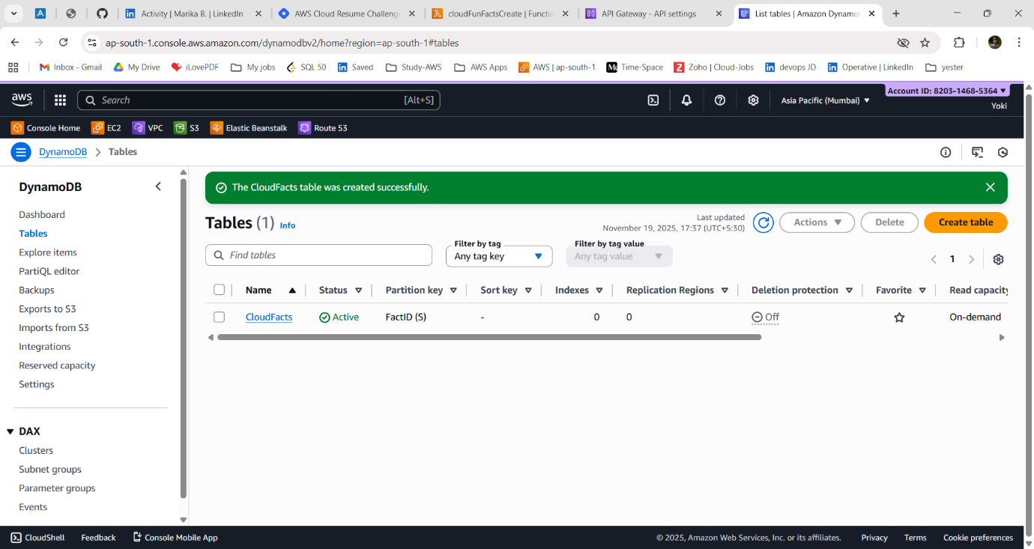

Step - 2: Insert Sample Items:
~ Now, let’s add a few sample fun facts to our database:
1. Go to your CloudFacts table → Explore table items → Create item.
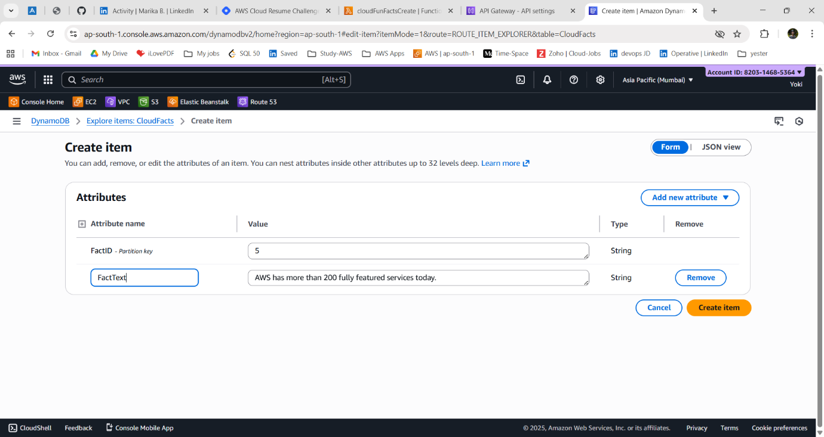

2. Add entries like:
{ "FactID": "1", "FactText": "AWS S3 was one of the very first AWS services, launched in 2006." }
{ "FactID": "2", "FactText": "Netflix runs almost all of its infrastructure on AWS." }
{ "FactID": "3", "FactText": "Cloud computing can save companies up to 30% on IT costs." }
{ "FactID": "4", "FactText": "NASA uses AWS to store and share Mars mission data with the public." }
{ "FactID": "5", "FactText": "AWS has more than 200 fully featured services today." }
{ "FactID": "6", "FactText": "The 'cloud' doesn’t float in the sky, it’s made of giant data centers on Earth." }
{ "FactID": "7", "FactText": "More than 90% of Fortune 100 companies use AWS." }
{ "FactID": "8", "FactText": "AWS data centers are so secure that they require retina scans and 24/7 guards." }
{ "FactID": "9", "FactText": "Serverless doesn’t mean there are no servers, it just means you don’t manage them." }
{ "FactID": "10", "FactText": "Each AWS Availability Zone has at least one independent power source and cooling system." }
{ "FactID": "11", "FactText": "Amazon once accidentally took down parts of the internet when S3 had an outage in 2017." }
{ "FactID": "12", "FactText": "The fastest-growing AWS service is Amazon SageMaker, used for Machine Learning." }
{ "FactID": "13", "FactText": "The word 'cloud' became popular in the 1990s as a metaphor for the internet." }
{ "FactID": "14", "FactText": "AWS Lambda can automatically scale from zero to thousands of requests per second." }
{ "FactID": "15", "FactText": "More data is stored in the cloud today than in all personal computers combined." }
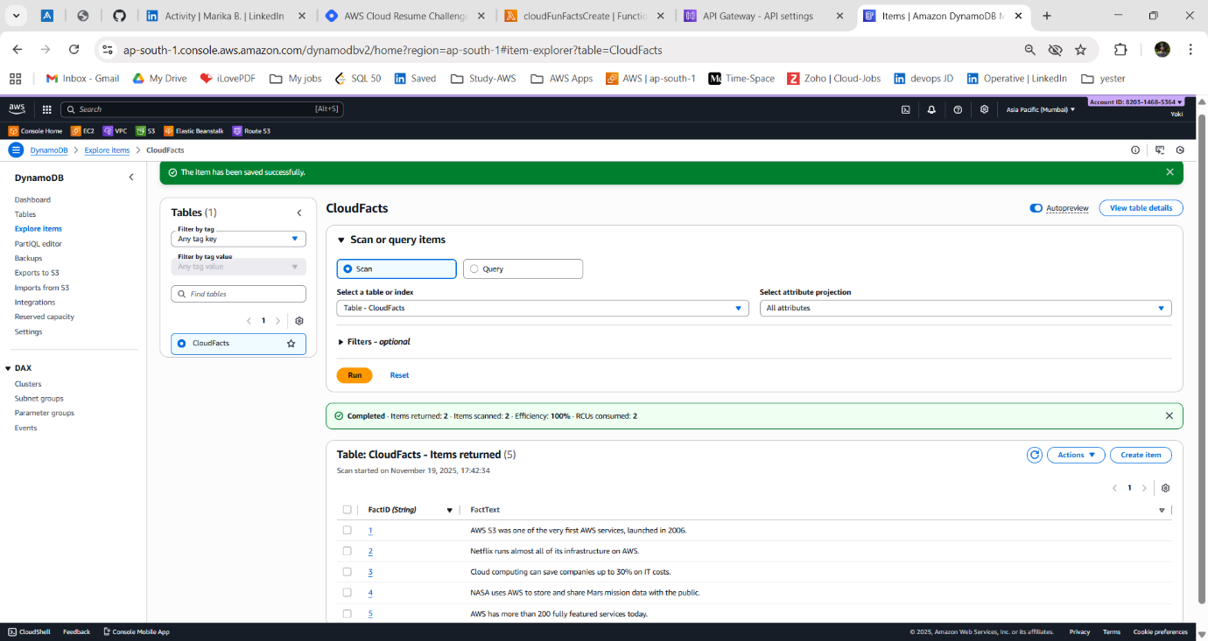
👉 What’s happening here?
- We’re populating our database with facts.
- Later, instead of editing Lambda code, you can just add more rows here.

Step - 3: Update Lambda Role:
~ By default, our Lambda cannot talk to DynamoDB. We must grant it permission:
1. Go to IAM → Roles.
2. Find the role associated with your CloudFunFacts Lambda.
3. Attach policy: AmazonDynamoDBReadOnlyAccess.
→ You should see a random fun fact returned in the response.
👉 Why?
- AWS follows least privilege principle. Without explicit permissions, Lambda cannot access other AWS services.
- By attaching AmazonDynamoDBReadOnlyAccess, we’re allowing Lambda to read items but not modify/delete them (safer).

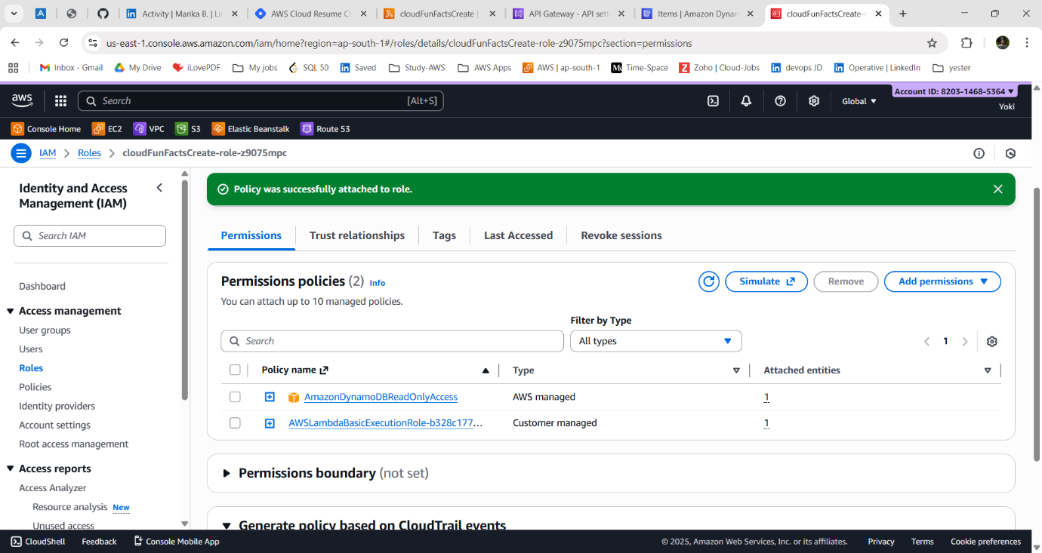

👉 What’s happening here?
- You’re manually invoking the Lambda in the console
- AWS runs your code in a temporary environment, then destroys it (that’s the beauty of serverless).

Step - 4: Update Lambda Code:
1. Replace your Lambda code with this:
Lambda Code:
import boto3
import random
import json
# Create DynamoDB client
dynamodb = boto3.resource("dynamodb")
table = dynamodb.Table("CloudFacts")

def lambda_handler(event, context):
# Scan entire table (not efficient for huge tables, but fine here)
response = table.scan()
items = response.get("Items", [])
if not items:
return {
"statusCode": 500,
"body": json.dumps({"error": "No facts found"})
}
# Pick random fact
fact = random.choice(items)["FactText"]

return {
"statusCode": 200,
"headers": {"Content-Type": "application/json"},
"body": json.dumps({"fact": fact})
}

2. Click Deploy to save the code.

👉 What’s happening here?
- boto3.resource("dynamodb") → Connects to DynamoDB.
- table.scan() → Reads all items from the table.
- random.choice(items) → Picks one random fact.
- Returns it as JSON response.

Step - 5: Test the API:
1. Go back to API Gateway.
2. Hit your endpoint:
Copy the URL (e.g., https://abcdedf.execute-api.ap-south -1.amazonaws.com).
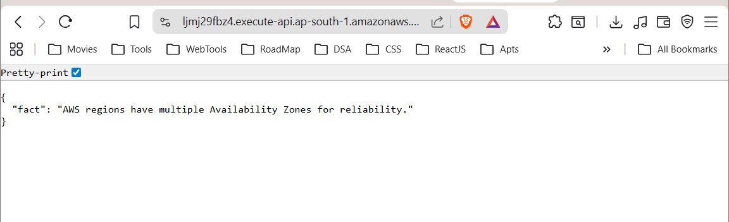

This time, the response should come from DynamoDB. Example:
{
"fact": "NASA uses AWS to store and share Mars mission data with the public."
}

Outcome of Stage - 2:
At this point, your API is data-driven:
~ Fun facts are stored in DynamoDB.
~ Lambda fetches them dynamically.
~ You can add new facts without changing code.
~ This is exactly how modern apps evolve: starting with hardcoded logic, then moving to database-backed flexibility.

