Serverless Birthday Countdown website
using AWS S3
STATIC WEBSITE HOSTING ON AMAZON S3:
~ project-name: s3-static-bday-countdown
- This document describes how to host a static website using Amazon S3’s built-in static hosting feature.
- This approach is suitable for simple static sites that do not require HTTPS, backend logic, authentication, or private hosting.
ARCHITECTURE DIAGRAM:
-------------------------------------------------------------------------------------
User Browser ← (user visits the birthday countdown site)
↓
S3 Static Hosting ← (serves HTML/JS/CSS countdown files)
↓
Client-Side Script ← (calculates real-time countdown in browser)
↓
Countdown Display ← (updates UI every second)
-------------------------------------------------------------------------------------
S3 STATIC HOSTING:
- S3 static hosting in AWS is a feature that lets you host static websites (HTML, CSS, JavaScript, images) directly from an Amazon S3 bucket without needing a web server.
- It serves your site via HTTP/HTTPS with high availability and low cost.
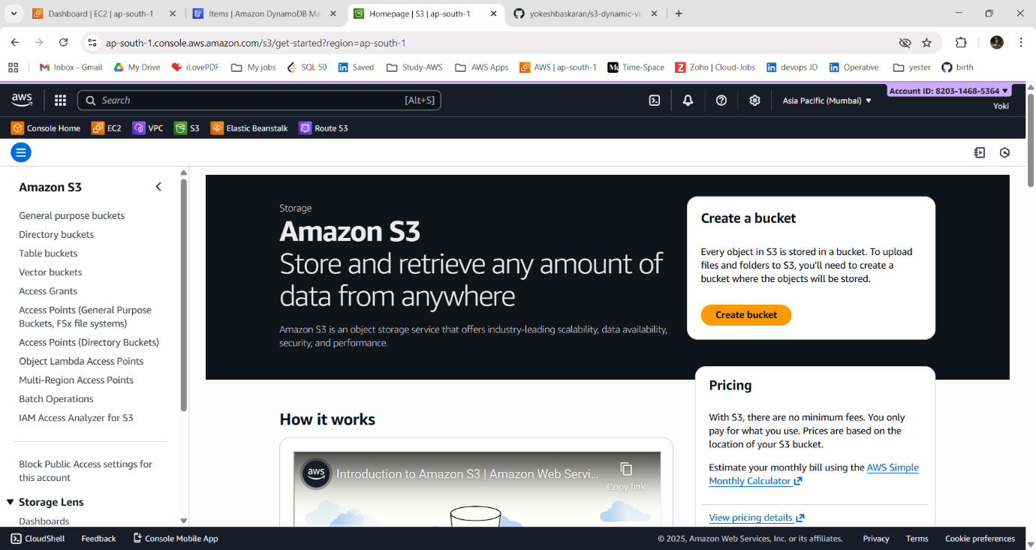
Here, we will see how to host a static website using Amazon S3’s built-in static hosting feature. This approach is suitable for simple static sites that do not require HTTPS, backend logic, authentication, or private hosting.
~ Go AWS Management Console and Open the S3 service.
1. Create an S3 Bucket:
i) Choose “Create bucket”.
ii) Enter the bucket name (must be globally unique).
Bucket-name: s3-static-bday-countdown
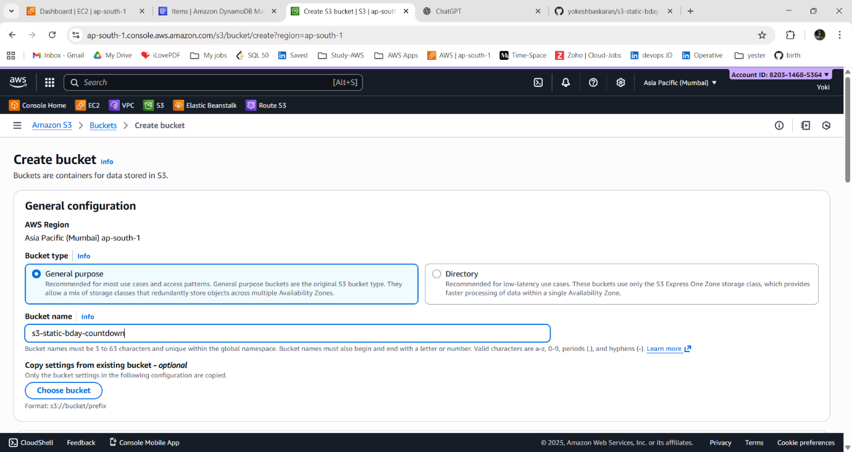
iii) Select an AWS Region - ap-south-1
iv) Create the bucket.
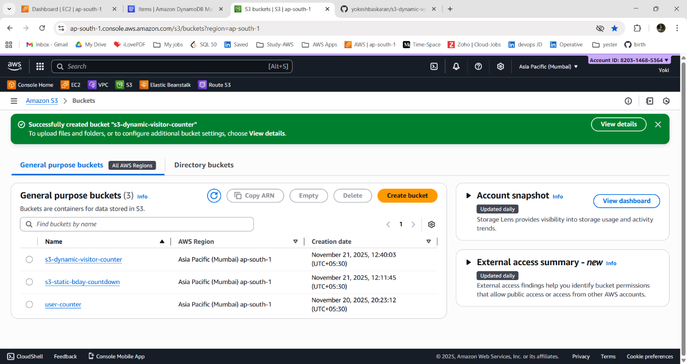
2. Upload Your Website Files:
i) Open the s3-static-bday-countdown bucket.
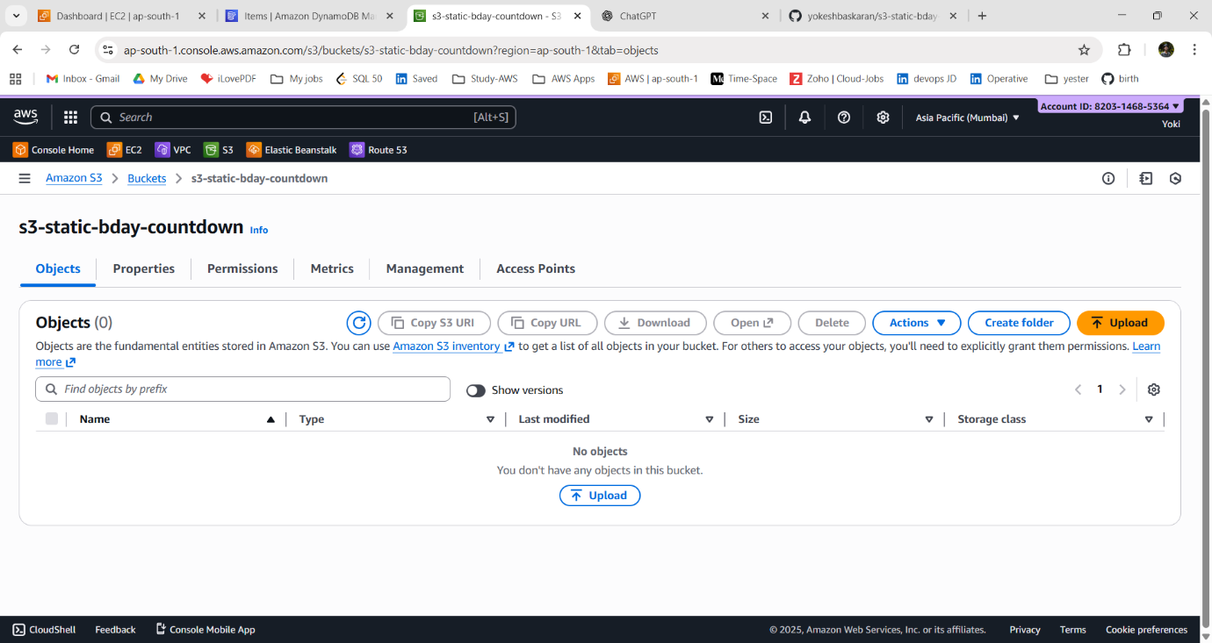
ii) Choose Upload to upload the files.
iii) Add all files related to your website (e.g., index.html, error.html, CSS, JS files).
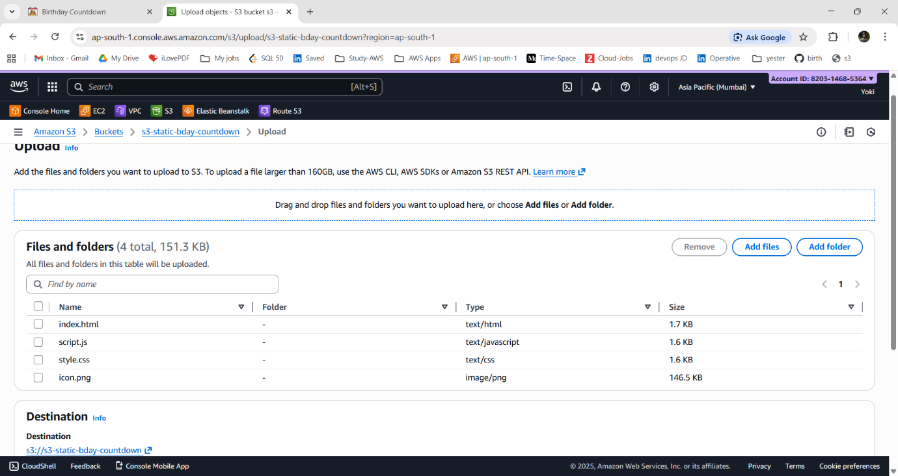

iv) Choose Upload again to complete the process.
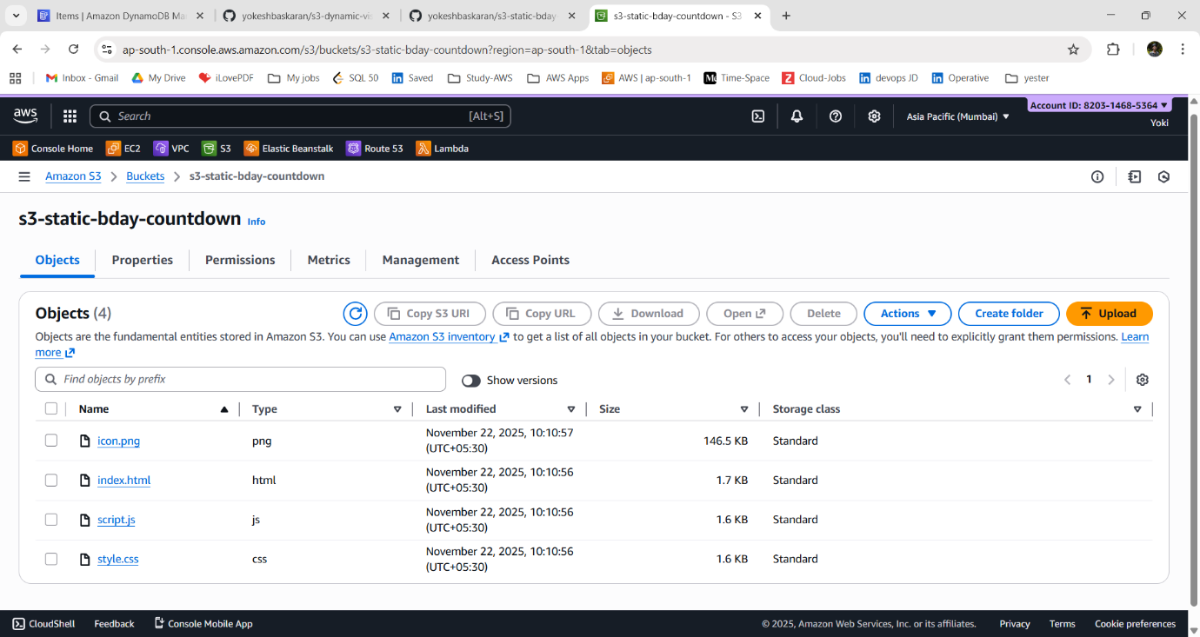
3. Enable Static Website Hosting:
i) Go to the “Properties” tab of the bucket.
ii) Scroll to Static website hosting.
iii) Choose Edit and then Select Enable.
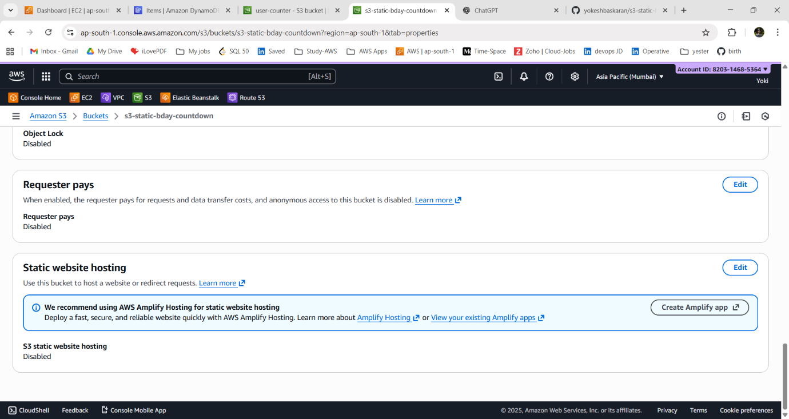

iv) Choose Host a static website.
v) Set your Index document (e.g., index.html).
vi) click Save changes.
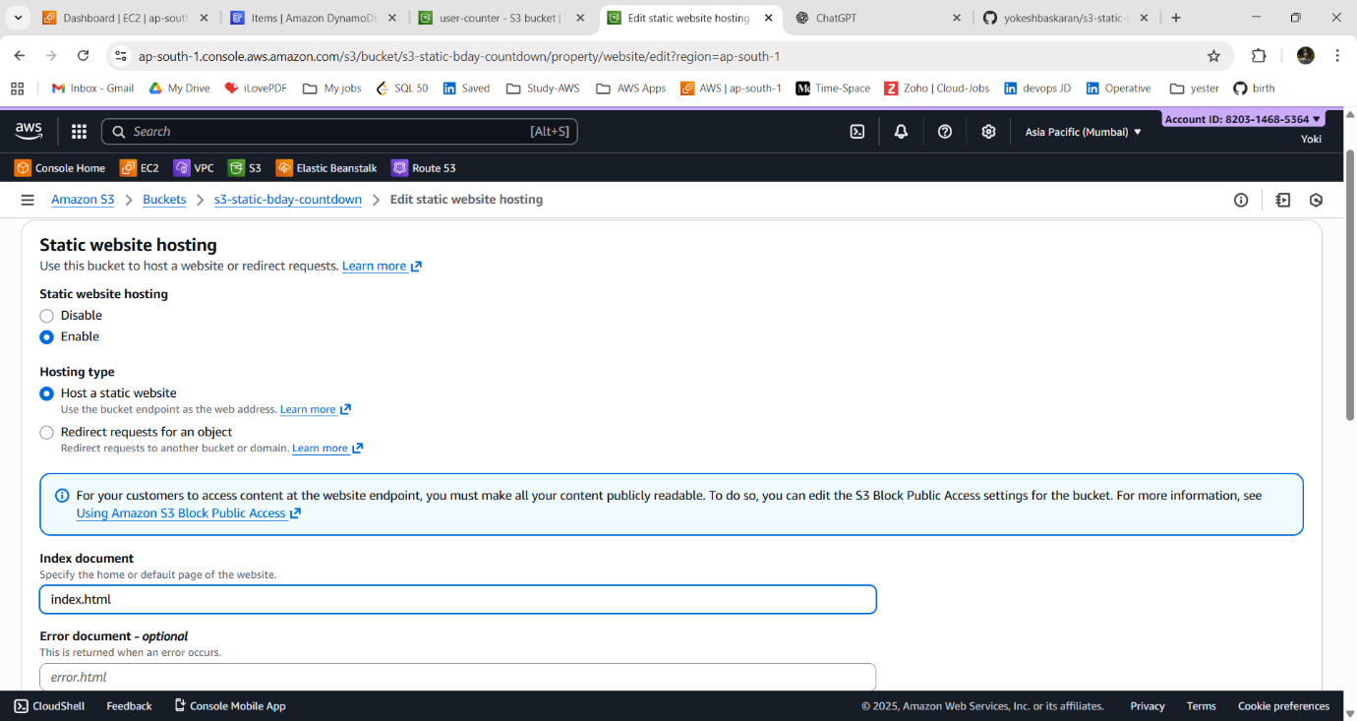
vii) Copy the Website endpoint shown after saving — this is your public website URL.
URL: http://s3-static-bday-countdown.s3-website.ap-south-1.amazonaws.com
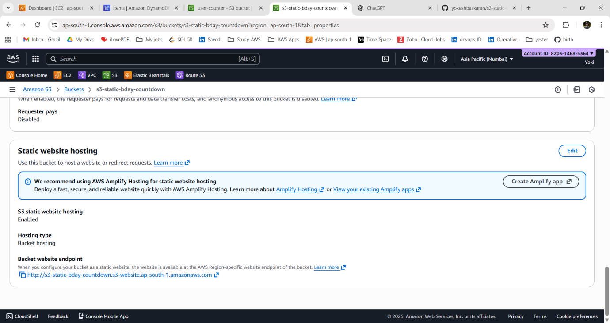

ERROR:
~ If we get 403 Forbidden or access denied. We need to check the bucket settings.
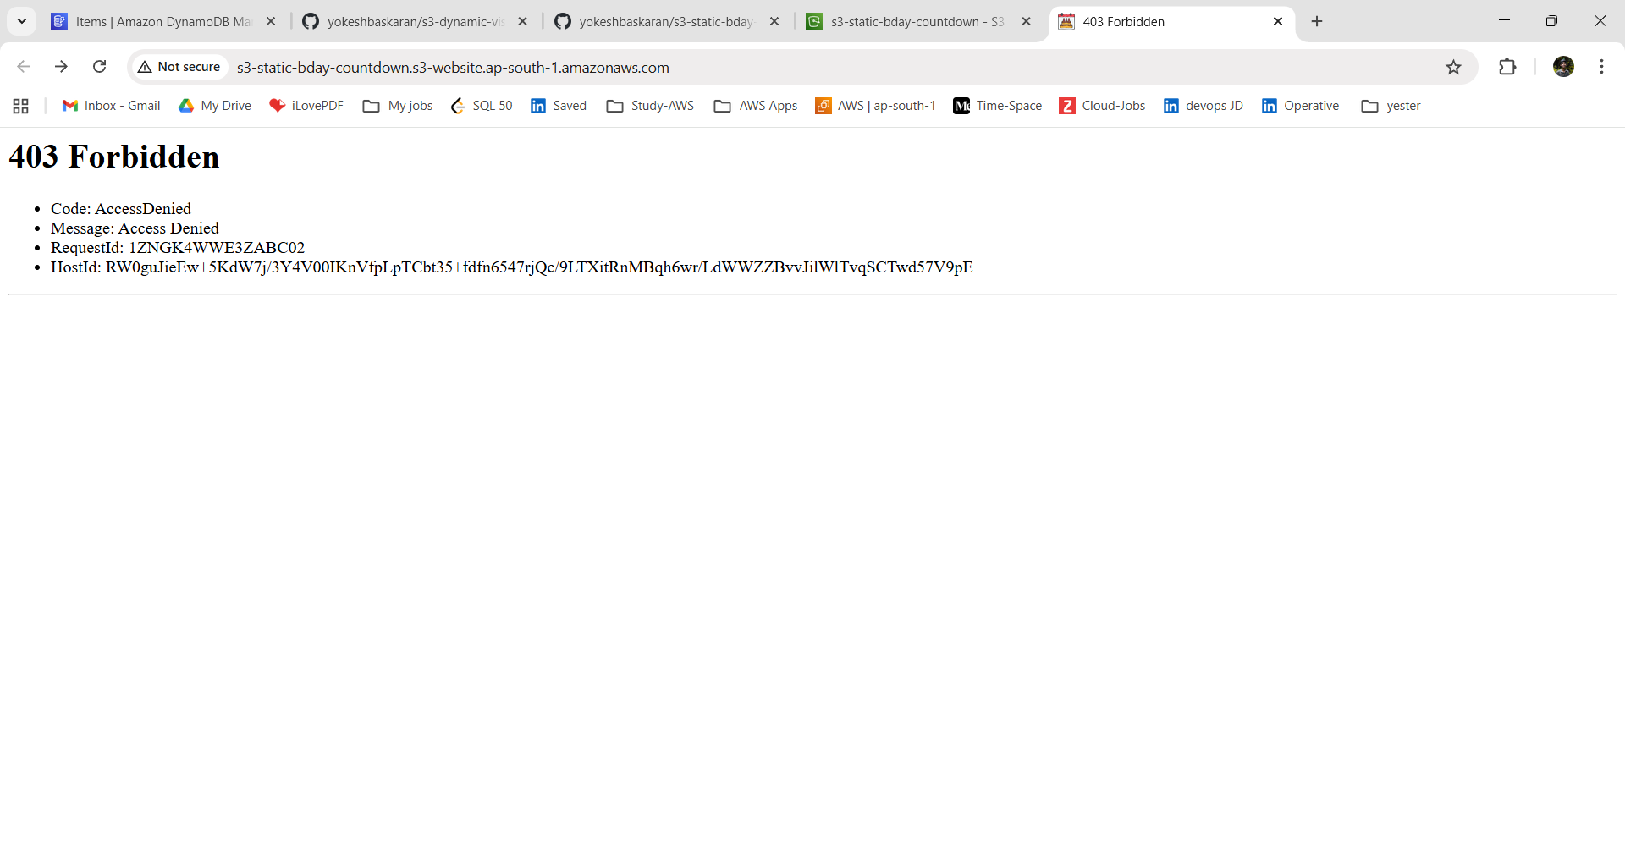
~ we need to Turn off “Block Public Access” (bucket settings).
~ Also, give the Bucket policy.
4. Allow Public Access to Website Files and add Bucket Policy:
i) Go to the “Permissions” tab of the bucket.
ii) Scroll to “Block Public Access” (bucket settings).
iii) Choose Edit and uncheck the “Block all Public Access”.
iv) type “confirm” and click Save Changes.
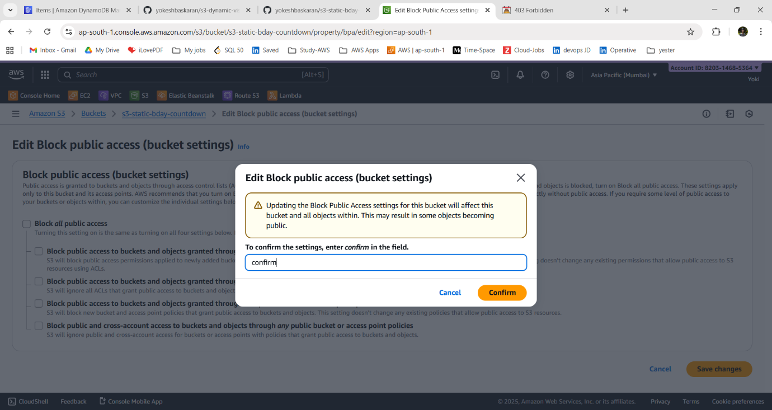

v) In same page of “Permissions” tab of the bucket. Scroll to Bucket policy.
vi) Choose Edit and add a policy that allows public read of all objects in the bucket.
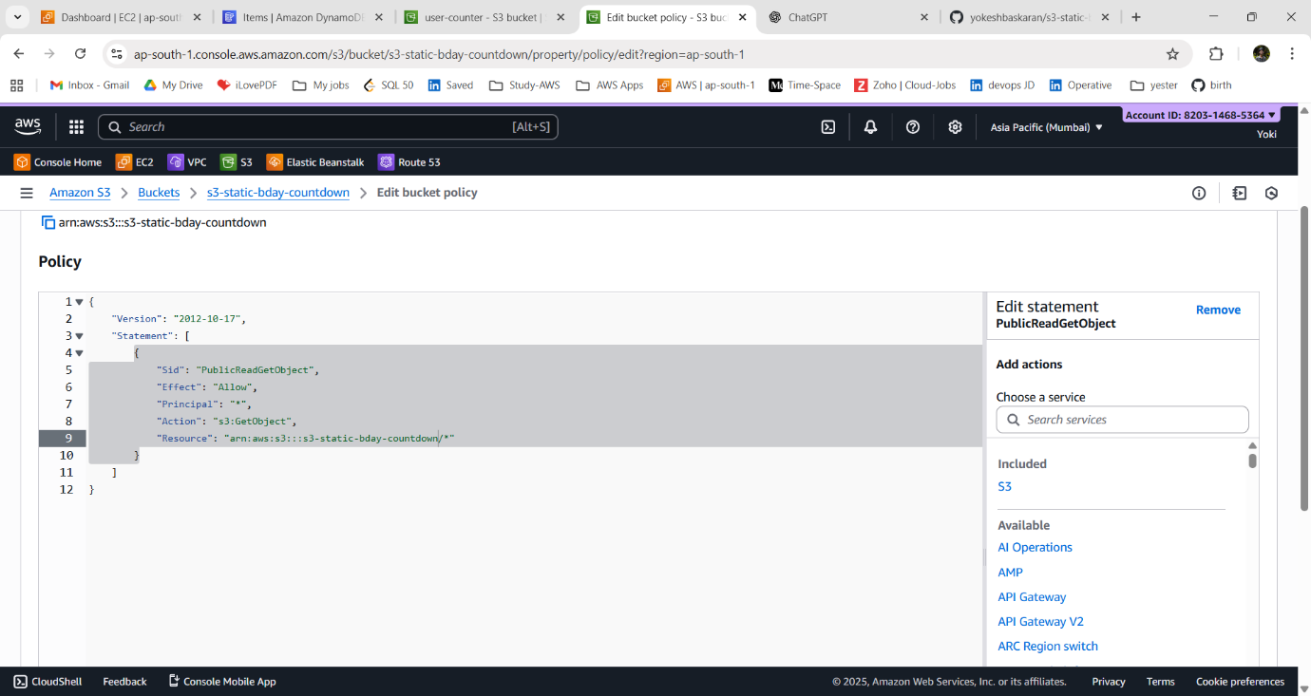
BUCKET POLICY:
```
{
"Version": "2012-10-17",
"Statement": [
{
"Sid": "PublicReadGetObject",
"Effect": "Allow",
"Principal": "*",
"Action": "s3:GetObject",
"Resource": "arn:aws:s3:::s3-static-bday-countdown/*"
}
]
}
```
vii) Save the policy.
viii) Verify that Public Access indicators show that the bucket allows public reads.
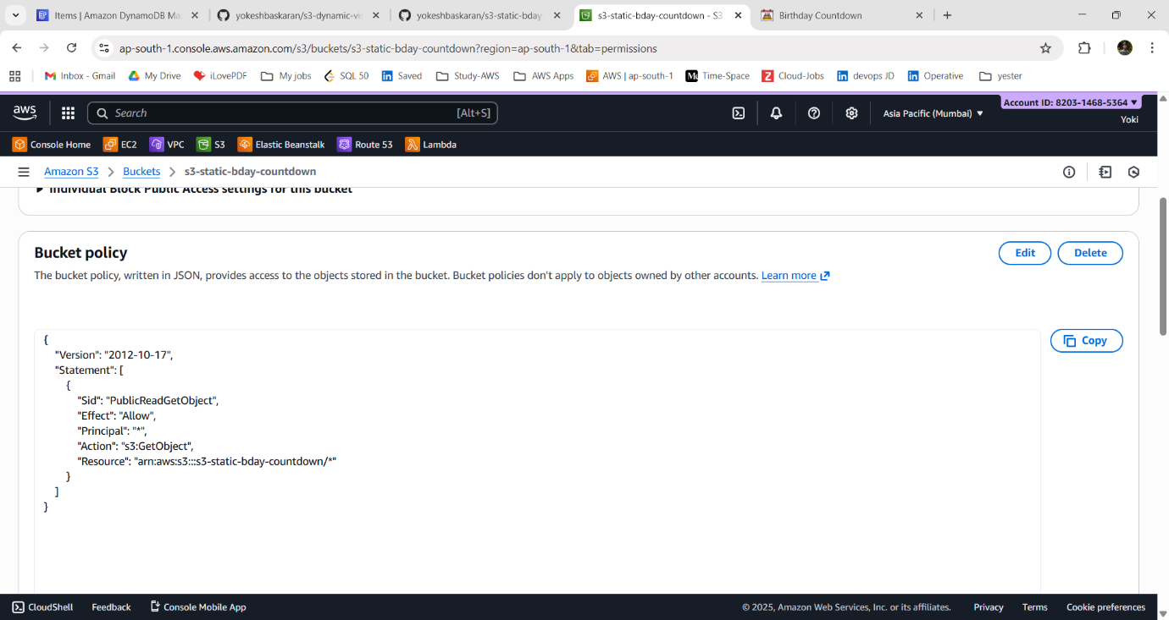

5. Verify Website Accessibility:
i) Open the S3 Website endpoint URL in your browser.
ii) Confirm that the site loads and that resources (CSS, JS files) work properly.
iii) If something doesn’t load, check:
- Files are uploaded at the correct paths
- Permissions allow public read
- File names match exactly (case-sensitive)
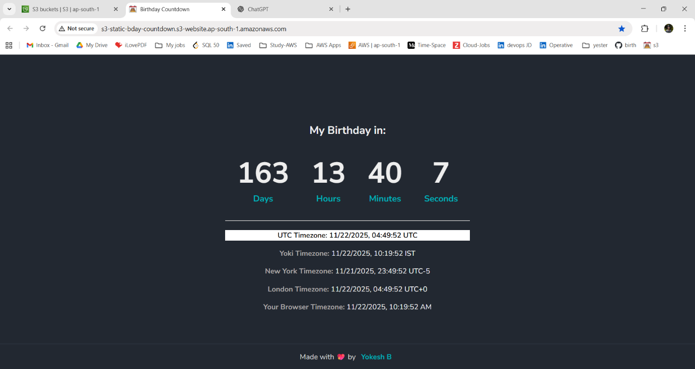
6. Maintenance & Updates:
i) To update your site, upload new versions of your files to the S3 bucket.
ii) Overwrite existing objects or delete and re-upload.
iii) Refresh the website to view changes (sometimes a hard refresh is needed: Ctrl+Shift+R).
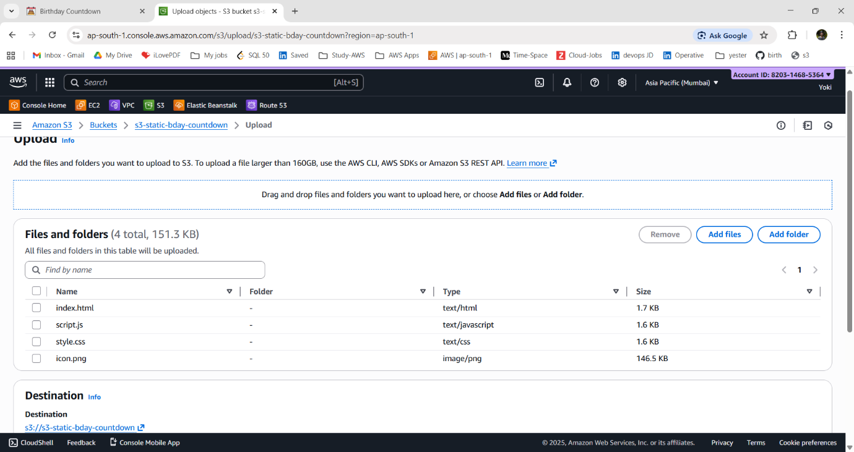
~ This concludes the steps for hosting a static website on Amazon S3.
~ Your site is now ready to be accessed from anywhere in the world.

