LEARNPATH
Detailed Technical
Project Report
AI based adaptive personalized learning path recommender
━━━━━━━━━━━━━━━━━━━━━━━━━━━━━━━━━━━━━━━━
Report scope | Coverage
System | Architecture, modules, data model, APIs and learner workflow
Intelligence | Diagnostics, mastery, retention, prerequisites, NetworkX and ML ranking
Assurance | Evidence provenance, safety boundaries, evaluation, governance and limitations

Prepared for project evaluation panel
Version 1.0 | September 2026

Executive summary
What LearnPath does, why it is different, and what the implementation proves
━━━━━━━━━━━━━━━━━━━━━━━━━━━━━━━━━━━━━━━━━━━━━━━━━━━━━━━━━━━━
LearnPath is an adaptive learning system built to answer one operational question: what should this learner learn next, and why? It combines global learner knowledge, skill-gap analysis, prerequisite constraints, retention risk, machine-learned benefit ranking and versioned path regeneration. The application is not a generic learning-management interface with an isolated recommender. The recommendation loop is the organizing principle of the data model, API and learner experience.
The core architectural choice is the separation of authority from advice. PostgreSQL holds curriculum and learner truth. The TypeScript application API owns evidence updates, mastery, confidence, retention, prerequisite safety and path transactions. Python provides two bounded intelligence functions: NetworkX derives structural graph signals, and a checksum-validated Random Forest estimates recommendation benefit for candidates that have already passed the prerequisite gate. The browser only renders decisions returned by the backend.
The resulting path is evidence-aware and dependency-safe. It recognizes knowledge demonstrated in another course, exposes unknown or weak foundations, distinguishes revision from new learning, explains why a skill is locked or recommended, and becomes stale when later evidence changes the learner model. Regeneration creates a new immutable version rather than silently rewriting history.
Implemented scope | Current project evidence
Curriculum | 5 compact courses and 36 shared active skills
Learning coverage | 36 of 36 skills have lesson, diagnostic, practice and separate post-lesson assessment content
Adaptive diagnostics | Maximum 15 questions with coverage, confirmation and verification stages
Recommendation model | Random Forest, 55 frozen features, learner-disjoint evaluation, checked serving contract
Demonstration | 5 synthetic learner stories covering cold start, uncertain knowledge, adaptation, retention and cross-course reuse
Latest verification | 101 API tests and 41 web tests after Diagnostic v3; documented final audit also records 17 PostgreSQL integration and 35 ML tests

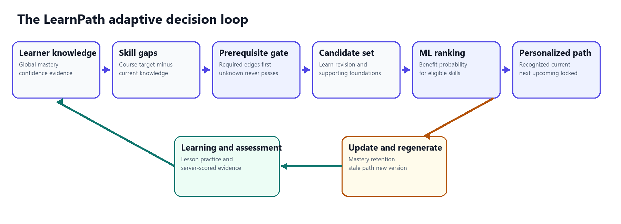
Figure 1 LearnPath closes the loop between evidence, safe recommendation and path adaptation

Report contents
A module-by-module technical and assurance narrative
━━━━━━━━━━━━━━━━━━━━━━━━━━━━━━━━━━━━━━━━━━━━━━━━━━━━━━━━━━━━
Section | Topic | Purpose
1 | Project objective and novelty | Problem, design principles and contribution
2 | Learner flow and adaptive loop | Visible journey from enrollment to regeneration
3 | System architecture | Client, API, database and intelligence service boundaries
4 | Authoritative data model | Global mastery, enrollment context, evidence and path history
5 | Module-wise implementation | Every major backend and frontend module
6 | Algorithms | Mastery, diagnostics, retention, graph, ranking and coordination
7 | Knowledge Graph v2 | Hybrid graph architecture and novelty
8 | Machine learning lifecycle | Synthetic data, features, model selection and inference
9 | Trust and assurance | Why the system can be relied on and where it is limited
10 | Database and API design | Persistence guarantees and main endpoint families
11 | Demonstration scenarios | Five learner profiles and panel walkthrough
12 | Verification and limitations | Test evidence, completion audit and honest boundaries
13 | Conclusion | What the project demonstrates
A | Appendix | Pseudocode, reason codes and panel defense points

Reading guide
- For the project idea and novelty, read Sections 1, 7 and 9.
- For an implementation defense, read Sections 3 through 8 and the Appendix.
- For the live panel demo, use Sections 2 and 11 as the presentation script.
- For limitations and responsible claims, use Sections 9 and 12.

1 Project objective and novelty
A system for deciding the next best learning action
━━━━━━━━━━━━━━━━━━━━━━━━━━━━━━━━━━━━━━━━━━━━━━━━━━━━━━━━━━━━

Problem statement
Traditional course platforms usually present the same module sequence to every learner. Completion percentages describe navigation, not knowledge. A learner may already know a prerequisite from another course, may have forgotten a previously mastered skill, or may understand an advanced topic while retaining a fragile basic foundation. A fixed sequence cannot represent these cases accurately.
LearnPath addresses the problem as a constrained decision system. The system must estimate what the learner knows, identify the gap relative to the active course, check prerequisite feasibility, rank only safe candidates, and update its decision when new evidence arrives. It must also show the learner and reviewer how that decision was made.

Primary research and engineering contribution
Contribution | Implementation meaning | Why it matters
Global Skill Passport | One learner-skill state is reused across every course context | Avoids relearning and demonstrates transfer of prior knowledge
Evidence-bounded diagnostic | Adaptive placement gathers repeated, varied evidence within a 15-question cap | Avoids claiming mastery from one answer while keeping onboarding practical
Hybrid Knowledge Graph v2 | Relational graph truth plus TypeScript safety gates and NetworkX structure analytics | Combines auditability, safe prerequisites and graph intelligence without duplicate truth stores
Constrained ML ranking | Random Forest sees only prerequisite-eligible candidates | ML optimizes priority but cannot make unsafe progression decisions
Versioned adaptation | Evidence marks an active path stale and explicit regeneration creates a new immutable version | Makes change visible, explainable and auditable
Cross-course coordination | Shared skills are recognized while each enrollment keeps its own dependency-valid path | Shows personalization across multiple simultaneous courses

Design principles
- Unknown is represented honestly. Missing evidence is not converted to zero knowledge or assumed mastery.
- Course completion and knowledge are separate. Passive activity cannot manufacture mastery.
- Safety precedes optimization. Required prerequisites are enforced before ML ranking.
- Every important decision is explainable from stored evidence, policy versions and reason codes.
- The system adapts only when learner evidence changes and preserves the earlier decision for comparison.
- Synthetic data and observational feedback are clearly labeled so the project does not overclaim real-world effectiveness.

2 Learner flow and adaptive loop
How the implemented UI turns personalization into a visible workflow
━━━━━━━━━━━━━━━━━━━━━━━━━━━━━━━━━━━━━━━━━━━━━━━━━━━━━━━━━━━━
- Authenticate and open the learner dashboard. The dashboard loads real enrollment, evidence, goal, retention and path summaries from the API.
- Enroll in one or more courses. Each enrollment establishes a course context but does not create duplicate skill mastery records.
- Take the course diagnostic when the starting evidence is insufficient. The server reveals one selected question at a time and stores answer drafts for resume.
- Submit the diagnostic. The server scores all responses, records immutable evidence, updates global skill estimates and returns tested, uncertain and explicitly untested skills.
- Generate the personalized path. The engine evaluates global mastery, retention and recursive prerequisite readiness, creates candidate lanes, requests benefit inference for eligible skills and persists a versioned path.
- Follow Learn Next directly into the lesson. Resource events record activity and time but do not change knowledge.
- Complete practice or a distinct assessment. Server-scored performance creates evidence, updates mastery and confidence, and may change retention or prerequisite eligibility.
- Observe the active path become stale. The UI explains that the learner model changed and offers explicit regeneration.
- Regenerate. The previous path becomes immutable SUPERSEDED history and a new ACTIVE path shows what moved, unlocked or became revision due.
- Switch courses. Shared global knowledge is recognized automatically while each course retains its own path and progress context.

What the learner should be able to answer
Learner question | Where LearnPath answers it
What do I already know | Global Skill Passport and recognized path lane
What is uncertain | Diagnostic results, mastery intervals, confidence and evidence state
Why is this skill locked | Prerequisite graph with exact required thresholds and shortfalls
What should I learn next | Current Learn Next path item and action
Why was it selected | Benefit score, gap, retention, course context, graph leverage and reason codes
What changed after learning | Before and after mastery, stale-path signal and immutable path comparison

3 System architecture
Four layers with explicit decision ownership
━━━━━━━━━━━━━━━━━━━━━━━━━━━━━━━━━━━━━━━━━━━━━━━━━━━━━━━━━━━━
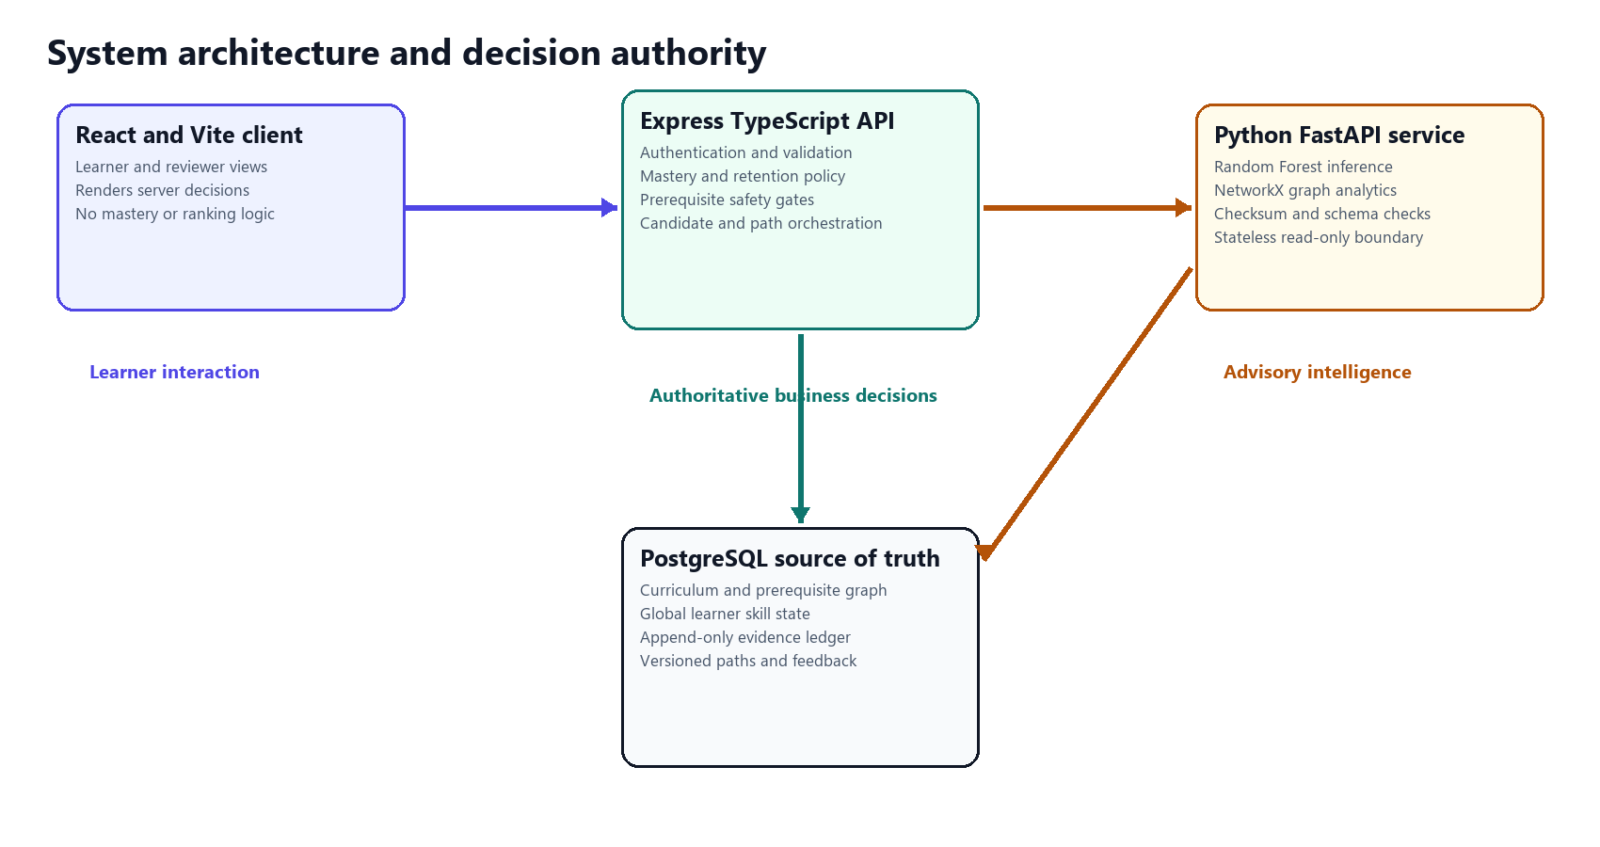
Figure 2 The API and database own learner truth; Python contributes bounded intelligence
Layer | Technology | Responsibilities | Not allowed to do
Presentation | React, TypeScript, Vite | Learner workflows, visual paths, graph, evidence and reviewer views | Calculate mastery, unlock a skill or invent recommendation scores
Application | Express, TypeScript | Authentication, validation, policy engines, orchestration and transactions | Delegate prerequisite safety to the ML model
Persistence | PostgreSQL | Curriculum, constraints, learner state, evidence, paths, feedback and migrations | Store separate conflicting mastery per course
Intelligence | FastAPI, scikit-learn, NetworkX | Checked benefit inference and read-only structural graph analytics | Write learner data, satisfy required edges or rank locked skills

Request and decision flow
The browser sends an authenticated request to the Express API. The API loads a transactionally consistent learner and curriculum snapshot from PostgreSQL. Deterministic policies compute knowledge, retention and eligibility. Only the eligible candidate feature matrix is sent to FastAPI. The intelligence service validates the artifact checksum and the 55-field schema, returns probabilities and structural analytics, and never receives permission to mutate application state. The API applies bounded policy bonuses, orders the path dependency-safely and persists both the decision and its provenance.

Failure behavior
- If PostgreSQL is unavailable, API readiness fails with HTTP 503 rather than serving incomplete state.
- If model metadata, schema or checksum is incompatible, inference returns an error; it does not silently substitute a heuristic score.
- If NetworkX analytics is unavailable, TypeScript prerequisite enforcement continues in safe mode and the graph bonus is omitted.
- A stale path is excluded from cross-course coordination until explicitly regenerated.

4 Authoritative data model
Separating knowledge, context, activity and decisions
━━━━━━━━━━━━━━━━━━━━━━━━━━━━━━━━━━━━━━━━━━━━━━━━━━━━━━━━━━━━

Core entities
Entity family | Scope and key rule | Examples of stored state
Learner | Authenticated person and profile | Identity, session ownership and learner preferences
Course enrollment | One learner in one course context | Status, module progress, diagnostic and path context
Learner goal | Optional relevance lens | Goal skills and course links; dropping it preserves learning evidence
Global learner skill | Unique by learner_id and skill_id | Mastery, confidence, evidence state and latest retention projection
Skill evidence | Append-only performance observations | Source, score, difficulty, timing, before and after state, metadata
Curriculum graph | Shared active skills plus typed edges | Course-skill mappings, REQUIRED and RECOMMENDED prerequisites
Personalized path | One current path per enrollment | ACTIVE, STALE or SUPERSEDED version plus ordered items and provenance
Recommendation feedback | Response to the active Learn Next item | Accepted or declined, reason, later assessed outcome and attribution

Knowledge state dimensions
Dimension | Meaning | Important distinction
Mastery | Estimated durable knowledge on a zero-to-one scale | Not the same as lesson or module completion
Confidence | How strongly available evidence supports the estimate | High mastery with weak confidence remains uncertain
Evidence state | UNKNOWN, ESTIMATED, ASSESSED or VERIFIED | A policy label derived from volume, sessions, diversity and consistency
Retention | Current projected accessibility of demonstrated knowledge | May fall with time while mastery remains the durable record
Course progress | Navigation and completion inside an enrollment | Never copied into mastery

Evidence ledger guarantees
All diagnostic, practice, quiz, assessment, module-assessment and retention-check observations pass through the same mastery service and create rows in skill_evidence. Database triggers reject update and delete operations. The ledger preserves the source event, measured score, correctness, difficulty, attempt number, timestamps, previous and resulting mastery, previous and resulting confidence, evidence-state transition, retention values and structured metadata. This is the audit trail behind every learner skill state.

5 Module-wise implementation
Inputs, internal logic and outputs of the implemented system
━━━━━━━━━━━━━━━━━━━━━━━━━━━━━━━━━━━━━━━━━━━━━━━━━━━━━━━━━━━━
Module family | Primary responsibility | Authority
Learner state | Skill Passport, evidence, mastery, confidence and retention | TypeScript plus PostgreSQL
Placement | Adaptive diagnostic and skill-gap classification | TypeScript plus PostgreSQL
Dependency intelligence | Prerequisite enforcement and structural analytics | TypeScript authoritative, NetworkX derived
Recommendation | Candidates, features, Random Forest rank and path ordering | TypeScript orchestrated, Python advisory
Learning loop | Lessons, practice, assessment, feedback and regeneration | TypeScript plus PostgreSQL
Experience | Learner and reviewer visualization | React renders backend state

5.1 Authentication and application security
Provides registration, login, token refresh, logout and current-user resolution. Passwords are hashed, access tokens are signed, authentication endpoints are rate-limited, and protected routers use common middleware.
Technical implementation Express routers validate inputs, issue short-lived access credentials, rotate refresh state and attach the authenticated learner identifier to the request. Authorization checks are repeated in enrollment, learning, practice and assessment services so a learner cannot operate on another learner's context.
Inputs | Outputs
Authenticated learner identity and request metadata | Authorized API context or explicit 4xx rejection

5.2 Catalog goals and enrollment
Presents courses, course skills and optional learning goals; creates multiple active enrollments without duplicating learner knowledge.
Technical implementation The catalog service reads active curriculum rows and goal mappings. The enrollment service creates the course relationship and module-progress records. Goal removal marks the goal dropped and unlinks context while preserving evidence, mastery and enrollment progress.
Inputs | Outputs
Course, learner and optional goal selection | Enrollment and context-specific progress state

5.3 Global Skill Passport
Shows one reusable learner knowledge profile across every enrolled course.
Technical implementation The learner-skills service joins global learner_skill_mastery with active skill and course mappings. It returns mastery, confidence, evidence state, retention, evidence counts and the courses that can reuse the skill. A database uniqueness constraint prevents course-specific duplicates.
Inputs | Outputs
Learner identifier and optional filters | Global skill records with reuse context

5.4 Central mastery and evidence engine
Transforms verified performance events into bounded mastery, confidence and evidence-state transitions.
Technical implementation Source-specific weights, difficulty-adjusted performance and evidence-history summaries are applied inside a row-level transaction. Confidence grows from volume, session count, source diversity, consistency and difficulty. Diagnostic confidence is capped at 0.45. The resulting state and immutable evidence are written atomically.
Inputs | Outputs
Server-scored evidence and prior learner-skill state | New mastery, confidence, evidence state and audit row

5.5 Adaptive diagnostic v3
Estimates a defensible starting point without interrupting the learner with a long exhaustive exam.
Technical implementation A server selector reveals one item at a time. Five coverage slots sample high-value breadth, eight confirmation slots deepen uncertain or contradictory observations, and two verification slots seek independent application evidence. Submission is all-or-nothing; classifications include MASTERED, READY, GAP, FORGOTTEN, FRAGILE_FOUNDATION, NEEDS_CONFIRMATION, PROBED and NOT_TESTED.
Inputs | Outputs
Course or goal context, answer history and current learner state | Evidence, intervals, classifications and path-generation handoff

5.6 Prerequisite engine
Determines which skills are safe to learn now and explains every required edge.
Technical implementation The service recursively loads course skills and supporting ancestors, orders the directed acyclic graph, and evaluates each REQUIRED edge against confidence-adjusted global mastery. RECOMMENDED edges remain advisory. Unknown mastery cannot satisfy a requirement. The output contains mastered, ready and locked nodes, shortfalls and reuse context.
Inputs | Outputs
Enrollment or optional goal plus live global skill state | Dependency order, readiness classifications and gate explanations

5.7 Retention and revision
Detects when previously demonstrated knowledge is likely becoming inaccessible and schedules revision separately from new learning gaps.
Technical implementation The retention service applies exponential decay from the latest immutable performance evidence. Confidence and evidence volume slow the effective decay rate. A skill becomes a revision candidate only if prior mastery was at least 0.65 and current retention is AT_RISK or CRITICAL. A retention check uses real server-scored questions and writes RETENTION_CHECK evidence.
Inputs | Outputs
Mastery, confidence, evidence history and elapsed time | Retention value, state and narrowly defined revision eligibility

5.8 Candidate generation
Creates the complete decision space before machine learning.
Technical implementation The engine combines course skills, recursive prerequisite ancestors, mastery gaps and revision needs. It assigns LEARN, REVISION or SUPPORTING_PREREQUISITE kinds and partitions results into eligible, locked and excluded lanes. Locked candidates retain explanations but never enter the inference matrix.
Inputs | Outputs
Course context, global knowledge, retention and prerequisite result | Eligible, locked and excluded candidate sets with reasons

5.9 Learning resources practice and assessment
Turns recommendations into measurable learning actions.
Technical implementation Lessons are mapped to skills and record activity events such as started, viewed and completed. Those events affect engagement only. Practice and distinct post-lesson assessment pools are selected by the server, correct options remain hidden until submission, and the mastery service receives scored performance evidence.
Inputs | Outputs
Current path action, resource events or submitted answers | Activity history or new performance evidence and state change

5.10 Synthetic research dataset
Provides reproducible training and evaluation data without presenting synthetic learners as real users.
Technical implementation A curriculum snapshot drives a seed-42 simulator with 1,000 synthetic learners and 20,000 interactions. It models mastery, prerequisites, retention, engagement, practice, completion, time, assessment improvement, feedback and explicit noise. Labels are determined from a weighted benefit score rather than assigned randomly. The data is never imported into the application database.
Inputs | Outputs
Versioned active curriculum snapshot and fixed random seed | Synthetic interactions, manifest, distributions and checksums

5.11 Feature engineering
Converts decision-time learner and candidate context into a stable model contract.
Technical implementation Feature version learner-candidate-features-v2 contains 55 numeric fields in a fixed order. Identifiers and labels remain separate. Current outcome fields are blocked, and historical outcome features are shifted by one interaction to prevent future leakage. A simulator-only latent ability variable was replaced with an observable performance proxy.
Inputs | Outputs
Candidate interaction history available at recommendation time | Normalized 55-feature matrix plus separate metadata and label

5.12 Model training and evaluation
Selects a benefit-ranking model through reproducible learner-disjoint experimentation.
Technical implementation Learners are split 70 percent training, 15 percent validation and 15 percent test with no overlap. Gradient Boosting, Random Forest and Logistic Regression are compared with Highest Skill Gap and Popularity baselines. Validation NDCG at 5 selects the model, ROC-AUC and F1 break ties, and the classification threshold is chosen on validation before the test set is opened.
Inputs | Outputs
Frozen features, labels, split assignment and seed 42 | Selected Random Forest artifact, manifest, metrics and checksum

5.13 Checked inference service
Serves model probabilities without allowing an incompatible or corrupt artifact to influence a path.
Technical implementation FastAPI verifies artifact SHA-256, model version, feature version, inference version, feature count, exact field order and positive-class contract before prediction. Invalid bounds or schema receive 422; missing or incompatible artifacts receive 503. There is no heuristic fallback and the service is stateless.
Inputs | Outputs
Eligible candidate records using the frozen feature contract | Benefit probabilities with model and contract metadata

5.14 Personalized path engine
Builds the visual centerpiece that connects prior knowledge, current action, future sequence and locked dependencies.
Technical implementation The API combines inference probability with a 0.08 revision bonus and at most 0.06 times the NetworkX gateway score. It then applies dependency-aware ordering and stable tie-breaks. One path belongs to one enrollment and exposes RECOGNIZED, CURRENT, RECOMMENDED_NEXT, UPCOMING and LOCKED lanes. The stored snapshot includes decision-time mastery, confidence, retention, prerequisites, reason codes and version identifiers.
Inputs | Outputs
Eligible candidates, ML scores, graph analytics and deterministic policy | Versioned dependency-safe path and Learn Next explanation

5.15 Cross-course coordination
Prevents multiple active courses from presenting confusing duplicate priorities while preserving each course path.
Technical implementation Only current ACTIVE paths participate. The service groups identical global skills across course contexts and adjusts coordination priority using the best course priority, up to two additional active-course contexts and optional goal relevance. The result recommends a coordinated next action without merging or rewriting the underlying paths.
Inputs | Outputs
Current active paths across the learner's enrollments | Coordinated next action and cross-course reuse explanation

5.16 Dynamic adaptation and history
Makes path changes explicit after meaningful learner evidence.
Technical implementation New evidence marks affected ACTIVE paths STALE. Regeneration runs the complete prerequisite, graph, candidate, inference and ordering pipeline inside a transaction. The old row becomes SUPERSEDED, the new row becomes ACTIVE, and change summaries identify moved, added, removed, unlocked or revision-due skills.
Inputs | Outputs
Stale path, current learner state and curriculum | New immutable path version plus event and change summary

5.17 Recommendation feedback and attribution
Captures learner response and later observed outcomes without claiming causality.
Technical implementation Accepted or declined feedback applies only to the current Learn Next item and can include a structured rejection reason. Later assessed evidence within a 30-day window is compared with the recorded baseline. A change of at least plus or minus 0.05 is classified as improvement or decline; missing baseline remains OBSERVED_NO_BASELINE.
Inputs | Outputs
Current recommendation response and later assessed evidence | Version-linked observational outcome for evaluation

5.18 Analytics governance and reviewer tools
Shows system performance honestly and blocks conclusions when the sample is too small.
Technical implementation Learner analytics summarizes real backend state. Reviewer pages expose candidate partitions, synthetic data lineage, feature contracts, model metrics, inference checks and governance. Acceptance rates are withheld below 30 responses, calibration below 30 assessed outcomes, drift below 50 recent and 50 reference predictions, and retraining eligibility below 100 assessed recommendation outcomes. Promotion remains human-controlled.
Inputs | Outputs
Stored path, feedback, prediction and outcome histories | Metrics or explicit insufficient-sample status and governance decision

5.19 Modern learner interface
Makes personalization immediately understandable rather than hiding it behind CRUD screens.
Technical implementation React pages consume typed API clients and render enrollment-aware dashboard cards, diagnostic progress and results, the horizontal personalized path, Learn Next explanation, skill passport, prerequisite graph, retention states, lessons, practice, assessment, path history and cross-course recognition. Loading, empty, error and stale states are represented explicitly.
Inputs | Outputs
Real API responses and route context | Accessible learner actions and reviewer-visible intelligence

6 Algorithms
How evidence becomes knowledge and knowledge becomes a path
━━━━━━━━━━━━━━━━━━━━━━━━━━━━━━━━━━━━━━━━━━━━━━━━━━━━━━━━━━━━

6.1 Difficulty-aware mastery update
Each server-scored observation becomes a bounded performance signal. The mastery service applies a source weight: 0.40 for assessment, diagnostic and module assessment, 0.30 for quiz, 0.25 for practice and 0.35 for retention check. Diagnostic reliability further reduces the effective weight when evidence is sparse or narrow.
Mastery update
effective weight = source weight × reliability | mastery after = mastery before × (1 − effective weight) + measured performance × effective weight
For a new skill, the diagnostic begins from a neutral 0.50 prior. All values are bounded to the valid zero-to-one interval.

6.2 Confidence and evidence-state policy
Confidence is not copied from mastery. It grows from independent evidence volume, multiple sessions, source diversity, answer consistency and difficulty coverage. Diagnostic evidence is capped at 0.45 because one placement session is not certification. ASSESSED requires at least five observations, two sessions and 0.45 confidence. VERIFIED requires at least twelve observations, four sessions, at least 0.70 consistency, at least 0.78 confidence, and source diversity or retention evidence.
State | Interpretation | Minimum policy meaning
UNKNOWN | No performance observation | Do not infer either weakness or mastery
ESTIMATED | Some evidence but still sparse or narrow | Useful for personalization with visible uncertainty
ASSESSED | Repeated evidence meets assessment policy | At least 5 observations, 2 sessions and confidence 0.45
VERIFIED | Strictest support for the estimate | At least 12 observations, 4 sessions, consistency 0.70 and confidence 0.78 plus diversity

6.3 Adaptive diagnostic selection
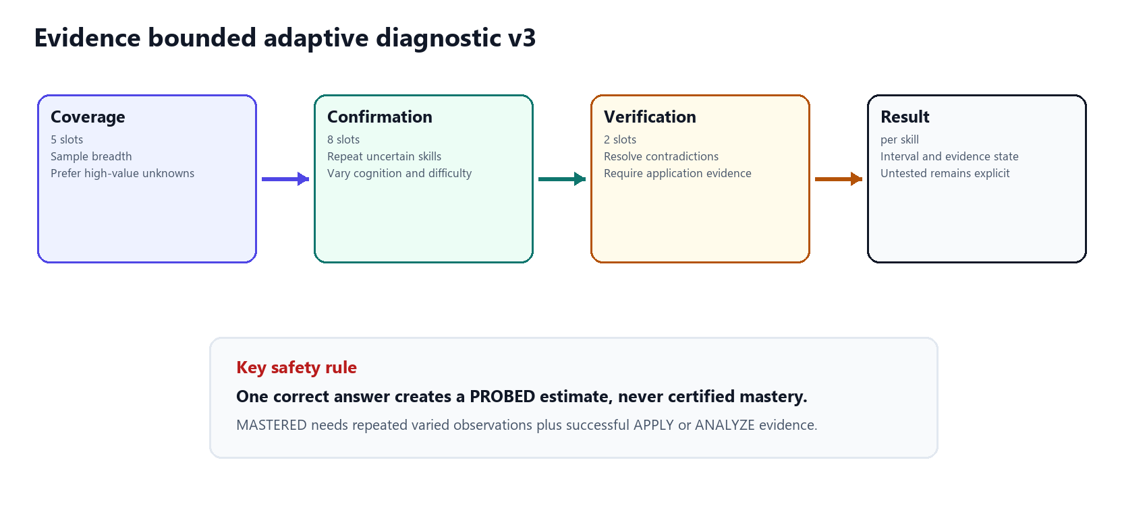
The selector scores active course questions from signals available at that point in the session: unknown state, distance from target, confidence, retention risk, required downstream dependents, item discrimination, difficulty fit, cognitive novelty, missing application evidence and contradiction risk. Coverage favors different high-value skills. Confirmation selects a second or third independent observation. Verification resolves contradictions or missing application evidence. No skill receives more than three direct observations in one session.
Diagnostic classification | Decision rule in plain language
MASTERED | Three varied observations, correct application or analysis, target mastery and sufficient confidence
READY | Positive evidence supports proceeding but is below certification
GAP | Repeated observations indicate a missing foundation
FORGOTTEN | Prior strong mastery and retention risk conflict with weak current evidence
FRAGILE_FOUNDATION | Advanced performance is strong but a tested required prerequisite is weak
NEEDS_CONFIRMATION | Evidence conflicts or remains insufficient
PROBED | Exactly one direct observation
NOT_TESTED | No direct observation inside the fixed question budget

6.4 Retention model
Forgetting projection
retention = mastery × exp(−effective decay × days since evidence)
The base decay constant is 0.025. Stronger confidence and evidence volume reduce effective decay. STRONG begins at 0.75, AT RISK below 0.55 and CRITICAL below 0.30.

Retention is a current projection, not a retroactive rewrite of knowledge. Only a skill whose earlier mastery reached 0.65 can become a revision candidate when retention falls to AT_RISK or CRITICAL. This prevents an ordinary unlearned gap from being mislabeled as forgetting.

6.5 Confidence-adjusted prerequisite gate
Required-edge evaluation
uncertainty penalty = (1 − confidence) × 0.10 | effective mastery = max(0, observed mastery − uncertainty penalty)
A REQUIRED edge passes only when effective mastery reaches the edge threshold. RECOMMENDED edges do not block. Missing mastery never passes.

6.6 Candidate partition
- Load the enrollment's active course skills and recursively include required prerequisite ancestors.
- Join each skill to global learner mastery, confidence, evidence state and retention.
- Mark already strong reusable knowledge as recognized rather than relearning it.
- Create REVISION candidates only for demonstrated knowledge with at-risk or critical retention.
- Create SUPPORTING_PREREQUISITE candidates for foundations needed to open a course skill.
- Place candidates whose REQUIRED edges pass in eligible; keep failed candidates in locked with explanations; place out-of-scope or already-satisfied items in excluded.
- Build the ML feature matrix only from eligible candidates.

6.7 Ranking and path priority
Path priority
priority = Random Forest benefit probability + 0.08 when revision is due + 0.06 × NetworkX gateway score
Both bonuses are bounded policy adjustments. The graph score cannot exceed one, so its maximum effect is 0.06. Locked skills have no priority because they never reach inference.

The path builder then uses dependency level and stable course sequence or name tie-breaks. This produces deterministic ordering for equal priorities and ensures a supporting prerequisite appears before its dependent. The highest actionable item becomes RECOMMENDED_NEXT, while other eligible items become CURRENT or UPCOMING according to state and order.

6.8 Multi-course coordination
Coordination score
min(1, best course priority + 0.04 × min(additional active course contexts, 2) + 0.06 × active-goal relevance)
Only current ACTIVE paths participate. Grouping occurs by global skill, but each enrollment path remains independent and dependency-safe.

6.9 Dynamic regeneration
The state machine is ACTIVE to STALE to SUPERSEDED, with a newly generated ACTIVE version. Performance evidence that changes a relevant learner-skill state marks the path stale. Regeneration locks the current row, reruns the complete decision pipeline, supersedes the old path, inserts new items and writes a change summary in one transaction. At most one ACTIVE or STALE path exists per enrollment; history can contain multiple immutable SUPERSEDED versions.

7 Knowledge Graph v2
The core novelty as a hybrid graph decision layer
━━━━━━━━━━━━━━━━━━━━━━━━━━━━━━━━━━━━━━━━━━━━━━━━━━━━━━━━━━━━
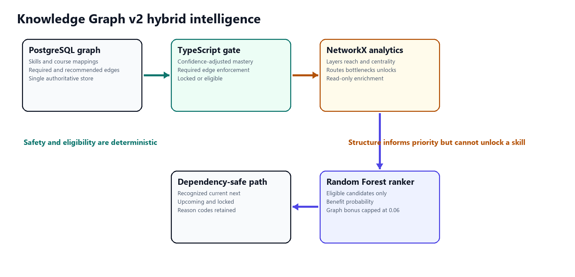
Figure 3 Graph truth, safety, analytics and ranking remain separate concerns

Why PostgreSQL plus NetworkX
PostgreSQL remains the only authoritative graph store because skills, course mappings and prerequisite edges are part of the same transactional curriculum as enrollments and learner state. Database constraints and cycle prevention already protect this graph. NetworkX receives a request-scoped, read-only projection for algorithms that are naturally expressed on a directed graph. This avoids a second synchronized truth store.
Neo4j was intentionally not introduced at this scale. It would be reasonable when the project requires very large heterogeneous graph traversal, independent graph teams, graph-native query workloads or cross-domain relationship discovery. For five courses and 36 shared skills, duplicating the curriculum in Neo4j would add synchronization, deployment and failure modes without improving the current learner decision. This is a deliberate architecture trade-off, not an absence of graph technology.

Structural analytics
NetworkX output | Purpose in LearnPath | Decision boundary
Topological layers | Show dependency-valid learning levels | Cannot change edge satisfaction
Downstream reach | Measure how many later skills depend on a foundation | Used only as bounded leverage
Betweenness centrality | Identify bridge skills between graph regions | Does not claim educational benefit by itself
Shortest foundation route | Explain a path from root knowledge to a target skill | Read-only explanation
Bottlenecks | Find currently weak foundations that block many descendants | TypeScript remains the source of lock status
Counterfactual unlocks | Show what would become ready if one prerequisite reached target | Never writes hypothetical mastery

Gateway score
0.50 × descendant ratio + 0.30 × normalized betweenness + 0.20 × immediate counterfactual unlock ratio
Every component is bounded from zero to one. The resulting graph contribution to final priority is capped at 0.06.

How the learner sees the graph
- Mastered, ready and locked nodes use distinct visual states.
- REQUIRED and RECOMMENDED edges use different styles and explanations.
- Each locked node exposes observed mastery, confidence-adjusted mastery, target threshold and shortfall.
- The view explains shortest routes, downstream reach, bottlenecks and potential unlocks in plain language.
- Changing course context reprojects the same global learner knowledge onto a different portion of the graph.

8 Machine learning lifecycle
From explicit synthetic data to checked runtime inference
━━━━━━━━━━━━━━━━━━━━━━━━━━━━━━━━━━━━━━━━━━━━━━━━━━━━━━━━━━━━

8.1 Data generation
Property | Implemented value
Classification | SYNTHETIC / SIMULATED DATA
Curriculum snapshot | 36 skills, 4-course source snapshot and 86 prerequisite edges in the training export
Scale | 1,000 learners and 20,000 candidate interactions
Random seed | 42
Beneficial label | Benefit score at or above 0.27
Benefit weights | 0.40 mastery gain, 0.25 completion, 0.25 assessment improvement, 0.10 learner feedback
Observed positive rate | 35.455 percent
Separation | Synthetic files remain under the ML data workspace and are not imported into PostgreSQL learner tables

The simulator models meaningful relationships rather than independent random columns. The stored manifest records positive prerequisite-mastery to post-assessment correlation, engagement to completion and mastery gain, practice to assessment improvement, and a negative relationship between difficulty mismatch and mastery gain. Noise flags include guessing, skipping, disengagement and inconsistent performance.

8.2 Feature contract
Version learner-candidate-features-v2 freezes 55 numeric features in exact order. The categories cover learner knowledge, evidence strength, recent performance, history, engagement, retention, prerequisite readiness, graph context, course context and candidate type. Learner, course, skill and interaction identifiers remain outside the numeric matrix. The target label is also excluded.
Leakage control | Implementation
Decision-time only | Features are calculated from information available before the candidate outcome
Shifted history | Completion, engagement, assessment improvement and feedback histories are shifted by one interaction
Blocked fields | Current completion, current engagement, current time, post-assessment, mastery gain, feedback, benefit score and label cannot enter features
Observable proxy | Simulator-only learner ability is removed and replaced with learner_performance_proxy
Shared schema | Training and inference load the same frozen feature names and order

8.3 Experiment design
Experiment element | Policy
Split | 700 train learners and 14,000 rows; 150 validation learners and 3,000 rows; 150 test learners and 3,000 rows
Isolation | No learner appears in more than one split
Candidates | Gradient Boosting, Random Forest and Logistic Regression
Baselines | Highest Skill Gap and curriculum-derived Popularity
Selection | Highest validation NDCG at 5, with ROC-AUC and F1 tie-breaks
Threshold | Chosen by maximizing validation F1 over 181 grid points and then applied unchanged to test
Test set | Untouched during selection and opened only for final evaluation

8.4 Selected model
The selected artifact is benefit-ranking-v2, a RandomForestClassifier with 220 estimators, maximum depth 12, square-root feature sampling, minimum leaf size 4, balanced class weighting, one execution job and seed 42. The classification threshold is 0.45. Important learned signals include recent score, current mastery, mastery gap, skill average score, historical feedback, score trend and historical completion rate.
Model or baseline | Validation NDCG@5 | Test NDCG@5 | Test ROC-AUC | Test Precision@5
Random Forest selected | 0.581021 | 0.578463 | 0.801410 | 0.525333
Gradient Boosting | 0.576017 | 0.589501 | 0.804062 | 0.521333
Logistic Regression | 0.564225 | 0.580259 | 0.802338 | 0.513333
Highest Skill Gap | 0.576408 | 0.581229 | 0.730785 | 0.510667
Popularity | 0.251677 | 0.272412 | 0.440132 | 0.284000

Interpretation Random Forest was chosen strictly from validation NDCG@5, not from the more favorable test result of another model. On the held-out test, it improved ROC-AUC and Precision@5 over Highest Skill Gap but did not improve NDCG@5. This mixed result is important: it supports using the model as a bounded ranking component, not claiming that the synthetic experiment proves general superiority.

8.5 Deployment evolution and runtime contract
The Phase 14 experiment manifest correctly records EVALUATED_NOT_DEPLOYED because ranking integration was outside that phase. Later implementation phases introduced the versioned FastAPI inference boundary and integrated the frozen selected artifact into path generation. Runtime loading verifies SHA-256 b67297304bd175b8a451c0a0f36011a8603b19d6fdf723a16e5ad94eb721fa6e, the model and feature versions, all 55 field names in order, the inference version and the positive class before deserialization and prediction.
The API never sends locked candidates to this service. Returned probability is therefore a priority estimate among safe options, not an eligibility decision. This distinction is central to the project's trust model.

9 Trust and assurance
How LearnPath supports confidence without overclaiming certainty
━━━━━━━━━━━━━━━━━━━━━━━━━━━━━━━━━━━━━━━━━━━━━━━━━━━━━━━━━━━━
Trust in LearnPath does not come from the phrase artificial intelligence. It comes from explicit boundaries, evidence provenance, conservative uncertainty handling, reproducible evaluation, failure-safe behavior and visible limitations. The system is designed so a reviewer can trace a recommendation from the path item back to eligibility checks, learner state, evidence and model version.
Trust risk | Implemented control | Evidence a reviewer can inspect
One answer treated as mastery | Diagnostic one-answer result is PROBED; mastery needs repeated varied application evidence | Attempt history, observation counts and result classification
Unknown treated as knowledge | Unknown mastery never satisfies REQUIRED prerequisite edges | Gate explanation with missing evidence state
ML unlocks an unsafe skill | Locked skills removed before feature construction and inference | Candidate eligible and locked lanes
Course completion inflates knowledge | Resource events update activity only and never call the mastery engine | Evidence ledger contains only scored performance sources
Evidence silently edited | Append-only ledger with update and delete rejection triggers | skill_evidence history and before or after state
Corrupt or incompatible model | Checksum, version, feature-order and class validation | Inference readiness and artifact manifest
Graph service unavailable | Authoritative TypeScript gate continues and omits graph bonus | Safe-mode analysis response
Future leakage inflates metrics | Decision-time allowlist, blocked fields, shifted histories and learner-disjoint splits | Feature and experiment manifests
Path history overwritten | Stale then superseded immutable path version with transactional replacement | Path history and change summary
Feedback presented as causal | Outcome labeled observational and requires a stored baseline | Version-linked feedback and OBSERVED_NO_BASELINE state
Small samples shown as reliable rates | Minimum thresholds for rates, calibration, drift and retraining | Governance page explains withheld metrics

Trust argument by layer
Layer | Trust claim | Reasonable confidence boundary
Data | Learner state is traceable | Every update points to immutable scored evidence
Policy | Unsafe progression is blocked | Required-edge decisions are deterministic and confidence-aware
Graph | Structural explanations are reproducible | Analytics are derived from the current directed acyclic graph and never authoritative
ML | Inference is technically reproducible | Artifact, features, split and metrics are versioned; educational effectiveness remains unproven on real learners
Path | A recommendation can be audited | Snapshot retains scores, reasons, prerequisite state and model or policy versions
UI | Learner sees uncertainty and change | Unknown, confidence, locked reasons, stale state and history are visible

What the system can and cannot claim
Supported claim | Unsupported claim
The implemented pipeline produces dependency-safe personalized paths from real backend state | The model is proven to improve learning outcomes in a production population
Knowledge earned in one course is reused in another course that maps the same skill | All domains share the same forgetting or mastery dynamics
The diagnostic is more defensible than a single-question mastery judgment | Fifteen questions can completely certify all 36 course skills
Model evaluation is reproducible on the disclosed synthetic dataset | Synthetic test performance is equivalent to external real-world validation
Recommendation changes are explainable and versioned | Observed improvement after acceptance is necessarily caused by the recommendation

Validation roadmap
- Calibrate diagnostic items with real response data using item difficulty, discrimination and misconception patterns.
- Run a prospective learner study comparing learning gain, time to mastery and completion against a non-personalized sequence.
- Measure calibration and subgroup performance only after governance sample thresholds are met.
- Review prerequisite edges with domain experts and compare predicted unlocks with observed success.
- Retrain and promote only through a human-reviewed model registry process with rollback capability.

10 Database and API design
Persistence guarantees and public service boundaries
━━━━━━━━━━━━━━━━━━━━━━━━━━━━━━━━━━━━━━━━━━━━━━━━━━━━━━━━━━━━

Forward-only schema evolution
The database is built through forward-only PostgreSQL migrations 0001 through 0028. The migration history evolves identity, curriculum, enrollments, diagnostics, mastery, evidence, prerequisites, retention, candidates, paths, feedback, governance, content coverage, Knowledge Graph v2 metadata and Diagnostic v3 question selection without destructive rebuilds.
Schema area | Representative tables or constraints | Guarantee
Curriculum | courses, modules, skills, course_skills, skill_prerequisites | Shared canonical skill identifiers and typed graph edges
Learning context | enrollments, enrollment_module_progress, learner_goals | Progress belongs to enrollment; goals remain optional
Knowledge | learner_skill_mastery, skill_evidence | Unique global state plus append-only provenance
Assessment | assessment_attempts, diagnostic_attempt_questions, diagnostic_answer_drafts, assessment_skill_results | Ordered attempt snapshot, resume and final evidence summary
Path | personalized_paths, path_items, path_events and change summaries | One current path per enrollment and immutable history
Evaluation | recommendation_feedback and attributed outcomes | Feedback linked to exact path and model version

Primary endpoint families
Family | Representative endpoints | Purpose
Authentication | POST /register, /login, /refresh, /logout; GET /me | Identity and session lifecycle
Catalog and goals | GET /overview, /goals/:id, /learner-goals; POST and DELETE learner goals | Course discovery and optional relevance context
Enrollment | GET and POST /enrollments; status and module progress endpoints | Multi-course ownership and progress
Diagnostics | GET /overview; POST /start; answer autosave, submit and results | Adaptive placement flow
Learner skills | GET /learner-skills | Global Skill Passport
Prerequisites | GET /prerequisites/analysis | Dependency readiness and graph explanations
Retention | GET /retention | Forgetting projection and revision state
Candidates | GET /:enrollmentId/candidates | Eligible, locked and excluded lanes
Paths | GET path, history and coordination; POST generate and regenerate | Versioned path lifecycle
Learning and practice | Resource overview, resource events, practice start and submit | Learning actions and scored evidence
Recommendations | Evaluation and path feedback endpoints | Response and later outcome attribution
Analytics governance | GET /analytics/overview and /governance/overview | Learner state and sample-gated oversight

Transaction and concurrency model
- Mastery updates lock only the affected learner-skill row, limiting contention across independent skills.
- The scored evidence row and resulting learner-skill state are committed atomically.
- Path regeneration locks the current path and persists supersession, new path, items and change events as one operation.
- Uniqueness constraints prevent duplicate global mastery and more than one current ACTIVE or STALE path per enrollment.
- All endpoint inputs are schema-validated before service logic and authorization checks are scoped to the authenticated learner.

11 Demonstration scenarios
Five synthetic profiles that expose distinct system behavior
━━━━━━━━━━━━━━━━━━━━━━━━━━━━━━━━━━━━━━━━━━━━━━━━━━━━━━━━━━━━
Profile | Starting state | What to demonstrate | Expected visible result
Maya Explorer | No enrollments and unknown mastery | Cold start and honest unknown state | Five courses available; no invented mastery or path
Noah Starter | Enrolled with diagnostic incomplete | Evidence gate before personalization | Diagnostic is the next action; no premature personalized path
Aisha Builder | Functions learning flow | Recommendation to evidence to regeneration | Accepted lesson, practice, assessment, 40-point observed assessed gain, stale path and new version
Elena Navigator | Multiple courses and retention risk | Cross-course coordination and revision | Two stale paths, shared skills and retention review
Ravi Strategist | Advanced evidence and one focused gap | Cross-course recognition and dependency focus | 20 recognized foundations with Basic Sorting isolated as the gap

Recommended panel demonstration
- Open Noah to show why LearnPath does not create a path without enough starting evidence.
- Open Aisha and explain the current Learn Next card, including mastery gap, prerequisite state, model score and recommendation reason.
- Start the linked lesson. Point out that lesson completion changes engagement but not mastery.
- Complete practice and the separate assessment. Show the before and after mastery, confidence and evidence-state result returned by the server.
- Return to the path and show STALE rather than a silently changed sequence. Regenerate and compare the superseded and new versions.
- Open Elena or Ravi, switch course contexts and show that shared mastery is recognized globally while course progress and paths remain separate.
- Open the prerequisite graph to explain a locked node, its confidence-adjusted threshold and the counterfactual skills that would unlock.
- Finish in the reviewer model and governance views. Disclose synthetic training data, show the evaluation metrics and explain why rates remain withheld at small sample sizes.

End-to-end Aisha trace
Step | Stored or computed change | Visible proof
Recommendation | Path item records skill, probability, policy bonuses, reasons and versions | Learn Next explanation
Acceptance | Feedback linked to the active path item | Accepted status and timestamp
Lesson | Resource activity and time recorded | Learning status changes; mastery does not
Practice | PRACTICE evidence updates state with source weight 0.25 | Before and after mastery and confidence
Assessment | Separate ASSESSMENT evidence updates state with source weight 0.40 | Observed assessed gain and stronger evidence state
Invalidation | Affected current path becomes STALE | Regenerate call to action
Regeneration | Old path SUPERSEDED and new path ACTIVE | What moved, unlocked or changed

12 Verification and limitations
Implemented evidence, honest boundaries and next validation work
━━━━━━━━━━━━━━━━━━━━━━━━━━━━━━━━━━━━━━━━━━━━━━━━━━━━━━━━━━━━

Completion evidence
Verification area | Recorded result | Interpretation
TypeScript checks | Typecheck, ESLint and production API or web builds pass | Static contracts and production compilation are healthy
Latest API suite | 101 passing tests after Diagnostic v3 | Covers service and policy behavior including adaptive diagnostic safeguards
Latest web suite | 41 passing tests after Diagnostic v3 | Covers typed API and learner component behavior
Documented PostgreSQL suite | 17 passing integration tests in the final completion audit | Verifies live database workflows and constraints
Documented ML suite | 35 passing Python tests in the final completion audit | Verifies data, feature, graph and inference contracts
Content gate | 36 of 36 recommendable skills fully covered | Every recommendation has lesson, diagnostic, practice and separate assessment content
Browser workflows | Five profiles and complete Aisha adaptation handoff passed | Core UI flows were exercised against local services

Test-count note The final completion audit dated 1 September 2026 records 90 API and 40 web tests. Diagnostic v3 subsequently added coverage, bringing the latest TypeScript totals to 101 API and 41 web tests. The 17 integration and 35 ML counts are cited from that documented completion audit and are not presented as newly rerun in this report-generation step.

Known limitations
Limitation | Impact | Responsible treatment
Synthetic model training | Metrics may not transfer to real learners | Always disclose synthetic lineage and require real prospective validation
Compact curriculum | Five courses and 36 skills do not represent every domain | Treat graph and policy as extensible architecture, not universal content
Fixed policy constants | Mastery, decay and prerequisite thresholds require calibration | Version constants and calibrate with domain and learner evidence
Bounded diagnostic | Not every skill can be directly tested in 15 questions | Return NOT_TESTED and continue collecting evidence during learning
Observational attribution | Accepted recommendations and later gains do not prove causation | Use associative labels and plan controlled evaluation
Governance sample size | Demo data cannot support stable rates, calibration or drift | Withhold metrics below explicit minimum samples
Local demonstration | Operational scale and production resilience are not yet established | Future work includes deployment hardening, monitoring and larger load tests

Acceptance criteria for a real deployment
- Expert review of curriculum skills, prerequisite edges and course mastery targets.
- Real response calibration for item difficulty, discrimination and guessing behavior.
- Prospective evaluation against a transparent baseline with predeclared learning-outcome measures.
- Calibration, subgroup and drift analysis after the minimum governance samples are reached.
- Security, privacy, data-retention and accessibility review appropriate to the institution.
- Human approval and rollback for any retrained model or policy version.

13 Conclusion
Strong core intelligence made visible to the learner
━━━━━━━━━━━━━━━━━━━━━━━━━━━━━━━━━━━━━━━━━━━━━━━━━━━━━━━━━━━━
LearnPath demonstrates a complete adaptive-learning architecture rather than a standalone prediction model. Its strongest contribution is the disciplined chain from evidence to knowledge, from knowledge to dependency-safe candidates, from candidates to bounded ML ranking, and from learner performance back to an explicitly regenerated path.
The Knowledge Graph v2 design is central to this result. PostgreSQL preserves one authoritative curriculum graph, TypeScript enforces safety, NetworkX adds structural explanation, and Random Forest estimates benefit only after eligibility is settled. Global mastery makes the graph useful across simultaneous courses, while retention and diagnostics keep the learner state current and evidence-bounded.
The project can be trusted as a transparent local demonstration because it preserves evidence, distinguishes uncertainty from mastery, validates model contracts, survives analytics failure safely, stores versioned decisions and refuses to turn small or synthetic samples into stronger claims than they support. The remaining research step is real-world educational validation, not hidden implementation work.
Panel takeaway | Implemented proof
What the learner knows | Global Skill Passport with mastery, confidence, evidence and retention
What is missing | Diagnostic classifications and skill-gap candidates
Why something is locked | Confidence-aware REQUIRED-edge explanation
What to learn next | Random-Forest-ranked eligible candidate in a dependency-safe path
Why it was recommended | Stored scores, graph leverage, retention state, course context and reason codes
How the path changes | Evidence marks the path stale and explicit regeneration creates an auditable new version

Appendix
Technical pseudocode, reason vocabulary and panel defense points
━━━━━━━━━━━━━━━━━━━━━━━━━━━━━━━━━━━━━━━━━━━━━━━━━━━━━━━━━━━━

A Adaptive path generation pseudocode
INPUT enrollment_id, authenticated_learner_id
LOAD enrollment, course skills, prerequisite ancestors and global learner-skill state
PROJECT retention from latest immutable performance evidence
EVALUATE REQUIRED prerequisite gates in TypeScript
ANALYZE read-only graph projection with NetworkX when available
BUILD candidates and partition into ELIGIBLE, LOCKED and EXCLUDED
ASSERT no LOCKED candidate enters the feature matrix
BUILD 55-feature records for ELIGIBLE candidates
PREDICT benefit probability with checksum-validated Random Forest
COMPUTE bounded revision and graph policy bonuses
ORDER by dependency level, priority and stable tie-breaks
PERSIST path version, items, decision-time snapshot and reason codes
RETURN RECOGNIZED, CURRENT, RECOMMENDED_NEXT, UPCOMING and LOCKED lanes

B Diagnostic submission pseudocode
LOCK the open attempt and verify ownership
REJECT incomplete submissions and never expose correct options before submit
SCORE each answer using the stored question snapshot
GROUP observations by skill and calculate difficulty and discrimination weighted signals
CLASSIFY each tested skill with repeated evidence and application constraints
WRITE immutable evidence and update the global learner-skill row atomically
RETURN mastery interval, before or after state, counts and explicit NOT_TESTED skills
GENERATE or regenerate the enrollment path and open it directly

C Core reason vocabulary
Reason family | Learner-facing meaning
Knowledge gap | Current mastery remains below the course target
Prerequisite satisfied | Required foundations meet confidence-adjusted thresholds
Supporting foundation | This skill opens one or more dependent course skills
Revision due | Previously demonstrated knowledge has decayed to an actionable retention state
Cross-course recognition | Evidence earned elsewhere satisfies this course context
High predicted benefit | The selected model estimates this safe candidate is likely to help
Locked prerequisite | One or more REQUIRED edges remain below target or unknown
Needs more evidence | Current estimate is too uncertain for a stronger claim

D Short panel questions and answers
Question | Answer
Where is machine learning used | Only to rank prerequisite-eligible candidate skills by predicted benefit. It does not calculate mastery, unlock prerequisites or create learner evidence.
Why use NetworkX | It provides topological layers, reach, centrality, routes, bottlenecks and counterfactual unlocks from a read-only graph projection.
Why not Neo4j | At the current scale PostgreSQL already stores the constrained curriculum graph transactionally. A second graph database would duplicate truth and add synchronization risk without a demonstrated learner benefit.
Can one question prove mastery | No. One answer is PROBED. Diagnostic mastery requires three varied observations, successful application or analysis evidence, target mastery and sufficient confidence.
How can fifteen questions test every skill | They cannot and do not claim to. The adaptive budget gathers the highest-value evidence, returns untested skills explicitly and continues learning-state estimation through later practice and assessment.
What if a learner knows an advanced skill but forgot a basic one | The diagnostic can classify FRAGILE_FOUNDATION, the prerequisite graph exposes the weak required edge, and the path recommends the supporting foundation without discarding advanced evidence.
How do you trust the model | The artifact and feature contract are versioned and checksum-validated, evaluation uses learner-disjoint splits, leakage is blocked and the model is constrained behind prerequisite safety. Real-world effectiveness still requires prospective validation.
What is the core novelty | An explainable adaptive loop built on global cross-course skill knowledge, evidence-bounded diagnostics, hybrid prerequisite graph intelligence, constrained ML ranking and auditable path regeneration.

E Source evidence inside the repository
- README.md for repository scope, local setup and learner routes.
- docs/architecture.md for authoritative boundaries and domain decisions.
- docs/diagnostic-v3.md for the evidence-bounded adaptive assessment policy.
- docs/knowledge-graph-v2.md for hybrid graph design and structural algorithms.
- docs/final-completion-audit.md and docs/demo-runbook.md for completion evidence and learner scenarios.
- services/ml/data and services/ml/models manifests for data lineage, feature contract, evaluation metrics and artifact checksum.
- database/migrations 0001 through 0028 and apps/api/src for executable persistence and application policies.

