LearnPath Evidence Driven Adaptive Learning with Knowledge Graph Constraints and Machine Learning
LearnPath Project Team
Project manuscript for academic review
Abstract Learning-path recommenders must estimate what a learner knows, respect prerequisite dependencies, select useful next skills, and revise the decision after new evidence. This paper presents LearnPath, a working adaptive-learning prototype that combines an append-only evidence ledger, a global learner-skill model, an evidence-driven diagnostic assessment, a confidence-aware prerequisite graph, retention projection, and a checked Random Forest inference service. PostgreSQL and a TypeScript engine remain authoritative for required prerequisite gates; NetworkX contributes read-only structural analytics, while machine learning ranks only prerequisite-eligible candidates. The resulting course path distinguishes recognized, current, recommended, upcoming, and locked skills and stores the evidence and model versions that produced each decision. A deterministic synthetic study with 1,000 simulated learners and 20,000 interactions was used because longitudinal production data was unavailable. On the learner-disjoint held-out set, the selected Random Forest reached 0.801 ROC-AUC and 0.525 Precision at 5, while NDCG at 5 was 0.578 compared with 0.581 for the strongest skill-gap baseline. These results support the engineering feasibility of the pipeline but do not establish real-world learning effectiveness. The main contribution is therefore an auditable architecture that combines conservative educational constraints with data-driven ranking and visible path adaptation.
Index Terms adaptive learning, educational knowledge graph, computerized diagnostic assessment, mastery estimation, retention, learning-path recommendation, Random Forest, explainable decision support
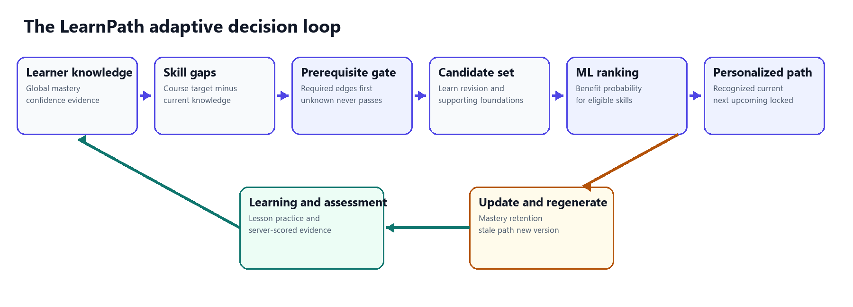
Fig. 1. LearnPath closes the loop from observed learner knowledge to a regenerated personalized path.

I INTRODUCTION
Online learning platforms often organize content as a fixed module sequence. That sequence is simple to administer, but it does not answer the learner's immediate question: what should I learn next, given what I already know, what I have forgotten, and what later topics depend on? A useful answer requires more than a course recommender. It requires a maintained learner model, evidence-aware diagnosis, prerequisite reasoning, candidate generation, benefit estimation, and a mechanism that revises the path after learning.
Knowledge tracing research models how proficiency changes through interaction. Bayesian Knowledge Tracing introduced a compact probabilistic account of latent skill acquisition [1], Performance Factors Analysis used prior successes and failures as predictors [2], and Deep Knowledge Tracing showed that recurrent networks can learn more complex interaction patterns [3]. These approaches motivate stateful learner modeling, but a final-year prototype with limited real learner history cannot credibly claim a calibrated latent-state model. LearnPath therefore uses conservative, inspectable mastery and confidence updates while preserving the event history needed for future calibration.
Adaptive testing research also shows that question choice should depend on information value and uncertainty rather than a fixed questionnaire [4]. LearnPath adopts this principle as an engineering policy: it samples course regions, confirms uncertain evidence, and spends extra questions on gateway skills or contradictions. Its coefficients are declared policy priors, not validated psychometric constants. This distinction matters because a short diagnostic can inform placement without certifying mastery.
The system separates educational safety from prediction. Required prerequisite edges are enforced deterministically before any candidate reaches the Random Forest. NetworkX supplies structural measures such as topological layers, descendants, betweenness centrality, and counterfactual unlocks [5]. The model then estimates learning benefit only within the safe candidate set. This ordering prevents a high probability from recommending a skill whose foundations are missing.
Contributions The implemented work makes four practical contributions:
- a global learner-skill state that is reused across independent course enrollments while course progress remains separate from demonstrated knowledge
- an evidence-driven diagnostic with explicit uncertainty, misconception evidence, decision-specific stopping, and a rule that one answer cannot establish mastery
- a hybrid knowledge-graph layer in which PostgreSQL and TypeScript enforce prerequisite safety while NetworkX adds bounded structural intelligence
- a versioned candidate-ranking and path-regeneration pipeline that records why a skill was recommended and how later assessed evidence changed the decision
The paper evaluates the system as a software and decision prototype. Model metrics come from reproducible synthetic interactions and learner-disjoint splits. Functional claims come from automated tests and seeded end-to-end demonstrations. No claim is made that the current model improves real learner outcomes; that requires a prospective study with representative learners.

II RELATED WORK

A Learner Knowledge Modeling
Bayesian Knowledge Tracing represents a knowledge component with interpretable probabilities for initial knowledge, learning, guessing, and slipping [1]. Performance Factors Analysis provides an alternative logistic formulation based on prior opportunities, successes, and failures [2]. Deep Knowledge Tracing replaces the hand-specified state transition with a recurrent neural network and demonstrated improved next-response prediction on several datasets [3]. LearnPath differs in purpose and evidence conditions. It does not estimate a single hidden ability from a long historical sequence; it maintains a global state per learner and skill with an explicit confidence and evidence-state label. The design sacrifices statistical sophistication for auditability until real longitudinal data is available.

B Adaptive Assessment
Computerized adaptive testing commonly selects items using information measures. Chang and Ying showed that global information can improve early-stage selection when the current ability estimate is unreliable [4]. LearnPath uses a related intuition but does not implement item-response-theory calibration. Its diagnostic selector combines item discrimination, guessing probability, knowledge uncertainty, prerequisite impact, retention risk, and cognitive diversity. The stopping decision is tied to downstream path decisions rather than a single population-comparable score.

C Educational Graphs and Learning Paths
Prerequisite relations support curriculum planning and intelligent tutoring. Liang et al. recovered concept prerequisites from university course dependencies and emphasized that prerequisite discovery is an important educational-data-mining problem [6]. Recent learning-path recommenders also combine graph representations with collaborative, sequential, or reinforcement-learning methods [7]. LearnPath focuses on a different systems question: how to prevent a statistical ranker from violating required dependencies while still using graph structure to explain leverage. The graph is expert-authored and database constrained; automatic edge discovery is left for future work.

D Retention and Ranking
Spaced-repetition research models recall as a function of elapsed time and prior practice. Half-life regression demonstrated that trainable forgetting models can outperform several recall-prediction baselines [8]. LearnPath uses a simpler configurable exponential projection because its dataset is too small to fit learner- or skill-specific decay parameters. For ranking, Random Forests offer nonlinear interactions and noise tolerance [9]. Ranking quality is measured with Precision at k and normalized discounted cumulative gain, which rewards relevant candidates near the top [10].

III SYSTEM MODEL AND ARCHITECTURE

A Core Entities
Let L be the set of learners, S the global skill set, C the course set, and E the directed prerequisite edges. LearnPath stores one learner-skill row for each observed pair in L by S. A course enrollment supplies context and module progress but does not own another mastery value. This rule enables cross-course reuse: if recursion is evidenced in one course, another course that references recursion reads the same mastery, confidence, and retention state.
Performance evidence is append-only. Each diagnostic answer, practice attempt, post-lesson assessment, quiz, or retention check stores source, score, correctness, difficulty, timing, attempt number, and state before and after the update. Resource completion is activity evidence, not knowledge evidence, and cannot change mastery. This prevents the common error of treating a watched lesson as proof that the learner can apply the skill.
TABLE I IMPLEMENTATION BOUNDARIES
Layer | Responsibility | Technology
Learner interface | Render decisions and collect actions | React TypeScript Vite
Application API | Auth evidence mastery gates paths | Express TypeScript
Authoritative store | Curriculum state evidence versions | PostgreSQL
Advisory intelligence | Graph analytics and benefit inference | FastAPI NetworkX scikit learn

B Decision Authority
The browser never calculates mastery, confidence, eligibility, or ranking. The Express API validates context, updates state, enforces required prerequisites, creates candidate vectors, invokes the inference service, and persists path versions. PostgreSQL is authoritative for graph edges, learner knowledge, evidence, enrollments, and decisions. The Python service is stateless and read-only with respect to application data. It verifies the model checksum and 55-feature contract before serving probabilities.
This boundary produces a fail-closed system. If NetworkX is unavailable, the TypeScript prerequisite gate still returns a complete safety decision and omits only the structural bonus. If the model artifact or feature schema is incompatible, path generation fails explicitly rather than substituting an unversioned heuristic.

IV EVIDENCE DRIVEN DIAGNOSTIC
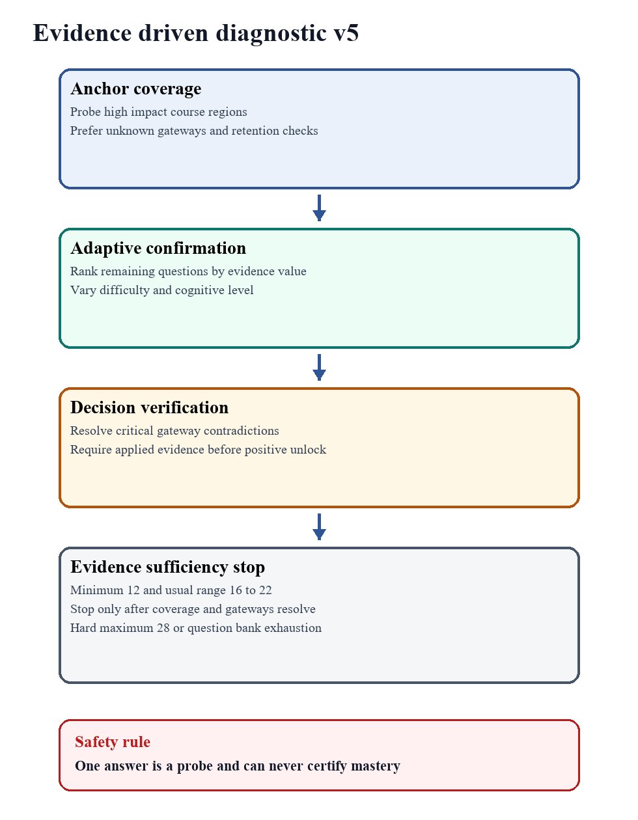
Fig. 2. Diagnostic v5 gathers only the evidence needed for a path decision and preserves uncertainty.

A Question Selection
Diagnostic v5 begins with anchor questions across high-impact course regions. After each response, the server recomputes a value for every unasked item. The value uses eight bounded components: information gain, current uncertainty, prerequisite-gateway importance, decision impact near a mastery threshold, course relevance, retention risk, evidence diversity, and misconception value. Exposure and topic-switch penalties control repetition. A verification boost is applied only when mixed evidence on an important skill must be resolved.

(1)
In (1), x sub k is a bounded component and alpha sub k is its declared weight. The current weights are 0.25 for information gain, 0.15 each for uncertainty, gateway importance, and decision impact, 0.10 for course relevance, 0.08 for retention risk, 0.07 for evidence diversity, and 0.05 for misconception value. These values make the policy inspectable. They should later be calibrated against diagnostic efficiency and downstream error on real learners.
Item information is approximated from discrimination and guessing metadata. Difficulty is matched to the current estimate, while cognitive diversity rewards a question that adds REMEMBER, UNDERSTAND, APPLY, or ANALYZE evidence not yet observed. The initial eight regions receive coverage priority. Later selections prefer confirmation or verification, so the diagnostic can detect the rare but important case in which a learner answers an advanced item correctly while failing a required foundation.

B Evidence Strength and Per Skill Decisions
Every answer receives an evidence-strength value rather than a uniform vote. A correct hard application item with high discrimination is stronger than an easy recall item with a high guessing probability. Selecting I am not sure reduces certainty without treating the answer as missing.

(2)
The weighted diagnostic performance for a skill averages response values using at least 0.1 evidence weight per observation. A single observation is classified PROBED regardless of its score. MASTERED requires at least three observations, at least two cognitive levels, a correct APPLY or ANALYZE item, mastery of at least 0.80 or the course target if higher, and confidence of at least 0.70. READY requires two correct observations with mastery at least 0.65 and confidence at least 0.50. GAP requires two consistent negative observations and mastery below 0.50. Mixed evidence remains NEEDS CONFIRMATION.
TABLE II DIAGNOSTIC CLASSIFICATION POLICY
Class | Minimum evidence | Interpretation
PROBED | 1 observation | Initial signal only
READY | 2 correct M at least 0.65 C at least 0.50 | Can continue with caution
MASTERED | 3 varied with applied success M at least 0.80 C at least 0.70 | Strong diagnostic placement
GAP | 2 negative M below 0.50 | Repeated foundation weakness
NEEDS CONFIRMATION | Limited or mixed evidence | No forced decision

C Evidence Sufficiency Stopping
The assessment asks at least 12 questions when the bank permits. It normally stops between 16 and 22, and never exceeds 28. After each saved answer, the server checks whether at least 75 percent of course skill regions, and at least eight regions where available, have been sampled; whether the three gateways with the most dependents are resolved; and whether a high-impact contradiction remains. Positive gateway evidence must include an application or analysis observation before it can unlock a dependent skill. Two independent negative observations are sufficient to preserve a lock.
This stopping rule does not claim that 12 to 28 questions measure all knowledge. It claims only that the collected evidence is sufficient for the current path decision. Untested skills remain explicit. Confidence intervals widen when confidence is low or observations are sparse, and the learner can later strengthen the state through practice and assessment.

D Misconception Evidence
Incorrect distractors can map to misconception codes. The system appends a misconception-evidence event and updates a bounded learner-skill misconception state. The selector can then choose a follow-up item that discriminates the suspected pattern. The result page reports the pattern, its evidence count, and confidence instead of flattening every error into a low percentage.

V GLOBAL MASTERY CONFIDENCE AND RETENTION

A Central Mastery Update
All assessed sources use one mastery service. For an existing state, the source weight is 0.40 for diagnostic, assessment, or module assessment; 0.30 for quiz; 0.25 for practice; and 0.35 for a retention check. Reliability scales that weight. A new skill starts directly from the bounded performance estimate because no earlier mastery exists.

(3)
Equation (3) is an exponential moving update, not a psychometrically calibrated posterior. It has two useful engineering properties: each event has a bounded effect, and the stored before-and-after state explains the change. A row lock limits concurrent updates to the affected learner-skill pair.

B Confidence and Evidence State
Confidence is separate from mastery. It grows with evidence count, source diversity, independent sessions, average difficulty, consistency, and retention evidence. Diagnostic-only confidence is capped at 0.45 in the central evidence policy, even though the diagnostic result also reports its own within-session classification confidence. This prevents a one-session placement test from becoming VERIFIED knowledge.
Evidence states summarize defensibility. UNKNOWN means no performance evidence. ESTIMATED means evidence exists but remains sparse. ASSESSED requires at least five observations over two sessions with confidence of at least 0.45. VERIFIED requires at least 12 observations over four sessions, consistency of at least 0.70, confidence of at least 0.78, and either retention evidence or broad source and session diversity.

C Retention Projection
Mastery records demonstrated knowledge; retention projects its present accessibility. The latest immutable performance event anchors the elapsed time. Confidence and repeated evidence slow the decay rate. Passive lesson completion cannot move the anchor.

(4)
The base daily decay parameter lambda zero is 0.025. A skill is STRONG when retention is at least 0.75, MODERATE from 0.50 to below 0.75, AT RISK from 0.30 to below 0.50, and CRITICAL below 0.30. Revision eligibility additionally requires previously demonstrated mastery above a configured floor. This prevents an ordinary knowledge gap from being mislabeled as forgetting. The function is intentionally presented as a configurable heuristic until real delayed-recall observations permit calibration [8].

VI KNOWLEDGE GRAPH AND CANDIDATE GENERATION
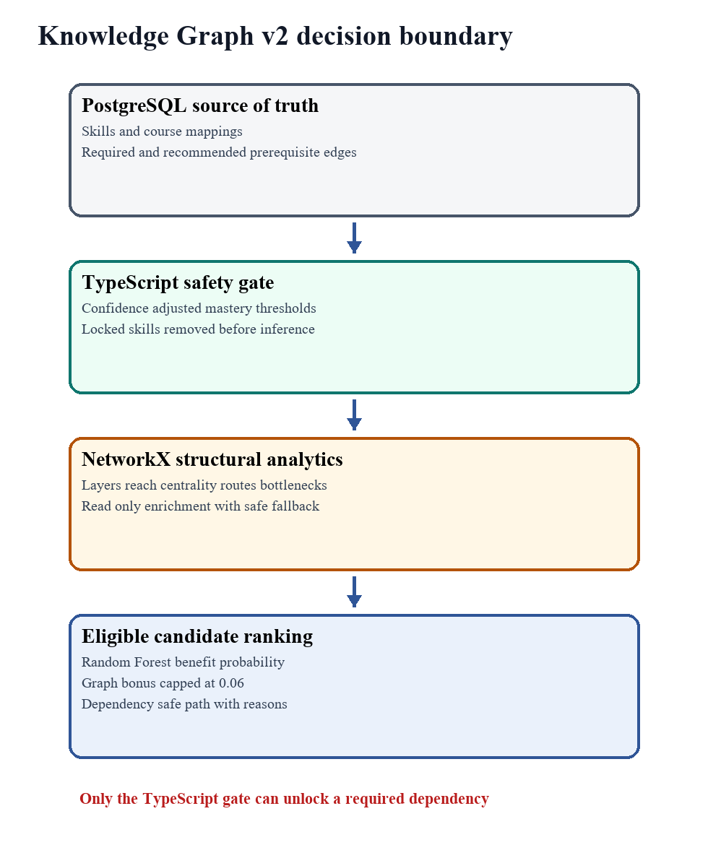
Fig. 3. The graph enriches priority after deterministic prerequisite eligibility is established.

A Authoritative Prerequisite Gate
The curriculum is a directed acyclic graph whose nodes are global skills and whose edges are REQUIRED or RECOMMENDED dependencies. Database constraints and cycle-prevention logic protect the required-edge graph. For a course analysis, the API loads course skills and recursively includes supporting prerequisite ancestors. An unknown mastery never satisfies a required edge. Recommended edges are advisory and cannot lock a skill.
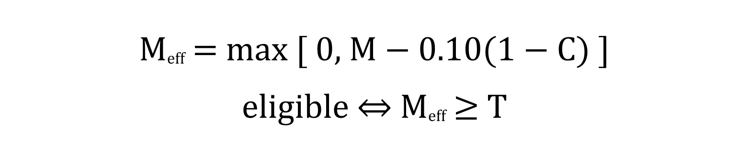
(5)
In (5), M is observed mastery, C is confidence, and T is the edge-specific required threshold. The maximum confidence penalty is 0.10. For example, M equal to 0.73 and C equal to 0.40 produce effective mastery 0.67, so a threshold of 0.70 remains locked. This conservative buffer prevents a weakly supported estimate from opening an advanced branch.

B NetworkX Structural Intelligence
The API sends a request-scoped projection of the required-edge graph to NetworkX. The service validates acyclicity, computes topological generations, descendants, direct dependents, normalized betweenness centrality, shortest foundation routes, and the DAG longest path. A counterfactual unlock identifies a currently locked direct dependent that would become eligible if one selected prerequisite reached its threshold while every other required edge remained satisfied.
For each skill, the gateway score combines descendant ratio D, normalized betweenness B, and immediate counterfactual-unlock ratio U. The score describes structural leverage rather than predicted learning gain. If graph analytics fail, eligibility still works and the bonus becomes zero.

C Candidate Pools
Candidate generation is enrollment scoped. It begins with course skills and recursively adds supporting prerequisites. Each relevant skill belongs to exactly one pool: eligible learning, supporting prerequisite, retention revision, locked, or covered. Covered means global mastery meets the course target and revision is not due. Locked candidates carry exact failed edges and mastery shortfalls. Only the three eligible kinds move to feature construction and model inference.

VII MACHINE LEARNING RANKING

A Synthetic Research Boundary
No suitable longitudinal learner dataset was available for the implemented curriculum. The project therefore uses a deterministic, curriculum-grounded simulator with random seed 42. It generates 20,000 sequential interactions for 1,000 synthetic learners across beginner, intermediate, and advanced levels, fast and slow pace, and consistent and inconsistent performance. Noise mechanisms include guessing, disengagement, skipped content, difficulty mismatch, and inconsistent performance. The synthetic artifact is physically separate from PostgreSQL learner tables and is never imported into application evidence.
The benefit label is not sampled independently. A versioned formula combines mastery gain with weight 0.40, completion rate with 0.25, assessment improvement with 0.25, and normalized learner feedback with 0.10. A row is beneficial when the score is at least 0.27. The generated data has 7,091 positive and 12,909 negative labels. The manifest records checksums, distributions, modeled correlations, and validation gates.

B Feature Contract and Leakage Control
The feature entity is learner by eligible candidate skill. The frozen vector contains 55 numeric features across learner state, skill metadata, mastery, performance, retention, prerequisites, and prior interaction. Examples include current mastery, confidence, mastery gap, evidence strength, recent score, score trend, retention, revision due, satisfied prerequisite ratio, prerequisite readiness, prior completion, prior engagement, and candidate kind. Identifiers and the target label are metadata only.
Current completion, engagement, time spent, post-assessment, mastery gain, feedback, benefit score, and label are blocked from the current vector. Historical outcome-derived features are shifted by learner before aggregation so that an interaction cannot use its own result. The same validator enforces names, order, bounds, and finiteness in training and live inference. Unknown live values use explicit bounded imputations while learner-facing knowledge remains nullable.

C Training and Model Selection
Learners, rather than rows, are split with seed 42 into 700 training, 150 validation, and 150 test learners. The corresponding row counts are 14,000, 3,000, and 3,000. No learner appears in more than one split. Gradient Boosting, Random Forest, and Logistic Regression use the same feature matrix, while highest skill gap and curriculum popularity are deterministic baselines. Selection uses validation NDCG at 5, with ROC-AUC and F1 as tie breakers. Classification thresholds are chosen on validation data and applied unchanged to test data.
The selected Random Forest contains 220 trees, maximum depth 12, square-root feature sampling, class-balanced training, minimum leaf size 4, and seed 42. The checked artifact stores its SHA-256 checksum, feature version, library versions, split checksum, metrics, and feature importances. The runtime verifies these fields before deserialization and exposes a bounded batch probability endpoint.

(6)
Equation (6) shows the final course priority. The Random Forest benefit probability remains the dominant term. Retention revision adds 0.08, and graph structure adds at most 0.06 times G. A locked skill never reaches this equation. The cap lets a gateway break a close decision without making centrality an alternative unlock path.

VIII PERSONALIZED PATH AND DYNAMIC ADAPTATION

A Path Construction
A generated path is owned by one course enrollment. Covered skills are persisted as RECOGNIZED, an in-progress recently used skill may appear as CURRENT, the highest priority eligible skill becomes RECOMMENDED NEXT, remaining eligible skills become UPCOMING in score order, and prerequisite failures remain LOCKED. Each item stores decision-time mastery, confidence, retention, missing prerequisites, benefit probability, priority, graph metrics, reason codes, and model, feature, inference, and policy versions.
The learner interface makes this path the main course surface. Learn Next explains the number of eligible alternatives, predicted benefit, mastery gap or revision need, prerequisite status, and any bounded graph contribution. The prerequisite view exposes exact edges, thresholds, shortest foundation routes, bottlenecks, and counterfactual unlocks. The Skill Passport shows the same global knowledge reused across every course.

B Multiple Course Coordination
Independent course paths are not merged. A learner-level coordinator compares their fresh Learn Next items. Matching recommendations are grouped by global skill identity, so a foundation that advances two active courses receives a bounded cross-course bonus. The coordinator also applies at most 0.06 active-goal relevance. It cannot create a candidate, unlock a prerequisite, or overwrite a course path.

C Evidence Triggered Regeneration
New assessed evidence updates the global skill state and marks every current path for that learner stale in the same transaction. A stale path remains visible for audit but is excluded from cross-course coordination. Explicit regeneration reruns prerequisite analysis, candidate generation, feature construction, inference, and path ordering. The previous row becomes SUPERSEDED, the new version becomes ACTIVE, and a structured comparison records whether Learn Next changed and why.
This lifecycle makes the adaptive claim observable: assessment changed knowledge, the changed state invalidated an earlier recommendation, and regeneration either changed the next skill or retained it with updated evidence. Recommendation acceptance, lesson completion, and later assessment are linked to the frozen path version for observational evaluation.

IX EVALUATION

A Offline Model Results
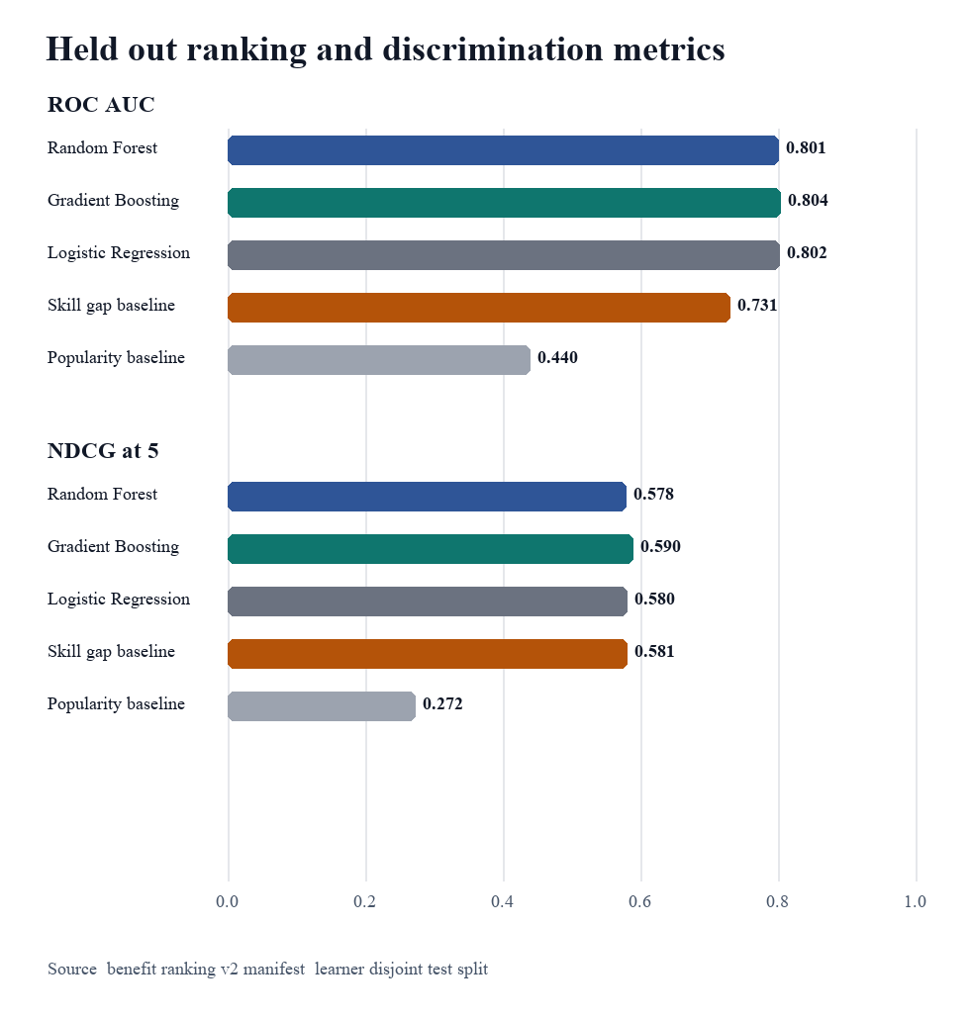
Fig. 4. Held-out metrics from 150 synthetic test learners and 3,000 candidate rows.
TABLE III HELD OUT TEST METRICS
Method | AUC | P at 5 | NDCG at 5
Random Forest | 0.801 | 0.525 | 0.578
Gradient Boosting | 0.804 | 0.521 | 0.590
Logistic Regression | 0.802 | 0.513 | 0.580
Highest Skill Gap | 0.731 | 0.511 | 0.581
Popularity | 0.440 | 0.284 | 0.272

Random Forest was selected before opening the test set because it had the highest validation NDCG at 5, 0.581. On test, it achieved accuracy 0.717, F1 0.655, ROC-AUC 0.801, Precision at 5 of 0.525, and NDCG at 5 of 0.578. Its ROC-AUC exceeded the strongest deterministic baseline by 0.071, and Precision at 5 exceeded it by 0.015. However, test NDCG at 5 was 0.003 below the highest-skill-gap baseline and 0.011 below Gradient Boosting. This is evidence of predictive signal, not evidence that Random Forest is uniformly superior.
The most important Random Forest features were recent score 0.105, current mastery 0.074, mastery gap 0.073, skill average score 0.069, historical feedback 0.064, and score trend 0.052. These importances are global impurity-based summaries and should not be interpreted as causal effects or local explanations. A future real-data evaluation should add calibrated probabilities, confidence intervals, subgroup analysis, and local attributions such as SHAP [11].

B Diagnostic Demonstration
Seeded learner profiles exercise clear, uncertain, and contradictory evidence. In a database audit of six completed diagnostic attempts, three stopped at 13 questions, while the remaining attempts stopped at 16, 17, and the 28-question maximum. The audit contained 100 answer-level evidence records with stored evidence strengths and state changes, 20 misconception events, and 100 question-selection decision records. These counts show that the stopping policy and audit trail execute at different lengths; they do not measure diagnostic validity.

C Functional Verification
The current source tree was rechecked for this manuscript on 5 September 2026. The API unit suite passed 107 tests in 26 files, and the web suite passed 41 tests in 20 files. The Python service collected and passed 37 tests across feature engineering, graph analytics, health, inference, synthetic generation, and training. A prior database-connected completion audit on 1 September 2026 recorded 17 PostgreSQL integration tests, complete content coverage for 36 of 36 active skills, and browser demonstrations across five learner profiles. The present shell could not rerun the database content gate because its default database credentials did not match the already running local service; the paper therefore treats the earlier database audit as historical evidence rather than a fresh measurement.
TABLE IV VERIFICATION EVIDENCE
Evidence | Result | What it supports
API unit tests | 107 passed | Decision services and routes
Web tests | 41 passed | Client data and core components
Python tests | 37 passed | Graph model and data contracts
PostgreSQL integration | 17 passed in prior audit | Transactional cross module behavior
Content coverage | 36 of 36 in prior audit | Complete learn practice assess loop
Demo profiles | 5 in prior audit | Distinct learner journeys

D Demonstrated Cross Course Behavior
The seeded profiles include a new learner with no evidence, an enrolled learner before diagnosis, a developing learner whose assessed performance makes a path stale, a cross-course learner with retention needs, and an advanced learner whose shared foundations are recognized while a specific sorting gap remains. These profiles demonstrate state transitions and knowledge reuse without presenting synthetic profiles as research participants.

X TRUSTWORTHINESS AND LIMITATIONS

A Trust Mechanisms
LearnPath does not ask reviewers to trust a single model score. Trust comes from layered controls. Required prerequisites are deterministic and checked before inference. Unknown knowledge cannot satisfy a gate. Mastery is separated from confidence and course completion. Evidence is append-only, and each path stores its data and model context. Checksums and schema versions prevent silent model or feature drift. Failure modes are explicit, and small-sample governance withholds rates, calibration, drift conclusions, and retraining readiness until documented evidence thresholds are met.
Explanations are also separated by audience. Learners see a concise reason tied to mastery gap, prerequisite readiness, retention, and predicted benefit. Reviewers can inspect graph metrics, feature and model versions, decision-time snapshots, path history, and answer-level diagnostic selection records. This design follows the broader requirement that predictive systems make their basis inspectable [11] while avoiding the false precision of claiming a causal explanation from feature importance.

B Threats to Validity
The strongest limitation is external validity. The ranking model was trained and tested on a simulator whose label is a deterministic formula chosen by the project. Performance therefore measures recovery of simulated benefit structure, not learner achievement in a real population. Public educational datasets such as EdNet contain large interaction histories [12], but their curricula and event semantics do not directly match LearnPath's prerequisite graph and benefit definition. Transfer evaluation would require a careful mapping rather than treating their logs as interchangeable.
Diagnostic thresholds, item metadata, evidence weights, and retention decay are policy parameters. They are transparent and tested but not calibrated against standardized assessments. The graph contains 36 active skills and expert-authored edges in a compact computing curriculum; missing or incorrect prerequisites can block or misorder paths. The one-number mastery state also cannot represent every misconception or context-dependent performance.
The offline test contains only 150 synthetic learners. The difference between Random Forest and the skill-gap baseline on NDCG at 5 is small and unfavorable on test, so model promotion should remain conditional. The system does not automatically retrain or promote a model. It also does not perform causal estimation; recommendation acceptance and later assessed gain are observational associations attached to immutable versions.

C Required Real World Study
A credible next study should enroll representative learners, obtain consent, pre-register outcomes, and compare at least the checked Random Forest policy, the highest-skill-gap baseline, and a dependency-valid nonpersonalized path. Primary outcomes should include post-assessment gain and delayed retention. Secondary outcomes should include time to mastery, path acceptance, diagnostic length, and learner-reported clarity. Learners must remain grouped across train, validation, and test, and analysis should report calibration and subgroup performance. A randomized or carefully controlled design is needed before attributing gains to the recommender.

XI CONCLUSION
LearnPath implements the complete adaptive loop from learner evidence to dynamic path regeneration. Its central design choice is to use the right form of reasoning at each boundary: immutable evidence for audit, global skill state for cross-course reuse, deterministic graph gates for educational safety, NetworkX for structural leverage, Random Forest inference for benefit ranking, and versioned paths for visible adaptation.
The prototype is technically complete enough to demonstrate diagnosis, skill gaps, prerequisite explanations, retention review, multiple enrollments, machine-learning ranking, and before-and-after path changes using real backend data. The measured evaluation also shows why caution is necessary. The selected model has useful discrimination, but it does not beat the strongest baseline on every ranking metric, and all training outcomes are synthetic. The defensible contribution is an auditable, dependency-safe architecture and a clear experimental plan for replacing engineering priors with calibrated evidence from real learners.

REFERENCES
[1] A. T. Corbett and J. R. Anderson, "Knowledge tracing: Modeling the acquisition of procedural knowledge," User Modeling and User-Adapted Interaction, vol. 4, no. 4, pp. 253-278, 1995, doi: 10.1007/BF01099821.
[2] P. I. Pavlik Jr., H. Cen, and K. R. Koedinger, "Performance Factors Analysis: A new alternative to knowledge tracing," in Proc. 14th Int. Conf. Artificial Intelligence in Education, Brighton, U.K., 2009, pp. 531-538.
[3] C. Piech et al., "Deep knowledge tracing," in Advances in Neural Information Processing Systems 28, 2015, pp. 505-513.
[4] H. H. Chang and Z. Ying, "A global information approach to computerized adaptive testing," Applied Psychological Measurement, vol. 20, no. 3, pp. 213-229, 1996, doi: 10.1177/014662169602000303.
[5] A. A. Hagberg, D. A. Schult, and P. J. Swart, "Exploring network structure, dynamics, and function using NetworkX," in Proc. 7th Python in Science Conf., Pasadena, CA, USA, 2008, pp. 11-16.
[6] C. Liang, J. Ye, Z. Wu, B. Pursel, and C. L. Giles, "Recovering concept prerequisite relations from university course dependencies," in Proc. 31st AAAI Conf. Artificial Intelligence, 2017, doi: 10.1609/aaai.v31i1.10550.
[7] H. Ngo, K. Vo, and T. Nguyen, "Personalized learning path recommendations: Fusing knowledge graph embedding, sequence mining, and collaborative filtering," in 2024 IEEE Int. Conf. Big Data, Washington, DC, USA, 2024, pp. 8145-8153, doi: 10.1109/BigData62323.2024.10825001.
[8] B. Settles and B. Meeder, "A trainable spaced repetition model for language learning," in Proc. 54th Annual Meeting of the Association for Computational Linguistics, Berlin, Germany, 2016, pp. 1848-1858, doi: 10.18653/v1/P16-1174.
[9] L. Breiman, "Random forests," Machine Learning, vol. 45, pp. 5-32, 2001, doi: 10.1023/A:1010933404324.
[10] K. Jarvelin and J. Kekalainen, "Cumulated gain-based evaluation of information retrieval techniques," ACM Trans. Information Systems, vol. 20, no. 4, pp. 422-446, 2002, doi: 10.1145/582415.582418.
[11] S. M. Lundberg and S. I. Lee, "A unified approach to interpreting model predictions," in Advances in Neural Information Processing Systems 30, 2017, pp. 4765-4774.
[12] Y. Choi et al., "EdNet: A large-scale hierarchical dataset in education," in Artificial Intelligence in Education, I. I. Bittencourt et al., Eds. Cham, Switzerland: Springer, 2020, pp. 69-73, doi: 10.1007/978-3-030-52237-7_6.
[13] M. Mitchell et al., "Model cards for model reporting," in Proc. Conf. Fairness, Accountability, and Transparency, Atlanta, GA, USA, 2019, pp. 220-229, doi: 10.1145/3287560.3287596.

