LEARNPATH

Reviewer Explanation Handbook
Technical and nontechnical explanations for presenting and defending the LearnPath project
This handbook explains the completed LearnPath system in the language a reviewer can understand and at the technical depth a panel can challenge. Each core module includes a plain explanation, the implemented data and algorithm, a worked example, the user-visible proof, and the limits of the claim.
Use this handbook when | What to read
You need a short project explanation | The one minute and five minute presentation scripts
A reviewer asks how a feature works | The relevant module chapter and request flow
A reviewer asks where the AI is | The machine learning and Knowledge Graph chapters
A reviewer challenges accuracy or trust | The evidence, uncertainty, assurance and limitations chapters
You are preparing the live demo | The demonstration sequence and profile walkthroughs

Prepared for final project review panel
Companion to the detailed technical project report | September 2026

How to use this handbook
Start with Sections 1 and 2 until you can explain the problem and complete learner flow without technical terms. Then study Sections 3 through 7 to answer implementation questions. Sections 8 through 11 contain worked examples, trust arguments, demo guidance and a large question bank.
Section | Purpose
1 Presentation scripts | One minute, five minute and technical presentation versions
2 Complete system in plain language | A reviewer friendly explanation of the adaptive loop
3 Technical architecture and data ownership | Service boundaries, database truth and request flow
4 Learner knowledge and evidence | Mastery, confidence, evidence state and the Skill Passport
5 Diagnostic and prerequisite intelligence | Adaptive assessment and Knowledge Graph v2
6 Recommendation and adaptation | Candidates, Random Forest ranking, paths and regeneration
7 Supporting learning modules | Lessons, practice, assessment, retention, feedback and governance
8 Worked numerical examples | Calculations you can reproduce at the panel
9 Trust and validation | What can be trusted, why, and what is still unproven
10 Live demonstration guide | A clear panel flow using the five demo learners
11 Reviewer question bank | Short answers and deeper technical answers
12 Glossary and final revision sheet | Key terms and the last page summary

The explanation pattern
Layer | Question it answers
Plain explanation | What does this feature do for the learner
Technical explanation | What data, policy and service implement it
Worked example | Can we follow the decision with numbers or a concrete scenario
Visible proof | Where can a reviewer see real backend behavior in the interface
Trust boundary | What is deterministic, what is predicted and what remains uncertain

1 Presentation scripts

One minute explanation
How to explain it to the panel LearnPath decides what a learner should study next. It keeps one global record of what the learner knows, so knowledge demonstrated in one course can satisfy a prerequisite in another. When evidence is missing, a short adaptive diagnostic gathers the most useful observations without pretending that one answer proves mastery. The prerequisite graph removes unsafe choices, a Random Forest ranks the remaining choices by predicted learning benefit, and the system creates a path that shows recognized knowledge, the current skill, Learn Next, upcoming skills and locked skills. After practice or assessment changes mastery or retention, the path becomes stale and is regenerated as a new version. The learner can therefore see what they know, what is missing, why a skill is locked and why the next skill was selected.

Five minute explanation
- Begin with the limitation of a fixed course sequence. Two students who enter the same course may have different prior knowledge and different forgotten skills.
- Explain the global Skill Passport. A skill belongs to the learner, while course progress belongs to an enrollment. This separation is what makes cross-course reuse possible.
- Explain evidence. Diagnostics, practice, assessment and retention checks create server-scored observations. Lesson completion records activity but never creates mastery.
- Explain the diagnostic. It has a maximum of 15 questions and selects coverage, confirmation and verification items. A single answer is only a probe. Untested skills remain explicitly untested.
- Explain the Knowledge Graph. TypeScript enforces required prerequisite thresholds. NetworkX adds graph structure such as layers, bottlenecks, shortest routes and counterfactual unlocks.
- Explain ML. Only eligible candidates go to the 55-feature Random Forest model. The model predicts relative benefit among safe choices; it cannot unlock a skill.
- Explain the path. The API stores every lane, score, learner state, reason code and version used at decision time.
- Close the loop. New assessed evidence marks the path stale. Regeneration runs the entire pipeline again and preserves the previous version for comparison.

Technical explanation in ten points
Point | Technical statement
1 | PostgreSQL is the source of truth for curriculum, learner state, evidence and versioned decisions
2 | The global learner skill key is learner_id plus skill_id, not learner plus course plus skill
3 | The Express TypeScript API owns all authoritative policy and transaction boundaries
4 | Evidence updates use source weights, difficulty-adjusted performance and confidence policy
5 | Diagnostic v3 selects one question at a time under a 15-item evidence budget
6 | Required prerequisite gates use confidence-adjusted mastery before any ranking
7 | NetworkX receives a read-only request-scoped graph projection and cannot mutate learner state
8 | Random Forest inference verifies checksum, versions and the exact 55-feature order
9 | The path transaction stores model, feature, inference and policy provenance
10 | Evidence invalidation and explicit regeneration preserve historical path versions

Statements to avoid
Avoid saying | Say this instead
The AI decides everything | Deterministic policy decides safety and learner state; ML ranks safe candidates
The diagnostic knows every skill after 15 questions | It gathers the highest-value evidence and returns untested skills honestly
The model is highly accurate | The frozen synthetic evaluation is reproducible, but real-world effectiveness still requires a learner study
Completing a lesson improves mastery | Only scored performance evidence updates mastery
We use Neo4j for the knowledge graph | PostgreSQL stores graph truth and NetworkX performs derived graph algorithms
A recommendation caused the learner improvement | The system observed later improvement after acceptance; the association is not proof of causation

2 Complete system in plain language
A course normally asks every learner to follow the same order. LearnPath instead treats the order as a decision that can change. The decision starts from evidence about the learner and ends with one explainable next action.
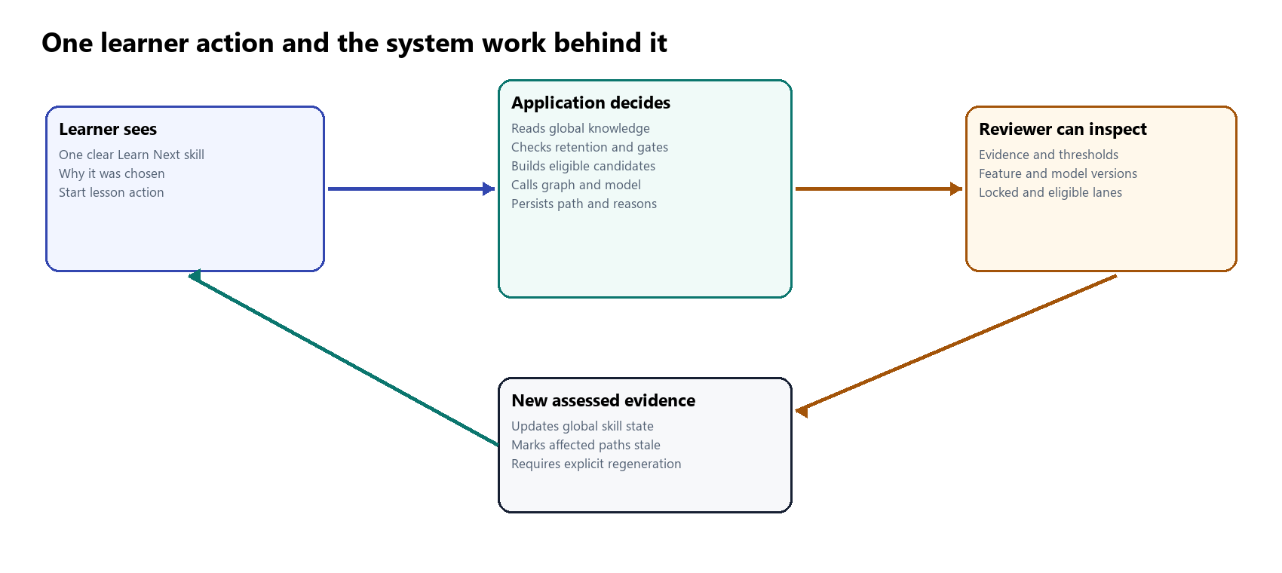
The simple learner action is backed by a complete auditable decision

The eight questions LearnPath answers
Question | Answer produced by the system
What does the learner know | Global mastery, confidence and evidence state for each skill
How certain are we | Observation count, multiple sessions, source diversity, consistency and confidence
What may have been forgotten | A retention projection anchored to the latest scored evidence
What is required for this course | Course skill targets and recursive required prerequisite ancestors
What is safe now | Eligible candidates after all required gates pass
What is the best safe option | Random Forest benefit probability plus bounded policy adjustments
Why was it selected | A stored explanation using gap, retention, graph leverage, course and goal context
What changed later | A stale signal and a versioned regenerated path with a change summary

A simple learner story
Assume a learner enters an algorithms course. They already demonstrated recursion in another course, have weak evidence for sorting, and have not been tested on dynamic programming. LearnPath recognizes recursion globally, keeps dynamic programming locked behind the required foundation, and creates sorting as an eligible learning candidate. The model ranks sorting against other eligible skills. The path shows recursion as recognized, sorting as Learn Next and dynamic programming as locked with the exact missing prerequisite.
After the learner studies sorting, lesson completion alone does not change mastery. Practice supplies a low-weight observation, and a separate assessment supplies a stronger observation. If the global sorting state changes, the current path becomes stale. The learner chooses regeneration, and the new path may unlock a dependent algorithm skill. The old path remains in history.
How to explain it to the panel The system does not force a different order simply because it can. It changes the order only when learner evidence, retention or prerequisite readiness gives a reason.

3 Technical architecture and data ownership
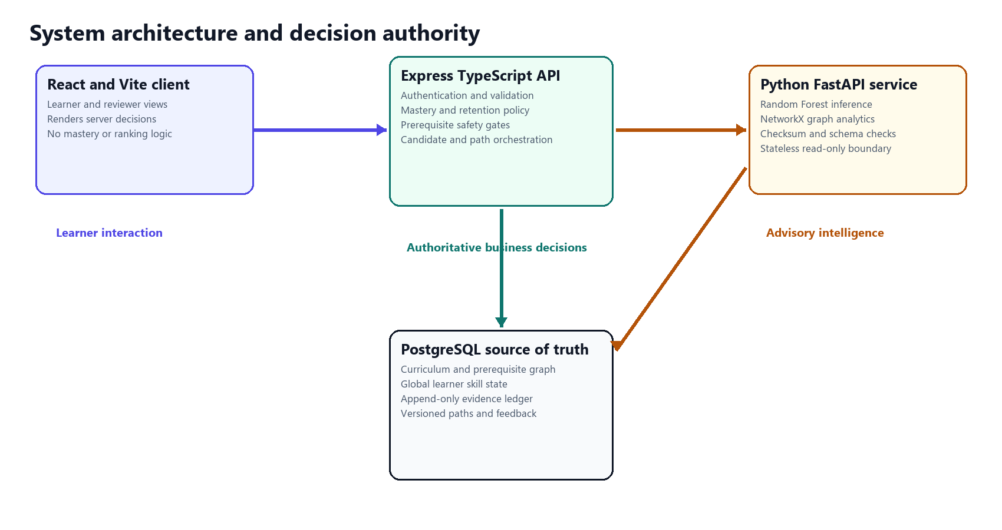
The API owns decisions and Python contributes bounded intelligence

Why four layers
Layer | What it owns | Why this boundary is important
React and Vite web client | Navigation, visual explanation, forms and learner actions | The browser cannot invent scores or bypass a prerequisite
Express TypeScript API | Authentication, validation, mastery, diagnostics, retention, prerequisites, candidates and paths | All authoritative rules execute in one application boundary
PostgreSQL | Curriculum, global skill state, evidence, enrollments, path history and feedback | Transactions and constraints protect a single source of truth
FastAPI intelligence service | Random Forest inference and NetworkX graph analytics | Stateless advisory work can fail safely without corrupting learner state

A path generation request
- The browser sends an authenticated generate request for one enrollment.
- The API confirms that the enrollment belongs to the authenticated learner.
- The API loads course skills, recursive prerequisite ancestors, global learner state, recent activity and retention.
- The TypeScript prerequisite engine decides which required edges pass and which candidates are locked.
- The API optionally sends a read-only graph projection to NetworkX for structural metrics.
- The candidate engine creates eligible, locked and excluded lanes. It asserts that only eligible candidates continue.
- The API builds the exact 55-field feature record for each eligible candidate and calls FastAPI inference.
- FastAPI verifies the artifact checksum and feature contract, then returns benefit probabilities.
- The API applies bounded revision and graph bonuses, orders dependency-safely and writes a path transaction.
- The browser receives the persisted path and renders its lanes and explanations.

Single source of truth
LearnPath deliberately avoids storing the same mastery in an enrollment table, goal table and learner profile. The only knowledge record is identified by learner_id and skill_id. Enrollment owns course progress. A goal adds relevance but does not own knowledge. This decision prevents three values for the same skill from disagreeing.
Fact | Owner
The learner scored 8 out of 10 on a recursion assessment | Append-only skill evidence
The current recursion mastery estimate is 0.82 | Global learner skill state
The learner completed Module 3 in Course A | Enrollment module progress
Recursion is relevant to the interview goal | Learner goal mapping
Course B recognizes recursion as a prerequisite | Live prerequisite projection from global state

Where it is implemented apps/web/src | apps/api/src/app.ts | apps/api/src | database/migrations | services/ml/app

4 Learner knowledge and evidence

Global Skill Passport
Plain explanation The Skill Passport is the learner's reusable knowledge record. If the learner proves a skill in one course, every other course that uses the same canonical skill can read that knowledge. The learner does not have to repeat an already demonstrated prerequisite merely because they enrolled in another course.
Technical explanation PostgreSQL enforces one row per learner_id and skill_id. The learner-skills service joins that row to the active skill catalog, evidence counts, retention and course mappings. It returns the same mastery and confidence in every course context while leaving course progress inside the enrollment.
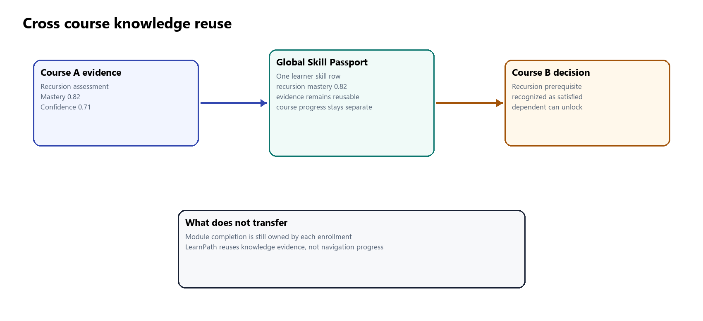
Knowledge transfers through the global skill key while course completion stays local
How to explain it to the panel We reuse demonstrated knowledge, not course completion. That distinction prevents a learner from receiving mastery merely by opening or completing content.
Where it is implemented apps/api/src/learner-skills/service.ts | database/migrations/0006_global_learner_skill_model.sql

Evidence ledger
Plain explanation Every mastery value needs a reason. LearnPath therefore keeps the performance observations that produced it. A reviewer can inspect whether the evidence came from a diagnostic, practice, assessment or retention check and see the before and after state.
Technical explanation skill_evidence is append-only. Database triggers reject update and delete operations. Each row preserves learner, skill, source type, score, correctness, difficulty, session and attempt information, timestamps, state before and after, retention values and structured metadata. The application commits the evidence row and learner-skill update atomically.
Evidence source | Weight | Why the weight differs
Diagnostic | 0.40 multiplied by diagnostic reliability | Placement is useful but one session remains bounded
Practice | 0.25 | Practice is formative and may include trial and error
Quiz | 0.30 | More structured than practice but usually narrower than assessment
Assessment | 0.40 | Separate scored assessment is stronger direct evidence
Module assessment | 0.40 | Summative performance evidence
Retention check | 0.35 | Directly tests whether earlier knowledge remains accessible

How to explain it to the panel The weights control how fast an estimate moves. They do not convert activity into knowledge; only server-scored performance reaches this engine.
Where it is implemented apps/api/src/skill-evidence/service.ts | apps/api/src/mastery/service.ts | apps/api/src/mastery/policy.ts

Mastery update
Plain explanation Mastery is a moving estimate. New evidence pulls the old estimate toward the measured performance. Stronger evidence pulls more; weaker evidence pulls less. The result stays between zero and one.

Mastery update used for scored evidence
M is mastery, P is measured performance, wsource is the configured source weight, r is reliability and clip keeps the result from zero to one.
Technical detail When prior mastery exists, the source weight comes from policy. A new skill begins from a neutral 0.50 prior. Diagnostic evidence uses the same engine but multiplies the source weight by reliability. Difficulty-adjusted performance gives more credit for a correct hard answer and a stronger negative signal for an incorrect easy answer.
How to explain it to the panel We use incremental updating rather than replacing mastery with the latest score. One unusual attempt therefore cannot erase or create a complete knowledge profile.

Confidence and evidence state
Plain explanation Mastery answers how well the learner appears to know the skill. Confidence answers how much evidence supports that estimate. A learner can have high estimated mastery with low confidence if the estimate comes from only one or two observations.
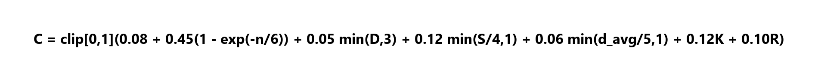
Confidence grows from repeated and varied evidence
n is observation count, D is source diversity, S is session count, d is average difficulty, K is consistency and R is one when retention evidence exists. Diagnostic-only confidence is capped at 0.45.
Evidence state | Rule | How to explain it
UNKNOWN | No scored observation | We do not know yet
ESTIMATED | Some evidence but below assessed thresholds | Useful for personalization but still uncertain
ASSESSED | At least 5 observations, 2 sessions and confidence 0.45 | Repeated assessment evidence supports the estimate
VERIFIED | At least 12 observations, 4 sessions, consistency 0.70, confidence 0.78 and evidence diversity | The strictest implemented evidence standard

How to explain it to the panel A high mastery number alone is never enough to call a skill verified. Verification requires evidence volume, multiple sessions, consistency, confidence and diversity.

5 Diagnostic and prerequisite intelligence

Adaptive diagnostic v3
Plain explanation The diagnostic is a short placement conversation. It first samples different important skills. It then returns to uncertain or contradictory skills. The final questions try to verify application-level knowledge. This gives a useful starting point without pretending to examine every skill exhaustively.
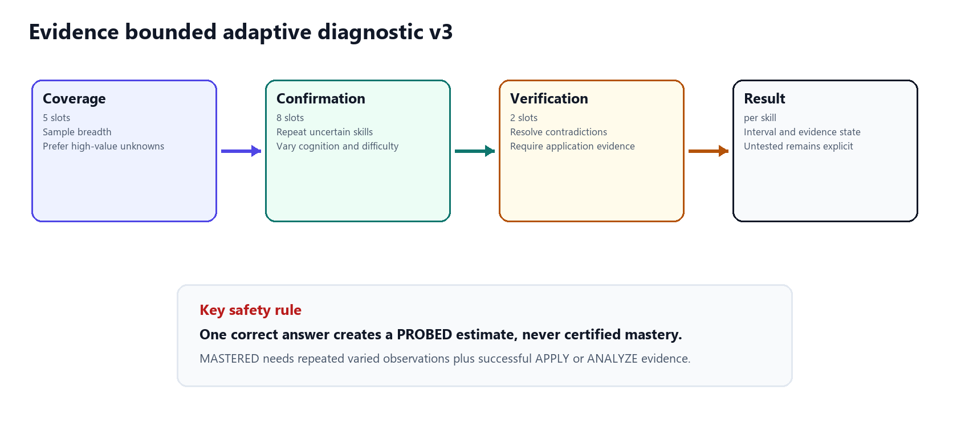
The diagnostic spends its fixed budget on coverage confirmation and verification
Technical explanation The server reveals exactly one question at a time. It selects from active skill-linked questions in the course. The fixed maximum is 15 questions: five coverage slots, eight confirmation slots and two verification slots. Correctness stays hidden until final submission, so an early item cannot coach later answers. Answer drafts allow exact resume.

How the selector scores a question
Signal | Implemented effect
Unknown skill | Adds 100 to base skill priority
Mastery gap | Adds 50 times the distance from course target
Uncertainty | Adds 20 times one minus current confidence
Graph gateway | Adds 4 for each required downstream dependent
Retention risk | Adds up to 25 for critical or at-risk knowledge
Discrimination | Adds 8 times the item's bounded discrimination
Cognitive novelty | Adds 12 when the cognitive level is new for that skill
Application needed | Adds 18 when APPLY or ANALYZE evidence is still missing
Difficulty fit | Favors difficulty close to the level implied by current mastery
Confirmation need | Strongly favors the second or third observation for unresolved evidence

The selector is a transparent deterministic policy, not an item-response-theory model. Its job is to spend a small question budget on useful evidence. The item metadata includes cognitive level, discrimination, guessing prior, calibration state and optional misconception codes so later real response data can support formal calibration.

How answers become a cautious result
A correct item produces a difficulty-aware measurement value of 0.72 plus 0.05 times difficulty. An unsure incorrect response produces 0.12 plus 0.035 times difficulty. Another incorrect response produces 0.03 plus 0.05 times difficulty. The skill performance score is the discrimination-weighted average of these values, where discrimination is clipped between 0.25 and 2.5.

Diagnostic reliability is bounded even when all answers agree
n is direct observations, L is distinct cognitive levels, A is one when application evidence is present, and K is one when all answers are consistent. The maximum reliability is 0.78.

The result reports an uncertainty interval around mastery
M is mastery, C is confidence and n is direct observations. More observations and higher confidence narrow the interval.
Classification | Implemented meaning
PROBED | Exactly one direct observation; never mastery certification
READY | At least two correct observations and mastery at least 0.55, but below mastery certification
MASTERED | At least three observations, a correct APPLY or ANALYZE item, target mastery and confidence at least 0.35
GAP | At least two observations, no correct answers and mastery below 0.45
NEEDS CONFIRMATION | Mixed or insufficient evidence
FORGOTTEN | Earlier mastery met target, retention is at risk or critical, and current performance is below 0.45
FRAGILE FOUNDATION | Advanced knowledge coexists with a weak tested required prerequisite
NOT TESTED | No direct item was selected inside the fixed budget

How to explain it to the panel Fifteen questions do not certify all course skills. The engine prioritizes the most informative evidence and keeps untested skills visible. Later practice and assessment continue the estimation process.
Where it is implemented apps/api/src/diagnostics/selection.ts | apps/api/src/diagnostics/estimation.ts | apps/api/src/diagnostics/service.ts

Knowledge Graph v2
Plain explanation The graph describes which skills depend on which foundations. It stops LearnPath from recommending an advanced skill before the learner is ready and explains the sequence needed to reach it.
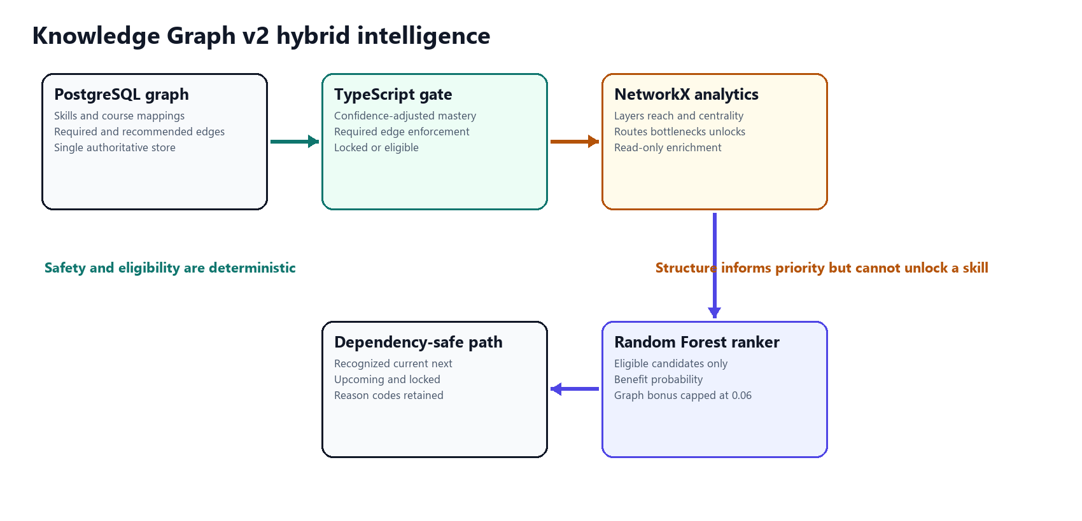
Graph truth safety analytics and ranking remain separate
Technical explanation PostgreSQL stores canonical skills, course mappings and typed prerequisite edges. TypeScript recursively loads the relevant subgraph and makes every REQUIRED gate decision. NetworkX analyzes a read-only projection. The graph is a directed acyclic graph, so topological layers and dependency order are defined.

Required and recommended edges
A REQUIRED edge blocks the dependent skill until the prerequisite reaches the edge threshold. A RECOMMENDED edge adds guidance but does not block. Unknown mastery never satisfies a required edge. Low confidence reduces the mastery value used by the gate.

Confidence adjusted prerequisite gate
C is confidence, M is observed mastery and T is the threshold stored on the prerequisite edge. The largest possible uncertainty penalty is 0.10.
How to explain it to the panel Observed mastery 0.73 with confidence 0.40 becomes effective mastery 0.67. If the edge requires 0.70, the skill stays locked. This is deliberate caution, not a model prediction.

What NetworkX adds
Algorithm | What it tells us | Use in LearnPath
Topological generations | Which skills belong to each dependency level | Learner-facing graph layers and valid order
Descendants and direct dependents | How much later learning relies on one foundation | Downstream reach
Betweenness centrality | Whether a skill connects graph regions | Structural bridge importance
Shortest path | A minimal prerequisite route from a foundation to a target | Explainable foundation route
Bottleneck analysis | Which weak skills currently block many descendants | Focused prerequisite attention
Counterfactual unlocks | What would become ready if one selected prerequisite met target | Explain the value of closing a specific gap


NetworkX gateway score
Dr is descendant ratio, Bn is normalized betweenness and Ur is immediate counterfactual unlock ratio. Every input is bounded from zero to one.

Why NetworkX and not Neo4j
NetworkX is used because the project needs in-memory algorithms on a small request-scoped graph. PostgreSQL already stores the graph together with curriculum constraints and learner state. Adding Neo4j would create a second authoritative copy that must be synchronized. At the implemented scale of five courses and 36 shared skills, that operational cost is not justified. Neo4j becomes attractive when graph-native queries, heterogeneous relationships, very large traversals or independent graph operations dominate the workload.
How to explain it to the panel We are using graph algorithms. We are not using a graph database because the relational curriculum is already the safest source of truth at this scale.
Where it is implemented apps/api/src/prerequisites/engine.ts | apps/api/src/prerequisites/service.ts | services/ml/app/graph.py | docs/knowledge-graph-v2.md

6 Recommendation and adaptation

Candidate generation
Plain explanation Before asking the model which skill is best, LearnPath creates a safe list. It separates skills that can be learned now, skills that are locked and skills that are already satisfied.
Technical explanation The candidate engine combines the enrollment's course skills with recursive required ancestors. It joins global mastery, confidence, evidence state, retention, module context, goal relevance, content availability and prerequisite results. Each candidate is LEARN, REVISION or SUPPORTING_PREREQUISITE and is placed in ELIGIBLE, LOCKED or EXCLUDED.
Lane | Rule | What happens next
ELIGIBLE | Target is not already satisfied and no required prerequisite is missing | Feature construction and ML inference
LOCKED | At least one required prerequisite gate fails | Displayed with exact missing prerequisites; never sent to ML
EXCLUDED | Global mastery meets course target and no revision signal is active | Displayed as recognized prior knowledge

How to explain it to the panel Candidate generation is where we protect the model boundary. A high model score can never rescue a locked skill because the model never receives that row.
Where it is implemented apps/api/src/candidates/engine.ts | apps/api/src/candidates/service.ts

Machine learning ranking
Plain explanation The model compares the safe options and predicts which one is most likely to produce useful learning. It considers current knowledge, recent performance, evidence strength, retention, prerequisite readiness and engagement history.
Technical explanation The deployed contract is learner-candidate-features-v2 with 55 numeric features in fixed order. Identifiers and the label remain outside the matrix. Current outcomes such as post-assessment, mastery gain, feedback and completion are blocked. Historical outcome features are shifted by one interaction, so the model cannot see the answer it is supposed to predict.

Training data and experiment
Element | Implemented value
Data | 1,000 synthetic learners and 20,000 interactions, seed 42
Label | Benefit score at least 0.27 using mastery gain, completion, assessment improvement and feedback
Split | 700 train learners, 150 validation learners and 150 test learners with no learner overlap
Models | Gradient Boosting, Random Forest and Logistic Regression
Baselines | Highest Skill Gap and curriculum-derived Popularity
Selection | Validation NDCG at 5, then ROC-AUC and F1 tie-breaks
Selected model | Random Forest with 220 trees, depth 12, minimum leaf 4 and balanced class weights

Candidate | Validation NDCG at 5 | Test NDCG at 5 | Test ROC AUC | Test Precision at 5
Random Forest | 0.581021 | 0.578463 | 0.801410 | 0.525333
Gradient Boosting | 0.576017 | 0.589501 | 0.804062 | 0.521333
Logistic Regression | 0.564225 | 0.580259 | 0.802338 | 0.513333
Highest Skill Gap | 0.576408 | 0.581229 | 0.730785 | 0.510667
Popularity | 0.251677 | 0.272412 | 0.440132 | 0.284000

How to interpret the result Random Forest won by the declared validation selection rule. Its test ROC-AUC and Precision at 5 exceed the Highest Skill Gap baseline, but its test NDCG at 5 is slightly lower. This mixed result supports using the model as a bounded ranking component. It does not support claiming that the synthetic model is universally better or educationally proven.

Checked inference
- FastAPI verifies the artifact SHA-256 before deserialization.
- The model, feature and inference versions must match the manifest.
- The request must contain all 55 feature names in exact order and valid bounds.
- A bad request returns 422. A missing or incompatible artifact returns 503.
- There is no heuristic probability fallback and the service never writes PostgreSQL.
How to explain it to the panel We can trust the serving contract to reject the wrong artifact or schema. We cannot yet claim real learner effectiveness because the training evaluation is synthetic.
Where it is implemented services/ml/app/inference.py | services/ml/models/benefit-ranking-v2/manifest.json | apps/api/src/paths/features.ts | apps/api/src/paths/ml-client.ts

Personalized path
Plain explanation The path shows what the learner already knows, what they are doing, the next recommended skill, later safe work and skills that remain locked. It is the final explanation of the system's reasoning.
Technical explanation Every eligible candidate has a Random Forest benefit probability. The API adds a fixed revision bonus when a previously mastered skill is due for review and a bounded graph bonus based on gateway value. It sorts by total priority, probability, dependency level, course sequence and skill name. Locked and recognized skills are inserted as separate lanes without model probabilities.

Final priority among eligible candidates
The probability comes from Random Forest. The revision indicator adds 0.08. G is the zero-to-one NetworkX gateway score, so the largest graph contribution is 0.06.
Path lane | Meaning
RECOGNIZED | Global mastery already meets this course target
CURRENT | Recently active in-progress learning stays visible
RECOMMENDED NEXT | Highest priority eligible candidate
UPCOMING | Other eligible candidates in dependency-aware order
LOCKED | Required prerequisite is missing and candidate was excluded from ML

The stored path snapshot includes mastery, confidence, evidence state, retention, prerequisite checks, model probability, policy bonuses, goal relevance, course context, reason codes, explanations and the model, feature, inference and policy versions. A reviewer can therefore reconstruct why the item appeared where it did.
How to explain it to the panel The model suggests priority only among safe candidates. The path engine still applies dependency order, bounded policy bonuses and deterministic tie-breaks.
Where it is implemented apps/api/src/paths/engine.ts | apps/api/src/paths/policy.ts | apps/api/src/paths/service.ts

Cross course coordination
If two active course paths recommend the same global skill, the coordination service can prefer that skill because one learning action helps more than one course. It groups current ACTIVE paths by skill, keeps the strongest course priority, adds up to two shared-course bonuses and optionally adds goal relevance.

Cross course coordination score
Qbest is the strongest course path priority, k is the number of active course contexts for that skill and g is goal relevance from zero to one.
How to explain it to the panel Coordination does not merge the courses. It selects one learner-facing next action while preserving the independent dependency-safe path for every enrollment.
Where it is implemented apps/api/src/paths/coordination.ts | apps/api/src/paths/policy.ts

Dynamic path regeneration
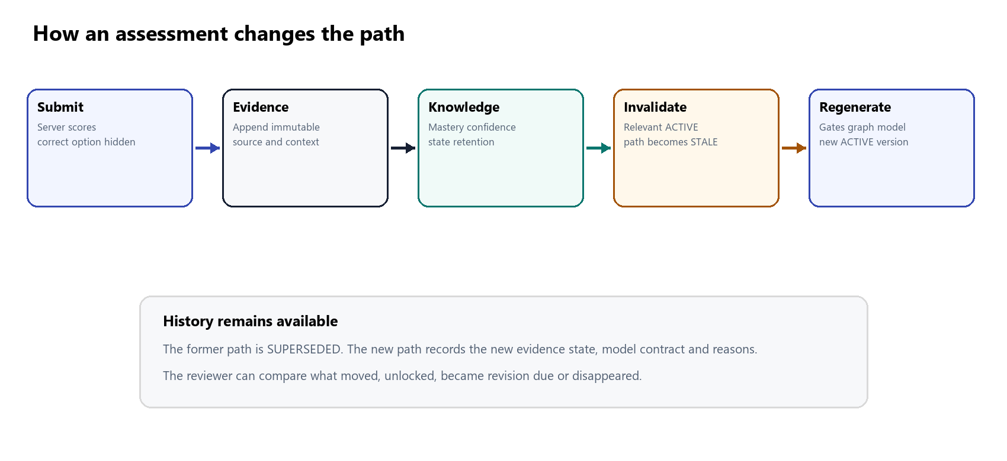
Assessed evidence invalidates a path before a new version is generated
Plain explanation LearnPath does not silently rewrite the learner's path. When new evidence matters, it marks the current path as stale and asks for regeneration. The learner and reviewer can compare the former and new versions.
Technical explanation The lifecycle is ACTIVE to STALE to SUPERSEDED, followed by a newly created ACTIVE path. Regeneration locks the current path row, reruns prerequisite analysis, NetworkX, candidate generation, feature construction, inference and ordering, then inserts the new path, items, events and change summary in one transaction.
How to explain it to the panel The old recommendation remains evidence of what the system knew at that time. This is why path versioning matters for trust and evaluation.
Where it is implemented apps/api/src/paths/change.ts | apps/api/src/paths/service.ts | database/migrations/0020_dynamic_path_regeneration.sql

7 Supporting learning modules

Learning resources practice and assessment
Activity | What it records | Does it update mastery
Open or complete lesson | Activity event, resource status and time | No
Practice answer | Server-scored PRACTICE evidence | Yes with weight 0.25
Quiz answer | Server-scored QUIZ evidence | Yes with weight 0.30
Separate assessment | Server-scored ASSESSMENT evidence | Yes with weight 0.40
Retention check | Server-scored RETENTION_CHECK evidence | Yes with weight 0.35

The server owns question selection and correctness. The browser never receives correct-option metadata before submission. Practice confirms that the learner owns the optional enrollment context and that the skill belongs to it. The assessment uses a separate content pool so a learner does not merely repeat the same item they practiced.
How to explain it to the panel The visible learning flow and the knowledge engine are connected through scored evidence, not through a fake completion-to-mastery shortcut.
Where it is implemented apps/api/src/learning/service.ts | apps/api/src/practice/service.ts | apps/web/src/pages/StudyResourcePage.tsx

Retention and forgetting
Plain explanation A learner may have demonstrated a skill earlier but may no longer recall it easily. LearnPath keeps the original mastery estimate and separately predicts current retention. This allows revision without pretending the learner never learned the skill.

Retention projection with confidence and repetition adjusted decay
C is confidence, n is evidence count, M is mastery and t is days since the latest scored evidence. The base decay value is 0.025.
Retention state | Range | Interpretation
STRONG | 0.75 to 1.00 | Knowledge is projected to remain readily accessible
MODERATE | 0.55 to below 0.75 | Usable knowledge with a future check approaching
AT RISK | 0.30 to below 0.55 | Review may be due if mastery was previously demonstrated
CRITICAL | Below 0.30 | Urgent review may be due if mastery was previously demonstrated
UNKNOWN | No evidence anchor | The system cannot project retention

Revision eligibility is intentionally narrow. Mastery must first have reached at least 0.65, and the retention state must be AT_RISK or CRITICAL. A weak unlearned skill is therefore a learning gap, not a revision recommendation.
How to explain it to the panel Mastery stores demonstrated knowledge. Retention estimates current accessibility. Separating them lets us distinguish never learned from learned but forgotten.
Where it is implemented apps/api/src/retention/service.ts | apps/api/src/retention/policy.ts

Recommendation feedback and outcome attribution
The learner may accept or decline only the current Learn Next item. A decline can include a structured reason. For an accepted item, later assessed evidence within 30 days is compared with the decision-time baseline. A gain of at least 0.05 becomes IMPROVED, a loss of at least 0.05 becomes DECLINED, a smaller change becomes STABLE, and evidence without a baseline becomes OBSERVED_NO_BASELINE.
This process is observational. It associates a later outcome with a versioned recommendation and does not claim that the recommendation caused the outcome. A causal claim would require a controlled study or another defensible experimental design.
Where it is implemented apps/api/src/recommendations/policy.ts | apps/api/src/recommendations/service.ts

Governance
Metric or action | Minimum sample | Behavior below minimum
Acceptance rates | 30 responses | Rate is withheld
Calibration | 30 assessed outcomes | Calibration conclusion is withheld
Prediction drift | 50 recent and 50 reference predictions | Drift conclusion is withheld
Retraining eligibility | 100 assessed recommendation outcomes | Retraining remains ineligible

No automatic retraining or promotion occurs. A human must review evidence and deliberately promote a new artifact or policy version. This prevents a small demonstration dataset from changing production behavior automatically.
How to explain it to the panel A blank or withheld governance metric is a safety feature when the sample is too small. Showing a percentage would imply evidence that does not exist.
Where it is implemented apps/api/src/governance/service.ts | apps/api/src/governance/router.ts

8 Worked numerical examples

Assessment mastery update
Assume current mastery is 0.50 and a separate assessment produces performance 0.90. Assessment weight is 0.40 and reliability is 1.00. The effective weight is 0.40. New mastery is 0.50 times 0.60 plus 0.90 times 0.40, which equals 0.66. The strong assessment moves the estimate by 0.16; it does not replace the entire history with 0.90.
Input | Value
Previous mastery | 0.50
Measured performance | 0.90
Source weight | 0.40
New mastery | 0.66

Diagnostic mastery update
Use the same prior mastery 0.50 and measured diagnostic performance 0.90, but assume diagnostic reliability is 0.60. Effective weight becomes 0.40 times 0.60, or 0.24. New mastery is 0.50 times 0.76 plus 0.90 times 0.24, which equals 0.596. The diagnostic moves the estimate less because the bounded session is not certification.

Confidence calculation
Assume six observations from two source types over two sessions, average difficulty 3, consistency 0.80 and no retention evidence. The signals are approximately 0.284 from count, 0.10 from diversity, 0.06 from sessions, 0.036 from difficulty and 0.096 from consistency, plus the 0.08 base. Total confidence is approximately 0.656. If every source were diagnostic, the diagnostic-only ceiling would reduce it to 0.45.

Retention after thirty days
Assume mastery 0.80, confidence 0.70, ten observations and 30 days since evidence. The confidence factor is 0.80. The repetition factor is about 0.777. Effective decay is about 0.0155. Retention is 0.80 times e raised to minus 0.0155 times 30, which is approximately 0.50. That falls in AT_RISK. Because earlier mastery exceeds 0.65, revision is due.

Prerequisite gate
Assume observed mastery 0.73, confidence 0.40 and required threshold 0.70. Uncertainty penalty is 0.06. Effective mastery is 0.67. The required edge fails, so the dependent skill is locked and excluded from ML. If confidence later grows to 0.80 while mastery remains 0.73, the penalty becomes 0.02 and effective mastery becomes 0.71, so the same edge passes.

Path priority
Assume Random Forest predicts benefit 0.72. The candidate is due for revision, adding 0.08. NetworkX gateway score is 0.50, adding 0.03 because the graph multiplier is 0.06. Final priority is 0.83. If the skill were locked, this calculation would never occur because it would not enter inference.

Cross course coordination
Assume a skill has best course priority 0.78, appears as Learn Next in two active courses and has goal relevance 0.50. One additional course adds 0.04. Goal relevance adds 0.03. Coordinated score is 0.85. The service may present this as the overall next action because one skill advances both course contexts.

Advanced skill with a weak basic foundation
Suppose the learner answers an advanced recursion application correctly but misses two basic function-scope questions. LearnPath preserves the recursion evidence rather than forcing a monotonic ability assumption. The weak required foundation remains visible. Diagnostic classification can identify a fragile foundation, the graph shows which advanced skills depend on it, and the path can recommend the foundation while recognizing the advanced evidence. This rare case is exactly why the project stores evidence by skill instead of assigning one overall learner level.

9 Trust and validation

Two meanings of trust
Trust question | Current answer
Does the software apply the implemented rules correctly | Supported by constraints, unit tests, integration tests, version checks and reproducible flows
Does the model improve real learner outcomes | Not yet proven; the model was trained and evaluated on explicitly synthetic data

The first question is engineering correctness. The second is educational effectiveness. LearnPath provides substantial evidence for the first and clearly limits the second. This distinction is the most important trust statement to make at the panel.

Assurance chain
Risk | Control | What the reviewer can inspect
One answer creates mastery | One answer is PROBED; mastery requires repeated varied application evidence | Diagnostic result and direct observation count
Unknown passes a gate | Unknown never satisfies REQUIRED edges | Prerequisite explanation and evidence state
ML chooses a locked skill | Locked rows are removed before features and inference | Candidate partitions and path reason codes
Lesson completion creates knowledge | Resource activity never invokes mastery | Evidence source history
Evidence is edited | Database rejects update and delete on skill_evidence | Append-only ledger
Wrong model is loaded | SHA-256, versions, feature order and class contract are checked | Model manifest and readiness
Graph analytics fails | TypeScript gates continue in safe mode and omit the bonus | Prerequisite response and service health
Future outcomes leak into training | Blocked fields, shifted histories and learner-disjoint split | Feature and experiment manifests
Path silently changes | Evidence creates STALE and explicit regeneration creates a new version | Path history and change summary
Small samples create misleading rates | Governance withholds below minimum counts | Governance overview

Verification evidence
Area | Recorded result
Latest API tests after Diagnostic v3 | 101 passing
Latest web tests after Diagnostic v3 | 41 passing
Documented PostgreSQL integration tests | 17 passing in the final completion audit
Documented ML tests | 35 passing in the final completion audit
Content coverage | 36 of 36 skills have lesson, diagnostic, practice and separate assessment content
Browser flows | Five learner stories and the complete Aisha adaptation flow passed in the local demo audit

The integration and ML counts above come from the documented final completion audit. The later Diagnostic v3 work increased the TypeScript totals to 101 API and 41 web tests. The handbook does not present the older integration or ML counts as newly rerun during document generation.

Limitations to state openly
- The Random Forest was trained on synthetic interactions and requires prospective validation with real learners.
- Five courses and 36 shared skills demonstrate the architecture but do not validate every learning domain.
- Diagnostic item difficulty, discrimination and guessing behavior need calibration from real responses.
- Mastery, retention and prerequisite constants are versioned engineering policies that require empirical calibration.
- Recommendation attribution is observational and does not establish causality.
- Governance correctly withholds rate, calibration and drift conclusions at demonstration sample sizes.
How to explain it to the panel Our claim is that the system is implemented, auditable and dependency-safe. Our next research claim must come from a real learner study, not from the synthetic experiment alone.

10 Live demonstration guide

Recommended sequence
- Open Maya Explorer. Show the honest cold start: no enrollment, unknown skill knowledge and no invented path.
- Open Noah Starter. Show that enrollment exists but personalization waits for diagnostic evidence.
- Open Aisha Builder. Explain the current Learn Next item and its mastery, prerequisite and model reasoning.
- Start the lesson. State clearly that resource completion records activity and does not update mastery.
- Complete practice and then the separate assessment. Show the server-returned before and after mastery and confidence.
- Return to the path. Show that it is STALE, then regenerate and compare the SUPERSEDED and ACTIVE versions.
- Open Elena Navigator. Show retention risk, more than one course and coordination across current paths.
- Open Ravi Strategist. Show advanced evidence, 20 recognized foundations and the focused Basic Sorting gap.
- Open the prerequisite graph. Select a locked node and explain its observed mastery, confidence penalty, target and counterfactual unlocks.
- Finish in the reviewer model and governance views. Disclose synthetic training, mixed test results and sample-gated monitoring.

What each profile proves
Profile | Technical state | Reviewer lesson
Maya Explorer | No enrollment and UNKNOWN mastery | The system does not manufacture knowledge
Noah Starter | Enrolled with incomplete diagnostic | Evidence precedes personalization
Aisha Builder | Recommendation, learning, assessment, 40-point observed gain and regeneration | The full adaptive loop works visibly
Elena Navigator | Multiple courses, stale paths and retention review | Coordination and forgetting are separate from course progress
Ravi Strategist | 20 recognized foundations and one focused gap | Global knowledge reuse prevents unnecessary repetition

Demonstration narration
How to explain it to the panel On this screen the recommendation is not hardcoded. The API rebuilt the learner context, checked every required prerequisite, sent only eligible candidates to the frozen Random Forest and stored the final reasons. I will now create new assessed evidence so you can see the path become stale and regenerate.

If a service fails during the demo
Failure | Expected behavior | What to explain
PostgreSQL unavailable | API readiness returns 503 | The app refuses to claim readiness without learner truth
Inference artifact unavailable | Inference returns 503 | There is no fabricated probability fallback
Invalid feature request | Inference returns 422 | Schema and bounds are part of the model contract
NetworkX unavailable | Prerequisite gates still work and graph bonus is omitted | Safety stays in TypeScript; analytics degrade safely
Path is stale | Coordination excludes it until regeneration | The app does not combine outdated recommendations

11 Reviewer question bank
Use the short answer first. Continue with the technical answer only when the reviewer asks how the claim is implemented.

Question 1 What is the main objective
Short answer Determine the best safe next learning action from current learner evidence and make the reason visible.
Technical answer The pipeline combines global learner state, course targets, retention, confidence-aware prerequisite gates, candidate generation, checked Random Forest inference and versioned path construction.

Question 2 What is your core novelty
Short answer Cross-course learner knowledge and prerequisite graph intelligence drive an explainable adaptive path.
Technical answer The novelty is the integrated boundary: one global learner-skill state, evidence-bounded diagnostics, deterministic graph gates, NetworkX leverage, ML ranking only after eligibility and auditable regeneration.

Question 3 Where exactly is machine learning used
Short answer It ranks the safe candidate skills.
Technical answer FastAPI loads benefit-ranking-v2 and predicts benefit probability for each eligible 55-feature record. TypeScript owns mastery, retention, gates and path policy.

Question 4 Why do you need ML if you have a graph
Short answer The graph answers what is possible; ML estimates which possible option is most beneficial.
Technical answer Required edges create the feasible set. Random Forest orders that set from learner and candidate features. The graph contributes only a bounded structural bonus.

Question 5 Can ML recommend a locked skill
Short answer No.
Technical answer Locked candidates are removed before feature construction. constructPath also requires inference output to cover every and only eligible candidate.

Question 6 Why Random Forest
Short answer It won the declared validation ranking metric and handles nonlinear feature interactions.
Technical answer Selection used validation NDCG at 5. Random Forest reached 0.581021, slightly above the Highest Skill Gap baseline at 0.576408. The test result is mixed and is disclosed.

Question 7 Is the model accurate
Short answer The synthetic evaluation is reproducible, but real learner effectiveness is not yet proven.
Technical answer Test ROC-AUC is 0.801410 and Precision at 5 is 0.525333. Test NDCG at 5 is 0.578463, slightly below Highest Skill Gap at 0.581229.

Question 8 How do you prevent data leakage
Short answer The model uses only information available before the recommendation outcome.
Technical answer Identifiers and labels are separate, current outcome columns are blocked, outcome histories are shifted one interaction and learners do not overlap across train, validation and test.

Question 9 Why synthetic data
Short answer It allowed a reproducible ML pipeline without presenting invented records as real learners.
Technical answer The simulator is seed 42, labels come from an explicit benefit formula and the data remains outside PostgreSQL learner tables. Real validation remains future work.

Question 10 How can fifteen questions evaluate a whole learner
Short answer They cannot evaluate every skill completely. They gather the most useful starting evidence.
Technical answer The selector spends five slots on coverage, eight on confirmation and two on verification. Untested skills are returned as NOT TESTED and later evidence continues the estimate.

Question 11 Can one question determine mastery
Short answer No. One question produces PROBED.
Technical answer MASTERED needs at least three observations, a correct application or analysis item, target mastery and confidence at least 0.35.

Question 12 What about a learner strong in advanced work but weak in basics
Short answer LearnPath stores evidence per skill, so it can recognize advanced knowledge and repair the weak foundation.
Technical answer Diagnostic logic can identify FRAGILE FOUNDATION. The prerequisite graph exposes the weak edge and the candidate engine adds a supporting prerequisite without discarding advanced evidence.

Question 13 What is confidence
Short answer Confidence measures how much evidence supports mastery.
Technical answer It grows from count, source diversity, sessions, difficulty, consistency and retention evidence. Diagnostic-only evidence is capped at 0.45.

Question 14 What is the difference between mastery and evidence state
Short answer Mastery is the estimate; evidence state is the strength category behind it.
Technical answer UNKNOWN, ESTIMATED, ASSESSED and VERIFIED use explicit observation, session, consistency, confidence and diversity thresholds.

Question 15 Why does lesson completion not update mastery
Short answer Opening content is activity, not proof that the learner understood it.
Technical answer Resource events update activity and time only. Practice and assessment create server-scored evidence through the centralized mastery service.

Question 16 How is forgetting implemented
Short answer Retention decays from the last scored evidence while mastery remains the durable record.
Technical answer The exponential model adjusts its decay rate with confidence and evidence repetition. Revision needs earlier mastery at least 0.65 and current AT RISK or CRITICAL retention.

Question 17 Why separate retention from mastery
Short answer It distinguishes never learned from learned but currently forgotten.
Technical answer A low mastery gap becomes LEARN. Strong earlier mastery with decayed retention becomes REVISION. These are different candidate kinds and explanations.

Question 18 How does the prerequisite graph work
Short answer Each required edge says which foundation and threshold a skill needs.
Technical answer The service recursively loads the context graph, validates dependency order and compares confidence-adjusted global mastery with the threshold on every REQUIRED edge.

Question 19 Why NetworkX
Short answer It calculates graph structure that is difficult to express as ordinary table joins.
Technical answer It produces topological layers, descendants, betweenness, shortest foundation routes, bottlenecks and counterfactual unlocks from a read-only projection.

Question 20 Why not Neo4j
Short answer The graph is small and PostgreSQL already owns the curriculum transactionally.
Technical answer A second graph database would duplicate truth and require synchronization. Neo4j would be justified by much larger graph-native workloads or heterogeneous relationship discovery.

Question 21 How is the path personalized
Short answer Its order depends on this learner's evidence, retention, course targets and safe model scores.
Technical answer The stored items include mastery, confidence, evidence state, retention, prerequisites, benefit probability, bounded bonuses, reason codes and model or policy versions.

Question 22 Why is path regeneration explicit
Short answer The learner should know when the recommendation changed.
Technical answer New evidence marks an ACTIVE path STALE. A transaction supersedes it and creates a new ACTIVE version plus change summary.

Question 23 How do multiple courses work
Short answer Every course has its own progress and path, but all courses read the same Skill Passport.
Technical answer Coordination groups the same Learn Next skill across current active paths and adds bounded shared-course and goal relevance bonuses without merging paths.

Question 24 How do you explain a recommendation
Short answer Show the gap, prerequisites, retention, model benefit and course context.
Technical answer The path persists explanation text and reason codes such as ML HIGHEST PRIORITY, PREREQUISITES SATISFIED, MASTERY GAP, RETENTION REVISION and NETWORKX GATEWAY PRIORITY.

Question 25 How do you trust the inference service
Short answer It refuses incompatible data or artifacts.
Technical answer Startup verifies SHA-256, versions, feature count, exact order and positive class. Invalid requests return 422; missing or incompatible artifacts return 503.

Question 26 What happens if NetworkX is down
Short answer The safe prerequisite result still works.
Technical answer The TypeScript engine remains authoritative, the graph analytics status becomes safe mode and the gateway bonus is omitted.

Question 27 How do you prevent fake improvement claims
Short answer We call later outcomes observed, not caused.
Technical answer Attribution uses a 30-day window, a stored baseline and a 0.05 threshold. Missing baseline becomes OBSERVED NO BASELINE.

Question 28 How do you handle small evaluation samples
Short answer We withhold unstable conclusions.
Technical answer Governance requires 30 responses for rates, 30 assessed outcomes for calibration, 50 plus 50 predictions for drift and 100 assessed outcomes for retraining eligibility.

Question 29 What would you improve next
Short answer Calibrate with real learner data and evaluate learning gain prospectively.
Technical answer Next steps are item calibration, expert graph review, controlled learner study, subgroup and calibration analysis, and human-reviewed model promotion.

Question 30 What does the frontend calculate
Short answer It does not calculate learner intelligence.
Technical answer React renders typed API responses and sends learner actions. Mastery, retention, gates, scores and paths are created by backend services.

12 Glossary and final revision sheet
Term | Meaning in LearnPath
Global skill state | One learner-specific knowledge record reused across all courses
Mastery | Zero-to-one estimate of durable demonstrated knowledge
Confidence | Zero-to-one strength of evidence supporting mastery
Evidence state | UNKNOWN, ESTIMATED, ASSESSED or VERIFIED support category
Retention | Current projection of how accessible earlier knowledge remains
Evidence | An immutable scored performance observation
Course target mastery | The mastery level this course expects for a skill
Required prerequisite | A blocking edge with a mastery threshold
Recommended prerequisite | Advisory preparation that does not block
Candidate | A relevant skill considered for learning, revision or support
Eligible | Candidate with every required prerequisite satisfied
Locked | Candidate with at least one failed required edge
Excluded | Candidate already satisfied and not due for revision
Benefit probability | Random Forest estimate for an eligible candidate
Gateway score | Bounded NetworkX structural leverage measure
Learn Next | The highest-priority actionable item in the persisted path
Stale path | Current path whose decision inputs changed after new evidence
Superseded path | Immutable former path kept for comparison
Synthetic data | Simulated data clearly separated from real learner records
Governance gate | Minimum sample requirement before a metric or action is allowed

Final revision sheet
Reviewer asks | Remember this answer
What is LearnPath | An evidence-driven system for choosing and explaining the learner's next safe skill
Where is ML | Only in benefit ranking of eligible candidates
Where is the knowledge graph | PostgreSQL graph truth, TypeScript gates and NetworkX analytics
Why can one answer not prove mastery | One answer is PROBED; mastery needs repeated varied application evidence
How are multiple courses handled | Global knowledge is shared; course progress and paths remain separate
How does the path adapt | New evidence makes it stale; regeneration creates a new auditable version
Why trust it | Immutable evidence, conservative gates, checked artifacts, reproducible evaluation and honest limitations
What remains to prove | Improved learning outcomes with real learners

How to explain it to the panel LearnPath makes the next-learning decision explainable from evidence. Its engineering controls are implemented and testable. Its educational effectiveness is the next empirical research question.

