1.Introduction

Overview;Creating a reels design using Canva is a parthi restaurant

CReate Canva reel: Parthi Restaurant

“Welcome to Parthi Restaurant, where culinary excellence meets tradition. Our restaurant is a culinary haven, specializing in the art of Indian cuisine. From the aromatic spices to the rich flavors, every dish on our menu is a celebration of authentic flavors and warm hospitality. Whether you’re craving a classic biryani, indulging in tandoori delights, or savoring vegetarian delicacies, our menu is a feast for the senses. Join us and embark on a gastronomic journey through India’s diverse and exquisite flavors at Parthi Restaurant.”

Parthi Restaurant, a culinary destination where the essence of India’s rich gastronomic heritage comes to life. Nestled in the heart of [Location], we are more than just a restaurant; we’re a celebration of tradition, flavor, and warmth. Our chefs craft each dish with passion, using authentic ingredients and time-honored techniques, delivering a symphony of tastes that transport you to the bustling streets and vibrant kitchens of India. From the sizzle of our tandoor oven to the fragrant spices that infuse every bite, every experience here is a culinary journey. Whether you’re an avid fan of spicy curries, creamy butter chicken, or a vegetarian seeking palate-pleasing delights, our extensive menu caters to all tastes. We invite you to join us on this unforgettable voyage, where every meal at Parthi Restaurant is a story worth savoring. Experience the heart and soul of Indian cuisine, right here with us.”

1.2  **purposes:**

1. **Visual Appeal: Canva offers a wide range of design templates and tools that can help you create visually appealing and eye-catching Reels. This can attract more viewers and engagement.**
2. **Branding: You can use Canva to maintain a consistent visual identity for your brand or content. Customize your Reels with your brand colors, fonts, and logo to strengthen your branding.**
3. **Efficiency: Canva’s user-friendly interface and pre-designed templates make it easy to create Reels designs quickly. This is especially beneficial when you need to post content regularly.**
4. **Engagement:Well-designed Reels are more likely to engage and retain viewers. Canva allows you to add elements like text, icons, and graphics to make your content more engaging.**
5. **Storytelling: Use Canva to tell a story or convey a message through your Reels. You can use images, videos, and text to create a narrative or share information effectively.**
6. **Consistency: Canva helps you maintain a consistent look and feel for your Reels, which can be important for building a loyal audience and brand recognition.**
7. **Effortless Sharing: After creating your Reels design in Canva, you can easily export it and share it on your Instagram account. This streamlines the content creation process.**
8. **Stand Out:With Canva’s tools and features, you can create unique and creative Reels that set you apart from others on the platform. This can help you stand out and gain more attention.**

**In summary, using Canva for Reels design enhances the quality and impact of your Instagram Reels, making them more visually appealing, engaging, and aligned with your brand. It simplifies the design process, allowing you to focus on creating compelling content and connecting with your audience effectively.**

**2) problem definition and design thinking**

**Problem Definition in Design Thinking:**

**Problem Statement: The problem is that individuals and businesses on Instagram struggle to create visually appealing and engaging Reels, which hinders their ability to attract and retain viewers.**

**Design Thinking Approach:**

**1. Empathize:**

**- Understand the target audience, their needs, and pain points when it comes to creating Reels.**

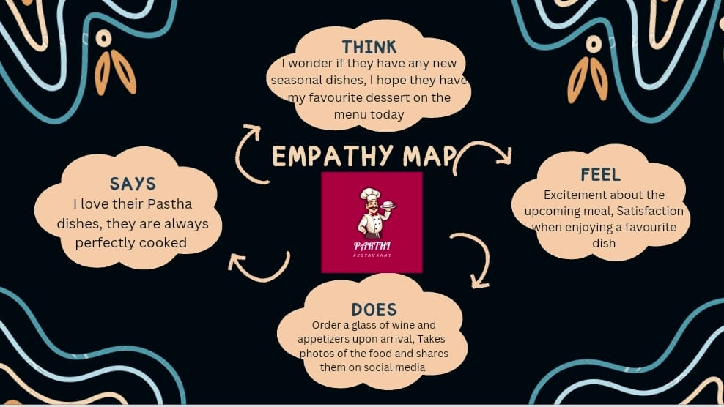 **- Interview Instagram users and content creators to gather insights.**

**2. Define:**

**- Craft a well-defined problem statement: “The challenge is to enable Instagram users to easily create captivating Reels that engage their audience.”**

**3. Ideate:**

**- Brainstorm potential solutions for creating Reels.**

**- Consider features, tools, and resources that can simplify the design process.**

**4. Prototype:**

**- Use Canva as a prototyping tool to design a user-friendly interface for Reels creation.**

**- Experiment with features such as templates, drag-and-drop elements, and an intuitive design editor.**

**5. Test:**

**- Share the Canva-based Reels creation interface with a sample group of users.**

**- Collect feedback on usability, efficiency, and the impact of the design.**

**6. Refine:**

**- Analyse user feedback and make iterative improvements to the Canva Reels design feature.**

**- Ensure it addresses the problem and user needs effectively.**

**7. Implement:**

**- Collaborate with Canva’s development team to integrate the new Reels design feature.**

**- Ensure it’s user-tested, bug-free, and user-friendly.**

**8. Launch:**

**- Introduce the enhanced Canva Reels design feature to the platform, making it available to a wider audience.**

**9. Evaluate:**

**- Continuously gather user data and feedback to assess the impact and success of the solution.**

**- Make further improvements based on real-world usage.**

**In this context, the problem definition and design thinking approach aim to solve the challenge of simplifying Reels design using Canva, ultimately helping Instagram users create engaging and visually appealing content with ease.Ideation is a crucial step in the design process, where you generate creative and innovative ideas for your Reels design using Canva. Here are some ideation techniques to help you come up with unique and engaging Reels concepts:**

**Ideation;**

**1. Brainstorming:**

**- Gather a group of creative individuals and brainstorm ideas for your Reels.-Encourage open and free-flowing discussions to generate a wide range of concepts.**

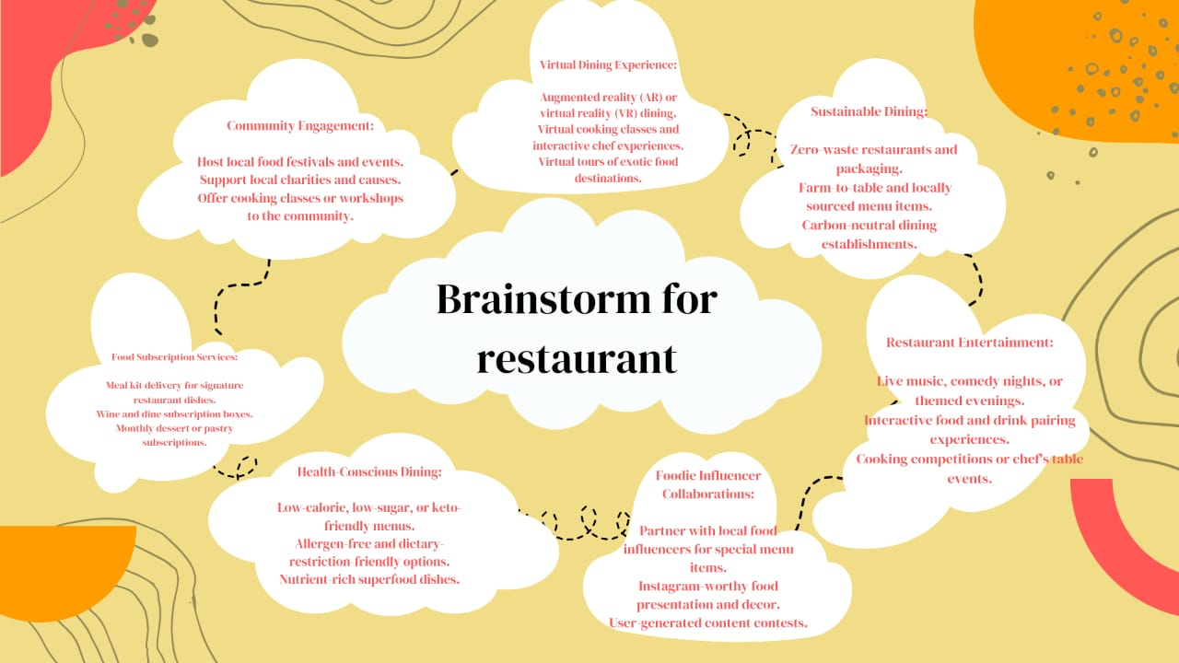

**2. Mood Board Creation:**

**- Create a mood board in Canva by collecting images, colors, and design elements that resonate with the message or theme of your Reels.**

**3. Visual Storyboarding:**

**- Sketch out a visual storyboard or sequence of scenes for your Reels.**

**- Use Canva to create a visual representation of your Reels’ flow.**

**4. User-Centered Design:**

**- Put yourself in the shoes of your audience. What kind of content would resonate with them?**

**- Design your Reels with your viewers’ preferences in mind.**

**5. Trending Topics and Challenges:**

**- Stay up to date with trending topics, challenges, and hashtags on Instagram.**

**- Create Reels that align with these trends to increase visibility and engagement.**

**6. Incorporate Educational Content:**

**- Share informative or how-to Reels. Use Canva to create step-by-step graphics or infographics to illustrate your message.**

**7. Interactive Elements:**

**- Think of ways to engage your audience with interactive elements like polls, quizzes, or call-to-action buttons in your Reels design.**

**8. Use Canva Features:**

**- Explore Canva’s features like animations, stickers, and transitions to add flair to your Reels.**

**9. Collaborate and Draw Inspiration:**

**- Look at successful Reels from others for inspiration.**

**- Collaborate with fellow creators and bounce ideas off each other.**

**10. Experiment:**

**- Don’t be afraid to try unconventional ideas. Experiment with different styles, formats, and themes to see what resonates with your audience.**

**11. Feedback and Iteration:**

**- Share your ideation with a small group for feedback.**

**- Be open to refining your ideas based on constructive input.**

**12. Consistency:**

**- Consider how your Reels fit into your overall content strategy and maintain consistency in your branding and messaging.**

**Remember that the key to successful ideation is to remain open to various possibilities and iterate on your ideas. Canva provides a versatile platform for visual design, enabling you to bring your creative concepts to life effectively.**

**3 ) results;**

**Creating Reels designs using Canva can lead to a variety of positive results, including increased engagement, audience growth, improved brand recognition, and the ability to deliver your message effectively. By using Canva’s design tools, you can enhance your content’s visual appeal, maintain a consistent brand identity, and streamline the content creation process. Furthermore, creating Reels that align with current trends and challenges can boost your visibility, and well-designed Reels have the potential to drive website traffic and open up monetization opportunities. Ultimately, Canva helps you showcase your creativity, collaborate efficiently, and gather valuable user feedback to refine your content strategy. Setting specific goals and measuring relevant metrics will allow you to track the success of your Reels and make adjustments as needed to achieve your objectives. Keep in mind that content quality and relevance are key factors in determining the ultimate success of your Reels.**

**Advantage;**

1. **User-Friendly Platform:*Canva is known for its intuitive and easy-to-use interface, making it accessible to both beginners and experienced designers.**
2. **Design Templates: Canva provides a wide range of Reels templates tailored to Instagram’s specifications, saving you time and effort in design creation.**
3. **Customization: You can fully customize your Reels with Canva, from text and graphics to colors and fonts, ensuring your content matches your brand identity.**
4. **Design Elements: Canva offers an extensive library of design elements, including images, icons, stickers, and animations, enabling you to enhance the visual appeal of your Reels.**
5. **Efficiency: Canva streamlines the design process, allowing you to create professional-looking Reels quickly and efficiently.**
6. **Consistency: You can maintain a consistent look and feel across your Reels, strengthening your brand recognition.**
7. **Creative Freedom: Canva gives you the freedom to experiment with various design elements, styles, and formats to create unique and engaging Reels.**
8. **Collaboration:You can collaborate with team members or other content creators in real-time on Canva, making it easier to create compelling Reels together.**

**Disadvantaged;**

1. **Limited Video Editing: Canva’s video editing capabilities are not as advanced as dedicated video editing software. You may find it challenging to perform complex video edits, transitions, or effects within Canva.**
2. **Watermark: The free version of Canva may add a watermark to your designs, which can be distracting and unprofessional in Reels content. To remove the watermark, you’ll need a paid Canva subscription.**
3. **Customization Constraints: While Canva offers a lot of design elements, the level of customization may be limited for those who require highly specific and unique design features.**
4. **Design LimitationsCanva’s Reels templates are based on Instagram’s specifications, which may restrict your design flexibility if you want to explore unconventional formats or layouts.**
5. **Learning Curve:Although Canva is user-friendly, it still requires some time to learn how to use its features effectively, especially for users who are new to graphic design.**
6. **File Size Limitations:Canva may have file size limitations, and large video files may not be uploaded or edited as easily as in professional video editing software.**
7. **Online Dependency:Canva is a web-based tool, which means you need a stable internet connection to access and use it. This can be a drawback if you’re in an area with limited internet connectivity.**
8. **Limited Advanced Features: Canva is primarily designed for quick and straightforward design tasks. It may not be the best choice for advanced graphic design or video editing needs.**
9. **Pricing: To unlock the full range of features and remove watermarks, you need to subscribe to a Canva Pro plan, which comes with a monthly or annual fee.**
10. **Limited Collaboration Features: While Canva does support collaboration, it may not have the advanced collaboration features found in specialized team design tools.**

**Application;**

**Creating a Reels design using Canva involves several steps for parthi restaurant**

**1. Open Canva:**

**- If you haven’t already, sign in to your Canva account. If you don’t have an account, you can create one for free.**

**2. Select “Instagram Reels” Format:**

**- In Canva’s dashboard, search for “Instagram Reels” in the search bar.**

**- Choose the “Instagram Reels” template to start designing within the recommended dimensions.**

**3. Choose a Template or Start from Scratch:**

**- You can select a pre-designed template from Canva’s library that suits your content theme. Alternatively, start with a blank canvas.**

**4. Customize Your Design:**

**- Edit text: Click on the text elements to modify text content, fonts, sizes, colors, and alignment.**

**- Add media: Click on image or video placeholders to upload your own media or use Canva’s extensive library of assets.**

**- Use elements: Explore Canva’s design elements like stickers, icons, shapes, and animations. Drag and drop them onto your canvas as needed.**

**5. Edit Background:**

**- Change the background color or add gradients.**

**- Upload your own background images or use Canva’s library.**

**6. Add Effects:**

**- Apply filters and effects to your images or videos for a unique look.**

**7. Preview and Save:**

**- Review your design to ensure it meets your expectations.**

**- Once satisfied, click the “Download” button to save your design to your device.**

**8. Upload to Instagram Reels:**

**- Open the Instagram app on your mobile device.**

**9. Create a New Reels:**

**- Tap the ‘+’ icon at the top to create a new Reels.**

**10. Select Your Designed Content:**

**- Select the video or image you created in Canva from your device’s gallery.**

**11. Add Captions and Hashtags:**

**- Write your captions and add relevant hashtags as needed.**

**12. Share Your Reels:**

**- After making any additional adjustments within the Instagram app, you can share your designed Reels with your followers.**

**By following these steps, you can easily create engaging and visually appealing content for Instagram Reels using Canva. Remember to adhere to Instagram’s guidelines for Reels dimensions and content rules to ensure your Reels are published without issues.**

**Conclusion;**

**In conclusion, creating Instagram Reels using Canva is a straightforward process. Canva offers a user-friendly platform with pre-designed templates and creative tools to customize your Reels. You can easily add text, images, stickers, and music, allowing for endless creative possibilities. Once your Reel is ready, simply download it and upload it to Instagram to share your engaging content with your audience. Canva’s intuitive interface makes it accessible for users of all design skill levels, making it a valuable tool for content creators looking to craft captivating Instagram Reels.**

**“At Parthi Restaurant, we are more than just a place to dine; we are a place to create memories. As you’ve explored the flavors and traditions of India through our culinary offerings, we hope you’ve felt the warmth of our hospitality and the passion in every dish. It’s our pleasure to serve you, and we look forward to welcoming you back for more delicious journeys, conversations, and connections. Join us, not just for a meal, but for an experience that lingers long after the plates are cleared. Thank you for choosing Parthi Restaurant, where every visit is an invitation to savor life’s most delicious moments.”**