PUBLIC-RESOURCE ANALYSIS
Dependency and Numerical
Traceability in Public Hubble-Constant
Inference
An Integrated Audit of the Local Distance Ladder, Supernova Processing, BAO, CMB, Posterior Geometry, and Other Distance Methods
INTEGRATED PUBLIC-RESOURCE STUDY
Field | Value
Author | Keiji Yoshimura
Affiliation | Independent Researcher
Corresponding author | Keiji Yoshimura
Email | keiji.yoshimura.research@gmail.com
Date | July 28, 2026
Public repository | https://github.com/yokken0907/hubble-constant-inference-traceability
Versioned snapshot | https://github.com/yokken0907/hubble-constant-inference-traceability/tree/v1.7.0
Repository version | v1.7.0 (final package assembled; remote tag not verified)
This preprint does not claim resolution of the Hubble tension, a unique cause, a measurement correction, a causal systematic, or new physics.
Version 1.7.0 final package assembled and verified locally; a remote v1.7.0 tag and Jxiv publication are not claimed until independently confirmed.

Abstract
Estimates of the Hubble constant are produced by inference chains rather than by direct readings of a single observable. Those chains connect observations, calibration, data processing, prior assumptions, cosmological models, and posterior summaries. This study consolidates analyses based on public data products, public posterior samples, public code, and preserved machine-readable outputs, and traces dependencies across the local distance ladder, Type Ia supernova processing, baryon acoustic oscillations (BAO), cosmic microwave background (CMB) inference, cross-probe posterior geometry, strong-lensing time delays, megamasers, and other distance methods. The underlying project included Gaussian fits, posterior summaries, response calculations, geometric comparisons, and counterfactual sensitivity tests.
Initial manuscript preparation performed no new MCMC sampling, likelihood evaluation, or observational correction; 30 scientific statements and 46 principal numerical results were checked against archived machine-readable outputs and source-version records. A limited subset, including the DESI BAO Gaussian fit, was re-executed from specified public inputs using an identified implementation. The version-fixed public repository records the implementation, input locators and hashes, tested environment, run command, expected output, and verification utilities. After synthesis, a bounded project-internal cross-check using a separately written implementation was added. Following a three-file pilot, the implementation, equal-weight Type-7 quantile definition, source manifest, comparison tolerance, and stopping rule were fixed before an unchanged-code extension to 13 public TDCOSMO HDF5 files. It recovered structure for 13/13 files and q16, q50, and q84 values within the frozen project tolerance for 39/39 comparisons; all 12 Table 6 rows matched at published precision. This later validation is recorded as V001 and does not alter the original 30 statements or 46 principal numerical results. The check does not reproduce the original likelihood, sampler, burn-in, thinning, convergence diagnostics, posterior weights, log probabilities, or posterior-generation process.
Two additional project-internal replay records were added without changing the registered scientific statements or principal numerical results. A fixed-seed rerun of the 1,000-draw CMB amplitude bootstrap reproduced N025-N026, and a two-layer replay of the archived posterior-attribution workflow reproduced N029-N035 within the registered numerical tolerances. The latter combines re-execution of HTS59-HTS65 from hash-fixed posterior exports with replay of HTS66 from verified path-sanitized replicas of its historical intermediate archives. The official empty-cache Phase2C replay reproduced the eight designated HTS67 substantive scientific tables byte-for-byte relative to the preserved historical substantive reference. Path-dependent and packaging-dependent records are not claimed to be byte-identical and were checked separately by semantic and provenance criteria. These records do not reproduce the originating likelihoods, samplers, or posterior-generation processes and are not external independent validation.
Within these limits, the study verifies the BAO constraint on the product H₀ r_d, an approximately common direction between several CMB posterior centers and the DESI reference point, and an algebraic decomposition of a redshift trend in a public supernova vector into an explicit BEAMS with Bias Corrections (BBC) term.
Causal interpretation is limited where simulation-reference products, cross-experiment covariance, stability under analysis conventions, source-level pipeline information, or genuinely independent external validation are unavailable. The study does not identify a unique cause, validate a measurement correction, establish new physics, or resolve the Hubble tension. It was conducted by a non-specialist independent researcher with extensive general-purpose AI assistance and has not undergone independent expert review.
Keywords: Hubble constant; numerical traceability; reproducibility limits; dependency analysis; public data; distance ladder; baryon acoustic oscillations; cosmic microwave background; strong lensing; provenance

1. Introduction
The disagreement between values of H₀ inferred from the local distance ladder and from early-Universe analyses is often summarized as a difference between two numbers. The two sides, however, are not independent instruments that directly measure the same observable. The local route connects geometric anchors, stellar distance indicators, calibrator supernovae, Hubble-flow supernovae, light-curve standardization, selection corrections, peculiar velocities, and covariance models [1, 2, 3, 4, 5]. Measurements from the Dark Energy Spectroscopic Instrument (DESI) use BAO to constrain ratios of distances to the sound horizon r_{d} and therefore do not determine H₀ by themselves [6]. A CMB-derived value of H₀ is a posterior inference that depends on the acoustic angular scale, physical densities, recombination history, low-multipole information, calibration, foreground modeling, and the assumed cosmological model [7, 8, 9]. Megamasers, strong-lensing time delays, standard sirens, and related methods use different observational information, but each introduces its own disk, velocity-field, population, lens-model, or catalog dependencies [10, 11, 12, 13].
This study uses the term dependency audit to mean an explicit trace from an observational source through calibration, processing, parameterization, and posterior representation to the reported numerical result. Several distinctions are essential. A data component can strongly affect a fitted result without being statistically inconsistent with the fitted model. Locating a numerical trend in one correction term does not establish that the correction is valid or invalid. Posterior centers can shift in a common direction without sharing a common cause. Stability across variants of the same dataset is not equivalent to replication with independent data or an independent implementation. Re-expressing the same source in different coordinate systems, partitions, or metrics does not create additional observational evidence.
The analyses consolidated here used public data products, public posterior samples, public code, executable analysis packages, and machine-readable result files. The paper is organized around four questions:
1. Which numerical relations can be recalculated from specified public inputs, and which can only be traced to archived machine-readable outputs?
2. Which results depend on source selection, calibration, processing, posterior representation, or analytic convention?
3. Where should robustness within one dataset be distinguished from validation using independent information?
4. At what point does the available evidence cease to support a transition from descriptive structure to a cause, correction, or resolution?
The central claim is deliberately bounded. Public resources and preserved outputs were sufficient to identify several local dependency structures and limits of numerical traceability across multiple inference methods. They were not sufficient to establish a unique cause, a uniquely justified correction, a global joint significance, or new physics.

2. Scope and Methodology

2.1 Scope and evidence records
The study used execution reports, machine-readable tables, source registers, code, manifests, checksums, review records, and documented corrections preserved in the project archive. A structured verification table connects each of 30 scientific statements to its designated supporting output, source version, numerical result, limitation, and location in the manuscript and/or the version-fixed public repository. A separate numerical table records 46 principal results at their stored precision, together with units, uncertainty definitions, source rows or fields, and file hashes. Large third-party posterior archives are not redistributed because the reported results can be checked from the included summary outputs and source identifiers.
A separate post-synthesis validation register records the later TDCOSMO second-implementation result as V001. The earlier C026 and C027 records remain unchanged as descriptions of the historical NOT_DONE and HOLD stage; V001 records the later COMPLETE_WITH_SCOPE result. Thus C001-C030 remain the original manuscript statements, N001-N046 remain the original principal numerical results, and V001 is a separate later validation record.
The scope is dependency analysis, numerical traceability, and explicitly bounded computational reproduction. It does not include construction of a new cosmological theory, introduction of a new physical mechanism, production of a combined H₀ estimate, or proposal of an observational correction. File integrity was treated separately from scientific validity; rerunning one code path was treated separately from reproduction with an alternate implementation; and descriptive posterior shifts were treated separately from causal effects.

2.2 Scientific analyses included in the synthesis
The underlying analyses did perform scientific calculations. Depending on the observational domain, these included acquisition and versioning of public data and posterior samples; Gaussian fitting of BAO measurements; conditional sound-horizon calculations; posterior-quantile summaries; calculations of changes in posterior centers; counterfactual response calculations in which selected modes were neutralized while the remaining information was held fixed; two- and six-dimensional geometric comparisons; profile and bootstrap calculations; covariance and dependency checks; sensitivity tests under changes of coordinates, partitions, and pooling metrics; comparison with published leave-one-out results; limited reproduction of public code; and structural inspection of public TDCOSMO HDF5 files.
Every numerical result is conditional on the recorded inputs, parameterization, priors, covariance assumptions, and prespecified validation criteria of the corresponding analysis. Significance measures and posterior intervals from different analyses were not automatically placed on a common scale. During initial manuscript preparation, previously computed results were checked against their machine-readable outputs rather than recalculated. The later TDCOSMO cross-check using a second implementation was confined to source integrity, HDF5 structure, equal-weight Type-7 quantiles, and published-precision Table 6 comparison; it introduced no new likelihood evaluation, sampling, observational correction, physical interpretation, or reconstruction of burn-in, thinning, convergence, effective sample size, posterior weights, log probabilities, or the original posterior-generation environment.

2.3 Cross-study synthesis and verification
Initial manuscript preparation consisted of archive inventory, reconciliation of documented corrections, mapping of statements to evidence, direct numerical cross-checks, compilation of source and version records, assessment of shared dependencies, definition of limits on causal interpretation, preparation of publication tables, and figure generation from stored values. It did not include a new posterior-sample read, new quantile calculation, new MCMC run, new likelihood evaluation, new observational correction, or new scientific-data download.
After the initial synthesis, a bounded project-internal TDCOSMO cross-check, recorded as V001, examined 13 fixed public HDF5 files using a separately written implementation. A three-file pilot preceded the extension. The implementation SHA-256, equal-weight Type-7 quantile rule, 13-file source manifest, comparison tolerance, and stopping rule were fixed before the extension results were examined, and the implementation was then applied unchanged to the 13-file set. The earlier C026 and C027 NOT_DONE and HOLD records describe the preceding historical stage and remain unchanged. The later V001 record documents a separate subsequent workflow ending at COMPLETE_WITH_SCOPE.
The reimplementation did not reconstruct the original posterior-generation pipeline. The 46 principal numerical results remain N001-N046. The 13/13 structural matches, 39/39 quantile comparisons, and 12/12 published-table matches are reported separately under V001 as post-synthesis validation results.
Two later re-execution evidence records are maintained separately from C001-C030, N001-N046, and V001. E001 records the fixed-seed CMB amplitude-bootstrap replay covering N025-N026. E002 records the two-layer archived posterior-attribution workflow replay covering N029-N035. Both are classified COMPLETE_WITH_SCOPE and are indexed in PROVENANCE/REEXECUTION_EVIDENCE_REGISTER.tsv.

2.4 Levels of evidential support and independence
The study distinguishes seven levels of support: (i) verified file identity and provenance; (ii) output-level numerical traceability to archived machine-readable analysis outputs; (iii) re-execution from stated inputs and an identified implementation; (iv) robustness across variants based on the same underlying source; (v) descriptive agreement across different source summaries; (vi) implementation-diversity validation, which may remain project-internal and is not automatically external independent replication; and (vii) causal attribution. Establishing one level does not automatically establish the next (Figure 2).
Independence was assessed through shared data, calibration, likelihoods, priors, posterior summaries, and code paths rather than through the number of analysis labels. Planck, ACT, and SPT use different high-multipole CMB measurements but can share external optical-depth information and calibration interfaces [7-9]. Official ACT robustness variants share the same ACT observations [8]. Multiple posterior decompositions in this study use the same set of posterior centers. TDCOSMO nested posteriors share time-delay data and a common hierarchical framework [13].

2.5 Traceability safeguards and numerical checks
For most analyses, the intended source, version, file hashes, reference values, tolerances, and prespecified validation criteria were recorded before interpretation of the results. Analyses formalized only after results were available are identified as post hoc. Source identity was checked in code where possible, and neither a rerun of the same implementation nor the TDCOSMO cross-check using a second implementation within this study was described as external independent replication.
Each principal numerical result was traced through four layers:
manuscript value -> publication table -> archived analysis output -> public source and version
The first check compared the manuscript value with the publication table. The second read the archived output directly and compared the extracted value with the numerical-validation record. Stored precision was retained, and asymmetric intervals were not converted into symmetric errors. All 46 principal numerical results passed these direct output-level checks. This establishes numerical traceability within the preserved archive; it does not by itself show that every result can be regenerated from raw public data. Analysis-level re-execution status is therefore recorded separately in PROVENANCE/REPRODUCTION_STATUS.tsv, using categories that distinguish output trace only, re-execution with fixed external inputs, project-internal implementation diversity, and results not re-executable from the public package. Where a historical source version could not be established, it was reported as unresolved rather than assigned a guessed version.
The later V001 validation is registered separately from N001-N046. Its protocol, implementation hash, input-file manifest, structural comparisons, quantile comparisons, and published-precision Table 6 comparison are available under POST_SYNTHESIS_VALIDATION/tdcosmo_second_implementation/ and are indexed by PROVENANCE/POST_SYNTHESIS_VALIDATION_REGISTER.tsv.
Re-execution status is recorded separately from output-level numerical traceability. R012 links N025-N026 to REPRODUCTION/cmb_fixed_seed_bootstrap/, while the updated R008 links N029-N035 to REPRODUCTION/posterior_attribution/. E001 and E002 preserve the input identities, methods, tolerances, acceptance results, and scope limitations of the two replay workflows. Their existence does not upgrade the remaining CMB geometry calculations or any observational evidence to external independent validation.

2.6 Analysis-specific definitions and computational boundary
The shared-host distance-modulus comparison used a diagonal inverse-variance weighted mean. Its quoted standard error and descriptive mean-versus-zero statistic use the same diagonal approximation. The reported probability to exceed instead evaluates the dispersion of the ten host differences around the fitted common mean; it is not a test of whether that mean differs from zero and is not a significance for the final difference between published values of H₀.
For the DESI BAO calculation, the 13-component Data Release 2 mean vector d and released covariance C were evaluated with the Gaussian statistic
χ² = (d - m)ᵀ C⁻¹ (d - m),
where m is the flat-ΛCDM prediction parameterized by (Ω_m, H₀ r_d). With two fitted parameters, the displayed goodness of fit uses 11 degrees of freedom. This fit was re-executed from specified public inputs using an identified implementation. The version-fixed repository records the implementation, input locators, byte sizes and SHA-256 hashes, tested environment, run command, expected output, and validation code under REPRODUCTION/desi_bao_gaussian_fit/. The input mean vector and covariance remain fixed external public inputs rather than redistributed author-generated data. The BBN and projected-Gaussian calculations are lower-dimensional conditional checks, not replacements for full Boltzmann-code or joint-likelihood analyses.
The DESI component-neutralization calculations are counterfactual sensitivity operations in specified linear bases: selected components are set to their fitted-model values while the remaining released information is held fixed. They are not deletions of data, pipeline corrections, or estimates of what the collaboration would obtain after a revised reduction.
The CMB common-direction calculation uses published posterior moments, a shared DESI reference, the recorded DESI covariance, and zero cross-experiment CMB covariance where such covariance was unavailable. The parametric bootstrap used 1,000 draws under the specified nested Gaussian amplitude models. Posterior-distance and Shapley/Owen summaries are conditional on the selected coordinates, covariance representation, block partition, and pooling convention; invariant totals do not make the component allocations unique physical attributions.
The E001 replay begins from included frozen Gaussian posterior moments and uses NumPy default_rng, seed 10199, and 1,000 draws. The official empty-cache Phase2C E002 replay begins from 51 posterior-export members acquired from the recorded official archives and verified by byte size and SHA-256. HTS59-HTS65 are compared at the substantive-output level. HTS66 uses verified path-sanitized portable replicas of the historical intermediate archives required by its fixed input gates. The official empty-cache Phase2C replay reproduced the eight designated HTS67 substantive scientific tables byte-for-byte relative to the preserved historical substantive reference. Path-dependent and packaging-dependent records are not claimed to be byte-identical and were checked separately by semantic and provenance criteria. Third-party posterior chain bytes are not redistributed. These boundaries distinguish replay of the archived calculations from reconstruction of the originating likelihoods, samplers, convergence assessment, or posterior-generation environment.
For TDCOSMO, equal-weight 16th, 50th, and 84th percentiles were calculated from flattened public HDF5 exports using the equal-weight Type-7 quantile rule. Dataset attributes were treated as authoritative for the file-to-sample crosswalk. The exports do not preserve weights, log probabilities, walker or time dimensions, burn-in, thinning, random seeds, convergence diagnostics, or effective sample size, so the audit verifies released sample summaries rather than reconstructing the original sampling process. Detailed locators, formulas, source identities, and limitations are provided in machine-readable ledgers and analysis records in the version-fixed public repository.
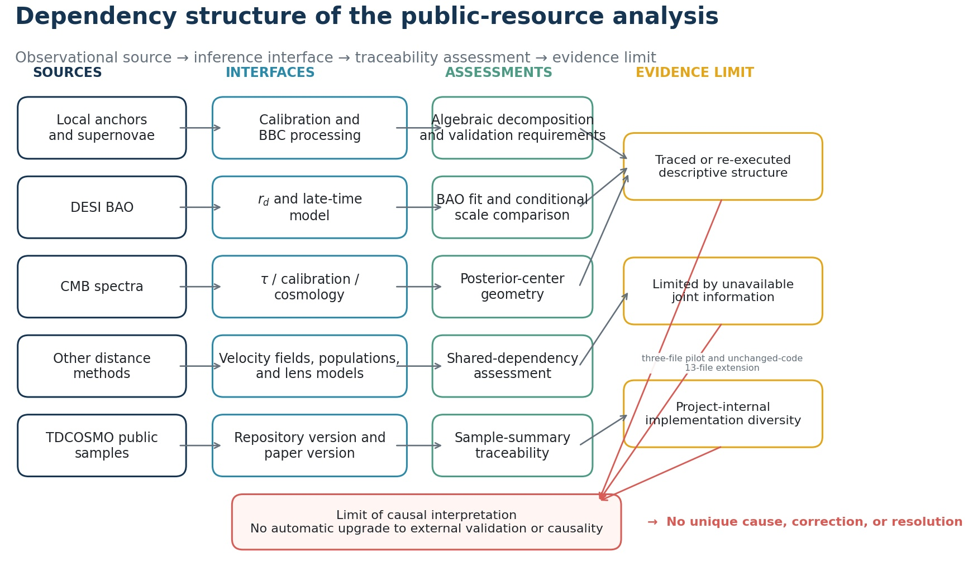
Figure 1. Dependency structure from observational sources through inference steps and numerical-traceability checks to the limit of causal interpretation. Arrows denote dependencies in the analysis, not physical causes.
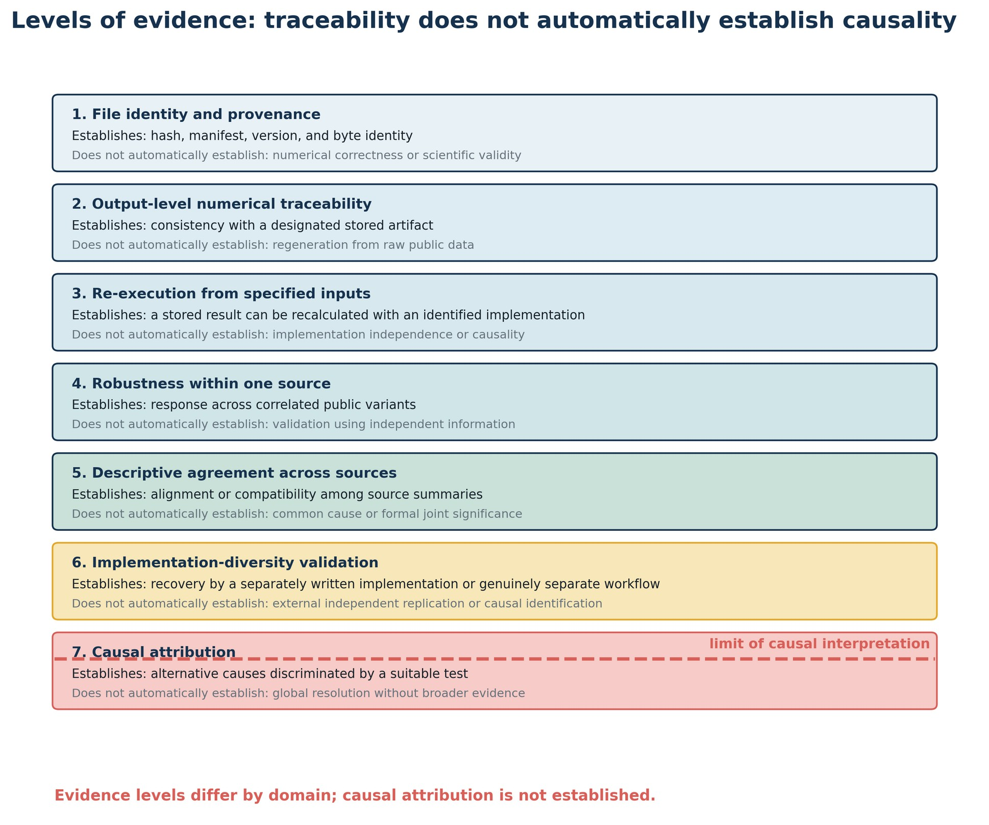
Figure 2. Distinction among file provenance, output traceability, limited re-execution, robustness within one source, descriptive agreement across sources, and causal attribution. A project-internal alternate implementation is not automatically external independent replication, and establishing one level does not automatically establish the next.

3. Results

3.1 Local distance ladder and supernova processing
For ten galaxies with both Supernova H₀ for the Equation of State (SH0ES) Cepheid distances and Chicago-Carnegie Hubble Program (CCHP) James Webb Space Telescope (JWST) tip-of-the-red-giant-branch distances, a diagonal diagnostic gave
Δμ = μ_{TRGB} - μ_{Cepheid} = 0.04166 ± 0.02965 mag.
Under the same diagonal approximation, the mean differs from zero by only z=1.41, corresponding to a two-sided p≈0.16. The separate goodness-of-fit statistic, χ²/dof=5.40/9 with PTE=0.798, tests the dispersion of the ten host differences around their fitted common mean, not the mean-versus-zero hypothesis. The point estimate has the sign expected if this shared-host offset contributes to the difference between selected local-distance estimates, but it is not statistically distinguishable from zero under this approximation. The calculation also omits the joint covariance and does not account for differences in anchor sets, calibrator samples, supernova compilations, or transfer to the Hubble-flow sample. It therefore cannot be interpreted as a causal fraction of the final H₀ difference [1, 2, 3].
Across the local-distance tests included here, no single evaluated factor - a simple zero-point shift, one calibrator supernova, survey composition, a common wavelength-independent calibration term, or peculiar velocity - reproduced the full difference between the selected local estimates by itself. This negative result applies only to the tested configurations; it neither excludes untested systematics nor validates the complete distance ladder [1, 2, 3, 4, 5, 11, 15].
In a published Pantheon+ comparison, the combined change from the SuperCal calibration and original SALT2 training to the Fragilistic calibration and retrained SALT2 model was Δw=+0.057. The same table separated this into a calibration-surface contribution of +0.002, a zero-point contribution of +0.034, and a non-additive interaction of +0.021. The calibration and light-curve-training effects were therefore not simply additive. This result concerns w in the published comparison and was not converted into a causal fraction of the H₀ difference [4].
In a survey-fixed diagnostic of the public Pantheon+ Hubble-flow vector, the redshift slope of the corrected intercept was -0.129333. Adding back the explicit biasCor_{mb} term, as a partial-removal proxy, changed the slope to +0.003689; the slope carried by the explicit bias term was -0.133022, closing the algebraic decomposition. The uncertainty used for this diagnostic treats surveys as clusters and is not a formal significance based on the full covariance. The proxy also retains the selected sample, nuisance parameters, intrinsic-scatter model, and covariance of the final fit; it is not a complete reanalysis without BEAMS with Bias Corrections (BBC) [5].
Validation of BBC against matched simulations or other truth-labeled products was not possible because the required public set - a nominal correction map, matched simulated and fitted quantities, distances before and after correction, nuisance parameters, and matched covariance - was not available in a fixed, reusable form. The supported conclusion is therefore limited to algebraic decomposition of a trend in one specified public vector. It does not show that BBC is wrong, demonstrate overcorrection, or produce a corrected value of H₀ [4, 5].

3.2 BAO, BBN, and the sound-horizon connection
A Gaussian fit of the 13-component DESI Data Release 2 BAO mean vector and covariance in flat ΛCDM gave
Ω_m = 0.2975 ± 0.0086,
H₀ r_d = 10154 ± 73 km s⁻¹,
χ²/dof = 10.27/11, PTE = 0.506.
The fit illustrates that BAO constrains distances relative to r_d, and hence primarily the combination H₀ r_d in this parameterization, rather than H₀ alone [6].
A conditional calculation using a Big Bang nucleosynthesis (BBN) fitting relation gave H₀ = 68.51 ± 0.54 km s⁻¹ Mpc⁻¹ and r_d = 148.22 ± 1.38 Mpc. Combining the same BAO-only H₀ r_d product with the selected local estimate, H₀ = 73.49 ± 0.93 km s⁻¹ Mpc⁻¹ [15], required r_d = 138.17 ± 2.01 Mpc, 6.78% below the BBN-based mean under the same approximation. This is a conditional scale comparison under the specified flat-ΛCDM expansion, local estimate, and fitting relation; it is not evidence for a particular early-Universe mechanism or for new physics [6, 15, 16].
A separate low-dimensional Gaussian calculation combining DESI, BBN, and published Planck summary quantities gave a profile mode of H₀=67.525 and a product-of-Gaussians mean of 67.514 km s⁻¹ Mpc⁻¹. This calculation uses rounded low-dimensional summaries and does not reproduce the full Planck posterior covariance [6, 7, 16].

3.3 Internal DESI response: separating influence from inconsistency
The released DESI BAO vector was examined in several equivalent decompositions, including block, isotropic-versus-anisotropic, and common-versus-differential bases. An intermediate-redshift common isotropic component produced a comparatively large shift in the direction opposite to the CMB posterior centers. Removing that component in the prespecified response calculation changed Ω_m by +0.00331 and q = h r_d by -0.665 Mpc, where h=H₀/(100 km s⁻¹ Mpc⁻¹). Its conditional posterior-predictive probability was nevertheless p=0.114, so the component was not statistically inconsistent with the fitted DESI covariance [6].
The transverse component of the lowest-redshift luminous-red-galaxy sample acted in the opposite direction. When both components were neutralized while the remaining information was held fixed, the residual response was distributed rather than concentrated in a third isolated component. These calculations diagnose sensitivity of the fitted result; they are not corrections to the DESI measurement [6].

3.4 CMB posterior geometry and ACT robustness
Using DESI as the common reference in the (Ω_m, h r_d) plane, posterior centers from Planck, SPT, and ACT were displaced along nearly the same direction, with ΔΩ_m > 0 and Δ(h r_d) < 0. In a Gaussian approximation based on published posterior moments, the residual orthogonal to the common direction had χ²/dof = 0.214/2 and p = 0.899; the minimum fraction captured by the common direction was 97.24%, and the largest orthogonal residual was 0.445 standard deviations [6, 7, 8, 9].
The common direction agreed to within 0.199 degrees with the secant direction that approximately preserves the acoustic angular scale in flat ΛCDM. The fractional difference between the predicted and observed slopes was -0.75%. This is a statement about the geometry of posterior summaries. It does not identify an eigenmode of the original likelihoods, a common instrumental systematic, or a common physical cause [7, 14].
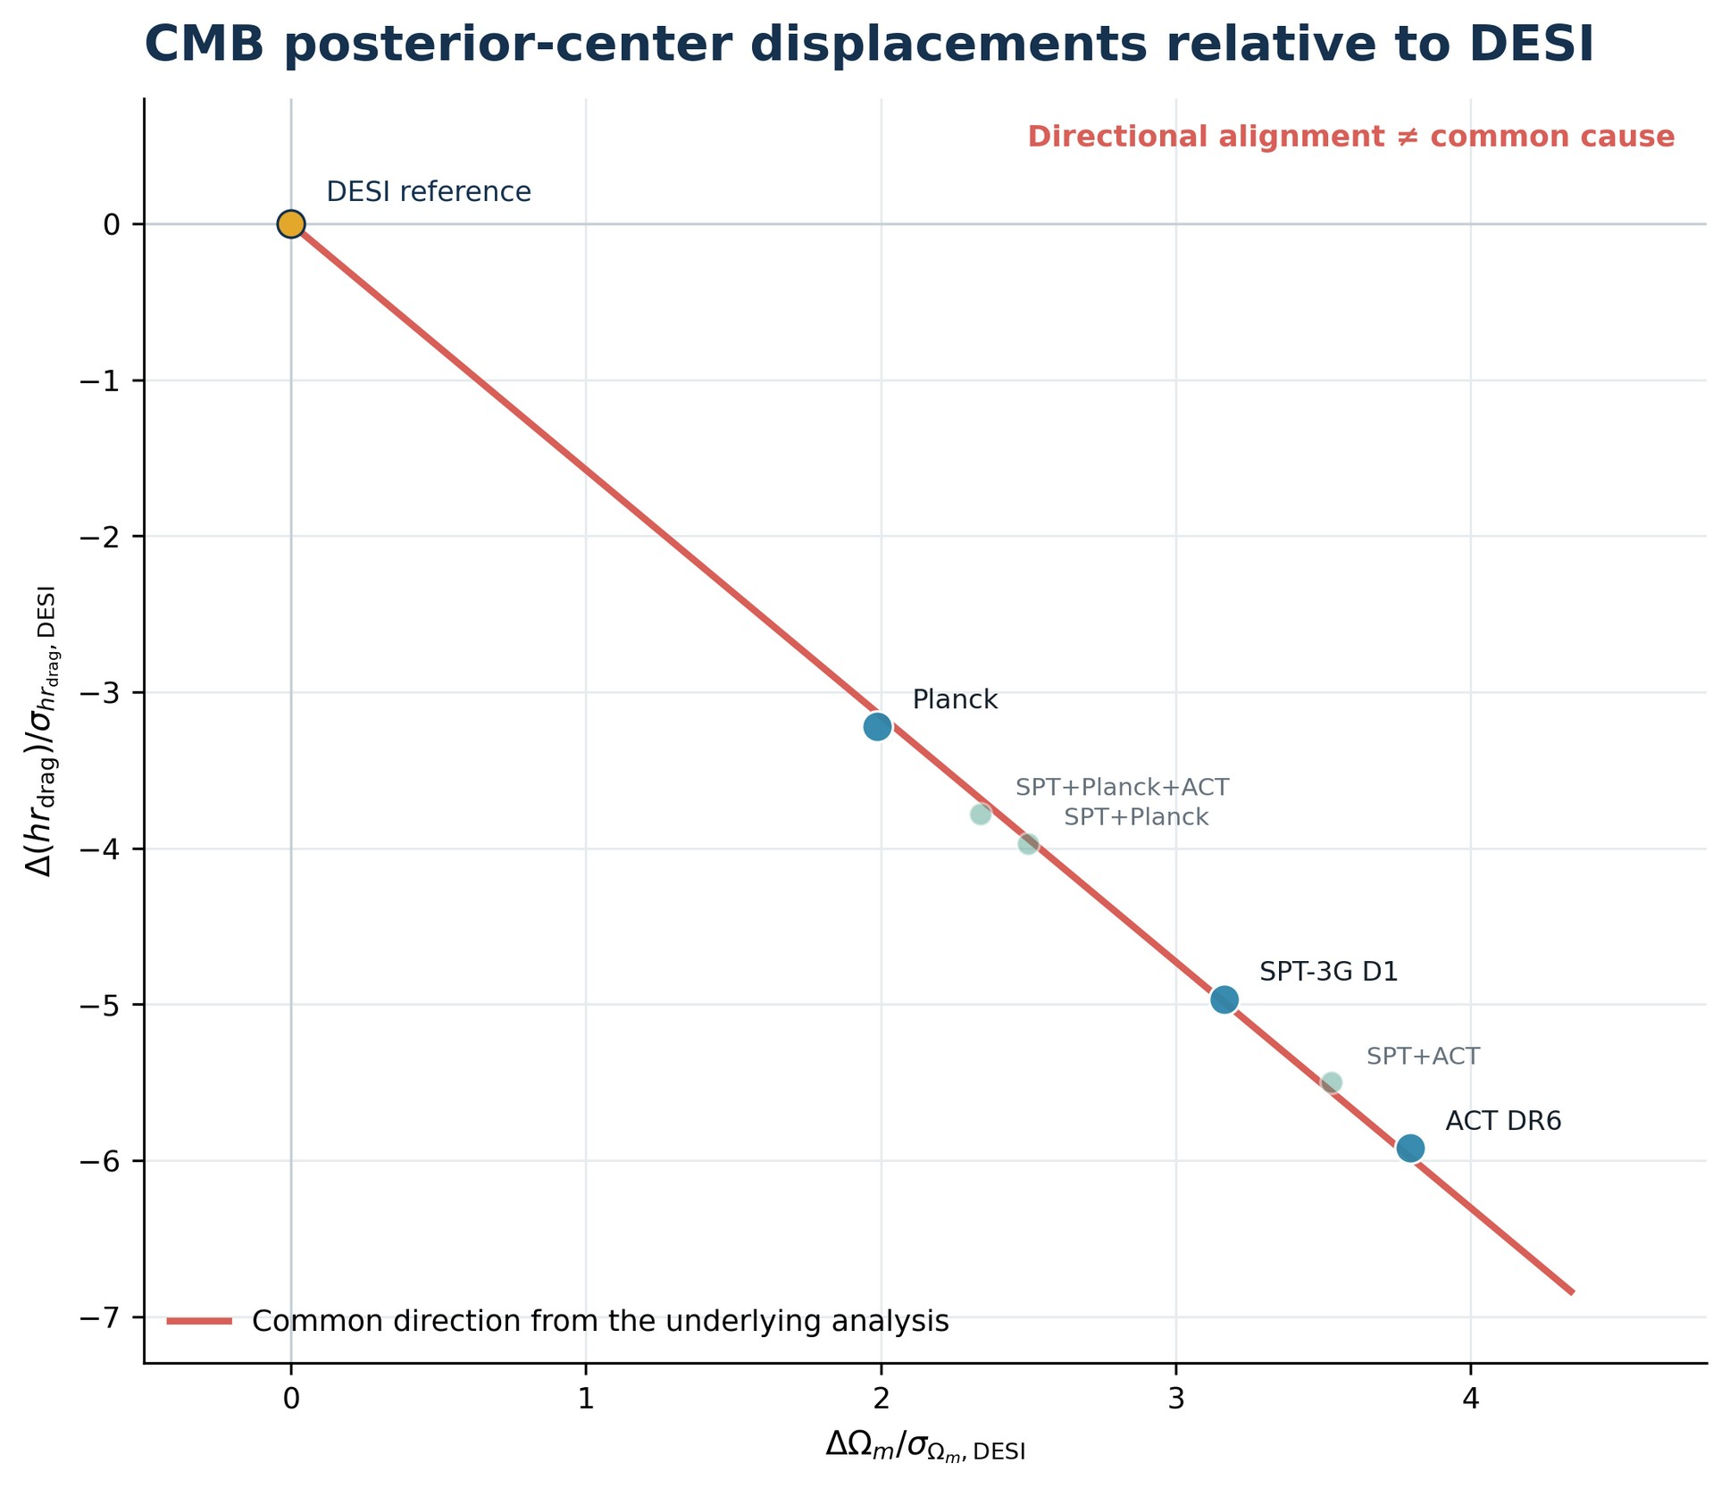
Figure 3. CMB posterior-center displacements relative to DESI in coordinates normalized by the DESI marginal uncertainties. The line shows the common direction obtained in the underlying analysis; it is not a new fit performed during manuscript preparation. Directional agreement does not imply a common cause.
A post hoc contrast of positions projected along the common direction gave a parametric-bootstrap equivalent of 2.05 standard deviations for the separation of ACT from Planck plus SPT, whereas the omnibus statistic for any amplitude difference was 1.59 standard deviations. Because the first contrast was selected after examining the same data, it is reported as a local descriptive contrast rather than a global hierarchy [6, 7, 8, 9].
The two bootstrap contrasts were subsequently replayed from the preserved fixed Gaussian moments and archived HTV101 implementation using 1,000 draws, NumPy default_rng, and seed 10199. The replay reproduced the registered 2.05-standard-deviation local descriptive contrast and 1.59-standard-deviation omnibus result. This verifies the archived calculation path within the stated Gaussian model; it does not reproduce the original CMB likelihoods or establish a global hierarchy.
For the ACT Data Release 6 baseline posterior and three official robustness variants, the largest movement of a posterior center was 0.116 baseline standard deviations in the physical cold-dark-matter density ω_c, and 0.114 baseline standard deviations along the DESI tangent direction. An initial bookkeeping error incorrectly marked this comparison as unresolved because a validation script expected non-chain products that did not exist. Correcting that bookkeeping condition did not change any scientific number; the largest arithmetic residual in the stored response differences was 2.76×10⁻¹⁰ [8].
This stability is robustness within one observational dataset, not three independent validations. The ACT variants share the same data and many modeling components. ACT and SPT are partly independent of Planck at high multipoles, but the analyses can share external optical-depth constraints and calibration information [7, 8, 9].

3.5 Posterior decomposition and sensitivity to analytic convention
A sequence of calculations represented the same set of six-dimensional posterior summaries through conditional distances, eigenmodes, cooperative-game attribution measures (Shapley and Owen allocations), rotations within parameter blocks, and alternative coalition partitions. Under a prespecified division of the parameter space into a two-parameter geometric block and a four-parameter complementary block, the largest discrepancy in the conditional distance was 1.42×10⁻¹³, and the largest discrepancy in the fixed block totals was 1.67×10⁻¹⁵. These residuals demonstrate arithmetic invariance within the specified metric and partition [6, 7, 8, 9].
Attribution to individual parameters was not invariant. All 14 directed comparisons were sensitive to rotations within the parameter blocks, and the largest range of the leading attribution share was 0.465. Labels attached to nearly degenerate subspaces, coordinate axes, or coalition partitions were therefore not interpreted as unique physical importance [6, 7, 8, 9].
Two prespecified symmetric pooling metrics were also compared. The largest difference in a block attribution was 0.290, the largest difference in order sensitivity was 0.380, and the qualitative classifications agreed for 4 of 7 directed comparisons. The attribution of precision to individual components therefore remains sensitive to the pooling convention. This does not invalidate the geometric comparisons themselves; it limits physical interpretation of the decomposed shares [6, 7, 8, 9].
The posterior-attribution results were subsequently replayed through the preserved HTS59-HTS67 workflow. HTS59-HTS65 were re-executed from a hash-fixed set of posterior exports and compared at the substantive-output level. HTS66 used verified path-sanitized portable replicas of its historical intermediate inputs. The official empty-cache Phase2C replay reproduced the eight designated HTS67 substantive scientific tables byte-for-byte relative to the preserved historical substantive reference. Path-dependent and packaging-dependent records are not claimed to be byte-identical and were checked separately by semantic and provenance criteria. The replay reproduced N029-N035 within the registered tolerances, including the 14/14 basis-sensitive comparisons and the 4/7 qualitative agreement under the two pooling conventions. This is not reconstruction of the original samplers or external independent validation.

3.6 Other distance methods
Megamasers, time-delay lenses, standard sirens, and lensed supernovae do not directly require the Cepheid-supernova distance ladder or the sound horizon. Their complete inferences nevertheless depend, respectively, on disk modeling and peculiar velocities; the mass-sheet degeneracy, stellar kinematics, and external lens populations; source populations and catalogs; or cluster-lens models, photometry, and microlensing. Because compatible likelihoods and cross-method covariances were not available, these results were not combined as independent measurements by simple inverse-variance weighting [10, 11, 12, 13].
In the published Megamaser Cosmology Project leave-one-out analysis, excluding NGC 4258 still gave H₀=73.6 (+3.1/-3.0) km s⁻¹ Mpc⁻¹, indicating that the high central value was not solely determined by that anchor. Across six peculiar-velocity prescriptions, however, the all-galaxy median ranged from 71.8 to 76.9 km s⁻¹ Mpc⁻¹. This range was retained as sensitivity to velocity-field modeling and distance priors, not converted into a Gaussian systematic uncertainty [10, 11].
In the Local Distance Network data-membership split, O1 (Milky Way, Large Magellanic Cloud, and Small Magellanic Cloud anchors + Cepheids + SNe Ia + the Coma Fundamental Plane) gave 73.110 ± 0.920 km s⁻¹ Mpc⁻¹, whereas O2 (NGC 4258 + tip of the red giant branch + surface-brightness fluctuations + megamasers) gave 73.451 ± 1.777 km s⁻¹ Mpc⁻¹. Their difference, divided by the quadrature sum of the quoted conditional uncertainties, was 0.170 display sigma. Here, “display sigma” denotes this descriptive standardized difference; it is not a systematics-complete significance. The comparison supports consistency between routes with separated data membership, but it does not demonstrate independence of velocity-field models, cosmographic assumptions, or the broader analysis framework [12].

3.7 Public TDCOSMO posterior files and traceability limitations
The reproducibility analysis inspected 28 Hierarchical Data Format (HDF5) files in the public TDCOSMO2025_public repository. Each file contained 500,000 rows, but the exports did not retain walker or time dimensions, burn-in, thinning, random seeds, weights, or log probabilities. For 12 flat-ΛCDM entries, equal-weight empirical 16th, 50th, and 84th percentiles calculated from the public samples agreed, after rounding to one decimal place, with separately transcribed values from Table 6 of the paper. The table was transcribed manually rather than extracted automatically from the PDF [13].
Among comparable nested posteriors, changes in the medians of H₀ and the internal mass-sheet parameter λ_int were larger when the Sloan Lens ACS Survey (SLACS) sample was added than when the Strong Lensing Legacy Survey (SL2S) sample was added. Without auxiliary cosmological data, the corresponding H₀ median shifts were 3.05 and 0.43 km s⁻¹ Mpc⁻¹; with Pantheon+ they were 2.49 and 0.47. These are descriptive differences among nested analyses. They do not identify a systematic, establish independent significance, or show which modeling component controls the precision. Simultaneous inclusion of SLACS and SL2S can also produce non-additive interactions [13].
The original numerical reconstruction remains a post hoc exploratory analysis: it was formalized after the numerical results were available, initially did not fully enforce expected source identifiers, and stored manually transcribed reference values in the same script. The preserved paper PDF has now been identified as arXiv:2506.03023v4 by full-file SHA-256 equality. A later, separately written project-internal implementation was first exercised on a three-file pilot. Its code, equal-weight Type-7 quantile rule, source manifest, comparison tolerance, and stopping rule were then fixed before an unchanged-code extension to 13 release files. The earlier C026/C027 NOT_DONE and HOLD records remain valid descriptions of the preceding stage; the later result is recorded separately as V001 COMPLETE_WITH_SCOPE.
File structure matched for 13/13 files, all 39 q16/q50/q84 comparisons passed the frozen project tolerance, and all 12 Table 6 rows matched at published precision. This provides a bounded project-internal implementation-diversity check for the released-sample summary calculation. It is not external independent replication and does not reproduce the original likelihood, sampler, burn-in, thinning, convergence diagnostics, posterior weights, log probabilities, or posterior-generation process [13]. The protocol, implementation hash, input manifest, structural comparisons, quantile comparisons, and Table 6 comparison are available in the version-fixed repository under POST_SYNTHESIS_VALIDATION/tdcosmo_second_implementation/, with the stable validation record V001 in PROVENANCE/POST_SYNTHESIS_VALIDATION_REGISTER.tsv.

4. Synthesis Across Observational Domains
Figure 1 and Table 1 trace each observational domain from measurement source through calibration or processing, posterior representation, reproducibility result, and the limit of causal interpretation. The recurring conclusions are distinctions rather than claims about a particular cause:
1. A large response is not equivalent to statistical inconsistency.
2. Algebraic localization to a correction term is not equivalent to validation of that correction.
3. A common direction among posterior centers is not equivalent to a common cause.
4. Robustness across variants of one dataset is not equivalent to independent validation.
5. A posterior shift is not equivalent to a causal effect or a measurement correction.
6. Repeated transformations of one source do not create additional independent evidence.
7. Separation of data membership is not equivalent to independence of all systematic assumptions.
8. Reproducibility of a number is not equivalent to correctness of its causal interpretation.
The CMB-DESI directional agreement in Figure 3 is geometrically strong but cannot, by itself, identify a cause shared across instruments. Figure 4 shows that one scientific domain can simultaneously contain reproduced numerical relationships, incomplete source information, sensitivity to analytic convention, and only partial implementation independence. The evidence should therefore not be reduced to a single pass-or-fail label.
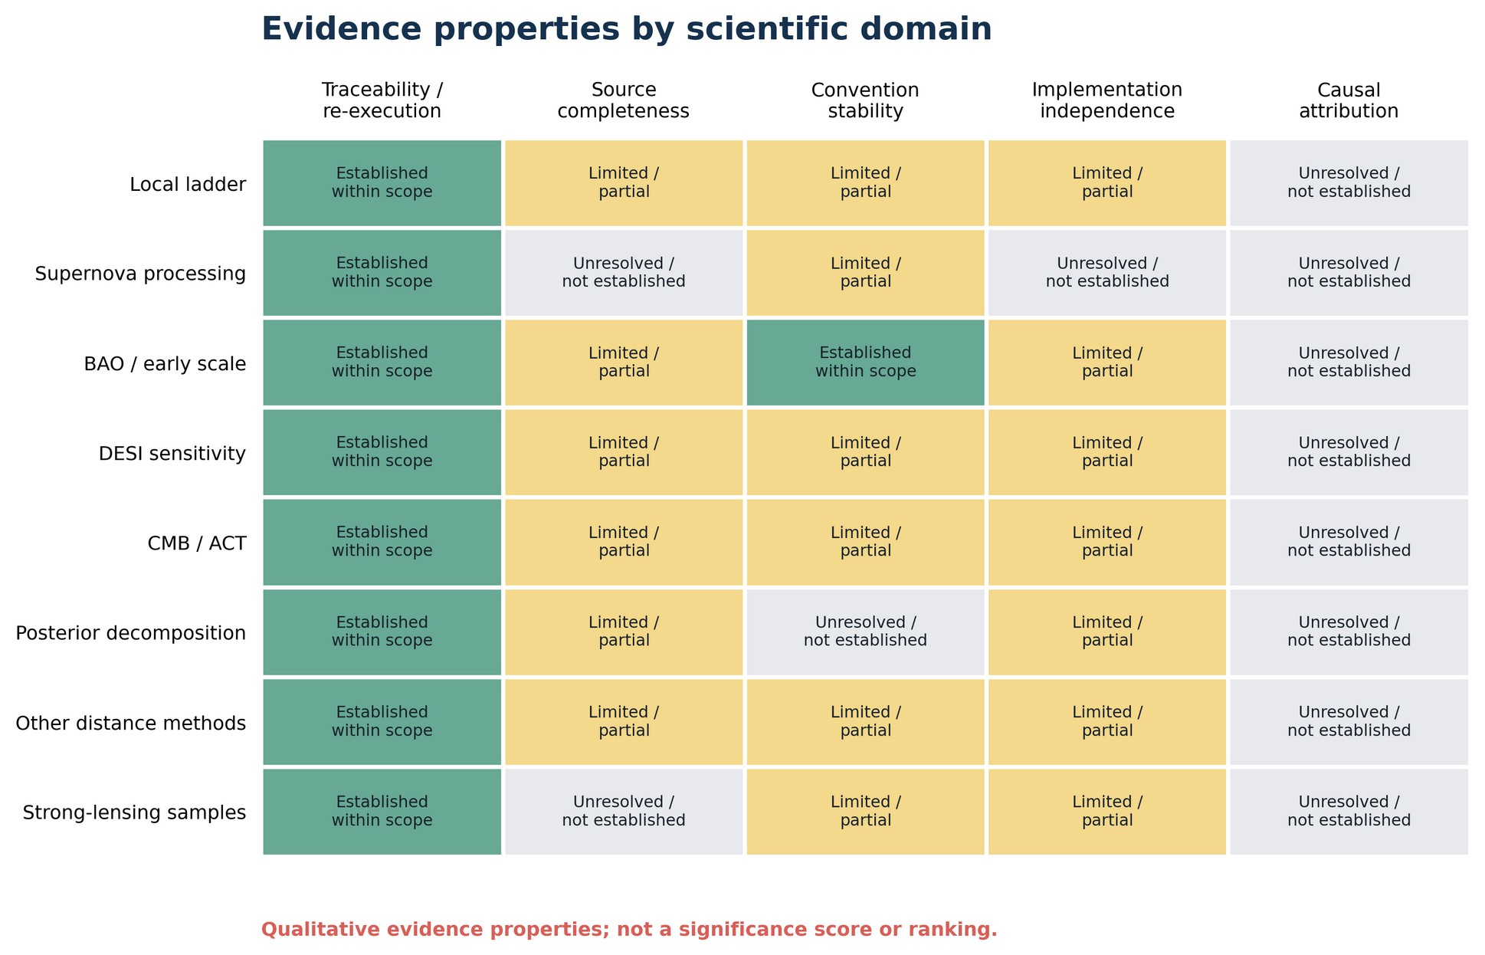
Figure 4. Qualitative summary of numerical reproduction, source completeness, stability under analytic conventions, implementation independence, and causal attribution across scientific domains. The panel is neither a significance score nor a ranking.
The comparatively robust elements of the study are the H₀ r_d structure of BAO, response calculations within the specified DESI vector, the common geometric direction of CMB posterior centers, small movements across public ACT robustness variants, posterior distance within a fixed metric and partition, and reproduction of several public tables or posterior summaries [4, 5, 6, 7, 8, 9, 10, 11, 12, 13]. The reasons that causal interpretation remains limited differ by domain: the supernova analysis lacks matched simulation-reference products; the CMB comparison lacks cross-experiment covariance; posterior attribution is sensitive to metrics and partitions; megamaser and Local Distance Network comparisons lack complete covariance for velocity-field and framework assumptions; and the original TDCOSMO reconstruction was post hoc, while the later V001 project-internal implementation-diversity check addresses only released-sample summaries and not the original inference pipeline or external validation.
The absence of evidence for a unique cause should not be reinterpreted as proof that multiple causes have been established. The available public evidence does not yet provide the source-independent, convention-stable, and independently replicated basis required to support either a unique cause or a uniquely justified correction.

5. Limitations
First, some required inputs are not publicly available in matched form. Validation of BBC would require simulation-reference and fitted products with matched covariance; CMB comparisons require cross-experiment covariance; and comparisons involving peculiar velocities require joint treatment of shared flow uncertainties [4, 5, 7, 8, 9, 10, 11, 12, 13]. Further decomposition of released downstream summaries cannot reconstruct a counterfactual that was never released.
Second, several inputs are compressed representations. Some CMB results are available only as Gaussian moments or rounded tables [7, 8, 9], and the audited TDCOSMO files are flattened samples that do not preserve the history of the sampler [13]. Tracing saved quantiles or posterior-center geometry is not the same as reproducing the original likelihood and sampling process.
Third, posterior distances and attribution measures depend on analytic convention. Results can change with the parameter basis, partition, and pooled covariance. The study therefore does not assign unique physical importance to a parameter or parameter block when that attribution is not stable under the tested alternatives.
Fourth, the degree of pre-analysis specification was uneven. The original TDCOSMO reconstruction was post hoc and is not equivalent to a pre-specified confirmatory test. The later alternate implementation fixed the paper version, repository commit, input hashes, equal-weight Type-7 quantile definition, comparison tolerance, and stopping rule before the 13-file extension results were examined. Even so, it verifies only the released-sample summary calculation; a full confirmatory reproduction would require the original likelihood, sampling configuration, burn-in, thinning, convergence information, posterior weights, log probabilities, and posterior-generation environment.
Fifth, rerunning the same script, a copy of it, or another product generated by the same workflow is not an independent validation. The TDCOSMO check used code developed separately after a three-file pilot under an information-restriction contract, which provides a stronger implementation-level cross-check, but the same project and general-purpose AI environment administered both sides. The package audit supports compliance with the documented information-restriction contract, but it cannot establish the absence of unrecorded exposure outside the packaged workflow. The result therefore does not constitute external independent replication, original-likelihood or sampler reconstruction, convergence reconstruction, causal certification, or independent certification of scientific validity.
Sixth, several historical provenance items remain unresolved, including historical repository commits for Pantheon+ and the BAO data interface. The preserved TDCOSMO PDF has been fixed as arXiv v4 by full-file SHA-256 equality. Redistribution conditions also limit which third-party files can be included in a public package. Versions or permissions are not inferred when documentary evidence is absent; unresolved items remain explicit scope limitations.
Successful replay of E001 and E002 strengthens computational traceability without adding observational independence. E001 begins from frozen Gaussian posterior moments. E002 begins from fixed posterior exports; HTS66 uses verified portable replicas of the historical intermediate inputs required by its fixed gates. The official empty-cache Phase2C replay reproduced the eight designated HTS67 substantive scientific tables byte-for-byte relative to the preserved historical substantive reference. Path-dependent and packaging-dependent records are not claimed to be byte-identical and were checked separately by semantic and provenance criteria. Neither replay reconstructs raw calibration, likelihood evaluation, sampling, convergence assessment, or the originating posterior-generation environment.
Accordingly, this study does not claim to have resolved the Hubble tension, identified a unique cause or causal systematic, validated a measurement correction, established new physics, or completed independent validation of every result.

6. Discussion
The main contribution of this study is not a new single explanation of the Hubble tension. It is a separation of recalculated or numerically traced relationships from the additional evidence required for causal interpretation. In the local-supernova analysis, algebraic contribution to a correction term was separated from validation of the correction [4, 5]. In DESI, influence on a fitted result was separated from statistical inconsistency [6]. In the CMB comparison, a common posterior direction was separated from a common cause [7, 8, 9, 14]. In TDCOSMO, a difference between nested posterior medians was separated from a causal effect [13]. These distinctions help determine whether further work merely repeats an existing source or introduces genuinely new discriminatory information.
Small shifts among public ACT robustness variants narrow simple explanations based on those specific within-dataset variations but do not exclude untested instrumental or foreground effects [8]. Arithmetic invariance of a posterior distance does not rescue parameter-level attributions that change under rotations, partitions, or pooling metrics [6, 7, 8, 9]. The absence of matched simulation-reference products for BBC [4, 5] and of the original TDCOSMO likelihood, sampler metadata, and external replication [13] should be treated as explicit requirements for stronger tests rather than concealed by successful released-sample checks.
Public-data audits have a distinct role and distinct limitations. Public posterior summaries and exports may omit raw calibration information, blinding procedures, full covariance, sampler history, or unpublished nuisance freedom [4, 5, 6, 7, 8, 9, 10, 11, 12, 13]. Such an audit does not replace the original collaboration analysis; it narrows the claims that can be checked externally. The number of computations, files, or tables is not itself evidence of scientific progress.
The next useful step is independent review of the scientific statements, numerical verification table, source-version records, figure source data, and the documented TDCOSMO historical correction sequence and later V001 validation evidence. A new scientific calculation is most informative when it introduces genuinely external implementation or data independence, or obtains simulation-reference, raw, likelihood, or covariance information that can discriminate among causal explanations.

7. Conclusion
Analysis of public data, posterior samples, code, and preserved outputs identified several dependency structures that are numerically traceable, and in a limited subset recalculable, within stated assumptions across the local distance ladder, supernova processing, BAO, CMB posterior summaries, posterior geometry, and other distance methods [1, 2, 3, 4, 5, 6, 7, 8, 9, 10, 11, 12, 13, 14, 15, 16]. BAO primarily constrains H₀ r_d [6]; CMB posterior centers are aligned with an approximately common direction relative to DESI in the examined parameter plane [6, 7, 8, 9, 14]; public ACT variants show small changes in posterior centers [8]; and a redshift trend in a public supernova vector can be algebraically decomposed into an explicit BBC term [4, 5].
Causal attribution cannot be advanced where matched simulation-reference products, cross-experiment covariance, stability under analytic conventions, source-level inference information, or genuinely independent validation are absent. Repeated responses, coordinate changes, partitions, or nested posterior comparisons derived from the same source do not become independent evidence.
The strongest conclusion supported by this study is that it makes explicit which numerical results hold under which public sources, processing choices, and analytic conventions, and where the evidence no longer supports causal or corrective claims. Resolution of the Hubble tension, a unique cause, a measurement correction, a causal systematic, and new physics have not been established. This preprint presents a bounded public-resource audit and is not an independent validation of the originating collaboration analyses.

Data and Code Availability
The public traceability repository associated with this study is available at:
https://github.com/yokken0907/hubble-constant-inference-traceability
The locally assembled version-fixed package is v1.7.0. A remote tag was not independently verified during final assembly; cite the following snapshot URL only after it resolves publicly:
https://github.com/yokken0907/hubble-constant-inference-traceability/tree/v1.7.0
The repository preserves the original 30 statement records C001-C030 and 46 principal numerical results N001-N046, and separately preserves the later TDCOSMO second-implementation validation as V001. V001 does not alter the original C001-C030 or N001-N046 records. The repository contains publication tables, figure-source data, source-and-version records, archived machine-readable analysis outputs, selected author-generated outputs, documented corrections, manifests, SHA-256 checksums, verification tools, repository-relative public evidence locations, and an analysis-level reproduction-status register. Large raw third-party posterior archives, third-party HDF5 files, likelihood products, and paper PDFs are not redistributed.
For each of the 30 registered manuscript statements and 46 principal numerical results, the designated source, version, artifact path, hash, row or field locator, and stated limitation can be followed through the repository. The later V001 validation is traced separately through its post-synthesis validation register and evidence directory. Numerical traceability and re-executability are not treated as equivalent. PROVENANCE/REPRODUCTION_STATUS.tsv records the applicable status for each analysis. The DESI BAO Gaussian fit is documented under REPRODUCTION/desi_bao_gaussian_fit/ as re-executable with fixed external public inputs whose byte sizes and SHA-256 hashes are specified.
The repository additionally contains REPRODUCTION/cmb_fixed_seed_bootstrap/ for E001 and REPRODUCTION/posterior_attribution/ for E002. The latter records official archive locators and verifies 51 selected posterior-export members by byte size and SHA-256; chain bytes are obtained from the official provider and are not included in the repository or release assets. PROVENANCE/REEXECUTION_EVIDENCE_REGISTER.tsv records the COMPLETE_WITH_SCOPE classifications and their non-independence boundaries. The sole current E002 acceptance lineage is the official empty-cache Phase2C run. Its retained HTS67 result ZIP is compared directly with the preserved historical substantive reference in REPRODUCTION/posterior_attribution/HTS67_HISTORICAL_VS_FRESH_COMPARISON.tsv. This comparison establishes byte identity only for the eight designated substantive tables; path-dependent and packaging-dependent records are checked separately.
Phase2C replayed E002 in a network-enabled WSL environment from newly empty external cache, work, and output directories. The FIXED archive passed its full-archive SHA-256 gate; 40/40 selected ORIGINAL members and 11/11 selected FIXED members matched their registered byte sizes and SHA-256 values; and E002 completed successfully. The 6.19 GB ORIGINAL archive was accessed by HTTP Range and was not fully materialized, so no complete-archive ORIGINAL SHA-256 is claimed. The official empty-cache Phase2C replay reproduced the eight designated HTS67 substantive scientific tables byte-for-byte relative to the preserved historical substantive reference. Path-dependent and packaging-dependent records are not claimed to be byte-identical and were checked separately by semantic and provenance criteria. The final repository tree is validated by python tools/verify_publication_package.py --final-package, which checks CAP001-CAP013. This local verification does not create or independently verify a remote Git tag.
No supplementary ZIP archive is submitted with this manuscript. The version-fixed repository is the associated traceability archive; the local release ZIP is only a transport copy of the same verified tree. Historical source-version gaps and unavailable external covariance or simulation-reference products are stated explicitly. No repository DOI or other persistent repository identifier had been assigned at the time of this manuscript revision, and no GitHub tag, Release, or Jxiv record is claimed by the local assembly step.

AI Assistance Disclosure
OpenAI ChatGPT and Codex assisted with manuscript structure, code generation, file inventory, hash comparison, statement-to-evidence mapping, numerical-validation tables, figure and table generation, translation, and prose revision. AI-generated material was checked against archived machine-readable outputs, SHA-256 records, public-source records, documented corrections, and tests designed to detect overstatement. AI is not a coauthor, expert endorser, or independent validator. Final publication decisions and responsibility remain with the human author. The manuscript has not undergone expert peer review; its claims are limited to numerical traceability, limited re-execution, a cross-check using a second implementation within this study, and descriptive dependency analysis.

Competing Interests
The author declares no competing interests.

Funding
This research received no external funding.

Main Tables
Table 1. Evidence summary by scientific domain
Scientific domain | Traced, re-executed, or mapped result | Important dependency | Current evidential status | Limit of interpretation
Local distance ladder and shared galaxies | Small positive shared-host distance-modulus offset; no single shared host exceeds two diagonal sigma | joint covariance and transfer to the final supernova inference are unavailable | output-traced under stated diagonal scope; mean-versus-zero z=1.41, p≈0.16 | no causal fraction of the final H0 difference
Supernova calibration and BBC processing | controlled calibration/retraining response is non-additive; released-vector slope localizes algebraically to explicit BBC term | simulation-reference closure and matched covariance unavailable | algebraic decomposition output-traced; correction validity not assessed | no claim that BBC is invalid or that H0 has been corrected
BAO, BBN, and early-scale bridge | DESI BAO constrains Omega_m and H0 r_d; selected local H0 estimate implies a conditional r_d budget | BBN/fitting-formula and flat-LambdaCDM calibration | BAO fit re-executed; v1.7.0 records an identified implementation and fixed external-input hashes; calibration dependence explicit | no preferred early-Universe mechanism
DESI internal sensitivity | largest tested common isotropic response is not an internal predictive outlier; residual influence is distributed | basis choice and common released vector | no additional isolated component in the tested bases | no correction or pipeline-failure attribution
CMB posterior-center geometry and ACT robustness | Planck/SPT/ACT displacements align with a common geometric direction; tested ACT variants show small center response | shared DESI reference, external tau/calibration, absent CMB cross-covariance | geometry remains output-traced; later E001 fixed-seed replay reproduced N025-N026 from included frozen Gaussian moments; ACT variants remain within-source robustness | common direction is not common cause
Posterior decomposition | distance and fixed-block totals are invariant, but variable/mode allocations are convention-sensitive | coordinate, partition, eigengap, and pooling convention | later official empty-cache Phase2C E002 replay reproduced N029-N035: HTS59-HTS65 were re-executed from hash-fixed posterior exports; HTS66 used verified portable replicas of its historical intermediate inputs; the eight designated HTS67 substantive scientific tables were byte-identical to the preserved historical substantive reference; path-dependent and packaging-dependent records were checked separately; original samplers not reconstructed | no unique physical attribution to a parameter or sector
Other distance methods | measurement cores differ, the megamaser result is not determined by one anchor, and the Local Distance Network data split is stable | flow models, population assumptions, catalogs, covariance architecture | method-specific results retained; no simple combined estimate | no combined or corrected H0 estimate
Public TDCOSMO posterior exports | chain structure and rounded reference agreement retained; nested shifts mapped descriptively; later V001 second implementation recovered 13-file structure and 39 quantiles within the frozen project tolerance | original reconstruction was post hoc; exports omit likelihood, weights, sampler history, convergence information, and source-level posterior-generation details | historical C026/C027 NOT_DONE and HOLD records preserved; later project-internal implementation diversity documented separately as V001 COMPLETE_WITH_SCOPE; 12/12 Table 6 rows matched at published precision | no external independent replication, original-pipeline reproduction, systematic localization, causal effect, or precision-control claim

Table 2. Principal numerical results and limitations
Number ID | Quantity | Value | Unit | Scope or limitation
N001 | shared-host weighted mean distance-modulus offset | 0.04166 | mag | diagonal diagnostic; joint covariance unavailable; z=1.41 and two-sided p≈0.16 are derived diagnostics
N002 | shared-host diagonal goodness-of-fit PTE | 0.798 | dimensionless | goodness of fit around the weighted mean; not a mean-versus-zero test or final-H0 significance
N003 | SuperCal-to-Fragilistic combined delta w | 0.057 | dimensionless | not transferred to full H0
N004 | non-additive interaction difference | 0.021 | dimensionless | descriptive algebra, not causal fraction
N005 | corrected-vector redshift slope | -0.129333 | mag per redshift | formal significance not assigned
N006 | bias-removed proxy redshift slope | +0.003689 | mag per redshift | partial-removal proxy
N007 | explicit bias-term redshift slope | -0.133022 | mag per redshift | algebraic carrier, not validity test
N008 | BAO-only Omega_m | 0.297462 | dimensionless | flat LambdaCDM Gaussian fit
N009 | BAO-only H0 r_d | 10153.98 | km s^-1 | BAO does not determine H0 alone
N010 | BAO-only fit PTE | 0.506 | dimensionless | model-conditional fit diagnostic
N011 | approximate BBN-calibrated H0 | 68.508 | km s^-1 Mpc^-1 | conditional fitting-relation calculation, not a full Boltzmann-code likelihood
N012 | approximate BBN sound horizon | 148.223 | Mpc | fitting-formula output
N013 | sound horizon required by the selected local H0 estimate | 138.17 | Mpc | conditional budget
N014 | fractional sound-horizon reduction | 6.7839 | percent | not evidence for a specific mechanism
N015 | projected-Gaussian profile mode H0 | 67.5247 | km s^-1 Mpc^-1 | low-dimensional calculation based on rounded summaries
N016 | projected posterior-product mean H0 | 67.5136 | km s^-1 Mpc^-1 | not full Planck joint posterior
N017 | common isotropic response delta Omega_m | +0.003309 | dimensionless | sensitivity calculation, not a measurement correction
N018 | common isotropic response delta q | -0.664576 | Mpc | sensitivity calculation, not causal attribution
N019 | common isotropic posterior-predictive p | 0.114 | dimensionless | large influence does not imply statistical inconsistency
N020 | orthogonal residual about the common direction | 0.213570/2; p=0.898719 | chi2/dof | CMB cross-covariance unavailable
N021 | minimum fraction captured by the common direction | 97.24 | percent | geometry of posterior summaries only
N022 | maximum orthogonal residual | 0.445 | sigma | does not identify a shared cause
N023 | angle between acoustic-scale secant and common direction | 0.1986 | degree | base-LambdaCDM geometry
N024 | predicted-versus-observed slope difference | -0.7484 | percent | not an eigenmode of the original likelihoods
N025 | post hoc ACT-versus-Planck+SPT bootstrap equivalent | 2.054 | sigma | post hoc local contrast
N026 | omnibus amplitude-difference bootstrap equivalent | 1.594 | sigma | does not establish global hierarchy
N027 | maximum omega_c robustness-center response | 0.115897 | baseline standard deviations | correlated variants of the same ACT dataset
N028 | maximum tangent robustness-center response | 0.114023 | baseline standard deviations | not independent significance
N029 | maximum discrepancy in conditional distance | 1.42e-13 | dimensionless | invariance within the specified metric and partition
N030 | maximum discrepancy in fixed block totals | 1.67e-15 | fraction | invariance of fixed block totals only
N031 | basis-sensitive directed edges | 14/14 | count | individual shares depend on coordinate choice
N032 | maximum top-share range under rotation | 0.4654 | fraction | not evidence of unique physical importance
N033 | maximum pooling block-share difference | 0.2900 | fraction | sensitive to the pooling convention
N034 | maximum pooling order-sensitivity difference | 0.3801 | fraction | sensitive to the pooling convention
N035 | agreement under two pooling conventions | 4/7 | edges | does not invalidate the geometric comparison
N036 | Megamaser result excluding NGC 4258 | 73.6 (+3.1/-3.0) | km s^-1 Mpc^-1 | same Megamaser Cosmology Project likelihood family
N037 | Megamaser all-galaxy medians across velocity-field prescriptions | 71.8–76.9 | km s^-1 Mpc^-1 | not a Gaussian systematic
N038 | Local Distance Network path O1 | 73.110 | km s^-1 Mpc^-1 | separated data membership only
N039 | Local Distance Network path O2 | 73.451 | km s^-1 Mpc^-1 | full systematics may overlap
N040 | descriptive O1-O2 difference | 0.1704 | display sigma | does not include all shared systematic assumptions
N041 | TDCOSMO public HDF5 files audited | 28 | files | structural inspection of public files
N042 | rows per TDCOSMO HDF5 export | 500,000 | rows per file | does not imply effective sample size
N043 | rounded matches to transcribed Table 6 values | 12/12 | rows | manual table transcription; separately written project-internal implementation also matched all 12 rows at published precision
N044 | no-auxiliary SLACS versus SL2S H0 median shifts | 3.05 vs 0.43 | km s^-1 Mpc^-1 | descriptive comparison, not a prespecified confirmatory test
N045 | Pantheon+ SLACS versus SL2S H0 median shifts | 2.49 vs 0.47 | km s^-1 Mpc^-1 | non-additive interaction possible
N046 | maximum arithmetic residual after bookkeeping correction | 2.76e-10 | native parameter units | bookkeeping correction only; scientific values unchanged

Table 3. Repeated limits on causal interpretation
Observed, traced, or re-executed | Not equivalent to | Reason
high response | outlier | a datum can be influential while remaining predictive under the fitted covariance
algebraic localization | valid correction | validation against matched simulation-reference products and matched covariance are separate requirements
common posterior direction | common cause | shared parameterization, calibration, and reference data can align posterior centers
within-source robustness | independent validation | variants retain the same data and much of the same implementation
posterior median shift | causal effect or measurement correction | nested posteriors share data, priors, model structure, and possible interactions
many repeated analyses or output files | many independent evidence units | repeated analyses can transform the same source without adding independent data
data-graph separation | full-systematics orthogonality | flow, cosmography, and framework assumptions can remain shared
numerically traced or re-executed number | correct causal interpretation | arithmetic and provenance checks do not identify physical causes
project-internal alternate implementation (V001) | external independent replication | the same project and general-purpose AI environment administered the implementation and post-pilot audit, and the original likelihood, sampler, convergence diagnostics, weights, and posterior-generation pipeline were not reconstructed

Table 4. Historical traceability sequence and later V001 validation for the public TDCOSMO analysis
Historical order | Record | Current status | Use in manuscript | Limitation | Public evidence link
1 | Original posterior-summary analysis | post hoc released-sample outputs retained | file structure, posterior summaries, and descriptive nested shifts | historical original-analysis scope; original likelihood and sampler were not reconstructed | ANALYSIS_OUTPUTS/tdcosmo/original_results/
2 | Historical method/contract corrections | 2026-07-24 CORR1 and 2026-07-25 CORR2 retained; alternate implementation = NOT_DONE and future rerun = HOLD at that stage | documents post-hoc design, source-integrity requirements, and future-rerun governance | method patches did not themselves recompute a scientific result; later V001 does not overwrite these historical statuses | ANALYSIS_OUTPUTS/tdcosmo/corr1/; ANALYSIS_OUTPUTS/tdcosmo/corr2/; C026; C027
3 | Paper and source identity | repository commit fixed; preserved PDF identified as arXiv:2506.03023v4 by full-file SHA-256 equality | source/version provenance and identifier crosswalk | third-party HDF5 bytes and paper PDF are referenced rather than redistributed | POST_SYNTHESIS_VALIDATION/tdcosmo_second_implementation/METHOD_FREEZE_RECORD.json; SOURCE_MANIFEST_13_CHAINS.tsv; IDENTIFIER_CROSSWALK.tsv
4 | Later project-internal second implementation | V001 COMPLETE_WITH_SCOPE after three-file pilot and unchanged-code 13-file extension | 13/13 structural comparisons; 39/39 quantiles within frozen tolerance; 12/12 Table 6 rows at published precision | not external independent replication; no original likelihood, sampler, convergence, weights, or posterior-generation reconstruction | PROVENANCE/POST_SYNTHESIS_VALIDATION_REGISTER.tsv#V001; POST_SYNTHESIS_VALIDATION/tdcosmo_second_implementation/

References
1. Riess, A. G. et al. A Comprehensive Measurement of the Local Value of the Hubble Constant with 1 km s⁻¹ Mpc⁻¹ Uncertainty from the Hubble Space Telescope and the SH0ES Team. The Astrophysical Journal Letters 934, L7 (2022). arXiv:2112.04510v3; doi:10.3847/2041-8213/ac5c5b.
2. Hoyt, T. J. et al. The Chicago Carnegie Hubble Program: Improving the Calibration of SNe Ia with JWST Measurements of the Tip of the Red Giant Branch. The Astrophysical Journal 1002, 11 (2026). arXiv:2503.11769v1; doi:10.3847/1538-4357/ae29eb.
3. Freedman, W. L. et al. Status Report on the Chicago-Carnegie Hubble Program (CCHP): Measurement of the Hubble Constant Using the Hubble and James Webb Space Telescopes. The Astrophysical Journal 985, 203 (2025). arXiv:2408.06153v3; doi:10.3847/1538-4357/adce78.
4. Brout, D. et al. The Pantheon+ Analysis: SuperCal-Fragilistic Cross Calibration, Retrained SALT2 Light Curve Model, and Calibration Systematic Uncertainty. The Astrophysical Journal 938, 111 (2022). arXiv:2112.03864v2; doi:10.3847/1538-4357/ac8bcc.
5. Brout, D. et al. The Pantheon+ Analysis: Cosmological Constraints. The Astrophysical Journal 938, 110 (2022). arXiv:2202.04077v2; doi:10.3847/1538-4357/ac8e04.
6. DESI Collaboration. DESI DR2 Results II: Measurements of Baryon Acoustic Oscillations and Cosmological Constraints. Physical Review D 112, 083515 (2025). arXiv:2503.14738v3; doi:10.1103/tr6y-kpc6.
7. Planck Collaboration. Planck 2018 Results. VI. Cosmological Parameters. Astronomy & Astrophysics 641, A6 (2020). arXiv:1807.06209v4; doi:10.1051/0004-6361/201833910.
8. Louis, T. et al. The Atacama Cosmology Telescope: DR6 Power Spectra, Likelihoods and ΛCDM Parameters. Journal of Cosmology and Astroparticle Physics 11, 062 (2025). arXiv:2503.14452v2; doi:10.1088/1475-7516/2025/11/062.
9. Camphuis, E. et al. SPT-3G D1: CMB Temperature and Polarization Power Spectra and Cosmology from 2019 and 2020 Observations of the SPT-3G Main Field. Physical Review D 113, 083504 (2026). arXiv:2506.20707v2; doi:10.1103/7wt3-9v2y.
10. Pesce, D. W. et al. The Megamaser Cosmology Project. XIII. Combined Hubble Constant Constraints. The Astrophysical Journal Letters 891, L1 (2020). arXiv:2001.09213v2; doi:10.3847/2041-8213/ab75f0.
11. Boruah, S. S., Hudson, M. J. & Lavaux, G. Peculiar Velocities in the Local Universe: Comparison of Different Models and the Implications for H₀ and Dark Matter. Monthly Notices of the Royal Astronomical Society 507, 2697-2713 (2021). arXiv:2010.01119; doi:10.1093/mnras/stab2320.
12. H0DN Collaboration. The Local Distance Network: A Community Consensus Report on the Measurement of the Hubble Constant at 1% Precision. Astronomy & Astrophysics 708, A166 (2026). arXiv:2510.23823; doi:10.1051/0004-6361/202557993.
13. TDCOSMO Collaboration. TDCOSMO 2025: Cosmological Constraints from Strong Lensing Time Delays. Astronomy & Astrophysics 704, A63 (2025). arXiv:2506.03023v4; doi:10.1051/0004-6361/202555801.
14. Eisenstein, D. J. & Hu, W. Baryonic Features in the Matter Transfer Function. The Astrophysical Journal 496, 605-614 (1998). arXiv:astro-ph/9709112; doi:10.1086/305424.
15. Riess, A. G. et al. The Perfect Host: JWST Cepheid Observations in a Background-Free SN Ia Host Confirm No Bias in Hubble-Constant Measurements. arXiv:2509.01667v1.
16. Schöneberg, N. The 2024 BBN Baryon Abundance Update. arXiv:2401.15054v3.

