Upon regularization only half of leave credit can be availed

This is intial Value for the regularation avialment

\*General Leave Parameter

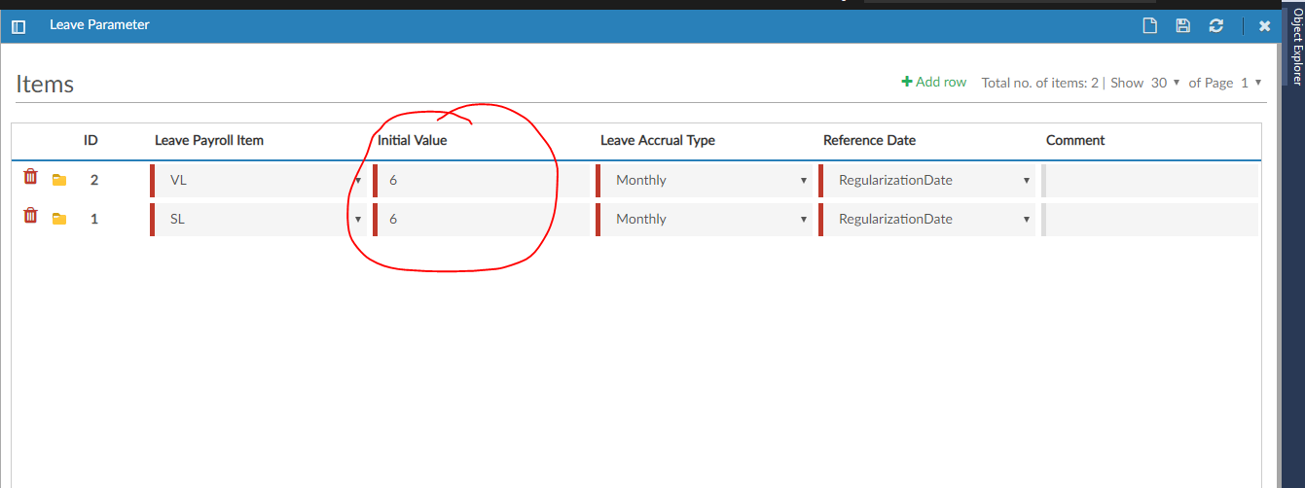

If Employee one year then the leave Accrual Availed is 12

\*Leave Parameter Item Value

