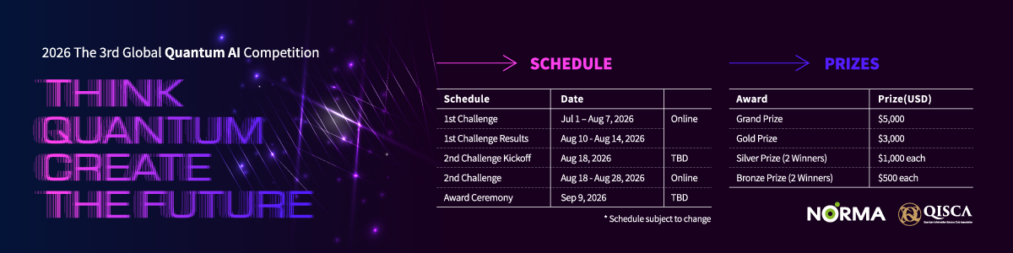
The 1st Challenge
- Data
Results from a social survey of a certain populace
(processed to be fit for the competition)
- Objective
Build a quantum circuit that classifies the data into two underlying classes.
- Equipment
A 1st Challenge lab dataset consisting of:
  - A training set, which you can use to train your quantum circuit.
  - A public test set, which you can freely use to test your trained circuit.
- Constraints
Submissions must follow the constraints below:
  - Maximum number of qubits: 8
  - Maximum circuit depth / number of layers: 50
  - Maximum two-qubit gate count: 80
  - Allowed gates: X, Y, Z, H, S, T, RX, RY, RZ, CX, CZ
  - Allowed measurement scheme: 1-qubit measurement
  - Allowed shots: up to 1024 shots
  - The training data must be encoded directly to the quantum circuit with no pre-processing.
  - Data augmentation is not allowed.
  - Training must be done exclusively with the training set.
No portion of the public test set may be used for training.
- Leaderboard
The leaderboard server will implement your quantum circuit and classify a private, server-side test dataset. This private test dataset is not available to participants.
Ranking is determined by the following metrics, in order of priority:
Priority 1: Balanced accuracy – $\frac{True Positive Rate + True Negative Rate}{2}.$
Higher balanced accuracy higher ranking
(This is the foremost metric. Up to the second decimal digit.)
Priority 2: Circuit depth – the no. of layers in your quantum circuit.
Lower circuit depth higher ranking
(This acts as a tiebreaker if balanced accuracy is identical.)
Priority 3: Number of two-qubit gates – the no. of two-qubit gates in your circuit.
Fewer two-qubit gates higher ranking
(This acts as a tiebreaker if the above two metrics still result in a tie.)
Priority 4: Submission time – the time when you made your submission.
Earlier submission time higher ranking
(This acts as a tiebreaker if all other metrics still result in a tie.)

- Evaluation
Evaluation will proceed as follows:
  - A shortlist based on the final version of the leaderboard as of the 1st Challenge deadline is compiled.
  - The shortlisted teams are requested to share their source code and other information with the organizers.
  - The organizers use the shared code and information to replicate the team’s leaderboard results and check compliance with the rules.
  - A team is disqualified from the shortlist and the competition if:
    - The organizers fail to replicate the leaderboard results with the shared materials, or
    - A submission is not compliant with the competition rules and constraints.
  - If a team is disqualified, the next highest ranked team on the leaderboard is included in the shortlist.
  - Results replication and compliance checks are repeated until the shortlist consists of only compliant teams.
  - The teams on the final shortlist (valid top 10% of submissions, minimum 10%) advance to the 2nd Challenge.

- Submission Format
You will submit the following on the Submission page:
  - classifier.qasm: Quantum circuit architecture in the OpenQASM 3.0 format.
    - The circuit must contain symbolic parameter placeholders.
    - Parameter names must follow the format: theta_0, theta_1, theta_2, ….
  - weights.json: Trained parameter values in the JSON format.
    - The evaluation server will inject these values into the submitted circuit.
  - Direct input on submission page:
    - Index of the measured qubit.
    - A comment on how the training data was encoded into the circuit.

- Submission Limit (Daily)
- Each team may submit up to 3 submissions per day (KST, UTC+9) on the leaderboard.
- Code of Conduct & IP
- Participants must submit original work. Plagiarism or unauthorized copying of other teams’ solutions is strictly prohibited.
- Sharing or attempting to reconstruct the test data is not allowed.
- By joining, participants agree that anonymized results and circuits may be used for:
  - Research publications
  - Educational materials
  - Future tutorial examples (Specific IP and licensing terms will be clarified in the official rules.)

