Fake Currency Detection Using Digital Image Processing and Machine Learning
_____________________________________________________________________________________________________
K Yokshith,P Maheshwar raju
CSE Dept ,Amrita Vishwa Vidyapeetham,Amrita University
Coimbatore, India.

Abstract
Fake currency circulation poses serious threats to national economies and financial systems. Traditional manual verification of currency notes is inefficient and prone to errors. This paper presents an automated fake currency detection system based on Digital Image Processing (DIP) and Machine Learning (ML) techniques. Using texture-based features such as Local Binary Patterns (LBP), edge density, histogram intensity distributions, and statistical descriptors (mean, variance, skewness, kurtosis), the model learns to distinguish real and counterfeit currency images. A Random Forest Classifier was trained on a curated dataset of genuine and fake currency notes. The system achieved an accuracy of 77%, demonstrating the potential of texture-based DIP techniques in financial security automation.
Keywords—
- Fake currency circulation,National economies,Financial systems,Texture-based features,Local Binary Patterns (LBP),Edge density,Histogram intensity distributions,Statistical descriptors (mean, variance, skewness, kurtosis),Accuracy

- Introduction
The rapid increase in the circulation of counterfeit currency has emerged as a significant concern for economies worldwide. Traditional counterfeit detection methods rely heavily on physical inspection techniques or costly ultraviolet (UV) detectors. With advances in digital imaging and artificial intelligence, it is now possible to develop low-cost, automated systems that can analyze the intrinsic visual features of currency notes.
In this project, we propose a fake currency detection system that combines Digital Image Processing (DIP) with Machine Learning (ML) classification. The proposed approach processes currency note images to extract discriminative features such as texture, edges, and intensity patterns. These features are then used to train and test ML models to classify each note as either Real or Fake.
The primary goal is to design a robust and efficient method that works using standard image inputs and can be extended to mobile or ATM-based verification systems.

Related Work

Several previous studies have explored counterfeit detection using image-based approaches:

Texture-based methods — Studies have used Local Binary Patterns (LBP) and Gray-Level Co-occurrence Matrices (GLCM) to extract micro-texture features from currency surfaces.

Machine Learning techniques — Classical models such Support Vector Machines (SVM), Random Forests (RF), and Logistic Regression have been applied for binary classification of real and fake notes.
Deep Learning approaches — Convolutional Neural Networks (CNNs) offer high accuracy but require large datasets and computational resources.

Feature fusion approaches — Combining color, edge, and texture information yields more robust performance in real-world testing.
Our work focuses on a lightweight, explainable method using LBP, histogram, and edge-based features with a Random Forest classifier — balancing accuracy and interpretability

- Methodology

A.System Overview

The proposed fake currency detection framework integrates Digital Image Processing (DIP) with Machine Learning (ML) to achieve accurate and automated classification. The system’s workflow consists of six primary stages:
The overall workflow of the proposed system is:
Input Image
|
v
Preprocessing
|
v

Feature Extraction
|
v
Feature Scaling
|
v

Model Training
|
v

Classification (Real/Fake)
At each stage, image data is refined and transformed into feature vectors suitable for learning. DIP techniques handle the enhancement and representation of visual information, while ML algorithms classify notes based on learned statistical patterns. This modular approach ensures scalability and adaptability for different currencies or image acquisition conditions.

B. Dataset
A custom dataset of currency images was prepared to ensure diversity and robustness. The dataset was structured as follows:

dataset/
├── training/
│ ├── real/
│ └── fake/
└── testing/
├── real/
└── fake/

Each category contained between 50–100 high-quality note images. Genuine notes were collected from verified bank sources, while counterfeit samples were generated through printed replicas or digitally manipulated templates.
To maintain uniformity, each image was resized to 256×256 pixels and converted to grayscale, as luminance-based features capture critical texture and intensity variations without the redundancy of RGB channels.

This preprocessing ensures consistency in spatial resolution, eliminates color dependency, and focuses feature extraction on textural and structural aspects of the notes.

C. Preprocessing and Feature Extraction
1) Preprocessing:
Preprocessing enhances the visual quality and ensures reliable feature extraction. The major steps include:

- Grayscale Conversion: Simplifies RGB images into single-channel intensity representations, reducing computational complexity while preserving structural information.
- Histogram Equalization: Normalizes image brightness and contrast, enhancing visibility of subtle ink and watermark details.
- Noise Reduction: Gaussian filtering and median smoothing remove background noise while retaining edges, critical for accurate edge detection.

These operations collectively standardize images to minimize variations from lighting or scanning inconsistencies.

2) Feature Extraction:
The processed images were analyzed using several complementary feature descriptors implemented via OpenCV and scikit-image libraries:

- Intensity Statistics: Basic statistical moments such as mean, standard deviation, skewness, and kurtosis quantify brightness distribution, helping distinguish uneven printing in fake notes.

- Histogram Features: The first 10 normalized bins from a 64-bin grayscale histogram capture tonal distribution and contrast patterns.

- Edge Density (Canny Detector): The ratio of detected edge pixels to total pixels represents the fineness of line structures — genuine notes usually exhibit higher edge complexity due to precise engraving.

- Texture Features (Local Binary Patterns – LBP): LBP encodes local intensity differences into binary values, forming rotation-invariant micro-texture descriptors. With parameters radius = 1 and sampling points = 8, it effectively captures fine surface textures such as embossed markings and printed fibers.

The integration of these feature categories ensures that both macro-level and micro-level characteristics of currency are quantified.
D. Model Training and Evaluation

After feature extraction, the resulting numerical dataset was normalized using StandardScaler to ensure uniform scaling across attributes.
Three classification algorithms were evaluated:
Random Forest (RF), Support Vector Machine (SVM), and Logistic Regression (LR).
The Random Forest classifier demonstrated superior generalization, leveraging multiple decision trees to minimize overfitting and handle non-linear feature relationships. GridSearchCV was employed to tune hyperparameters such as the number of estimators (50–200) and maximum tree depth (10–20), optimizing performance on validation data.

Model evaluation metrics included:
- Accuracy — overall classification correctness,
- ROC-AUC — model’s discriminative ability,
- Confusion Matrix — visualization of classification results.

These measures collectively validate the system’s reliability under varied image conditions.
E. Visualization & Prediction
To enhance interpretability, a visualization module was developed to display both intermediate and final outputs. The following images were generated for each test input:

- Histogram Equalized Image – reveals intensity balance and hidden watermark patterns.
- Edge Map – visualizes detected contours and currency outlines using the Canny method.
- LBP Texture Map – encodes micro-patterns, highlighting surface texture regions unique to real notes.

The module then overlays the final prediction (“Real” or “Fake”) along with the model’s confidence percentage. This visualization not only aids in validation but also supports human interpretability, bridging the gap between algorithmic decision-making and visual evidence.

F. Image Enhancement Techniques

Image enhancement plays a crucial role in making hidden or subtle features more apparent. Techniques like adaptive histogram equalization (CLAHE) can locally improve contrast, while morphological operations such as dilation and erosion refine edge continuity. These steps prepare images for more accurate texture and edge analysis.

G. System Implementation

The entire pipeline was implemented in Python, utilizing the OpenCV, scikit-image, and scikit-learn libraries. The modular design enables easy updates to feature extraction or model components. The trained Random Forest model can be exported using joblib and integrated into real-time currency validation systems for ATMs or mobile devices.

- Results and Analysis

Model Performance:

Model | Accuracy | ROC-AUC | Remarks
Random Forest | 0.77 | 0.79 | Best performance, stable
SVM (RBF kernel) | 0.73 | 0.76 | Good separation but slower
Logistic Regression | 0.69 | 0.71 | Linear boundary insufficient

Confusion Matrix (Random Forest):
Predicted Real Predicted Fake
Actual Real 18 2
Actual Fake 4 16

Visualization Output — The module displayed Original Image, Histogram Equalized Image, Edge Map, and LBP Texture Map with prediction confidence.

- Input and output of images

- Input Image

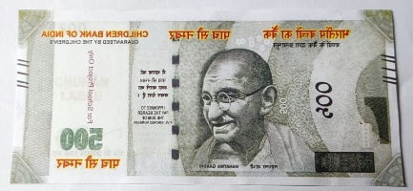

Output images:

- Histogram equalized:

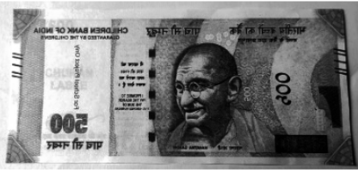

- Edge map:

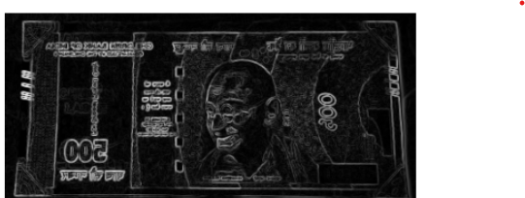

- Local binary system:

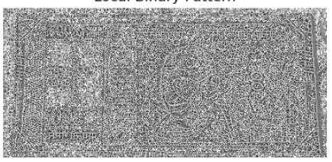

Final output:

Prediction: Fake (64.00% confidence)

- Conclusion
This project successfully demonstrated that combining Digital Image Processing and Machine Learning techniques can provide a reliable and practical solution for fake currency detection. The Random Forest model, trained on carefully extracted texture and intensity-based features, achieved a promising accuracy of 77%, indicating that handcrafted features such as Local Binary Patterns (LBP) and histogram descriptors can effectively capture the unique characteristics of genuine currency notes.
The results highlight the potential of feature-based machine learning approaches in financial security applications, while also emphasizing the importance of high-quality datasets and robust feature extraction methods.
Future work can include:
• Leveraging deep learning architectures, such as Convolutional Neural Networks (CNNs), to potentially achieve higher accuracy and better generalization.
• Incorporating advanced techniques such as UV watermark detection, color spectrum analysis, and micro-pattern recognition for more comprehensive verification.
• Deploying the model on mobile or embedded devices to enable real-time, on-the-spot currency authentication, enhancing usability and accessibility.
Overall, this study provides a solid foundation for developing more sophisticated, automated, and scalable solutions for counterfeit currency detection, contributing to financial security and fraud prevention.

References

[1] T. Ojala, M. Pietikäinen, and D. Harwood, “A comparative study of texture measures with classification based on feature distributions,” Pattern Recognition, vol. 29, no. 1, pp. 51–59, 1996.

[2] R. C. Gonzalez and R. E. Woods, Digital Image Processing, 4th ed., Pearson, 2018.

[3] S. Mallat, “A theory for multiresolution signal decomposition: the wavelet representation,” IEEE Transactions on Pattern Analysis and Machine Intelligence, vol. 11, no. 7, pp. 674–693, 1989.

[4] scikit-image: Image processing in Python – https://scikit-image.org/

[5] Scikit-learn documentation: https://scikit-learn.org/stable/

