SNKERS WEBSITE
Please record either written or video of the changes you are making so I can learn

SNKER HEADER
Remove the click - white background flash

SNKERS HEADER is doubling up please remove


DRAW
Draw color change pink outline btn to red


SEARCH
Search btn to be activated
Color change pink btn outline to red


PROFILE
Profile color change pink btn outline to red


DASHBOARD INSIDE PROFILE
Dashboard purple all Headers & graph to red
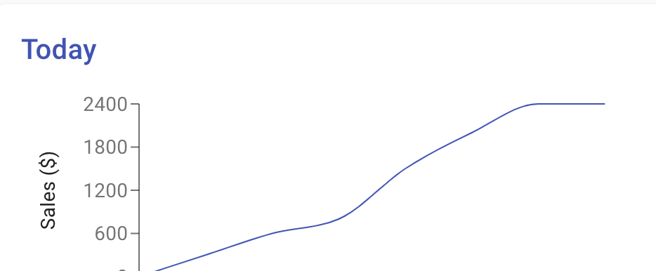

DASHBOARD HOME text create a hyperlink back to Home Page


DASHBOARD
Color change pink btn outline of Home to red
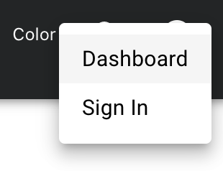

SIGN IN
Sign In from pink to red


CHANGE EMAIL + PASSWORD
color change purple text + box outline to red

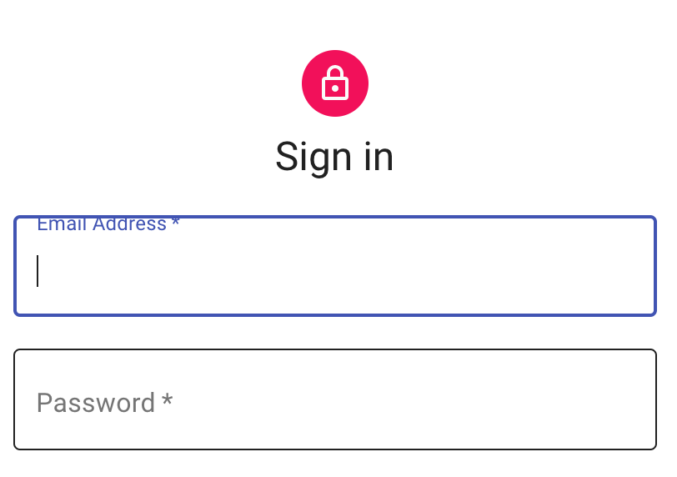

CARDS
Change red S log to SN logo


BODY
Home page ‘Body Headers’ to be hyperlink back to ‘4 main pages

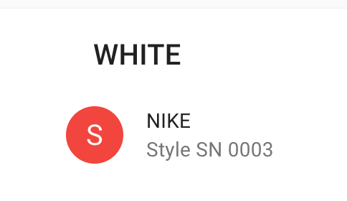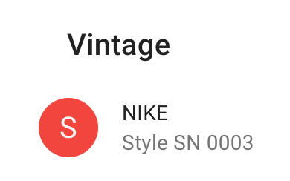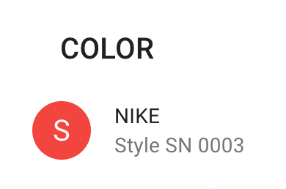



ADD A REACT RESPONSIVE CAROUSEL – npm
https://react-responsive-carousel.js.org/

use images like these for slider

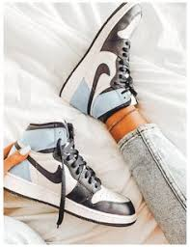

FOOTER
Add Social Media Icon above footer centred same as ZARA


https://www.zara.com/th/en/woman-accessories-l1003.html?v1=1699982

Footer hyperlinks blue color change to red
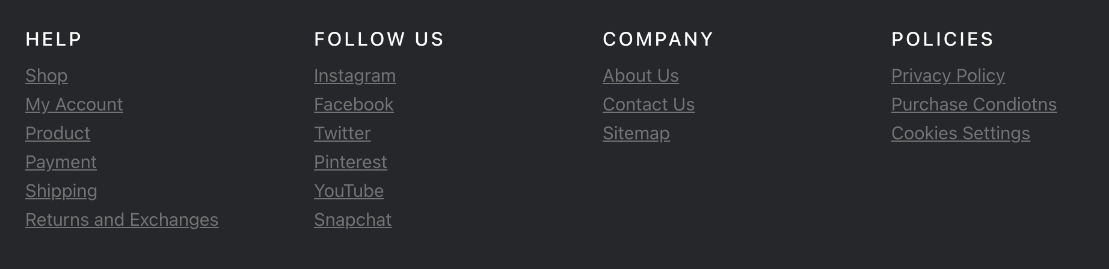
This will be the stage 2 once I have finished the home page images and card details

^ the down arrow when pressed actives both card please just one card at a time


HEART
When press turn should turn red


