Problem 1 1
Problem 2 7
Problem 3 9
Problem 4 11
Problem 5 12
Problem 6 13
% -----------------------------------------
% HW1
% LiXin
% 2022/2/18
% -----------------------------------------
clear all; close all; clc

Problem 1
% 1
r=0.15; % interest rate
L=50000; % loan amount
N=[0.5:1/12:20]; % number of years
PN=(r*L*(1+r/12).^(12*N))./(12*((1+r/12).^(12*N)-1)) % monthly payment
% 2
plot(N, PN) % plot the monthly payment and the number of years
% 3
text(10,1000,"LiXin")
PN =
1.0e+03 *
Columns 1 through 7
8.7017 7.5044 6.6067 5.9085 5.3502 4.8934 4.5129
Columns 8 through 14
4.1910 3.9153 3.6763 3.4673 3.2830 3.1192 2.9728
Columns 15 through 21
2.8410 2.7219 2.6136 2.5148 2.4243 2.3411 2.2644
Columns 22 through 28
2.1933 2.1274 2.0661 2.0089 1.9555 1.9054 1.8584
Columns 29 through 35
1.8142 1.7726 1.7333 1.6961 1.6610 1.6277 1.5961
Columns 36 through 42
1.5660 1.5375 1.5102 1.4843 1.4595 1.4358 1.4132
Columns 43 through 49
1.3915 1.3708 1.3509 1.3318 1.3134 1.2958 1.2789
Columns 50 through 56
1.2626 1.2469 1.2317 1.2172 1.2031 1.1895 1.1764
Columns 57 through 63
1.1637 1.1515 1.1396 1.1281 1.1170 1.1063 1.0959
Columns 64 through 70
1.0858 1.0760 1.0665 1.0573 1.0483 1.0396 1.0312
Columns 71 through 77
1.0230 1.0150 1.0072 0.9997 0.9923 0.9852 0.9782
Columns 78 through 84
0.9714 0.9648 0.9584 0.9521 0.9460 0.9401 0.9342
Columns 85 through 91
0.9286 0.9230 0.9176 0.9124 0.9072 0.9022 0.8973
Columns 92 through 98
0.8925 0.8878 0.8832 0.8787 0.8743 0.8700 0.8659
Columns 99 through 105
0.8618 0.8577 0.8538 0.8500 0.8462 0.8425 0.8389
Columns 106 through 112
0.8354 0.8319 0.8286 0.8252 0.8220 0.8188 0.8157
Columns 113 through 119
0.8126 0.8096 0.8067 0.8038 0.8010 0.7982 0.7955
Columns 120 through 126
0.7928 0.7902 0.7876 0.7851 0.7826 0.7802 0.7778
Columns 127 through 133
0.7755 0.7732 0.7709 0.7687 0.7665 0.7644 0.7623
Columns 134 through 140
0.7602 0.7582 0.7562 0.7542 0.7523 0.7504 0.7486
Columns 141 through 147
0.7468 0.7450 0.7432 0.7415 0.7398 0.7381 0.7365
Columns 148 through 154
0.7348 0.7332 0.7317 0.7301 0.7286 0.7271 0.7257
Columns 155 through 161
0.7242 0.7228 0.7214 0.7201 0.7187 0.7174 0.7161
Columns 162 through 168
0.7148 0.7135 0.7123 0.7110 0.7098 0.7087 0.7075
Columns 169 through 175
0.7063 0.7052 0.7041 0.7030 0.7019 0.7008 0.6998
Columns 176 through 182
0.6988 0.6977 0.6967 0.6958 0.6948 0.6938 0.6929
Columns 183 through 189
0.6920 0.6910 0.6901 0.6893 0.6884 0.6875 0.6867
Columns 190 through 196
0.6858 0.6850 0.6842 0.6834 0.6826 0.6818 0.6811
Columns 197 through 203
0.6803 0.6796 0.6789 0.6781 0.6774 0.6767 0.6760
Columns 204 through 210
0.6753 0.6747 0.6740 0.6734 0.6727 0.6721 0.6715
Columns 211 through 217
0.6708 0.6702 0.6696 0.6691 0.6685 0.6679 0.6673
Columns 218 through 224
0.6668 0.6662 0.6657 0.6651 0.6646 0.6641 0.6636
Columns 225 through 231
0.6631 0.6626 0.6621 0.6616 0.6611 0.6607 0.6602
Columns 232 through 235
0.6597 0.6593 0.6588 0.6584
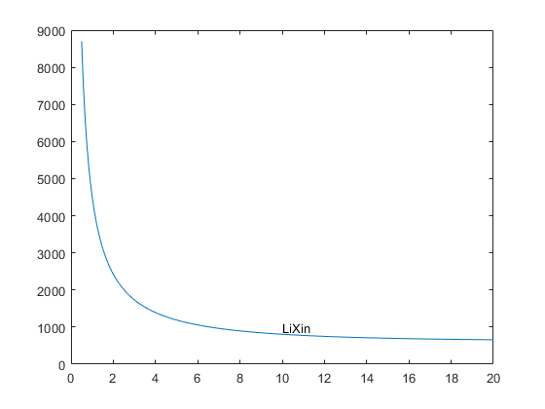

Problem 2
clear all; close all; clc % erase all the workspace data, command window output, and close all figures
% a
A=[20 4 2 6; 6 37 2 3;8 5 9 9] % create the matrix
% b
x1=A(1,:) % assign the first row of A to a vector called x1
% c
y=A([end-1 end],:) % assign the last 2 rows of A to an array called y
% d
B=A(:,2:2:size(A,2)) % assign the even-numbered columns of A to an array called B
% e
C=A' % assign the transpose of A to C
% f
reciprocal = 1./A % compute the reciprocal of each element of A
% g
A(3, 2)=100 % change the number in column 2, row 3 of A to 100
A =
20 4 2 6
6 37 2 3
8 5 9 9
x1 =
20 4 2 6
y =
6 37 2 3
8 5 9 9
B =
4 6
37 3
5 9
C =
20 6 8
4 37 5
2 2 9
6 3 9
reciprocal =
0.0500 0.2500 0.5000 0.1667
0.1667 0.0270 0.5000 0.3333
0.1250 0.2000 0.1111 0.1111
A =
20 4 2 6
6 37 2 3
8 100 9 9

Problem 3
clear all; close all; clc % erase all the workspace data, command window output, and close all figures
% a
figure % create an empty figure
% b
t=0:0.01:2*pi; % create a vector contains numbers range from 0 to 2*pi
y=sin(4*t).*cos(2*t); % calculate the result of the function according to the scope
ax1=subplot(1,2,1);
plot(t,y) % normal plot
ax2=subplot(1,2,2);
polarplot(t,y) % polar plot
% c
legend(ax1,'y^k_{max}=sin(4t)cos(2t)') % put legend on the first subgraph
% d
grid(ax1, 'on') % grid on the first subgraph
% e
text(0,0,'Lixin') % text on the second subgraph
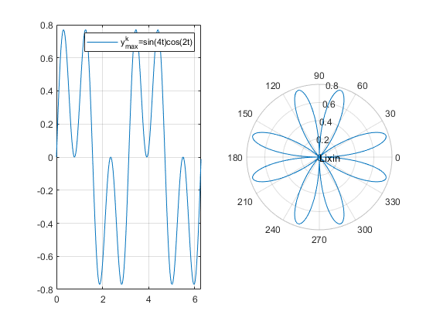

Problem 4
clear all; close all; clc % erase all the workspace data, command window output, and close all figures
% a
num=input('Enter a number: ');
% b
num_cm=num * 2.54; % convert to cm
fprintf('%.2f inches is %.2f cm\n', num, num_cm)
% c
num_mm=num_cm * 10; % the number converted to mm
formatSpec='%.2f';
str = [num2str(num, formatSpec), ' is also ', num2str(num_mm, formatSpec), 'mm'];
disp(str)
Error using input
Cannot call INPUT from EVALC.
Error in Homework_01 (line 64)
num=input('Enter a number: ');

Problem 5
clear all; close all; clc % erase all the workspace data, command window output, and close all figures
Nr = logspace(4,8,100); % Reynolds number
for De = [20 100 1000 1000 100000] % D/epsilon
f = 0.25./(log(1/(3.7*De)+5.74./Nr.^0.9)/log(10)).^2;
loglog(Nr, f)
hold on
end
grid on
grid minor
Nr=[1e2:0.2e4];
f = 64./Nr;
plot(Nr, f) % plot f = 64 / Nr
title('Moody''s Diagram')
ylabel('Friction Factor')
xlabel('Reynolds Number N_R')
legend('D/\epsilon = 20', 'D/\epsilon = 100', 'D/\epsilon = 1000', 'D/\epsilon = 10000', 'D/\epsilon = 100000','Laminar flow',...
'Location','southwest')
text(1e7,0.08,'Lixin') % print my name
xlim([0.8e3 1e8])
ylim([0.8e-2 1e-1])% adjust axis limits

Problem 6
clear all; close all; clc % erase all the workspace data, command window output, and close all figures
[x, y]=meshgrid(-2:0.1:2);
f=50*y.^2.*exp(-x.^2-0.5*y.^2);
C=x.*y;
surf(x,y,f,C)
xlabel('x');
ylabel('y');
zlabel('f(x,y) = 50y^2e^{-x^2-0.5y^2}');
title('My Plot Title')
Published with MATLAB® R2021a

