Input for Problem 1~5 1
Problem 6 2
Problem 7 2
Problem 8 3
Problem 1 5
Problem 2 6
Problem 3 6
Problem 4 7
Problem 5 7
% -----------------------------------------
% HW1
% LiXin
% 2022/2/28
% -----------------------------------------
close all; clear all; clc;

Input for Problem 1~5
% Problem 1
M = [1 2; 3 4];
even_index(M)
% Problem 2
v = [1 2 3 4];
flip_it(v)
% Problem 3
N = magic(5);
n = 2;
top_right(N, n);
% Problem 4
A = magic(5);
peri_sum(A)
% Problem 5
cal(pi/2)

Problem 6
h = 2;
v = sqrt(2 * 9.8 *h);
for i = 1:8 % rebound 8 times
v = 0.85 * v;
end
h = v*v/(2*9.8)
h =
0.1485

Problem 7
n=1;
T=300;
R=0.08206;
a=1.39;
b=0.039;
V=linspace(0.08,6,100);
P1=n*R*T./V;
P2=n*R*T./(V-n*b)-n*n*a./V.^2;
plot(V,P1)
hold on
plot(V,P2)
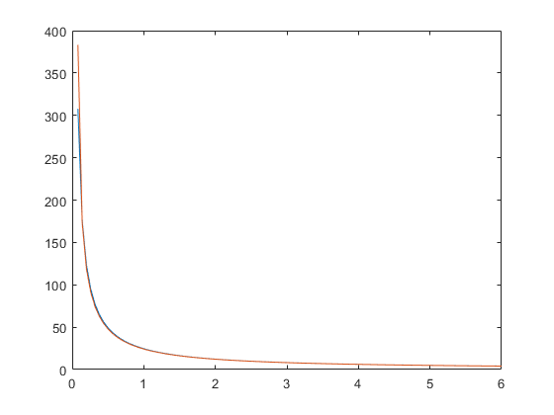

Problem 8
% a
x = 10 * rand(ceil(10*rand)+2,1)
% b
mysum=0;
for i = 1:size(x,1)
mysum = mysum + x(i,1);
end
mysum
% c
if mysum == sum(x)
disp('Congratulations!! you did it right')
load handel;
sound(y, Fs)
else
fprintf('Sorry, %.2f ~= %.2f. Please try again.\n', mysum, sum(x))
end
% d
x = 10 * rand(ceil(10*rand)+2,1);
mysum=0;
i = 1;
while i <= size(x,1)
mysum = mysum + x(i,1);
i = i + 1;
end
mysum
if mysum == sum(x)
disp('Congratulations!! you did it right')
load handel;
sound(y, Fs)
else
fprintf('Sorry, %.2f ~= %.2f. Please try again.\n', mysum, sum(x))
end
x =
9.0579
1.2699
9.1338
6.3236
0.9754
2.7850
5.4688
9.5751
9.6489
1.5761
9.7059
mysum =
65.5204
Congratulations!! you did it right
mysum =
76.7005
Congratulations!! you did it right

Problem 1
returns a matrix that contains only those elements of M that are in even rows and columns
function res = even_index(M) % M as a matrix
res = M(2:2:end, 2:2:end);
end
ans =
4

Problem 2
returns the opposite order of v
function w = flip_it(v) % row vector v, row vector w
for i = size(v,2) : -1 : 1
w(1,size(v,2) - i + 1) = v(1,i);
end
end
ans =
4 3 2 1

Problem 3
returns the n-by-n square subarray of N located at the top right corner of N
function M = top_right(N, n) % a matrix N, a scalar non-negative integer n
M = N(1:n, end-n+1:end)
end
M =
8 15
14 16

Problem 4
add together the elements that are in the first and last rows and columns
function my_sum = peri_sum(A)
my_sum = 0;
my_sum = my_sum + sum(A(:,1)) + sum(A(:,end)) + sum(A(1,:)) + sum(A(end,:));
my_sum = my_sum - A(1,1) - A(1,end) - A(end, end) - A(end,1);
end
ans =
208

Problem 5
power series for sin(x), 5 terms are needed, when i exceeds 20, the loop terminates
function sin_x = cal(x)
sin_x = 0;
for i = [1:2:20]
sin_x = sin_x + (-1)^floor(i/2)*x^i/factorial(i);
sin(x)-sin_x
end
end
ans =
-0.5708
ans =
0.0752
ans =
-0.0045
ans =
1.5690e-04
ans =
-3.5426e-06
ans =
5.6259e-08
ans =
-6.6278e-10
ans =
6.0232e-12
ans =
-4.3743e-14
ans =
0
ans =
1
Published with MATLAB® R2021a

