Modelling Ammonia Volatilization and Indirect Nitrous Oxide across the Cropping Systems of the Trajectoire Platform
A reproducible EMEP Tier 2 and ALFAM2 workflow, with an estimate of indirect N₂O and a sensitivity analysis
Daniela Zúñiga-Jiménez
AgroParisTech — UMR ECOSYS (INRAE / AgroParisTech, Université Paris-Saclay)
Research internship report
2026

Abstract
Ammonia (NH₃) volatilization after nitrogen fertilization is the dominant source of NH₃ in French agriculture and represents both a loss of fertilizer value and an air-quality and climate concern. This report documents, in a fully reproducible way, an inventory of NH₃ volatilization from the seven cropping systems of the Trajectoire experimental platform (2018–2025), estimated with two complementary models: the emission-factor–based EMEP/EEA Tier 2 method and the semi-empirical, process-informed ALFAM2 model. The volatilized nitrogen is then converted into indirect nitrous oxide (N₂O) following the IPCC 2019 methodology, and a sensitivity analysis quantifies the main sources of uncertainty. Over 152 fertilization events the corrected EMEP inventory totals 1,125.5 kg NH₃-N ha⁻¹; the associated indirect N₂O amounts to about 4,830 kg CO₂-eq ha⁻¹. The transition of two systems to methanized (digestate-based) fertilization raises the emission intensity per unit of applied nitrogen (+21 % and +49 %); the small fall in their absolute emissions reflects mainly the smaller amount of nitrogen applied in the second rotation rather than a genuine reduction in volatilization. A fair comparison between models (once the EMEP band-spreading abatement factor is applied) shows close agreement in totals but a different distribution across application methods. Band application of digestate is identified as the single most effective on-farm mitigation lever. The complete data and code are provided so that the workflow can be repeated for other rotations, sites, or fertilizer strategies.

1. Introduction

1.1 Ammonia volatilization in French agriculture
Ammonia is a reactive nitrogen gas that, once in the atmosphere, contributes to the formation of fine particulate matter and to the eutrophication and acidification of natural ecosystems. In France, agriculture is responsible for roughly 94–98 % of national NH₃ emissions, of which more than half originates from nitrogen (N) fertilization of soils, with the remainder coming from livestock housing, manure storage, and grazing (Ramanantenasoa et al., 2018; CITEPA figures reported in Viatte et al., 2020). Because the nitrogen that escapes as NH₃ is nitrogen that never reaches the crop, volatilization is simultaneously an environmental problem and an agronomic and economic inefficiency.
Volatilization is strongly variable. Reported losses from surface-applied cattle slurry alone range from a few per cent to close to 100 % of the applied ammoniacal nitrogen, depending on the product (dry matter, pH, ammoniacal fraction), the application technique, incorporation, the soil, and above all the weather in the hours following application (Sintermann et al., 2012; Hafner et al., 2019). This variability is the central difficulty of any inventory: a single fixed emission factor cannot capture it, yet the mechanistic detail needed to explain it is rarely available at the scale of a national or farm inventory.

1.2 Approaches to modelling NH₃ volatilization
Three broad families of methods are used to estimate NH₃ volatilization, and they map onto the “Tier” structure of international inventory guidance. Tier 1 applies a single default emission factor to the applied nitrogen. Tier 2, as codified in the EMEP/EEA Air Pollutant Emission Inventory Guidebook, applies product- and technique-specific emission factors expressed as a fraction of the total ammoniacal nitrogen (TAN), together with abatement factors for low-emission application techniques (EMEP/EEA, 2023). Tier 3 uses dynamic models that resolve the effect of weather and management on the emission trajectory.
Two Tier-3 traditions are relevant here. Process-based mechanistic models such as the French model Volt’Air describe the physical and chemical equilibria of the soil–slurry–atmosphere system on an hourly basis and have been used to build spatially explicit French inventories (Génermont & Cellier, 1997; Garcia et al., 2012; Ramanantenasoa et al., 2018). Semi-empirical models such as ALFAM2 instead fit a compact dynamic structure to a large database of field measurements (about 600 plots), capturing the effects of application method, slurry dry matter and pH, application rate, incorporation, and weather while remaining light enough to run on many events (Hafner et al., 2018, 2019). ALFAM2 was in fact used to derive the revised Tier-2 emission factors of the EMEP/EEA Guidebook, so the two approaches are related rather than fully independent.
Finally, part of the volatilized nitrogen redeposits on soils and waters and is subsequently converted to nitrous oxide, a potent greenhouse gas. The IPCC methodology accounts for this “indirect” N₂O with the emission factor EF4, linking the NH₃ inventory to a climate metric (IPCC, 2019).

1.3 The Trajectoire platform and study objectives
The Trajectoire experimental platform compares seven cropping systems over two crop rotations (2018–2025). The central question of this work is the effect of a transition to methanization: two systems switch from their original fertilization (coded CTR and MF) to the field application of liquid digestate from anaerobic digestion (coded COM and LOM). The objectives of this report are (i) to build a transparent NH₃ volatilization inventory with both EMEP Tier 2 and ALFAM2; (ii) to translate it into indirect N₂O; (iii) to test how sensitive the results are to the main modelling choices; and (iv) to document every step so the workflow can be reproduced and extended.

2. Justification and rationale
Each component of the workflow answers a specific and complementary question, which is why all of them are needed rather than any single model.
- Why EMEP Tier 2. It is the reference method for regulatory inventories under the LRTAP Convention and the EU National Emission Ceilings Directive. It is transparent, cheap to run on every event, and directly comparable with national figures. It provides the inventory baseline against which everything else is measured.
- Why ALFAM2. A fixed emission factor cannot tell a farmer whether to change application method or timing. ALFAM2 resolves exactly those levers — method, incorporation, weather — and therefore allows the impact of a mitigation practice to be quantified for the specific events observed on the platform.
- Why indirect N₂O. NH₃ loss is not only an air-quality and agronomic issue; the redeposited nitrogen becomes a greenhouse gas. Estimating indirect N₂O expresses the volatilization inventory in the same climate currency (CO₂-equivalents) used by investors and carbon accounting, and is essential when the fertilizer in question is a by-product of a climate technology (methanization).
- Why a sensitivity analysis. The models rest on uncertain factors (emission factors, EF4, the treatment of a specific product). Testing the response of the results to these choices shows which conclusions are robust and which parameters most deserve better measurement.
- Why the reproducibility audit. Inventories are only useful if their numbers can be traced back to the data. Documenting each step, checking internal consistency, and re-running the ALFAM2 model rather than reusing a stored result all guard against errors propagating silently into reported figures.

3. Materials and methods

3.1 Experimental platform and event database
The primary data are organized as a flat event table in which each row is one fertilization event (a product applied to a system on a date), described by 37 variables covering the product, its composition, the application technique, the soil, and the weather at application. The full database contains 152 events across the seven systems and two rotations (87 events in the first rotation, 65 in the second). All downstream products are derived from this table.

3.2 Variables required by each model
The two NH₃ models require overlapping but distinct inputs. EMEP Tier 2 needs relatively few descriptors, because most of the physics is folded into the emission factor; ALFAM2 needs an explicit description of the product, the technique, and the weather so that it can reconstruct the emission over time.
Table 1. Input variables required by each model.
Model | Variables required | Role
EMEP Tier 2 | Product category; total N; TAN (ammoniacal N); application method; incorporation and delay | Select the emission factor and any abatement; multiply by TAN
ALFAM2 | TAN applied; application rate; application method (bc, bsth…); manure dry matter; manure pH; manure source; air temperature; wind speed at 2 m; rain rate; cumulative rain; incorporation and its timing; time since application (hourly) | Drive the two-pool dynamic emission model over the hours after application
Indirect N₂O (IPCC 2019) | NH₃-N volatilized (from the models above); EF4; molar-mass ratio 44/28; GWP₁₀₀(N₂O) | Convert redeposited N into N₂O and then into CO₂-equivalents

3.3 Emission factors
EMEP Tier 2 emission factors are expressed as a fraction of TAN for organic products and, in this implementation, as a fraction of TAN for mineral products as well. The Entec product was reclassified from an ammonium-sulphate to an ammonium-sulphate-nitrate factor after review (see Section 4.2).
Table 2. Emission factors used (fraction of applied TAN).
Product / category | Factor | Type
Cattle slurry, liquid digestate | 0.55 | Organic (surface reference)
Solid manure | 0.68 | Organic
UAN solution | 0.133 | Mineral
Urea | 0.170 | Mineral
Thiosulphate | 0.154 | Mineral
Entec (corrected, ASN) | 0.090 | Mineral
Ammonium nitrate | 0.043 | Mineral

Note. The organic factor of 0.55 is the EMEP reference for surface (broadcast) application of cattle slurry. For band application (trailing hose) the Guidebook prescribes an abatement of roughly 30 %; this is applied in the fair model comparison of Section 5.

3.4 Indirect N₂O accounting
Indirect N₂O from volatilized nitrogen was computed as CO₂-eq = NH₃-N × EF4 × (44/28) × GWP₁₀₀, with EF4 = 0.010 kg N₂O-N per kg of NH₃-N (and NOx-N) volatilized (range 0.002–0.018; IPCC, 2019) and GWP₁₀₀(N₂O) = 273 (IPCC, 2021). Because NOx was not modelled, EF4 was applied to NH₃-N only, which makes the estimate a slight lower bound of the volatilization pathway.

3.5 Software and reproducibility
The pipeline is implemented in Python (data handling and EMEP Tier 2, with matplotlib for figures) and R (the official ALFAM2 package, parameter set 3). All scripts accept command-line arguments for input file and scope so they can be re-run for any rotation or for the full inventory. The ALFAM2 re-run used the ALFAM2 R package installed from source; the model reproduced the archived per-event results exactly before any counterfactual was computed.

4. Step-by-step methodology
The workflow below can be reproduced end-to-end. Script names refer to the accompanying code repository (Section 8).

Step 1 — Database cleaning and rotation split
The clean event database is read and split into the two rotations, preserving the system relabelling of the transition (CTR→COM, MF→LOM). This yields the full (152), first-rotation (87) and second-rotation (65) event sets. Two digestate applications made on the same day to two different systems are retained as two genuine events, not treated as duplicates.

Step 2 — EMEP Tier 2 inventory
For every event, the volatilized NH₃-N is the product of TAN and the emission factor of Table 2, adjusted for incorporation where relevant. Events are aggregated by system and by product category, and the emission intensity (per unit of applied N) is computed. Running the script on the three input databases reproduces totals of 1,125.5 (full), 667.2 (first) and 458.3 (second) kg NH₃-N ha⁻¹.

Step 3 — ALFAM2 simulation (R)
The liquid organic events (cattle slurry and liquid digestate) are written to an hourly input table with the ALFAM2 predictor columns of Table 1 and passed to the ALFAM2 R function with the central parameter set. The model returns the cumulative emission trajectory for each event, from which the final emission and the emission as a percentage of TAN are extracted.

Step 4 — Model comparison
EMEP and ALFAM2 estimates are joined event by event for the liquid organic events and compared by application method and product. Crucially, the EMEP band-spreading abatement (≈30 %) is applied to band-applied events so that the two models are compared on the same footing.

Step 5 — Indirect N₂O
The per-system NH₃-N totals are converted to indirect N₂O and to CO₂-equivalents using the factors of Section 3.4, with the EF4 range propagated as an uncertainty band.

Step 6 — Sensitivity analysis
Four axes are tested: (a) the structural reclassification of the Entec product (baseline vs corrected factor); (b) a one-at-a-time perturbation of each product’s emission factor (±30 %), ranked as a tornado; (c) the EF4 range for indirect N₂O; and (d) the choice of GWP (AR4/AR5/AR6). A fifth, model-specific axis re-runs ALFAM2 with a changed application method to price the band-application counterfactual.

Step 7 — Quality audit
All reported figures are checked against the exact data subset they describe; internal ratios are recomputed; and the ALFAM2 result is regenerated from the model rather than reused, so that any discrepancy between the report text and the data is caught before publication.

5. Results

5.1 Inventory and composition
Over the full inventory (152 events) the corrected EMEP total is 1,125.5 kg NH₃-N ha⁻¹. Emissions are dominated by UAN solution among mineral products and by liquid digestate and cattle slurry among organic products (Figure 1). Normalized by the nitrogen actually applied, the systems rank from MF (16.1 %) and CTR (14.7 %) down to the low-input GHG system (9.6 %) and the organic-farming OF system (1.0 %). This inventory total is the sum of the seven systems’ cumulative per-hectare emissions (about 161 kg NH₃-N ha⁻¹ per system on average over the rotations), not the loss of a single hectare. The very low value of the OF system should be read with caution: its solid organic products are recorded with an ammoniacal-N (TAN) content of zero, so the EMEP method returns no emission for them; if that TAN is missing rather than truly negligible, the OF emission is underestimated (Figure 2).
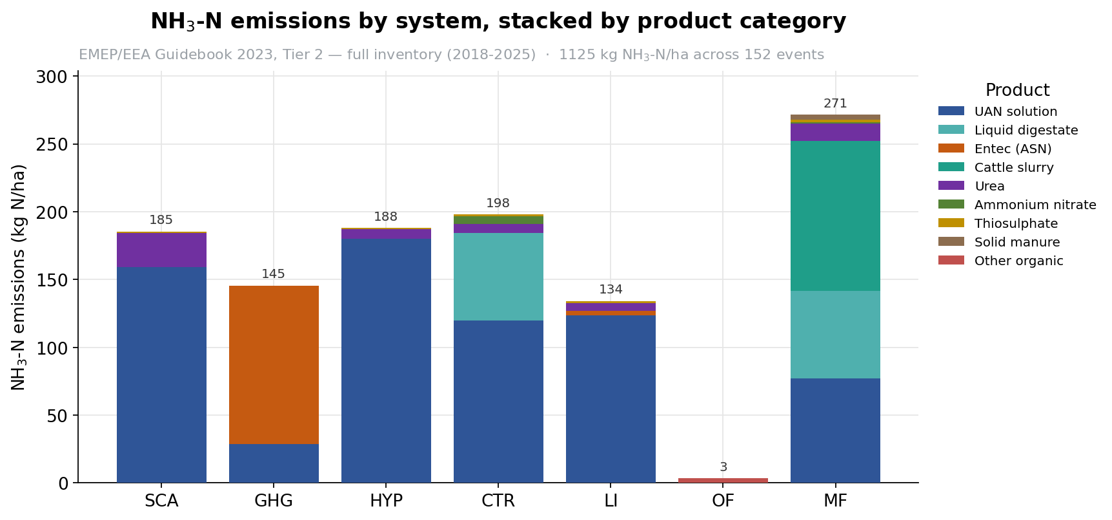
Figure 1. NH₃-N emissions by cropping system, stacked by product category (EMEP Tier 2, full inventory 2018–2025). UAN solution and liquid organics dominate the inventory.
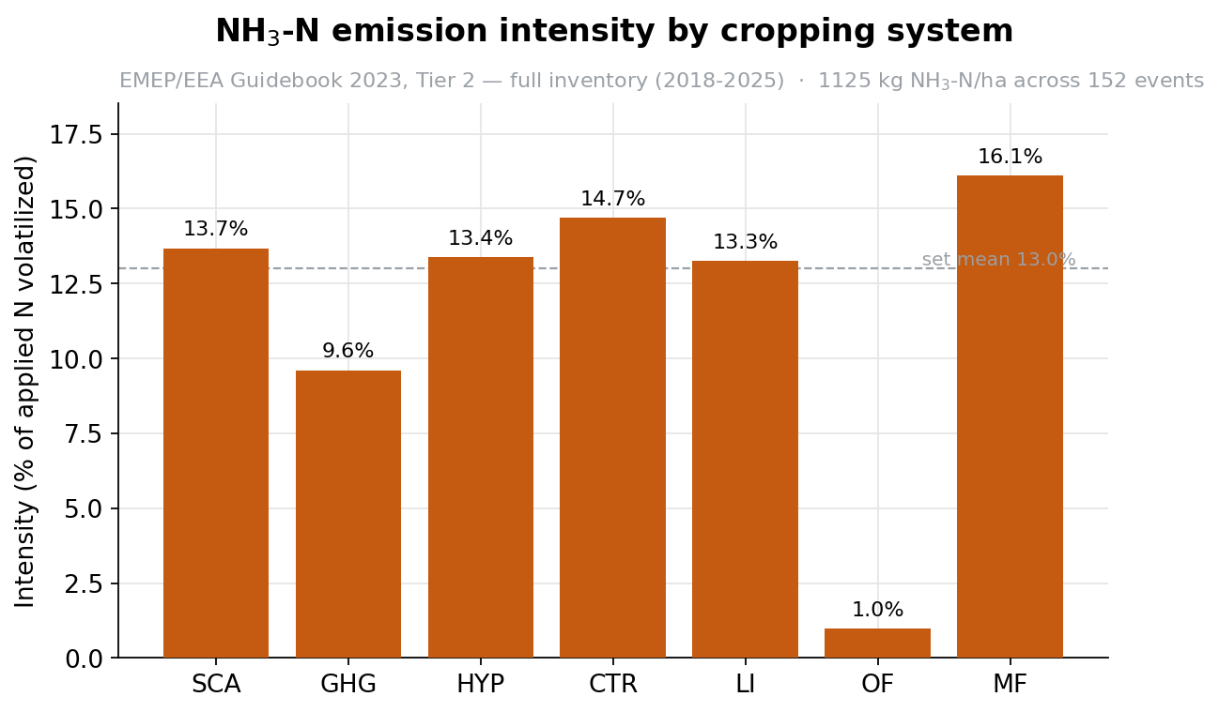
Figure 2. NH₃-N emission intensity (percentage of applied nitrogen volatilized) by cropping system. The dashed line is the nitrogen-weighted mean of the whole set.

5.2 The methanization transition and indirect N₂O
The volatilized nitrogen corresponds to about 4,830 kg CO₂-eq ha⁻¹ of indirect N₂O over the full inventory (range 966–8,691, from the EF4 range). The key result of the transition is shown in Figure 3: after switching to digestate, the absolute emission of the two systems falls slightly (CTR→COM −7 %, MF→LOM −6 %), but these systems also received much less nitrogen in the second rotation (−23 % and −37 % respectively), so the small absolute drop is largely an exposure effect and not a genuine reduction. The exposure-independent metric — the emission intensity, or climate cost per kilogram of nitrogen applied — instead rises markedly, by 21 % and 49 % (see also Section 5.5). In other words, digestate fertilization makes each unit of nitrogen more emission-intensive, even where the field-level total happens to be lower.
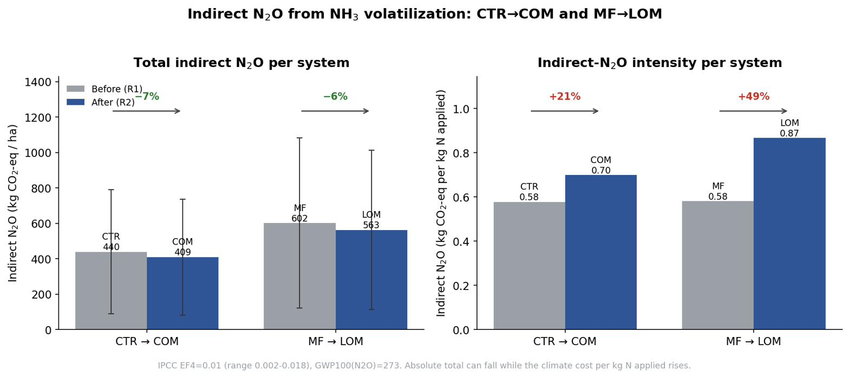
Figure 3. Indirect N₂O before (R1) and after (R2) the transition for the two changing lineages. Absolute emission falls slightly while intensity per kilogram of applied nitrogen rises (+21 %, +49 %). Error bars show the EF4 range.

5.3 Model comparison and the role of application method
When the EMEP factor is applied uniformly, ALFAM2 appears to emit less than EMEP for the liquid organic events (a summed ratio of 0.82). However, this is not a like-for-like comparison, because the band-applied events were not given the abatement that EMEP Tier 2 itself prescribes. Once the ≈30 % trailing-hose abatement is applied to EMEP for those events, the two models agree closely in total (ratio ≈ 1.0), while still differing in how the emission is distributed across methods: ALFAM2 puts more emission on the hot broadcast digestate event and less on the cool-season band slurry events (Figure 4). The mechanism is visible in the emission trajectories (Figure 5): broadcast application loses on the order of 80 % of TAN within hours, whereas band application loses much less and more slowly.
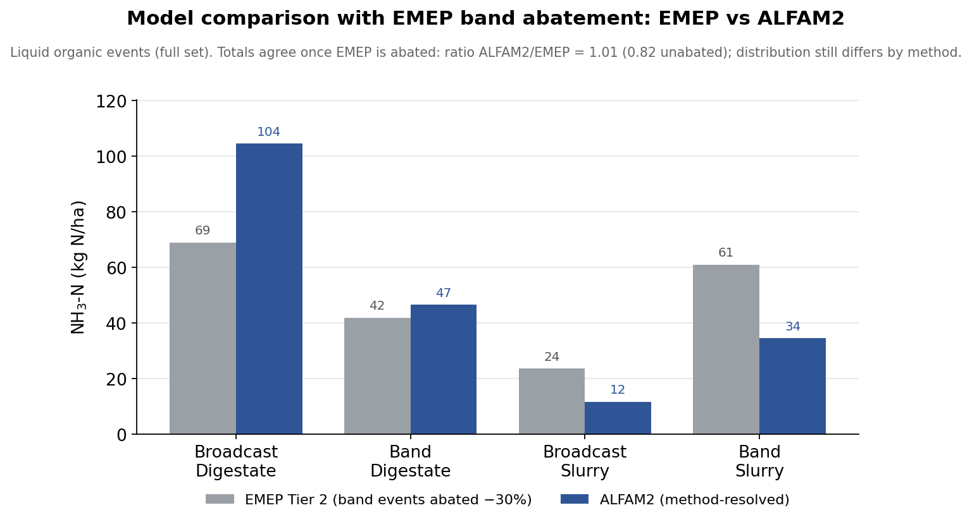
Figure 4. EMEP versus ALFAM2 for the liquid organic events, with the EMEP band-spreading abatement applied to band events. Totals agree (ratio ≈ 1.0, versus 0.82 unabated); the distribution across methods still differs.
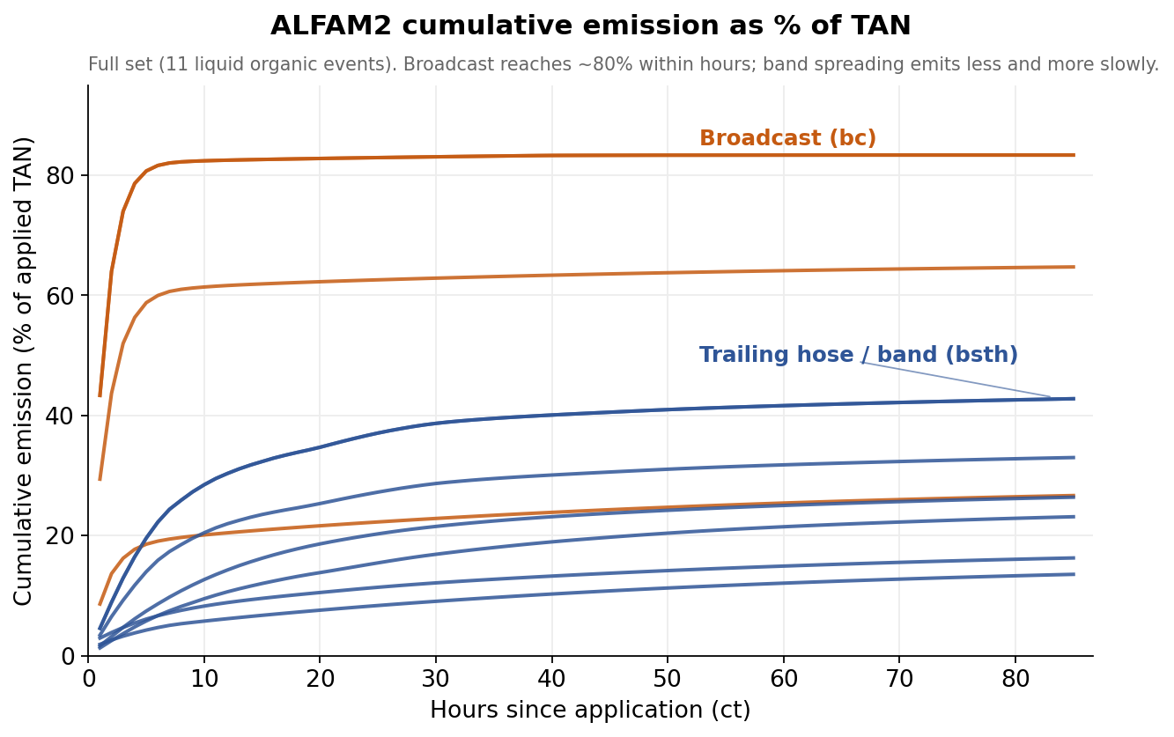
Figure 5. ALFAM2 cumulative emission (percentage of applied TAN) over time. Broadcast events reach high losses within hours; band (trailing-hose) events emit less and more gradually.

5.4 Mitigation and sensitivity
Re-running ALFAM2 with the two broadcast digestate events changed to band application, under their real weather, reduces the emission of those events from about 83 % to 59 % of TAN, avoiding roughly 30 kg NH₃-N ha⁻¹ or about 130 kg CO₂-eq ha⁻¹ (Figure 6). The benefit is real but smaller than a naive estimate would suggest, because band application still loses a large share of TAN under hot conditions. The sensitivity analysis (Figure 7) shows that the inventory total is dominated by the emission factor of the UAN solution: a ±30 % change in that single factor moves the total by about 207 kg NH₃-N ha⁻¹, far more than any other product. A structural choice matters too: reclassifying the Entec product (from an ammonium-sulphate to an ammonium-sulphate-nitrate emission factor) lowers the GHG system by about 83 kg NH₃-N ha⁻¹ across the full inventory, the largest single structural adjustment. For the indirect-N₂O estimate, the dominant uncertainty is the EF4 range, which spans almost a factor of nine.
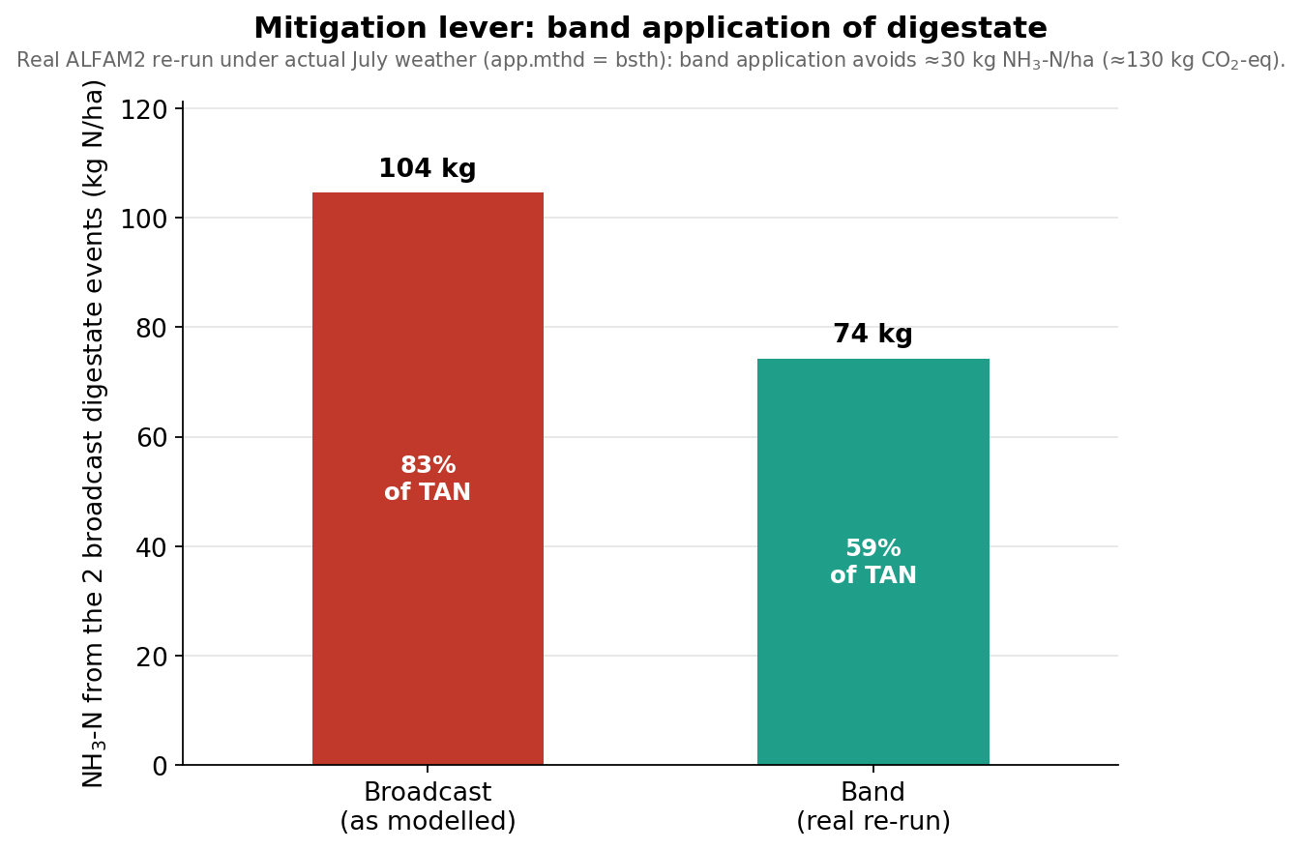
Figure 6. Real ALFAM2 re-run of the broadcast digestate events as band-applied under their actual weather. Band application avoids about 30 kg NH₃-N ha⁻¹ (≈ 130 kg CO₂-eq ha⁻¹).
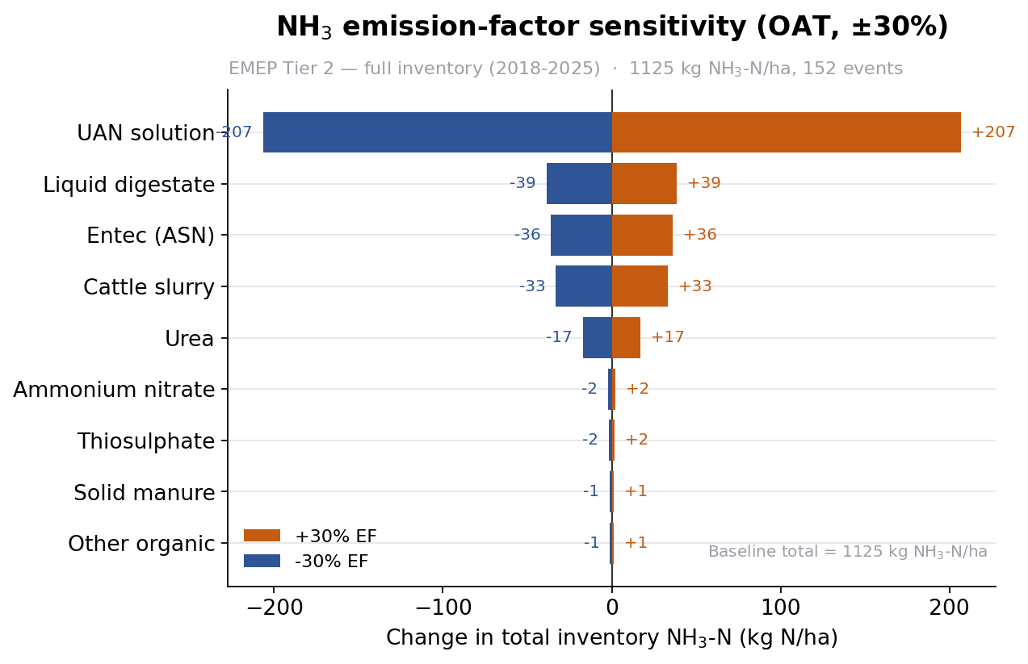
Figure 7. One-at-a-time sensitivity of the total inventory to each product’s emission factor (±30 %). The UAN-solution factor dominates the response.

5.5 Comparability across rotations: a caution on absolute totals
Because the two rotations do not cover the same length of record, their absolute totals are not directly comparable. The first rotation spans 4.2 years, 87 events and 5,533 kg N ha⁻¹ applied; the second spans only 2.8 years, 65 events and 3,130 kg N ha⁻¹ applied. The second-rotation total is therefore lower (458 versus 667 kg NH₃-N ha⁻¹, −31 %) largely because less fertilization was recorded, not because the emission behaviour improved. When exposure is removed, the picture reverses: the emission per year is essentially unchanged (159 versus 164 kg ha⁻¹ yr⁻¹, +3 %) and the intensity per unit of applied nitrogen is clearly higher in the second rotation (12.1 % versus 14.6 %, +21 %) (Figure 8). The absolute drop is thus a record-length artefact; the correct rotation comparison uses intensity or per-year emission, and both indicate that emissions did not fall.
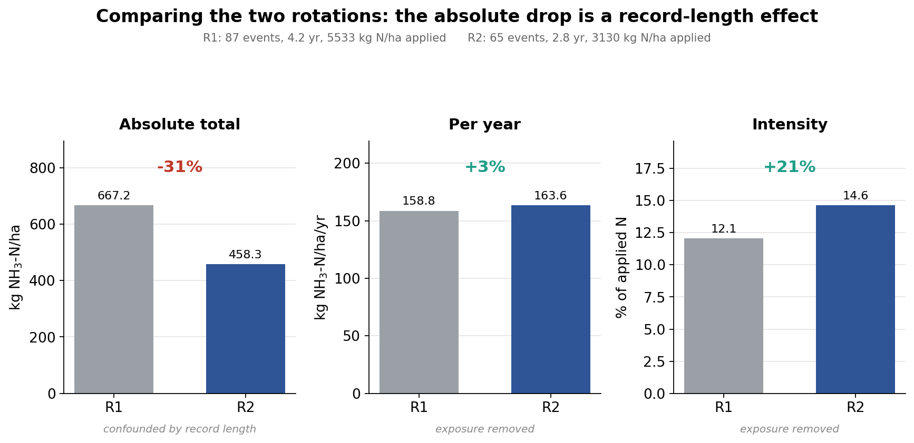
Figure 8. Comparison of the two rotations. The absolute total falls (−31 %) only because the second rotation covers a shorter record with less applied nitrogen; once normalized per year or per unit of applied nitrogen, emissions are equal or higher in the second rotation.

6. Discussion

6.1 What the transition means
The most policy-relevant finding is that the switch to methanized fertilization is not automatically favourable for ammonia. The small fall in the absolute emissions of the two systems is not, in itself, evidence of mitigation: those systems also applied markedly less nitrogen in the second rotation (−23 % and −37 %), and the whole second rotation covers a shorter record (Section 5.5). Once exposure is removed, the emission intensity per unit of applied nitrogen rose substantially (+21 % and +49 %), and per-year emissions did not fall. This happens because liquid digestate is rich in readily volatilizable ammoniacal nitrogen and, when surface-applied in warm weather, loses a large fraction of it quickly. The climate benefit of methanization (elsewhere in the system) can therefore be partly offset at the field stage unless application is managed carefully.

6.2 Model congruence
A methodological result of practical value is that EMEP Tier 2 and ALFAM2 agree well once EMEP is used correctly — that is, with its band-spreading abatement. The apparent 18 % discrepancy in the raw comparison was largely an artefact of comparing an abated (ALFAM2) against an unabated (EMEP) treatment of the same events. The residual difference is concentrated in cool-season band slurry, where ALFAM2 predicts lower emissions than the fixed factor. Because the EMEP Tier-2 factors were themselves derived with ALFAM, the two should be read as consistent rather than as an independent cross-validation.

6.3 The emission hotspot
Across the whole dataset, the clearest hotspot is warm-season broadcast application of liquid digestate. This is where the models agree that losses are largest, where the mitigation lever is strongest, and where management can change the outcome most. It is also where the calibration domain of ALFAM2 is most stretched, so the exact percentages should be read as high-end estimates rather than precise values.

6.4 Recommendations for farmers
- Apply liquid digestate and slurry with a trailing hose or, better, a trailing shoe or shallow injection rather than by broadcast. Band spreading reduced losses by roughly a quarter to a third in this study, and injection can reduce them far more (Smith et al., 2000; Webb et al., 2010).
- Avoid application in the warmest, driest, windiest hours. Weather in the hours after application is a first-order driver; cool, calm, or lightly rainy conditions markedly reduce loss.
- Incorporate quickly where possible. Rapid incorporation on arable land is among the most effective abatement options.
- Treat digestate as a high-risk, high-value product. Its high ammoniacal fraction makes it an excellent fertilizer if the nitrogen stays in the soil, and a large emitter if it does not.

6.5 Relevance for investors and organic-fertilizer companies
For companies producing or marketing organic and digestate-based fertilizers, the results carry three practical messages. First, the field-stage NH₃ loss can erode both the agronomic value and the climate credentials of a digestate product; product stewardship that promotes low-emission application (and, where appropriate, acidification) protects the nitrogen the customer paid for. Second, because a large share of the applied ammoniacal nitrogen can be lost within hours of a warm broadcast application, the difference between a well-managed and a poorly managed application is commercially material — it is effectively free nitrogen retained in the crop. Third, when a product’s value proposition includes a climate benefit, the indirect-N₂O term computed here should be part of the accounting: it is modest relative to the whole life cycle but is the part most directly under the farmer’s control and therefore the easiest to improve through guidance and equipment.

6.6 Limitations
The indirect-N₂O estimate covers only the volatilization pathway (EF4) and applies EF4 to NH₃-N alone, so it is a conservative lower bound; direct N₂O (EF1) and the leaching pathway (EF5) are outside its scope. The EF4 range is very wide and dominates the climate uncertainty. ALFAM2 predictions for the warmest events extrapolate near the edge of the model’s calibration domain and should be treated as high-end estimates. Finally, the study is a single platform, and the two apparent digestate “duplicates” are genuine same-day applications to two systems; pooled statistics that weight both should acknowledge this structure. The two rotations also differ in length and in applied nitrogen, so only rate-based metrics (intensity or per-year), not absolute totals, should be compared between them (Section 5.5). Finally, the emission intensity is expressed per unit of total applied nitrogen, whereas volatilization is driven by the ammoniacal fraction (TAN); part of the intensity increase on switching to digestate therefore reflects the high TAN content and high organic emission factor of digestate rather than management alone, although the independent ALFAM2 results corroborate that field-applied digestate volatilizes strongly.

7. Conclusion
This report set out to build a transparent, reproducible inventory of ammonia volatilization on the Trajectoire platform, to translate it into indirect nitrous oxide, and to test its robustness. Its most instructive outcome is not a single number but a correction of reading. At first sight the results seem to contradict themselves: after the transition to digestate, absolute field emissions fall (−31 % over the second rotation) while the emission intensity rises (+21 % to +49 %). This apparent paradox is a statistical mirage. Absolute emissions and intensity answer two different questions, and comparing them without controlling for the scale of production manufactures a contradiction that does not exist. The second rotation did not emit less because it was cleaner; it emitted less because it fertilized less — fewer events, 43 % less applied nitrogen, over a shorter record. The moment the figures are normalized to the productive unit — emission per kilogram of nitrogen applied, or per year — the tension dissolves entirely: on a like-for-like basis the second rotation is not lower but equal or higher. There is no paradox, only a difference of scale that must be divided out before the two rotations can be compared at all.
This is also why the study deliberately retains two models rather than one, and treats that duality as a strength by design rather than a compromise. EMEP Tier 2 (absolute emissions) and ALFAM2 (method- and weather-resolved intensity) serve two legitimate and non-interchangeable logics of evaluation. Absolute-emission modelling is the language of regulatory compliance: emission ceilings, national inventories and environmental accounting are written in total mass, and a system is judged by the burden it places on the airshed. Intensity modelling is the language of productive efficiency: it measures how much nitrogen is lost per unit of fertilizer — and ultimately per unit of agricultural output — and it is the only metric that stays meaningful when the scale of production changes. Keeping only the absolute view would hide efficiency and, as shown above, actively mislead whenever scales differ; keeping only the intensity view would ignore the total load that regulation actually caps. Held together, the two models triangulate: each corrects the blind spot of the other, and the analysis is richer precisely because it refuses to choose between them.
Read through both lenses, the platform’s ammonia story converges on a single, actionable conclusion: warm-season broadcast application of liquid digestate is where value leaks, and band application is where it is recovered. The real ALFAM2 re-run showed that switching those applications to a trailing hose keeps roughly 30 kg of nitrogen per hectare in the soil rather than the air — about 130 kg CO₂-equivalent of avoided indirect N₂O. For the farmer, and for the investors who finance organic and digestate-based fertilizers, this is more than a technical result; it is an investment argument. Every kilogram of ammoniacal nitrogen retained is a kilogram of fertilizer that need not be repurchased: at nitrogen values of the order of one euro per kilogram, retained nitrogen converts directly into profitability per hectare, and the effect compounds across every application and every hectare of a rotation. Higher nutrient-use efficiency lowers the operating cost of each unit of yield; low-emission application simultaneously hedges a tightening regulatory horizon, as broadcast spreading of slurry and digestate is progressively restricted across Europe. And because nitrogen kept in the soil is nitrogen that never becomes indirect N₂O, band application protects the very climate credential that gives methanized fertilizer its market value. Agronomic efficiency and financial return therefore do not compete here — they reinforce one another: band application is the lever that aligns economic return with the decarbonization trajectory, making the efficient practice, the compliant practice and the profitable practice one and the same.
The conclusion of this work is thus one of alignment rather than trade-off. Once emissions are measured at the right scale, the apparent conflict between absolute and intensity metrics disappears; once both modelling logics are retained, the analysis speaks to regulator and operator alike; and once the mitigation lever is priced, environmental and economic performance point in the same direction. The methods, data and code are shared in full so that this reasoning can be reproduced, audited and extended to other sites and fertilizer strategies. The central message, however, stands on its own: on the Trajectoire platform, keeping nitrogen in the soil is at once the cleaner, the cheaper and the more defensible choice.

8. Data and code availability
The complete event database, the processing and modelling scripts (Python and R), and the figure-generation code required to reproduce every result in this report are openly available in the project repository:
GitHub repository: [ INSERT REPOSITORY LINK HERE — e.g. https://github.com/<user>/trajectoire-nh3 ]
The repository includes: the cleaning and rotation-split script; the EMEP Tier 2 script; the ALFAM2 input builder and R run script; the model-comparison, indirect-N₂O and sensitivity scripts; the figure scripts; and this report, together with a README documenting command-line usage and the emission factors and constants used.

9. References
Garcia, L., Génermont, S., Bedos, C., Simon, N. N., Garnier, P., Loubet, B., & Cellier, P. (2012). Accounting for surface cattle slurry in ammonia volatilization models: The case of Volt’Air. Soil Science Society of America Journal, 76(6), 2184–2194. https://doi.org/10.2136/sssaj2012.0067
Génermont, S., & Cellier, P. (1997). A mechanistic model for estimating ammonia volatilization from slurry applied to bare soil. Agricultural and Forest Meteorology, 88(1–4), 145–167. https://doi.org/10.1016/S0168-1923(97)00044-0
Hafner, S. D., Pacholski, A., Bittman, S., Burchill, W., Bussink, W., Chantigny, M., … Sommer, S. G. (2018). The ALFAM2 database on ammonia emission from field-applied manure: Description and model evaluation. Agricultural and Forest Meteorology, 258, 66–79. https://doi.org/10.1016/j.agrformet.2017.11.027
Hafner, S. D., Pacholski, A., Bittman, S., Carozzi, M., Chantigny, M., Génermont, S., … Sommer, S. G. (2019). A flexible semi-empirical model for estimating ammonia volatilization from field-applied slurry. Atmospheric Environment, 199, 474–484. https://doi.org/10.1016/j.atmosenv.2018.11.034
Hafner, S. D., Pedersen, J., Fuß, R., Kamp, J. N., Dalby, F. R., Amon, B., … Sommer, S. G. (2025). Improved tools for estimation of ammonia emission from field-applied animal slurry: Refinement of the ALFAM2 model and database. Atmospheric Environment, 340, 120910. https://doi.org/10.1016/j.atmosenv.2024.120910
IPCC. (2019). 2019 Refinement to the 2006 IPCC Guidelines for National Greenhouse Gas Inventories — Volume 4: Agriculture, Forestry and Other Land Use. Intergovernmental Panel on Climate Change. https://www.ipcc-nggip.iges.or.jp/public/2019rf/vol4.html
IPCC. (2021). Climate Change 2021: The Physical Science Basis. Contribution of Working Group I to the Sixth Assessment Report of the Intergovernmental Panel on Climate Change (Chapter 7). Cambridge University Press. https://www.ipcc.ch/report/ar6/wg1/
EMEP/EEA. (2023). EMEP/EEA air pollutant emission inventory guidebook 2023 — 3.D Crop production and agricultural soils; 3.B Manure management. European Environment Agency. https://www.eea.europa.eu/publications/emep-eea-guidebook-2023
Ramanantenasoa, M. M. J., Gilliot, J.-M., Mignolet, C., Bedos, C., Mathias, E., Eglin, T., Makowski, D., & Génermont, S. (2018). A new framework to estimate spatio-temporal ammonia emissions due to nitrogen fertilization in France. Science of the Total Environment, 645, 205–219. https://doi.org/10.1016/j.scitotenv.2018.06.202
Sintermann, J., Neftel, A., Ammann, C., Häni, C., Hensen, A., Loubet, B., & Flechard, C. R. (2012). Are ammonia emissions from field-applied slurry substantially over-estimated in European emission inventories? Biogeosciences, 9(5), 1611–1632. https://doi.org/10.5194/bg-9-1611-2012
Smith, K. A., Jackson, D. R., Misselbrook, T. H., Pain, B. F., & Johnson, R. A. (2000). Reduction of ammonia emission by slurry application techniques. Journal of Agricultural Engineering Research, 77(3), 277–287. https://doi.org/10.1006/jaer.2000.0604
Viatte, C., Petit, J.-E., Yamanouchi, S., Van Damme, M., Doucerain, C., Emmanuel, E., … Clerbaux, C. (2020). Ammonia and PM2.5 air pollution in Paris during the 2020 COVID lockdown. Atmosphere / CITEPA national inventory figures. https://www.citepa.org/
Webb, J., Pain, B., Bittman, S., & Morgan, J. (2010). The impacts of manure application methods on emissions of ammonia, nitrous oxide and on crop response — A review. Agriculture, Ecosystems & Environment, 137(1–2), 39–46. https://doi.org/10.1016/j.agee.2010.01.001

