Modelling ammonia volatilization across the cropping systems of the Trajectoire experimental platform.
A dual-model NH₃-N inventory (EMEP Tier 2 + ALFAM2) with an indirect-N₂O climate cost
Daniela Jacqueline Zúñiga-Jiménez
Summer Program 2026 — Final Defense
UMR ECOSYS — INRAE / AgroParisTech, Grignon
July 2026

Abstract
This work builds a complete NH₃-N inventory for the seven cropping systems of the Trajectoire experimental platform between 2018 and 2025, and asks a simple question: how do those emissions change once two of the systems shift to anaerobic digestion? Two models were used side by side. The EMEP/EEA Tier 2 approach delivered the whole-platform inventory across 152 fertilization events; ALFAM2 (Set 3) resolved the eleven liquid-organic events at hourly resolution, capturing weather and product effects that a fixed emission factor cannot see.
The corrected inventory totals 1,125.5 kg NH₃-N ha⁻¹. Read as a single absolute number, emissions fall 31% between rotations — but rotation 1 covers 4.2 years and rotation 2 only 2.8, so the drop is largely a record-length effect. Once exposure is controlled for, the direction reverses: emissions rise 3% per year, and their intensity per kg N applied climbs from 12.1% to 14.6%, a +21% increase. Broken down by transitioning lineage, intensity rises 21% for CTR→COM and 49% for MF→LOM.
ALFAM2 explains the mechanism. Under the trailing-shoe technique used throughout the platform, cattle slurry loses 29.1% of its TAN on average, while liquid digestate loses 63.1% — roughly twice as much for the same placement, driven by digestate's higher pH and TAN. Warm-season events push this further: summer digestate reaches 83% of TAN, near the upper edge of the model's calibration domain. Translated into indirect N₂O via IPCC 2019 (EF₄ × 44/28 × GWP₁₀₀), the platform total is about 4,830 kg CO₂-eq ha⁻¹, and the same +21%/+49% intensity signal appears in climate units.
Because the difference is embedded in digestate itself, technique alone will not close it. The results point to acidification, cool-season timing, and direct measurement of the high-risk summer events as the three fronts where mitigation should focus.

1. Introduction
Ammonia lost to the atmosphere after field application is both an agronomic loss and an environmental burden. Deposited, it acidifies soils and eutrophies semi-natural ecosystems; in the air, it forms ammonium salts that contribute to fine particulate matter (PM₂.₅) and damage human health (Sommer & Hutchings, 2001). Gu et al. (2021) recently showed that mitigating NH₃ is more cost-effective than mitigating NOₓ for tackling PM₂.₅, which puts agricultural ammonia squarely at the centre of integrated air-quality policy.
There is a second, less visible consequence. A fraction of the deposited nitrogen returns to the atmosphere as nitrous oxide (N₂O), a greenhouse gas with a 100-year warming potential 273 times that of CO₂ (IPCC, 2019). Ammonia is therefore a node in the wider nitrogen cascade that links air quality and climate — and any assessment of a fertilization strategy that stops at direct emissions is incomplete.
The Trajectoire platform, established in 2017 at the AgroParisTech farm in Grignon (Île-de-France), was designed to evaluate the multi-year sustainability of contrasting cropping systems on a common soil (AgroParisTech, 2024). It comprises seven parallel strips of roughly 1.4 hectares each, corresponding to distinct farming philosophies: soil conservation agriculture (SCA), a low-carbon system (GHG), high yield performance (HYP), a control system (CTR), low input (LI), organic farming (OF), and mixed farming (MF).
Between the first (2018–2022) and second (2022–2025) rotations, two of these systems were reconfigured around anaerobic digestion. The control lineage became a crop-oriented methanization system (CTR→COM) and the mixed-farming lineage became a livestock-oriented one (MF→LOM). Anaerobic digestion is expected to raise both the pH and the TAN fraction of the resulting digestate (Möller & Müller, 2012; Fangueiro et al., 2015), which in turn should raise the risk of volatilization once the digestate reaches the field. Trajectoire is therefore a rare opportunity to test that expectation with a controlled field record — to see whether a technology promoted for its climate benefit carries a hidden air-quality cost.

Objectives
- Quantify NH₃-N emissions from all 152 fertilization events across the seven systems, using two complementary modelling approaches.
- Measure how the emissions change after the two systems transition to anaerobic digestion, distinguishing record-length effects from underlying intensity change.
- Translate the volatilized nitrogen into an indirect-N₂O climate cost, closing the nitrogen-cascade loop.

2. Database elaboration
The starting point was a single flat event database in which each row corresponds to one fertilization event. After cleaning it comprised 152 events described by 37 variables spanning all seven systems and the years 2018–2025.

2.1 Structure, soil and product classification
Field records were consolidated into one row per application, carrying the system, plot, date, product, total nitrogen applied, and — for organic products — the ammoniacal fraction (TAN). Soil properties came from on-site analyses: the platform sits on a silt-loam (roughly 20% clay, 72% silt, 8% sand) with a mean pH of 7.66. That pH matters directly, because the EMEP emission factors are pH-dependent (EEA, 2023). Each product was mapped to an EMEP category, and for organic products the TAN fraction was resolved from product datasheets so the organic emission could be computed on the correct basis.

2.2 Corrections and audit toggles
Four corrections were needed as the database was assembled. Rather than baking them in, each was implemented as an independent, reversible toggle so its effect on the inventory remains traceable. The most consequential reclassified the Entec product as ammonium sulphate–nitrate, which lowers its emission factor from 0.154 to 0.090 kg NH₃-N per kg N. A second corrected an implausible TAN value for one organic event, and the remaining two back-calculated missing total-N values from a known emission factor. Keeping each correction as a switch means the inventory can be reproduced with or without any given assumption — a property that pays off in the sensitivity analysis later.

2.3 Rotation split and system relabelling
The dataset was split at 1 August 2022, chosen to fall at the sowing of the second rotation. Events before that date belong to rotation 1 (87 events across 4.2 years); events on or after belong to rotation 2 (65 events across 2.8 years). Only in the second rotation were the two reconfigured systems relabelled — CTR to COM, MF to LOM — so the transition can be read directly from the results.

2.4 Field validation of application method
For each liquid organic event, ALFAM2 requires an application-method code. All eleven such events (seven cattle-slurry, four liquid-digestate) were verified with the platform's field manager to have been applied by the same trailing-shoe technique: a machine opens a shallow furrow (about 15 cm), places the effluent inside, and closes it immediately behind. No surface-broadcast applications occurred in the dataset. All events are therefore coded uniformly as trailing-shoe (ts), which means any variation ALFAM2 predicts reflects product chemistry and weather rather than technique differences — a critical constraint for interpreting the results.

3. Model construction

3.1 EMEP/EEA Tier 2
The Tier 2 approach of the EMEP/EEA Guidebook (EEA, 2023) computes the emission of each event as the product of the nitrogen basis and a product- and pH-specific emission factor. For mineral fertilizers the basis is total N; for organic effluents it is TAN. Table 1 lists the factors used at the platform's pH.
Table 1. EMEP/EEA Tier 2 emission factors applied at Trajectoire (soil pH > 7).
Product | Basis | EF (soil pH > 7) | Notes
UAN solution | Total N | 0.16 | Dominant mineral fertilizer at Trajectoire
Ammonium nitrate | Total N | 0.043 | Low EF at high pH
Urea | Total N | 0.170 | Highest EF among mineral products
Entec (ASN) | Total N | 0.090 | Ammonium sulphate–nitrate with nitrification inhibitor
Cattle slurry | TAN | 0.55 | Fixed 55% of TAN
Liquid digestate | TAN | 0.55 | Same as slurry in EMEP; ALFAM2 differentiates them
Solid manure | TAN | 0.68

The method is transparent, reproducible, and directly comparable across every fertilizer type. Its limitation is deliberate: a single factor per product, which cannot vary with event weather and does not distinguish slurry from digestate even though the two behave very differently in the field.

3.2 ALFAM2 (Set 3)
ALFAM2 is a semi-empirical dynamic model that predicts the time course of NH₃ emission from field-applied slurry and digestate as first-order transfer from a fast and a slow TAN pool. Its parameters have been estimated from a multi-country measurement database (Hafner et al., 2018, 2019). The Set 3 parameters, fitted to over 700 field plots, add a sink term for more realistic multi-day behaviour (Hafner et al., 2025).
The model takes hourly weather (air temperature, wind speed, rainfall), product characteristics (dry matter, pH, TAN), and application details (rate, incorporation, technique) over a 96-hour window. For Trajectoire it was run through the official R implementation on the eleven liquid-organic events under the uniform trailing-shoe method. What EMEP cannot see — the effect of a warm afternoon or a specific pH — ALFAM2 resolves.

3.3 Workflow
Figure 0 summarises how the data flow through both models. Field records, soil and product data, hourly weather, and the IPCC 2019 parameters converge into a single consolidated event database. EMEP Tier 2 processes all 152 events; ALFAM2 processes the eleven liquid-organic ones. The EMEP inventory then feeds into the indirect-N₂O estimate through the IPCC 2019 chain.
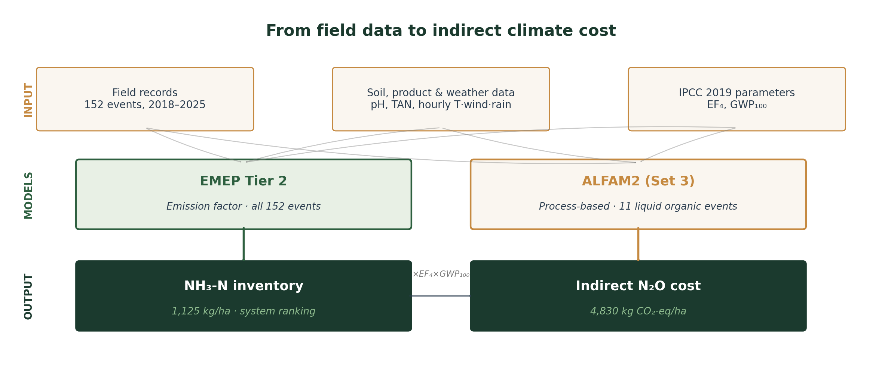
Figure 0. From field data to the indirect climate cost.

4. Results

4.1 The EMEP inventory
The corrected EMEP inventory totals 1,125.5 kg NH₃-N ha⁻¹ across the two rotations (667.2 in the first, 458.3 in the second). By intensity — the share of applied N that ends up as NH₃ — the ranking is MF 16.1%, CTR 14.7%, SCA 13.7%, HYP 13.4%, LI 13.3%, GHG 9.6%, and OF 1.0% (Figure 1).
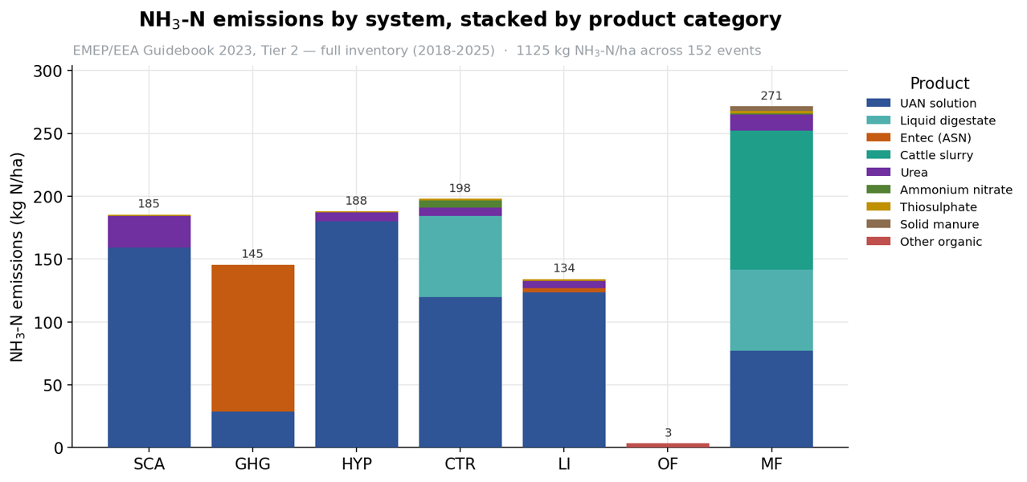
Figure 1. Total NH₃-N emissions by cropping system, stacked by product category. EMEP Tier 2, full inventory 2018–2025 (152 events, 1,125.5 kg NH₃-N ha⁻¹ total).
Two things stand out. First, the organic-farming system (OF) is the lowest emitter by a wide margin, both absolutely (3.4 kg NH₃-N ha⁻¹ across five events) and by intensity (1.0%), reflecting inputs dominated by low-TAN products. Second, the low-carbon system (GHG) reaches a strikingly low intensity (9.6%) despite applying a substantial dose — most of its nitrogen goes through Entec, whose nitrification inhibitor keeps ammonia low. The mixed-farming system (MF), at the other extreme, is the highest on both metrics (271 kg NH₃-N ha⁻¹, 16.1%), driven by its slurry applications.
The stacked bars in Figure 1 also make the product structure visible: UAN solution dominates most systems, Entec drives most of GHG's emission, cattle slurry appears only in the MF/LOM lineage, and liquid digestate contributes substantially in CTR (before the transition) and LOM (after).

4.2 The methanization transition
This is the central result, and it depends on how the comparison is framed. Read as a single absolute number, the platform-wide emission falls 31% between rotations, from 667.2 to 458.3 kg NH₃-N ha⁻¹. But rotation 1 spans 4.2 years and rotation 2 only 2.8, so the two totals cover very different exposure windows. Figure 2 shows the same signal three ways.
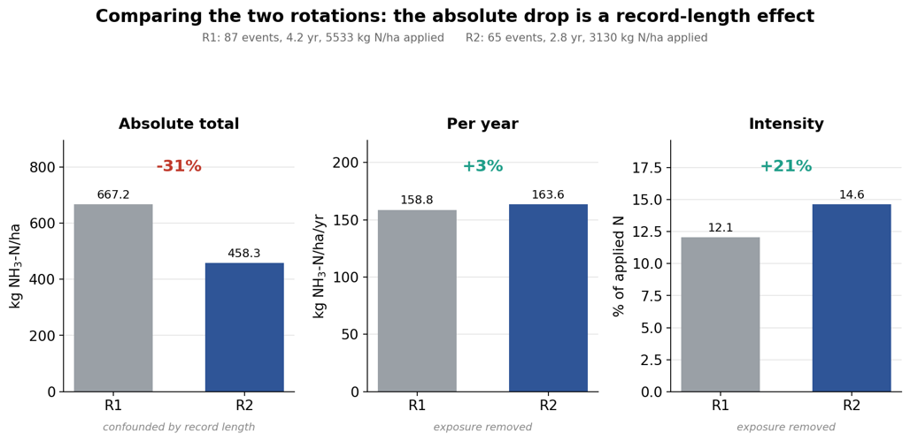
Figure 2. Comparing the two rotations. The –31% absolute drop is confounded by record length; per year, emissions rise slightly (+3%); per unit N applied, intensity rises 21%.
Once exposure is removed, the direction of the change reverses. Per year, the platform emits 158.8 kg NH₃-N ha⁻¹ in R1 versus 163.6 in R2 — a small 3% increase. Per unit of nitrogen actually applied, the ratio climbs from 12.1% to 14.6% — a 21% jump in intensity. The apparent good news of falling absolute emissions is a statistical mirage: less nitrogen enters the system, but each kilogram that does enter volatilizes more.
Broken down by lineage the same signal appears more sharply. CTR→COM sees intensity climb from 13.5% to 16.3% (+21%). MF→LOM climbs from 13.5% to 20.2% (+49%). The livestock-oriented lineage carries the strongest signal because MF applies more nitrogen through organic effluents to start with, and its digestate share is higher after conversion.

4.3 ALFAM2: why intensity rises
ALFAM2 clarifies the mechanism. Under the uniform trailing-shoe technique used on the platform, cattle slurry loses 29.1% of its TAN on average (seven events, MF/LOM), while liquid digestate loses 63.1% (four events, COM and LOM) — roughly twice as much under identical placement.
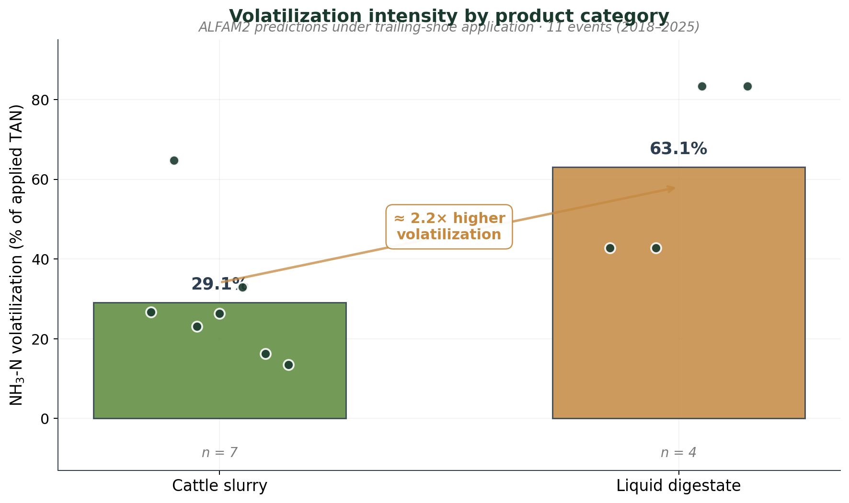
Figure 3. Volatilization intensity by product category (ALFAM2, trailing-shoe application, 11 events).
The reason lies in the effluent chemistry. Anaerobic digestion raises the effluent's pH (from around 7.2 to 8.0) and concentrates ammonia in the TAN fraction (up to 80% of total N), and both effects amplify volatilization once the digestate is placed (Möller & Müller, 2012). Because trailing-shoe already limits surface exposure, the twofold difference cannot be eliminated by further technique optimization — it is baked into the product.

4.4 Weather amplification
Beyond product chemistry, ALFAM2 also resolves the effect of ambient conditions during the 96-hour emission window. For digestate the temperature response is dramatic: at around 20°C summer events reach 83% of TAN, while at around 11°C spring events of the same product stay at 43% (Figure 4). Slurry spans a wider band (14 to 65%) depending on temperature and event conditions.
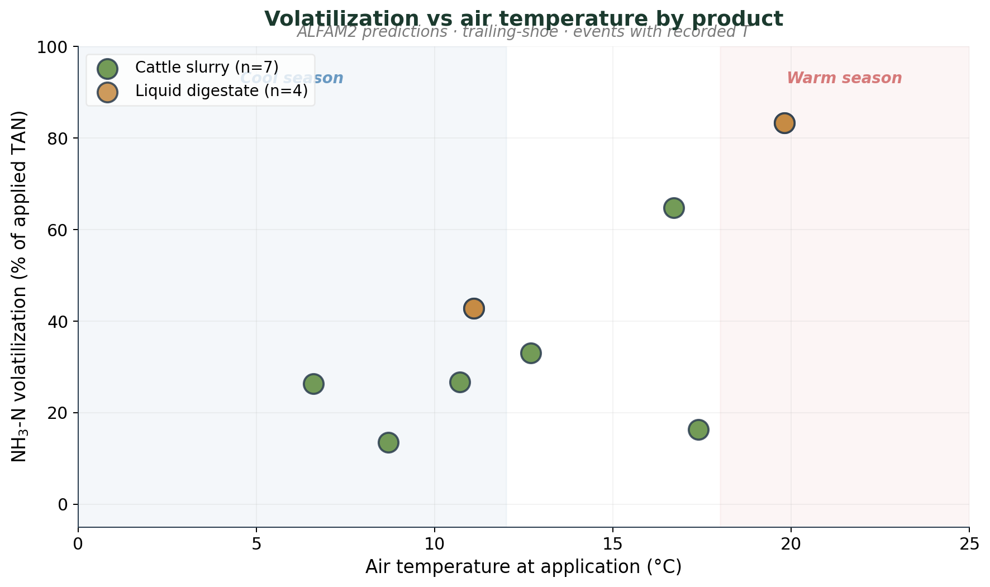
Figure 4. Modelled volatilization intensity vs. air temperature during application, by product.
The summer digestate events also sit near the upper boundary of the ALFAM2 Set-3 calibration domain (high T, high pH), so their high values should be read as an upper bound rather than a fixed prediction — they mark precisely the field conditions that would most repay direct measurement.

4.5 EMEP vs ALFAM2 per event
Across the eleven liquid-organic events both models cover, EMEP and ALFAM2 agree on average (their total ratio is close to 0.82) but diverge event by event (Figure 5). EMEP applies 55% of TAN uniformly. ALFAM2 systematically undershoots this for slurry, whose actual behaviour is closer to 29% of TAN; and it matches or overshoots EMEP for digestate, particularly in summer.
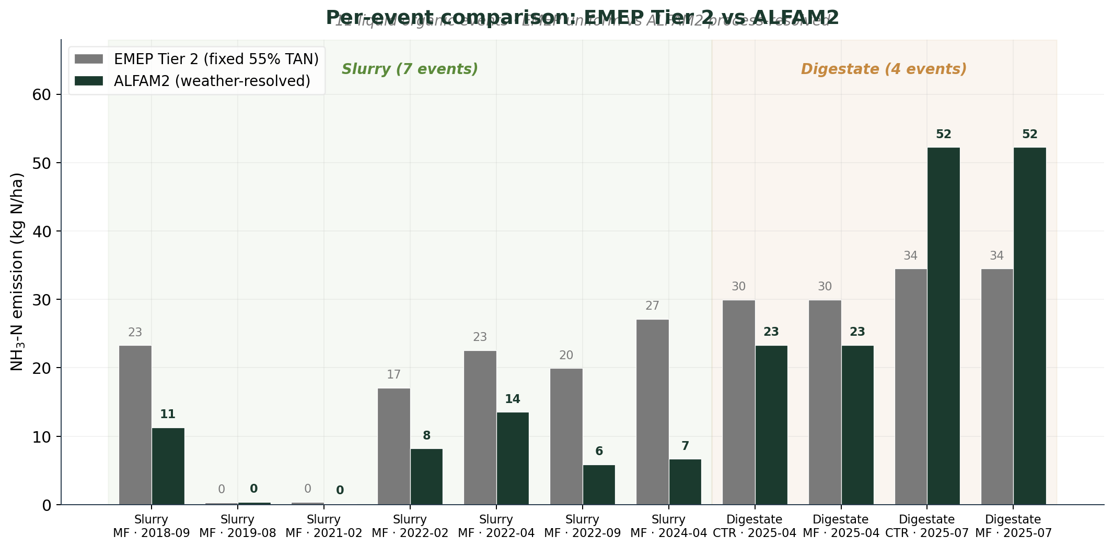
Figure 5. Per-event comparison of the two models. For slurry, EMEP overshoots the fixed 55%; for warm-season digestate, ALFAM2 exceeds EMEP because the fixed factor is blind to temperature.
The two summer digestate events make the point clearly: ALFAM2 predicts about 52 kg NH₃-N ha⁻¹, EMEP 34 — the fixed factor underestimates the actual risk by more than half. This is the missing sensitivity that ALFAM2 supplies. EMEP defines the magnitude and the ranking; ALFAM2 shows where the estimate is fragile (event-specific weather) and where the mitigation potential lies (product properties).

5. Indirect N₂O climate cost
The volatilized nitrogen was translated into indirect nitrous-oxide emissions following the 2019 IPCC Refinement. The deposited N is multiplied by EF₄ = 0.010 kg N₂O-N per kg N (with an uncertainty range of 0.002–0.018), converted to N₂O mass (×44/28), and expressed in CO₂-equivalent using a 100-year GWP of 273. Using the modelled volatilization as the input to EF₄ is a refinement over the Tier 1 default, which would apply a fixed volatilization fraction to the applied nitrogen instead.
For the full inventory, 1,125.5 kg NH₃-N ha⁻¹ corresponds to about 17.7 kg N₂O ha⁻¹, or roughly 4,830 kg CO₂-eq ha⁻¹ (with a range of 966–8,691 from the EF₄ uncertainty alone). The system ranking mirrors that of ammonia — highest for MF, negligible for OF.
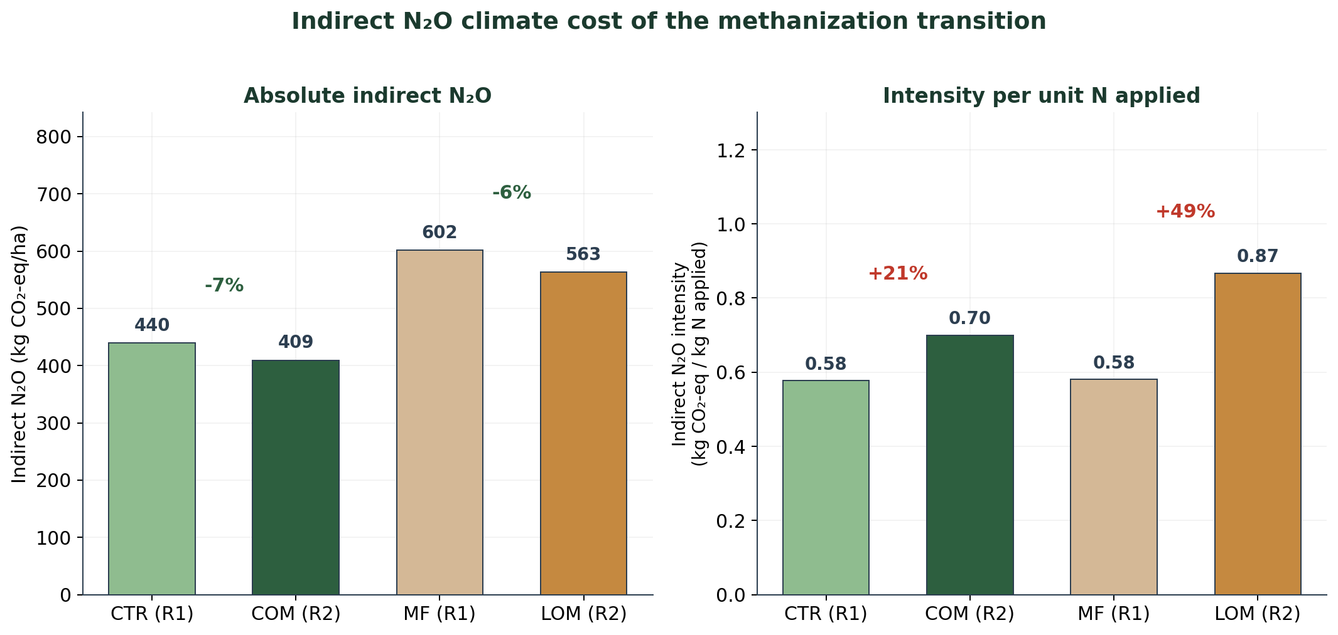
Figure 6. Indirect N₂O climate cost of the methanization transition. Absolute totals fall modestly (left) while intensity per unit N rises 21% and 49% (right).
Applied to the transition, the same conversion carries the air-quality story into climate units. Indirect-N₂O intensity rises from 0.58 to 0.70 kg CO₂-eq per kg N for CTR→COM (+21%) and from 0.58 to 0.87 for MF→LOM (+49%). A system adopted partly for its climate benefit thus generates an uncounted indirect-N₂O cost through greater ammonia loss. Because the IPCC term also includes leaching and NOₓ pathways, the estimate here is a lower bound on the total indirect flux.

6. Sensitivity analysis
Three sources of sensitivity matter for the interpretation of the results.
The first is structural: because the data corrections were built as toggles, their effect is quantifiable. The Entec reclassification alone shifts the GHG system by around 83 kg NH₃-N ha⁻¹ and changes the between-system ranking, which makes it the single most influential structural assumption in the EMEP inventory.
The second is parametric. The indirect-N₂O estimate inherits the wide uncertainty of EF₄, which propagates to a platform-level range of 966–8,691 kg CO₂-eq ha⁻¹ around the central 4,830. The direction of the transition effect (intensity up) is nonetheless robust, because it depends on the change in volatilization intensity rather than the value of EF₄, which cancels in the before/after ratio.
The third is model-domain: the summer digestate events sit at the upper edge of the ALFAM2 Set-3 calibration domain (high temperature, elevated pH). Their high values are reported as an upper bound rather than a fixed point, and model outputs for out-of-range conditions were flagged rather than treated as calibrated predictions (Hafner et al., 2025). That transparency about calibration limits is itself part of the result: it identifies exactly which events would most repay direct measurement.

7. Discussion and conclusions
Read as a single number, the platform's move toward methanization looks benign: the absolute ammonia emission of the reconfigured systems fell 31% between rotations. Read correctly — per year and per unit of nitrogen actually applied — it did the opposite. Per year emissions rise 3%. On an intensity basis they rise 21% at the platform level, 21% in the crop-oriented lineage (CTR→COM), and 49% in the livestock-oriented one (MF→LOM). The same signal appears again, undiminished, when the loss is expressed as indirect N₂O in CO₂-equivalent.
The mechanism is now quantified for this platform. Anaerobic digestion raises the pH and TAN content of the effluent, and both promote volatilization once the digestate is placed. Under the trailing-shoe technique already used here, digestate still volatilizes twice as much as slurry — the difference is baked into the product, not the placement. Trajectoire therefore offers a concrete, quantified example of pollution swapping: a technology chosen for a climate benefit that shifts part of the burden onto air quality and, through indirect N₂O, partly back onto the climate.

7.1 Implications for practice
Because the risk is embedded in the digestate, technique alone will not close it. The platform already uses trailing-shoe placement, which is the best available surface-application method for slurry and digestate. The results point to three practical fronts:
- Pre-treatment: acidification of the digestate before application, which lowers its pH and slows the equilibrium shift toward volatile NH₃ — a well-documented technique in Northern Europe (Fangueiro et al., 2015).
- Application timing: favouring cool-season applications (spring, autumn) over warm-season ones, where the temperature response of digestate volatilization is strongest (Sommer & Hutchings, 2001).
- Direct measurement: validating the high-risk events (summer digestate) with field NH₃ measurements — the same events that sit at ALFAM2's calibration edge and would most inform both the model and the mitigation choice (Hafner et al., 2025).

7.2 Why two models
The exercise also shows why two models are better than one for this question. The EMEP Tier 2 factor is indispensable for a complete, policy-comparable inventory across every fertilizer type; it anchored the whole-system totals and the transition analysis. But its single fixed factor is, by construction, insensitive to event weather and product properties. ALFAM2 supplies exactly that missing sensitivity for the liquid-organic events, at the cost of covering only those events and demanding more input data. Used together they are complementary rather than redundant — EMEP defines the magnitude and the ranking, ALFAM2 reveals where the estimate is fragile and where the mitigation potential lies. For a platform whose defining change is a shift toward digestate, that combination is not a methodological luxury; it is what separates a misleading headline from a defensible conclusion.

References
- AgroParisTech. (2024). Trajectoire — Review of the first crop rotation 2017–2022. Experimental farm of AgroParisTech, Grignon.
- European Environment Agency. (2023). EMEP/EEA air pollutant emission inventory guidebook 2023: Technical guidance to prepare national emission inventories. Publications Office of the European Union. https://www.eea.europa.eu/publications/emep-eea-guidebook-2023
- Fangueiro, D., Hjorth, M., & Gioelli, F. (2015). Acidification of animal slurry — a review. Journal of Environmental Management, 149, 46–56. https://doi.org/10.1016/j.jenvman.2014.10.001
- Gu, B., Zhang, L., Van Dingenen, R., Vieno, M., van Grinsven, H. J. M., Zhang, X., … Sutton, M. A. (2021). Abating ammonia is more cost-effective than nitrogen oxides for mitigating PM₂.₅ air pollution. Science, 374(6568), 758–762. https://doi.org/10.1126/science.abf8623
- Hafner, S. D., Pacholski, A., Bittman, S., Burchill, W., Bussink, W., Chantigny, M., … Sommer, S. G. (2018). The ALFAM2 database on ammonia emission from field-applied manure: Description and illustrative analysis. Agricultural and Forest Meteorology, 258, 66–79. https://doi.org/10.1016/j.agrformet.2017.11.027
- Hafner, S. D., Pacholski, A., Bittman, S., Carozzi, M., Chantigny, M., Génermont, S., … Sommer, S. G. (2019). A flexible semi-empirical model for estimating ammonia volatilization from field-applied slurry. Atmospheric Environment, 199, 474–484. https://doi.org/10.1016/j.atmosenv.2018.11.034
- Hafner, S. D., Pedersen, J., Fuß, R., Kamp, J. N., Dalby, F. R., Amon, B., Pacholski, A., Adamsen, A. P. S., & Sommer, S. G. (2025). Improved tools for estimation of ammonia emission from field-applied animal slurry: Refinement of the ALFAM2 model and database. Atmospheric Environment, 340, 120910. https://doi.org/10.1016/j.atmosenv.2024.120910
- Intergovernmental Panel on Climate Change. (2019). 2019 Refinement to the 2006 IPCC Guidelines for National Greenhouse Gas Inventories: Vol. 4. Agriculture, forestry and other land use, Chapter 11. IPCC, Geneva. https://www.ipcc-nggip.iges.or.jp/public/2019rf/
- Möller, K., & Müller, T. (2012). Effects of anaerobic digestion on digestate nutrient availability and crop growth: A review. Engineering in Life Sciences, 12(3), 242–257. https://doi.org/10.1002/elsc.201100085
- Sommer, S. G., & Hutchings, N. J. (2001). Ammonia emission from field applied manure and its reduction. European Journal of Agronomy, 15(1), 1–15. https://doi.org/10.1016/S1161-0301(01)00112-5

