Practical Journal

Enterprise Networking

Submitted by
Priyal Shrimali
SAP ID: 53003160092
T.Y. B.Sc. (IT) - SEM VI

Department of Information Technology
Usha Pravin Gandhi College of Arts, Science, & Commerce
Vile Parle (W), Mumbai – 400 056
2018-19
INDEX

Sr. No. | Practical Name | Date | Signature
1a | Single-Area OSPF Link Costs and Interface Priorities
1b | Multi-Area OSPF with Stub Areas and Authentication
2a | OSPF Virtual Links and Area Summarization
2b | OSPF over Frame Relay
3a | Redistribution Between RIP and OSPF
3b | Manipulating Administrative Distances
4a | Configuring BGP with Default Routing
5a | Configuring OSPF for IPv6
5b | Configuring 6to4 Tunnels
6a | Static VLANS, VLAN Trunking, and VTP Domains and Modes
6b | Configuring EtherChannel
7a | Spanning Tree Protocol (STP) Default Behaviour

Practical 1a-Single-Area OSPF Link Costs and Interface Priorities
Topology-
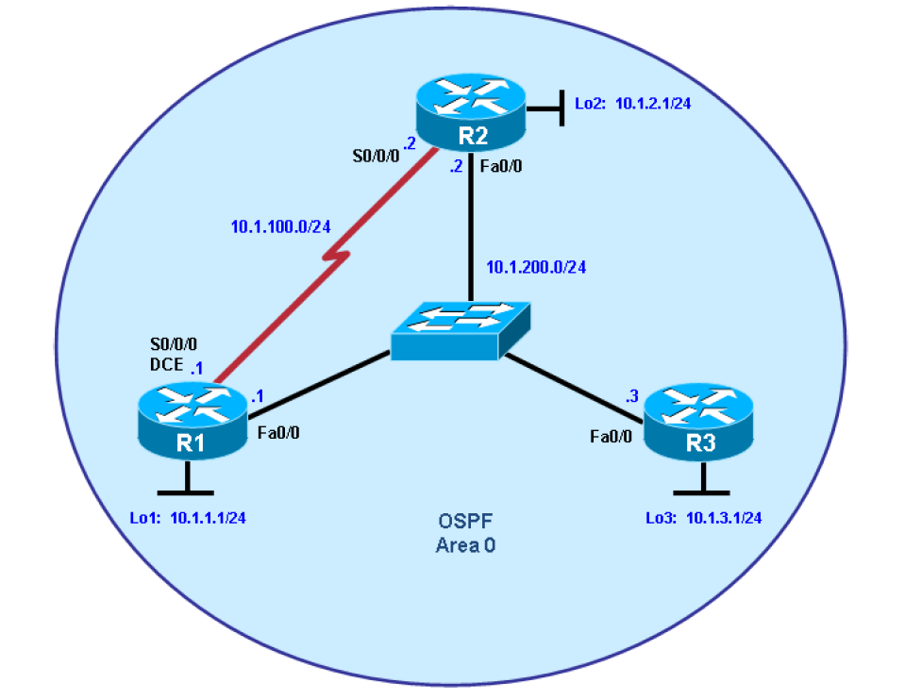

Objectives
• Configure single-area OSPF on a router.
• Advertise loopback interfaces into OSPF.
• Verify OSPF adjacencies.
• Verify OSPF routing information exchange.
• Modify OSPF link costs.
• Change interface priorities.
• Utilize debugging commands for troubleshooting OSPF.

Description-
You are responsible for configuring the new network to connect your company’s engineering, marketing, and accounting departments, represented by the loopback interfaces on each of the three routers. The physical devices have just been installed and connected by Fast Ethernet and serial cables. Configure OSPF to allow full connectivity between all departments.
Required Resources-
• 3 routers (Cisco 1841 with Cisco IOS Release 12.4(24)T1 Advanced IP Services or comparable). For each router add HWIC2T for 2 fast-ethernet and 2 serial port interfaces.
• 1 switch (Cisco 2960 with the Cisco IOS Release 12.2(46)SE C2960-LANBASEK9-M image or comparable)
• Serial and Ethernet cables

Step 1: Configure addressing and loopbacks.
R1# configure terminal
R1(config)# interface Loopback1
R1(config-if)# description Engineering Department
R1(config-if)# ip address 10.1.1.1 255.255.255.0
R1(config-if)# exit
R1(config)# interface FastEthernet0/0
R1(config-if)# ip address 10.1.200.1 255.255.255.0
R1(config-if)# no shutdown

R2# configure terminal
R2(config)# interface Loopback2
R2(config-if)# description Marketing Department
R2(config-if)# ip address 10.1.2.1 255.255.255.0
R2(config-if)# exit
R2(config)# interface FastEthernet0/0
R2(config-if)# ip address 10.1.200.2 255.255.255.0
R2(config-if)# no shutdown

R3# configure terminal
R3(config)# interface Loopback3
R3(config-if)# description Accounting Department
R3(config-if)# ip address 10.1.3.1 255.255.255.0
R3(config-if)# exit
R3(config)# interface FastEthernet0/0
R3(config-if)# ip address 10.1.200.3 255.255.255.0
R3(config-if)# no shutdown
Configure the serial interfaces on R1 and R2 with the IP addresses shown in the diagram. Add the clockrate command where needed.
R1(config)# interface Serial 0/0/0
R1(config-if)# ip address 10.1.100.1 255.255.255.0
R1(config-if)# clockrate 64000
R1(config-if)# bandwidth 64
R1(config-if)# no shutdown
R2(config)# interface Serial 0/0/0
R2(config-if)# ip address 10.1.100.2 255.255.255.0
R2(config-if)# bandwidth 64
R2(config-if)# no shutdown
Verify that the appropriate interfaces are up and that you can ping across each link.

Step 2: Add physical interfaces to OSPF.
Enter the commands on R1. Exit to privileged EXEC mode and type debug ip ospf adj. The debug command lets you watch OSPF neighbors come up and see neighbor relationships.
R1(config)# router ospf 1
R1(config-router)# network 10.1.100.0 0.0.0.255 area 0
R1(config-router)# network 10.1.200.0 0.0.0.255 area 0
R1(config-router)# end
R1#
R1# debug ip ospf adj
OSPF adjacency events debugging is on

Add network statements to the other two routers.

R2(config)# router ospf 1
R2(config-router)# network 10.1.100.0 0.0.0.255 area 0
R2(config-router)# network 10.1.200.0 0.0.0.255 area 0
R3(config)# router ospf 1
R3(config-router)# network 10.1.200.0 0.0.0.255 area 0
Step 3: Use OSPF show commands.
R1# show ip protocols
Routing Protocol is "ospf 1"
Outgoing update filter list for all interfaces is not set
Incoming update filter list for all interfaces is not set
Router ID 10.1.1.1
Number of areas in this router is 1. 1 normal 0 stub 0 nssa
Maximum path: 4
Routing for Networks:
10.1.100.0 0.0.0.255 area 0
10.1.200.1 0.0.0.0 area 0
Reference bandwidth unit is 100 mbps
Routing Information Sources:
Gateway Distance Last Update
Distance: (default is 110)
R1# show ip ospf
Routing Process "ospf 1" with ID 10.1.1.1
Start time: 00:17:44.612, Time elapsed: 00:10:51.408
Supports only single TOS(TOS0) routes
Supports opaque LSA
Supports Link-local Signaling (LLS)
Supports area transit capability
Router is not originating router-LSAs with maximum metric
Initial SPF schedule delay 5000 msecs
Minimum hold time between two consecutive SPFs 10000 msecs
Maximum wait time between two consecutive SPFs 10000 msecs
R1# show ip ospf neighbor
Neighbor ID Pri State Dead Time Address Interface
10.1.2.1 1 FULL/BDR 00:00:36 10.1.200.2 FastEthernet0/0
10.1.3.1 1 FULL/DR 00:00:35 10.1.200.3 FastEthernet0/0
10.1.2.1 0 FULL/ - 00:00:36 10.1.100.2 Serial0/0/0
R1# show ip ospf interface FastEthernet 0/0
R1# show ip ospf interface brief
Interface PID Area IP Address/Mask Cost State Nbrs F/C
Fa0/0 1 0 10.1.200.1/24 1 DROTH 2/2
Se0/0/0 1 0 10.1.100.1/24 1 P2P 1/1

The show ip ospf database command displays the various LSAs in the OSPF database, organized by area and type.
R1# show ip ospf database
OSPF Router with ID (10.1.1.1) (Process ID 1)
Router Link States (Area 0)
Link ID ADV Router Age Seq# Checksum Link count
10.1.1.1 10.1.1.1 1782 0x80000002 0x001AC7 3
10.1.2.1 10.1.2.1 1783 0x80000001 0x001DC2 3
10.1.3.1 10.1.3.1 1720 0x80000002 0x00F077 1
Net Link States (Area 0)
Link ID ADV Router Age Seq# Checksum
10.1.200.1 10.1.1.1 1719 0x80000002 0x00EC3C
OSPF Router with ID (10.1.1.1) (Process ID 1)

Step 4: Add loopback interfaces to OSPF.
All three routers have loopback interfaces, but they are not yet advertised in the routing process. You can verify this with the show ip route command on the three routers.
R1# show ip route
R2# show ip route
R3# show ip route
R1(config)# router ospf 1
R1(config-router)# network 10.1.1.0 0.0.0.255 area 0
R2(config)# router ospf 1
R2(config-router)# network 10.1.2.0 0.0.0.255 area 0
R3(config)# router ospf 1
R3(config-router)# network 10.1.3.0 0.0.0.255 area 0

Verify that these networks have been added to the routing table using the show ip route command.
R1# show ip route
R1# show ip ospf interface Lo1
To change this default behavior use the ip ospf network point-to-point command in interface configuration mode for each loopback.
R1(config)# interface loopback1
R1(config-if)# ip ospf network point-to-point
R2(config)# interface loopback2
R2(config-if)# ip ospf network point-to-point
R3(config)# interface loopback3
R3(config-if)# ip ospf network point-to-point
R1# show ip route
Step 5: Modify OSPF link costs.
R1(config)# interface FastEthernet 0/0
R1(config-if)# ip ospf cost 50
R2(config)# interface FastEthernet 0/0
R2(config-if)# ip ospf cost 50
R3(config)# interface FastEthernet 0/0
R3(config-if)# ip ospf cost 50
R1# show ip route
The cost calculation can be adjusted to account for network links that are faster than 100 Mb/s by using the auto-cost reference-bandwidth command to change the reference bandwidth.
R1(config)# router ospf 1
R1(config-router)# auto-cost reference-bandwidth 1000
% OSPF: Reference bandwidth is changed.
Please ensure reference bandwidth is consistent across all routers.
Step 6: Modify interface priorities to control the DR and BDR election.
R1(config)# interface FastEthernet 0/0
R1(config-if)# ip ospf priority 10
R2(config)# interface FastEthernet 0/0
R2(config-if)# ip ospf priority 5
R1# show ip ospf neighbor detail
Neighbor 10.1.2.1, interface address 10.1.200.2
In the area 0 via interface FastEthernet0/0
Neighbor priority is 5, State is FULL, 12 state changes
DR is 10.1.200.1 BDR is 10.1.200.2
Options is 0x52
LLS Options is 0x1 (LR)
Dead timer due in 00:00:37
Neighbor is up for 00:01:32
Index 3/3, retransmission queue length 0, number of retransmission 0
First 0x0(0)/0x0(0) Next 0x0(0)/0x0(0)
Last retransmission scan length is 0, maximum is 0
Last retransmission scan time is 0 msec, maximum is 0 msec
Neighbor 10.1.3.1, interface address 10.1.200.3
In the area 0 via interface FastEthernet0/0
Neighbor priority is 1, State is FULL, 12 state changes
DR is 10.1.200.1 BDR is 10.1.200.2
Options is 0x52

Practical 1b-Multi-Area OSPF with Stub Areas and Authentication
Topology-
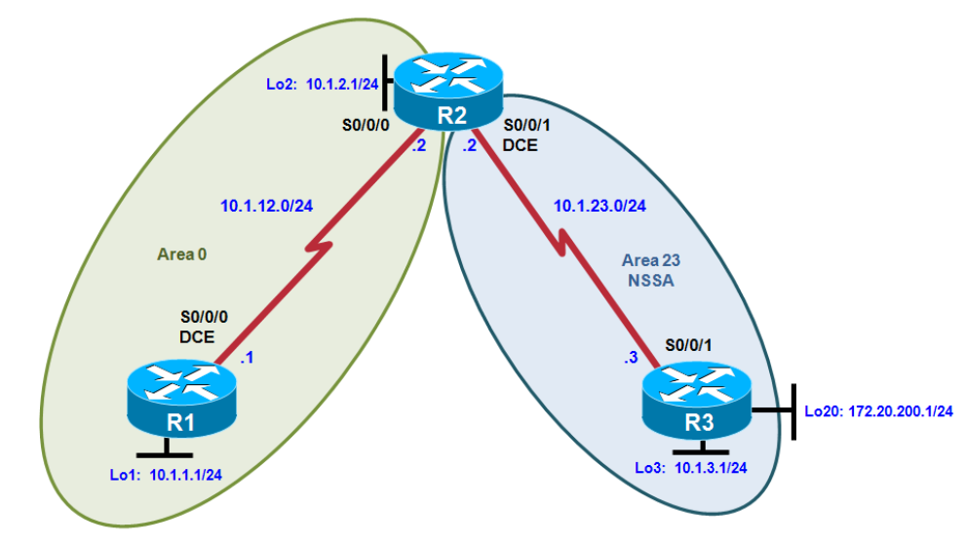
Objectives
• Configure multiple-area OSPF on a router.
• Verify multiple-area behavior.
• Configure OSPF stub, totally stubby, and not-so-stubby areas.
• Configure OSPF authentication.

Description-
You are responsible for configuring the new network to connect your company’s engineering, marketing, and accounting departments, represented by loopback interfaces on each of the three routers. The physical devices have just been installed and connected by serial cables. Configure multiple-area OSPF to allow full connectivity between all departments.
Required Resources
• 3 routers (Cisco 1841 with Cisco IOS Release 12.4(24)T1 Advanced IP Services or comparable). For each router add HWIC2T for 2 fast-ethernet and 2 serial port interfaces.
• Serial and console cables

Step 1: Configure addressing and loopbacks.
R1# configure terminal
Enter configuration commands, one per line. End with CNTL/Z.
R1(config)# interface loopback 1
R1(config-if)# description Engineering Department
R1(config-if)# ip address 10.1.1.1 255.255.255.0
R1(config-if)# interface serial 0/0/0
R1(config-if)# ip address 10.1.12.1 255.255.255.0
R1(config-if)# clockrate 64000
R1(config-if)# no shutdown
R2# configure terminal
Enter configuration commands, one per line. End with CNTL/Z.
R2(config)# interface loopback 2
R2(config-if)# description Marketing Department
R2(config-if)# ip address 10.1.2.1 255.255.255.0
R2(config-if)# interface serial 0/0/0
R2(config-if)# ip address 10.1.12.2 255.255.255.0
R2(config-if)# no shutdown
R2(config-if)# interface serial 0/0/1
R2(config-if)# ip address 10.1.23.2 255.255.255.0
R2(config-if)# clockrate 64000
R2(config-if)# no shutdown
R3# configure terminal
Enter configuration commands, one per line. End with CNTL/Z.
R3(config)# interface loopback 3
R3(config-if)# description Accounting Department
R3(config-if)# ip address 10.1.3.1 255.255.255.0
R3(config-if)# interface loopback 20
R3(config-if)# description Connection to another AS
R3(config-if)# ip address 172.20.200.1 255.255.255.0
R3(config-if)# interface serial 0/0/1
R3(config-if)# ip address 10.1.23.3 255.255.255.0
R3(config-if)# no shutdown
Step 2: Add interfaces into OSPF.
R1(config)# router ospf 1
R1(config-router)# network 10.1.12.0 0.0.0.255 area 0
R1(config-router)# network 10.1.1.0 0.0.0.255 area 0
R1(config-router)# exit
R1(config)# interface loopback 1
R1(config-if)# ip ospf network point-to-point
R2(config)# router ospf 1
R2(config-router)# network 10.1.12.0 0.0.0.255 area 0
R2(config-router)# network 10.1.2.0 0.0.0.255 area 0
R2(config-router)# exit
R2(config)# interface loopback 2
R2(config-if)# ip ospf network point-to-point
Verify that both routers have OSPF neighbors using the show ip ospf neighbors command.
R1# show ip ospf neighbor
Neighbor ID Pri State Dead Time Address Interface
10.1.2.1 0 FULL/ - 00:00:38 10.1.12.2 Serial0/0/0
R2# show ip ospf neighbor
Neighbor ID Pri State Dead Time Address Interface
10.1.1.1 0 FULL/ - 00:00:35 10.1.12.1 Serial0/0/0
Verify that the routers can see each other’s loopback with the show ip route command.
R1# show ip route
R2# show ip route
Add the subnet between R2 and R3 into OSPF area 23 using the network command. Add loopback 3 on R3 into area 23.
R2(config)# router ospf 1
R2(config-router)# network 10.1.23.0 0.0.0.255 area 23
R3(config)# router ospf 1
R3(config-router)# network 10.1.23.0 0.0.0.255 area 23
R3(config-router)# network 10.1.3.0 0.0.0.255 area 23
R3(config-router)# exit
R3(config)# interface loopback 3
R3(config-if)# ip ospf network point-to-point
Verify that this neighbor relationship comes up using the show ip ospf neighbors command.
R2# show ip ospf neighbour
If you look at the output of the show ip route command on R1, you see a route to the R3 loopback. Notice that it is identified as an inter-area route.
R1# show ip route
Issue the show ip route command on R2. Notice that R2 has no inter-area routes because R2 is in both areas. It is an ABR, or area border router.
R2# show ip route
Step 3: Configure a stub area.
Under the OSPF process on R2 and R3, make area 23 the stub area using the area area stub command. The adjacency between the two routers might go down during the transition period, but it should come back up afterwards.

R2(config)# router ospf 1
R2(config-router)# area 23 stub
R3(config)# router ospf 1
R3(config-router)# area 23 stub

Confirm that it comes up by using the show ip ospf neighbors command.

R2# show ip ospf neighbor
Neighbor ID Pri State Dead Time Address Interface
10.1.1.1 0 FULL/ - 00:00:36 10.1.12.1 Serial0/0/0
10.1.3.1 0 FULL/ - 00:00:36 10.1.23.3 Serial0/0/1
R3# show ip ospf neighbor
Neighbor ID Pri State Dead Time Address Interface
10.1.2.1 0 FULL/ - 00:00:31 10.1.23.2 Serial0/0/1

Using the show ip route command, you can see that R3 now has a default route pointing toward R2. A stub area does not receive any external routes. It receives a default route and OSPF inter-area routes.

R3# show ip route
Look at the output of the show ip ospf command to see what type each area is.
R2# show ip ospf
Step 4: Configure a totally stubby area.
First issue the show ip route command on R3. Notice the inter-area routes, in addition to the default route generated by R2.
R3# show ip route
Look at the output of the show ip ospf database command on R2 to see which LSAs are in its OSPF database.
R2# show ip ospf database
Enter the stub no-summary command on R2 (the ABR) under the OSPF process.
R2(config)# router ospf 1
R2(config-router)# area 23 stub no-summary

Go back to R3 and issue the show ip route command again. Notice that it shows only one incoming route from OSPF.
R3# show ip route
Look at the show ip ospf database output to see which routes are in area 23.
R3# show ip ospf database
Step 5: Configure a not-so-stubby area.
Change area 23 into an NSSA. NSSAs are not compatible with stub areas, so the first thing to do is issue the no area 23 stub command on routers R2 and R3. Next, issue the area area nssa command on routers R2 and R3 to change area 23 to an NSSA.
R2(config)# router ospf 1
R2(config-router)# no area 23 stub
R2(config-router)# area 23 nssa
R3(config)# router ospf 1
R3(config-router)# no area 23 stub
R3(config-router)# area 23 nssa
R3(config-router)# redistribute connected subnets
In the output of the show ip ospf command on R2, notice that area 23 is an NSSA and that R2 is performing the LSA type 7 to type 5 translation
R2# show ip ospf
Look at the show ip route output on R2. Notice that the external route comes in as type N2 from R3.
R2# show ip route
Look at the show ip route output on R1. Notice that the route is now a regular E2 external route, because R2 has performed the type 7 to type 5 translation.
R1# show ip route
Look at the show ip route output on R3. Notice that it no longer has a default route in it, but inter-area routes are coming in.
R3# show ip route
Issue the area 23 nssa no-summary command on R2, similar to converting a stub area into a totally stubby area.
R2(config)# router ospf 1
R2(config-router)# area 23 nssa no-summary

Check the routing table on R3. Notice that the inter-area routes have been replaced by a single default route.
R3# show ip route
On R2, look at the show ip ospf database output to see the various LSA types.
R2# show ip ospf database

Step 6: Configure OSPF interface authentication.
Configure the link between R2 and R3 for plaintext authentication. To set up plaintext authentication on an interface, type ip ospf authentication at the interface command prompt. Then set the password to cisco with the ip ospf authentication-key key-string command.
R2(config)# interface serial 0/0/1
R2(config-if)# ip ospf authentication
R2(config-if)# ip ospf authentication-key cisco
R3(config)# interface serial 0/0/1
R3(config-if)# ip ospf authentication
R3(config-if)# ip ospf authentication-key cisco
Verify the authentication using the show ip ospf interface interface command.
R2# show ip ospf interface serial 0/0/1
MD5 authentication encrypts the password for stronger security. Configure the link between R1 and R2 for MD5 authentication using the ip ospf authentication message-digest interface command
R1(config)# interface serial 0/0/0
R1(config-if)# ip ospf authentication message-digest
R1(config-if)# ip ospf message-digest-key 1 md5 cisco
R2(config)# interface serial 0/0/0
R2(config-if)# ip ospf authentication message-digest
R2(config-if)# ip ospf message-digest-key 1 md5 cisco
Verify the configuration using the show ip ospf interface interface command.
R1# show ip ospf interface serial 0/0/0

Practical 2a-OSPF Virtual Links and Area Summarization
Topology-

Objectives-
• Configure multi-area OSPF on a router.
• Verify multi-area behavior.
• Create an OSPF virtual link.
• Summarize an area.
• Generate a default route into OSPF.

Description-
You are responsible for configuring the new network to connect your company’s engineering, marketing, and accounting departments, represented by loopback interfaces on each of the three routers. The physical devices have just been installed and connected by serial cables. Configure multiple-area OSPF to allow full connectivity between all departments.
Required Resources
• 3 routers (Cisco 1841 with Cisco IOS Release 12.4(24)T1 Advanced IP Services or comparable). For each router add HWIC2T for 2 fast-ethernet and 2 serial port interfaces.
• Serial and console cables

Step 1: Configure addressing and loopbacks.
Using the addressing scheme in the diagram, apply IP addresses to the serial interfaces on R1, R2, and R3. Create loopbacks on R1, R2, and R3, and address them according to the diagram.
R1# configure terminal
Enter configuration commands, one per line. End with CNTL/Z.
R1(config)# interface loopback 1
R1(config-if)# description Engineering Department
R1(config-if)# ip address 10.1.1.1 255.255.255.0
R1(config-if)# interface loopback 30
R1(config-if)# ip address 172.30.30.1 255.255.255.252
R1(config-if)# interface serial 0/0/0
R1(config-if)# ip address 10.1.12.1 255.255.255.0
R1(config-if)# clockrate 64000
R1(config-if)# no shutdown
R2# configure terminal
Enter configuration commands, one per line. End with CNTL/Z.
R2(config)# interface loopback 2
R2(config-if)# description Marketing Department
R2(config-if)# ip address 10.1.2.1 255.255.255.0
R2(config-if)# interface serial 0/0/0
R2(config-if)# ip address 10.1.12.2 255.255.255.0
R2(config-if)# no shutdown
R2(config-if)# interface serial 0/0/1
R2(config-if)# ip address 10.1.23.2 255.255.255.0
R2(config-if)# clockrate 64000
R2(config-if)# no shutdown
R3# configure terminal
Enter configuration commands, one per line. End with CNTL/Z.
R3(config)# interface loopback 3
R3(config-if)# description Accounting Department
R3(config-if)# ip address 10.1.3.1 255.255.255.0
R3(config-if)# interface loopback 100
R3(config-if)# ip address 192.168.100.1 255.255.255.0
R3(config-if)# interface loopback 101
R3(config-if)# ip address 192.168.101.1 255.255.255.0
R3(config-if)# interface loopback 102
R3(config-if)# ip address 192.168.102.1 255.255.255.0
R3(config-if)# interface loopback 103
R3(config-if)# ip address 192.168.103.1 255.255.255.0
R3(config-if)# interface serial 0/0/1
R3(config-if)# ip address 10.1.23.3 255.255.255.0
R3(config-if)# no shutdown

Step 2: Add interfaces into OSPF.
Create OSPF process 1 on all three routers. Using the network command, configure the subnet of the serial link between R1 and R2 to be in OSPF area 0.
R1(config)# router ospf 1
R1(config-router)# network 10.1.12.0 0.0.0.255 area 0
R1(config-router)# network 10.1.1.0 0.0.0.255 area 0
R1(config-router)# exit
R1(config)# interface loopback 1
R1(config-if)# ip ospf network point-to-point
R2(config)# router ospf 1
R2(config-router)# network 10.1.12.0 0.0.0.255 area 0
R2(config-router)# network 10.1.2.0 0.0.0.255 area 0
R2(config-router)# exit
R2(config)# interface loopback 2
R2(config-if)# ip ospf network point-to-point

Verify that you can see OSPF neighbors in the show ip ospf neighbors output on both routers and also see each other’s loopback with the show ip route command.
R1# show ip ospf neighbor
R1# show ip route
R2# show ip ospf neighbor
R2# show ip route

Add the subnet between R2 and R3 into OSPF area 23 using the network command. Add loopback 3 on R3 into area 23.
R2(config)# router ospf 1
R2(config-router)# network 10.1.23.0 0.0.0.255 area 23
R3(config)# router ospf 1
R3(config-router)# network 10.1.23.0 0.0.0.255 area 23
R3(config-router)# network 10.1.3.0 0.0.0.255 area 23
R3(config-router)# exit
R3(config)# interface loopback 3
R3(config-if)# ip ospf network point-to-point

Verify that this neighbor relationship comes up with the show ip ospf neighbors command.
R2# show ip ospf neighbour
Step 3: Create a virtual link.
Add loopbacks 100 through 103 on R3 to the OSPF process in area 100 using the network command. Change the network type to advertise the correct subnet mask.
R3(config)# router ospf 1
R3(config-router)# network 192.168.100.0 0.0.3.255 area 100
R3(config-router)# exit
R3(config)# interface loopback 100
R3(config-if)# ip ospf network point-to-point
R3(config-if)# interface loopback 101
R3(config-if)# ip ospf network point-to-point
R3(config-if)# interface loopback 102
R3(config-if)# ip ospf network point-to-point
R3(config-if)# interface loopback 103
R3(config-if)# ip ospf network point-to-point

Look at the output of the show ip route command on R2.
R2# show ip route
Prior to creating a virtual link you need to identify the OSPF router ID for the routers involved (R2 and R3), using a command such as show ip ospf, show ip protocols or show ip ospf interface. The output for the show ip ospf command on R1 and R3 is shown below.
R2# show ip ospf
R3# show ip ospf
Create a virtual link using the area transit_area virtual-link router-id OSPF configuration command on both R2 and R3.
R2(config)# router ospf 1
R2(config-router)# area 23 virtual-link 192.168.103.1
R3(config)# router ospf 1
R3(config-router)# area 23 virtual-link 10.1.2.1
After you see the adjacency over the virtual interface come up, issue the show ip route command on R2 and see the routes from area 100. You can verify the virtual link with the show ip ospf neighbor and show ip ospf interface commands.
R2# show ip route
R2# show ip ospf neighbour
R2# show ip ospf interface
Step 4: Summarize an area.
Loopbacks 100 through 103 can be summarized into one supernet of 192.168.100.0 /22. You can configure area 100 to be represented by this single summary route.
Configure R3 (the ABR) to summarize this area using the area area range network mask command.

R3(config)# router ospf 1
R3(config-router)# area 100 range 192.168.100.0 255.255.252.0

You can see the summary route on R2 with the show ip route and show ip ospf database commands.
R2# show ip route
R2# show ip ospf database
Notice on R3 that OSPF has generated a summary route pointing toward Null0.
R3# show ip route
Step 5: Generate a default route into OSPF.
You can simulate loopback 30 on R1 to be a connection to the Internet. You do not need to advertise this specific network to the rest of the network. Instead, you can just have a default route for all unknown traffic to go to R1.
To have R1 generate a default route, use the OSPF configuration command default-information originate always. The always keyword is necessary for generating a default route in this scenario. Without this keyword, a default route is generated only into OSPF if one exists in the routing table.
R1(config)# router ospf 1
R1(config-router)# default-information originate always

Verify that the default route appears on R2 and R3 with the show ip route command.
R2# show ip route
R3# show ip route
You should be able to ping the interface connecting to the Internet from R2 or R3, despite never being advertised into OSPF.
R3# ping 172.30.30.1

Practical 2b-OSPF over Frame Relay
Topology-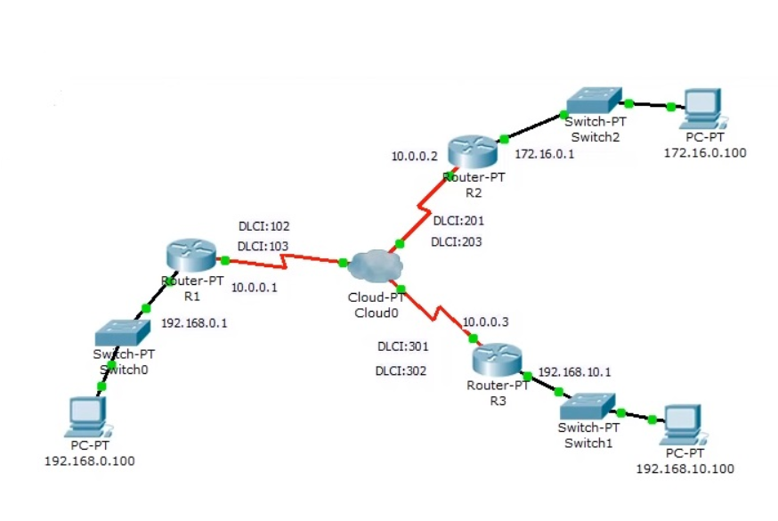
Objectives-
• Configure OSPF over Frame Relay.
• Use non-broadcast and point-to-multipoint OSPF network types.

Description- You are responsible for configuring the new network to connect your company’s branches through the company headquarters represented by loopback interfaces on each of the three routers. The physical devices have just been installed and connected over Frame Relay hub-and-spoke topology. Configure OSPF to allow full connectivity between all departments. To simulate the Frame Relay WAN connections, use a router with three serial ports to act as a Frame Relay switch.
Required Resources-
- Generic Cloud PT
- 3 Generic Routers
- 3 PC-PT
- Serial and console cables

Steps 1:-
1.Consider Three Generic Routers as R1,R2,R3 and take Fourth Router as R4(Cloud).
2.Connect all the three routers with DC cable(clock side cable wire) as mentioned below,
3.Connect,
R4 router Serial0 cable with R1(Serial 2/0) cable
R4 router Serial1 cable with R2(Serial 2/0) cable
R4 router Serial2 cable with R3(Serial 2/0) cable
4.Now take Three PC’s i.e. (PC0, PC1, PC2) connect each PC’S with the Three Routers i.e. (R1, R2, R3) respectively using the cross over wire i.e. (dotted line cable wire).
5.Connect,
PC0 of FastEthernet with FastEthernet0/0 of R1
PC1 of FastEthernet with FastEthernet0/0 of R2
PC2 of FastEthernet with FastEthernet0/0 of R3
In Router R1:-
Ip Address Serial2/0 ->10.0.0.1 Subnet Mask-> 255.0.0.0
FastEthernet0/0 ->192.168.1.1 Subnet Mask-> 255.255.0.0
DLCI: 102
DLCI: 103
In Router R2: -
IP Address of Serial2/0 ->10.0.0.2 Subnet Mask-> 255.0.0.0
FastEthernet0/0 ->172.16.0.1 Subnet Mask-> 255.255.0.0
DLCI: 201
DLCI: 203

In Router R3: -
IP Address of Serial2/0 ->10.0.0.3 Subnet Mask-> 255.0.0.0
FastEthernet0/0 ->192.168.5.1 Subnet Mask-> 255.255.255.0
DLCI: 301
DLCI: 302

In PC PC0: -
IP address ->192.18.1.100
Subnet Mask->255.255.255.0
Default Gateway-> 192.168.1.1

In PC PC1: -
IP address ->172.16.0.100
Subnet Mask->255.255.255.0
Default Gateway-> 172.16.0.1

In PC PC2: -
IP address ->192.168.5.100
Subnet Mask->255.255.255.0
Default Gateway-> 192.168.5.1

Step2:
Go to PC0:
Click on Desktop
Go to IP Configuration
Set
IP Address as 192.168.1.100
Subnet Mask as 255.255.255.0
Default Gateway as 192.168.1.1
Now PC0 is configured.

Click on Router R1
go to CLI
Router>en
Router#conf t
Router(config)#interface Se2/0
Router(config-if) #ip address 10.0.0.1 255.0.0.0
Router(config-if) #no shut
Router(config-if) #interface fa0/0
Router(config-if) #ip address 192.168.1.1 255.255.255.0
Router(config-if) #no shut
Router#conf t
Router(config)#router rip
Router(config-router) #network 10.0.0.0
Router(config-router) #network 192.168.1.0

Go to PC1:
Click on Desktop
Go to IP Configuration
Set
IP Address as 172.16.0.100
Subnet Mask as 255.255.0.0
Default Gateway as 172.16.0.1
Now PC1 is configured.

Click on Router R2
go to CLI
Router>en
Router#conf t
Router(config)#interface Se2/0
Router(config-if) #ip address 10.0.0.2 255.0.0.0
Router(config-if) #no shut
Router(config-if) #interface fa0/0
Router(config-if) #ip address 172.16.0.1 255.255.0.0
Router(config-if) #no shut
Router#conf t
Router(config)#router rip
Router(config-router) #network 10.0.0.0
Router(config-router) #network 172.16.0.0

Go to PC2:
Click on Desktop
Go to IP Configuration
Set
IP Address as 192.168.5.100
Subnet Mask as 255.255.255.0
Default Gateway as 192.168.5.1
Now PC2 is configured.

Click on Router R3
go to CLI
Router>en
Router#conf t
Router(config)#interface Se2/0
Router(config-if) #ip address 10.0.0.3 255.0.0.0
Router(config-if) #no shut
Router(config-if) #interface fa0/0
Router(config-if) #ip address 192.168.5.1 255.255.255.0
Router(config-if) #no shut
Router#conf t
Router(config)#router rip
Router(config-router) #network 10.0.0.0
Router(config-router) #network 192.168.5.0

Now PC and Routers are Configured
Cloud and Frame Relay commands in next Step

Steps3: -
1] Configure Interfaces with the cloud, cloud has 3 serial interfaces: - Se0, Se1, Se2 connected to routers R1, R2 and R3 respectively.
2] Click on cloud-> config->serial0
Since serial0 is connected to router1 add
DLCI as 102 and Name as R2 and click on add, similarly add DLCI as 103, Name as R3 and click on add.
Check whether the Port Status is ON
Now configure Serial1 with,
DLCI as 201 and Name as R1 and click on add, similarly add DLCI as 203, Name as R3 and click on add.
Now configure Serial2,
DLCI as 301 and Name as R1 and click on add, similarly DLCI as 302, Name as R2 and click on add.
Now click on Frame Relay to set up the links:
The links are as follows:
- Serial0 R2 <-> Serial1 R1 Click on Add
- Serial0 R3 <-> Serial2 R1 Click on Add
- Serial1 R3 <-> Serial2 R2 Click on Add

Now the configuration of the Frame Relay is Completed.

Step4 :-
Let us do Frame Relay Static mapping first.
R1>en
R1#conf t
R1(config)#
R1(config)-int se2/0
R1(config)-encapsulation frame-relay
R1(config)-bandwidth 64
R1(config)-frame-relay map ip 10.0.0.2 102 broadcast
R1(config)- no shut

Do the same steps for router R2 and R3 also.
R2>en
R2#conf t
R2(config)#
R2(config)-int se2/0
R2(config)-encapsulation frame-relay
R2(config)-bandwidth 64
R2(config)-frame-relay map ip 10.0.0.3 203 broadcast
R2(config)-no shut

R3>en
R3#conf t
R3(config)#
R3(config)
R3(config)-int se2/0
R3(config)-encapsulation frame-relay
R3(config)-bandwidth 64
R3(config)-frame-relay map ip 10.0.0.1 301 broadcast
R3(config)-no shut

R3#show frame-relay map
The above command checks the static mapping of router R3
Now if everything works then to test ping across the network
From PC with ip 192.168.5.100 ping to both the PCs on the network
PC>ping 192.168.1.100
PC>ping 172.16.0.100

Step5:-
Open Router 1> CLI> enter the following commands
Router1 (config)# int s2/0
Router1 (config-if)# no ip split-horizon

In Router 3
Open Router 3>CLI> enter the following commands
Router>en
Router# conf t
Router(config)# int s2/0
Router (config -if)# no ip address 10.0.0.3 255.0.0.0
Router (config-if)# no encap
Router (config-if)# no encapsulation frame-relay
Router# show run
Router (config)# int s2/0
Router (config – if)# encapsulation frame-relay
Router ( config -if)# no shut
Router (config-if)# int s2/0.301 point-to-point
Router (config-subif)# ip address 10.0.1.2 255.255.255.0
Router (config-subif)# bandwidth 64
Router (config-subif)# frame-relay interface -dlci 301
Router (config-subif)# int s2/0. 302 point-to-point
Router (config-subif)# ip address 10.0.2.2 255.255.255.0
Router (config-subif)# bandwidth 64
Router (config-subif)# frame-relay interface-dlci 302

Practical 3a-Redistribution Between RIP and OSPF
Topology-
Objectives
• Review configuration and verification of RIP and OSPF.
• Configure passive interfaces in both RIP and OSPF.
• Filter routing updates using distribute lists.
• Redistribute static routes into RIP.
• Redistribute RIP routes into OSPF.
• Redistribute OSPF routes into RIP.
• Originate a default route into OSPF.
• Set a default seed metric.
• Modify OSPF external network types.
• Configure summary addresses.

Description-
Two online booksellers, Example.com and Example.net, have merged and now need a short-term solution to inter-domain routing. Since these companies provide client services to Internet users, it is essential to have minimal downtime during the transition.
Example.com is a small firm running RIP, while Example.net has a somewhat larger network running OSPF. The diagram identifies R2 as the router that will bridge the two networks. Because it is imperative that the two booksellers continuously deliver Internet services, you should bridge these two routing domains without interfering with each router’s path through its own routing domain to the Internet.
The CIO determines that it is preferable to keep the two protocol domains shown in the diagram during the transition period, because the network engineers on each side need to understand the other’s network before deploying a long-term solution. Redistribution will be a short-term solution.

Required Resources
• 3 routers (Cisco 1841 with Cisco IOS Release 12.4(24)T1 Advanced IP Services or comparable). For each router add HWIC2T for 2 fast-ethernet and 2 serial port interfaces.
• Serial and console cables

Step 1: Configure loopbacks and assign addresses.
Configure all loopback interfaces on the three routers in the diagram. Configure the serial interfaces with the IP addresses, bring them up, and set a DCE clock rate where appropriate.

R1(config)# interface Loopback0
R1(config-if)# ip address 172.16.1.1 255.255.255.0
R1(config-if)# interface Loopback48
R1(config-if)# ip address 192.168.48.1 255.255.255.0
R1(config-if)# interface Loopback49
R1(config-if)# ip address 192.168.49.1 255.255.255.0
R1(config-if)# interface Loopback50
R1(config-if)# ip address 192.168.50.1 255.255.255.0
R1(config-if)# interface Loopback51
R1(config-if)# ip address 192.168.51.1 255.255.255.0
R1(config-if)# interface Loopback70
R1(config-if)# ip address 192.168.70.1 255.255.255.0
R1(config-if)# interface Serial0/0/0
R1(config-if)# ip address 172.16.12.1 255.255.255.0
R1(config-if)# clock rate 64000
R1(config-if)# bandwidth 64
R1(config-if)# no shutdown

R2(config)# interface Loopback0
R2(config-if)# ip address 172.16.2.1 255.255.255.0
R2(config-if)# interface Serial0/0/0
R2(config-if)# ip address 172.16.12.2 255.255.255.0
R2(config-if)# bandwidth 64
R2(config-if)# no shutdown
R2(config-if)# interface Serial0/0/1
R2(config-if)# ip address 172.16.23.2 255.255.255.0
R2(config-if)# clock rate 64000
R2(config-if)# bandwidth 64
R2(config-if)# no shutdown

R3(config)# interface Loopback0
R3(config-if)# ip address 172.16.3.1 255.255.255.0
R3(config-if)# interface Loopback20
R3(config-if)# ip address 192.168.20.1 255.255.255.0
R3(config-if)# interface Loopback25
R3(config-if)# ip address 192.168.25.1 255.255.255.0
R3(config-if)# interface Loopback30
R3(config-if)# ip address 192.168.30.1 255.255.255.0
R3(config-if)# interface Loopback35
R3(config-if)# ip address 192.168.35.1 255.255.255.0
R3(config-if)# interface Loopback40
R3(config-if)# ip address 192.168.40.1 255.255.255.0
R3(config-if)# interface Serial0/0/1
R3(config-if)# ip address 172.16.23.3 255.255.255.0
R3(config-if)# bandwidth 64
R3(config-if)# no shutdown
On each router, create an enable secret password. Configure the console line for synchronous logging and no timeout. Configure the vty lines to allow Telnet to and remote configuration of network devices.
R1 example:
R1(config)# enable secret cisco
R1(config)# line con 0
R1(config-line)# logging synchronous
R1(config-line)# exec-timeout 0 0
R1(config)# line vty 0 4
R1(config-line)# password cisco
R1(config-line)# login
Step 2: Configure RIPv2.
Configuring RIPv2 on a router is fairly simple:
• Type the global configuration command router rip to enter RIP configuration mode.
• Enable RIPv2 with the version 2 command.
• Enter the no auto-summary command to disable automatic summarization at classful network boundaries.
• Add the networks you want using the network network command.

Apply the following commands to R1 and R2.
R1(config)# router rip
R1(config-router)# version 2
R1(config-router)# no auto-summary
R1(config-router)# network 172.16.0.0
R1(config-router)# network 192.168.48.0
R1(config-router)# network 192.168.49.0
R1(config-router)# network 192.168.50.0
R1(config-router)# network 192.168.51.0
R1(config-router)# network 192.168.70.0
R2(config)# router rip
R2(config-router)# version 2
R2(config-router)# no auto-summary
R2(config-router)# network 172.16.0.0

Verify that the RIP routes were learned from the other routers using the show ip route rip command on each router.
R1# show ip route rip
R2# show ip route rip
You can also verify which routes are coming in from RIP advertisements with the show ip rip database command.
R1# show ip rip database
R2# show ip rip database
Step 3: Configure passive interfaces in RIP.
On R1, use the show ip route rip command to view the RIP routes in the routing table
R1# show ip route rip
Issue the show ip protocols command to verify that RIPv2 updates are being sent out both serial interfaces.
R2# show ip protocols
On R2, configure the serial interface connecting to R3 as passive. Notice that the interface is no longer listed in the output of the show ip protocols command.
R2(config)# router rip
R2(config-router)# passive-interface serial 0/0/1
R2# show ip protocols

On R1, issue the show ip route rip command. Notice that the 172.16.23.0 network is still in the routing table and being sourced from RIP.
R1# show ip route rip

If you are unsure, monitor the output of the debug ip rip command to verify your answer. On R1 and R2, configure all loopbacks from which RIPv2 is sending advertisements in passive state with the passive-interface command.

R1(config)# router rip
R1(config-router)# passive-interface loopback 0
R1(config-router)# passive-interface loopback 48
R1(config-router)# passive-interface loopback 49
R1(config-router)# passive-interface loopback 50
R1(config-router)# passive-interface loopback 51
R1(config-router)# passive-interface loopback 70
R2(config)# router rip
R2(config-router)# passive-interface loopback 0
R1(config)# router rip
R1(config-router)# passive-interface default
R1(config-router)# no passive-interface Serial0/0/0
Step 4: Summarize a supernet with RIP.
On R2, issue the show ip route rip command. Notice that you can see all prefixes from R1 in the R2 routing table.
R2# show ip route rip
Under normal circumstances, you could simply summarize the four consecutive class-C networks with the ip summary address rip command on the R1 serial 0/0/0 interface.
R1(config)# interface serial 0/0/0
R1(config-if)# ip summary-address rip 192.168.48.0 255.255.252.0
Summary mask must be greater or equal to major net
To get around the ip summary-address rip message error, create a static route on R1 to summarize the networks of loopbacks 48 through 51. Then redistribute the route on R1.
R1(config)# ip route 192.168.48.0 255.255.252.0 null0
R1(config)# router rip
R1(config-router)# redistribute static
On R1 and R2, verify that the RIP supernet has been added to the routing table with the show ip route command.
R1# show ip route
R2# show ip route
Step 5: Suppress routes using prefix lists

On R1, use a prefix list as a distribution filter to prevent the more specific routes to loopbacks 48 through 51 from being advertised. Allow all other destination networks, including the summary route.
R1(config)# ip prefix-list RIP-OUT permit 192.168.48.0/22
R1(config)# ip prefix-list RIP-OUT deny 192.168.48.0/22 le 24
R1(config)# ip prefix-list RIP-OUT permit 0.0.0.0/0 le 32

Line 1 of the prefix list permits the summary route and nothing else, because no other route can match that network address with a mask of exactly 22 bits.
Line 2 denies all prefixes with a network address in the 192.168.48.0/22 block of addresses that have subnet masks from 22 bits to 24 bits. This removes exactly four network addresses matching the 22, 23, and 24 bits in length of the subnet mask. Line 2 would deny the 192.168.48.0/22 summary route you created if Line 1 did not explicitly permit the summary route.
Line 3 allows all IPv4 prefixes that are not explicitly denied in previous statements of the prefix list.

From the RIP configuration prompt on R1, apply this access list with the distribute-list command.
R1(config)# router rip
R1(config-router)# distribute-list prefix RIP-OUT out serial0/0/0

On R2, verify that the filtering has taken place using the show ip route rip and show ip rip database commands.
R2# show ip route rip
R2# show ip rip database
Step 6: Configure OSPF.
Configure single-area OSPF between R2 and R3. On R2, include just the serial link connecting to R3. On R3, include the serial link and all loopback interfaces.

R2(config)# router ospf 1
R2(config-router)# network 172.16.23.0 0.0.0.255 area 0
R3(config)# router ospf 1
R3(config-router)# network 172.16.0.0 0.0.255.255 area 0
R3(config-router)# network 192.168.0.0 0.0.255.255 area 0

On R3, change the network type for the loopback interfaces to point-to-point so that they are advertised with the correct subnet mask (/24 instead of /32).
R3(config)# interface Loopback0
R3(config-if)# ip ospf network point-to-point
R3(config-if)# interface Loopback20
R3(config-if)# ip ospf network point-to-point
R3(config-if)# interface Loopback25
R3(config-if)# ip ospf network point-to-point
R3(config-if)# interface Loopback30
R3(config-if)# ip ospf network point-to-point
R3(config-if)# interface Loopback35
R3(config-if)# ip ospf network point-to-point
R3(config-if)# interface Loopback40
R3(config-if)# ip ospf network point-to-point

Verify the OSPF adjacencies on R2 and R3 with the show ip ospf neighbors command. Also make sure that you have routes from OSPF populating the routing tables with the show ip route ospf command.
R2# show ip ospf neighbor
R3# show ip ospf neighbour
R2# show ip route ospf
R3# show ip route ospf
Step 7: Configure passive interfaces in OSPF.
On R3, configure Loopback0 as a passive interface in OSPF. At the OSPF router configuration prompt, use the passive-interface interface_type interface_number command.
R3(config-router)# passive-interface loopback 0
Cisco IOS Software provides a quick way of selecting interfaces for passive mode. Use the passive-interface default command to make all interfaces passive. Then use the no passive-interface interface interface_number command to bring the Serial0/0/1 interface out of passive mode.
R3(config)# router ospf 1
R3(config-router)# passive-interface default
R3(config-router)#
*Oct 15 01:49:44.174: %OSPF-5-ADJCHG: Process 1, Nbr 172.16.2.1 on Serial0/0/1 from FULL to DOWN, Neighbor Down: Interface down or detached
R3(config-router)# no passive-interface serial 0/0/1
You can verify the application of this command by issuing the show ip protocols command.
R3# show ip protocols
Step 8: Allow one-way redistribution.
R2(config)# router rip
R2(config-router)# redistribute ospf 1 metric 4
Verify the redistribution with the show ip protocols command.
R2# show ip protocols
On R1, look at the routing table with the show ip route rip command. It has all the routes in the topology.
R1# show ip route rip
On R1, ping a loopback on R3. Notice that it shows that R1 has a route to R3, but R3 does not have a route back to R1.
R1# ping 192.168.30.1
On R1, verify that R3 does not have a route back with the traceroute command.
R1# traceroute 192.168.30.1
From the OSPF configuration prompt, issue the default-information originate always command to force R2 to advertise a default route in OSPF.
R2(config)# router ospf 1
R2(config-router)# default-information originate always

Verify that this route is present in the R3 routing table.
R3# show ip route ospf
Step 9: Redistribute between two routing protocols.
You can substitute this default route with actual, more specific routes.
On R2, under the OSPF router configuration prompt, remove the default route advertisement with the no default-information originate always command
R2(config)# router ospf 1
R2(config-router)# no default-information originate always
R2(config-router)# redistribute rip
% Only classful networks will be redistributed

If you display the routing table on R3, the external OSPF routes that were added are the 192.168.70.0/24 and 192.168.48.0/22 networks.
R3# show ip route ospf
You can modify this behavior by adding the subnets keyword to the redistribute command.
R2(config)# router ospf 1
R2(config-router)# redistribute rip subnets

On R3, verify the configuration with the show ip route ospf command.
R3# show ip route ospf
Step 10: Set a default seed metric.
R3# show ip route ospf
On R2, in OSPF configuration mode, issue the default-metric metric command to configure a default metric for redistributed routes
R2(config)# router ospf 1
R2(config-router)# default-metric 10000

Verify the new metric in the R3 routing table. It might take some time for the new metric to propagate.
R3# show ip route ospf
Step 11: Change the OSPF external network type.
You can change the external type using the metric-type argument with the redistribute command. Change the type to E1 for RIP redistributed routes.
R2(config)# router ospf 1
R2(config-router)# redistribute rip subnets metric-type 1

Display the R3 routing table again.
R3# show ip route ospf

Practical 3b-Manipulating Administrative Distances
Topology-
Objectives-
• Configure RIP on a router.
• Configure OSPF on a router.
• Manipulate administrative distances.
• Compare routing protocol behavior.

Description-
In this lab, you will compare the RIP and OSPF routing protocols based on how efficient they are at selecting routes, as well as what happens when you manipulate administrative distances in the routing table.
Required Resources
• 3 routers (Cisco 1841 with Cisco IOS Release 12.4(24)T1 Advanced IP Services or comparable)
• 1 switch (Cisco 2960 with the Cisco IOS Release 12.2(46)SE C2960-LANBASEK9-M image or comparable). For each router add HWIC2T for 2 fast-ethernet and 2 serial port interfaces.
• Serial and Ethernet cables

Step 1: Review default administrative distances. Fill in the following table with all the administrative distances you can recall from your reading.
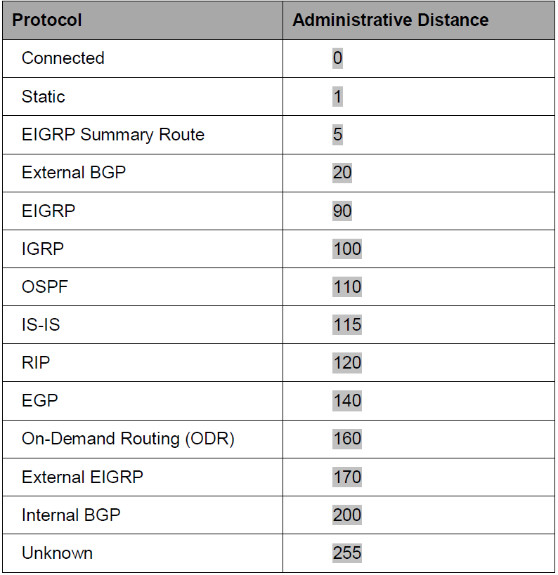

Step 2: Configure router loopbacks and addressing.
Configure all loopback interfaces on the three routers in the diagram. Configure the serial interface with the IP addresses, bring them up, and set a clock rate where appropriate.
R1# conf t
R1(config)# interface loopback 1
R1(config-if)# ip address 172.16.1.1 255.255.255.0
R1(config-if)# interface loopback 101
R1(config-if)# ip address 192.168.101.1 255.255.255.0
R1(config-if)# interface fastethernet 0/0
R1(config-if)# ip address 172.16.12.1 255.255.255.0
R1(config-if)# no shutdown
R1(config-if)# interface serial 0/0/1
R1(config-if)# bandwidth 64
R1(config-if)# ip address 172.16.13.1 255.255.255.0
R1(config-if)# no shutdown
R2# conf t
R2(config)# interface loopback 2
R2(config-if)# ip address 172.16.2.1 255.255.255.0
R2(config-if)# interface loopback 102
R2(config-if)# ip address 192.168.102.1 255.255.255.0
R2(config-if)# interface fastethernet 0/0
R2(config-if)# ip address 172.16.12.2 255.255.255.0
R2(config-if)# no shutdown
R2(config-if)# interface fastethernet 0/1
R2(config-if)# ip address 172.16.23.2 255.255.255.0
R2(config-if)# no shutdown
R3# conf t
R3(config)# interface loopback 3
R3(config-if)# ip address 172.16.3.1 255.255.255.0
R3(config-if)# interface loopback 103
R3(config-if)# ip address 192.168.103.1 255.255.255.0
R3(config-if)# interface fastethernet 0/0
R3(config-if)# ip address 172.16.23.3 255.255.255.0
R3(config-if)# no shutdown
R3(config-if)# interface serial 0/0/0
R3(config-if)# bandwidth 64
R3(config-if)# ip address 172.16.13.3 255.255.255.0
R3(config-if)# clock rate 64000
R3(config-if)# no shutdown

Step 3: Configure switch VLANs.
Configure the switch VLANs, and place the correct access ports in each VLAN.
Switch(config)# vlan 12
Switch(config-vlan)# name R1-R2
Switch(config-vlan)# vlan 23
Switch(config-vlan)# name R2-R3
Switch(config-vlan)# exit
Switch(config)# interface fastEthernet 0/1
Switch(config-if)# description To R1 Fa0/0
Switch(config-if)# switchport mode access
Switch(config-if)# switchport access vlan 12
Switch(config-if)# interface fastEthernet 0/2
Switch(config-if)# description To R2 Fa0/0

Switch(config-if)# switchport mode access
Switch(config-if)# switchport access vlan 12
Switch(config-if)# interface fastEthernet 0/3
Switch(config-if)# description To R3 Fa0/0
Switch(config-if)# switchport mode access
Switch(config-if)# switchport access vlan 23
Switch(config-if)# interface fastEthernet 0/4
Switch(config-if)# description To R2 Fa0/1
Switch(config-if)# switchport mode access
Switch(config-if)# switchport access vlan 23
b. Verify that you can ping across the local subnets.

Step 4: Configure RIP.
Configure RIPv2 on all three routers for the major networks. Disable automatic summarization.

R1(config)# router rip
R1(config-router)# version 2
R1(config-router)# no auto-summary
R1(config-router)# network 172.16.0.0
R1(config-router)# network 192.168.101.0
R2(config)# router rip
R2(config-router)# version 2
R2(config-router)# no auto-summary
R2(config-router)# network 172.16.0.0
R2(config-router)# network 192.168.102.0
R3(config)# router rip
R3(config-router)# version 2
R3(config-router)# no auto-summary
R3(config-router)# network 172.16.0.0
R3(config-router)# network 192.168.103.0

Verify the configuration using the show ip route rip command on each router.
R1# show ip route rip
R2# show ip route rip
R3# show ip route rip

Verify that each router is receiving RIP routes from other routers using the show ip protocols command.
R1# show ip protocols
R2# show ip protocols
R3# show ip protocols
Step 5: Configure OSPF.
Configure OSPF on all routers. Include the entire major network in area 0 on all three routers. Remember to change the network type on the loopback interfaces.

R1(config)# interface loopback 1
R1(config-if)# ip ospf network point-to-point
R1(config-if)# interface loopback 101
R1(config-if)# ip ospf network point-to-point
R1(config-if)# router ospf 1
R1(config-router)# network 172.16.0.0 0.0.255.255 area 0
R1(config-router)# network 192.168.101.0 0.0.0.255 area 0
R2(config)# interface loopback 2
R2(config-if)# ip ospf network point-to-point
R2(config-if)# interface loopback 102
R2(config-if)# ip ospf network point-to-point
R2(config-if)# router ospf 1
R2(config-router)# network 172.16.0.0 0.0.255.255 area 0
R2(config-router)# network 192.168.102.0 0.0.0.255 area 0
R3(config)# interface loopback 3
R3(config-if)# ip ospf network point-to-point
R3(config-if)# interface loopback 103
R3(config-if)# ip ospf network point-to-point
R3(config-if)# router ospf 1
R3(config-router)# network 172.16.0.0 0.0.255.255 area 0
R3(config-router)# network 192.168.103.0 0.0.0.255 area 0

Verify the configuration using the show ip ospf neighbors and show ip route commands on each router.
R1# show ip ospf neighbor
R1# show ip route
R2# show ip ospf neighbor
R2# show ip route
R3# show ip ospf neighbour
R3# show ip route
R1# show ip ospf database router adv-router 192.168.103.1
Step 6: Modify the routing protocol distance.
On all three routers, change the distance of RIP to 100.
R1(config)# router rip
R1(config-router)# distance 100
R2(config)# router rip
R2(config-router)# distance 100
R3(config)# router rip
R3(config-router)# distance 100

Examine the output of the show ip route command. Notice that all the routes have become RIP routes because RIP now has a lower distance than OSPF.
R1# show ip route
R2# show ip route
R3# show ip route
You can display the new default distance for RIP using the show ip protocols command.
R1# show ip protocols

Step 7: Modify distance based on route source.
On all three routers, change the OSPF administrative distance to 85 for any routes being advertised from routers with IDs in the range of 192.168.100.0/21.
R1(config)# router ospf 1
R1(config-router)# distance 85 192.168.100.0 0.0.3.255
R2(config)# router ospf 1
R2(config-router)# distance 85 192.168.100.0 0.0.3.255
R3(config)# router ospf 1
R3(config-router)# distance 85 192.168.100.0 0.0.3.255

Verify the change with the show ip protocols and show ip route commands.
R1# show ip route
R2# show ip route
R3# show ip route
R1# show ip protocols

Step 8: Modify distance based on an access list.
On all three routers, change the distances of the affected routes to 65.
R1(config)# access-list 1 permit 172.16.0.0 0.0.255.255
R1(config)# router rip
R1(config-router)# distance 65 0.0.0.0 255.255.255.255 1
R2(config)# access-list 1 permit 172.16.0.0 0.0.255.255
R2(config)# router rip
R2(config-router)# distance 65 0.0.0.0 255.255.255.255 1
R3(config)# access-list 1 permit 172.16.0.0 0.0.255.255
R3(config)# router rip
R3(config-router)# distance 65 0.0.0.0 255.255.255.255 1
Verify the change with the show ip protocols and show ip route commands.
R1# show ip protocols
R1# show ip route
R2# show ip protocols
R2# show ip route
R3# show ip protocols
R3# show ip route

Practical 4a-Configuring BGP with Default Routing
Topology-

Objectives-
• Configure BGP to exchange routing information with two ISPs.

Description-
The International Travel Agency (ITA) relies extensively on the Internet for sales. For this reason, the ITA has decided to create a multihomed ISP connectivity solution and contracted with two ISPs for Internet connectivity with fault tolerance. Because the ITA is connecting to two different service providers, you must configure BGP, which runs between the ITA boundary router and the two ISP routers.

Required Resources
• 3 routers (Cisco 1841 with Cisco IOS Release 12.4(24)T1 Advanced IP Services or comparable). For each router add HWIC2T for 2 fast-ethernet and 2 serial port interfaces.
• Serial and console cables

Step 1: Prepare the routers for the lab.
Cable the network as shown in the topology diagram. Erase the startup configuration and reload each router to clear previous configurations.
Step 2: Configure the hostname and interface addresses.
Assign the routers hostnames. Using the addressing scheme in the diagram, create the loopback interfaces and apply IP addresses to these and the serial interfaces on ISP1 (R1), ISP2 (R3), and ITA (R2). The ISP loopbacks simulate real networks that can be reached through the ISP. The two loopbacks for the ITA router simulate the connections between the ITA boundary router and their core routers. Set a clock rate on the DCE serial interfaces.

Router R1 (hostname ISP1)
hostname ISP1
!
interface Lo0
description ISP1 Internet Network
ip address 10.1.1.1 255.255.255.0
!
interface Serial0/0/0
description ISP1 -> ITA
ip address 10.0.0.1 255.255.255.252
clock rate 128000
no shutdown
!
end
Router R2 (hostname ITA)
hostname ITA
!
interface Lo0
description Core router network link 1
ip address 192.168.0.1 255.255.255.0
!
interface Lo1
description Core router network link 2
ip address 192.168.1.1 255.255.255.0
!
interface Serial0/0/0
description ITA -> ISP1
ip address 10.0.0.2 255.255.255.252
no shutdown
interface Serial0/0/1
description ITA -> ISP2
ip address 172.16.0.2 255.255.255.252
clock rate 128000
no shutdown
!
end
Router R3 (hostname ISP2)
hostname ISP2
!
interface Lo0
description ISP2 Internet Network
ip address 172.16.1.1 255.255.255.0
!
interface Serial0/0/1
description ISP2 -> ITA
ip address 172.16.0.1 255.255.255.252
no shutdown
!
end

Use ping to test the connectivity between the directly connected routers. Note that router ISP1 cannot reach router ISP2.

Step 3: Configure BGP on the ISP routers.
On the ISP1 and ISP2 routers, configure BGP to peer with the ITA boundary router and advertise the ISP loopback networks.
ISP1(config)# router bgp 200
ISP1(config-router)# neighbor 10.0.0.2 remote-as 100
ISP1(config-router)# network 10.1.1.0 mask 255.255.255.0
ISP2(config)# router bgp 300
ISP2(config-router)# neighbor 172.16.0.2 remote-as 100
ISP2(config-router)# network 172.16.1.0 mask 255.255.255.0

Step 4: Configure BGP on the ITA boundary router.
Configure the ITA router to run BGP with both Internet providers.
ITA(config)# router bgp 100
ITA(config-router)# neighbor 10.0.0.1 remote-as 200
ITA(config-router)# neighbor 172.16.0.1 remote-as 300
ITA(config-router)# network 192.168.0.0
ITA(config-router)# network 192.168.1.0
You should see BGP neighbor peering messages on the console similar to the following.
*Mar 4 14:07:38.667: %BGP-5-ADJCHANGE: neighbor 10.0.0.2 Up
To verify the configuration, check the ITA routing table with the show ip route command.
ITA# show ip route

Step 5: Verify BGP on the routers.
To verify the BGP operation on ITA, issue the show ip bgp command.
ITA# show ip bgp

To verify the operation of ISP1, issue the show ip bgp command.
ISP1# show ip bgp

On the ISP1 router, issue the shutdown command on Loopback0. Then on ITA, issue the show ip bgp command again.
ITA# show ip bgp

Bring ISP1 router Loopback0 back up by issuing the no shutdown command.
On ITA, issue the show ip bgp neighbors command. The

Step 6: Configure route filters.
Check the ISP2 routing table using the show ip route command. ISP2 should have a route that belongs to ISP1, network 10.1.1.0.

ISP2# show ip route

On the ITA router, configure the following access list.
ITA(config)# access-list 1 permit 192.168.0.0 0.0.1.255

Apply this access list as a route filter using the distribute-list keyword with the BGP neighbor statement.
ITA(config)# router bgp 100
ITA(config-router)# neighbor 10.0.0.1 distribute-list 1 out
ITA(config-router)# neighbor 172.16.0.1 distribute-list 1 out

Check the routing table for ISP2 again. The route to 10.1.1.0, ISP1, should still be in the table.
Return to ITA and issue the clear ip bgp * command.
ITA# clear ip bgp *
ISP2# show ip route
ISP1# show ip route

Step 7: Configure primary and backup routes using floating static routes.
With bidirectional communication established with each ISP via BGP, configure the primary and backup routes. This can be done with floating static routes or BGP.
Issue the show ip route command on the ITA router.
ITA# show ip route

Configure static routes to reflect the policy that ISP1 is the primary provider and that ISP2 acts as the backup by specifying a lower distance metric for the route to ISP1 (210) as compared to the backup route to ISP2 (distance metric 220).
ITA(config)# ip route 0.0.0.0 0.0.0.0 10.0.0.1 210
ITA(config)# ip route 0.0.0.0 0.0.0.0 172.16.0.1 220

Verify that a default route is defined using the show ip route command.
ITA# show ip route

Test this default route by creating an unadvertised loopback on the router for ISP1.
ISP1# config t
ISP1(config)# interface loopback 100
ISP1(config-if)# ip address 192.168.100.1 255.255.255.0

Issue the show ip route command to ensure that the newly added 192.168.100.0 /24 network does not appear in the routing table.
ITA# show ip route

In extended ping mode, ping the ISP1 loopback 1 interface 192.168.100.1 with the source originating from the ITA loopback 1 interface 192.168.1.1.
ITA# ping
Protocol [ip]:
Target IP address: 192.168.100.1
Repeat count [5]:
Datagram size [100]:
Timeout in seconds [2]:
Extended commands [n]: y
Source address or interface: 192.168.1.1
Type of service [0]:
Set DF bit in IP header? [no]:
Validate reply data? [no]:
Data pattern [0xABCD]:
Loose, Strict, Record, Timestamp, Verbose[none]:
Sweep range of sizes [n]:
Type escape sequence to abort.
Sending 5, 100-byte ICMP Echos to 192.168.100.1, timeout is 2 seconds:
!!!!!
Success rate is 100 percent (5/5), round-trip min/avg/max = 32/32/36 ms

Step 8: Configure primary and backup routes using a default network and a static route.
Another method for configuring primary and backup routes is to use the ip default-network command instead of a 0.0.0.0/0 route.

Remove the floating static routes configured in Step 7.
ITA(config)# no ip route 0.0.0.0 0.0.0.0 10.0.0.1 210
ITA(config)# no ip route 0.0.0.0 0.0.0.0 172.16.0.1 220

The network that was added in Step 7, 192.168.100.0/24, should now be advertised on the ISP1 router. You might need to wait a few moments for BGP to advertise the new network.
ISP1(config)# router bgp 200
ISP1(config-router)# network 192.168.100.0
ISP1(config-router)# end

Make sure that the classful network 192.168.100.0 /24 appears in the ITA routing table.
ITA# show ip route

On the ITA router, configure the ip default-network statement to reestablish a gateway of last resort.
ITA(config)# ip default-network 192.168.100.0

Wait a few moments and then re-examine the routing table on ITA.
ITA# show ip route

Make ISP2 the backup ISP by adding a backup route on ITA to ISP2 serial 0/0/1 interface 172.16.0.1.
ITA(config)# ip route 0.0.0.0 0.0.0.0 172.16.0.1 220

Verify that this newly added route establishes a consistent default route while the BGP conversation between ITA and ISP1 re-establishes
ITA# show ip route
ITA# clear ip bgp 10.0.0.1
ITA# show ip route
ITA# show ip route

Practical 5a-Configuring OSPF for IPv6

Topology-
Objectives-
• Configure a static IPv6 address on an interface.
• Change the default link-local address on an interface.
• Configure an EUI-64 IPv6 address on an interface.
• Enable IPv6 routing and CEF.
• Configure and verify single-area OSPFv3 operation.

Description-
In this lab, you configure static IPv6 addresses and EUI-64 IPv6 addresses on interfaces. You then configure OSPFv3 to route between the IPv6 networks.
Required Resources
• 3 routers (Cisco 1841 with Cisco IOS Release 12.4(24)T1 Advanced IP Services or comparable)
• 1 switch (Cisco 2960 with the Cisco IOS Release 12.2(46)SE C2960-LANBASEK9-M image or comparable). For each router add HWIC2T for 2 fast-ethernet and 2 serial port interfaces.
• Serial and Ethernet cables

Step 1: Prepare the routers for the lab.
Cable the network as shown in the topology diagram. Erase the startup configuration, and reload each router to clear the previous configurations.

Step 2: Configuring the hostname and loopback interfaces.
Configure the loopback interface on each router with both the IPv4 address and IPv6 address shown in the diagram. The IPv4 address is configured using the ip address address mask command. The IPv6 address configuration is similar, using the ipv6 address address/mask command.
Router(config)# hostname R1
R1(config)# interface loopback0
R1(config-if)# ip address 10.1.1.1 255.255.255.0
R1(config-if)# ipv6 address FEC0::1:1/112
Router(config)# hostname R2
R2(config)# interface loopback0
R2(config-if)# ip address 10.1.2.1 255.255.255.0
R2(config-if)# ipv6 address FEC0::2:1/112
Router(config)# hostname R3
R3(config)# interface loopback0
R3(config-if)# ip address 10.1.3.1 255.255.255.0
R3(config-if)# ipv6 address FEC0::3:1/112
Step 3: Configure static IPv6 addresses.
Configure the two serial links with IPv6 addresses. Use the ipv6 address address/mask command to configure the interfaces with the addresses shown in the diagram. Set the clock rates where appropriate, and bring up the interfaces.

R1(config)# interface serial0/0/0
R1(config-if)# ipv6 address FEC0::12:1/112
R1(config-if)# clockrate 64000
R1(config-if)# bandwidth 64
R1(config-if)# no shutdown
R1(config-if)# interface serial0/0/1
R1(config-if)# ipv6 address FEC0::13:1/112
R1(config-if)# bandwidth 64
R1(config-if)# no shutdown
R2(config)# interface serial0/0/0
R2(config-if)# ipv6 address FEC0::12:2/112
R2(config-if)# bandwidth 64
R2(config-if)# no shutdown
R3(config)# interface serial0/0/0
R3(config-if)# ipv6 address FEC0::13:3/112
R3(config-if)# clockrate 64000
R3(config-if)# bandwidth 64
R3(config-if)# no shutdown
Use ping to verify local subnet connectivity.
R1# ping FEC0::12:2
R1# ping FEC0::13:3
R2# ping FEC0::12:1
R3# ping FEC0::13:1

Step 4: Change the link-local address on an interface.
Use the show ipv6 interface command to look at IPv6-related properties of the router interfaces. You can also specify a type/number of an interface to see the output of that interface only.
R1# show ipv6 interface serial 0/0/0
R2# show ipv6 interface serial 0/0/0

To change the link-local address, use the ipv6 address address link-local command.
R1(config)# interface serial0/0/0
R1(config-if)# ipv6 address FE80::1 link-local
R2(config)# interface serial0/0/0
R2(config-if)# ipv6 address FE80::2 link-local

Verify that you can ping the link-local address on the other side. When pinging link-local addresses, you must specify an outgoing interface because the addresses are not routed and not in the routing table.
R1# ping FE80::2
Output Interface: Serial0/0/0
R2# ping FE80::1
Output Interface: Serial0/0/0
Verify the link-local addresses with the show ipv6 interface command.
R1# show ipv6 interface serial 0/0/0
R2# show ipv6 interface serial 0/0/0
Step 5: Configure EUI-64 addresses.
Configure IPv6 EUI-64 addresses on an interface using the ipv6 address address/mask eui-64 command. Configure the R2 and R3 Fast Ethernet interfaces with the subnet shown in the diagram, and enable the interfaces.
R2(config)# interface fastEthernet 0/0
R2(config-if)# ipv6 address FEC0:23::/64 eui-64
R2(config-if)# no shutdown
R3(config)# interface fastEthernet 0/0
R3(config-if)# ipv6 address FEC0:23::/64 eui-64
R3(config-if)# no shutdown

Get the IPv6 addresses of the interfaces with the show ipv6 interface or show ipv6 interface brief command, and then ping the other side of the link.

R2# show ipv6 interface fastEthernet 0/0
R2# show ipv6 interface brief
R3# show ipv6 interface brief
R2# ping FEC0:23::218:B9FF:FECD:BEF0
R3# ping FEC0:23::218:B9FF:FE92:28D8

Step 6: Enable IPv6 routing and CEF.
To enable IPv6 routing, use the ipv6 unicast-routing command in global configuration mode. To enable IPv6 CEF, use the ipv6 cef command. Enter these commands on all three routers.
R1(config)# ipv6 unicast-routing
R1(config)# ipv6 cef
R2(config)# ipv6 unicast-routing
R2(config)# ipv6 cef
R3(config)# ipv6 unicast-routing
R3(config)# ipv6 cef
Step 7: Configure OSPFv3.
Unlike IPv4 OSPF, where networks are added to the OSPF process using network statements under the routing protocol configuration prompt, IPv6 OSPF uses the interface-level command ipv6 ospf process area area-id to add an interface to an area.
R1(config)# interface loopback0
R1(config-if)# ipv6 ospf 1 area 0
R1(config-if)# interface serial0/0/0
R1(config-if)# ipv6 ospf 1 area 0
R1(config-if)# interface serial0/0/1
R1(config-if)# ipv6 ospf 1 area 0
R2(config)# interface loopback0
R2(config-if)# ipv6 ospf 1 area 0
R2(config-if)# interface serial0/0/0
R2(config-if)# ipv6 ospf 1 area 0
R2(config-if)# interface fastEthernet 0/0
R2(config-if)# ipv6 ospf 1 area 0
R3(config)# interface loopback0
R3(config-if)# ipv6 ospf 1 area 0
R3(config-if)# interface serial0/0/0
R3(config-if)# ipv6 ospf 1 area 0
R3(config-if)# interface fastEthernet 0/0
R3(config-if)# ipv6 ospf 1 area 0

Verify that you have OSPFv3 neighbors with the show ipv6 ospf neighbor command.
R1# show ipv6 ospf neighbor
R2# show ipv6 ospf neighbour
R3# show ipv6 ospf neighbour

View the routing table on all three routers with the show ipv6 route command.
R1# show ipv6 route
R2# show ipv6 route
R3# show ipv6 route

You can also look at per-interface OSPF behavior with the show ipv6 ospf interface command.
R1# show ipv6 ospf interface
R2# show ipv6 ospf interface
R3# show ipv6 ospf interface

Practical 5b- Tunneling router ipv6 to ipv4 with Packet Tracer
Toplogy:
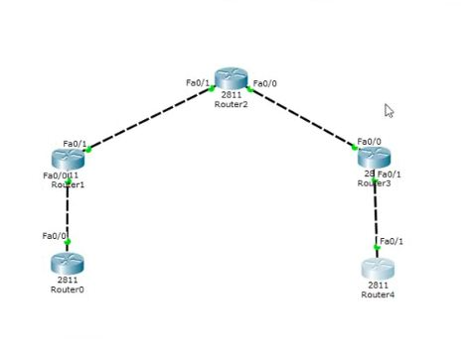
Objectives-
- Configure all 5 routers as ospf routers.
- Create a 6to4 tunnel.

Requirements-
- 5 routers (Cisco 2811 with Cisco IOS Release 12.4(24)T1 Advanced IP Services or comparable)
- FastEthernet cables.

Step1- Configure all the routers with OSPF Configuration
For Router 1 -> Open Command Line Interface
Router>enable
Router#configure terminal
Enter configuration commands, one per line. End with CNTL/Z.
Router(config)#ipv6 unicast-routing
Router(config)#interface fastEthernet0/0
Router(config-if)#ipv6 enable
Router(config-if)#ipv6 address 1000:1:1:1:1:1:1:1158/112
Router(config-if)#ipv6 rip 6bone enable
Router(config-if)#no shutdown
Router(config-if)#
%LINK-5-CHANGED: Interface FastEthernet0/0, changed state to up
Router(config-if)#exit
Router(config)#exit
Router#

Step2- For Router 2-> Open Command Line Interface
Step a:
Router>enable
Router#configure terminal
Enter configuration commands, one per line. End with CNTL/Z.
Router(config)#ipv6 unicast-routing
Router(config-if)#interface tunnel0
Router(config-if)#
%LINK-5-CHANGED: Interface tunnel0, changed state to up
Router(config-if)#ipv6 address 2000::1/64
Router(config-if)#ipv6 rip 6bone enable
Router(config)# interface fastEhernet0/1
Router(config-if)#ipv6 address 192.168.10.1 255.255.255.0
Router(config-if)#no shut
%LINK-5-CHANGED: Interface FastEthernet0/1, changed state to up
Router(config-if)#exit
Router(config)# interface fastEhernet0/0
Router(config-if)#ipv6 enable
Router(config-if)# ipv6 address 1000::2/64
Router(config-if)#ipv6 rip 6bone enable
Router(config-if)#no shut
%LINK-5-CHANGED: Interface FastEthernet0/0, changed state to up
Router(config-if)#exit
Next Step b :
Router(config-if)#router ospf1
Router(config-router)#network 192.168.10.0 0.0.0.255 area 0
Router(config-router)#exit
Router(config)#exit

Step 3- For Router 3-> Open Command Line Interface
Step a:
Router>enable
Router#configure terminal
Enter configuration commands, one per line. End with CNTL/Z.
Router(config)# interface fastEhernet0/1
Router(config-if)#ipv6 address 192.168.10.2 255.255.255.0
Router(config-if)#no shut
%LINK-5-CHANGED: Interface FastEthernet0/1, changed state to up
Router(config-if)#exit
Router(config)# interface fastEhernet0/0
Router(config-if)# ipv6 address 192.168.20.2 255.255.255.0
Router(config-if)#no shut
%LINK-5-CHANGED: Interface FastEthernet0/0, changed state to up
Router(config-if)#exit

Next Step b:
Router(config)#router ospf1
Router(config-router)#network 192.168.10.1 0.0.0.255 area 0
Router(config-router)#network 192.168.20.0 0.0.0.255 area 0
Router(config-router)#exit
Router(config)#exit
Router#

Step 4- For Router 4-> Open Command Line Interface
Step a:
Router>enable
Router#configure terminal
Enter configuration commands, one per line. End with CNTL/Z.
Router(config)#ipv6 unicast-routing
Router(config-if)#interface tunnel0
Router(config-if)#
%LINK-5-CHANGED: Interface tunnel0, changed state to up
Router(config-if)#ipv6 address 2000::2/64
Router(config-if)#ipv6 rip 6bone enable
Router(config-if)#tunnel source fasteEthernet0/0
Router(config-if)#tunnel destination 192.168.10.1
Router(config-if)#tunnel mode ipv6ip
Router(config-if)#no shut
Router(config-if)#exit
Next Step b:
Router(config)#interace fastEthernet0/0
Router(config-if)#ipv6 address 192.168.20.1 255.255.255.0
Router(config-if)#no shut
%LINK-5-CHANGED: Interface FastEthernet0/0, changed state to up
Router(config-if)#exit
Router(config)# interface fastEhernet0/1
Router(config-if)#ipv6 enable
Router(config-if)#ipv6 address 3000::2/64
Router(config-if)#ipv6 rip 6bone enable
Router(config-if)#no shut
%LINK-5-CHANGED: Interface FastEthernet0/1, changed state to up
Router(config-if)#exit
Next Step c:
Router(config)#router ospf1
Router(config-router)#network 192.168.20.0 0.0.0.255 area 0
Router(config-router)#exit
Router(config)#exit
Router#

Step 5-For Router 5-> Open Command Line Interface
Router>enable
Router#configure terminal
Enter configuration commands, one per line. End with CNTL/Z.
Router(config)#ipv6 unicast-routing
Router(config)#interface fastEthernet0/1
Router(config-if)#ipv6 enable
Router(config-if)#ipv6 address 3000:1:1:1:1:1:1:1158/112
Router(config-if)#ipv6 rip 6bone enable
Router(config-if)#no shutdown
Router(config-if)#
%LINK-5-CHANGED: Interface FastEthernet0/0, changed state to up
Router(config-if)#exit
Router(config)#exit

Now Test the Connectivity by Pinging Router 1 To Router 5
i.e. the First router to the last router !!

In Router 5-> Open Command Line Interface
Router>ping ipv6 3000:1:1:1:1:1:1:1158/112
Success rate should be 100% for the ping command.
Also Ping from Router 5 to Router 1
Router>ping ipv6 1000:1:1:1:1:1:1:1158/112
Success rate should be 100% for the ping command.
If Both the Ping commands give successful output then the activity can be considered as completed.

Practical 6a-Static VLANS, VLAN Trunking, and VTP Domains and Modes
Topology
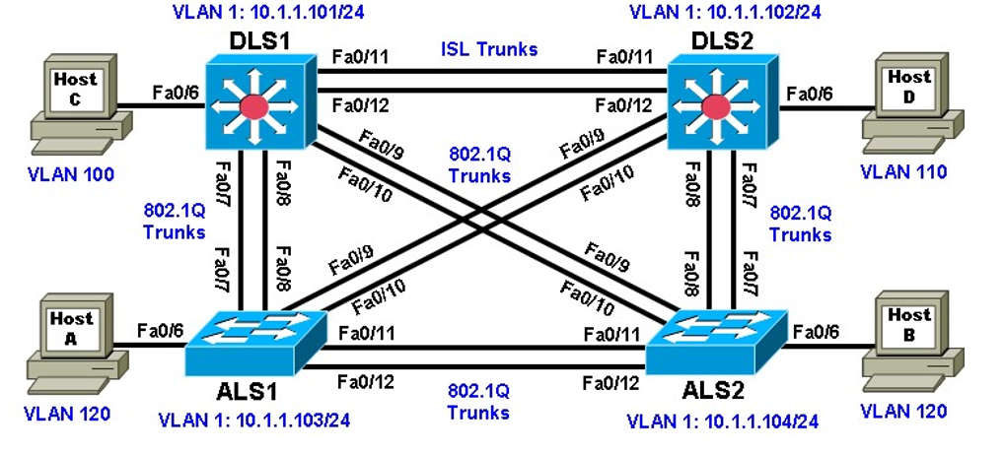
Objectives
- Set up a VTP domain.
- Create and maintain VLANs.
- Configure ISL and 802.1Q trunking.
Background
VLANs logically segment a network by function, team, or application, regardless of the physical location of the users. End stations in a particular IP subnet are often associated with a specific VLAN. VLAN membership on a switch that is assigned manually for each interface is known as static VLAN membership.
Trunking, or connecting switches, and the VLAN Trunking Protocol (VTP) are technologies that support VLANs. VTP manages the addition, deletion, and renaming of VLANs on the entire network from a single central switch.

Required Resources
- 2 switches (Cisco 2960 with the Cisco IOS Release 12.2(46)SE C2960-LANBASEK9-M image or comparable)
- 2 switches (Cisco 3560 with the Cisco IOS Release 12.2(46)SE C3560-ADVIPSERVICESK9-M image or comparable)
- 4 PCs (optional)
- Ethernet and console cables
Step 1: Prepare the switches for the lab.
Power up the switches and use the standard process for establishing a HyperTerminal console connection from a workstation to each switch in your pod. If you are connecting remotely to the switches, follow the instructions that have been supplied by your instructor.
Step 2: Configure basic switch parameters.
Assign each switch a hostname and configure an IP address on the management VLAN according to the diagram. By default, VLAN 1 is used as the management VLAN.
Enter basic configuration commands on each switch according to the diagram. DLS1 example:
Switch# configure terminal
Enter configuration commands, one per line. End with CNTL/Z.
Switch(config)# hostname DLS1
DLS1(config)# interface vlan 1
DLS1(config-if)# ip address 10.1.1.101 255.255.255.0
DLS1(config-if)# no shutdown
(Optional) On each switch, create an enable secret password and configure the vty lines to allow remote access from other network devices. DLS1 example:
DLS1(config)# enable secret cisco
DLS1(config)# line vty 0 15
DLS1(config-line)# password cisco
DLS1(config-line)# login

Step 3: Display the switch default VLAN information.
Use the show vlan command in privileged mode on any switch. The following output is for a 2960 switch. ALS1# show vlan
DLS1# show vlan

Step 4: Examine VTP information.
A VTP domain, also called a VLAN management domain, consists of trunked switches that are under the administrative responsibility of a switch or switches in server VTP mode. A switch can be in only one VTP domain with the same VTP domain name. The default VTP mode for the 2960 and 3560 switches is server mode. VLAN information is not propagated until a domain name is specified and trunks are set up between the devices.
The following table describes the three VTP modes.
VTP Mode | Description
VTP server | You can create, modify, and delete VLANs and specify other configuration parameters, such as VTP version and VTP pruning, for the entire VTP domain. VTP servers advertise their VLAN configuration to other switches in the same VTP domain and synchronize their VLAN configuration with other switches based on advertisements received over trunk links.  VTP server is the default mode.
VTP client | VTP clients behave the same way as VTP servers, but you cannot create, change, or delete VLANs on a VTP client.
VTP transparent | VTP transparent switches do not participate in VTP. A VTP transparent switch does not advertise its VLAN configuration nor synchronize its VLAN configuration based on received advertisements. Transparent switches do forward VTP advertisements that they receive out their trunk ports in VTP Version 2.

Use the show vtp status command on any switch. The output should be similar to the following sample for DLS1.
DLS1# show vtp status
Because no VLAN configurations were made, all settings are the defaults. Notice that the VTP mode is server mode. The number of existing VLANs is the five built-in VLANs. The 3560 switch supports 1,005 maximum VLANs locally. The 2960 switch supports 255 VLANs. The configuration revision is 0, and the default VTP version is 1. All switches in the VTP domain must run the same VTP version.
The importance of the configuration revision number is that the switch with the highest revision number in VTP server mode propagates VLAN information over trunked ports. Every time VLAN information is modified and saved in the VLAN database or vlan.dat file, the revision number is increased by one when the user exits from VLAN configuration mode.
Multiple switches in the VTP domain can be in VTP server mode. These switches can be used to manage all other switches in the VTP domain. This is suitable for small-scale networks where the VLAN information is small and easily stored in all switches. In a large network, the administrator must determine which switches make the best VTP servers. The network administrator should select switches to function as VTP servers. The other switches in the VTP domain can be configured as clients. The number of VTP servers should be consistent based on the amount of redundancy desired in the network.
Step 5: Configure VTP on the switches.
Change the VTP domain name on DLS1 to SWLAB using the vtp domain command. If the VTP version defaults to 1, set it manually to version 2 using the vtp version command.
DLS1(config)# vtp domain SWLAB
Changing VTP domain name from NULL to SWLAB

DLS1(config)# vtp version 2
Set up the switches so that the distribution layer switches are in VTP server mode, and the access layer switches are in VTP client mode. Set the version number to 2 on the DL switches.
DLS1(config)# vtp mode server
device mode already VTP SERVER.
Because the default mode is server, you receive a message on DLS1 stating that the device mode is already VTP server.
ALS1(config)# vtp mode client Setting device to VTP CLIENT mode.
Use the show vtp status command on either of the AL switches. The output should be similar to the following sample for ALS1.
ALS1# show vtp status

Step 6: Configure trunking.
The show interfaces switchport command lists the configured mode of each port in detail. The following partial sample output is for a 2960 switch on Fa0/7.
ALS# show interfaces fastEthernet 0/7 switchport
Administrative mode:dynamic auto
The 2960 and 3560 switches have a range command that you can use to designate multiple individual ports or a continuous range of ports for an operation. Use the interface range command to configure all trunk ports at once for trunking. The following is a sample configuration for the 802.1Q and ISL trunk ports on DLS1.
DLS1(config)# interface range fastEthernet 0/7 - 10
DLS1(config-if-range)# switchport trunk encapsulation dot1q
DLS1(config-if-range)# switchport mode trunk

DLS1(config)# interface range fastEthernet 0/11 - 12
DLS1(config-if-range)# switchport trunk encapsulation isl (not required)
DLS1(config-if-range)# switchport mode trunk
The following is a sample configuration for the trunk ports on ALS1.
ALS1(config)# interface range fastEthernet 0/7 – 12
ALS1(config-if)# switchport mode trunk
The following is a sample configuration for the trunk ports on DLS2.
DLS2(config)# interface range fastEthernet 0/7 - 8
DLS2(config-if-range)# switchport trunk encapsulation dot1q
DLS2(config-if-range)# switchport mode trunk
Step 7: Verify trunk configuration. Use the show interfacefastEthernet 0/7 switchport command on ALS2.
ALS2# show interfaces fastEthernet 0/7 switchport
Name: Fa0/7
Administrative mode:dynamic auto
Trunking native mode vlan:1(default)
Once the above command was issued, trunking was negotiated between the two switch ports. Use the show interfaces trunk command on DLS1.
DLS1# show interfaces trunk
Use the show interfaces trunk command on DLS2.
DLS2# show interfaces trunk

Step 8: Configure access ports.
A port on the 2960 switch can operate in one of three modes, and a port on the 3560 switch can operate in one of five modes. Use the switchport mode ? command for interface Fast Ethernet 0/6 in interface configuration mode to view the modes. The following command output is for a 2960 switch.
ALS1(config)# interface fastEthernet 0/6
ALS1#(config-if)# switchport mode ? access Set trunking mode to ACCESS unconditionally
dynamic Set trunking mode to dynamically negotiate access or trunk mode trunk Set trunking mode to TRUNK unconditionally
The following command output is for a 3560 switch.
DLS1(config)# interface fastEthernet 0/6
DLS1(config-if)# switchport mode ? access Set trunking mode to ACCESS unconditionally dot1q-tunnel set trunking mode to TUNNEL unconditionally
dynamic Set trunking mode to dynamically negotiate access or trunk mode
private-vlan Set the mode to private-vlan host or promiscuous trunk Set trunking mode to TRUNK unconditionally
The Fast Ethernet ports connected to the hosts on the network can be set up as static access because they are not to be used as trunk ports. Use the switchport mode access command to set the access mode on the Fast Ethernet 0/6 port on all four switches in the pod. The following is a sample configuration for the access port on ALS1.
ALS1(config)# interface fastEthernet 0/6 ALS1(config-if)# switchport mode access
Use the show interfaces command for Fast Ethernet 0/6 to verify the configuration. The following command is for a 3560 switch.
DLS1# show interfaces fastEthernet 0/6 switchport
Administrative mode:static access
Step 9: Verify VTP configuration.
Before configuring the VLANs, verify the VTP configuration within the domain by using the show vtp status command on ALS1 and ALS2. The following sample output is from ALS1.
ALS1# show vtp status
ALS2# show vtp status

At this point, all switches in the lab are in VTP domain SWLAB and have five existing VLANs. All are running VTP version 2. DLS1 and DLS2 are configured as VTP servers, and ALS1 and ALS2 are configured as clients.
Step 10: Configure VLANs by assigning port membership.
VLANs can be configured on a switch in different ways, depending on the type of switch used and the Cisco IOS version.
DLS1# vlan database
Use the switchport access vlan command to assign port 6 on DLS1 and DLS2, according to the diagram. Port Fast Ethernet 0/6 of DLS1 will be assigned to VLAN 100, and Fast Ethernet 0/6 on DLS2 will be assigned to VLAN 110. The following command is for the 3560 switches.
DLS1(config)# interface FastEthernet 0/6
DLS1(config-if-range)# switchport access vlan 100 % Access VLAN does not exist. Creating vlan 100
VLAN 100 was created at the same time port 6 was assigned to it. Configure DLS2 in the manner similar to DLS1, but this time use VLAN 110.
DLS2(config)# interface FastEthernet 0/6
DLS2(config-if-range)# switchport access vlan 110
% Access VLAN does not exist. Creating vlan 110
Issue the show vlan command on DLS1 to verify that VLANs 100 and 110 have been created. The output should be similar to the following output.
DLS1# show vlan
Because VLAN 100 and 110 were not named, the switch automatically assigns default names, which are VLAN0100 and VLAN0110.
Step 11: Configure VLANs in configuration mode.
Another way of creating VLANs is to create them in configuration mode without assigning port membership.
You can create a VLAN in global configuration mode using the vlan command. Because ALS1 and ALS2 are configured for VTP client mode and it is not possible to create a VLAN when a switch is in client mode, you must create the VLAN on the switch that is acting as a server for the network. The VLAN then propagates to the other switches that are in client mode. Issue the vlan command in global configuration mode on DLS1.
DLS1(config)# vlan 120
Ports still need to be assigned to VLAN 120. Port assignment to a VLAN is an interface configuration operation. Use the switchport access vlan command on Fast Ethernet 0/6 of ALS1 and ALS2 to configure ports for VLAN 120.
ALS1(config)# interface fastEthernet 0/6
ALS1(config-if)# switchport access vlan 120

ALS2(config)# interface fastEthernet 0/6
ALS2(config-if)# switchport access vlan 120
Use the show vlan command to verify the creation of VLAN 120, with port Fa0/6 assigned to it. The output should be similar to the following.
ALS1# show vlan
Step 12: Change the VLAN names.
The VLANs have not been named yet. Naming VLANs can help network administrators identify the functionality of those VLANs. To add names, use the name command in VLAN configuration mode. The following is a sample configuration for naming the three VLANs created in the domain.
DLS1(config)# vlan 100
DLS1(config-vlan)# name Server-Farm-1
DLS1(config-vlan)# exit
DLS1(config)# vlan 110
DLS1(config-vlan)# name Server-Farm-2
DLS1(config-vlan)# exit DLS1(config)# vlan 120
DLS1(config-vlan)# name Net-Eng DLS1(config-vlan)# exit Use the show vlan command on DLS1 to verify that the new names have been added.
DLS1# show vlan

Step 13: Change the VLAN status to deactivate ports.
The default status of VLAN 1 and user-created VLANs is "active". A VLAN can be made locally inactive in the VLAN configuration mode by entering the command shutdown for the particular VLAN (does not apply to an SVI). This will cause all ports on a switch in a particular VLAN to stop transmitting data. Shutting down the VLAN on a switch does not influence its state on other switches in a VTP domain.
Shutdown the Net-Eng VLAN 120 on ALS1, wait a few moments, exit vlan configuration mode and then issue the show vlan brief command. The status should change to “act/lshut”.
ALS1(config)# vlan 120
ALS1(config-vlan)# shutdown

ALS1# show vlan brief
Reactivate all ports in ALS1 Net-Eng VLAN 120 using the no shutdown command in VLAN configuration mode..
ALS1(config)# vlan 120
Suspending a VLAN causes all ports in that VLAN throughout the VTP domain to stop transferring data.
Suspend Net-Eng VLAN 120 on ALS1, wait a few moments, exit VLAN configuration mode and then issue the show vlan brief command. The status should change to “suspended”.
ALS1(config)# vlan 120
ALS1(config-vlan)# state suspend

ALS1# show vlan brief
Reactivate VLAN 120 using the state active command in VLAN configuration mode..
ALS1(config)# vlan 120
ALS1(config-vlan)# state active

Step 14: Prepare for the next lab.
Prepare for the next lab by removing all the VLAN information and configurations. The VLAN database and startup configuration need to be deleted

Practical 6b-Configuring EtherChannel
Topology-
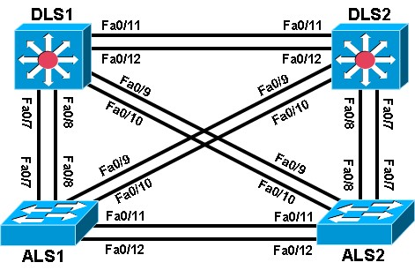
Objective
• Configure EtherChannel.
Background
Four switches have just been installed. The distribution layer switches are Catalyst 3560 switches, and the access layer switches are Catalyst 2960 switches. There are redundant uplinks between the access layer and distribution layer. Usually, only one of these links could be used; otherwise, a bridging loop might occur. However, using only one link utilizes only half of the available bandwidth. EtherChannel allows up to eight redundant links to be bundled together into one logical link. In this lab, you configure Port Aggregation Protocol (PAgP), a Cisco EtherChannel protocol, and Link Aggregation Control Protocol (LACP), an IEEE 802.3ad open standard version of EtherChannel.
Required Resources
- 2 switches (Cisco 2960 with the Cisco IOS Release 12.2(46)SE C2960-LANBASEK9-M image or comparable)
- 2 switches (Cisco 3560 with the Cisco IOS Release 12.2(46)SE C3560- ADVIPSERVICESK9-M image or comparable)
- Ethernet and console cables
Step 1: Prepare the switches for the lab.
Delete vlan.dat, erase the startup configuration, and reload all your switches.
Switch# delete vlan.dat
Delete flash:vlan.dat? [confirm]
Switch#
Switch# erase startup-config
Erasing the nvram filesystem will remove all configuration file Continue?
[confirm]
[OK]
Erase of nvram complete
Switch#
Switch# reload

Step 2: Configure basic switch parameters.
- Assign each switch a hostname according to the topology diagram.
Configure ports Fa0/7 through Fa0/12 as trunks. On the 3560 switches, you must first set the trunk encapsulation to 802.1Q. On the 2960s, only dot1q is supported, therefore the switchport trunk encapsulation command is unavailable, but the mode still needs to be changed to trunk
DLS1# configure terminal
Enter configuration commands, one per line. End with CNTL/Z.
DLS1(config)# interface range fastEthernet 0/7 - 12
DLS1(config-if-range)# switchport trunk encapsulation dot1q DLS1(config-if-range)# switchport mode trunk
Step 3: Configure an EtherChannel with Cisco PAgP.
The first EtherChannel created for this lab aggregates ports Fa0/11 and Fa0/12 between ALS1 and ALS2. Make sure that you have a trunk link active for those two links with the show interfaces trunk command.
ALS1# show interfaces trunk
On both switches, add ports Fa0/11 and Fa0/12 to port channel 1 with the channel-group 1 mode desirable command. The mode desirable option indicates that you want the switch to actively negotiate to form a PAgP link.
ALS1(config)# interface range fastEthernet 0/11 - 12
ALS1(config-if-range)# channel-group 1 mode desirable
Creating a port-channel interface Port-channel 1
Configure the logical interface to become a trunk by first entering the interface port-channel number command and then the switchport mode trunk command. Add this configuration to both switches.
ALS1(config)# interface port-channel 1
ALS1(config-if)# switchport mode trunk
Verify that EtherChannel is working by issuing the show etherchannel summary command on both switches. This command displays the type of EtherChannel, the ports utilized, and port states.
ALS1# show etherchannel summary
ALS2# show etherchannel summary
If the EtherChannel does not come up, you might want to try “flapping” the physical interfaces on both ends of the EtherChannel. This involves using the shut command on those interfaces, followed by a no shut command a few seconds later.
The show interfaces trunk and show spanning-tree commands also show the port channel as one logical link.
ALS1# show interfaces trunk
ALS1# show spanning-tree
Configure the link between DLS1 and ALS1 on ports Fa0/7 and Fa0/8 as an LACP EtherChannel. You must use a different port channel number on ALS1 than 1, because you already used that in the previous step. To configure a port channel as LACP, use the interface-level command channel-group number mode active. Active mode indicates that the switch actively tries to negotiate that link as LACP, as opposed to PAgP.
ALS1(config)# interface range fastEthernet 0/7 - 8
ALS1(config-if-range)# channel-group 2 mode active
Creating a port-channel interface Port-channel 2

ALS1(config-if-range)# interface port-channel 2
ALS1(config-if)# switchport mode trunk
Apply a similar configuration on DLS1. Verify the configuration with the show etherchannel summary command.
ALS1# show etherchannel summary
Step 5: Configure a Layer 3 EtherChannel.
In the previous steps, you configured EtherChannels as Layer 2 trunk connections between switches. You can also configure EtherChannels as Layer 3 (routed) connections on switches that support routed ports. Because DLS1 and DLS2 are both multilayer switches, they can support routed ports.
Use the no switchport command on Fa0/11 and Fa0/12 to make them Layer 3 ports, and then add them to the channel group with the channel-group number mode desirable command. On the logical interface, issue the no switchport command to make it a Layer 3 port. Add the IP address 10.0.0.1 for DLS1 and 10.0.0.2 for DLS2. Configure both with a /24 subnet mask.
DLS1(config)# interface range fastEthernet 0/11 - 12
DLS1(config-if-range)# no switchport
DLS1(config-if-range)# channel-group 3 mode desirable
Creating a port-channel interface Port-channel 3 DLS1(config-if-range)# interface port-channel 3
DLS1(config-if)# no switchport
DLS1(config-if)# ip address 10.0.0.1 255.255.255.0
Verify that you have Layer 3 connectivity by attempting to ping the other side of the link.
DLS1# ping 10.0.0.2

If you look at the output of the show etherchannel summary command, you see that it lists the port channel as a routed port, not a switched port. The RU in parentheses next to the name means routed and up, as opposed to switched and up (SU).
DLS1# show etherchannel summary

Step 6: Configure load balancing.
The switches can use different methods to load-balance traffic going through a port channel. The available methods as well as the default method used varies by hardware platform. By default, Cisco Catalyst 3560 and Catalyst 2960 switches load-balance using the source MAC address.
You can view the current load-balancing configuration with the show etherchannel load-balance command.
DLS1# show etherchannel load-balance

Other methods of load balancing are based on the destination MAC address, both source and destination MAC addresses, source IP address, destination IP address, and both source and destination IP addresses.
For this scenario, configure ALS1 to load-balance by both source and destination MAC addresses using the global configuration command port-channel load-balance method, where the method is src-dstmac.
ALS1(config)# port-channel load-balance src-dst-mac
Verify the configuration with the show etherchannel load-balance command. ALS1# show etherchannel load-balance
Challenge
The topology still has redundant links that you can aggregate. Experiment with the other port channel modes using the question mark on the interface-level command channel-group number mode ?. Look at the descriptions and implement some port channels in different ways. If The port mode is set to desirable, auto, active or passive (when PAgP or LACP are used), the command channel-protocol can be used. It cannot be used with channel-group number mode on command. The “on” mode statically sets the EtherChannel protocol without negotiation.

Practical 7a- Spanning Tree Protocol (STP) Default Behavior
Topology-
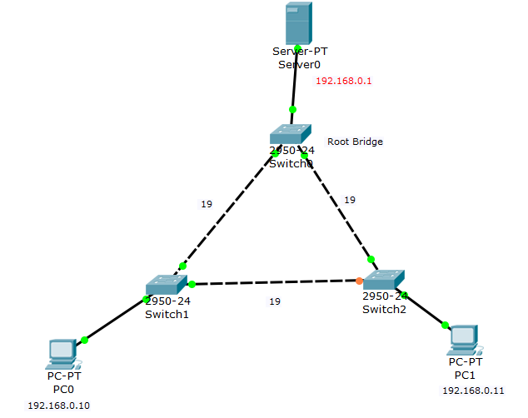

Objective-
- Find the Root Bridge.
- Select the best path to root bridge.
- Block unnecessary ports.
Requirements-
- 3 switches (Cisco 2950)
- 2 PCs (PC-PT)
- 1 Server(Server-PT)
- Consoles Cables
Step1:
After creating the given above topology, go to switch 0-> CLI
Switch>en
Switch#show spanning-tree
Check for other 2 switches also switch1 and switch2.
After running the above command we can find the root bridge switch from the description.
Root Bridge ID is found as-
Bridge ID=32768 + Mac address.
32768 + VLAN ID= 32768 + 1(VLAN001)=32769
Step2: In Switch 0
Switch>en
Switch# sh version
Check for all other 2 switches also.

To find the STP cost according to the data rate, follow the below table
Data rate STP cost
4 Mbps 250
10 Mbps 100
16 Mbps 62
100 Mbps 19
1 Gbps 4
2 Gbps 3
10 Gbps 2
Accordingly the link between the switches will have cost as 19 as it has 100 Mbps data rate.
Switch 0 is root bridge so run below command
Switch>en
Switch#sh spanning-tree
Run the above commands for other 2 switches and compare.
In switch2, there are 3 interfaces out of which one is root, designated and one is blocked as the mac address is lower than root bridge so it is blocked.
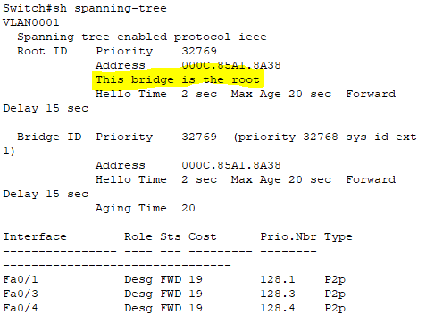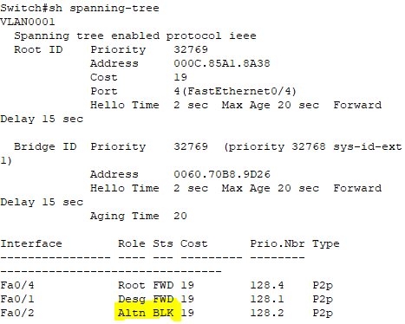

Step 3:
Go to Switch 2
Switch#conf t
Switch#spanning-tree ?
Switch#spanning-tree vlan ?
Switch#spanning-tree vlan 1 root primary
We can see the topology changes and switch 2 becomes the root bridge
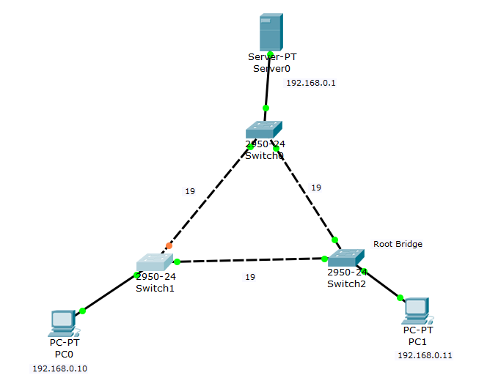

Step 4:
Insert the IP address for 2 PCs and the server
Step 5:
Ping from PCs 0 to server
Then shutdown from switch 1 the root interface fa0/2
Switch>en
Switch#conf t
Switch#int fa0/2
Switch# shut
Then ping again from PC0
PC0# ping –t 192.168.0.1
-t is for continues ping

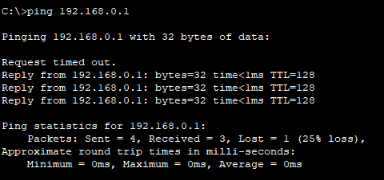
In above output is shows after shut command fa0/2 stops pinging and finds the best path for to communicate with the server with help for root bridge on switch 2.
