CURATE
Product Strategy, Feature Roadmap & Google AI Studio Build Prompts
MVP strategy document — October 2026
Everything worth exploring. On your schedule.
Scope note: This document consolidates the product strategy, screenshot-based UX audit, feature roadmap, monetization direction, growth/metrics framework, AI-built-product risks, and the sequential Google AI Studio prompts developed in this conversation. Claims about the interface are based on the screenshots supplied in the conversation. Any unverified market, pricing, CAC, LTV, or legal figures are explicitly marked as assumptions or validation items rather than presented as facts.

Executive summary
3 biggest opportunities | 3 biggest problems
Own the niche between visual curation and consumption planning. Cosmos/Pinterest-like collecting is not the end state; Curate can own the transition from saved content to scheduled consumption. | The current interface communicates “save and curate” more strongly than “why schedule?” A new user can mistake Curate for a beautiful bookmarking canvas.
Make time-aware planning the utility layer. The combination of weekly time budget, content duration, drag-and-drop scheduling, and a visual calendar is the clearest functional wedge. | The calendar can become a planning exercise unless completion and weekly return loops are built in.
Keep AI optional. A deterministic planning engine can solve much of the core problem at zero model cost. AI can be a late-stage, narrow add-on only if real users demonstrate a problem rules cannot solve. | The biggest strategic risk is feature sprawl before product-market signal. Social features, AI chat, complex tagging, gamification, and integrations should not precede proof that the core loop works.

North-star product model
SAVE → ORGANIZE → PLAN → CONSUME → COMPLETE
Core problem: “I save too much interesting content and never actually consume it.”
Core promise: Curate is a visual planner for everything a person wants to watch, read, listen to, and learn.
Recommended short positioning: Everything worth exploring. On your schedule.

Observed product strengths from the supplied screenshots
- The infinite canvas gives the product an immediately distinctive visual identity and makes the collection feel personal rather than database-like.
- The Inbox-to-Calendar relationship is strong: unscheduled cards live in the Inbox and can be moved into a Day/Week/Month planning context.
- The Day, Week, and Month views support different planning modes without changing the core mental model.
- Colored content cards make different topics and media types easy to scan, while the editorial typography keeps the interface calm rather than “productivity app” heavy.
- The product can plausibly serve the Cosmos/Are.na/Pinterest aesthetic audience while adding something those tools do not emphasize: time-based consumption planning.

Key assumptions
- Assumption: the strongest initial ICP is a knowledge worker, designer, marketer, creator, or serious learner who already saves a high volume of content.
- Assumption: users care about visual curation but have a stronger unresolved pain around actually consuming their saved backlog.
- Assumption: a deterministic planning engine can satisfy early users before AI is necessary.
- Assumption: a freemium model with a single paid tier is more appropriate initially than usage-based AI pricing.
- Validation required: competitor pricing, willingness-to-pay, CAC, LTV, retention, and legal/platform constraints should be revalidated with current market data before launch-scale decisions.

1. Product audit

What Curate does
Curate lets users save YouTube videos, articles, podcasts, and books into a visual infinite canvas, keep unscheduled items in an Inbox, and then schedule them across a calendar using Day, Week, and Month views. The central product transformation is from “interesting things I have saved” to “the things I will actually consume this week.”

Who it is for
Segment | Pain | Why Curate can fit
Visual learners / knowledge collectors | Large backlog of tabs, bookmarks, Watch Later queues, podcast episodes, and books. | Visual canvas makes the backlog feel curated; calendar converts it into action.
Knowledge workers, designers, creators, marketers, founders, engineers | Need structured time for learning and research but rarely have a realistic consumption plan. | Time Budget + calendar gives content a place in the week.
Cosmos / Readwise / Pinterest / Are.na fans | Want calm, image-first, aesthetic tools rather than tables and project-management dashboards. | Current visual language is a natural fit; planning becomes the functional wedge.

Core value proposition
Primary: Turn the content you save into a realistic schedule you can actually follow.
Secondary: Curate your interests visually, then decide when you will watch, read, listen, or learn.

UX / messaging issues visible in the screenshots
Issue | Why it matters | Recommended change
Collection is clearer than consumption | A user can interpret Home as a visual bookmarking app. | Make the save → schedule relationship explicit in the hero and empty states.
The calendar is powerful but under-explained | Users can drag cards, but the “why” behind planning is not immediately obvious. | Introduce a lightweight 3-item activation path and Time Budget.
Empty state needs more purpose | A blank canvas can look unfinished rather than intentional. | Use a restrained prompt: Start with 3 things you want to consume this week.
No clear completion loop in the screenshots | Planning without completion can reduce the product to a prettier calendar. | Add Saved → Scheduled → In Progress → Completed → Skipped states and a weekly review.
Potential feature sprawl risk | The visual concept invites many directions. | Protect the core loop and avoid social, AI, gamification, or complex databases until usage proves the need.

Aha moment
Recommended behavioral definition: a user saves 3–5 pieces of content, schedules at least 1, and then opens the calendar to see a coherent plan. This is the “3–5–1” activation event.
Target time-to-aha: under 3 minutes for a new user.

2. Market & competition
The relevant competitive set is not only calendar software. Curate sits at the intersection of visual bookmarking, read-it-later/reference tools, and personal planning. The opportunity is the gap between these categories.
Competitor / category | What it does well | Where Curate can differ | Pricing / validation status
Cosmos | Visual-first discovery and collection; highly aesthetic. | Add time-based planning and a consumption loop. | Current pricing should be rechecked before external use.
Are.na | Strong visual/idea collection and networked research. | Make collected media actionable through scheduling and completion. | Current pricing should be rechecked before external use.
Readwise | Powerful knowledge capture, highlighting, review, and retrieval. | Focus on visual curation + future consumption planning instead of knowledge retention mechanics. | Current pricing should be rechecked before external use.
Pinterest | Exceptional visual discovery and saving behavior. | Turn saved content into a personal learning/media schedule rather than a discovery feed. | Freemium/ad-supported; exact commercial comparison should be rechecked.
Raindrop.io / bookmark managers | Excellent capture, organization, and retrieval. | Make time and consumption the primary organizing layer, not bookmark storage. | Current pricing should be rechecked before external use.

Important: this section is strategic positioning, not a fresh verified pricing survey. Current competitor prices should be checked on official sites before publishing or using the figures in an investor-facing document.

Defensible wedge
The wedge is “visual curation + time-aware consumption planning.” The product is not trying to beat Pinterest on discovery, Readwise on note-taking, or a calendar on scheduling. It combines the parts those products keep separate.
Recommended category language: visual content planner / personal consumption planner / personal learning calendar. “Content calendar” is better avoided because the phrase is strongly associated with social-media publishing.

3. Feature roadmap and prioritization
Priority should be assigned to the features that strengthen SAVE → ORGANIZE → PLAN → CONSUME → COMPLETE. AI is intentionally excluded from the core roadmap and reserved for a late-stage experiment.
Feature | Purpose | Impact | Effort | Confidence | Priority
Messaging + empty state | Activation | 9 | 2 | 9 | Critical
3–5–1 activation flow | Activation | 10 | 3 | 9 | Critical
Time Budget | Planning / retention | 10 | 4 | 9 | Critical
Quick Plan (deterministic) | Activation / retention | 10 | 5 | 8 | Critical
Completion states | Retention | 9 | 3 | 9 | Very high
Inbox filters + backlog summary | Retention | 8 | 4 | 9 | High
Weekly Review | Retention | 8 | 4 | 8 | High
Browser capture | Activation / acquisition | 9 | 7 | 8 | High
Shareable collections | Virality | 8 | 6 | 7 | Medium
Freemium entitlements | Monetization | 7 | 5 | 7 | Later
AI “Help me choose” | Optional AI | 5 | 7 | 5 | Late experiment

Top 3 features to build first
- Time Budget: it gives the calendar a concrete job. Users can reason in available hours instead of arbitrary task slots.
- Quick Plan: it converts the backlog into a proposed week using transparent deterministic rules. It gives users a “smart” result without AI cost.
- 3–5–1 activation: it creates a measurable first success and gets users to the product’s differentiating surface quickly.

4. Monetization
Model | Pros | Cons | Recommendation
Freemium subscription | Simple to understand; predictable revenue; free users can experience the core loop. | Requires clear upgrade triggers and meaningful ongoing usage. | Recommended
Usage-based / AI credits | Aligns cost with paid usage if AI becomes meaningful. | Wrong incentive for a product whose core value should not depend on AI; adds complexity. | Do not use as the initial model
One-time purchase / lifetime | Easy purchase decision; useful for a small indie product. | Poor fit for ongoing hosting, storage, support, and future product work. | Possible later experiment, not primary

Recommended pricing structure
Tier | Suggested limits / features
Free | Up to 100 saved items; Canvas; Inbox; Day / Week / Month calendar; manual scheduling; Time Budget; Quick Plan; completion tracking.
Pro | Unlimited saved items; unlimited collections; advanced planning controls; Weekly Review; shareable collections; browser capture; future advanced features.
Price assumption | EUR (BGN) 8/month (EUR (BGN) 15.65/month) or EUR (BGN) 72/year (EUR (BGN) 140.82/year). These are hypotheses, not validated market prices.

Upgrade trigger: the user has enough content or enough recurring usage that planning capacity, unlimited storage, sharing, and capture convenience become valuable. Avoid crippling basic scheduling to force payment.

Rough unit economics — assumptions only
Metric | Illustrative assumption | Interpretation
ARPPU | EUR (BGN) 8/month | Initial test price hypothesis.
Gross margin | 85–95% | Assumes normal SaaS infrastructure and little/no AI usage; validate actual hosting/storage costs.
Paid CAC | EUR (BGN) 10–25 | Assumption for low-cost content/community-driven acquisition, not verified.
Monthly churn | 5–8% | Planning hypothesis for an early-stage consumer/prosumer product; must be measured.
Illustrative LTV | EUR (BGN) 100–160 | Derived from ARPPU and assumed churn range; not observed.
Break-even logic | LTV > CAC × safety margin | Do not scale paid acquisition until retention supports the economics.

The key early economic question is not maximizing price. It is proving that users return often enough for a recurring subscription to make sense.

5. Growth & acquisition

Three strongest channels
Channel | Why it fits | Execution
Visual-product communities | Cosmos/Are.na/Pinterest-style users are already comfortable with curation and aesthetic tools. | Share product examples, public collections, before/after backlog transformations, and visual weekly plans.
Content / SEO | The problem has strong intent around “how do I actually consume what I save?”, “YouTube watch later management”, “learning calendar”, etc. | Publish tactical pages and examples around content backlogs, personal learning schedules, and consumption planning.
Direct founder outreach / small communities | With 0 users, qualitative learning matters more than scale. | Recruit 5–10 users at a time from designers, marketers, creators, and serious learners; observe their first session and week.

First 100 users plan
Batch | Action | Goal
1–10 | Hand-recruit people who already save too much content. Watch first session live or by screen recording. | Find activation friction.
11–25 | Iterate on messaging + 3–5–1 + Time Budget. | Get consistent first-week usage.
26–50 | Publish shareable example collections and use them as acquisition assets. | Test whether the visual artifact attracts sign-ups.
51–100 | Run targeted outreach to knowledge workers, designers, marketers, creators, and learners. | Measure repeat usage and identify the best ICP.
All batches | Ask one recurring question: “What would make you use this next week?” | Prioritize real demand over feature requests.

Referral / sharing loop
The strongest referral object is not a generic invite. It is a useful public collection: “My October Marketing Watchlist”, “20 UX Research Articles I Want to Read”, or “My German A2 → B1 Study Queue”. The viewer should be able to save the collection into their own Curate account.

6. Retention & metrics
Metric | Definition | Early target / question
Activation | 3+ saves → 1+ scheduled → Calendar viewed | Can a stranger reach this within 3 minutes?
Weekly retained users | Users who return and interact with their plan in a later week. | Does the product create a repeat behavior?
Items completed/week | Count and duration of completed content. | Does planning translate into consumption?
Plan-to-completion rate | Completed scheduled items / scheduled items. | Are schedules realistic?
Paid conversion | Paid users / eligible active users. | Does the free experience create natural upgrade pressure?
Monthly churn | Paid users lost per month. | Does Curate remain useful after novelty wears off?
ARPU | Revenue / active paying users. | Is pricing aligned with perceived value?

Early warning signs
- Users save content but rarely schedule it: collection is more compelling than planning.
- Users schedule content but do not return: calendar is useful once but not habit-forming.
- Users complete very little of what they schedule: the planning model is unrealistic.
- Users request folders, tags, and database features before they use the calendar: the positioning may be drifting toward bookmark management.
- Users repeatedly ask for recommendations rather than scheduling control: investigate whether optional intelligence is needed later.
- Users like screenshots but do not come back: visual appeal is attracting attention without creating utility.

Cheap validation tests
- Five-user usability test: ask users to save three things and plan their week without explanation.
- Landing-page message test: compare “Save links visually” versus “Turn saved content into a weekly plan.”
- Time Budget test: manually run the planning exercise for 10 users and observe whether they find it useful.
- Completion test: add a simple complete button and see whether users return the next week.
- Public collection test: create 3 hand-curated collections and see whether anyone signs up after viewing them.

7. Technical & business risks
Risk | What matters now | Action before scaling
AI-generated code quality | AI Studio can create duplicated components, fragile state, and hidden coupling. | Keep a simple architecture, reuse components, inspect state/data flow, and test every core path after changes.
Data loss / persistence | Content libraries and calendar schedules are the product. | Use a clear persistent data model, backups/versioning where possible, and explicit migration discipline.
Security | Users will store saved URLs and possibly personal notes. | Avoid unnecessary permissions, secure auth/session handling, and never expose private library data through public sharing.
Platform dependency | YouTube, article metadata, podcast feeds, and browser capture may change. | Store the source URL as the canonical record and treat external metadata as enrichments, not the source of truth.
AI cost risk | AI can become an unnecessary variable cost. | Core product must work without AI. If AI is added, make it explicit, optional, rate-limited, and replaceable.
Privacy / legal | Public collections can accidentally expose private data; source content rights also matter. | Implement explicit sharing permissions, privacy defaults, and clear source attribution. Validate legal requirements before public launch.
Scale | Infinite canvas and large libraries can become expensive client-side. | Virtualize or paginate lists, limit expensive renders, and stress-test larger libraries before growth.
Scope creep | Visual products invite extra features. | Use the SAVE → ORGANIZE → PLAN → CONSUME → COMPLETE test for every feature.

Legal/compliance note: this document is a product strategy, not legal advice. Before public scale, validate privacy policy, terms, cookie/analytics requirements, data processing, public-sharing behavior, and any platform-specific API/metadata restrictions with current official documentation or counsel.

8. 30 / 60 / 90-day roadmap
Phase | Goal | Ordered actions | Success metric
Days 1–30 | Prove activation | Refine messaging; improve empty state; implement 3–5–1; add Time Budget; build Quick Plan; instrument core events. | A stranger can save 3 items, schedule 1, and reach the calendar in <3 minutes.
Days 31–60 | Prove repeat usage | Add completion states; Inbox filters; Weekly Review; browser-capture architecture; recruit 25–50 testers. | Meaningful share of activated users return in a later week and complete at least some planned content.
Days 61–90 | Prove distribution and monetization | Ship shareable collections; test public collections; implement free/pro entitlement logic; refine onboarding and pricing hypothesis. | First users who actively return; evidence of willingness to pay; at least one repeatable acquisition channel.

Feature order at a glance
1. Messaging + empty state → 2. 3–5–1 activation → 3. Time Budget → 4. Quick Plan → 5. Completion → 6. Inbox/backlog management → 7. Weekly Review → 8. Browser capture → 9. Shareable collections → 10. Monetization → 11. Optional AI experiment.

9. AI strategy: optional, late-stage, replaceable
The product should not be AI-centred. The core experience should remain useful with no model API calls at all. This keeps costs predictable and makes the product feel like a focused tool rather than an AI wrapper.

What AI should NOT do
- Do not put an AI chatbot in the main navigation.
- Do not require AI to save, organize, schedule, or complete content.
- Do not generate summaries or tags for every item by default.
- Do not make AI the headline or primary marketing message.
- Do not build the business model around AI credits unless real usage demonstrates a need.

Potential late-stage AI experiment
A narrow “Help me choose” action could be offered when a user has a large backlog and limited time. It would recommend a small subset of existing content using duration, priority, topic, and existing schedule. The deterministic Quick Plan remains the fallback and default.
Architecturally, AI should live behind an optional Intelligence layer. Curate Core must work if the AI provider is disabled or removed.

10. Google AI Studio build prompts
Use these sequentially. Do not ask Google AI Studio to rebuild the whole product in one shot. Each prompt is deliberately narrow so the existing interface and architecture remain intact.

Prompt 0 — Permanent product instruction
You are modifying an existing MVP called Curate.
IMPORTANT PRODUCT PRINCIPLE:
Curate is NOT an AI product.
Do not add AI features, AI copy, AI assistants, AI chat, AI recommendations, or AI-generated content unless a future prompt explicitly requests one.
The core product must work completely without AI or external model APIs.
PRODUCT
Curate is a visual planner for everything a person wants to watch, read, listen to, or learn.
Core loop:
SAVE → ORGANIZE → PLAN → CONSUME → COMPLETE
Core value:
Users save too much interesting content and often never consume it.
Curate helps turn that backlog into a realistic visual schedule.
PRIMARY DIFFERENTIATORS
1. Infinite visual canvas
2. Beautiful content cards
3. Inbox for unscheduled content
4. Calendar with Day / Week / Month views
5. Drag-and-drop planning
6. Time-aware scheduling
7. Completion tracking
8. Personal content collection
DESIGN PRINCIPLES
- dark editorial aesthetic
- calm and visual
- minimal interface
- content should remain the visual focus
- no generic SaaS dashboard design
- no excessive cards, widgets, badges, or analytics
- no gamification unless explicitly requested
- no AI branding
- no unnecessary onboarding modals
TECHNICAL PRINCIPLES
- Core functionality must not depend on AI
- Do not call external AI APIs for normal interactions
- Prefer deterministic algorithms
- Keep operating costs predictable
- Avoid unnecessary dependencies
- Reuse existing components
- Do not rebuild working features
- Do not change unrelated parts of the application
Before making changes:
1. inspect the existing architecture
2. reuse existing components
3. preserve existing data
4. preserve existing routes
5. preserve existing drag-and-drop behavior
Every new feature must strengthen:
SAVE → ORGANIZE → PLAN → CONSUME → COMPLETE

Prompt 1 — Fix messaging and first-use experience
Improve the first-use experience of Curate.
GOAL
A new user should understand within 10 seconds:
- what Curate is
- what problem it solves
- what to do next
POSITIONING
Headline:
Everything worth exploring. On your schedule.
Supporting copy:
Save YouTube videos, articles, podcasts and books, then plan when you'll actually consume them.
Primary input:
Paste a YouTube, article, podcast, or book link…
Primary action:
Save
EMPTY STATE
Instead of showing an empty canvas with little context, show a restrained invitation:
Start with 3 things you want to consume this week.
Actions:
+ Add a video
+ Add an article
+ Add a book
Do not create fake user content.
Do not add an onboarding carousel.
Do not add AI-related messaging.
The product should feel understandable from the interface itself.

Prompt 2 — Build 3–5–1 activation
Build a lightweight first-use activation flow.
TARGET ACTIVATION:
3 saved items → 1 scheduled item → Calendar viewed
After the first saved item:
1 of 3 added
After the second:
2 of 3 added
After the third:
3 of 3 added
Then display:
Your week is ready to plan.
Primary:
Plan my week
Secondary:
I'll do it manually
If the user chooses manual planning, close the prompt and return to the normal interface.
Do not create an AI onboarding assistant.
Do not force a tutorial.
Keep the experience subtle and consistent with the existing editorial UI.

Prompt 3 — Add Time Budget
Add a weekly Time Budget to Curate.
PURPOSE
The user should be able to tell Curate:
“I have 3 hours available this week.”
The product then shows how much of that time has been planned.
In the Week view display:
AVAILABLE 3h
PLANNED 2h 14m
REMAINING 46m
Allow the user to change the available time.
Presets: 30m, 1h, 2h, 3h, 5h, 7h, 10h, Custom
CONTENT
Each content item should have:
- duration
- type
- topic/category if available
- priority
- scheduled state
- completion state
If the planned content exceeds the budget:
OVER BUDGET +38m
Do not prevent the user from exceeding the budget. The system is informational, not restrictive.
Keep the visual treatment minimal.

Prompt 4 — Build deterministic Quick Plan
Add a feature called Quick Plan.
Quick Plan should automatically create a proposed weekly schedule using deterministic rules.
IMPORTANT:
Do NOT use AI.
Do NOT call an external model.
Do NOT generate natural-language recommendations.
INPUTS
Use:
- weekly time budget
- content duration
- priority
- content age
- content type
- scheduled state
- existing calendar
- preferred categories if available
RULES
Priority: High > Medium > Low
Then prioritize:
1. high-priority items
2. items that fit remaining time efficiently
3. older unscheduled items
4. items that create reasonable topic variety
Avoid filling the entire available time. Leave approximately 10–20% of the budget free when possible.
Example:
Available: 3h
Proposed: 2h 24m
42m Marketing
14m Psychology
28m Design
1h Sleep
Total: 2h 24m
Actions:
Add to calendar
Change selection
Cancel
IMPORTANT:
Do not immediately modify the calendar. Always show the proposed schedule first. The user remains in control. The scheduling algorithm must be deterministic and explainable.

Prompt 5 — Add completion system
Add a lightweight completion system.
CONTENT STATES:
Saved
Scheduled
In Progress
Completed
Skipped
Allow the user to mark scheduled content as completed.
Completed items should become visually quieter while remaining visible.
Week view should show:
3 of 5 completed
2h 12m consumed
Do not create streaks.
Do not create XP.
Do not create badges.
Do not gamify the product.
The purpose is simply to close the loop between planning and consumption.

Prompt 6 — Improve Inbox and backlog management
Improve the Inbox for users with large content collections.
Add filters:
All, Videos, Articles, Podcasts, Books
Additional filters:
Unscheduled, Scheduled, Completed
Duration:
<15m, 15–30m, 30–60m, 1h+
Sorting:
Newest, Oldest, Shortest, Longest, Priority
Add a subtle priority flag to each item.
Show an Inbox summary:
23 unplanned
7h 42m total
Allow:
Plan 2h
This should open Quick Plan.
Do not introduce folders, nested databases, complex tagging systems, or AI categorization.

Prompt 7 — Add Weekly Review
Add a Weekly Review.
At the beginning of a new week, allow the user to review the previous week.
Show:
THIS WEEK
2h 45m consumed
5 completed
2 skipped
Then sections:
Completed
Still interested
Didn’t get to
For unfinished items provide:
Keep
Reschedule
Remove
Then:
Plan next week
Use the user's existing content and Time Budget.
Do not generate AI commentary.
Do not create motivational copy.
The review should feel like a calm editorial recap, not a productivity report.

Prompt 8 — Prepare browser capture
Prepare Curate for frictionless content capture.
The future browser capture system should allow users to save the current webpage directly into Curate.
Capture:
- URL
- title
- thumbnail
- content type
- source
- duration where available
- author/channel where available
Default action:
Add to Inbox
Optional:
Schedule now
Do not automatically schedule saved content.
Do not require AI.
Do not store unnecessary browsing history.
Prepare the application architecture so a browser extension can be added later without rewriting the content model.

Prompt 9 — Add shareable collections
Add shareable public collections.
A user should be able to select content and create:
Marketing Research
October 2026
12 items
4h 20m
The public page displays:
- cover/title
- visual content cards
- source
- duration
- type
- description
Add:
Share collection
Viewer action:
Save to my Curate
Do not expose the owner's private calendar or unrelated content.
Do not add likes, comments, followers, feeds, or social profiles.

Prompt 10 — Prepare freemium monetization
Prepare Curate for freemium monetization.
Do not add payment processing yet.
FREE
- up to 100 saved items
- Canvas
- Inbox
- Day / Week / Month calendar
- manual scheduling
- Time Budget
- Quick Plan
- completion tracking
PRO
- unlimited saved items
- unlimited collections
- advanced calendar planning
- Weekly Review
- shareable collections
- browser capture
- additional planning controls
Proposed price:
EUR (BGN) 8/month
EUR (BGN) 72/year
The free product must remain genuinely useful.
The upgrade should happen because the user has become a serious Curate user, not because basic functionality is artificially blocked.
Do not add AI-related pricing or AI credits.

Prompt 11 — Optional late-stage AI experiment
OPTIONAL LATE-STAGE EXPERIMENT — DO NOT IMPLEMENT YET
If real user research demonstrates that deterministic planning is insufficient, test a narrowly scoped “Help me choose” feature.
The user has a large backlog and limited time.
The feature recommends a small subset based on existing metadata, duration, priority, topic, and existing schedule.
Requirements:
- AI must be optional
- Curate must remain fully functional without AI
- AI must not be part of onboarding
- AI must not be the primary navigation
- AI calls must be explicit and rate-limited
- Core planning must remain deterministic
- Do not send the entire library to a model when a subset is sufficient
- Do not present fabricated reasons or claim to have consumed content
- If AI is disabled, the product must fall back to Quick Plan

11. The single most important action this week
Do not build more features yet. Run a five-person activation test.
Give each person the same task: “You have three things you want to watch/read this week. Add them to Curate and make a plan without asking me what to do.” Observe where they hesitate. Record whether they reach 3 saves → 1 schedule → calendar view in under 3 minutes.
Then make only the changes that remove the observed friction. That experiment will tell you more than another round of feature generation.

Appendix A — Product screenshots reviewed
Screenshot 1
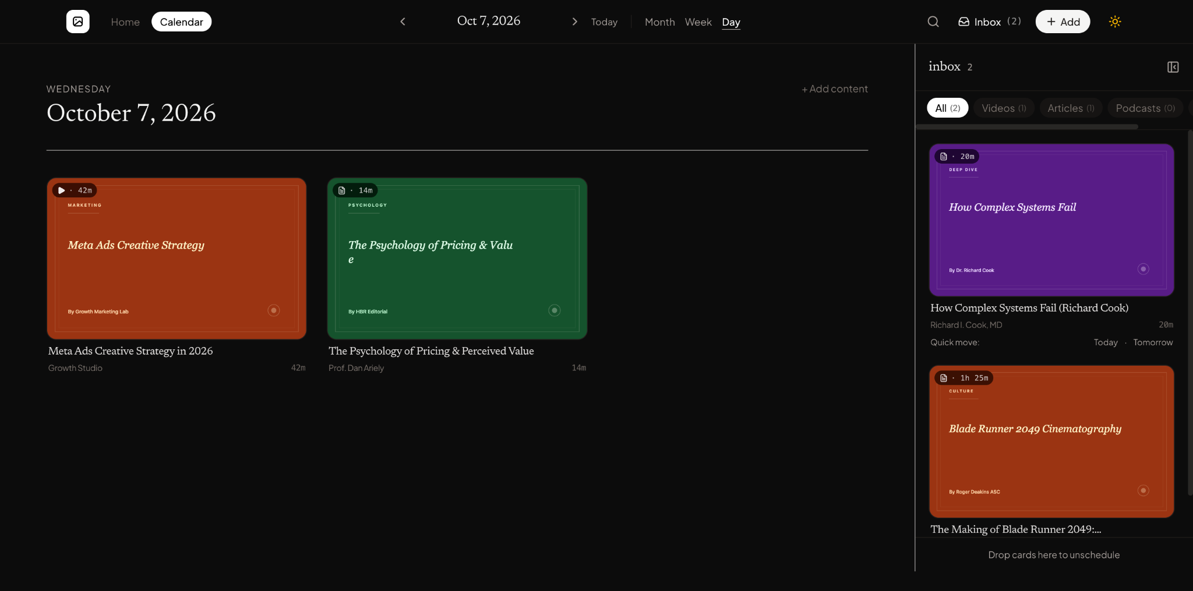

Screenshot 2
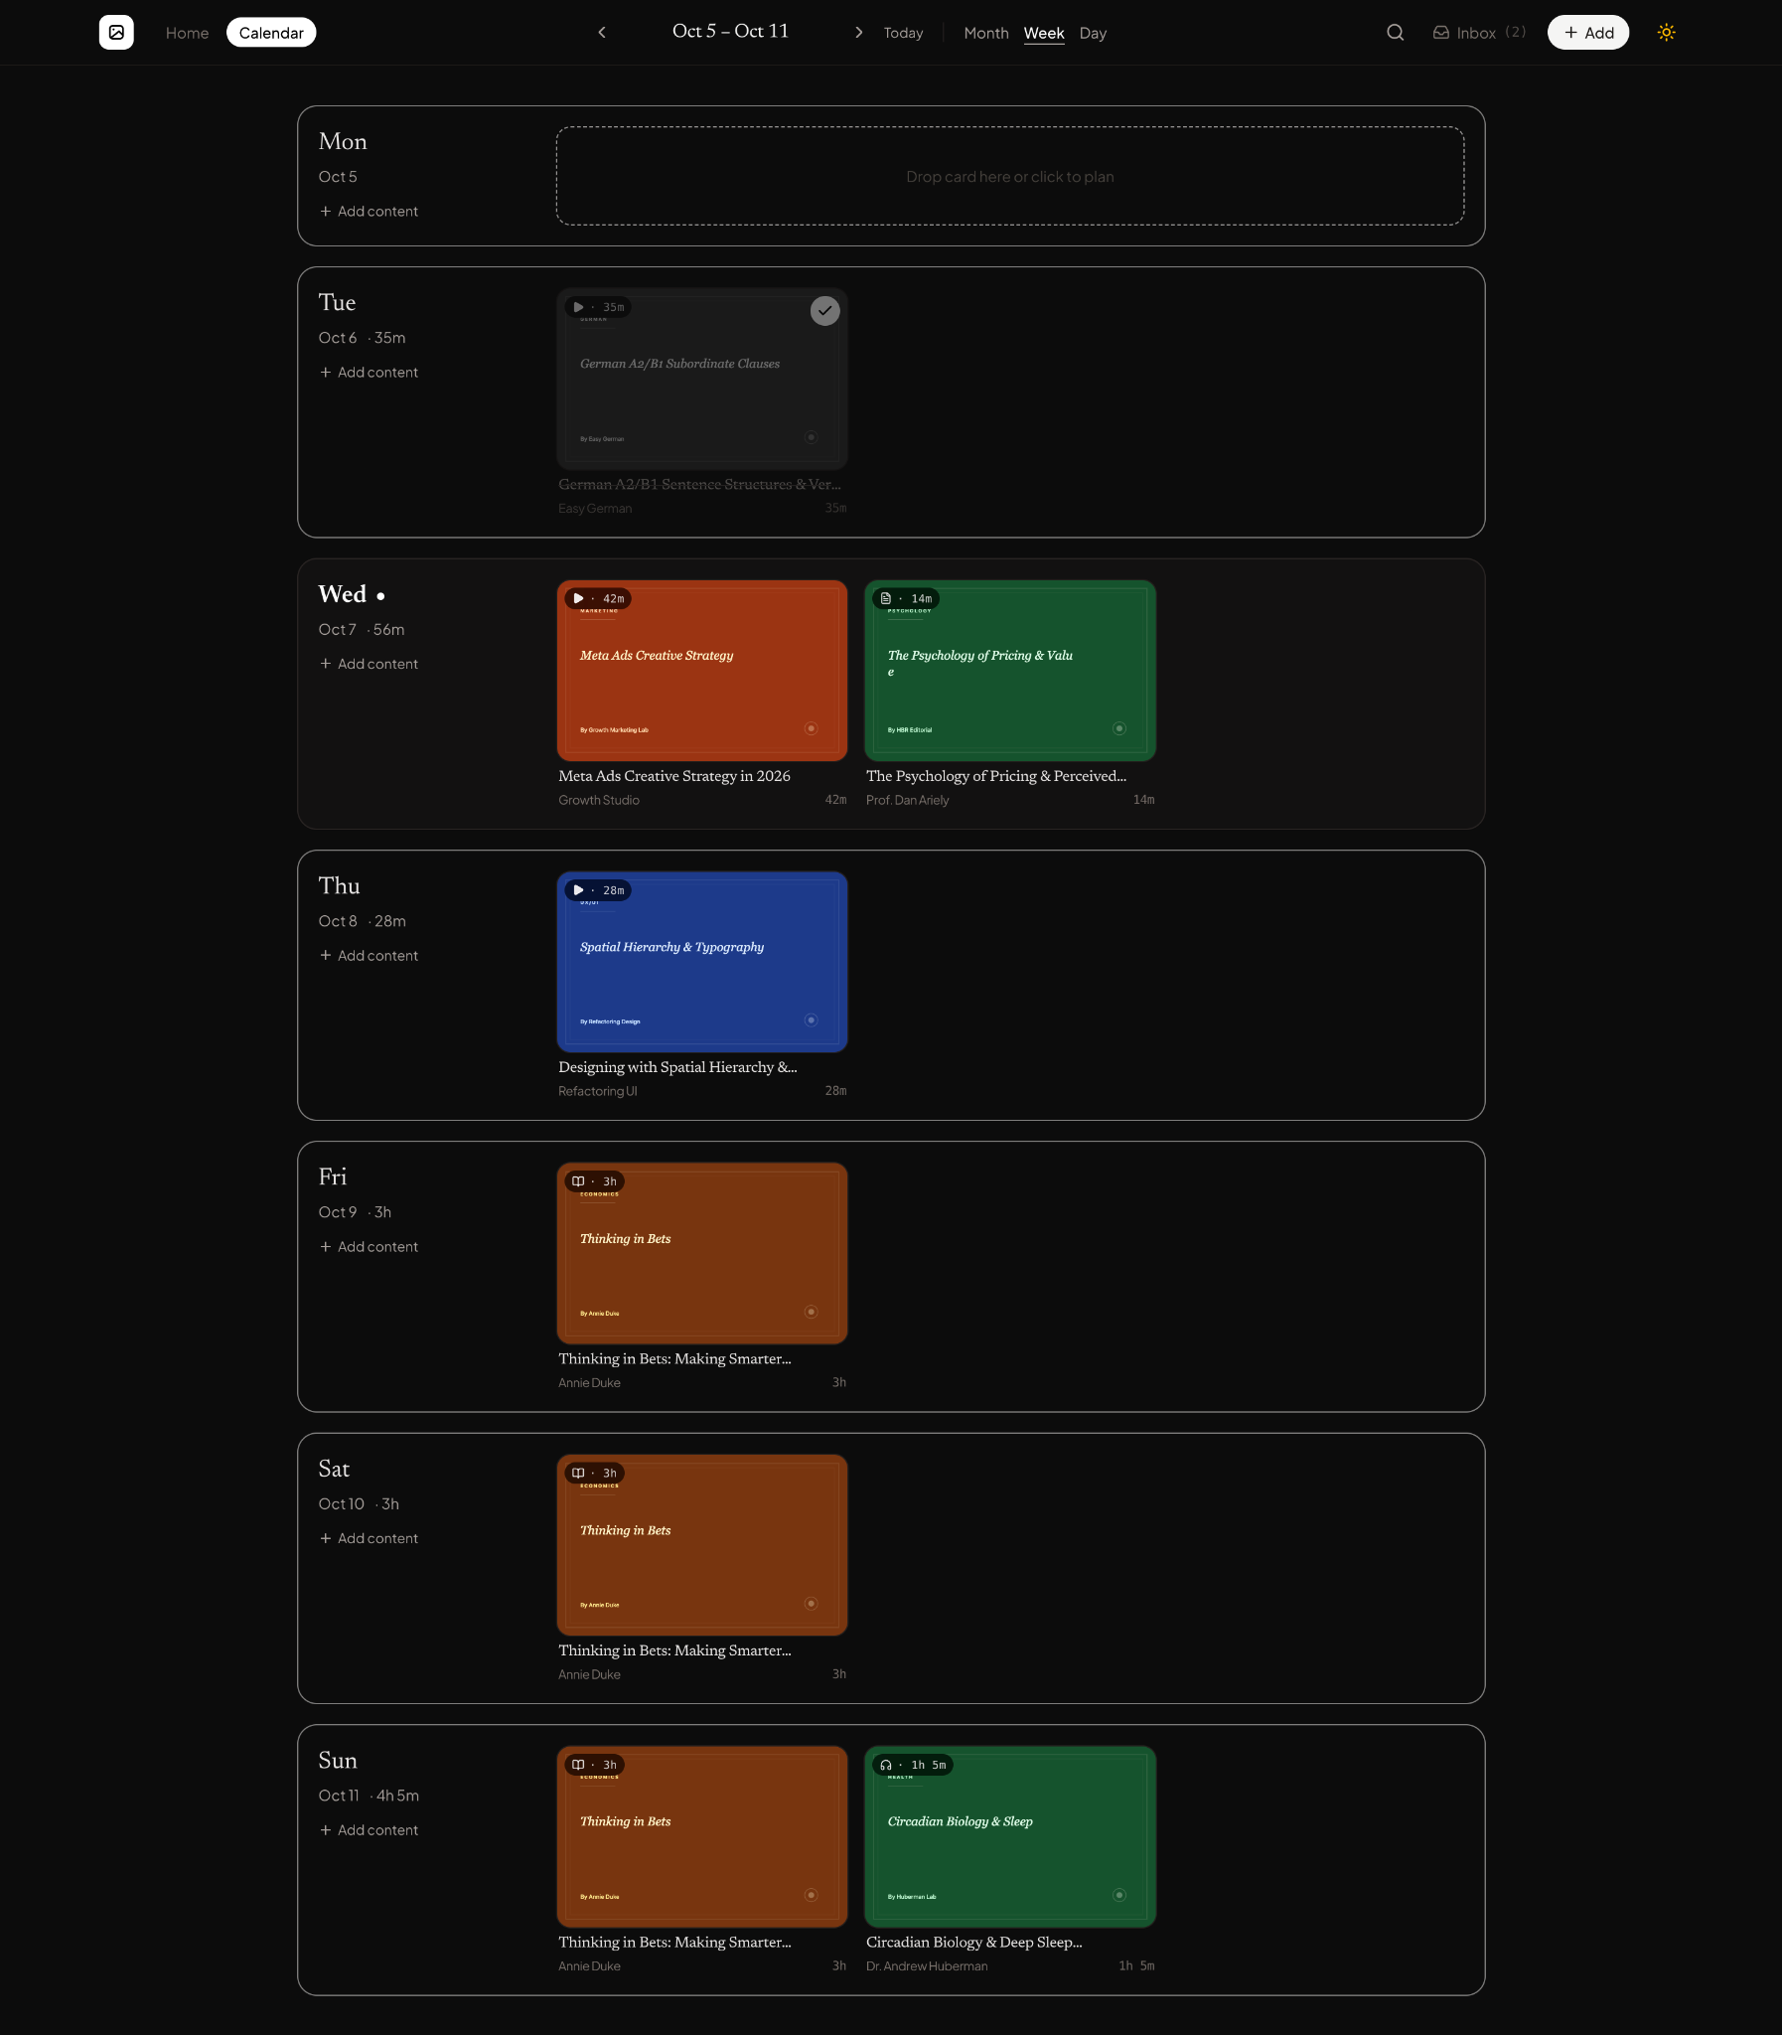

Screenshot 3
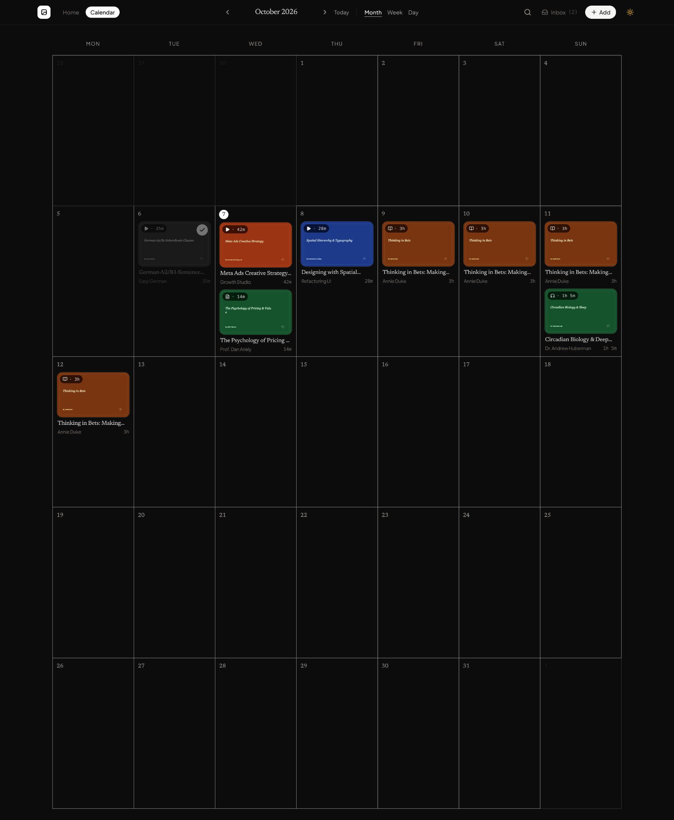

Screenshot 4
