OGHENEYOMA ELIM EBRESAFE | 9017169 | PROG2349 - LAB 2

(A) Introduction: This program uses an adjacency matrix to store African cities and their various flight connections. The value 1 in a cell indicates that there is a flight directly between the two cities. In order to find the shortest route from one city to another, it uses the Breadth-First Search algorithm. BFS checks all possible routes level by level, and the path returned is guaranteed to be the shortest concerning the number of flights. The final output gives a sequence of cities that make up the shortest route of travel.

(B) Algorithm Description
- How cities are stored: It stores cities by assigning each city name to one index in the vertex_data and uses the same index inside the adjacency matrix.
- How BFS works: BFS will explore all the connected cities in a level-by-level manner, ensuring the shortest route is found first.
- How paths are tracked :Each entry in the queue includes a full list of paths, and BFS makes new paths by appending the next city until it reaches its destination.

(C)

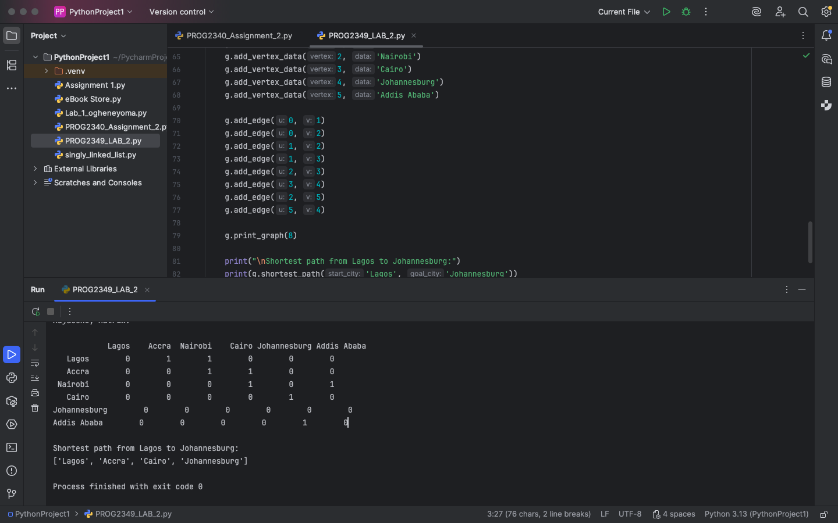

(D) Time/Space Complexity

Time Complexity: Using an adjacency matrix, most operations run in O(V²) time. BFS also runs in O(V²) because it scans every possible neighbor for each vertex.

Space Complexity: The adjacency matrix requires O(V²) space, and BFS adds only O(V) extra space for the queue and visited list.

(E) Conclusion : The program successfully finds the shortest route between cities, and BFS guarantees that the path returned uses the least number of flights.

