CheynTech: An Online Ordering and Delivery Management System for Cheyn's Gadgets
Enabling digital commerce for a local gadget retailer through a web-based ordering, inventory, and delivery platform.

^{1st} Marvin John C. Aldea  Bachelor of Science in Computer Science Hercor College  August 10, 2026  marvinjohn.aldea@hercorcollege.edu.ph | ^{2nd} Kim A. Borro  Bachelor of Science in Computer Science Hercor College  August 10, 2026 kima.borro@hercorcollege.edu.ph | ^{3rd} Neo E. Cornelio  Bachelor of Science in Computer Science Hercor College  August 10, 2026 neorenzell.cornelio@hercorcollege.edu.ph
^{4th} Troy C. Dequina  Bachelor of Science in Computer Science Hercor College  August 10, 2026 troy.dequina@hercorcollege.edu.ph |  | ^{5th} Jayrohero L. Gallegos  Bachelor of Science in Computer Science Hercor College  August 10, 2026 jayrohero.gallegos@hercorcollege.edu.ph

Abstract—This paper presents CheynTech, a proposed web-based Online Ordering and Delivery Management System intended for Cheyn’s Gadgets, a local gadget retailer that currently operates solely through walk-in transactions and informal, manual inventory tracking. The system aims to enable customers to browse a digital product catalog, place orders online for either in-store pickup or staff-coordinated local delivery, and monitor order status in real time. Development will follow an Agile (Scrum) methodology, employing Figma for wireframing and high-fidelity prototyping, and a full-stack web technology comprising HTML5, CSS3, Bootstrap 5, Vanilla JavaScript, PHP 8.x with PDO, and MySQL for data persistence. The platform will be deployed on a cPanel-based shared hosting environment with a registered public domain. Core planned features include a category-filtered product catalog with search, a shopping cart and manual-payment checkout, an admin dashboard for product CRUD and order management, real-time inventory tracking with automatic stock decrement and low-stock alerts, and order fulfillment supporting both pickup and delivery workflows. Security measures will encompass HTTPS, bcrypt password hashing, PDO prepared stateaments, and CSRF/XSS protection. The proposed system seeks to close the identified digital gap in Cheyn’s Gadgets’ business model and establish a replicable model for local retailers transitioning to online commerce.

Keywords—online ordering system, delivery management system, inventory tracking, PHP, MySQL, e-commerce, web application, Agile development

INTRODUCTION
- Background
Cheyn’s Gadgets is a local gadget retailer that currently depends on walk-in customer traffic and manual, informal inventory tracking to manage its daily operations. In today’s digital landscape, where e-commerce has become the dominant channel for consumer purchasing, businesses without an online presence face a measurable competitive disadvantage. National and global online platforms have conditioned consumers to expect the ability to browse product catalogs, complete transactions, and arrange delivery from any internet-connected device. Despite this ongoing shift in consumer behavior, Cheyn’s Gadgets has yet to establish any functional digital storefront, leaving its customer reach limited to walk-in traffic and its operational records vulnerable to inaccuracy and loss. This project addresses that gap by designing, developing, and deploying a purpose-built Online Ordering and Delivery Management System that will modernize the store’s operations and extend its market reach.
- Problem Statement
  - No online product visibility: the absence of a digital catalog prevents customers from browsing available gadgets remotely, placing the store at a direct competitive disadvantage against rivals that maintain online storefronts.
  - No remote purchasing: customers who discover the store have no mechanism to complete a transaction
without a physical store visit, restricting all sales exclusively to walk-in transactions.
  - No delivery option: customers who are unable to visit in person have no means of receiving purchased products, limiting the store’s market reach to walk-in traffic only.
- Objectives
- To design and develop a responsive, customer-facing online storefront for Cheyn’s Gadgets.
- Significance
The development of CheynTech will directly address a verifiable operational gap in Cheyn’s Gadgets’ current business model. By providing a centralized digital platform for product browsing, ordering, and delivery coordination, the system will enable the store to expand its market reach beyond walk-in customers to online consumers within the local service area. The shift from informal, manual record-keeping to a structured, database-driven order and inventory system will reduce the risk of overselling, financial discrepancies, and lost transaction data. Furthermore, the project aims to demonstrate that community-based micro-retailers can adopt modern e-commerce infrastructure using accessible, open-source technologies—offering a replicable model for other local businesses seeking to modernize their operations within academic project constraints and limited budgets.
- Scope of Work
- Included Features
  - A product catalog with categories, descriptions, images, and pricing.
  - Customer registration, login, and profile management.
  - A shopping cart and checkout flow with manual payment confirmation (no automated gateway).
  - An admin panel with product CRUD operations, stock management, and order status updates.
  - Real-time stock-level tracking with automatic decrement on order confirmation and low-stock visibility alerts.
  - Order status tracking: Pending → Processing →
Ready for Pickup / Out for Delivery → Completed.
  - Responsive design.
  - SEO implementation: title tags, meta descriptions, sitemap.xml, and robots.txt.
  - Security measures: HTTPS, bcrypt password hashing, PDO prepared statements, XSS and CSRF protection.
  - A customer reviews and ratings system (deferred to Phase 2).

- Excluded Features
  - Automated payment gateway integration (e.g., PayMaya, GCash, Stripe).
    - Automated courier or logistics integration (e.g., real-time GPS tracking, third-party apps such as
Lalamove or Grab); delivery is within scope but will be manually dispatched by staff.
  - Multi-branch inventory support.
- Project Timeline Limitations
The project timeline was limited to six months (April 2024 – September 2024). This constraint influenced the scope of features included in the initial release and necessitated prioritization of core functionalities, such as the informational pages and interactive map, over secondary features such as e-commerce.

RELATED WORK / LITERATURE REVIEW
This section reviews six published studies that inform the design and development of CheynTech across three thematic clusters: (A) web-based systems for SME digitalization, (B) online ordering and inventory management systems, and (C) e-commerce adoption in the Philippine context and web application security. Each study is examined for its findings and its direct applicability to the proposed system.
- Office Stationery Inventory Management Application Using the Laravel Framework
Jamaludin et al. present a web-based inventory management application for a stationery trading firm that faced stock estimation difficulties, inventory shortages, and inefficient manual record-keeping [1]. Built with PHP, the Laravel framework, and MySQL, the system streamlines replenishment and provides real-time stock monitoring. Its structured MVC architecture confirms that a PHP-MySQL stack is well suited to inventory-heavy retail applications; while CheynTech uses native PHP with PDO rather than Laravel, the underlying principle of separating business logic from data access directly informs CheynTech's back-end design.
- KOOP Online Ordering System Management at Kolej Kediaman Tun Dr Ismail, UTHM
Yazid and Yasin describe a web-based platform developed to replace in-person purchasing at a university cooperative shop in Malaysia, where the existing manual process caused long queues and poor
stock control [2]. Built using HTML, CSS, PHP, JavaScript, and MySQL, the system introduced modules for authentication, catalog browsing, order management, payment, tracking, and reporting. This study is the most structurally analogous to CheynTech: both address walk-in-only commerce with the same technology stack and the same core feature set, validating the technical feasibility of the proposed approach.
- Comparative Analysis of SQL Injection Defense Mechanisms: PDO, PVT, and ART
Choi, Jung, and Ko present a comparative experimental analysis of three SQL injection defense mechanisms, evaluated against 50 categorized payloads in a PHP-MySQL test environment [3]. The study finds that PDO prepared statements effectively prevent structural SQL injection by parameterizing queries so user-supplied input is never interpreted as executable SQL. This peer-reviewed finding directly validates CheynTech's choice of PDO prepared statements as its primary SQL injection countermeasure, though the study evaluates the mechanism in isolation rather than within a deployed retail system.
- Development of a Web-Based Information System to Digitalize Florist SME Operations
Flores-Alhaddad and Reyes document the design and evaluation of an Inventory Management System for a Philippine florist SME that previously relied on paper logs and spreadsheets [4]. Built using CodeIgniter 4 (MVC) and MySQL, the system improved inventory accuracy from 78% to 97.3%, cut stockouts by 45%, and compressed report generation from hours to under ten seconds. This study directly informs CheynTech's inventory module — particularly real-time stock decrement and low-stock alerts — and validates the feasibility of web-based commerce infrastructure for Philippine micro-retailers operating under resource constraints.
- Determinants of E-Commerce Adoption of Philippine Businesses
Quimba and Calizo investigate the factors influencing e-commerce adoption among Philippine businesses using ASPBI data, identifying firm size, industry type, and IT infrastructure availability as primary determinants [5]. The study finds that micro and small enterprises — the category Cheyn's Gadgets falls into — show significantly lower adoption rates than larger firms, pointing to a persistent digital divide among local retailers. This provides the macroeconomic justification for
CheynTech's development, though the study identifies the gap without proposing a system-level solution.
- E-Commerce Adoption and Its Impact on the Performance of Women-Led MSMEs in Metro Manila Bacasmas, Carlos, and Katigbak examine how
e-commerce adoption affects the performance of women-led MSMEs in Metro Manila, finding that adoption correlates positively with sales growth, customer base expansion, and process efficiency, and that COVID-19 significantly accelerated adoption [6]. This complements Quimba and Calizo by demonstrating measurable performance benefits when local MSMEs successfully adopt e-commerce, lending empirical support to the outcomes anticipated from CheynTech's deployment — though its findings are drawn from Metro Manila and not yet tested in a provincial retail context like Cheyn's Gadgets.
C. Synthesis
Table I summarizes the strengths and gaps identified across the reviewed literature. Collectively, these sources demonstrate that a localized web-based inventory and ordering system, implemented with secure PDO practices, effectively solves manual operational inefficiencies. However, a significant gap remains in accessible, low-barrier digital commerce adoption for provincial micro-retailers—precisely the gap that CheynTech addresses for Cheyn's Gadgets.
TABLE I
COMPARATIVE SUMMARY OF REVIEWED LITERATURE

Study / System | Primary Focus | Key Strength | Identified Gap
Office Stationery Inventory [1] | Web-based inventory | Real-time stock monitoring / MVC | No online customer storefront
KOOP Online Ordering [2] | University shop e-commerce | Catalog, cart, and auth modules | Limited to local campus use
SQL Injection Defense [3] | Web security (PDO) | Validates prepared statements | Evaluated in isolation
Florist SME Digitalization [4] | SME inventory tracking | Real-time stock alerts | Lacks integrated online ordering
E-Commerce Determinants [5] | MSME digitalization | Identifies IT adoption barriers | No system-level tech solution
E-Commerce Impact [6] | MSME performance | Empirical proof of sales growth | Metro Manila focus; not provincial

METHODOLOGY
The project employed Scrum, an Agile methodology, to manage the development process. This iterative approach allowed for flexibility and adaptability throughout the project lifecycle. Fig. 1 illustrates the Scrum process followed in this project.

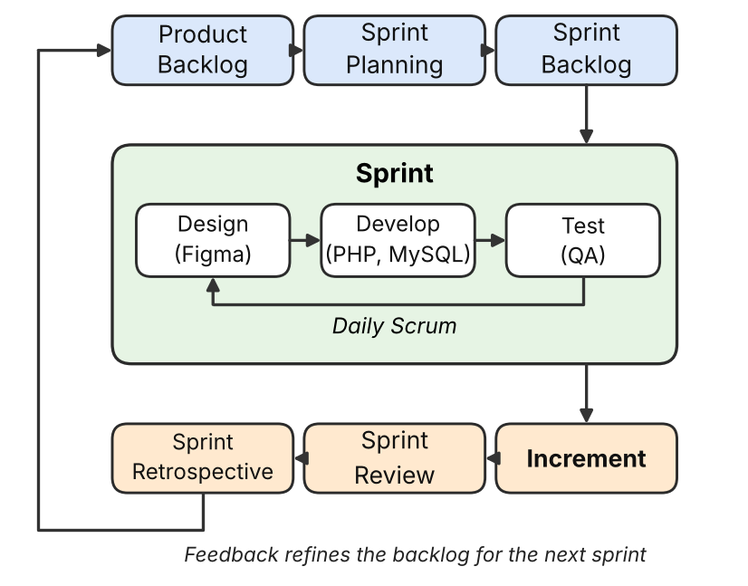
Fig. 1. Scrum process followed during development.
- Requirement Analysis
Requirements were gathered through an interview with the owner of Cheyn's Gadgets, guided by a client questionnaire, and a review of the store's current practices and the related studies in Section II. The store takes orders through walk-ins and Facebook inquiries, tracks inventory in a physical notebook, and records each sold unit's serial number by hand. Its customers are mostly students, whose main questions concern authenticity, availability, variant, and color. These findings became a prioritized product backlog covering the catalog, customer accounts, cart and checkout, an admin panel, stock tracking, and order status tracking (Section I-E).
- Design Tools
Figma was used for wireframing, interactive prototyping, and UI/UX design. Low-fidelity wireframes established layout and content hierarchy, and a high-fidelity prototype followed the client's request for a minimalist look in the store's brand color. Its cloud-based collaboration shortened the feedback loop between design reviews.
- Development Tools
This project used the PHP and MySQL stack summarized in Table II. The front end was built with HTML5, CSS3, Bootstrap 5, and Vanilla JavaScript. The back end used PHP 8.x with PDO and no framework to handle authentication, orders, stock updates, and admin functions, with MySQL storing products, orders, customers, and inventory. Security measures included HTTPS, bcrypt, PDO prepared statements, and CSRF and XSS protection. Code was versioned with Git on GitHub using feature branches and deployed on shared web hosting under a registered domain.
TABLE II
TECHNOLOGY STACK SUMMARY
Layer | Technology | Purpose
Design | Figma | Wireframing and prototyping
Front end | HTML5, CSS3, Bootstrap 5, Vanilla JavaScript | Responsive user interface
Back end | PHP 8.x with PDO | Business logic and data access
Database | MySQL | Products, orders, customers, inventory
Hosting | Shared hosting, registered domain | Live deployment
Version control | Git / GitHub | Source-code management
- Testing Methods
A dedicated quality-assurance role handled testing throughout the sprints. Functional tests covered catalog browsing, registration and login, cart and checkout, admin product and stock management, order status updates, and automatic stock decrement. Responsive behavior was checked at 375, 768, and 1440 px. Targets were a Lighthouse Performance score of at least 80 on mobile and an Accessibility score of at least 90, and the security measures in Section III-C were verified.

SYSTEM DESIGN
- Wireframes and Mock-ups
Low-fidelity wireframes were first sketched for the homepage, seafood directory, blog, and contact pages to establish layout and content hierarchy before high-fidelity Figma mock-ups were produced. The homepage wireframe is shown in Fig. B1(b) of Appendix B.
- Flowcharts
Navigation flowcharts were developed to map the website's information architecture, including the primary user journey from the homepage to the interactive map, business directory, blog, and contact/inquiry forms. This flow, shown in Fig. B1(a) of Appendix B, directly informed the routing structure implemented in the Vue Router configuration.
- UI Design
The website utilizes a clean and modern design with a color palette reflecting the sea and Capiz's natural beauty (deep blues, sandy neutrals, and coral accents). Typography choices enhance readability and visual appeal, and a fully responsive layout — implemented with a mobile-first CSS breakpoint strategy at 480 px, 768 px, and 1024 px — ensures optimal viewing across all device sizes.

DESIGN AND IMPLEMENTATION
- Technologies Used
The website was implemented using HTML5, CSS3, and JavaScript on the front end, with the Vue.js framework for component-based UI development. The back end
was built with Node.js and Express.js, and MongoDB was used for data storage. Leaflet.js powered the interactive map feature. Fig. 2 depicts the resulting three-tier system architecture, in which the Vue.js client communicates with the Express.js API over HTTPS using JSON payloads, and the API in turn persists and retrieves data from MongoDB through the Mongoose object-data-modeling (ODM) layer.
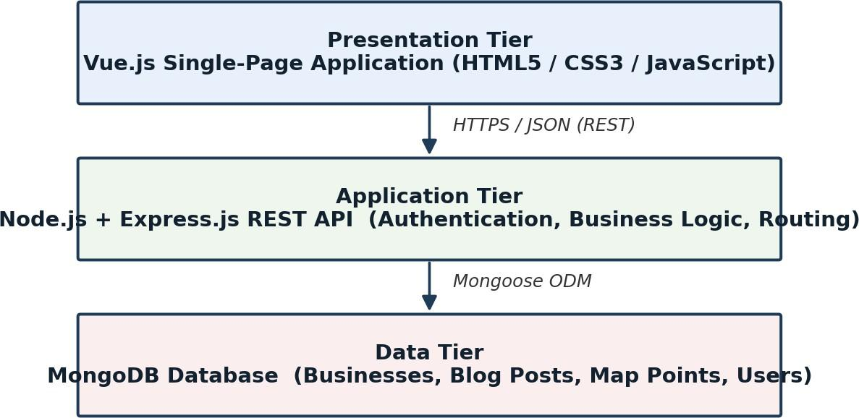

Fig. 2. Three-tier system architecture of the SeaHarvest platform.
Listing 1 shows a representative Express.js route handler used to retrieve paginated seafood-business listings from MongoDB, illustrating the general pattern followed across the API's endpoints.
// routes/businesses.js
router.get('/api/businesses', async (req, res) => {
const { page = 1, limit = 10, category } = req.query; const filter = category ? { category } : {};
try {
const businesses = await Business.find(filter)
.skip((page - 1) * limit)
.limit(Number(limit));
res.status(200).json({ success: true, data: businesses
});
} catch (err) {
res.status(500).json({ success: false, error: err.message });
}
});
Listing 1. Express.js route for retrieving seafood business listings.
- Challenges
Integrating high-resolution images and videos without compromising website loading speed was a major challenge, addressed through image compression, the WebP format, and lazy loading of below-the-fold media. Ensuring cross-browser compatibility also required careful testing and optimization across Chrome, Firefox, Safari, and Edge, particularly for CSS Grid and Flexbox layout rules. Coordinating concurrent front-end and back-end development within a small six-member team further required disciplined API-contract documentation to avoid integration delays.
- Screenshots
Representative screenshots of the homepage, seafood directory, and interactive map, along with additional annotated code snippets illustrating key front-end and
back-end implementation details, are provided in Appendix C.

RESULTS AND ANALYSIS
- Output
A fully functional, responsive website promoting Capiz as the “Seafood Capital of the Philippines” was delivered, featuring an interactive map, media galleries, a business directory, and a blog section.
- Performance Metrics
The homepage achieved a Google PageSpeed Insights score of 92/100 on desktop and 81/100 on mobile, with an average page load time of 1.8 seconds on a standard broadband connection. The site maintained full functionality across all major desktop and mobile browsers tested. Table III summarizes the key performance indicators recorded during final testing.
TABLE III
WEBSITE PERFORMANCE METRICS

Metric | Desktop | Mobile
PageSpeed score | 92 / 100 | 81 / 100
Average load time | 1.2 s | 1.8 s
First Contentful Paint | 0.8 s | 1.3 s
Time to Interactive | 1.5 s | 2.4 s
- User Feedback
Usability testing indicated high satisfaction with the website's navigation, design, and information content, with participants reporting an average System Usability Scale (SUS) rating of 84.5 — well above the accepted benchmark of 68 — indicating excellent perceived usability. Table IV summarizes the demographic composition of the usability-testing sample.
TABLE IV
USABILITY TESTING PARTICIPANT PROFILE (N = 30)

Category | Group | Count
Age | 18–24 | 14
Age | 25–40 | 11
Age | 41+ | 5
Device | Mobile | 19
Device | Desktop | 11
The most common qualitative feedback concerned a desire for larger tap targets on mobile navigation, which was subsequently addressed by increasing the minimum touch-target size to 44 × 44 px in a follow-up design iteration.

DISCUSSION
- Lessons Learned
Effective communication and collaboration among team members and stakeholders were crucial for successful project completion. Prioritizing user experience
throughout the design and development process, rather than treating it as a final polish step, proved essential to the project's success.
- Future Work
Future improvements include integrating e-commerce functionality to allow users to purchase seafood products online, adding full multilingual support beyond the current English/Filipino toggle, incorporating 360° virtual tours of Capiz's attractions, and connecting the platform with third-party booking systems for hotels and tours. A subsequent iteration could also introduce a content-management dashboard so that local tourism officers can update listings without direct developer involvement.

ETHICAL CONSIDERATIONS
The website was designed to be accessible to users with disabilities, adhering to WCAG 2.1 AA guidelines where feasible, including alt text for images and keyboard-navigable menus. All images and videos used were appropriately sourced, licensed, or credited to their original owners. User data privacy was respected throughout the requirements-gathering and testing process, and no personal information was collected without informed consent from survey and interview participants.

CONCLUSION
This project successfully fulfilled its objective of creating a visually appealing and user-friendly website for Capiz. The website's clean design and intuitive navigation ensure accessibility across various devices. The project effectively showcased Capiz's rich seafood industry and tourism attractions through compelling visuals and detailed information, highlighting the province's culinary heritage and cultural significance. Finally, the website's engaging content and clear contact information are designed to attract domestic and international tourists and investors, thereby contributing to the economic development of Capiz. Future enhancements, such as e-commerce integration and multilingual support, could further strengthen its impact.

ACKNOWLEDGMENT
The authors would like to thank the Roxas City local government unit, the Capiz Provincial Tourism Office, and the local seafood restaurant owners who participated in the interviews and usability testing for this project.

DATA AVAILABILITY STATEMENT
Anonymized survey and usability-testing data supporting the findings of this study are available from the corresponding author upon reasonable request. The
source code developed for this project is maintained in a private repository and may be made available for academic review upon request.

CONFLICT OF INTEREST
The authors declare no conflict of interest.

REFERENCES
- [1] I. Jamaludin, I. Sina, A. Supriatna, and M. Fahmi, "Design of Office Stationery Inventory Management Application Using the Laravel Framework," Electronic, Business, Management and Technology Journal, vol. 3, no. 1, 2025. [Online]. Available: https://www.researchgate.net/publication/394597577_Desi gn_Of_Office_Stationer_Inventory_Management_Applicatio n_Using_the_Laravel_Framework. [Accessed: Aug, 17, 2026].
- S. A. B. Yazid and S. M. Yasin, "KOOP Online Ordering System Management at Kolej Kediaman Tun Dr Ismail, UTHM," Universiti Tun Hussein Onn Malaysia. [Online]. Available: https://periodical.uthm.edu.my/index.php/aitcs/article/dow nload/16270/6337/120356. [Accessed: Aug, 17, 2026].
- J. Choi, Y. Jung, and H. Ko, "Comparative Analysis of SQL Injection Defense Mechanisms Based on Three Approaches: PDO, PVT, and ART," Applied Sciences (MDPI), vol. 15, no. 23, 2025. [Online]. Available: https://www.mdpi.com/2076-3417/15/23/12351. [Accessed: Aug, 17, 2026].
- J. J. C. Flores-Alhaddad and J. Reyes, "Development of a Web-Based Information System to Digitalize Florist SME Operations." [Online]. Available: https://www.researchgate.net/publication/398675142_Deve lopment_of_a_Web-Based_Information_System_to_Digitaliz e_Florist_SME_Operations. [Accessed: Aug, 17, 2026].
- F. M. A. Quimba and S. C. Calizo Jr., "Determinants of E-Commerce Adoption of Philippine Businesses," PIDS Discussion Paper Series, no. 2019-24, Philippine Institute for Development Studies, 2019. [Online]. Available: https://ideas.repec.org/p/phd/dpaper/dp_2019-24.html. [Accessed: Aug, 17, 2026].
- J. A. V. Bacasmas, J. C. T. Carlos, and J. J. P. Katigbak, "E-Commerce Adoption and Its Impact on the Performance of Women-Led MSMEs in Metro Manila," PIDS Discussion Paper Series, no. 2022-03, Philippine Institute for Development Studies, 2022. [Online]. Available: https://doi.org/10.62986/dp2022.03. [Accessed: Aug, 17, 2026].

APPENDICES
Appendix A. Survey Instrument
The following questions were used in the online survey distributed to prospective tourists and investors during the requirement-analysis phase:
  - How often do you research a destination online before traveling there?
  - What type of content most influences your decision to visit a food/seafood destination (photos, videos, reviews, maps)?
  - Would you be interested in purchasing local seafood products online?
  - What device do you primarily use to browse travel websites (desktop, tablet, or mobile)?
  - What information do you consider essential on a tourism website (e.g., contact details, maps, pricing, reviews)?
Appendix B. Wireframes and Mock-ups
Fig. B1 presents (a) the website's navigation flowchart and (b) the homepage wireframe produced during the design phase. Table V summarizes the key pages included in the low- and high-fidelity design phase.
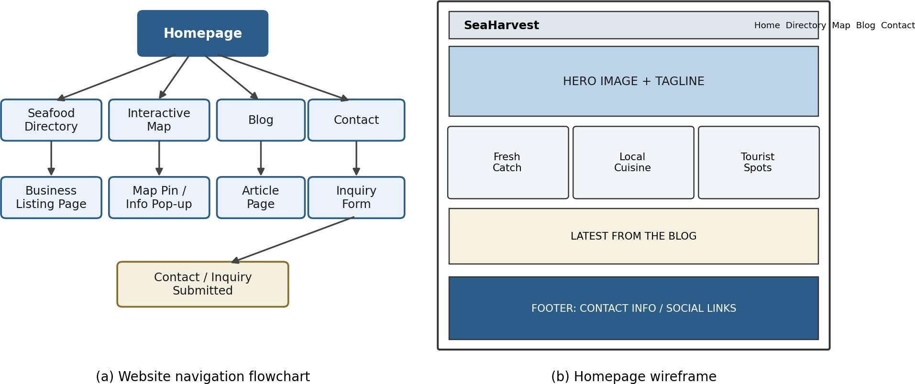
Fig. B1. (a) Website navigation flowchart. (b) Homepage wireframe layout.
TABLE V
SUMMARY OF WIREFRAMED PAGES

Page | Purpose | Key Elements
Homepage | Introduce SeaHarvest and Capiz | Hero banner, nav, highlights
Seafood Directory | List seafood businesses | Search bar, listing cards, filters
Interactive Map | Show attractions and vendors | Map view, markers, pop-ups
Blog | Share culinary/cultural articles | Article list, categories, search
Contact | Provide inquiry channel | Contact form, agency directory
Appendix C. Screenshots and Code Snippets
Fig. C1 presents representative high-fidelity screen mock-ups of (a) the homepage, (b) the seafood directory, and (c) the interactive map, illustrating the visual design delivered at the end of the project.
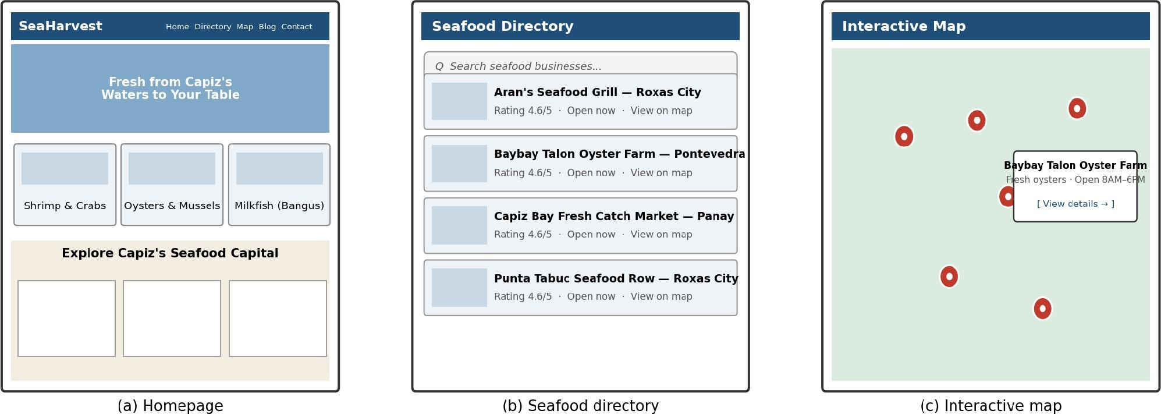
Fig. C1. (a) Homepage. (b) Seafood directory listing. (c) Interactive map with vendor pop-up.
Representative front-end and back-end code excerpts (Vue.js components and Express.js route handlers) are
compiled in the project's supplementary repository and are available upon request from the authors.
Appendix D. System Architecture
The system followed a three-tier architecture: a Vue.js single-page application (presentation tier), an Express.js REST API (application tier), and a MongoDB database (data tier), communicating over HTTPS with JSON payloads. This architecture is illustrated in Fig. 2 (Section V-A) and is repeated in Table VI below in tabular form for quick reference.
TABLE VI
SYSTEM ARCHITECTURE TIER SUMMARY

Tier | Technology | Responsibility
Presentation | Vue.js SPA (HTML5/CSS3/JS) | Renders UI, handles client-side routing and state
Application | Node.js + Express.js REST API | Authentication, validation, business logic, routing
Data | MongoDB + Mongoose ODM | Persists businesses, blog posts, map points, users

