CyberSRS
  - AI-Assisted Software Requirements Specification and
Development Planning Platform
FINAL ACADEMIC PROJECT REPORT

Current outcome: validated SRS-generation platform and a 519-record dataset signed off for QLoRA. Future outcome: an explainable SDLC recommendation and requirement-level Software Development Plan after SRS approval.

Submission Item | Detail
Prepared by | Aryan Bokolia
Prepared for | Project Guide / Faculty Supervisor
Project type | Academic software-engineering and applied-AI project
Development approach | Modified Waterfall with iterative quality gates
Main model | Qwen/Qwen3-4B-Instruct-2507
Report version | 2.0 - submission edition
Date | 13 August 2026

Department / Institution: __________________________________________

Document Control
Version | Date | Purpose | Status
1.0 | 10 Aug 2026 | Initial full project documentation | Superseded draft
2.0 | 13 Aug 2026 | Faculty submission edition | Current

Accuracy and Status Convention
Label | Meaning in this report
Implemented | Present in the repository and supported by code/tests.
Validated | Checked using schema, semantic, leakage, split, or automated tests.
Ready | Inputs and gates pass, but the next execution step has not yet run.
Planned | Approved future design; not claimed as current functionality.

Important current status: READY_FOR_QLORA=true means the dataset is ready. It does not mean that the Unsloth/Google Colab training run or the final four-way evaluation has already been completed.

Executive Summary
CyberSRS is a local-first, AI-assisted requirements-engineering platform for cybersecurity and network-infrastructure projects. A user enters an informal project description. The system extracts project context, identifies missing information, asks clarification questions, retrieves authoritative cybersecurity knowledge, generates a structured Software Requirements Specification (SRS), validates every generated JSON artefact, supports human review, and prepares the approved result for document export.
The main language model is Qwen/Qwen3-4B-Instruct-2507. Ollama provides local inference, nomic-embed-text provides local embeddings, ChromaDB stores the RAG index, FastAPI implements the modular-monolith backend, React implements the user interface, and SQLite persists project state. Fine-tuning is designed as QLoRA on Google Colab using Unsloth, because the verified local RTX 4050 Laptop GPU has only 6,141 MiB VRAM and leaves little reliable headroom for a 4B training run.
The final training dataset contains 519 records from 60 original, manually authored synthetic scenarios. The scenario-level split produces 469 training records and 50 validation records. All 519 assistant payloads validate, evaluation leakage is zero, and train/validation scenario overlap is zero. The complete Python suite currently passes 161 tests.
The current project itself follows a Modified Waterfall approach: phases are ordered, documented, and gated, while focused iteration is allowed within a phase when tests or manual review find defects. A future second-stage planner will not force Waterfall on every user project. After SRS approval it will derive a Project Development Profile, rank suitable SDLC or hybrid methods using deterministic rules, use Qwen to explain the ranked evidence, and generate a requirement-to-implementation and verification plan for human approval.

Table of Contents
Document Control 2
Accuracy and Status Convention 2
Executive Summary 3
Table of Contents 4
1. Project Introduction 7
1.1 Problem Statement 7
1.2 Proposed Solution 7
1.3 Project Objectives 7
1.4 Stakeholders 7
2. Scope, Outcomes, and Boundaries 9
2.1 Current In-Scope Outcome: Software Requirements Specification 9
2.2 Future Outcome: Software Development Plan 9
2.3 Explicit Non-Goals 9
2.4 Final Deliverable Hierarchy 9
3. Development Methodology 10
3.1 Selected Method: Modified Waterfall 10
3.2 Why Not Pure Agile for This Project? 10
3.3 Important Distinction 10
4. Project Phases and Entry/Exit Criteria 11
4.1 Change-Control Rule 11
5. End-to-End User Workflow 12
5.1 Failure and Fallback Workflow 12
6. System Architecture 13
6.1 Architectural Principles 13
6.2 Major Components 13
7. Technology Stack 14
7.1 Verified Local Environment 14
8. Qwen Model and Structured Generation 15
8.1 Model Selection 15
8.2 Prompt-to-Validation Pipeline 15
9. Retrieval-Augmented Generation 16
9.1 Knowledge Sources 16
9.2 Implemented Processing 16
9.3 Current RAG Statistics 16
9.4 Preliminary RAG Smoke Result 17
10. Fine-Tuning Dataset 18
10.1 Dataset Origin 18
10.2 Final Dataset Statistics 18
10.3 Quality Controls 19
11. QLoRA with Unsloth and Google Colab 20
11.1 Why QLoRA? 20
11.2 Why Unsloth + Colab? 20
11.3 Proposed Conservative Training Configuration 20
11.4 Training Entry and Exit Criteria 21
12. Testing and Evaluation 22
12.1 Test Strategy 22
12.2 Current Verified Quality Evidence 22
12.3 Final Four-Way Evaluation 22
13. Cost and Resource Feasibility 23
13.1 Cost Assumptions 23
13.2 Resource Feasibility 23
14. Project Timeline and Milestones 24
15. Security, Privacy, and Ethical Controls 25
15.1 Responsible AI Position 25
16. Future SDLC Selection and Development Planner 26
16.1 Purpose 26
16.2 Controlled SDLC Catalogue 26
16.3 Explainable Selection 26
16.4 Requirement Implementation Mapping 27
17. Risks and Mitigation 28
18. Final Outcomes and Acceptance Criteria 29
18.1 Current Demonstrable Outcome 29
18.2 Outcome After Current Fine-Tuning Track 29
18.3 Outcome After Future Planner 29
18.4 Final Acceptance Gate 29
19. Limitations 30
20. Conclusion 31
21. References 32
21.1 Repository Evidence 32
A. Appendix: Dataset Task Counts 33
B. Appendix: Runtime Configuration Summary 34
C. Appendix: Abbreviations 35
Review and Approval 36

1. Project Introduction

1.1 Problem Statement
Producing a professional SRS for a cybersecurity system requires simultaneous requirements-engineering skill, security knowledge, traceability, threat modelling, testable acceptance criteria, and careful handling of uncertainty. Students and small teams often have an idea but lack the time or specialist experience to convert it into a complete, internally consistent document.

1.2 Proposed Solution
CyberSRS combines an interactive clarification workflow, retrieval-augmented generation, a requirements-engineering-tuned Qwen model, deterministic validation, and human approval. It separates current external knowledge from learned writing behaviour: RAG supplies standards and citations, while QLoRA improves structure, classification, atomicity, testability, and JSON compliance.

1.3 Project Objectives
- Convert informal cybersecurity project descriptions into structured, reviewable SRS artefacts.
- Infer the project category without making the user manually select a domain.
- Ask only relevant clarification questions and preserve confirmed answers downstream.
- Use authoritative RAG sources with end-to-end citation metadata.
- Generate functional, non-functional, security, data, and network requirements where supported.
- Generate architecture, threats, mitigations, risks, tests, and acceptance criteria as validated JSON.
- Evaluate base, RAG-assisted, fine-tuned, and fine-tuned-plus-RAG configurations fairly.
- In future, recommend an appropriate SDLC and map each approved requirement to implementation and verification work.

1.4 Stakeholders
Stakeholder | Need
Student / requirements author | A guided path from idea to defensible SRS.
Project guide / faculty | Traceable design decisions, measurable evidence, and honest status.
Security practitioner | Relevant security requirements, sources, risks, and test plans.
Future developer/team | An approved specification and later an implementation-ready development plan.

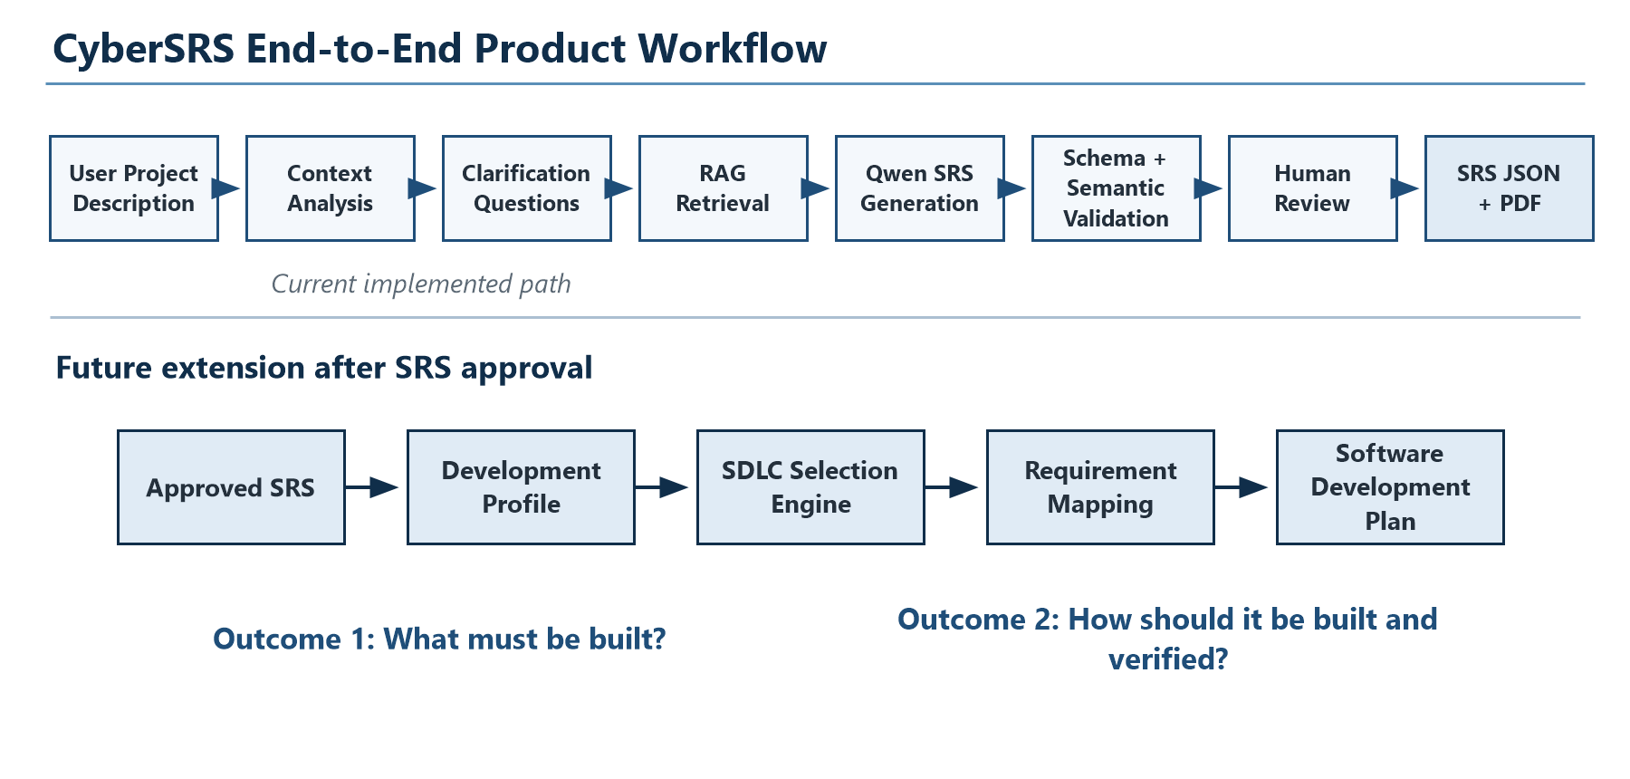
Figure 1. Current SRS workflow and the planned second-stage development-planning outcome.

2. Scope, Outcomes, and Boundaries

2.1 Current In-Scope Outcome: Software Requirements Specification
The first major output is a structured SRS answering, 'What must be built?' It contains project overview, scope, assumptions, stakeholders, user roles, requirement sections, architecture, threats, mitigations, testing recommendations, risks, unresolved questions, references, validation results, and generation metadata.

2.2 Future Outcome: Software Development Plan
After an SRS version is approved, the planned extension answers, 'How should the approved requirements be implemented and verified?' It will recommend a suitable pure or hybrid SDLC, explain alternatives, map every requirement to components/tasks/tests/deliverables, construct a dependency graph, and produce a second reviewable document. This extension is documented but not yet implemented.

2.3 Explicit Non-Goals
- No active penetration testing, exploit execution, malware execution, or network reconfiguration.
- No raw LLM output rendered without schema validation.
- No cloud dependency for normal application inference or project-data storage.
- No automatic code generation or autonomous software deployment in the current scope.
- No invented numerical, legal, safety, privacy, or deployment claims treated as confirmed facts.
- No fine-tuning of changing standards facts that belong in RAG.

2.4 Final Deliverable Hierarchy
Deliverable | Question answered | Status
Document 1: SRS | What must be built? | Core platform implemented; final adapter evaluation pending
Document 2: Software Development Plan | How should it be built and verified? | Future planned module
QLoRA adapter | Can Qwen follow CyberSRS RE behaviour more reliably? | Dataset ready; training pending
Comparative evaluation | Does QLoRA and/or RAG improve results? | Final C1-C4 run pending

3. Development Methodology

3.1 Selected Method: Modified Waterfall
Modified Waterfall is the best description of how CyberSRS itself is being developed. The project has a stable academic objective, substantial mandatory documentation, ordered technical dependencies, a defined model decision, and explicit phase-completion gates. Planning precedes implementation; the application foundation precedes AI integration; dataset preparation precedes QLoRA; QLoRA precedes final evaluation.
The method is modified because learning is not perfectly one-directional. RAG smoke tests, schema failures, independent dataset reviews, and UI tests can send work back to the active phase. Changes are controlled, documented, retested, and then baselined before progression. This preserves Waterfall's auditability without pretending that AI quality can be designed correctly in a single pass.
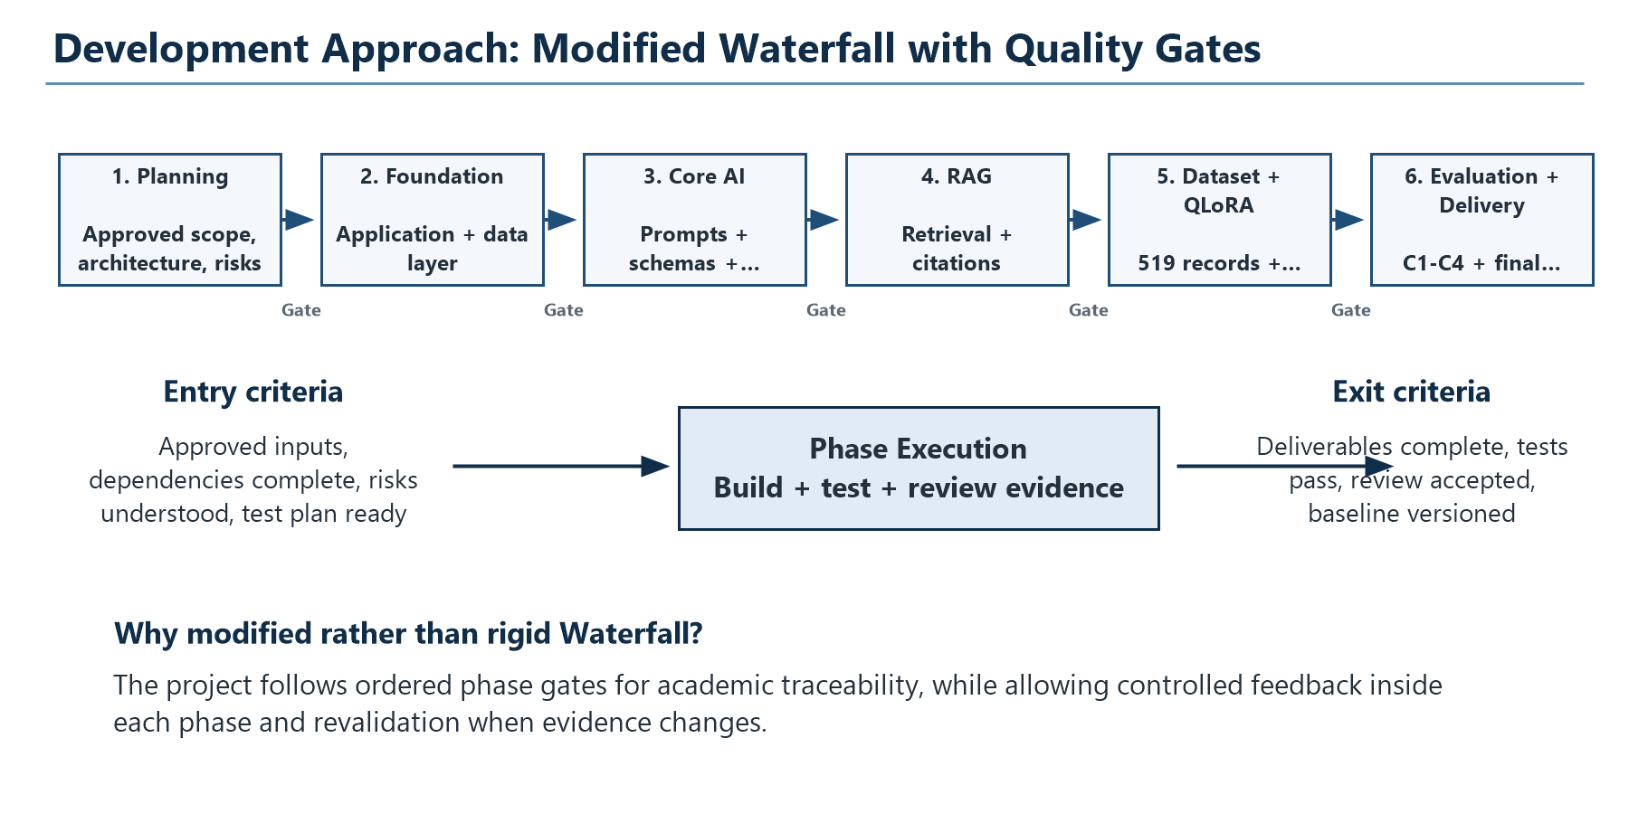
Figure 2. Modified Waterfall sequence with explicit entry and exit quality gates.

3.2 Why Not Pure Agile for This Project?
Agile practices are useful for UI feedback and prompt tuning, but a pure sprint-first model would understate the project's mandatory architecture, security, dataset-freeze, and evaluation dependencies. Modified Waterfall gives the faculty reviewer a clear evidence chain while still allowing iteration inside each phase.

3.3 Important Distinction
Modified Waterfall is the development method for building CyberSRS. It is not automatically the correct SDLC for every project entered by a CyberSRS user. The future SDLC selector will recommend Waterfall, V-Model, Agile, Spiral, Incremental, DevSecOps hybrids, or another controlled option based on that project's evidence.

4. Project Phases and Entry/Exit Criteria
Each phase starts only when required inputs are approved and ends only when its deliverables, tests, and review evidence satisfy the gate. The following matrix is the operational control for the project rather than a descriptive timeline alone.
Phase | Entry Criteria | Main Work / Output | Exit Criteria
0. Planning | Approved project brief and model decision | PRD, scope, architecture, risks, roadmap | Documents consistent; decisions recorded; no implementation claims
1. Foundation | Phase 0 gate; repository and environment ready | FastAPI/React scaffolds, SQLite, CRUD, tests | Health/CRUD pass; configuration and persistence verified
2. Base-model integration | Foundation stable; local Ollama model available | Provider interface, Qwen prompts, analysis and clarification | Valid structured outputs; retry/error paths tested
3. Structured SRS | Context/clarification pipeline validated | SRS schemas, service orchestration, IDs, UI views | Complete schema-valid SRS generated with mocked/real provider checks
4. RAG | SRS pipeline stable; approved corpus available | Ingestion, chunking, embeddings, ChromaDB, citations | Relevant retrieval, metadata propagation, and fallback tests pass
5. Validation and security | RAG/SRS artefacts available | Threats, mitigations, deterministic quality checks | Invalid references/requirements detected; security boundaries maintained
6. Review and export | Validated SRS version | Editing, versioning, approval, PDF rendering | Human can review and export canonical JSON-derived output
7. Dataset preparation | Stable schemas and frozen 30-case evaluation set | Original multi-task dataset, split, audits, signoff | 519/519 valid; leakage 0; overlap 0; READY_FOR_QLORA=true
8. QLoRA training | Dataset signed off; Colab/Unsloth environment verified | Adapter checkpoints, logs, hashes, best model | Training completes; validation monitored; adapter reproducible
9. Comparative evaluation | Base model and approved adapter available | C1-C4 metrics and human review | Same frozen cases/configuration used; limitations reported honestly
10. Final delivery | All prior phase gates passed | Final report, demo, user guide, release package | Tests pass; documents accurate; end-to-end demo succeeds

4.1 Change-Control Rule
If later evidence invalidates an earlier assumption, the affected baseline is revised as a new version and all dependent validation is rerun. The project does not silently edit a frozen evaluation set, approved SRS, signed-off dataset, or released adapter.

5. End-to-End User Workflow
- The user creates a project and enters an informal cybersecurity or network-system description.
- CyberSRS analyses the text and infers categories, stakeholders, users, assets, goals, constraints, and missing information.
- The system generates targeted clarification questions and records the user's confirmed answers.
- The retrieval service constructs queries from the validated project context and retrieves relevant local knowledge chunks.
- Qwen receives structured context, clarification answers, retrieved chunks, source IDs, and a task-specific output schema.
- The model generates JSON for requirements, architecture, threats, mitigations, risks, tests, and the complete SRS.
- Pydantic and deterministic semantic checks validate structure, IDs, citations, assumptions, acceptance criteria, and cross-references.
- If validation fails, CyberSRS uses a corrective retry up to the configured limit or returns a structured error.
- The user reviews, edits, regenerates selected sections, resolves assumptions, and approves an exact SRS version.
- The approved canonical JSON is rendered into the final SRS/PDF without exposing unvalidated raw model text.
- In the future planner, the approved SRS enters profile extraction, explainable SDLC selection, requirement mapping, and Software Development Plan approval.

5.1 Failure and Fallback Workflow
Failure | System Response | User Outcome
Ollama unavailable | Timeout/error captured; no raw stack trace exposed | Actionable local-model message
Invalid model JSON | Corrective prompt retry; schema revalidation | Validated output or structured failure
RAG unavailable/empty | Continue without RAG and record warning | SRS can proceed without invented citations
Citation ID invalid | Reject or flag reference deterministically | Unsupported evidence is not presented as valid
Unresolved project fact | Preserve as assumption/question | No unsupported mandatory requirement

6. System Architecture
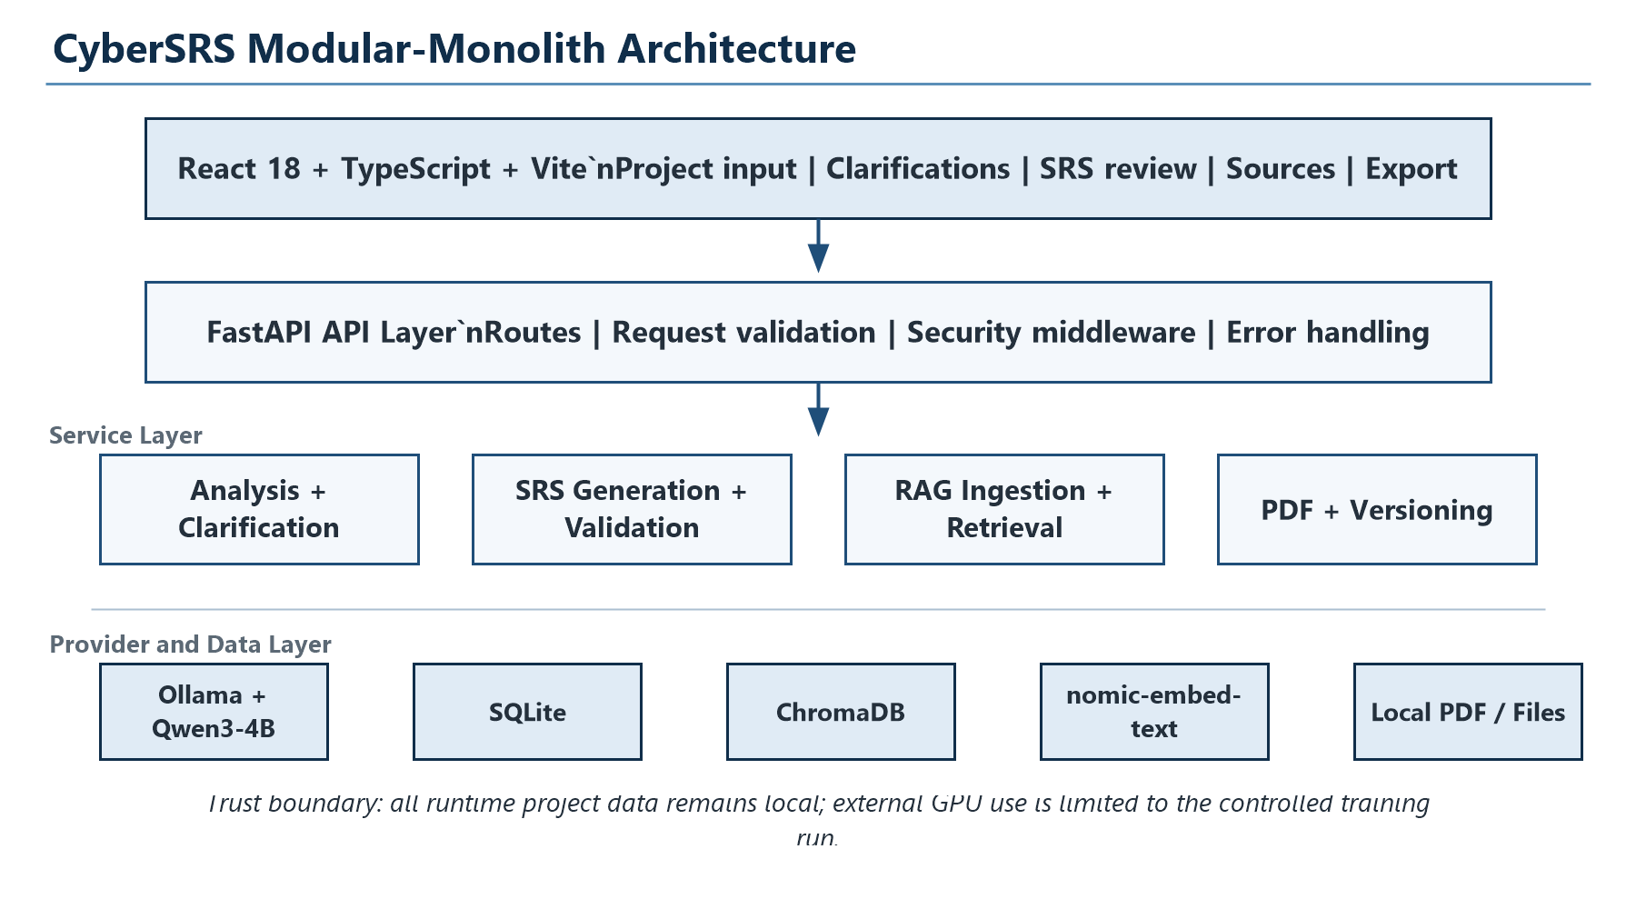
Figure 3. CyberSRS modular-monolith architecture and local trust boundary.

6.1 Architectural Principles
- Modular monolith: services have clear boundaries but deploy as one backend application.
- Provider-independent LLM interface: application services do not call Ollama-specific code directly.
- Structured JSON first: validated Pydantic models are canonical; rendering is deterministic.
- Generative/deterministic separation: Qwen drafts content; Python validates and controls state.
- Local-first runtime: SQLite, ChromaDB, Ollama, model weights, and project data stay local.
- RAG is not fine-tuning: retrieved facts and learned writing behaviour remain separate.

6.2 Major Components
Component | Responsibilities
React frontend | Project workflow, chat/clarification UI, SRS workspace, source display, editing, settings.
FastAPI routes | REST contracts, input validation, middleware, errors, and generation-run status.
Application services | Analysis, clarification, SRS generation, output validation, and requirement validation.
LLM provider | Mocked tests and local Ollama/Qwen generation through one abstraction.
RAG subsystem | Parsing, cleaning, chunking, embedding, indexing, retrieval, and source metadata.
Repositories / SQLite | Projects, contexts, clarifications, SRS versions, requirements, and run metadata.
ChromaDB | Persistent local vector storage for retrievable cybersecurity chunks.
Document renderer | Canonical structured SRS to professional output; never raw LLM text.

7. Technology Stack
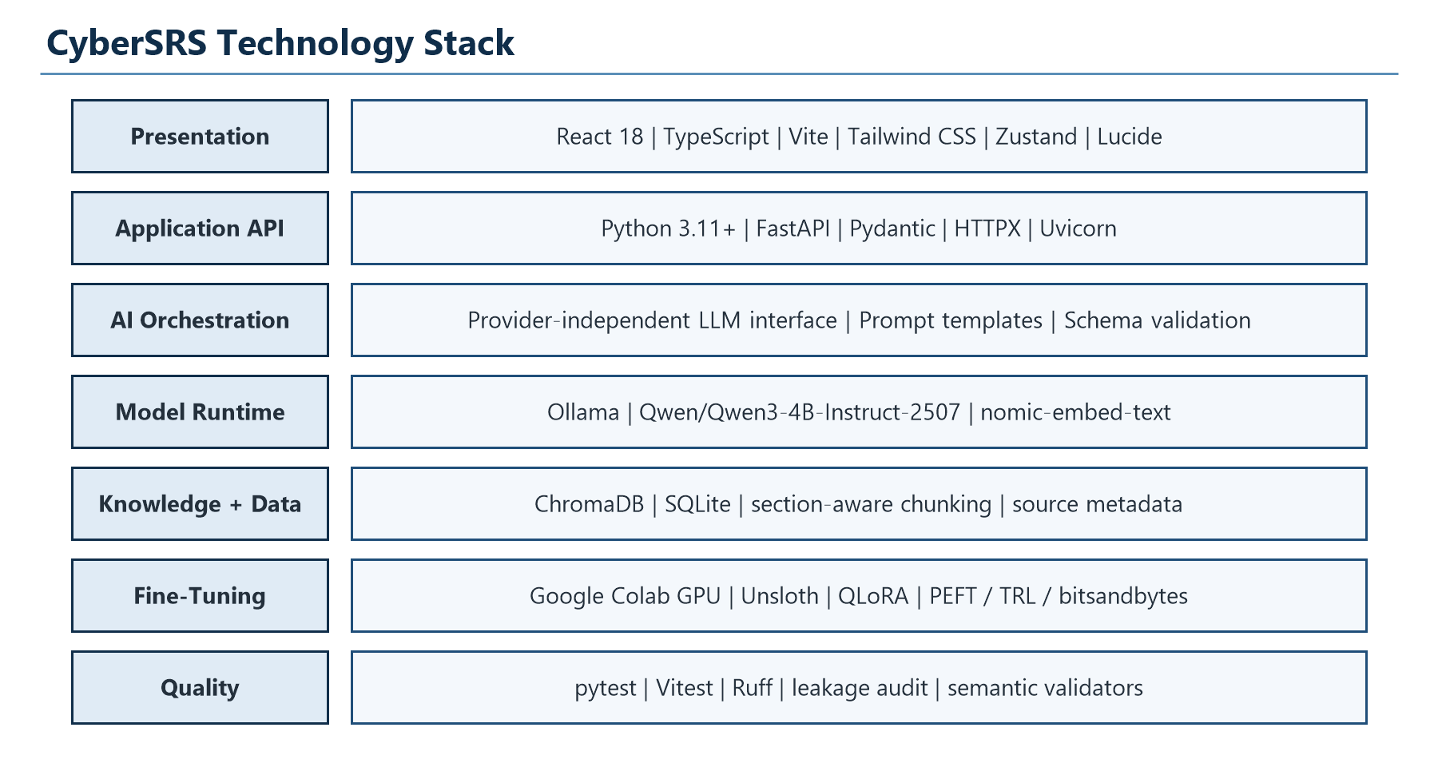
Figure 4. Technology stack by system layer.
Layer | Technology | Reason
Frontend | React 18, TypeScript, Vite | Typed SPA with fast local development and component testing.
UI support | Tailwind CSS, Zustand, Lucide | Consistent interface, compact state management, standard icons.
Backend | Python 3.11+, FastAPI, Pydantic | Typed APIs, schema-first validation, and strong AI ecosystem.
Persistence | SQLite | Simple, local, zero-service MVP storage.
Vector database | ChromaDB | Persistent local semantic retrieval with metadata.
Inference | Ollama | Local model serving through a stable HTTP boundary.
Main LLM | Qwen/Qwen3-4B-Instruct-2507 | 4B model selected for local feasibility and instruction following.
Embeddings | nomic-embed-text | Separate local embedding utility; Qwen is not misused for embeddings.
Fine-tuning | Unsloth + QLoRA on Google Colab | Memory-efficient 4-bit adapter training on accessible GPU compute.
Quality | pytest, Vitest, Ruff, semantic audits | Automated regression, schema, leakage, and consistency evidence.

7.1 Verified Local Environment
Item | Verified Value
Operating system | Windows / PowerShell
Python | 3.12.10 (project supports 3.11+)
Node.js / npm | 24.4.1 / 11.5.2
Ollama | 0.32.9
GPU | NVIDIA GeForce RTX 4050 Laptop GPU
VRAM | 6,141 MiB
GPU driver | 592.82

8. Qwen Model and Structured Generation

8.1 Model Selection
The approved main model is Qwen/Qwen3-4B-Instruct-2507, a 4.0B-parameter, non-thinking causal language model. The training base is the Hugging Face BF16 checkpoint. The local Ollama tag is a quantized runtime representation and is not used as the training base. The model supports system/user/assistant chat templates and is small enough for local quantized inference while retaining useful instruction-following capacity [R1].
Property | Value
Hugging Face model | Qwen/Qwen3-4B-Instruct-2507
Runtime model | qwen3:4b-instruct-2507-q4_K_M through Ollama
Parameters | 4.0B total / 3.6B non-embedding
Architecture | 36 layers; grouped-query attention
Mode | Non-thinking instruction model
Training base | BF16 checkpoint loaded in 4-bit for QLoRA
CyberSRS responsibility | Requirements-engineering reasoning and structured drafting

8.2 Prompt-to-Validation Pipeline
- Construct a task-specific system prompt containing the exact output contract and safety rules.
- Add validated project context, confirmed clarification answers, and relevant RAG chunks.
- Apply the Qwen chat template and request JSON only.
- Parse the response and validate against ProjectAnalysis, ClarificationQuestionSet, Requirement, ArchitectureSummary, Threat, Mitigation, or SRSSchema models.
- Run deterministic semantic checks for IDs, 'shall' language, category, acceptance criteria, numeric provenance, citations, dependencies, and assumption promotion.
- Retry with a corrective prompt on recoverable validation failure; otherwise return a structured error.
- Persist and render only the validated object.

9. Retrieval-Augmented Generation
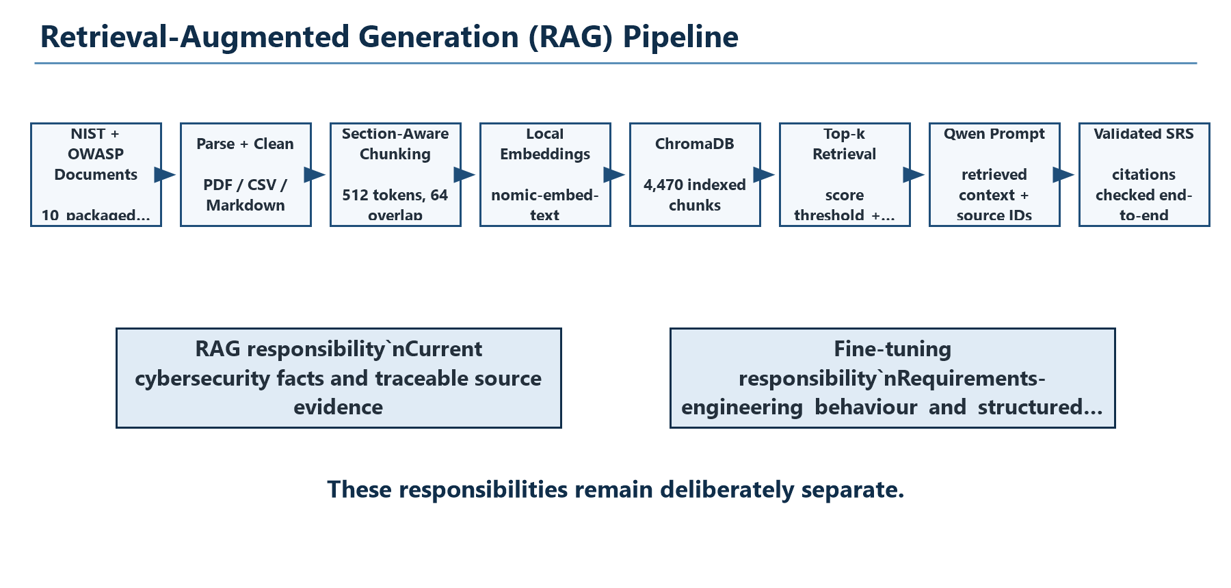
Figure 5. Implemented RAG ingestion and retrieval flow.

9.1 Knowledge Sources
The packaged starter corpus contains 10 verified files: 7 from NIST and 3 from OWASP. It includes NIST CSF 2.0, SP 800-53 Rev. 5, SP 800-61 Rev. 3, SP 800-63-4, SP 800-207, SP 800-41 Rev. 1, SP 800-92, OWASP ASVS 5.0.0 in PDF/CSV form, and an OWASP Top 10:2025 introduction. SHA-256 and file-size checks pass for all packaged files.

9.2 Implemented Processing
- Parse PDF, Markdown, text, and structured source formats through controlled parsers.
- Clean extracted content and retain document identity, section, page, and source metadata.
- Use section-aware and paragraph-aware chunking with a 512-token target, 64-token overlap, and 50-token minimum.
- Generate embeddings locally with nomic-embed-text through Ollama.
- Store vectors and metadata in the persistent cybersrs_knowledge ChromaDB collection.
- Retrieve ranked chunks using configurable top-k and minimum-score controls.
- Limit context size before prompt insertion and validate all returned citation IDs.

9.3 Current RAG Statistics
Metric | Value | Interpretation
Packaged source files | 10 | Curated NIST/OWASP starter corpus
ChromaDB embeddings | 4,470 | Current persistent local index count
Embedding model | nomic-embed-text | Local embedding-only model
Configured chunk size / overlap | 512 / 64 tokens | Section-aware retrieval units
Example runtime top-k / threshold | 3 / 0.45 | Environment example; configurable
Fallback | Generate without RAG + warning | System remains usable if retrieval fails

9.4 Preliminary RAG Smoke Result
Metric | Base | Base + RAG
Cases | 3 | 3
Successful full runs | 3 | 3
SRS schema validity | 100% | 100%
Requirements generated | 35 | 37
Average total latency | 106.5s | 127.0s
Retrieval success | N/A | 100%
Citation presence / validity | N/A | 100% / 100%

This is a three-case engineering smoke test, not the final academic comparison. It demonstrates pipeline viability and citation propagation; it is too small to prove general quality improvement.

10. Fine-Tuning Dataset

10.1 Dataset Origin
The QLoRA dataset is not downloaded from an external SRS repository. All 60 source scenarios are original, manually authored synthetic CyberSRS scenarios stored in scenario_bank_a.py, scenario_bank_b.py, and scenario_bank_c.py. Each scenario supplies a distinct informal description, analysis, clarification answers, requirements, architecture, threats, scope, tests, risk, and unresolved information. External RE-Bench, RE-GSC, QRAQ, and public SRS datasets were not incorporated.
The held-out evaluation set is separate: ai/evaluation/dataset.json contains 30 frozen cases (eval-001 through eval-030). It is excluded from training through exact, token, and embedding-similarity checks. RAG knowledge documents are also not converted into training input/output pairs; they serve current factual retrieval only.
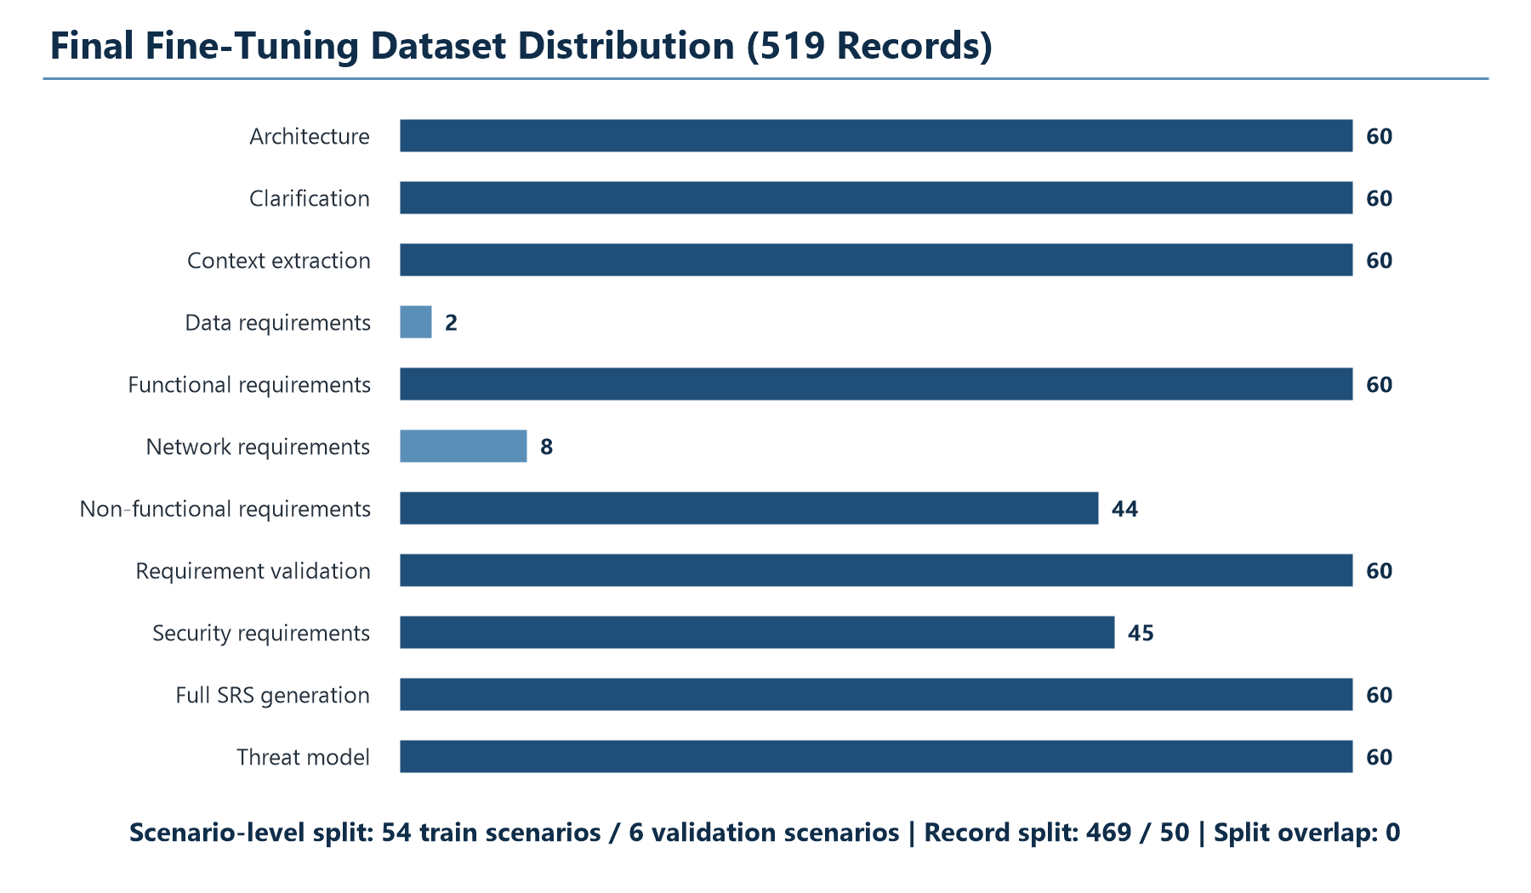
Figure 6. Final task distribution after independent semantic cleanup.

10.2 Final Dataset Statistics
Metric | Final Value
Original synthetic scenarios | 60
Total records | 519
Training scenarios / records | 54 / 469
Validation scenarios / records | 6 / 50
Assistant schema validity | 519/519
Evaluation leakage | 0
Train/validation scenario overlap | 0
Average / median tokens | 1606.52 / 1257
P90 / P95 tokens | 3322 / 3513
Maximum tokens | 3887
Records over 4096 tokens | 0
Final gate | READY_FOR_QLORA=true

10.3 Quality Controls
- Pydantic/schema validation for every assistant payload.
- Stable scenario-level split so related task records cannot cross train/validation boundaries.
- Embedding and lexical leakage checks against all 30 frozen evaluation descriptions.
- Numeric-provenance checks to prevent invented mandatory thresholds.
- Resolved-gap and cross-stage checks for context, scope, architecture, requirements, risks, and assumptions.
- Strict functional/security/NFR classification checks and repeated-template bias limits.
- Manual review sample containing context, SRS, requirements, validation defects, and threat-model records.

11. QLoRA with Unsloth and Google Colab
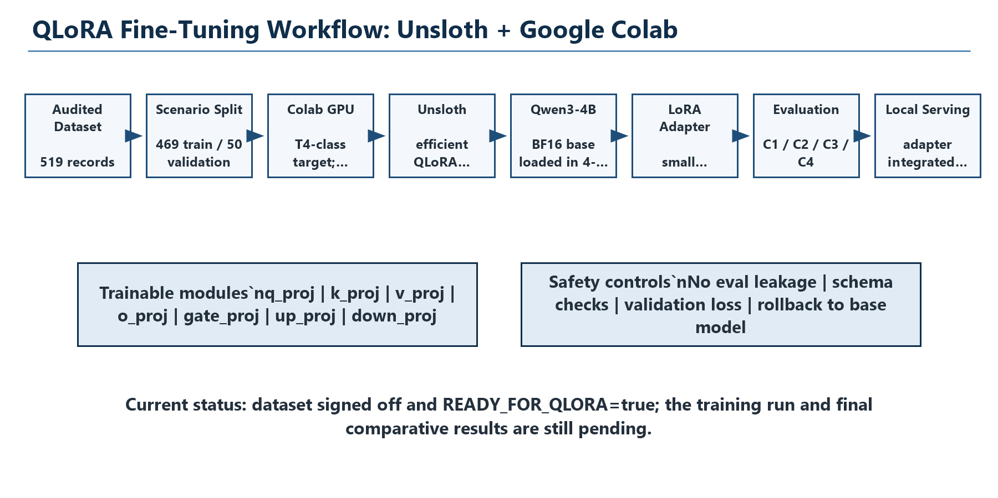
Figure 7. Planned, controlled QLoRA training workflow using Unsloth on Google Colab.

11.1 Why QLoRA?
QLoRA loads the frozen base model in 4-bit form and trains a small set of LoRA adapter parameters. This is suitable for CyberSRS because the goal is behavioural specialization, not training a language model from scratch. The adapter can improve schema compliance, clarification quality, requirement classification, atomicity, rationale quality, and acceptance-criteria structure while retaining the base model.

11.2 Why Unsloth + Colab?
Unsloth provides maintained Qwen3-2507 supervised-fine-tuning notebooks and supports 4-bit QLoRA workflows on Colab [R2, R3]. Google Colab is a hosted Jupyter service with free access to compute resources including GPUs, but free GPU availability and runtime duration are not guaranteed [R4]. The official Unsloth requirement guide identifies QLoRA as the 4-bit path and reports small-model VRAM requirements compatible with T4-class sessions, subject to sequence length and batch size [R3].
The local RTX 4050 has 6 GB VRAM. A 4B QLoRA run may fit only with aggressive constraints and little safety margin under Windows. A Colab T4-class runtime provides more headroom and a Linux CUDA environment. Only the curated training files and resulting adapter artefacts need to leave the local machine for this controlled experiment; normal CyberSRS inference and project data remain local.

11.3 Proposed Conservative Training Configuration
Parameter | Initial Setting | Reason
Base model | Qwen/Qwen3-4B-Instruct-2507 | Exact approved BF16 checkpoint
Quantization | 4-bit NF4, double quantization | QLoRA memory efficiency
Compute dtype | BF16 where supported; FP16 fallback | T4 compatibility requires checking
LoRA rank / alpha | 16 / 32 | Conservative capacity for a small dataset
LoRA dropout | 0.05 | Regularization against overfitting
Target modules | q/k/v/o + gate/up/down projections | Attention and MLP adaptation
Sequence length | 4096 preferred; 2048 dry-run fallback | Dataset maximum is 3887 tokens
Micro-batch | 1-2 | Fit available VRAM
Gradient accumulation | Adjusted for effective batch 8-16 | Stable optimization without large VRAM
Learning rate | 2e-4 starting point | Common LoRA baseline; validate empirically
Epochs | 1-3 with early stopping | Small dataset; avoid memorization
Optimizer | Paged AdamW 8-bit | Reduced optimizer memory
Logging | Train/validation loss, LR, steps, GPU memory | Reproducibility and failure analysis

These are proposed starting settings, not fabricated final results. The dry run must first verify tokenizer formatting, maximum sequence policy, loss calculation, checkpoint saving, and adapter reload before a full run is authorized.

11.4 Training Entry and Exit Criteria
Gate | Criteria
Entry | READY_FOR_QLORA=true; 519/519 schema valid; leakage 0; split overlap 0; manual sample approved; Colab GPU verified; package versions captured.
Dry-run exit | A small number of steps complete; loss is finite; checkpoint saves; adapter reloads; no OOM; sample generation is schema-checked.
Full-run exit | Best checkpoint selected using validation evidence; hashes and configuration saved; no catastrophic safety regression; adapter ready for frozen-set evaluation.
Rollback | If validation degrades, schema compliance collapses, or safety checks fail, discard adapter and retain base model.

12. Testing and Evaluation

12.1 Test Strategy
Layer | Examples
Unit | Schemas, repositories, services, chunking, retrieval, metrics, graph/ID utilities.
Integration | API round trips, database persistence, mocked LLM generation, RAG metadata propagation.
Schema | Every generated analysis, clarification, requirement, architecture, threat, and SRS object.
Semantic dataset | Gap state, assumptions, NFR classification, provenance, repetition, and scope promotion.
Frontend | React components, project workflow, clarification forms, requirement views, type checks.
Evaluation | Same frozen cases across C1-C4 with automated, retrieval, and human rubric metrics.
Manual | SRS/PDF visual inspection and end-to-end demonstrations on diverse descriptions.

12.2 Current Verified Quality Evidence
Evidence | Result
Python repository test suite | 161 passed; 5 warnings
Phase 4C.4 targeted semantic tests | Included in full passing suite
Dataset schema validation | 519 / 519 valid
Evaluation leakage | 0
Train/validation overlap | 0 scenarios
Scope-level assumption promotions | 0
Requirement-level assumption promotions | 0
Architecture-level assumption promotions | 0
Risk-level assumption promotions | 0
Ruff on Phase 4C.4 changed Python files | Pass

12.3 Final Four-Way Evaluation
Configuration | Model | RAG | Purpose
C1 | Base Qwen3-4B | No | Behavior and built-in knowledge baseline
C2 | Base Qwen3-4B | Yes | Measure retrieval and citation contribution
C3 | QLoRA adapter | No | Measure learned requirements-engineering behavior
C4 | QLoRA adapter | Yes | Full system: tuned behavior plus retrieved knowledge

All four configurations must use the same frozen evaluation descriptions, prompts, schema versions, decoding settings, and hardware reporting. Metrics include JSON/schema validity, requirement quality, completeness, category accuracy, retries, latency, citation validity/support, hallucinated citations, and a human 1-5 rubric. The expected order C4 > C2 approximately C3 > C1 is a hypothesis, not a result.

13. Cost and Resource Feasibility

13.1 Cost Assumptions
CyberSRS uses open-source software and an existing student laptop. Therefore the base incremental software-license cost is zero. Google states that Colab has a free tier, while also warning that free resources are not guaranteed or unlimited [R4]. Paid Colab or cloud compute is optional contingency, not a mandatory design dependency.
Cost Item | Base Estimate (INR) | Optional / Contingency | Assumption
Software licenses | 0 | 0 | Python, FastAPI, React, Ollama, ChromaDB, Unsloth are open source/free to use subject to their licenses.
Development laptop | 0 incremental | Replacement not budgeted | Existing RTX 4050 laptop is available.
Google Colab training | 0 on free tier | 1,000-5,000 planning reserve | Optional paid compute if free GPU capacity/runtime is insufficient; reserve is not a vendor quote.
Local storage / backup | 0 incremental | 500-1,500 | Existing disk used; optional external backup media.
Electricity / internet | 300-800 | Usage dependent | Incremental academic-project estimate only.
Printing / binding | 500-1,500 | Institution dependent | Only if a physical report is required.
Base incremental total | 800-2,300 | - | Existing hardware, free Colab, and normal connectivity.
With optional contingency | 1,800-8,800 | - | Includes paid-compute reserve and optional backup/printing.

The INR figures are academic planning estimates, not vendor quotations. Actual paid Colab availability and pricing vary by account, region, plan, and current Google terms. The project remains feasible at zero mandatory software-license cost.

13.2 Resource Feasibility
- Local inference is feasible using Ollama and a Q4_K_M 4B model on the verified RTX 4050 GPU.
- Local RAG is feasible because 4,470 embeddings and SQLite/ChromaDB are modest for the existing machine.
- Local QLoRA is marginal at 6 GB VRAM; Colab/Unsloth is the preferred training environment.
- The 519-record dataset is small enough for a controlled academic adapter experiment.
- Normal runtime does not depend on Colab after the adapter is downloaded and approved.

14. Project Timeline and Milestones
Stage | Planned Duration | Primary Milestone
Planning and governance | 7 days | Approved scope, architecture, requirements, risks
Application foundation | 10 days | CRUD, database, frontend/backend scaffolds
Base-model integration | 7 days | Qwen analysis and clarification pipeline
Structured SRS | 10 days | Validated multi-section SRS JSON
RAG | 10 days | Source-aware retrieval and citations
Validation and security | 7 days | Threat/quality checks
Editing and PDF | 10 days | Review/version/export workflow
Dataset preparation | 7 days | 519-record Phase 4C.4 signoff
QLoRA training | 7 days | Best adapter checkpoint
Comparative evaluation | 7 days | C1-C4 report
Final testing and documentation | 10 days | Submission and demonstration package

The nominal sequential plan totals 92 days. Some documentation, dataset, and UI work may overlap, but completion is controlled by the entry/exit gates in Section 4 rather than dates alone.

15. Security, Privacy, and Ethical Controls
- Project descriptions and normal inference stay local; no telemetry or cloud inference is required.
- Full sensitive descriptions are not written to production debug logs.
- Secrets and credentials are supplied through environment configuration, never committed source code.
- LLM output is treated as untrusted until parsing and schema/semantic validation succeed.
- Retrieved chunks retain source identity and citations are validated against actual retrieved IDs.
- The knowledge base is curated and hash-verified to reduce poisoned-source risk.
- Training exports only curated synthetic data; user project content and RAG documents are not uploaded as training examples.
- CyberSRS may plan authorized security testing but does not execute exploits, scans, or live-system attacks.
- Adapter hashes, model/version metadata, and rollback to the base model are required controls.

15.1 Responsible AI Position
CyberSRS assists rather than replaces professional review. It labels assumptions, preserves unresolved questions, exposes sources, records confidence and provenance, and allows users to edit or reject generated content. A schema-valid response can still be semantically wrong, so human approval remains mandatory for both the SRS and future development plan.

16. Future SDLC Selection and Development Planner
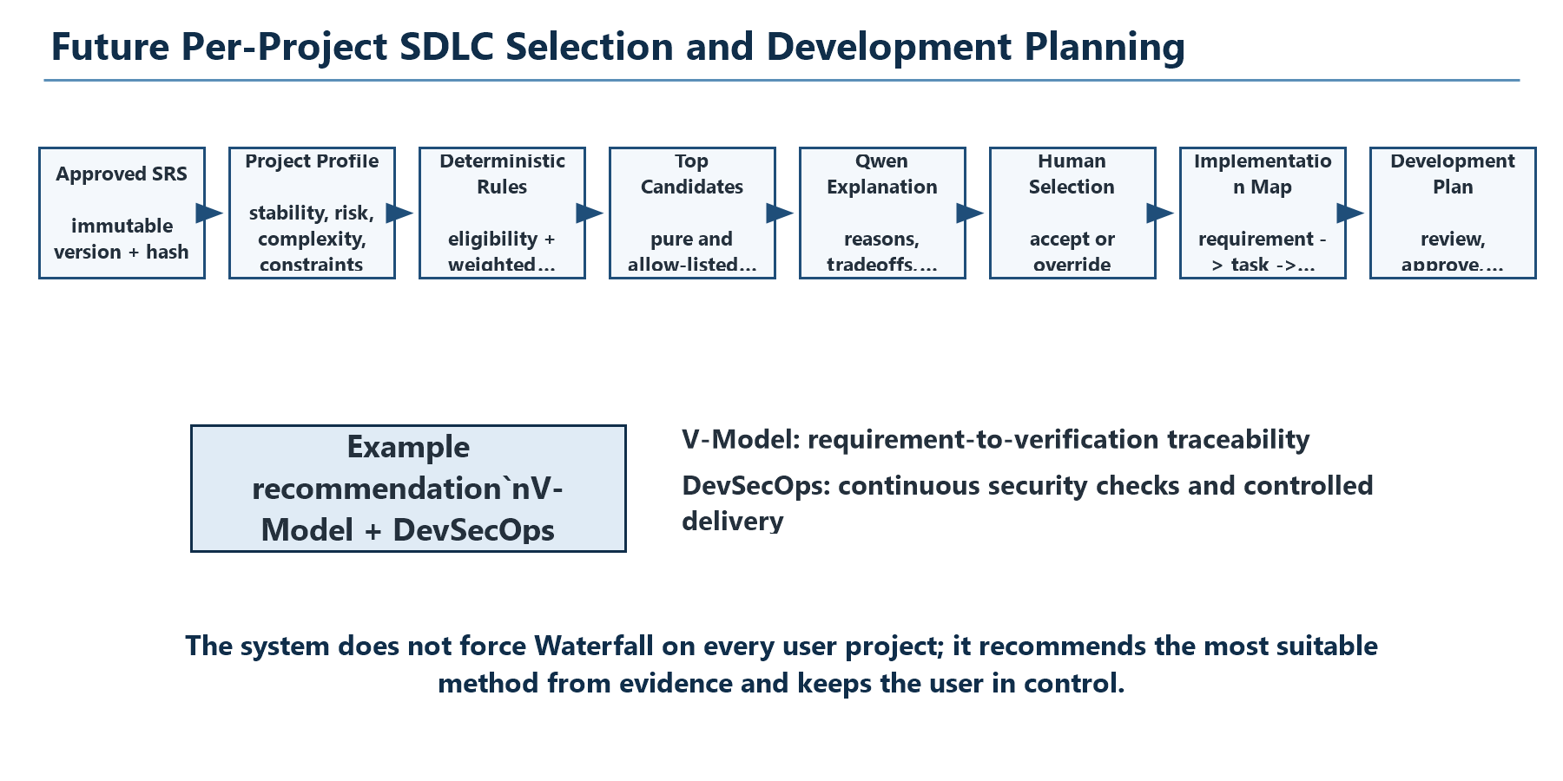
Figure 8. Planned explainable SDLC-selection and requirement implementation workflow.

16.1 Purpose
The extension begins only after an exact SRS version is approved. It extracts a ProjectDevelopmentProfile containing requirement stability/completeness, change frequency, complexity, technical uncertainty, security/safety criticality, regulatory constraints, stakeholder availability, team/duration facts, deployment frequency, integration complexity, testing intensity, risk, availability, and maintenance expectations.

16.2 Controlled SDLC Catalogue
Method / Framework | Suitable Signals | Avoid When
Waterfall | Stable scope, formal sequential approvals, high documentation | Requirements are highly volatile or discovery-heavy
V-Model | Stable requirements, regulated/security-critical verification | Frequent uncontrolled scope changes
Iterative | Need repeated refinement with a stable overall goal | A single irreversible release dominates
Incremental | Modular capabilities can be delivered in slices | System cannot provide value in partial increments
Spiral | High risk or technical uncertainty | Small low-risk project cannot justify cycle overhead
Prototyping / RAD | UI/technical uncertainty and rapid feedback | Formal baselines and assurance dominate
Scrum | Available product owner, stable team, time-boxed increments | Stakeholders cannot provide regular feedback
Kanban | Continuous intake and flow optimization | A fixed staged lifecycle is mandatory
DevOps / DevSecOps | Frequent build/release and continuous assurance | Used alone without a lifecycle or operational capability

16.3 Explainable Selection
- Each profile value is labelled USER_SPECIFIED, CLARIFICATION_CONFIRMED, SRS_DERIVED, or ASSUMPTION_REQUIRING_CONFIRMATION.
- Deterministic hard exclusions and weighted suitability rules score eligible methods.
- Only allow-listed hybrids are composed, and each component must have a separate responsibility.
- Qwen explains the top deterministic candidates, tradeoffs, risks, and conditions that would change the result.
- The user compares alternatives, accepts the recommendation, or chooses another method with an auditable override.
- The selected method controls the work-breakdown vocabulary: Scrum uses epic/story/task; V-Model uses requirement/design/implementation/verification; Waterfall uses staged design/build/integration/test.

16.4 Requirement Implementation Mapping
Every approved functional, non-functional, security, data, and network requirement receives one implementation-plan record. It links the requirement statement and priority to modules, backend/frontend/database/infrastructure/security work, development tasks, prerequisites, implementation phase, relative complexity, responsible role, testing strategy, original acceptance-criteria references, security validation, deliverables, risks, and assumptions.
Traceability Element | Required Link
Requirement | Exact ID from the approved SRS
Design component | Module/service/data/infrastructure allocation
Development task | Stable task ID and methodology-aware activity
Test case | Verification method and original acceptance-criterion reference
Deliverable | Code/configuration/document/test evidence expected
Milestone / sprint | Placement according to the selected method
Status | Planned, approved, blocked, or approved exception

Target: 100% structural requirement-to-implementation and verification mapping. This is a coverage target, not a claim that every generated plan is automatically correct; human review and approval remain mandatory.

17. Risks and Mitigation
Risk | Impact | Mitigation / Contingency
Invalid or malformed JSON | Generation failure | Detailed schemas, corrective retry, Pydantic validation, structured error.
Hallucinated requirements | Incorrect SRS | Clarification state, provenance checks, RAG citations, human review.
Poor retrieval | Irrelevant context | Curated corpus, metadata filters, score thresholds, retrieval evaluation.
Citation not supported | False authority | Validate source IDs and manually evaluate support/precision.
GPU out of memory | Training interruption | Unsloth QLoRA, Colab T4+, batch 1, checkpointing, shorter dry run.
Overfitting | Poor generalization | Scenario split, validation loss, dropout, early stopping, frozen evaluation.
Evaluation leakage | Invalid academic result | Frozen 30-case set, similarity audit, scenario-level split.
Colab termination | Lost runtime | Save checkpoints/config to controlled storage; resume; optional paid contingency.
Adapter regression | Worse/safety-invalid output | C1-C4 comparison, safety tests, hashes, rollback to base model.
Future SDLC recommendation bias | Unsuitable plan | Deterministic score breakdown, evidence provenance, alternatives, human override.

18. Final Outcomes and Acceptance Criteria

18.1 Current Demonstrable Outcome
- A modular local application for project creation, analysis, clarification, SRS generation, review, and persistence.
- A structured JSON-first SRS pipeline using Qwen through a provider-independent interface.
- An implemented local RAG pipeline with 10 packaged authoritative files and 4,470 indexed chunks.
- Deterministic schema, semantic, citation, and requirement-quality validation.
- A final 519-record, 60-scenario, multi-task QLoRA dataset with zero leakage and split overlap.
- A passing 161-test Python suite and targeted semantic regression coverage.
- An implementation-ready future plan for explainable SDLC selection and Software Development Plan generation.

18.2 Outcome After Current Fine-Tuning Track
- A versioned QLoRA adapter trained on the approved dataset using Unsloth/Colab.
- A reproducible training configuration, logs, validation evidence, checkpoint hashes, and rollback decision.
- A fair C1-C4 comparison showing whether fine-tuning and RAG improve the intended metrics.
- A final SRS/PDF workflow whose claims are aligned with measured results rather than expectations.

18.3 Outcome After Future Planner
- Document 1: approved Software Requirements Specification - what must be built.
- Document 2: approved Software Development Plan - how every requirement should be implemented and verified.
- An explainable SDLC or hybrid recommendation with alternatives and change conditions.
- A complete requirement-to-component-to-task-to-test-to-deliverable traceability matrix.

18.4 Final Acceptance Gate
Criterion | Pass Condition
Functionality | End-to-end project description -> approved SRS works on representative cases.
Structured output | All production artefacts parse and validate before use.
RAG | Retrieved source metadata survives ingestion, generation, storage, UI, and export.
Dataset | Final signed-off dataset remains reproducible with 0 leakage and 0 split overlap.
QLoRA | Adapter loads, generates valid outputs, and is evaluated against the frozen baseline.
Evaluation | C1-C4 results and limitations are documented without cherry-picking.
Security | No active offensive action; secrets and sensitive descriptions remain protected.
Documentation | Report, user guide, architecture, settings, and reproducibility evidence are accurate.

19. Limitations
- The dataset contains original synthetic scenarios rather than confidential industrial SRS documents.
- The final QLoRA adapter and four-way comparative evaluation are pending; no improvement is claimed yet.
- The three-case RAG smoke run is engineering evidence, not statistically reliable evaluation.
- The local 4B model may still omit requirements or generate plausible but incorrect content.
- Human review remains necessary for legal, regulatory, safety-critical, privacy, and organization-specific claims.
- ChromaDB relevance depends on corpus coverage, chunking, embedding quality, and query construction.
- Google Colab free GPU access is variable and runtimes are ephemeral.
- The future SDLC selection and Software Development Plan modules are planned, not implemented.

20. Conclusion
CyberSRS demonstrates a disciplined way to combine a compact local language model, retrieval from authoritative cybersecurity sources, deterministic structured-output validation, and human approval. Its design avoids treating the LLM as an unbounded source of truth: Qwen drafts, RAG supplies traceable external evidence, Python enforces contracts, and the user approves the final artefact.
The current project is appropriately managed using Modified Waterfall because it depends on ordered baselines and academic quality gates. The next immediate step is the small Unsloth QLoRA dry run on Google Colab, followed by the full controlled training run and C1-C4 evaluation. The longer-term extension will add explainable SDLC selection and a second Software Development Plan, allowing CyberSRS to progress from 'what must be built' to 'how each approved requirement should be built and verified.'

21. References
[R1] Qwen/Qwen3-4B-Instruct-2507 model card. https://huggingface.co/Qwen/Qwen3-4B-Instruct-2507
[R2] Unsloth official fine-tuning notebook catalogue. https://unsloth.ai/docs/get-started/unsloth-notebooks
[R3] Unsloth official requirements and QLoRA VRAM guidance. https://unsloth.ai/docs/get-started/beginner-start-here/unsloth-requirements
[R4] Google Colab official FAQ. https://research.google.com/colaboratory/faq.html
[R5] NIST Cybersecurity Framework 2.0. https://www.nist.gov/cyberframework
[R6] NIST Computer Security Resource Center publications. https://csrc.nist.gov/publications
[R7] OWASP Application Security Verification Standard. https://owasp.org/www-project-application-security-verification-standard/

21.1 Repository Evidence
- AGENTS.md; docs/PRD.md; docs/SCOPE.md; docs/ARCHITECTURE.md; docs/ROADMAP.md.
- docs/RAG_DESIGN.md; docs/PHASE4_FINETUNING_PLAN.md; docs/EVALUATION_PLAN.md.
- docs/FUTURE_SDLC_AND_DEVELOPMENT_PLANNER.md.
- ai/finetuning/data/dataset_report.json; leakage_report.json; cross_stage_consistency_report.json.
- ai/evaluation/corpus_inventory.json and the frozen ai/evaluation/dataset.json.
- Source code under src/, frontend/src/, ai/finetuning/scripts/, and tests/.

A. Appendix: Dataset Task Counts
Task | Records
Architecture | 60
Clarification Questions | 60
Context Extraction | 60
Data Requirements | 2
Functional Requirements | 60
Network Requirements | 8
Non Functional Requirements | 44
Requirement Validation | 60
Security Requirements | 45
Srs Generation | 60
Threat Model | 60

B. Appendix: Runtime Configuration Summary
Configuration | Example Value
CYBERSRS_LLM_PROVIDER | mock for deterministic tests; ollama for local inference
CYBERSRS_OLLAMA_BASE_URL | http://localhost:11434
CYBERSRS_MODEL_NAME | qwen3:4b-instruct-2507-q4_K_M
CYBERSRS_ADAPTER_PATH | empty for base; adapter path after approval
CYBERSRS_OLLAMA_NUM_CTX | 32768 runtime example
CYBERSRS_EMBEDDING_MODEL | nomic-embed-text
CYBERSRS_RAG_ENABLED | true
CYBERSRS_CHROMA_PATH | ./data/chroma
CYBERSRS_RAG_TOP_K | 3 environment example; code default configurable
CYBERSRS_RAG_MIN_SCORE | 0.45 environment example
CYBERSRS_RAG_CHUNK_SIZE | 512
CYBERSRS_RAG_CHUNK_OVERLAP | 64
CYBERSRS_DATABASE_URL | sqlite:///./data/cybersrs.db

C. Appendix: Abbreviations
Abbreviation | Meaning
AI | Artificial Intelligence
API | Application Programming Interface
DAST | Dynamic Application Security Testing
LLM | Large Language Model
LoRA | Low-Rank Adaptation
NF4 | Normal Float 4-bit quantization format
QLoRA | Quantized Low-Rank Adaptation
RAG | Retrieval-Augmented Generation
SAST | Static Application Security Testing
SDLC | Software Development Life Cycle
SRS | Software Requirements Specification
VRAM | Video Random-Access Memory

Review and Approval
This report is prepared for academic review. The signatures below confirm review of the document; they do not convert planned QLoRA or future SDLC-planner work into completed work.
Student signature: ____________________________________
Name: Aryan Bokolia
Date: ____________________

Project guide / faculty signature: ______________________________
Name: ______________________________________________
Date: ____________________

Comments:
________________________________________________________________________
________________________________________________________________________
________________________________________________________________________
________________________________________________________________________
________________________________________________________________________

