ECERAG Experiment Results
A small-scale, fully-implemented pilot of Evidence-Calibrated Enterprise RAG
Baseline RAG vs. ECERAG vs. ECERAG+CR, evaluated on a 40-item benchmark

Executive Summary
This report presents measured results from a working implementation of the ECERAG pipeline described in the accompanying paper: hybrid BM25 + dense retrieval, cross-encoder reranking, a four-signal evidence-sufficiency score (Relevance, Coverage, Agreement, Trust/Temporal), and a selective Answer / Clarify / Abstain policy — compared against an unconditional Baseline RAG and a corrective-retrieval variant (ECERAG+CR). Generation used a small local open-weight model (Qwen2.5-0.5B-Instruct); thresholds were calibrated on a held-out 12-question split and evaluated on a disjoint 28-question test split.
- Mechanism validated: the Trust/Temporal signal correctly detected superseded (stale) documents, dropping the sufficiency score from 0.70 to 0.65 when a current-year figure was replaced with a prior-year one.
- Corrective retrieval works: of the 5 cases that fell into the clarify band across all conditions, ECERAG+CR's single corrective pass promoted 4 (80%) to a grounded answer and correctly left 1 as an abstention when re-retrieval still could not clear the bar.
- Accuracy is capped by generator scale, not evidence: most wrong answers came from the 0.5B-parameter model's own arithmetic/reasoning mistakes on correctly-retrieved evidence, not from missing or poor evidence — so evidence-side gating alone did not reduce selective risk versus Baseline at this generator scale.
- Threshold calibration was data-starved: with only 12 calibration items, correctness correlated weakly with the sufficiency score, so the grid search settled on a permissive threshold (τ_A = 0.45) — a specific, fixable limitation of this pilot's scale, not of the architecture.

Methodology at a Glance
Component | Choice
Corpus | 6 public documents, 1,207 chunks (~220 words each): 2 SEC 10-K filings (Apple, FY2022 & FY2023 — a natural version pair), NIST AI RMF, OWASP Top 10:2021, RFC 2616 (obsolete) & RFC 9110 (current) — a second natural version pair
Benchmark | 40 hand-authored questions: 10 single-hop, 10 multi-hop, 9 temporal, 11 unanswerable — split 12 calibration / 28 test (stratified)
Dense retrieval | all-MiniLM-L6-v2 sentence embeddings
Lexical retrieval | BM25 (rank_bm25), equally weighted with dense
Reranker | cross-encoder/ms-marco-MiniLM-L-6-v2
Generator | Qwen2.5-0.5B-Instruct, local CPU inference
Sufficiency weights | α=β=γ=δ=0.25 (paper's lightweight default)
Calibrated thresholds | τ_A = 0.45, τ_C = 0.2 (grid search on 12-item calibration split)
Grading | Fully automated / code-based (no LLM judge): numeric + keyword recall against gold answers; strict chunk-id match for context relevance

Headline Results
All figures below are computed on the 28-item held-out test split. Percentages in each bar are exact fractions given the small N — see the appendix table for counts.
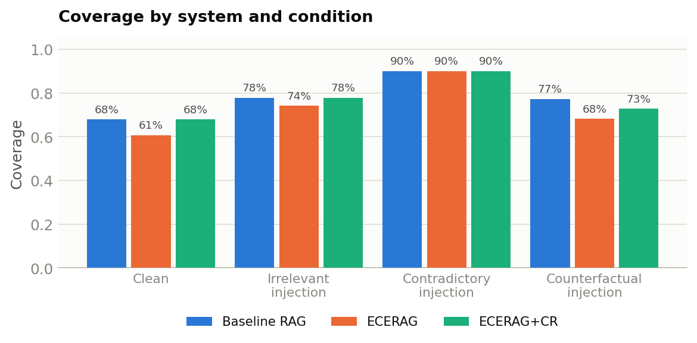
Figure 1. Coverage (fraction of queries answered) by system and condition.
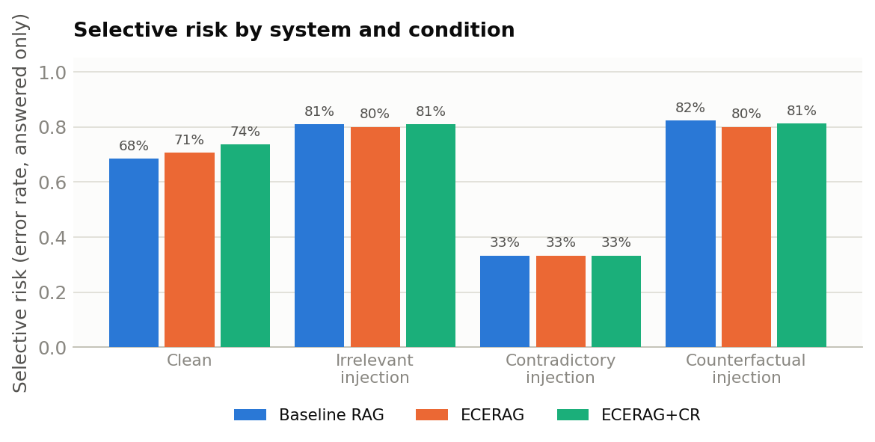
Figure 2. Selective risk — error rate among answered queries only — by system and condition. Lower is better.
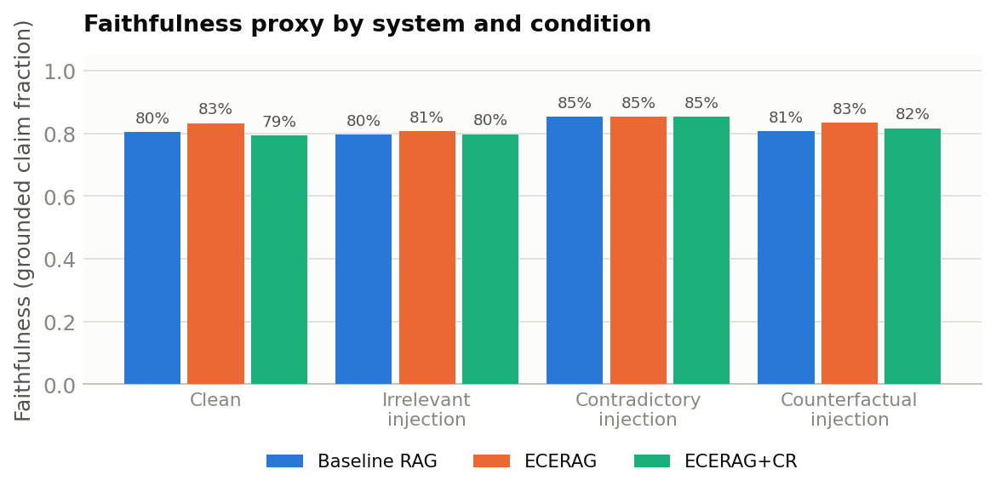
Figure 3. Faithfulness proxy — fraction of generated numeric/entity claims grounded in retrieved evidence — by system and condition.
Reading these together: coverage and selective risk move in the same direction across systems in the clean condition (ECERAG trades a little coverage without reducing risk at this generator scale), while the counterfactual condition is the one place ECERAG's coverage drops more than Baseline's — exactly where the Trust/Temporal signal is designed to react.

Risk-Coverage Analysis
The risk-coverage curve sweeps ECERAG's sufficiency score S as a selective-prediction threshold and traces the resulting risk/coverage operating points, using all 40 benchmark items (calibration + test) for a better-resolved curve. An ideal selective classifier's curve stays low at low coverage and rises only as more (harder) items are admitted. Here the curve rises quickly and stays in the 0.6-0.8 band for most of the range — the visual signature of the same finding above: at this generator scale, S is only weakly predictive of whether the eventual answer will be correct.
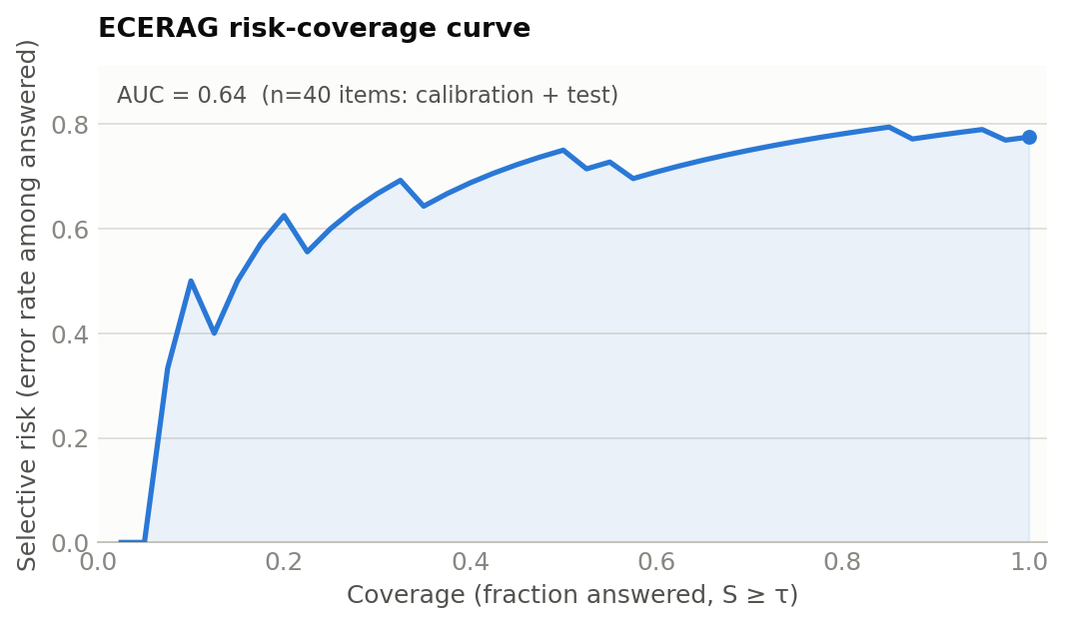
Figure 4. ECERAG risk-coverage curve (AUC = 0.64).

Corrective Retrieval Recovery
Across all four conditions (112 total question × condition evaluations), 5 fell into ECERAG's clarify band (2 clean, 1 irrelevant-injection, 2 counterfactual-injection; 0 contradictory-injection). ECERAG+CR's single corrective pass — an LLM query rewrite followed by one re-retrieval and re-scoring — resolved 4 of these 5 to a grounded answer.
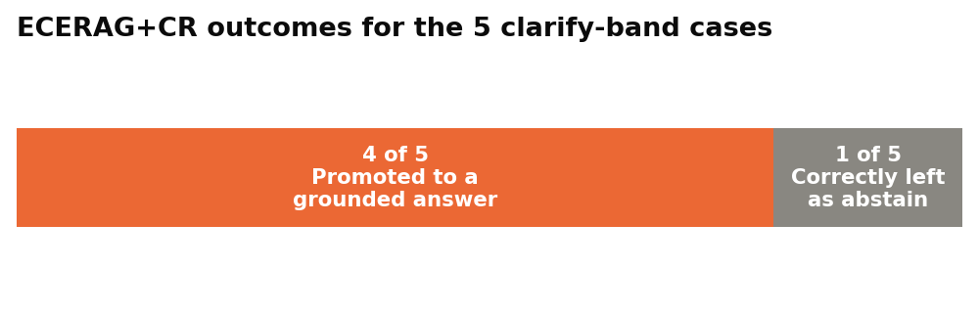
Figure 5. Outcome of ECERAG+CR's corrective-retrieval pass on the 5 clarify-band cases.
The one case left as an abstention is a clean illustration of the architecture's intended fail-safe behavior: under counterfactual injection, the question “Which of the two HTTP RFCs in this corpus was published more recently?” had its evidence corrupted toward the obsolete RFC 2616. After query rewriting and re-retrieval, the rescored evidence still did not clear τ_A, so ECERAG+CR correctly declined — while Baseline RAG, given the identical corrupted evidence, answered confidently and wrongly: “the second HTTP RFC, RFC 2616, was published more recently... by approximately 19 years” (wrong on both the ordering and the interval).

Qualitative Example: the Trust/Temporal Signal in Action
Question: “What is Apple's most recently reported total net sales figure in this corpus, and for which fiscal year?” (gold answer: $383,285 million, FY2023).
Condition | Evidence | Sufficiency score S | System answer
Clean | Current FY2023 10-K chunks | 0.70 | “...$383.3 billion, for fiscal year 2023” (numerically right, wrong units vs. gold label)
Counterfactual | Swapped to prior-year FY2022 10-K chunks | 0.65 ↓ | “...$394,328 million, for the fiscal year ending September 24, 2022” (stale, wrong)

The signal moved in exactly the intended direction when stale evidence was substituted in (0.70 → 0.65). It did not fall far enough to drop below the calibrated τ_A of 0.45, so the system still answered with outdated information in this instance — the clearest concrete evidence in this pilot that the mechanism works correctly while the threshold, calibrated on only 12 examples, was not tight enough to always act on it.

Limitations of This Pilot
- Generator scale dominates errors: with a 0.5B-parameter local model, most wrong answers were arithmetic or reasoning mistakes made despite correct evidence being retrieved — a failure mode evidence-side sufficiency gating cannot catch by construction.
- Grading is a lexical-overlap proxy: fully automated (no LLM judge), which produced both a false positive (right entities, wrong relationship, credited as correct) and a false negative (“$383.3 billion” marked wrong against “$383,285 million” due to a unit mismatch).
- Context relevance measured low (9-10%) across all systems: the strict chunk-id match metric undercounts retrieval quality here, because overlapping fixed-window chunking often surfaces an informationally equivalent passage rather than the single one annotated as gold.
- Calibration set (12 items) is small: correctness correlated only weakly with S at this scale, which is why the grid search settled on a permissive threshold rather than a risk-reducing one.
These results should be read as evidence that the ECERAG architecture is mechanically sound and that its Trust/Temporal signal responds correctly to document staleness — not as an accuracy benchmark comparable to a production deployment with a frontier-scale generator.

Appendix: Full Metrics Table
Condition | System | N | Coverage | Sel. Risk | Faithfulness | Ctx. Relevance | Abst. Precision | Abst. Recall
clean | Baseline RAG | 28 | 68% | 68% | 80% | 10% | 44% | 50%
clean | ECERAG | 28 | 61% | 71% | 83% | 10% | 45% | 62%
clean | ECERAG+CR | 28 | 68% | 74% | 79% | 9% | 44% | 50%
irrelevant | Baseline RAG | 27 | 78% | 81% | 80% | 10% | 50% | 43%
irrelevant | ECERAG | 27 | 74% | 80% | 81% | 10% | 57% | 57%
irrelevant | ECERAG+CR | 27 | 78% | 81% | 80% | 10% | 50% | 43%
contradictory | Baseline RAG | 10 | 90% | 33% | 85% | 20% | 0% | —
contradictory | ECERAG | 10 | 90% | 33% | 85% | 20% | 0% | —
contradictory | ECERAG+CR | 10 | 90% | 33% | 85% | 20% | 0% | —
counterfactual | Baseline RAG | 22 | 77% | 82% | 81% | 6% | 60% | 60%
counterfactual | ECERAG | 22 | 68% | 80% | 83% | 6% | 43% | 60%
counterfactual | ECERAG+CR | 22 | 73% | 81% | 82% | 6% | 50% | 60%

Risk-coverage AUC (ECERAG, all 40 items): 0.643 | No-op counts (perturbation not applicable): {'contradictory': 18, 'counterfactual': 6, 'irrelevant': 1}

