AZURE NETWORK ENGINEERING
DAY 1 — COMPLETE MASTER PRACTICE RUNBOOK
UKPropertyDealDesk • Azure Networking Foundation • Portal + Terraform + Troubleshooting + Git/GitHub
Built from the hands-on session, supplied screenshots, command history, errors, recovery work and Git evidence.

1. How to use this runbook
This is a practice document, not a theory summary. Re-run it from top to bottom when you want to reproduce the networking foundation.
- Follow the Azure Portal sections first to reproduce the architecture manually.
- Use the supplied screenshots as visual evidence alongside the numbered steps.
- Then reproduce the same design with Terraform.
- Use the troubleshooting sections deliberately: the failures documented here are part of the learning evidence.
- Use the command explanation boxes before running commands; never treat a command as unexplained copy/paste.
- Use the Git/GitHub section to reproduce the professional workflow.
- At the end, use the interview section as a technical interview rehearsal.
Important cost rule
The Day 1 Terraform environment was intentionally disposable. The final destroy operation reported that there were no Terraform-managed objects left to destroy. Do not leave billable resources running merely for practice.

2. Engineering standard used
The exercise follows the lifecycle:
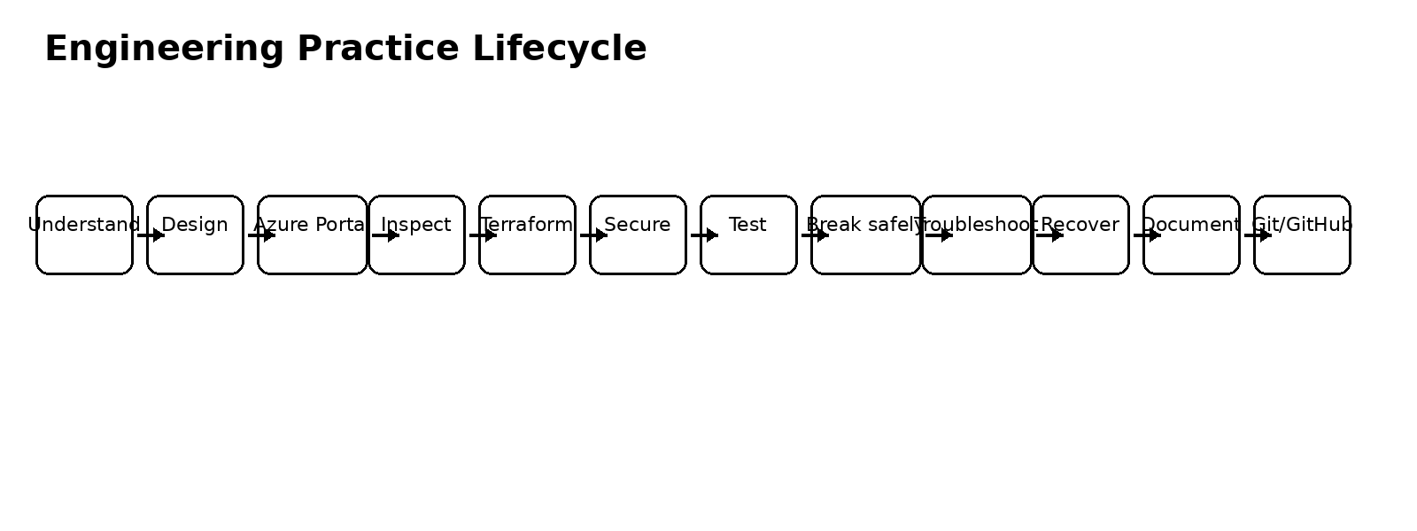
Diagram A — Engineering practice lifecycle used for the residency.
The goal is not merely to create Azure resources. The goal is to demonstrate design, implementation, security, testing, controlled failure, troubleshooting, recovery, automation, documentation and version control.

3. Day 1 objective and completed scope
Capability | Status | Evidence
VNet and CIDR design | Completed | 10.0.0.0/16 production-style VNet
Subnet segmentation | Completed | app, db and AzureBastionSubnet
NSGs | Completed | app/db subnet associations; controlled deny test
NAT Gateway | Completed | controlled VM outbound IP
Azure Bastion | Completed | private management access
Management VM | Completed | 10.0.0.4, no public IP
VNet peering | Completed | bidirectional Connected state
Network Watcher | Completed | IP Flow Verify / connectivity testing
Failure engineering | Completed | temporary RDP deny + diagnosis + recovery
Terraform | Completed | 26-resource baseline deployment
Terraform drift | Completed | Portal tag drift detected and reconciled
Git/GitHub | Completed | feature/networking-terraform pushed
Documentation | Completed | runbook and evidence committed

4. Architecture — Azure Portal practice design
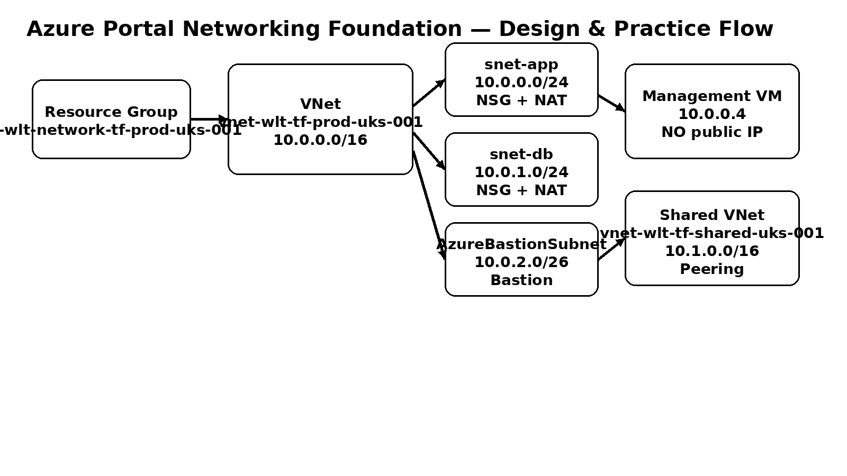
Diagram B — Portal architecture diagram for the networking foundation.
Component | Configuration
Resource Group | rg-wlt-network-tf-prod-uks-001
Region | UK South
Primary VNet | vnet-wlt-tf-prod-uks-001
Primary CIDR | 10.0.0.0/16
App subnet | 10.0.0.0/24
DB subnet | 10.0.1.0/24
Bastion subnet | 10.0.2.0/26
Shared VNet | vnet-wlt-tf-shared-uks-001
Shared CIDR | 10.1.0.0/16
Management VM | vm-wlt-tf-mgmt-prod-uks-001
Management private IP | 10.0.0.4
Bastion | bas-wlt-tf-prod-uks-001
NAT | natgw-tf-app-prod-uks-001 / natgw-tf-db-prod-uks-001

5. Azure Portal practice — complete click-by-click sequence
The following is the reproducible manual workflow. The production-style Terraform environment used different names from the preserved reference environment so the reference environment was not imported or overwritten.

5.1 Create the resource group
- Sign in to the Azure Portal.
- At the top search bar, type Resource groups.
- Select Resource groups.
- Click + Create.
- Select the Azure subscription.
- Click Create new for Resource group.
- Enter rg-wlt-network-tf-prod-uks-001.
- Select UK South.
- Click Review + create.
- Review the configuration.
- Click Create.
Why: the resource group provides the lifecycle boundary for the disposable networking environment. It makes cost cleanup and resource ownership easier.

5.2 Create the production VNet
- Search for Virtual networks.
- Open Virtual networks.
- Click + Create.
- On Basics, select the subscription and rg-wlt-network-tf-prod-uks-001.
- Enter vnet-wlt-tf-prod-uks-001.
- Select UK South.
- Open IP Addresses.
- Enter 10.0.0.0/16 as the VNet address space.
- Create the app, DB and Bastion subnets using the values in the architecture table.
- Open Tags and apply the standard UKPropertyDealDesk tags.
- Click Review + create.
- Review the configuration and click Create.
Why: the VNet is the Layer-3 private network boundary. The /16 gives room for future segmentation while the /24 workloads and /26 Bastion subnet keep the current design simple and explicit.

5.3 Create snet-app
Field | Enter
Subnet purpose | Default
Name | snet-app
IPv4 range | 10.0.0.0/24
NAT Gateway | natgw-tf-app-prod-uks-001 once NAT exists
NSG | nsg-tf-app once NSG exists
Private endpoint network policy | Enabled for the general workload subnet
Important: do not overlap 10.0.0.0/24 with another subnet.

5.4 Create snet-db
Field | Enter
Name | snet-db
IPv4 range | 10.0.1.0/24
NAT Gateway | natgw-tf-db-prod-uks-001 once NAT exists
NSG | nsg-tf-db once NSG exists
Private endpoint network policy | Enabled for the general workload subnet

5.5 Create AzureBastionSubnet — corrected production practice
This was one of the important troubleshooting/correction points in the session.
Field | Correct value
Subnet purpose | Azure Bastion
Name | AzureBastionSubnet
Address range | 10.0.2.0/26
Private subnet / no default outbound access | UNCHECKED
NAT Gateway | None
Route table | None
NSG | None for the initial Bastion deployment
- The exact subnet name AzureBastionSubnet is required by the Bastion service.
- /26 was used for the Bastion subnet.
- Do not attach the workload NAT gateways to the Bastion subnet.
- Do not attach a route table to the Bastion subnet.
- Do not prematurely attach an incomplete NSG to Bastion; validate Bastion first.
The session explicitly corrected an earlier Portal approach here. The corrected approach was retained as the production runbook standard.
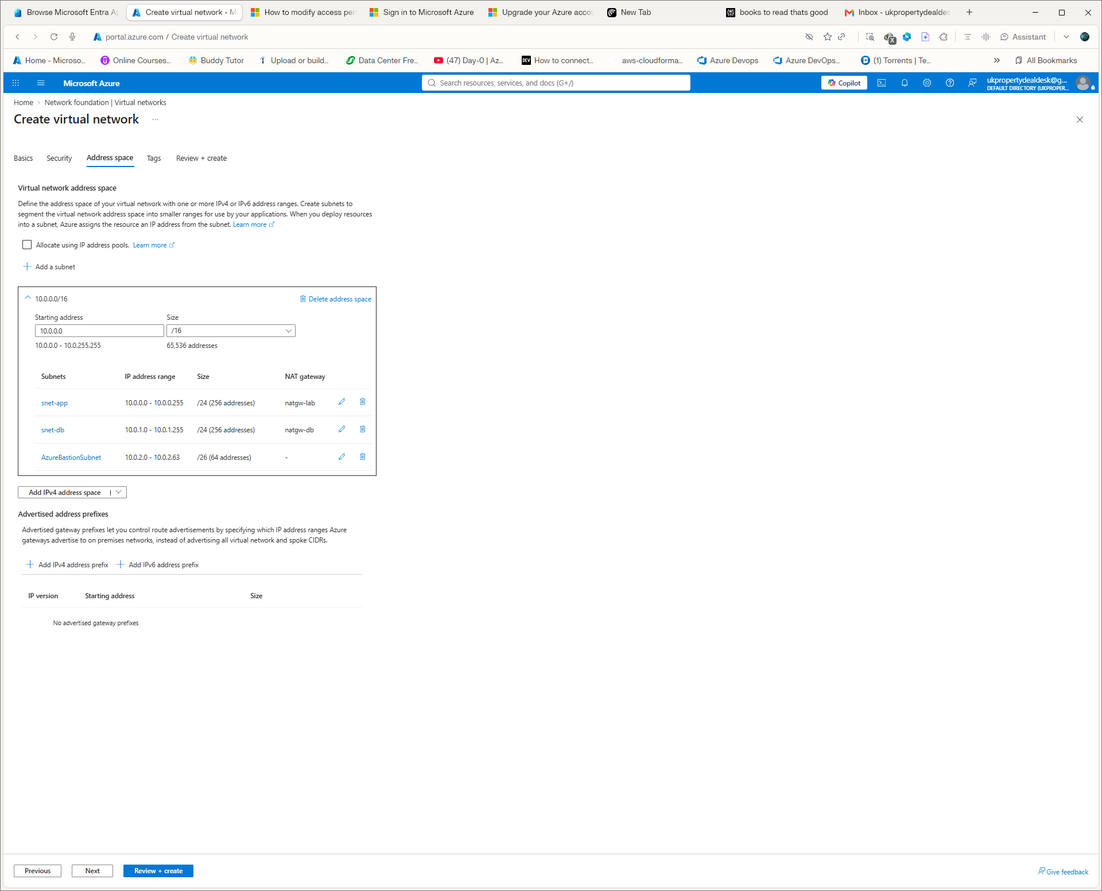
Portal evidence screenshot S01 — supplied during the hands-on networking session.
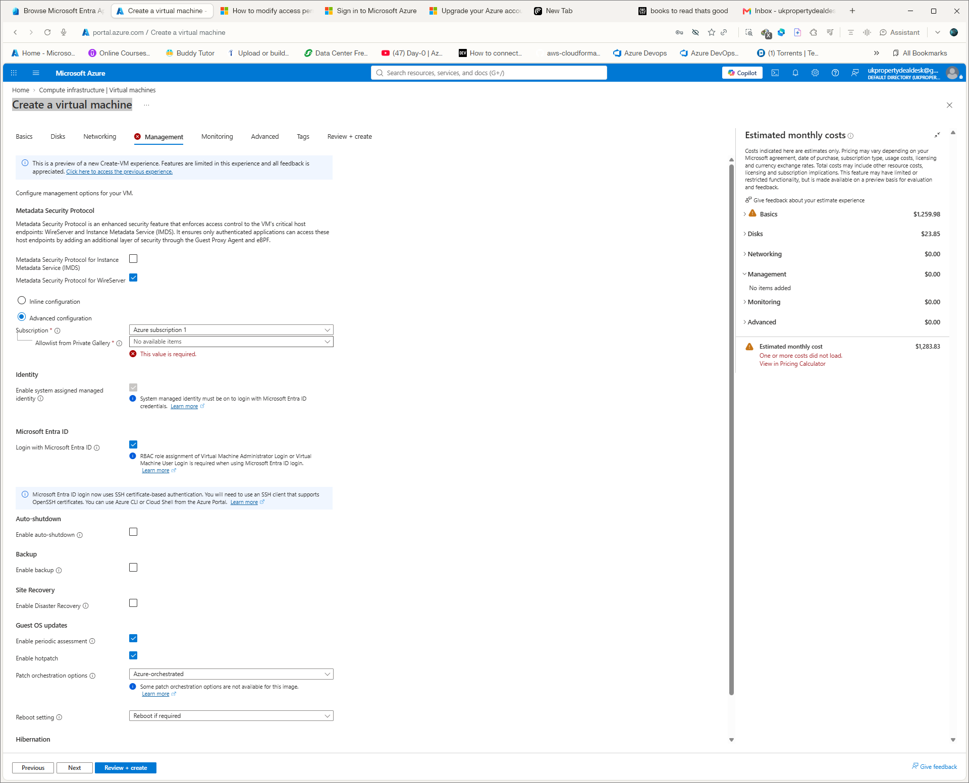
Portal evidence screenshot S02 — supplied during the hands-on networking session.
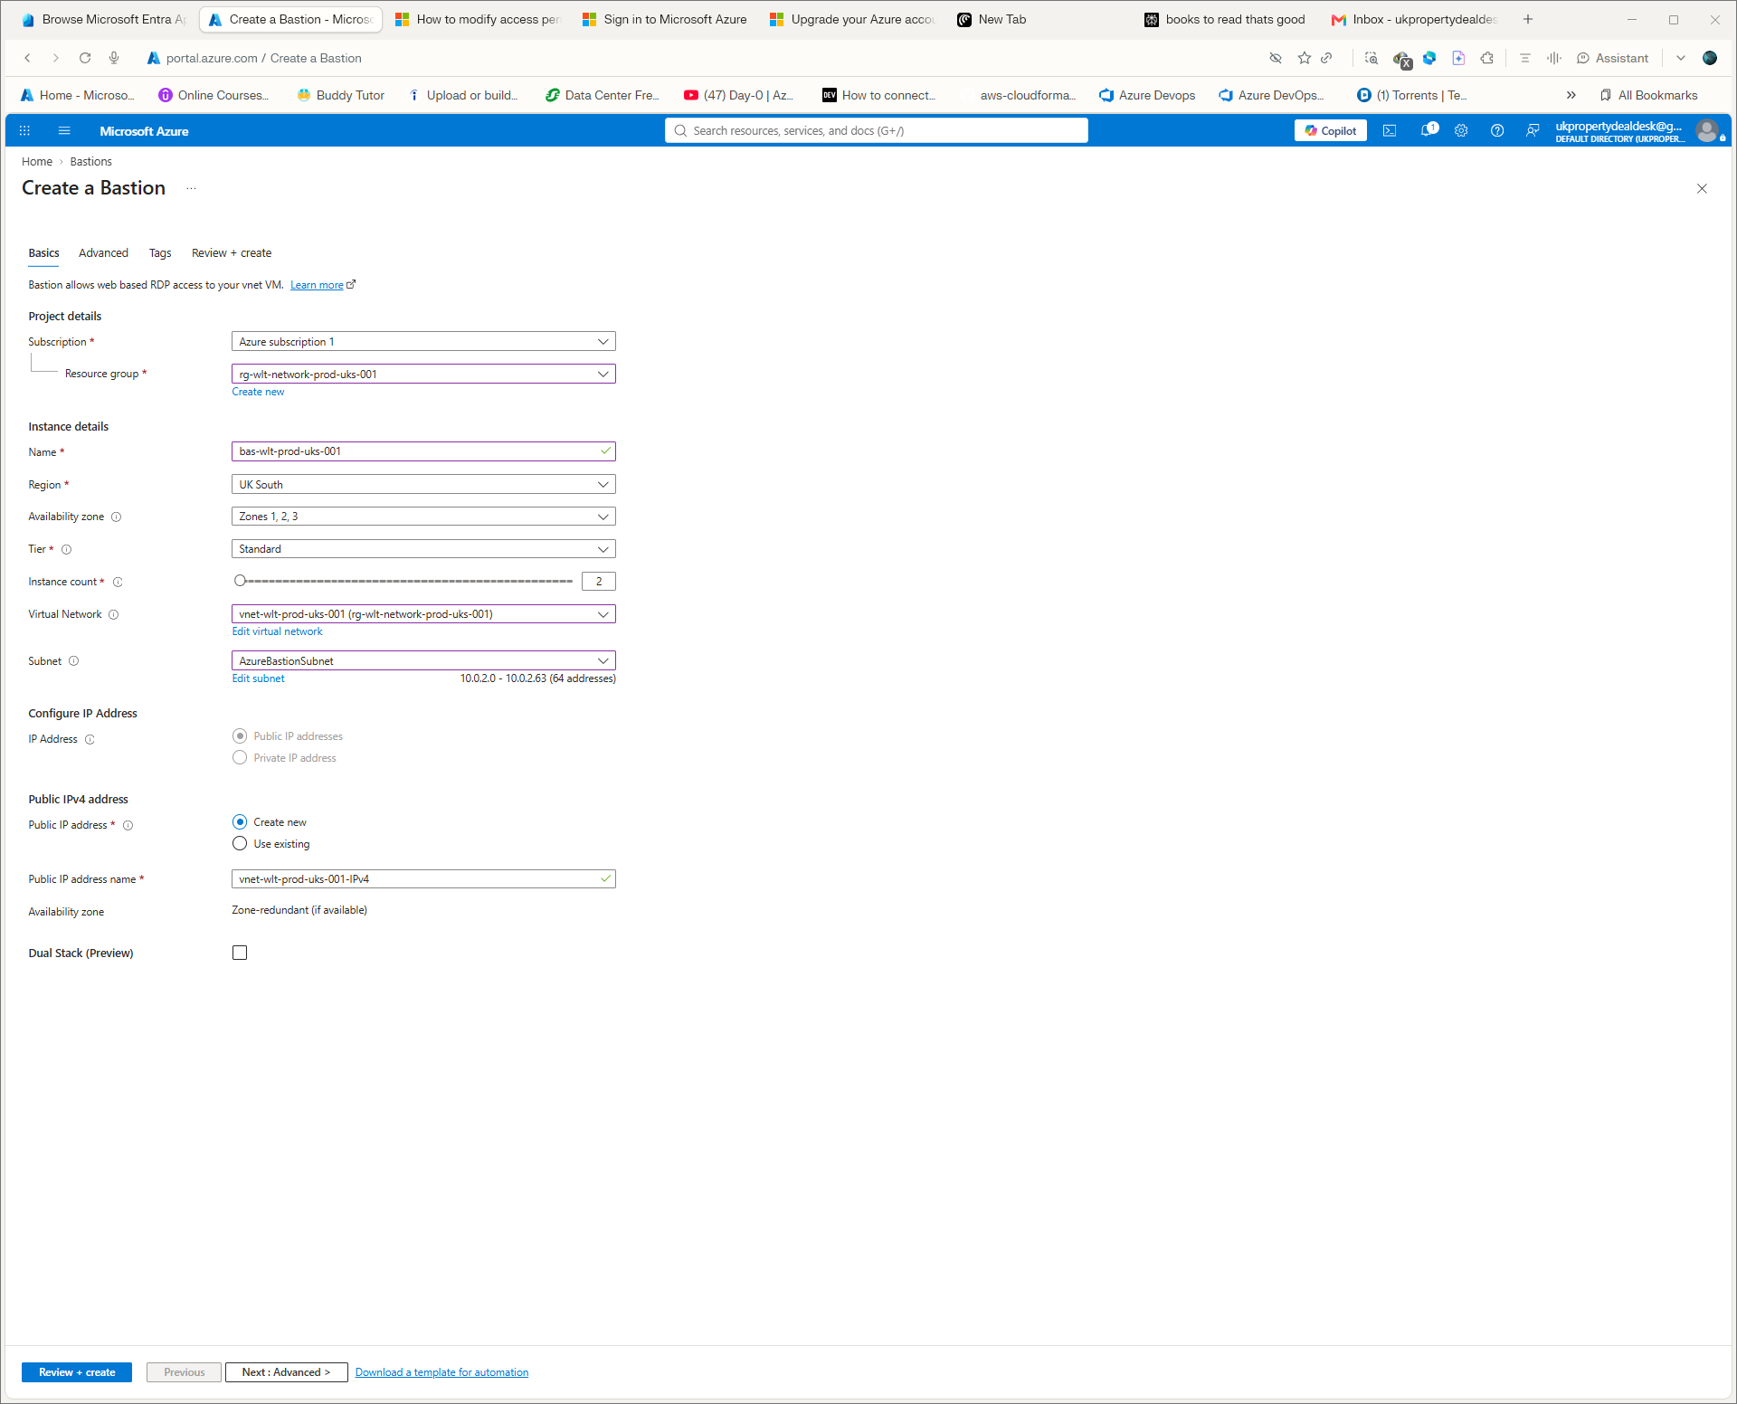
Portal evidence screenshot S03 — supplied during the hands-on networking session.
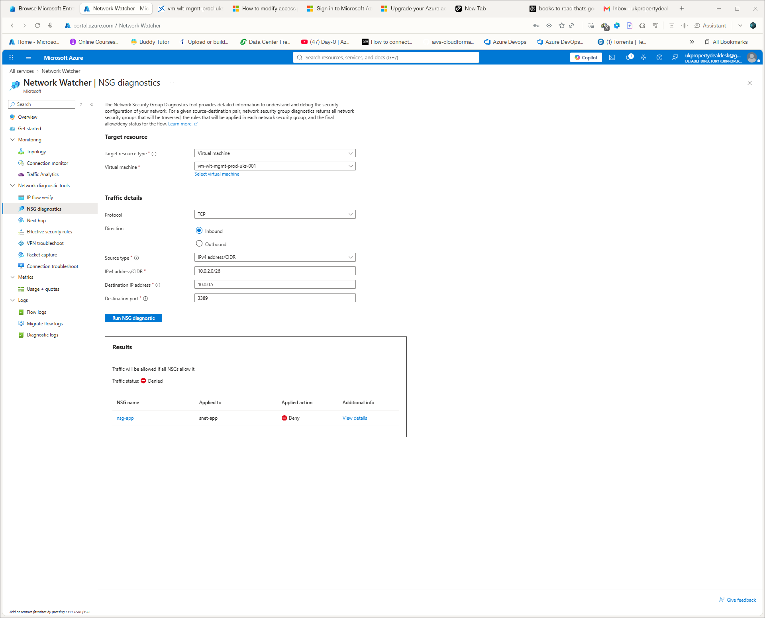
Portal evidence screenshot S04 — supplied during the hands-on networking session.
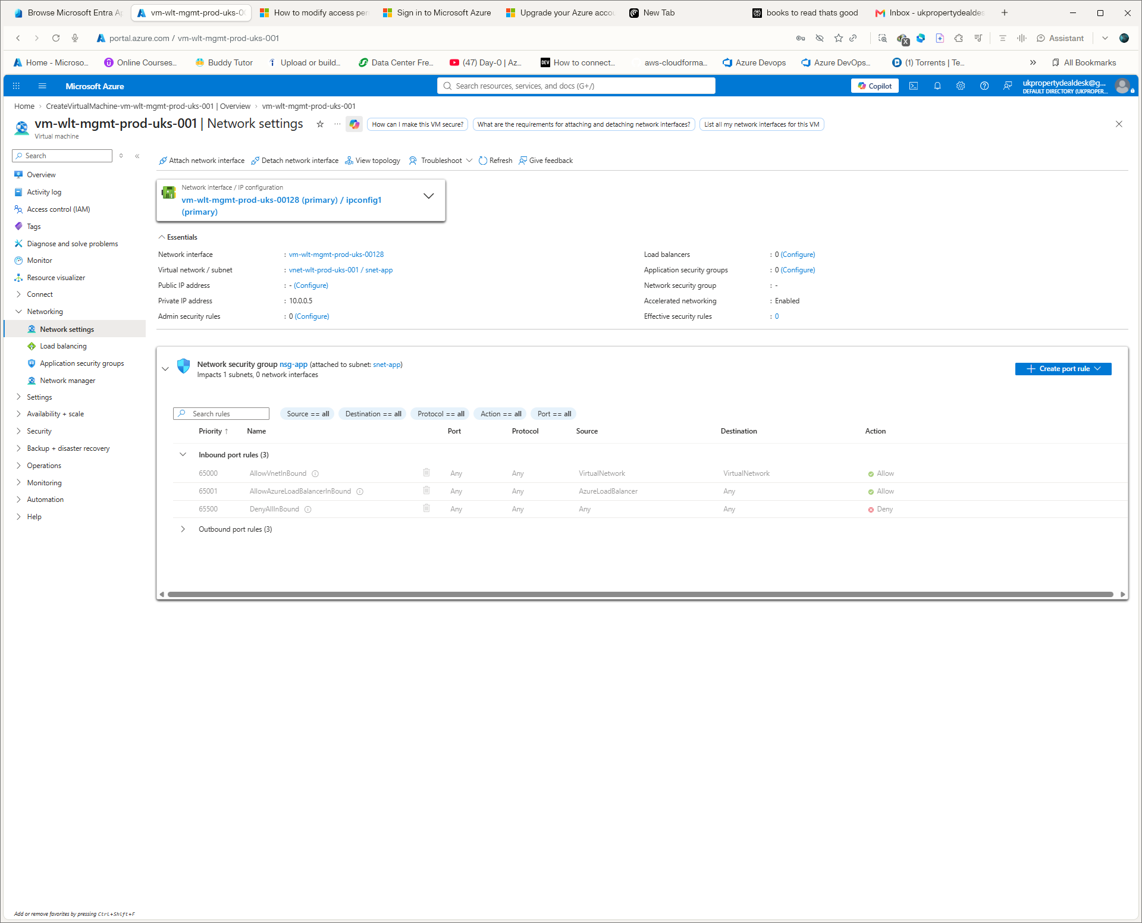
Portal evidence screenshot S05 — supplied during the hands-on networking session.

5.6 Create NSGs
- Search Network security groups.
- Click + Create.
- Select the subscription and rg-wlt-network-tf-prod-uks-001.
- Select UK South.
- Enter nsg-tf-app.
- Click Review + create, then Create.
- Repeat for nsg-tf-db.
- Open nsg-tf-app.
- Select Subnets.
- Click Associate.
- Select vnet-wlt-tf-prod-uks-001 and snet-app.
- Save.
- Repeat the association for nsg-tf-db and snet-db.
Final baseline: no custom rules. Azure default rules remain. During the controlled failure test a temporary custom deny rule was introduced and then removed.

5.7 Create NAT Gateways
- Search NAT gateways.
- Click + Create.
- Choose rg-wlt-network-tf-prod-uks-001 and UK South.
- Create natgw-tf-app-prod-uks-001.
- Create a Standard static public IP named pip-tf-natgw-app.
- Associate the NAT Gateway with snet-app.
- Repeat for natgw-tf-db-prod-uks-001 and pip-tf-natgw-db.
Why: NAT Gateway provides deterministic outbound SNAT for private workloads without assigning public IPs to the VMs.

5.8 Create the shared-services VNet
- Search Virtual networks.
- Click + Create.
- Use rg-wlt-network-tf-prod-uks-001.
- Enter vnet-wlt-tf-shared-uks-001.
- Use UK South.
- Set address space to 10.1.0.0/16.
- Create subnet snet-shared-services with 10.1.0.0/24.

5.9 Create VNet peering
- Open vnet-wlt-tf-prod-uks-001.
- Select Peerings.
- Click + Add.
- Name the local peering peer-prod-to-shared.
- Select vnet-wlt-tf-shared-uks-001 as the remote VNet.
- Allow virtual network access.
- Leave forwarded traffic disabled.
- Leave gateway transit disabled.
- Leave use remote gateways disabled.
- Create the peering.
- Open the shared VNet and create the reverse peering peer-shared-to-prod.
- Confirm both directions show Connected.

5.10 Create the management VM
- Search Virtual machines.
- Click + Create.
- Select rg-wlt-network-tf-prod-uks-001 and UK South.
- Name the VM vm-wlt-tf-mgmt-prod-uks-001.
- Use Windows Server 2025 Datacenter Gen2.
- Use Standard_D2nls_v6.
- Select Zone 1.
- Configure the administrator account.
- Do not create a public IP.
- Place the NIC in vnet-wlt-tf-prod-uks-001 / snet-app.
- Enable accelerated networking.
- Use a Premium SSD OS disk.
- Enable Trusted Launch, Secure Boot and vTPM.
- Enable system-assigned managed identity.
- Create the VM.
Error encountered — VM image generation
The first Terraform VM attempt used the Windows Server 2025 Datacenter Gen1 image with Standard_D2nls_v6. Azure rejected the combination because the selected VM size required Gen2. The configuration was corrected to WindowsServer 2025-Datacenter-g2 and the deployment succeeded.

5.11 Create Azure Bastion
- Search Bastion.
- Click + Create.
- Select rg-wlt-network-tf-prod-uks-001.
- Use UK South.
- Select vnet-wlt-tf-prod-uks-001.
- Use the dedicated AzureBastionSubnet.
- Create a Standard public IP for Bastion.
- Use Standard Bastion SKU.
- Use scale units 2.
- Leave tunneling disabled for this baseline.
- Review and create.
- Wait for Provisioning state Succeeded.
The VM itself has no public IP. Bastion provides the browser-based administrative path to the private VM.

5.12 Connect to the VM through Bastion
- Open the VM in Azure Portal.
- Click Connect.
- Select Bastion.
- Enter the VM administrator credentials.
- Click Connect.
- Wait for the browser session to open.
- Confirm the Windows desktop/session is available.
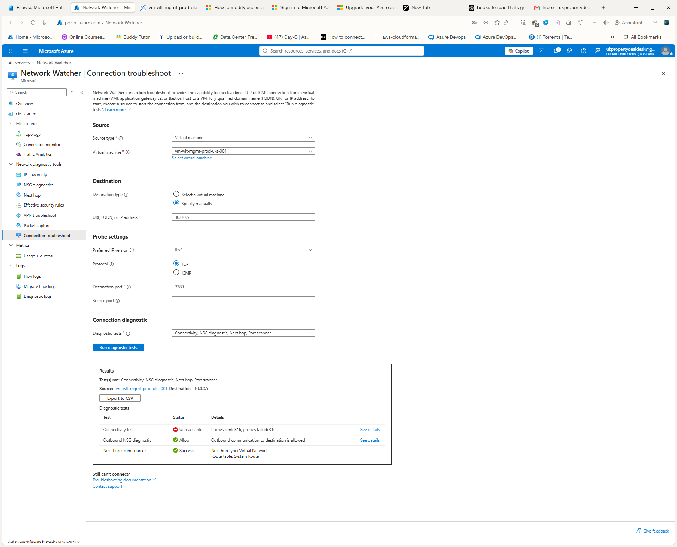
Portal evidence screenshot S06 — supplied during the hands-on networking session.
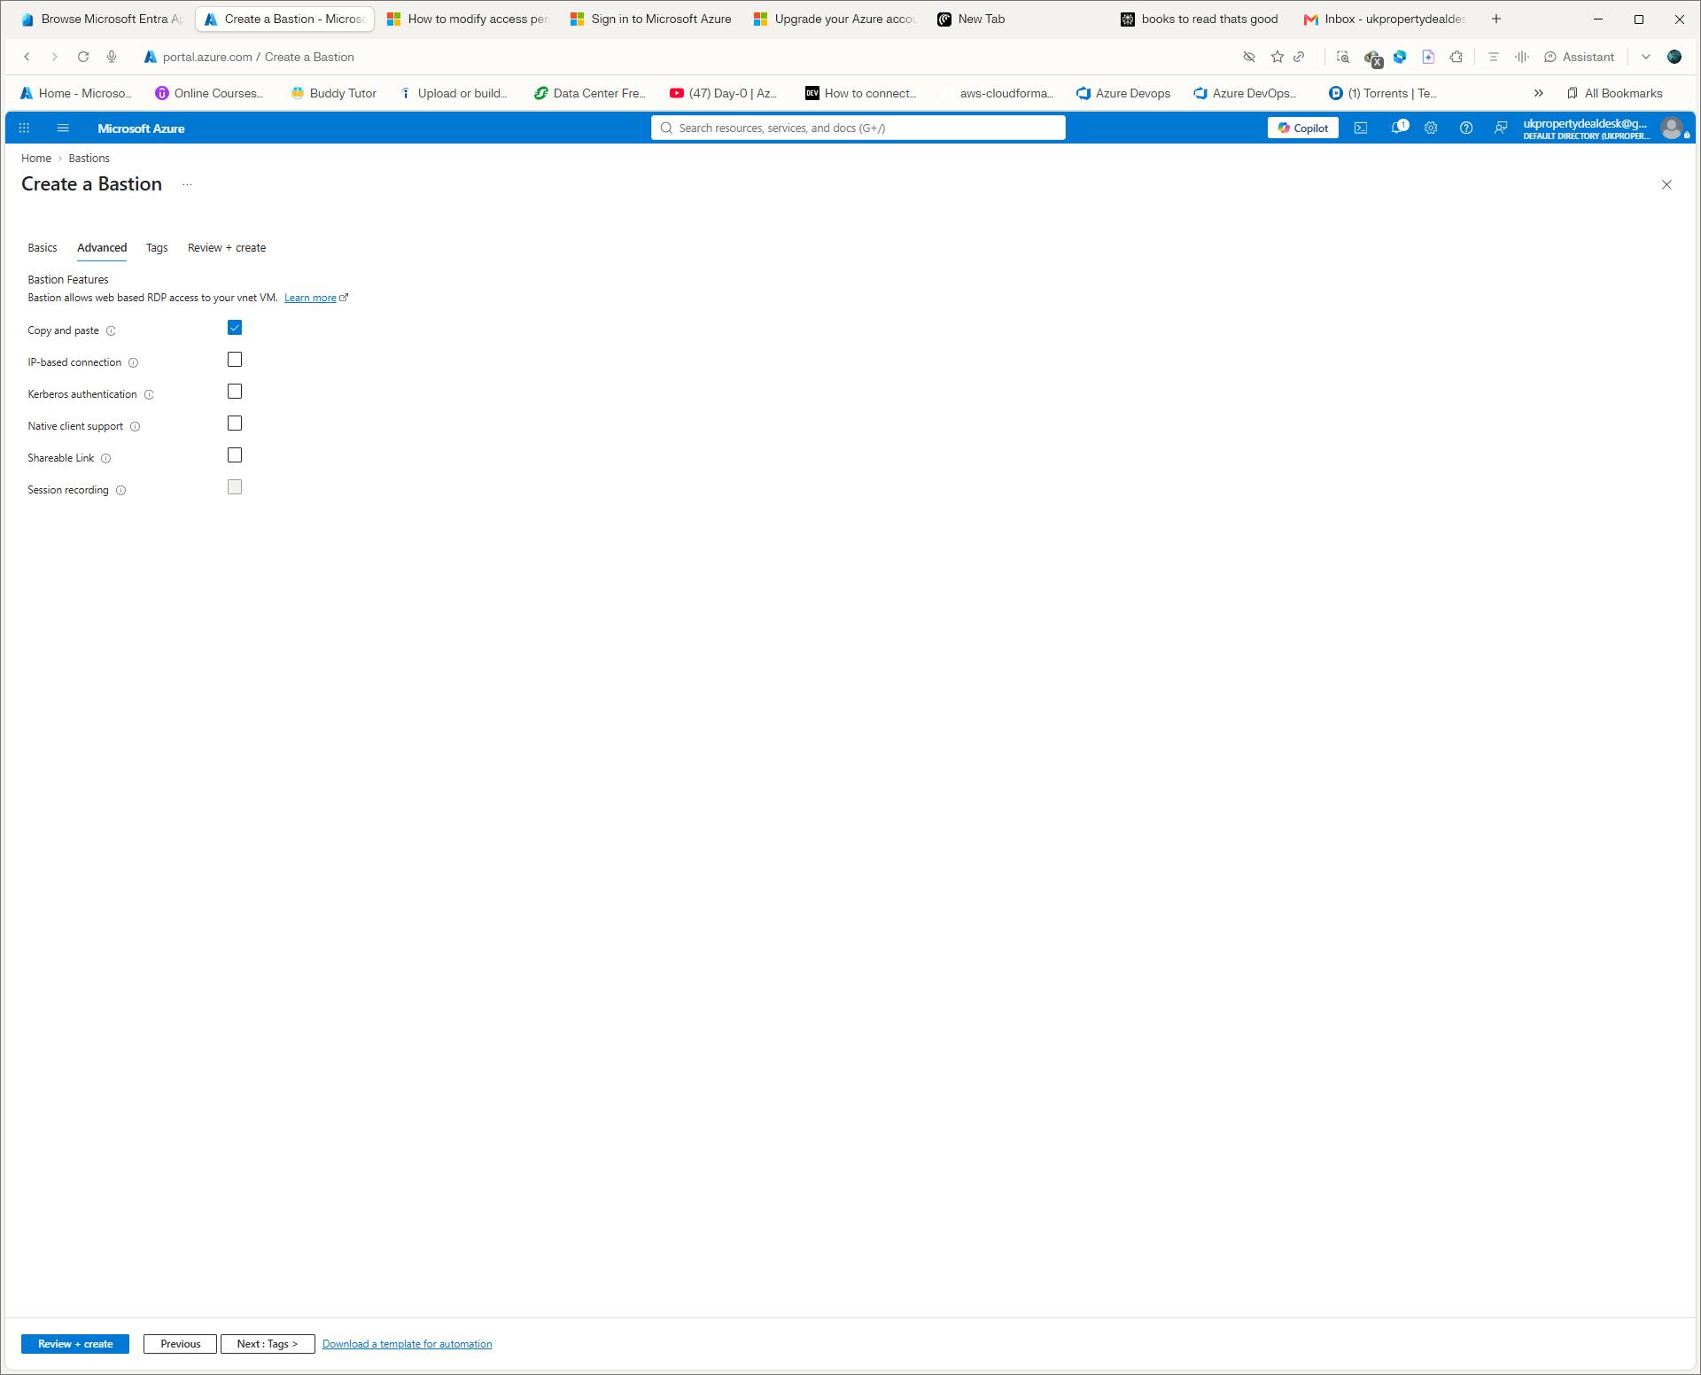
Portal evidence screenshot S07 — supplied during the hands-on networking session.
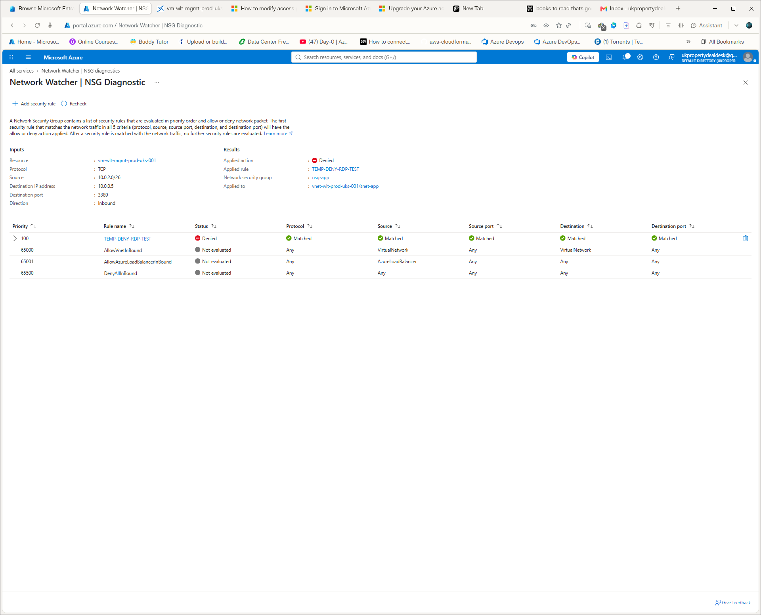
Portal evidence screenshot S08 — supplied during the hands-on networking session.
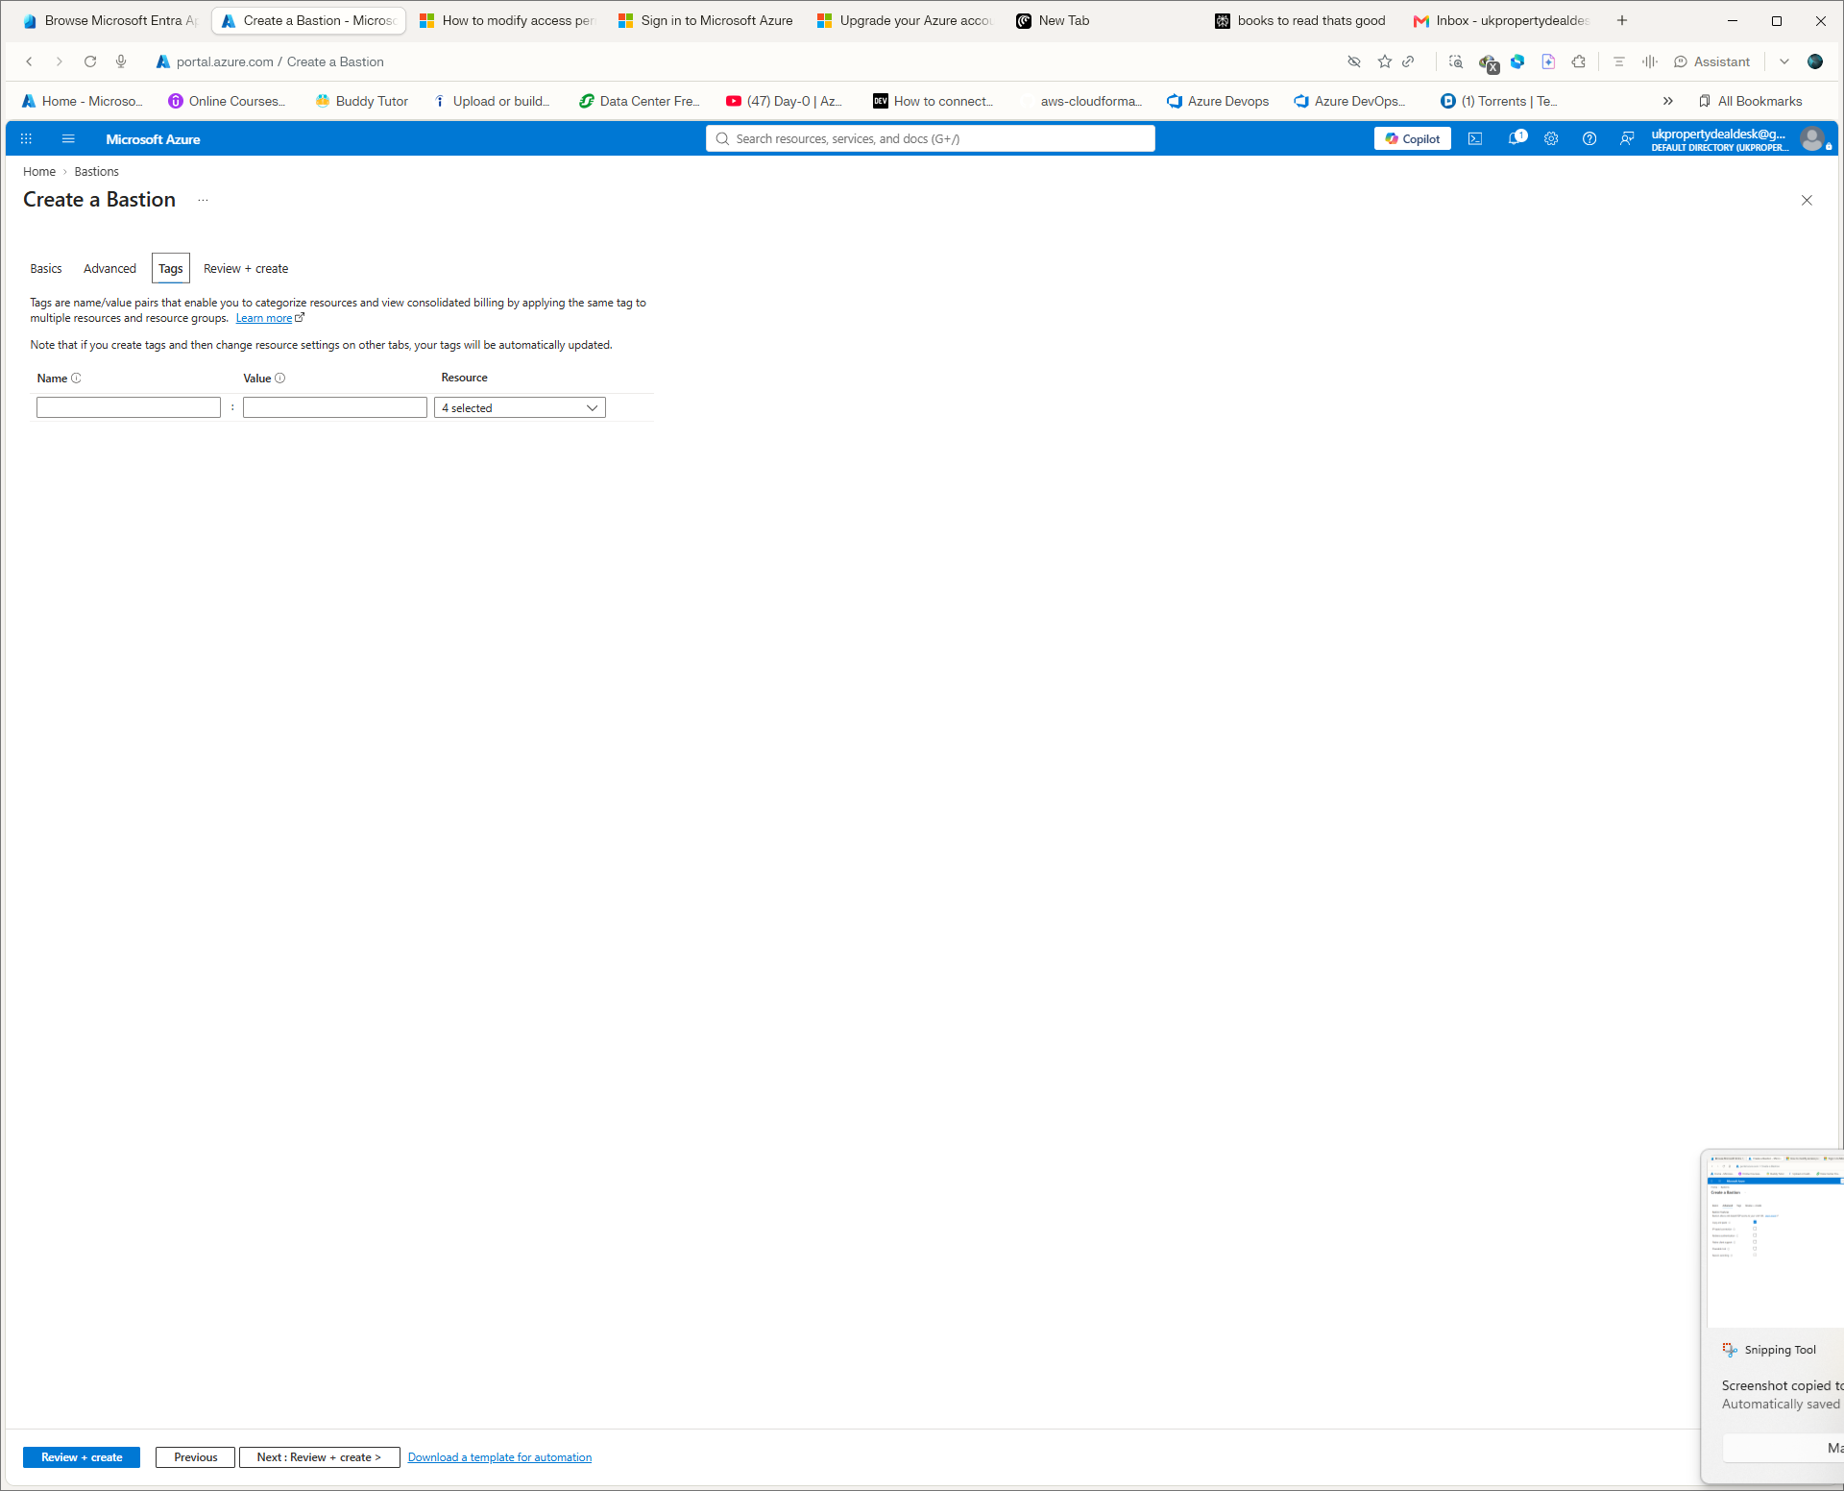
Portal evidence screenshot S09 — supplied during the hands-on networking session.
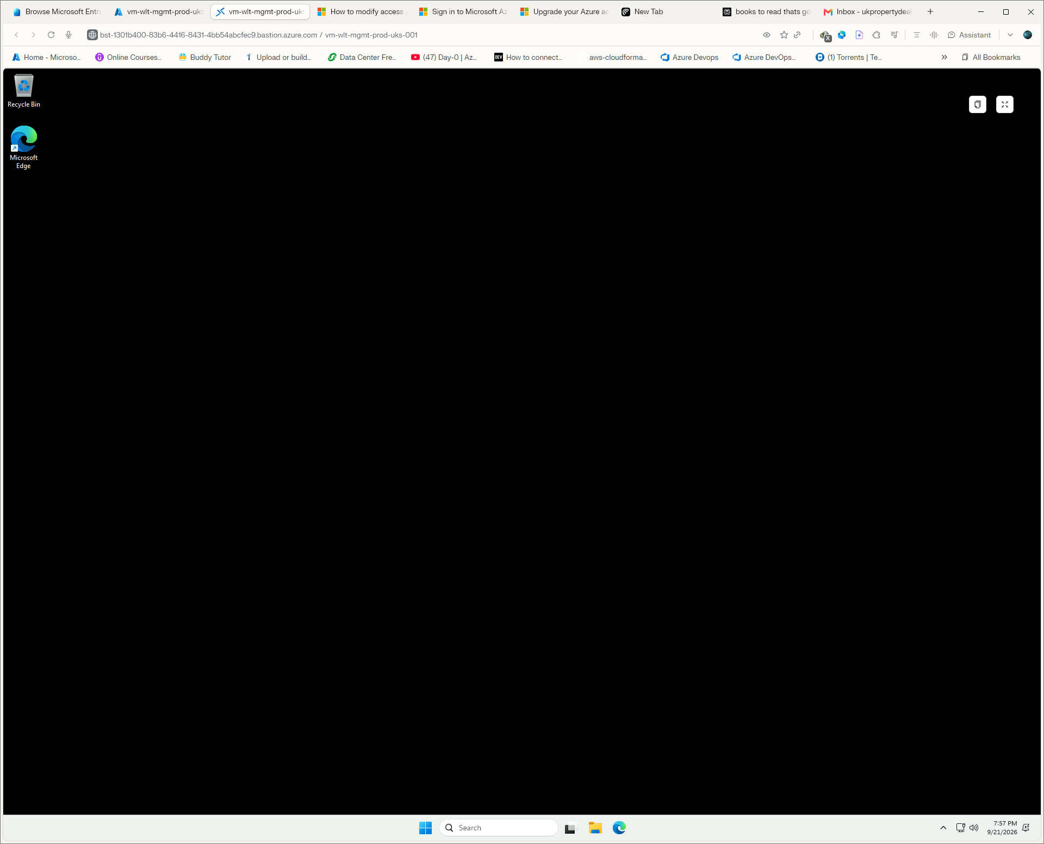
Portal evidence screenshot S10 — supplied during the hands-on networking session.

5.13 Verify the VM network from inside Windows
Open PowerShell inside the Bastion session.
hostname
Get-NetIPConfiguration
Get-NetRoute -AddressFamily IPv4
Test-NetConnection www.microsoft.com -Port 443
Invoke-RestMethod https://api.ipify.org
Resolve-DnsName www.microsoft.com

Command-by-command meaning
Command | What it does | Important option/part | Expected result | What result means / next
hostname | Displays computer name | No option | mgmt-tf-prd-01 | Confirms correct VM
Get-NetIPConfiguration | Shows NIC/IP/gateway/DNS | No option | 10.0.0.4, gateway 10.0.0.1, DNS 168.63.129.16 | Confirms private addressing
Get-NetRoute -AddressFamily IPv4 | Shows IPv4 routing table | -AddressFamily IPv4 limits output to IPv4 | Default route plus local/platform routes | Confirms routing exists
Test-NetConnection www.microsoft.com -Port 443 | Tests TCP connectivity | -Port 443 tests HTTPS | TcpTestSucceeded True | Confirms outbound TCP/443
Invoke-RestMethod https://api.ipify.org | Returns observed public egress IP | URL is the service queried | NAT public IP | Confirms controlled SNAT
Resolve-DnsName www.microsoft.com | Performs DNS lookup | Hostname is the query | A/AAAA/CNAME records | Confirms DNS resolution
If TCP/443 fails: inspect NSG, subnet association, NAT, effective routes and Azure service health before changing configuration. If DNS fails: inspect DNS settings and platform DNS availability.

5.14 Network Watcher connectivity test
- Search Network Watcher.
- Open Network Watcher.
- Select Connection troubleshoot.
- Select the management VM as the source.
- Use www.microsoft.com as destination.
- Use TCP and destination port 443.
- Run the test.
- Review reachability, probe count and failed probes.
- Record the result in the evidence log.
The completed reference test reported Reachable, with 316 probes and 0 failed probes.

6. Controlled NSG failure — reproduce the incident
This is a deliberate failure exercise. It is not a mistake in the final configuration.

6.1 Add the temporary deny rule in Terraform
security_rule {
name = "TEMP-DENY-RDP-TEST"
priority = 100
direction = "Inbound"
access = "Deny"
protocol = "Tcp"
source_port_range = "*"
destination_port_range = "3389"
source_address_prefix = "VirtualNetwork"
destination_address_prefix = "10.0.0.4"
description = "Temporary controlled failure test for Bastion-to-management VM RDP."
}
Purpose: intentionally deny Bastion-to-VM RDP so we can diagnose the failure using engineering evidence.

6.2 Terraform command sequence
terraform -chdir=. fmt -recursive
terraform -chdir=. validate
terraform -chdir=. plan
terraform -chdir=. apply
Command | What it does | Why | Expected | If different
terraform -chdir=. fmt -recursive | Formats Terraform files | Consistent code before plan | Files formatted | Review changed files
terraform -chdir=. validate | Checks Terraform configuration | Catch syntax/config errors before deployment | Success! configuration is valid | Read exact error; correct code
terraform -chdir=. plan | Calculates desired changes without applying | Preview blast radius | 0 to add, 1 to change, 0 to destroy for the test | Stop if unexpected resources change
terraform -chdir=. apply | Applies approved plan | Introduces the controlled failure | Apply complete | Do not proceed if destructive/unexpected changes appear
Important: never type a password or secret into the document. The VM password was supplied locally through TF_VAR_management_vm_admin_password.

6.3 Observe the failure
- Leave the existing Bastion session open.
- Start a new Bastion connection attempt.
- Observe the new connection fail with a generic Connection Error.
- Do not immediately change random settings.
- Treat the failure as a network diagnosis problem.

6.4 Diagnose with Network Watcher IP Flow Verify
- Open Network Watcher.
- Select IP flow verify.
- Choose the management VM/NIC.
- Set protocol TCP.
- Set local/source as the Bastion subnet source address.
- Set destination 10.0.0.4.
- Set destination port 3389.
- Run the test.
- Read the Allow/Deny result.
- Record the rule name responsible.
Observed result: Access denied by TEMP-DENY-RDP-TEST on nsg-tf-app.
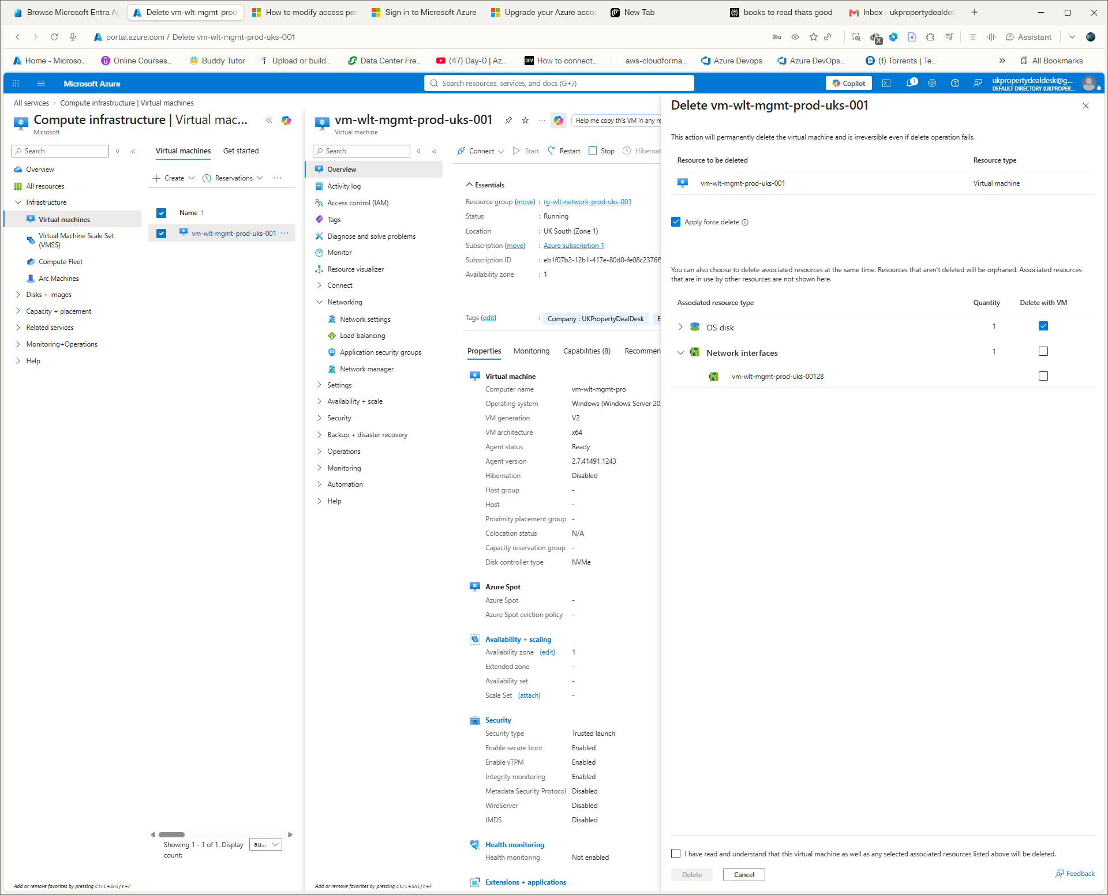
Troubleshooting evidence screenshot S11 — supplied during the hands-on session.
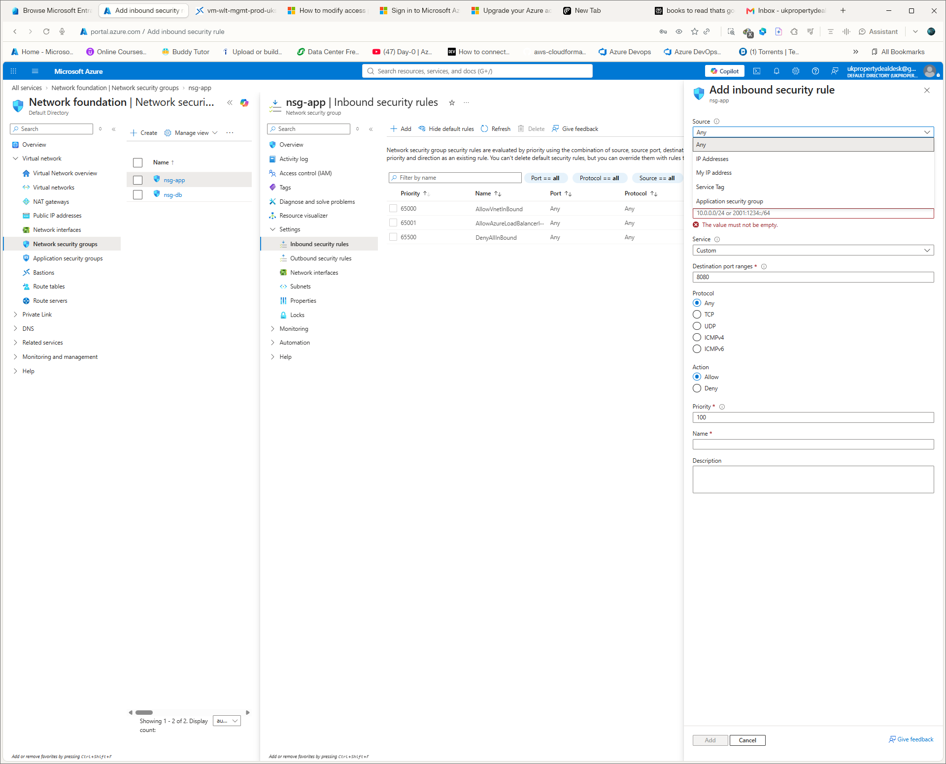
Troubleshooting evidence screenshot S12 — supplied during the hands-on session.
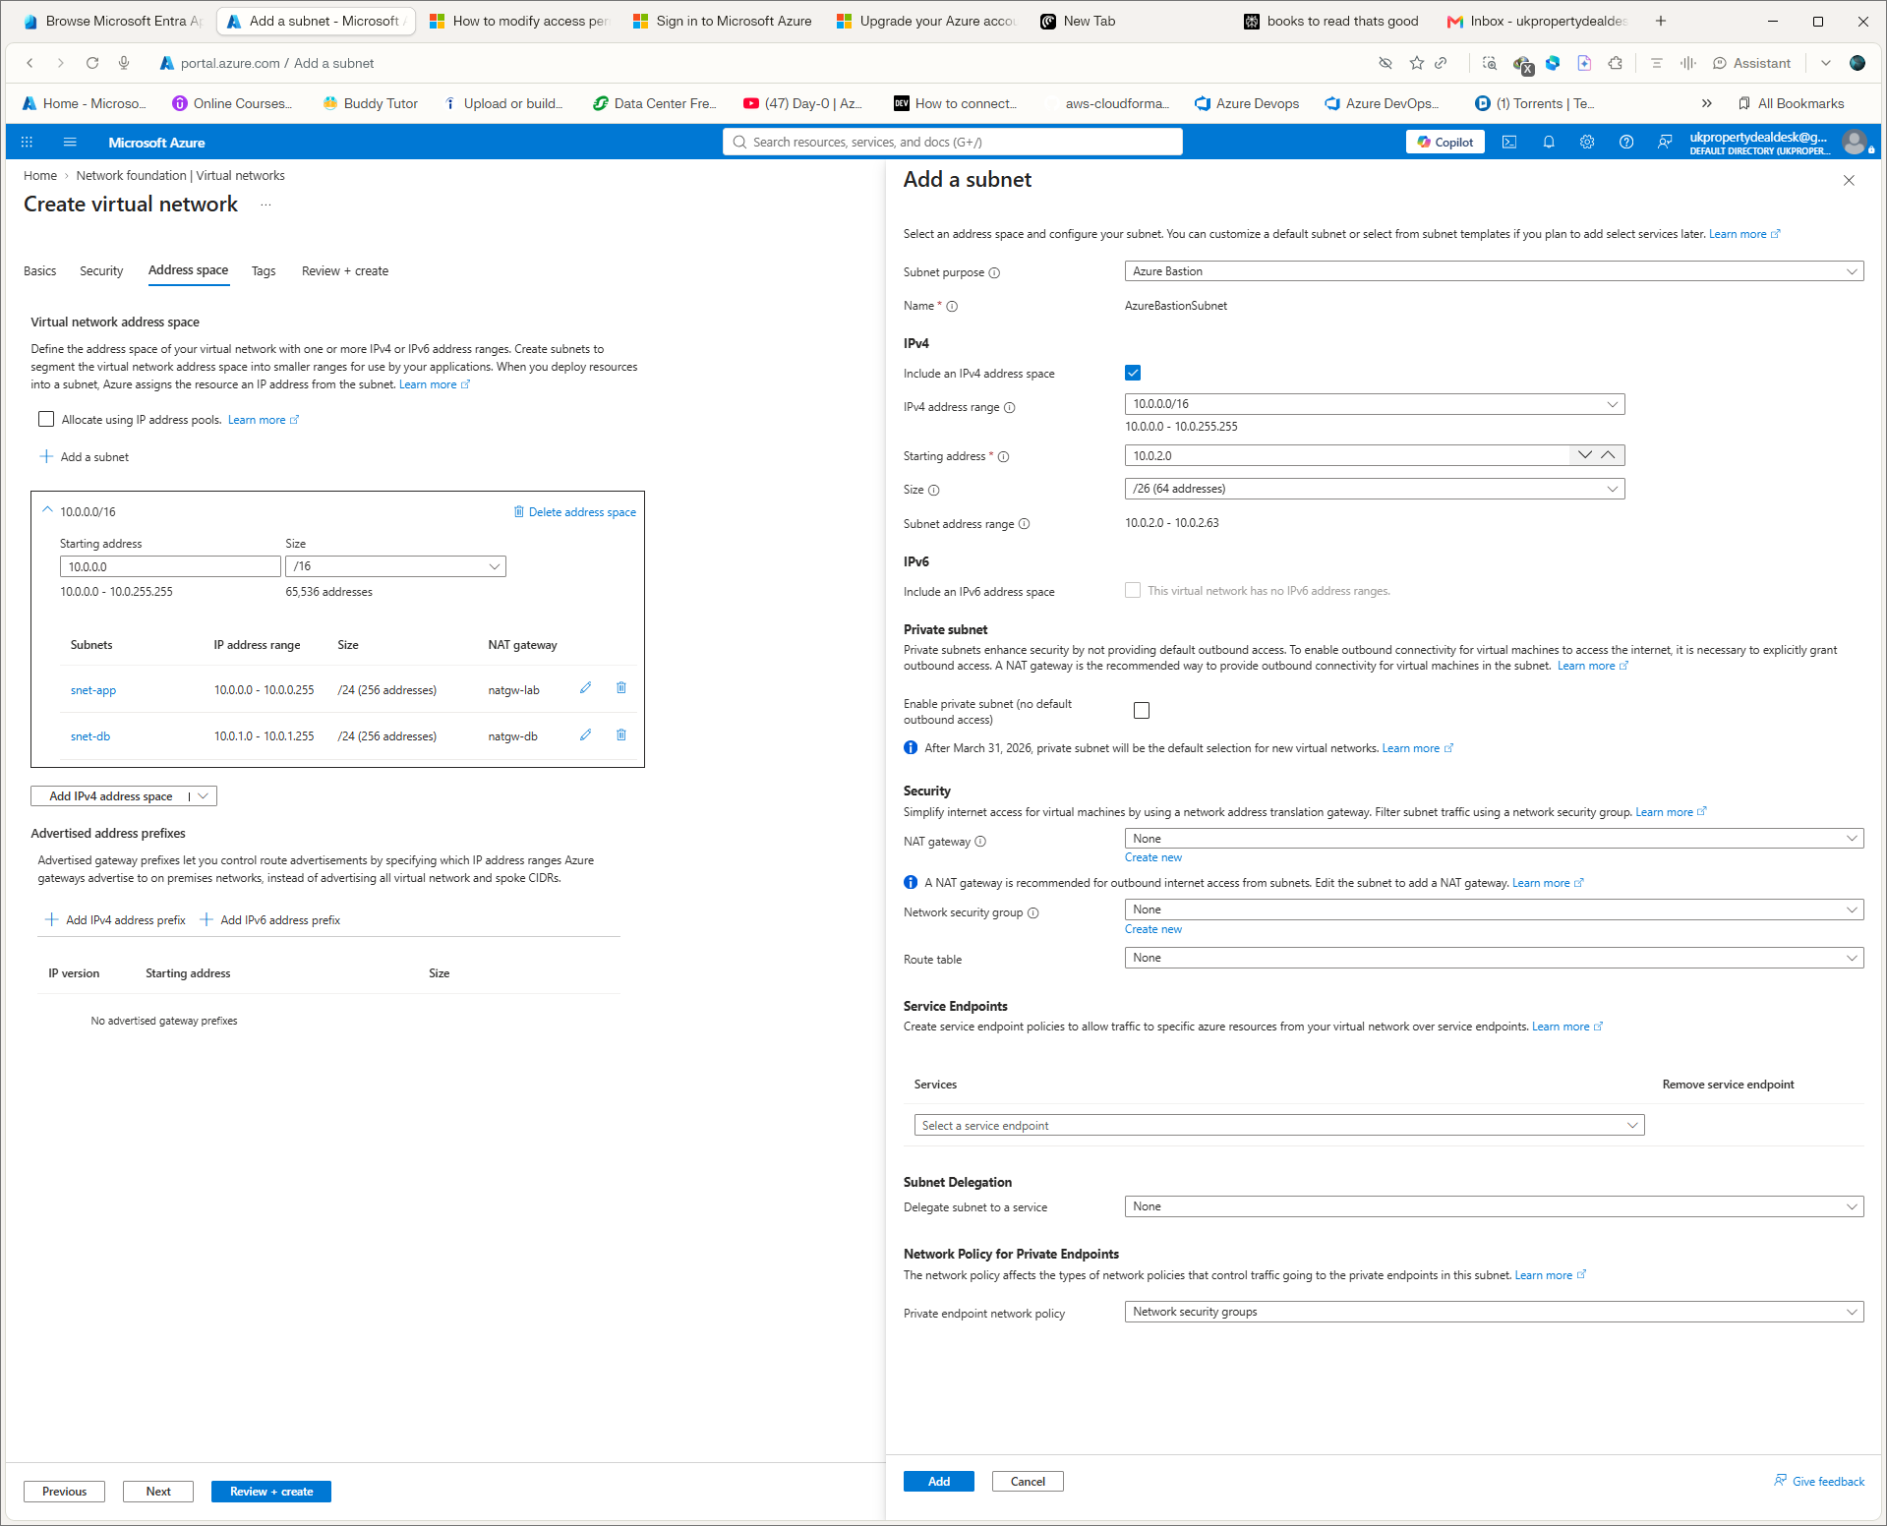
Troubleshooting evidence screenshot S13 — supplied during the hands-on session.
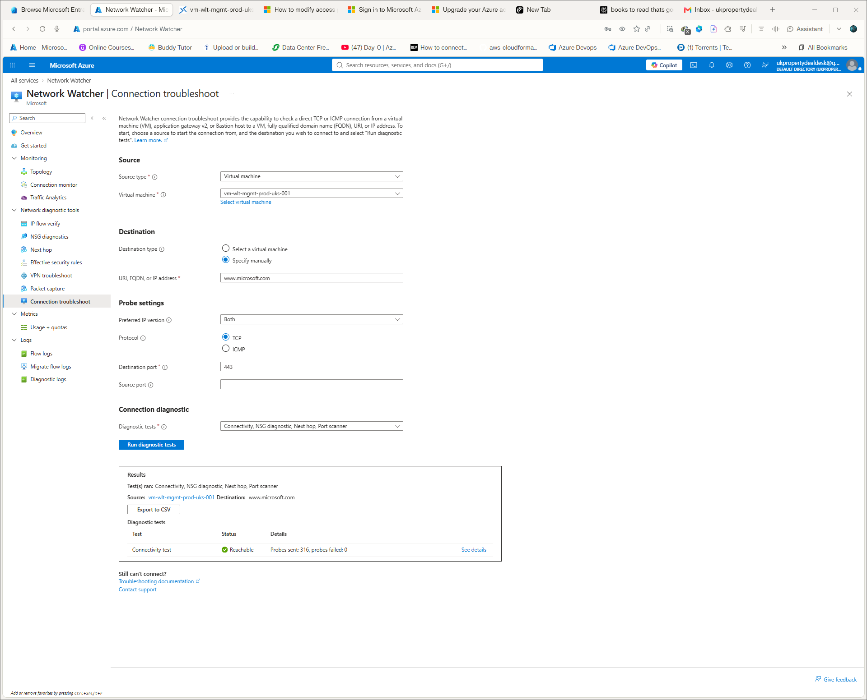
Troubleshooting evidence screenshot S14 — supplied during the hands-on session.

6.5 Recover the service
- Remove the temporary security_rule block from nsg.tf.
- Run terraform -chdir=. plan.
- If Terraform reports No changes even though the rule still exists, do not assume the rule is gone.
- Set security_rule = [] explicitly in the azurerm_network_security_group resource.
- Run terraform -chdir=. plan again.
- Confirm Terraform now proposes the removal of the temporary rule.
- Run terraform -chdir=. apply.
- Confirm the apply removes the temporary rule.
- Return the final NSG configuration to the baseline with no custom rules.
Important Terraform lesson
With the AzureRM inline security_rule collection, deleting the last rule block did not initially produce the expected plan. Explicitly declaring security_rule = [] made the desired empty collection unambiguous and caused Terraform to reconcile Azure correctly.

7. Terraform drift engineering
Drift demonstrates what happens when someone changes a Terraform-managed resource manually in the Portal.

7.1 Introduce drift
- Open vnet-wlt-tf-prod-uks-001 in Azure Portal.
- Open Tags.
- Add temporary tag DriftTest with value PortalChange.
- Save the change.

7.2 Detect drift
terraform -chdir=. plan
What the command does | Expected | Meaning
Compares configuration/state with Azure and calculates changes | DriftTest=PortalChange -> null; 0 to add, 1 to change, 0 to destroy | Terraform detected a Portal-only change and wants to restore the declared configuration.

7.3 Reconcile drift
terraform -chdir=. apply
terraform -chdir=. plan
Expected final plan: No changes. Your infrastructure matches the configuration.
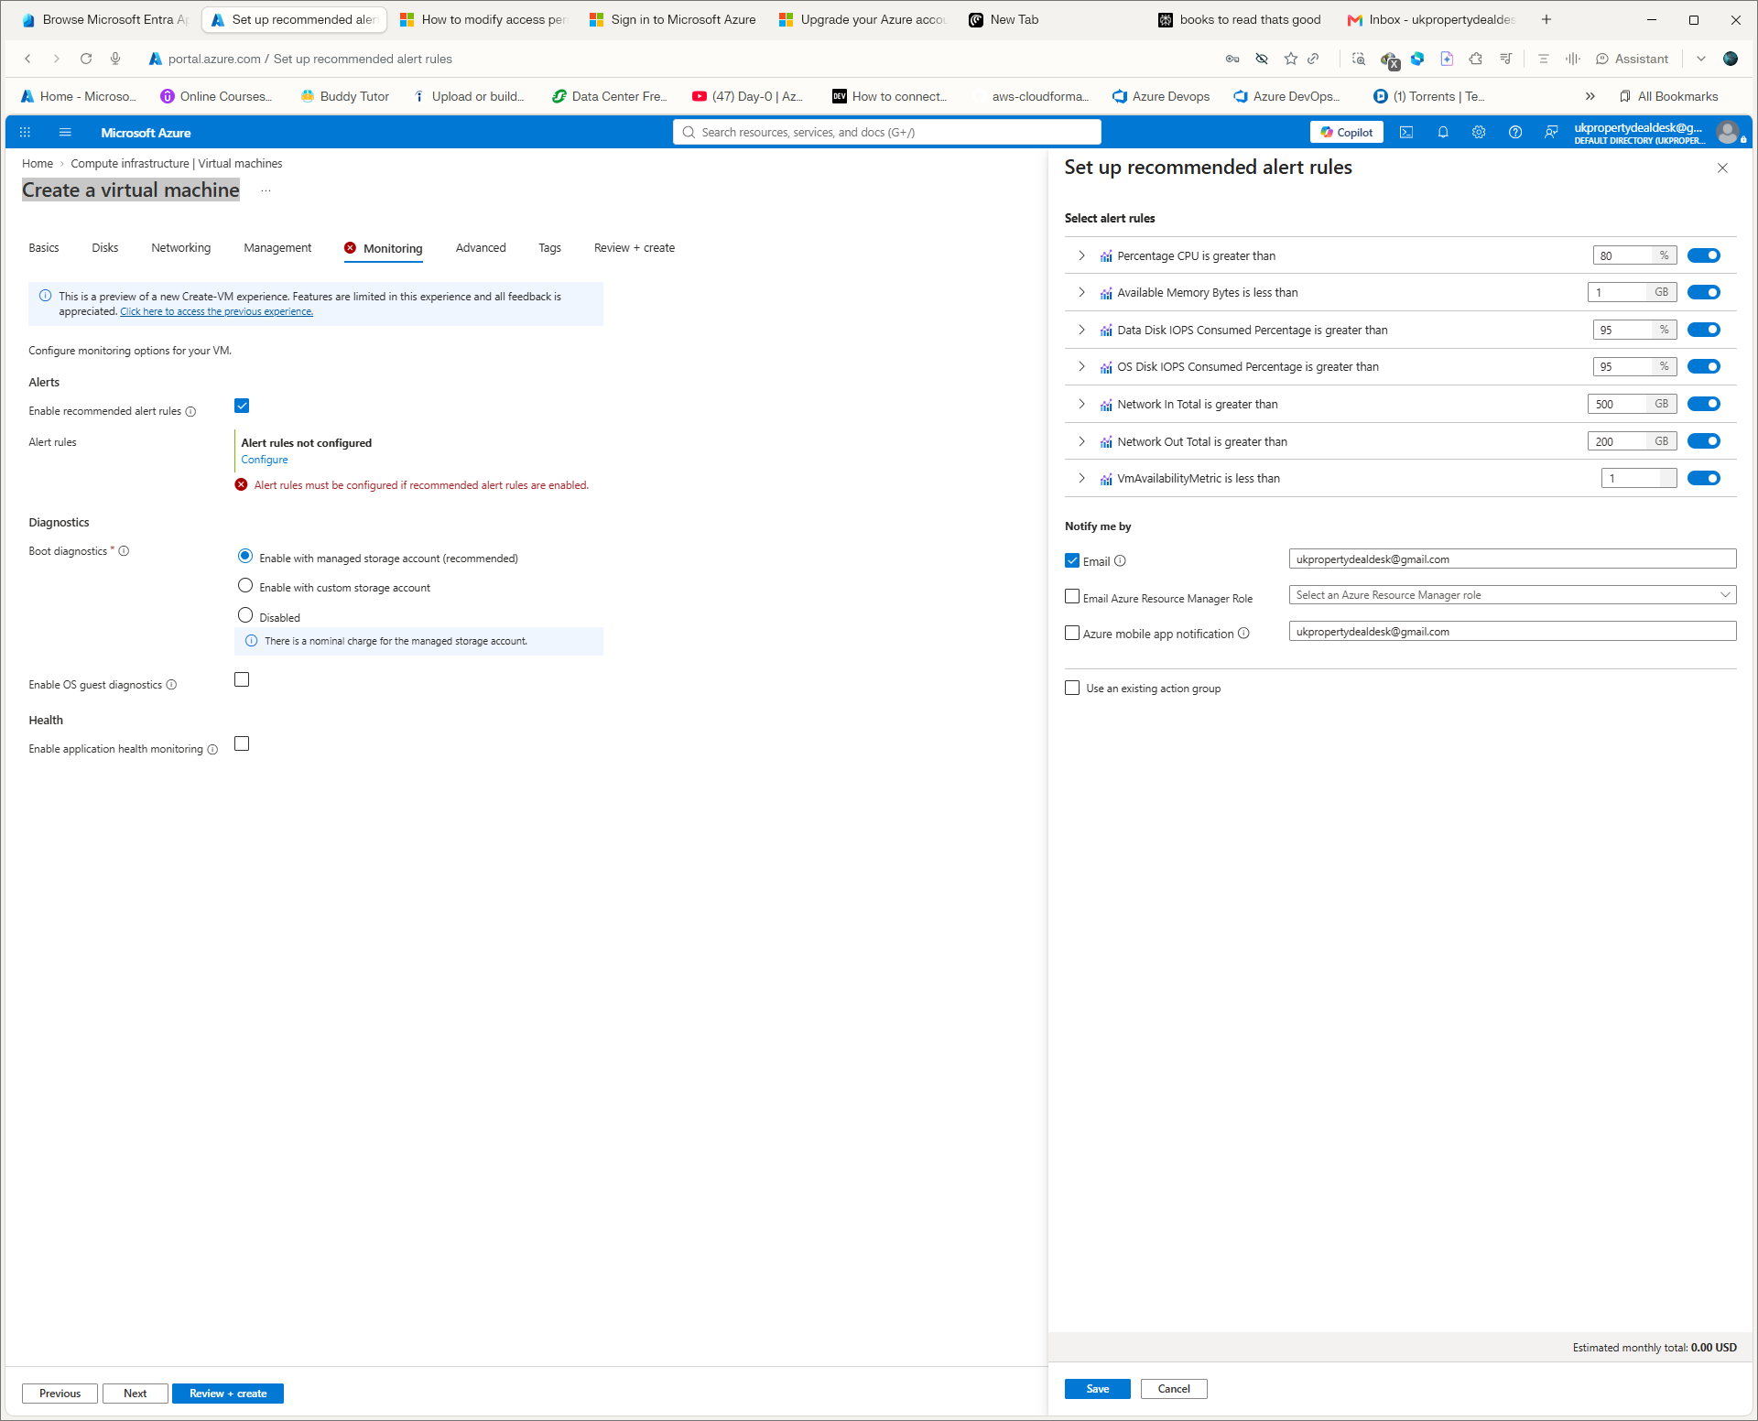
Terraform/Git evidence screenshot S15 — supplied during the hands-on session.
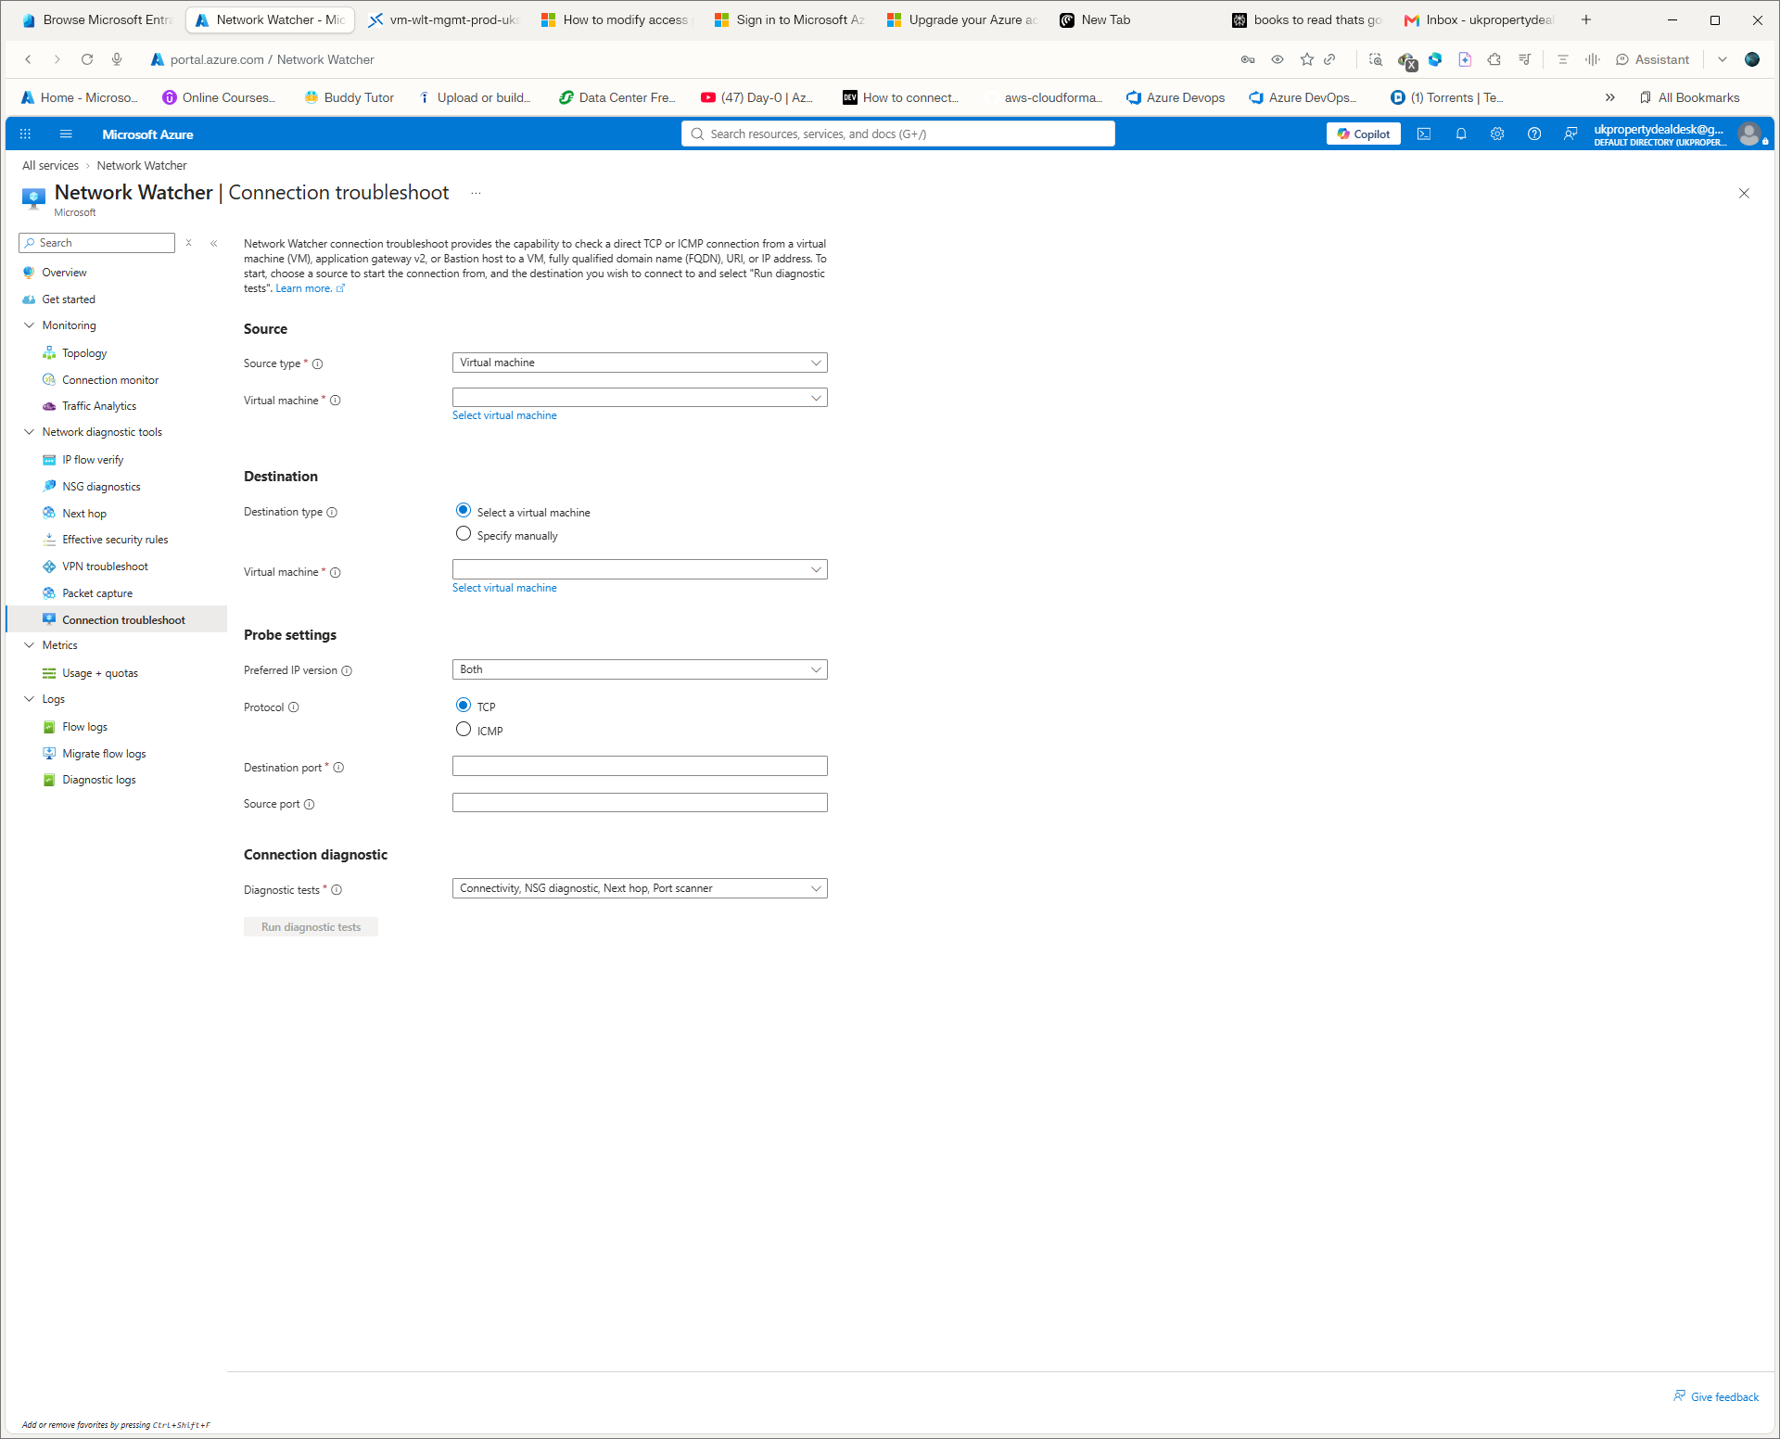
Terraform/Git evidence screenshot S16 — supplied during the hands-on session.
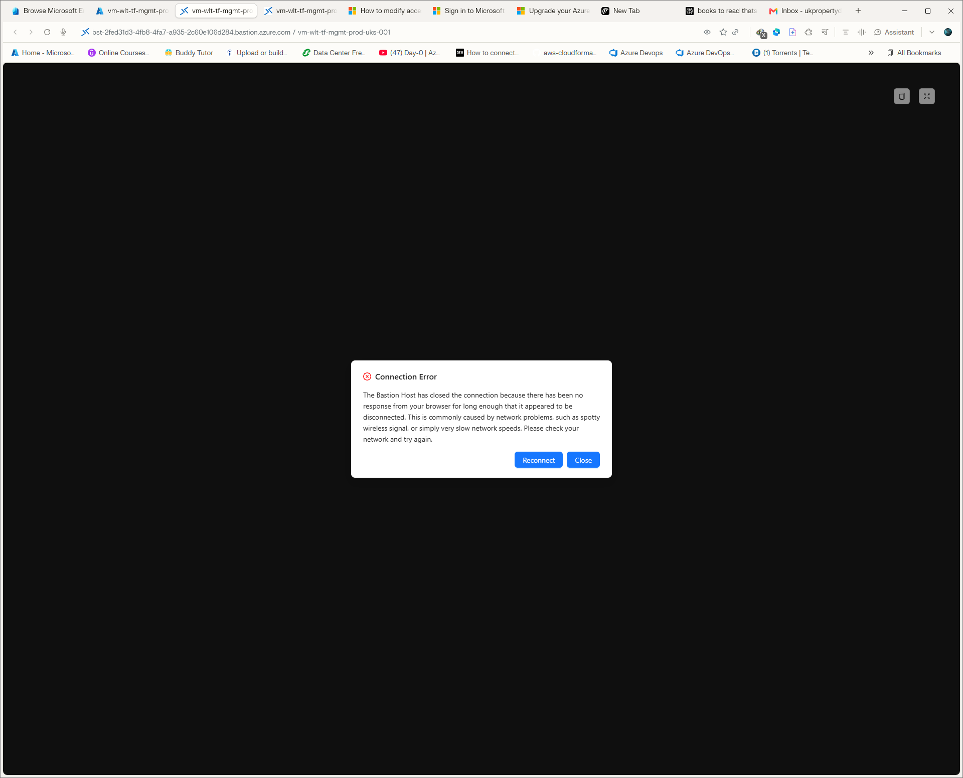
Terraform/Git evidence screenshot S17 — supplied during the hands-on session.

8. Terraform configuration reference
The final configuration was split into logical files. The following is the reproducible file map.
File | Purpose
provider.tf | AzureRM provider and Terraform provider version constraint
resource-group.tf | Terraform-managed production-style resource group
variables.tf | Location variable
vnet.tf | Primary/shared VNets and subnets
nsg.tf | Application/database NSGs and subnet associations
peering.tf | Bidirectional VNet peering
nat-gateway.tf | NAT gateways, public IPs and subnet associations
bastion.tf | Bastion public IP and Bastion host
vm-variables.tf | Management VM size, username and sensitive password variable
management-vm.tf | NIC, Windows VM, disk, identity and login extension
.terraform.lock.hcl | Provider dependency lock file
.gitignore | Prevents Terraform state, variables, plans and local artifacts being committed

8.1 Provider configuration
terraform {
required_providers {
azurerm = {
source = "hashicorp/azurerm"
version = "~> 4.0"
}
}
}

provider "azurerm" {
features {}
}
Meaning: the configuration declares the HashiCorp AzureRM provider and permits compatible 4.x releases. features {} enables provider configuration.

8.2 Core Terraform command workflow
terraform -chdir=. init
terraform -chdir=. fmt -recursive
terraform -chdir=. validate
terraform -chdir=. plan
terraform -chdir=. apply
terraform -chdir=. plan
terraform -chdir=. destroy
Command | Meaning | Why | Expected
init | Initialises provider/modules/state working directory | Prepare Terraform before other commands | Provider installed/lock file maintained
fmt -recursive | Formats Terraform recursively | Standardise code | No unexpected formatting changes
validate | Validates syntax and configuration | Catch errors early | Success
plan | Previews changes | Safety and review | Expected resource changes only
apply | Makes approved changes | Implementation | Apply complete
destroy | Removes Terraform-managed resources | Cost control for disposable environments | Resources destroyed or No changes if already absent

8.3 Terraform error — existing resource group
The first fresh Terraform apply targeted a resource group that already existed in the preserved Portal environment. Azure returned an existing-resource conflict.
Engineering decision: do not overwrite or blindly import the reference environment. The correct portfolio approach was a separate greenfield Terraform environment with distinct names.
A temporary import was performed only to understand Terraform state handling and was then removed from state. No further imports were used.

8.4 Git Bash import path conversion issue
When an Azure resource ID beginning with /subscriptions/... was passed through Git Bash, MSYS path conversion transformed it into a Windows path.
MSYS_NO_PATHCONV=1 terraform -chdir=. import <RESOURCE_ADDRESS> <AZURE_RESOURCE_ID>
Meaning: MSYS_NO_PATHCONV=1 prevents Git Bash from converting the Azure resource ID into a local Windows path. This was retained as a troubleshooting lesson, not as part of the final architecture.

8.5 VM image-generation error
The initial Windows Server image was Gen1 while Standard_D2nls_v6 required Gen2. Azure rejected the deployment.
WindowsServer 2025-Datacenter-g2
Correction: use the Gen2 image. The subsequent Terraform apply succeeded.

8.6 Hotpatch error
An attempt to enable hotpatching failed with:
InvalidParameter: The selected VM image is not supported for hotpatching...
The image was not silently changed to claim a fix. This remains documented as an observed limitation/failed configuration attempt.

8.7 Metadata Security Protocol observation
The session recorded an inconsistency between the live overview and review configuration around metadata security/IMDS enforcement. This was not falsely recorded as resolved. Treat it as an outstanding technical observation requiring a dedicated validation exercise before production adoption.

9. Git and GitHub — complete workflow

9.1 Protect main and create the feature branch
git branch -m master main
git checkout -b feature/networking-terraform
git branch
The baseline commit was initially made on master. The branch was then renamed to main and the working branch created. This corrected the workflow so main remains the baseline and active work occurs on a feature branch.

9.2 .gitignore
cat > .gitignore <<'EOF'
.terraform/
*.tfstate
*.tfstate.*
*.tfvars
*.tfvars.json
*.tfplan
*.plan
crash.log
crash.*.log
override.tf
override.tf.json
*_override.tf
*_override.tf.json
.env
.env.*
EOF
Meaning: prevents Terraform state, variable files, plans, override files and environment files from being committed. Secrets and local state should never be placed in Git.

9.3 Validate and commit
git diff --check
terraform -chdir=. fmt -recursive
terraform -chdir=. validate
git status --short
git add .gitignore .terraform.lock.hcl *.tf docs/networking/terraform-network-foundation.md
git commit -m "docs: document terraform network foundation"
git status
The actual documentation commit was 4ae1b16: docs: document terraform network foundation.

9.4 Configure the GitHub remote and push
git remote set-url origin https://github.com/yomiwumip/Enterprise-Azure-Platform.git
git remote -v
git push -u origin feature/networking-terraform
git branch -vv
git log --oneline --decorate -5
What happened: GitHub accepted the new feature branch and configured local tracking to origin/feature/networking-terraform.
Git state | Verified value
Remote | https://github.com/yomiwumip/Enterprise-Azure-Platform.git
Feature branch | feature/networking-terraform
Remote tracking | origin/feature/networking-terraform
Documentation commit | 4ae1b16
Baseline commit | 6e810bc
Working tree | Clean
GitHub evidence
The push returned: new branch feature/networking-terraform -> feature/networking-terraform, and the branch was set to track origin/feature/networking-terraform.
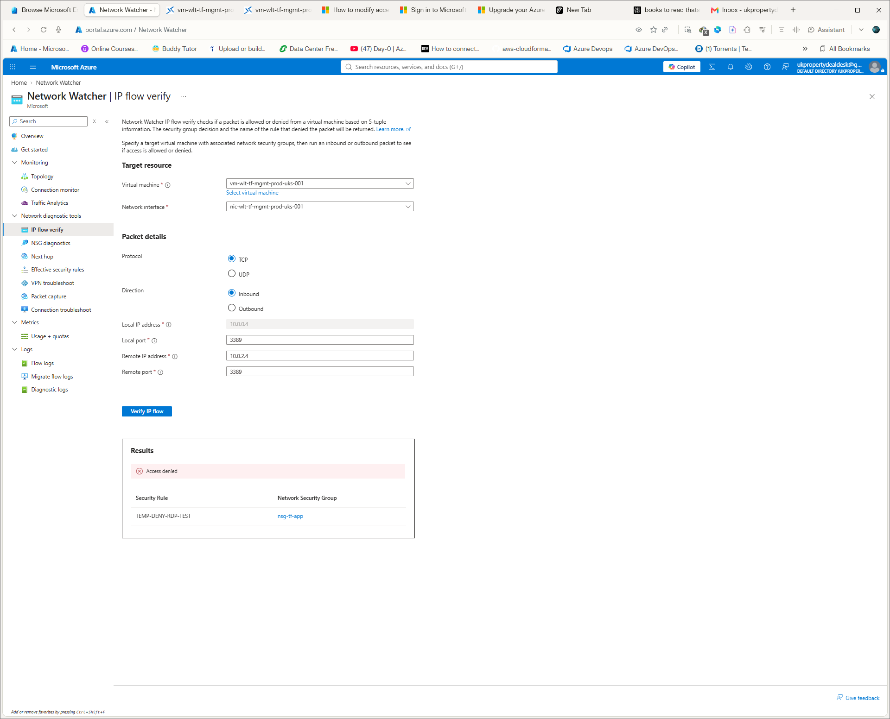
GitHub / final evidence screenshot S18 — supplied during the hands-on session.
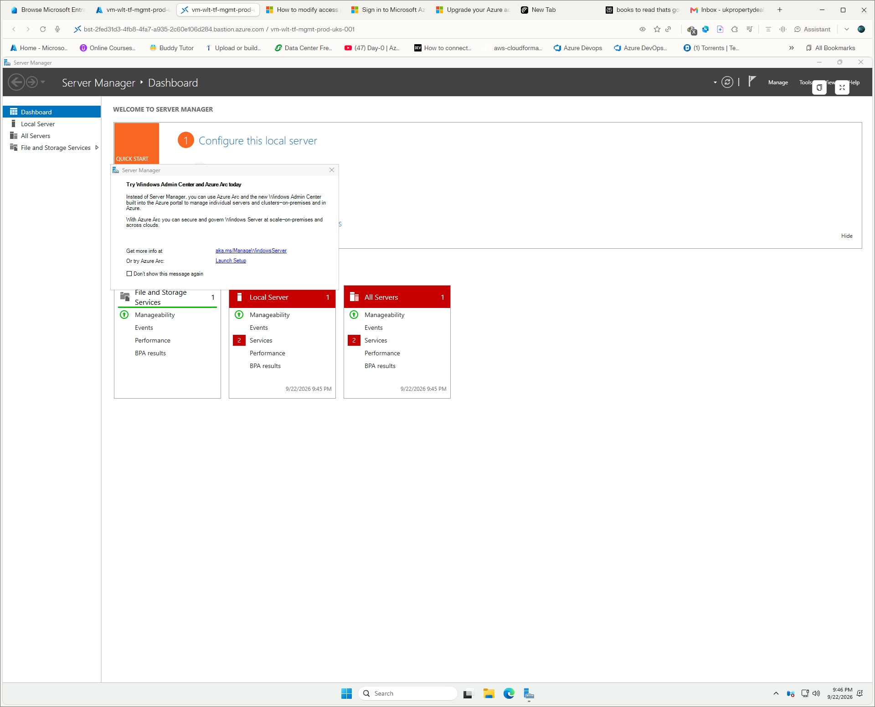
GitHub / final evidence screenshot S19 — supplied during the hands-on session.

10. Final cleanup and cost control
terraform -chdir=. destroy
The final command output recorded in the session was:
No changes. No objects need to be destroyed.

Either you have not created any objects yet or the existing objects were already deleted outside of Terraform.

Destroy complete! Resources: 0 destroyed.
Interpretation: at the time of this final destroy invocation, Terraform had no remaining managed resources requiring destruction. The environment had already been removed or was already empty. This is the correct final state for the disposable residency environment.

11. Evidence checklist
- Architecture documented.
- VNet and CIDR design documented.
- Subnet design documented.
- NSG baseline documented.
- NAT egress documented.
- Bastion private administration documented.
- VNet peering documented.
- Network Watcher diagnostics documented.
- Controlled failure documented.
- Failure recovery documented.
- Terraform deployment documented.
- Terraform errors documented.
- Terraform drift documented.
- Git workflow documented.
- GitHub push documented.
- Cost cleanup documented.
- All supplied screenshots included in this runbook.

12. Interview practice — recruiter / hiring-manager standard
These are technical practice answers. They are written to demonstrate engineering judgement, not to claim experience that was not actually performed. Where the answer refers to this project, it uses the verified Day 1 evidence.

Q1. Walk me through the Azure network you built.
I designed a production-style Azure network around a 10.0.0.0/16 VNet in UK South. I separated application, database and Bastion responsibilities into 10.0.0.0/24, 10.0.1.0/24 and a dedicated 10.0.2.0/26 AzureBastionSubnet. I associated NSGs with the workload subnets, used NAT Gateway for controlled outbound access, and kept the management VM private with no public IP. Administration was through Azure Bastion. I also built a second 10.1.0.0/16 shared-services VNet and configured bidirectional peering. The important engineering point is that I didn't stop at deployment: I tested connectivity, deliberately introduced an NSG failure, diagnosed it with Network Watcher, recovered it through Terraform, tested drift and then documented and version-controlled the result.
10/10 answer check
Direct answer → architecture/technical detail → personal engineering method → evidence → verification/operational consequence.

Q2. Why did you use a /16 VNet and /24 subnets?
The /16 was deliberate address-space headroom rather than allocating a narrow network that would immediately constrain future segmentation. The /24 workload subnets provide a simple, recognisable boundary for application and database tiers, while the Bastion subnet is separately sized at /26 for its dedicated service requirement. The key design principle is non-overlap, predictable allocation and enough capacity for future subnet growth. In a real environment I would derive the exact CIDR plan from workload counts, growth, regional expansion, reserved ranges and hybrid connectivity requirements rather than choosing numbers arbitrarily.
10/10 answer check
Direct answer → architecture/technical detail → personal engineering method → evidence → verification/operational consequence.

Q3. What is the difference between an NSG and a firewall?
An NSG is a distributed network access-control mechanism applied at subnet or NIC scope. It evaluates traffic using rule priority, direction, protocol, ports and source/destination. A firewall is a more centralised inspection and control service and can provide broader network, application and egress controls depending on the product. In this exercise the NSG was appropriate for subnet-level segmentation. I would not treat an NSG as a replacement for a full central firewall architecture where central inspection, application filtering or controlled hub-and-spoke egress is required.
10/10 answer check
Direct answer → architecture/technical detail → personal engineering method → evidence → verification/operational consequence.

Q4. Explain the NSG failure you deliberately created.
I added a temporary inbound deny rule at priority 100 to nsg-tf-app for TCP 3389 to the management VM at 10.0.0.4. A new Bastion connection then failed. Instead of changing multiple settings, I used Network Watcher IP Flow Verify with TCP/3389 and identified Access denied by TEMP-DENY-RDP-TEST. I removed the rule from the Terraform configuration. When Terraform initially reported no change, I investigated the desired-state behaviour and explicitly declared security_rule = [], which produced the expected one-change plan and removed the rule. The result was a controlled failure, evidence-based diagnosis and IaC-driven recovery.
10/10 answer check
Direct answer → architecture/technical detail → personal engineering method → evidence → verification/operational consequence.

Q5. How did you verify NAT Gateway was actually working?
I did not rely on the presence of the NAT resource alone. From the private management VM I tested TCP/443 to www.microsoft.com, resolved DNS, and queried api.ipify.org to obtain the observed public egress address. That public IP matched the NAT Gateway public IP. This proved the VM had no public IP of its own but still had deterministic outbound internet access through NAT. The verification therefore covered both service connectivity and the actual egress identity.
10/10 answer check
Direct answer → architecture/technical detail → personal engineering method → evidence → verification/operational consequence.

Q6. Why use Bastion instead of giving the VM a public IP?
The VM was a management workload and did not need to be directly exposed to the internet. Bastion provides administrative access through the Azure Portal while the VM retains only a private IP. This reduces the attack surface compared with exposing RDP directly. It also gives a clear separation between management access and workload networking. In production I would additionally apply identity, MFA, RBAC, logging and appropriate Bastion security controls.
10/10 answer check
Direct answer → architecture/technical detail → personal engineering method → evidence → verification/operational consequence.

Q7. How would you troubleshoot a VM that suddenly cannot reach the internet?
I would work from the lowest relevant layer outward rather than changing settings randomly. First I would establish the exact failure: DNS, TCP connectivity, or application-level failure. Then I would inspect the VM IP configuration and default route, effective routes, effective NSG rules, subnet/NIC associations, NAT Gateway association and public egress path. I would test DNS resolution separately from TCP/443, then use Network Watcher connection troubleshooting or IP Flow Verify where appropriate. I would also check Azure service health and recent configuration changes. Once the failing layer was proven, I would make the smallest safe remediation and re-test both the technical path and the user's required service.
10/10 answer check
Direct answer → architecture/technical detail → personal engineering method → evidence → verification/operational consequence.

Q8. What is VNet peering and what did you verify?
VNet peering provides private connectivity between separate Azure VNets over the Azure backbone. I used a production VNet at 10.0.0.0/16 and a shared-services VNet at 10.1.0.0/16. I configured the peering in both directions and verified both states reached Connected. I also kept forwarded traffic and gateway transit disabled for this baseline because they were not required by the scenario. In a larger architecture I would evaluate global peering, gateway transit, routing requirements and central inspection before selecting the exact topology.
10/10 answer check
Direct answer → architecture/technical detail → personal engineering method → evidence → verification/operational consequence.

Q9. What happens if DNS is wrong for a private endpoint?
The application can have network reachability but still fail because the normal service hostname resolves to a public address rather than the private endpoint address. For a private endpoint design I would verify the private DNS zone, the VNet link, the expected CNAME/A-record chain and the DNS server used by the workload. I would test resolution from inside the VNet rather than from my laptop because the private DNS view is network-scoped. I would then test TCP/443 separately so I can distinguish DNS failure from routing or security failure.
10/10 answer check
Direct answer → architecture/technical detail → personal engineering method → evidence → verification/operational consequence.

Q10. Explain Terraform drift.
Drift is when the actual Azure configuration differs from the configuration declared in Terraform. I demonstrated this by manually adding DriftTest=PortalChange to the Terraform-managed VNet. terraform plan detected the tag and proposed removing it. I applied the plan and a subsequent plan reported that the infrastructure matched the configuration. The lesson is that Terraform is the declared source of truth, while manual Portal changes should be controlled and reconciled rather than silently becoming the new standard.
10/10 answer check
Direct answer → architecture/technical detail → personal engineering method → evidence → verification/operational consequence.

Q11. Why did you not import the existing Portal network into Terraform?
The existing Portal environment was being preserved as a reference environment. Importing it wholesale would have blurred the boundary between learning/reference resources and the new IaC-controlled environment. After briefly testing an import to understand state handling, I removed it from Terraform state and chose a separate greenfield Terraform environment with distinct names. That gave me a clean production-style IaC baseline without risking the reference environment.
10/10 answer check
Direct answer → architecture/technical detail → personal engineering method → evidence → verification/operational consequence.

Q12. What Terraform error did you encounter with the management VM?
The initial VM deployment used a Gen1 Windows Server 2025 image with Standard_D2nls_v6. Azure rejected that combination because the selected size required a Gen2 image. I corrected the image reference to WindowsServer 2025-Datacenter-g2 and reran the deployment. The broader lesson is to treat Azure deployment errors as compatibility evidence: identify the exact constraint, change only the incompatible parameter and rerun validation/plan before applying again.
10/10 answer check
Direct answer → architecture/technical detail → personal engineering method → evidence → verification/operational consequence.

Q13. How do you keep Terraform safe in a team?
I use version control, feature branches, formatting and validation before plan, plan review before apply, controlled approvals and protected main. I also keep state out of Git. For a real shared environment I would use remote state with locking, controlled CI/CD identity, least-privilege permissions and separate environment state. The Day 1 environment deliberately used local state because it was disposable; that should not be confused with the recommended long-lived team model.
10/10 answer check
Direct answer → architecture/technical detail → personal engineering method → evidence → verification/operational consequence.

Q14. Why is remote Terraform state important?
Terraform needs state to map configuration to real Azure resources. In a team, local state on one laptop creates coordination and locking problems. A secured remote backend centralises the state, supports locking and makes controlled CI/CD execution possible. For the disposable residency environment I intentionally did not introduce remote state because the environment was temporary and was being destroyed after each exercise. For a persistent production platform, remote state would be part of the engineering baseline.
10/10 answer check
Direct answer → architecture/technical detail → personal engineering method → evidence → verification/operational consequence.

Q15. What would you do if a production application suddenly lost connectivity after an NSG change?
I would first establish the affected scope and business impact, then identify the exact change window and affected source/destination flows. I would use effective security rules and Network Watcher IP Flow Verify to determine whether the NSG is actually the blocking layer. If the change is confirmed as the cause, I would use the approved rollback or revert the IaC change rather than manually making unrelated changes. I would verify recovery from both the network and application perspective, document the incident and then address the prevention mechanism, such as validation or policy checks before future deployment.
10/10 answer check
Direct answer → architecture/technical detail → personal engineering method → evidence → verification/operational consequence.

Q16. What is a Private Endpoint?
A Private Endpoint gives an Azure service a private IP representation inside a VNet through Azure Private Link. The workload connects to the service through that private address rather than relying on public service access. The critical companion is DNS: the workload should resolve the normal service hostname to the private endpoint path. I would therefore design the private endpoint, dedicated subnet strategy, private DNS zone, VNet link and validation as one engineering unit rather than treating DNS as an afterthought.
10/10 answer check
Direct answer → architecture/technical detail → personal engineering method → evidence → verification/operational consequence.

Q17. How would you design controlled outbound traffic for a larger Azure estate?
I would first define the business requirement: which workloads need internet access, which destinations are allowed, and whether outbound identity must be deterministic. For simple subnet-level SNAT, NAT Gateway may be appropriate. For centralised inspection and policy enforcement, I would consider Azure Firewall in a hub-and-spoke or Virtual WAN architecture with appropriate routing. I would then design the UDRs, failure behaviour, logging, capacity and SNAT requirements. The choice should be driven by security and operational requirements rather than simply deploying the most advanced service.
10/10 answer check
Direct answer → architecture/technical detail → personal engineering method → evidence → verification/operational consequence.

Q18. What is your approach to Azure network troubleshooting?
I use a layered evidence chain: identity and scope, configuration, DNS, IP addressing, routes, security rules, service dependencies, logs and platform health. I define the exact source, destination, protocol and port first. Then I test the smallest relevant layer and use Azure-native evidence such as effective routes, effective security rules, Network Watcher and service diagnostics. I avoid changing multiple things simultaneously because that destroys causality. Once the failing layer is proven, I apply the smallest safe fix and verify recovery.
10/10 answer check
Direct answer → architecture/technical detail → personal engineering method → evidence → verification/operational consequence.

Q19. What would make this Day 1 environment more production-ready?
I would add centralised governance, policy, a proper remote Terraform backend, reusable Terraform modules, CI/CD with plan and approval gates, central logging and monitoring, Azure Firewall where required, private endpoints and private DNS, stronger identity controls, documented operational runbooks, cost controls and automated security checks. I would also introduce a formal hub-and-spoke or Virtual WAN design where the scale and connectivity requirements justify it. Day 1 is intentionally the foundation, not the complete production architecture.
10/10 answer check
Direct answer → architecture/technical detail → personal engineering method → evidence → verification/operational consequence.

Q20. What is the biggest lesson from the exercise?
The biggest lesson is that network engineering is not resource creation. The strongest evidence came from deliberately breaking the network, proving the failure with Network Watcher, recovering through Terraform, detecting Portal drift and documenting the lifecycle in Git. That demonstrates a repeatable engineering method: understand the requirement, design the network, implement it, secure it, test it, troubleshoot it under failure, recover it, automate it and leave evidence that another engineer can reproduce.
10/10 answer check
Direct answer → architecture/technical detail → personal engineering method → evidence → verification/operational consequence.

13. Practical interview rapid-fire questions
Question | 10/10 concise answer
What is a subnet? | A logical IP range inside a VNet used to segment workloads and apply controls such as NSGs and routes.
What is SNAT? | Source Network Address Translation changes the source address of outbound traffic so private workloads can reach external destinations through a controlled egress identity.
What is DNAT? | Destination NAT changes the destination address/port of traffic, commonly used when publishing or forwarding traffic through a NAT/firewall service.
What is an effective route? | The route Azure actually applies after system routes, user-defined routes and relevant propagated routes are evaluated.
What is an NSG priority? | Lower numeric priority is evaluated before higher numeric priority; the first matching rule determines the result.
Why should workload VMs avoid public IPs? | It reduces direct internet exposure and allows controlled ingress/administration through designed security paths.
Why is DNS part of networking? | Applications normally connect using names; incorrect DNS can make a healthy network path point to the wrong address.
Why use Terraform plan? | It provides a preview of the proposed state change so engineers can detect unexpected additions, changes or destruction before apply.
Why use feature branches? | They isolate changes, support review and prevent unreviewed work from being committed directly to the protected baseline.
What is drift? | A difference between the declared IaC configuration and the actual deployed infrastructure.

14. Next capability in the master Azure Network Engineer track
The foundation is complete. The next practice module is Private Endpoint + Private DNS, followed by routing and then progressively deeper security, application delivery, hybrid connectivity, monitoring, AKS networking, resilience and production incident engineering.
Next module | Evidence to produce
Private Endpoint | Private service access with no public dependency
Private DNS | Correct VNet-linked resolution and record chain
Routing | System routes, UDRs, next-hop and effective route troubleshooting
Azure Firewall | Central inspection, egress and DNAT/SNAT
Application Gateway | L7 ingress, probes and backend troubleshooting
Load Balancer | L4 load balancing and health probes
VPN/BGP | Hybrid connectivity and route advertisement
ExpressRoute | Architecture/design knowledge and operational considerations
Monitoring | Network Watcher, Azure Monitor, Log Analytics and alerts
AKS networking | CNI/overlay, ingress, DNS, egress and private clusters
Multi-region | Regional routing, resilience and DR
Terraform architecture | Modules, environments, state, CI/CD and policy
Production incidents | Break, diagnose, recover, prevent and document

15. Screenshot evidence index
All 20 screenshots supplied during the hands-on session have been embedded below in chronological upload order. They are preserved as visual evidence so the runbook can be used alongside the original Portal session.
S01 — original screenshot supplied during the Azure networking hands-on session.
S02 — original screenshot supplied during the Azure networking hands-on session.
S03 — original screenshot supplied during the Azure networking hands-on session.
S04 — original screenshot supplied during the Azure networking hands-on session.
S05 — original screenshot supplied during the Azure networking hands-on session.
S06 — original screenshot supplied during the Azure networking hands-on session.
S07 — original screenshot supplied during the Azure networking hands-on session.
S08 — original screenshot supplied during the Azure networking hands-on session.
S09 — original screenshot supplied during the Azure networking hands-on session.
S10 — original screenshot supplied during the Azure networking hands-on session.
S11 — original screenshot supplied during the Azure networking hands-on session.
S12 — original screenshot supplied during the Azure networking hands-on session.
S13 — original screenshot supplied during the Azure networking hands-on session.
S14 — original screenshot supplied during the Azure networking hands-on session.
S15 — original screenshot supplied during the Azure networking hands-on session.
S16 — original screenshot supplied during the Azure networking hands-on session.
S17 — original screenshot supplied during the Azure networking hands-on session.
S18 — original screenshot supplied during the Azure networking hands-on session.
S19 — original screenshot supplied during the Azure networking hands-on session.

16. Source and evidence note
This runbook was compiled from the hands-on session history, the uploaded Azure 24-Hour Crash Course, the supplied Portal screenshots, Terraform command/output captures, the Bastion correction notes, the Terraform plan/error captures and the Git/GitHub evidence. It intentionally records observed errors and the decisions taken rather than rewriting the session as if every first attempt had been correct.
Where an observed issue was not fully resolved in the session (for example the metadata security/IMDS observation), it is explicitly marked as an outstanding technical observation rather than being presented as fixed.

