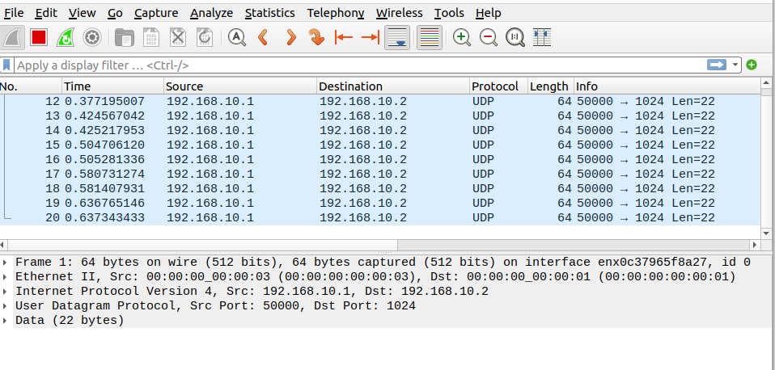

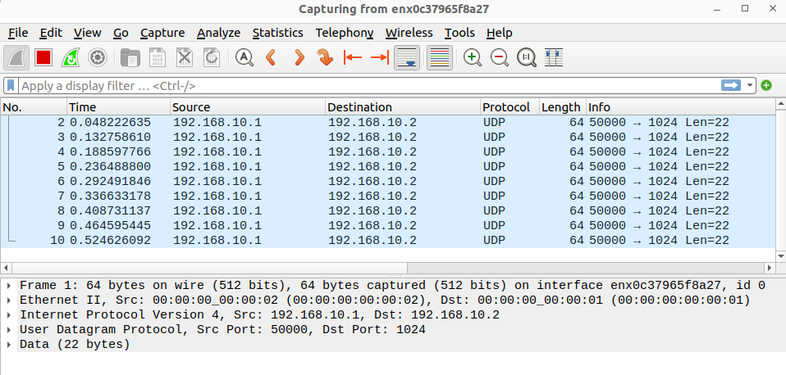
In the drop table you should use a mac address of 00:00:00:00:00:02 as source mac addresses are dropped from send.py

