1.
PING 192.168.10.2 (192.168.10.2) 56(84) bytes of data.
64 bytes from 192.168.10.2: icmp_seq=1 ttl=64 time=0.401 ms
64 bytes from 192.168.10.2: icmp_seq=2 ttl=64 time=0.509 ms
64 bytes from 192.168.10.2: icmp_seq=3 ttl=64 time=0.489 ms
64 bytes from 192.168.10.2: icmp_seq=4 ttl=64 time=0.411 ms
64 bytes from 192.168.10.2: icmp_seq=5 ttl=64 time=0.476 ms
64 bytes from 192.168.10.2: icmp_seq=6 ttl=64 time=0.466 ms
64 bytes from 192.168.10.2: icmp_seq=7 ttl=64 time=0.410 ms
64 bytes from 192.168.10.2: icmp_seq=8 ttl=64 time=0.484 ms
64 bytes from 192.168.10.2: icmp_seq=9 ttl=64 time=0.360 ms
64 bytes from 192.168.10.2: icmp_seq=10 ttl=64 time=0.459 ms
-- 192.168.10.2 ping statistics ---
10 packets transmitted, 10 received, 0% packet loss, time 1837ms
rtt min/avg/max/mdev = 0.360/0.446/0.509/0.045 ms

2.
PING 192.168.10.1 (192.168.10.1) 56(84) bytes of data.
64 bytes from 192.168.10.1: icmp_seq=1 ttl=64 time=0.409 ms
64 bytes from 192.168.10.1: icmp_seq=2 ttl=64 time=0.531 ms
64 bytes from 192.168.10.1: icmp_seq=3 ttl=64 time=0.522 ms
64 bytes from 192.168.10.1: icmp_seq=4 ttl=64 time=0.508 ms
64 bytes from 192.168.10.1: icmp_seq=5 ttl=64 time=0.536 ms
64 bytes from 192.168.10.1: icmp_seq=6 ttl=64 time=0.539 ms
64 bytes from 192.168.10.1: icmp_seq=7 ttl=64 time=0.539 ms
64 bytes from 192.168.10.1: icmp_seq=8 ttl=64 time=0.376 ms
64 bytes from 192.168.10.1: icmp_seq=9 ttl=64 time=0.515 ms
64 bytes from 192.168.10.1: icmp_seq=10 ttl=64 time=0.519 ms
--- 192.168.10.1 ping statistics ---
10 packets transmitted, 10 received, 0% packet loss, time 1835ms
rtt min/avg/max/mdev = 0.376/0.499/0.539/0.054 ms

3.
PING 192.168.10.1 (192.168.10.1) 56(84) bytes of data.
64 bytes from 192.168.10.1: icmp_seq=1 ttl=64 time=0.617 ms
64 bytes from 192.168.10.1: icmp_seq=2 ttl=64 time=0.321 ms
64 bytes from 192.168.10.1: icmp_seq=3 ttl=64 time=0.380 ms
64 bytes from 192.168.10.1: icmp_seq=4 ttl=64 time=0.533 ms
…

64 bytes from 192.168.10.1: icmp_seq=98 ttl=64 time=0.336 ms
64 bytes from 192.168.10.1: icmp_seq=99 ttl=64 time=0.344 ms
64 bytes from 192.168.10.1: icmp_seq=100 ttl=64 time=0.342 ms
--- 192.168.10.1 ping statistics ---
100 packets transmitted, 100 received, 0% packet loss, time 99ms
rtt min/avg/max/mdev = 0.303/0.346/0.617/0.039 ms

the minimum and maximum for this test was a lot higher or lower than previous test which is expected as there more tests therefore you will get a higher range of results.
However the mean is lower in this test than the previous test which may be due to the short time interval compared to the previously larger time interval.

4.
--- 192.168.10.1 ping statistics ---
10000 packets transmitted, 10000 received, 0% packet loss, time 3361ms
rtt min/avg/max/mdev = 0.170/0.292/0.655/0.016 ms, ipg/ewma 0.336/0.287 ms

5.
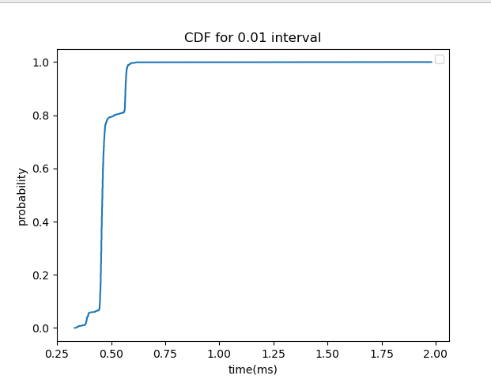

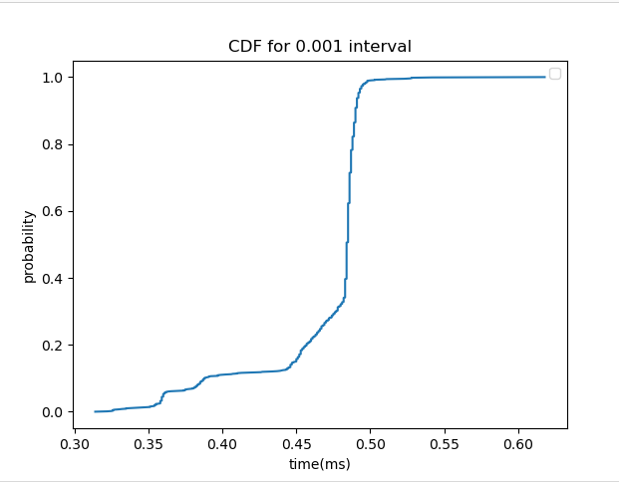

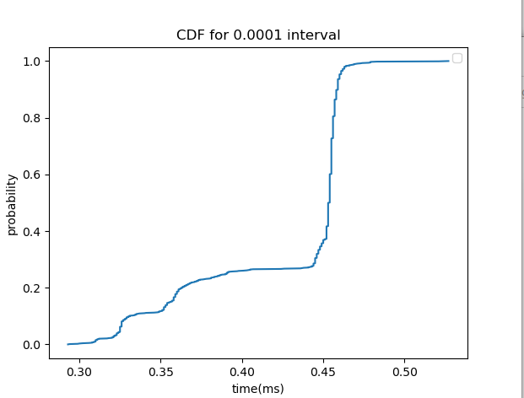
6. the time may be different as in the faster intervals there is less time between packets which may mean the start up time for the processing of the packets willl be smaller or omitted as by the time the raspberry pi has finished processing one packet the next packet will arrive, hiowveer in the longer time intervals there may be a startup time everytime a packet arrives so it may take longer. the best metric would be average as in all the cases the average is similar as there is a range in aveerages from 0.43 to 0.48, or mode may also be a good ,metric to use as there is less variation in this as well between the three tests.

Iperf

1. Interval Transfer Bandwidth
[ 3] 0.0000-10.0025 sec 1.09 GBytes 940 Mbits/sec

2. (TCP)
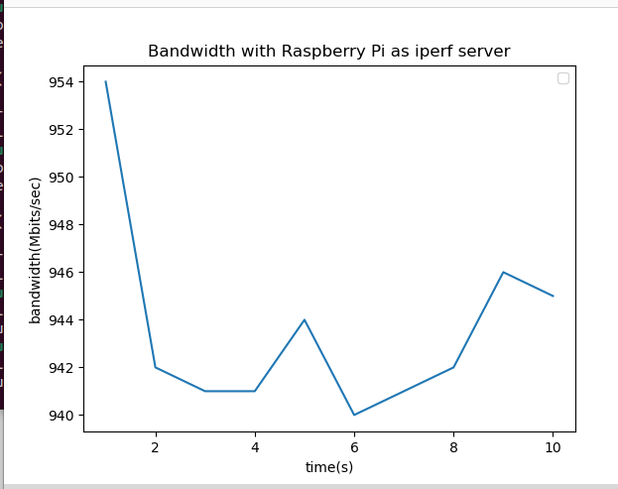

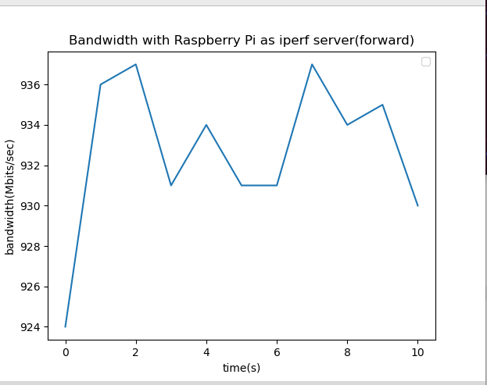
3.(TCP)

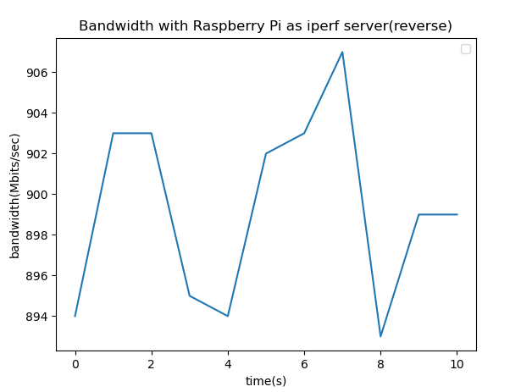
4. a) no packets dropped for any of the configurations

b) local 192.168.10.1 port 56629 connected with 192.168.10.2 port 5001
[ ID] Interval Transfer Bandwidth
[ 1] 0.0000-5.1747 sec 66.0 KBytes 105 Kbits/sec
[ 1] Sent 47 datagrams
[ 1] Server Report:
[ ID] Interval Transfer Bandwidth Jitter Lost/Total Datagrams
[ 1] 0.0000-5.1743 sec 66.0 KBytes 105 Kbits/sec 0.003 ms 0/46 (0%)

1] local 192.168.10.1 port 53205 connected with 192.168.10.2 port 5001
[ ID] Interval Transfer Bandwidth
[ 1] 0.0000-5.0219 sec 616 KBytes 1.00 Mbits/sec
[ 1] Sent 430 datagrams
[ 1] Server Report:
[ ID] Interval Transfer Bandwidth Jitter Lost/Total Datagrams
[ 1] 0.0000-5.0215 sec 616 KBytes 1.00 Mbits/sec 0.002 ms 0/429 (0%)

1] local 192.168.10.1 port 60809 connected with 192.168.10.2 port 5001
[ ID] Interval Transfer Bandwidth
[ 1] 0.0000-5.0001 sec 59.6 MBytes 100 Mbits/sec
[ 1] Sent 42521 datagrams
[ 1] Server Report:
[ ID] Interval Transfer Bandwidth Jitter Lost/Total Datagrams
[ 1] 0.0000-4.9997 sec 59.6 MBytes 100 Mbits/sec 0.006 ms 0/42520 (0%)

iperf3

1. (TCP)
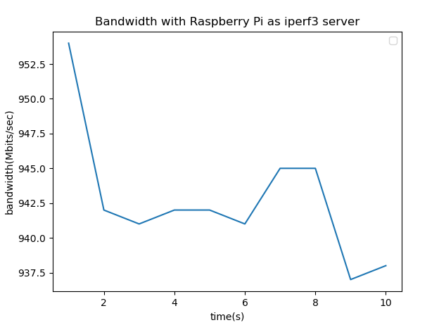

2.
a) there weren’t any packet drops

b) 100kbits/s

ID] Interval Transfer Bitrate Total Datagrams
[ 5] 0.00-1.00 sec 12.7 KBytes 104 Kbits/sec 9
[ 5] 1.00-2.00 sec 12.7 KBytes 104 Kbits/sec 9
[ 5] 2.00-3.00 sec 11.3 KBytes 92.7 Kbits/sec 8
[ 5] 3.00-4.00 sec 12.7 KBytes 104 Kbits/sec 9
[ 5] 4.00-5.00 sec 12.7 KBytes 104 Kbits/sec 9
- - - - - - - - - - - - - - - - - - - - - - - - -
[ ID] Interval Transfer Bitrate Jitter Lost/Total Datagrams
[ 5] 0.00-5.00 sec 62.2 KBytes 102 Kbits/sec 0.000 ms 0/44 (0%) sender
[ 5] 0.00-5.04 sec 62.2 KBytes 101 Kbits/sec 0.009 ms 0/44 (0%) receiver

1Mbits/s

ID] Interval Transfer Bitrate Total Datagrams
[ 5] 0.00-1.00 sec 123 KBytes 1.01 Mbits/sec 87
[ 5] 1.00-2.00 sec 122 KBytes 996 Kbits/sec 86
[ 5] 2.00-3.00 sec 122 KBytes 996 Kbits/sec 86
[ 5] 3.00-4.00 sec 123 KBytes 1.01 Mbits/sec 87
[ 5] 4.00-5.00 sec 122 KBytes 996 Kbits/sec 86
- - - - - - - - - - - - - - - - - - - - - - - - -
[ ID] Interval Transfer Bitrate Jitter Lost/Total Datagrams
[ 5] 0.00-5.00 sec 611 KBytes 1.00 Mbits/sec 0.000 ms 0/432 (0%) sender
[ 5] 0.00-5.04 sec 611 KBytes 992 Kbits/sec 0.006 ms 0/432 (0%) receiver

100Mbits/s

ID] Interval Transfer Bitrate Total Datagrams
[ 5] 0.00-1.00 sec 11.9 MBytes 99.9 Mbits/sec 8626
[ 5] 1.00-2.00 sec 11.9 MBytes 100 Mbits/sec 8633
[ 5] 2.00-3.00 sec 11.9 MBytes 100 Mbits/sec 8633
[ 5] 3.00-4.00 sec 11.9 MBytes 100 Mbits/sec 8632
[ 5] 4.00-5.00 sec 11.9 MBytes 100 Mbits/sec 8633
- - - - - - - - - - - - - - - - - - - - - - - - -
[ ID] Interval Transfer Bitrate Jitter Lost/Total Datagrams
[ 5] 0.00-5.00 sec 59.6 MBytes 100 Mbits/sec 0.000 ms 0/43157 (0%) sender
[ 5] 0.00-5.04 sec 59.6 MBytes 99.1 Mbits/sec 0.006 ms 0/43157 (0%) receiver

c) we’d expect the bandwidth of the iperf3 to be better than iperf. However although from the graph the mean is better it does not differ by that much therefore our experiments aren't enough to show this.
Furthermore the results from the UDP are very similar with very similar transfer however the jitter on the iperf3 is lower than on the iperf.

