Question 2:
- As proved in class, in the MSE sense, the optimal number for a sub-sample is the average of the function over the samples in the sub-sample. In the MAD sense, the optimal number for a sub-sample is the median of the function over the samples in the sub-sample.
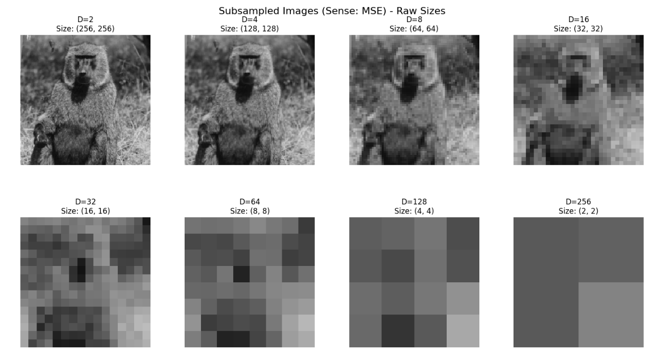
  - Sub-sampled images in MSE sense, for different sub-sampling factor, D:

In the graph of MSE as function of Sub-sampling factor D, the horizontal axis (Sub-sampling factor D) is taken in log scale so the different values of D will be evenly spaced.

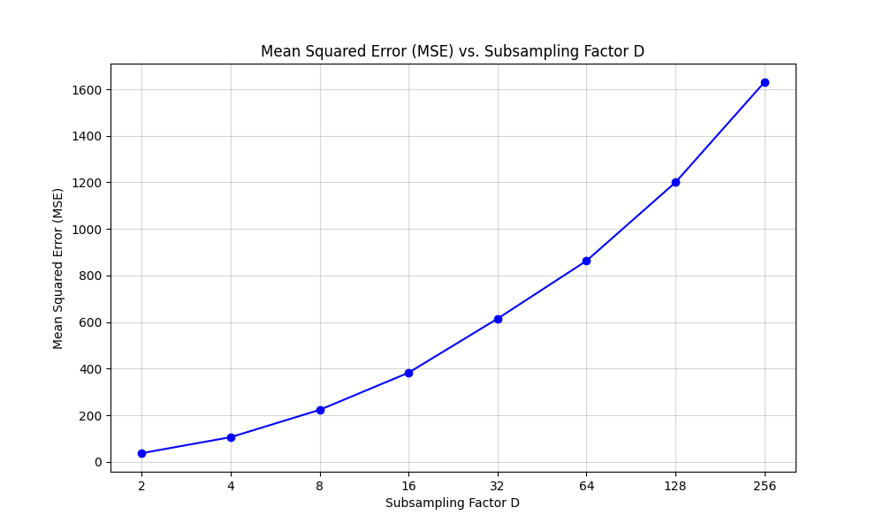

  - Sub-sampled images in MAD sense, for different sub-sampling factor, D:
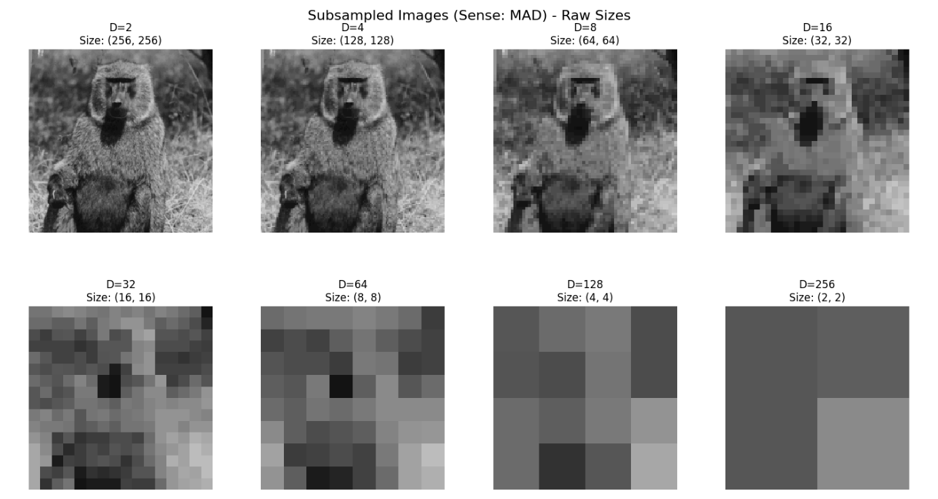

In the graph of MAD as function of Sub-sampling factor D, the horizontal axis (Sub-sampling factor D) is taken in log scale so the different values of D will be evenly spaced.
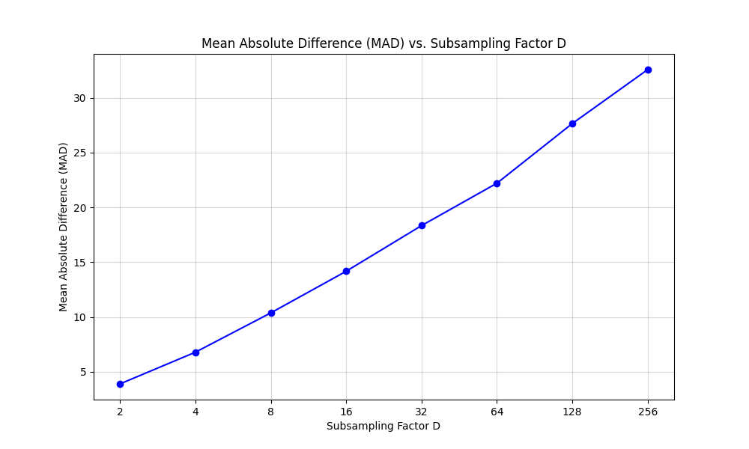

- We reconstruct the image by taking each pixel and duplicate it number of times such that we get a 512x512 image (original size). For example, in case D=2, we get a sampled image in size 256x256. In the reconstructed image, we will take each pixel and duplicate it 4 times – meaning each 1x1 pixel becomes 2x2 four pixels, and the result is 512x512 image.
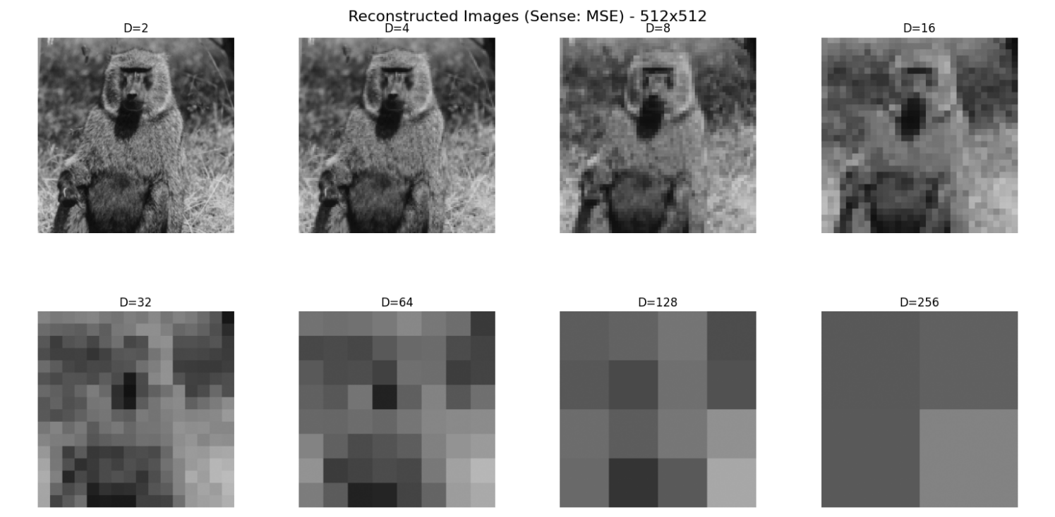

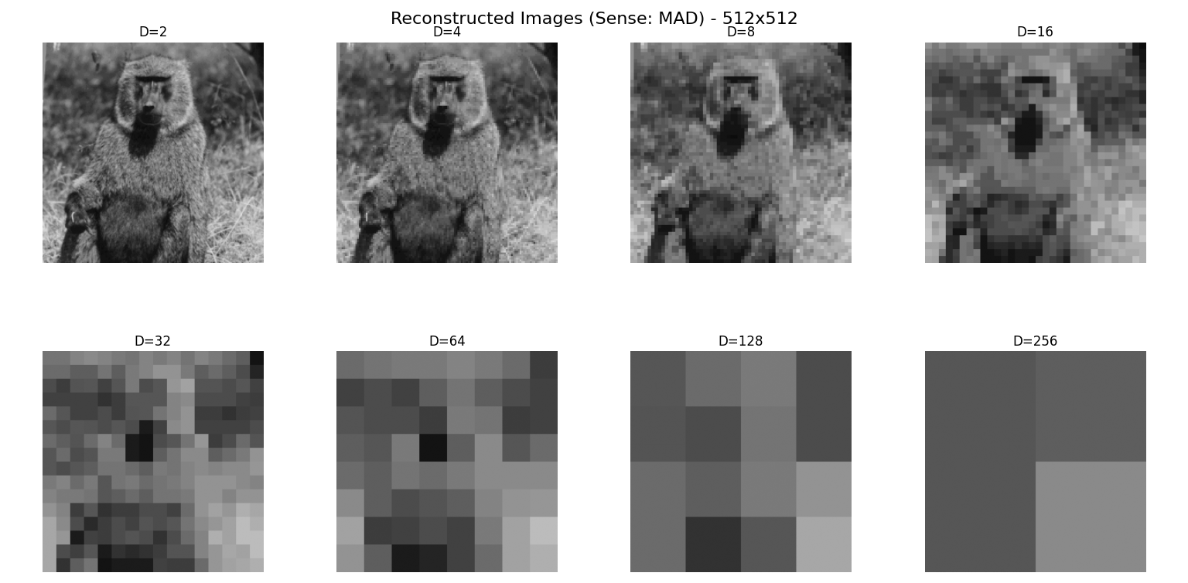

- As the sub-sampling factor $D$ increases, fewer pixels are retained from the original image, since each $D×D$ block is represented by a single sample. This leads to a loss of spatial detail and high-frequency information. After reconstruction, the image becomes increasingly blurred, and the reconstruction error increases accordingly, as reflected by higher MSE and MAD values, as we can see in the graph presented in previous sections of this answer.

