Future-Innovation Lab | UWC CoLab for Digital Inclusion and Social Innovation
STUDENT SUPPORT INSIGHTS TOOL
AI-Enabled Learner Support Analytics Prototype
Final Integrated Report | SFIA Level 3 Integrated Assessment | Programme AI Internship - Cohort 5
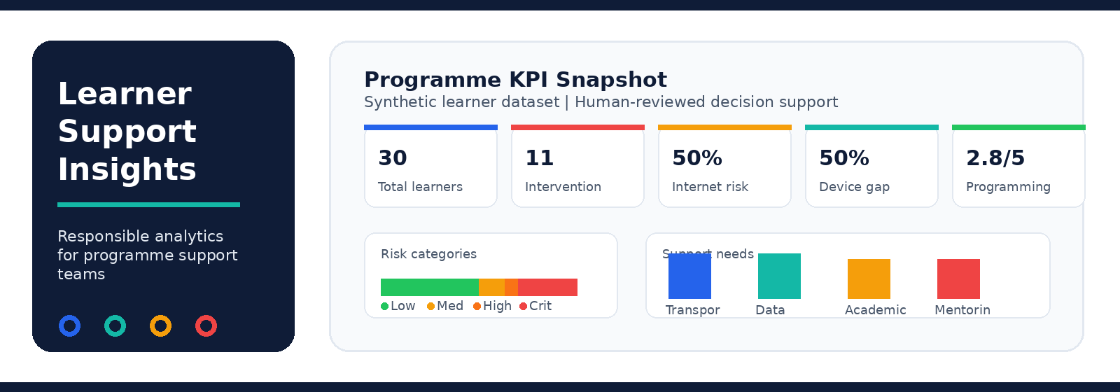
Student | Yonela Jongola
Student Number | 12525456122
Programme | AI Internship - Cohort 5
Assessment | SFIA Level 3 Integrated Assessment
Submission | Integrated Word/PDF Report and Evidence Folder
Date | 01 June 2026
A practical dashboard for proactive learner support, ethical risk review and data-informed programme decisions.

Table of Contents
1. Executive Summary ...................................................................... 3
2. Problem Statement and Context ...................................................................... 4
3. Stakeholder and User Needs Analysis ...................................................................... 5
4. Current and Improved Process ...................................................................... 6
5. Business and Value Model ...................................................................... 8
6. Data Description and Preparation ...................................................................... 9
7. Analytics Findings and KPI Dashboard ...................................................................... 11
8. Prototype Description and UX/UI Design ...................................................................... 15
9. AI, Data Ethics and Privacy Review ...................................................................... 18
10. Methods, Tools and Development Approach ...................................................................... 20
11. Testing, Review and Quality Evidence ...................................................................... 22
12. Hosting and Deployment Readiness ...................................................................... 24
13. Reflection and Future Improvements ...................................................................... 26
14. Evidence Inventory Mapped to SFIA Skills ...................................................................... 27
15. Final Submission Checklist ...................................................................... 29
Appendices ...................................................................... 30

Document Control
Item | Description
Report purpose | Integrated final report for the Student Support Insights Tool assignment.
Evidence basis | Project source code, dataset, documentation, screenshots, testing logs, bug logs, ethics review and SFIA evidence checklist.
Data status | Synthetic learner records only. No real learner personal information is used.
Decision status | Risk flags and recommendations are decision-support signals only and require human staff review.

1. Executive Summary
This report presents the Student Support Insights Tool, a working prototype designed to help programme staff capture, validate, analyse and interpret learner support survey data. The solution turns raw learner support information into operational insight through KPI cards, visual dashboards, explainable risk scoring, recommendation outputs and responsible-use controls.
The project responds to a common challenge in digital skills programmes: learner information is often collected, but it is not always used systematically to identify early support needs, access barriers or process improvement opportunities. This prototype demonstrates how a programme team can move from manual spreadsheet review to proactive, ethical and data-informed learner success management.
The prototype uses a synthetic dataset of 30 learners. The risk model identifies 11 learners who require high or critical staff review, while also highlighting connectivity risk, device access gaps and confidence patterns across digital, programming and AI familiarity skills. These outputs are not final decisions; they are structured evidence for staff review and support planning.
The final evidence pack includes source code, dataset files, data dictionary, process models, business value model, ethics and privacy review, testing evidence, bug log, screenshots, README/user guide, peer/stakeholder review evidence and SFIA mapping. Together, these artefacts show a complete integrated assessment outcome rather than disconnected mini-submissions.
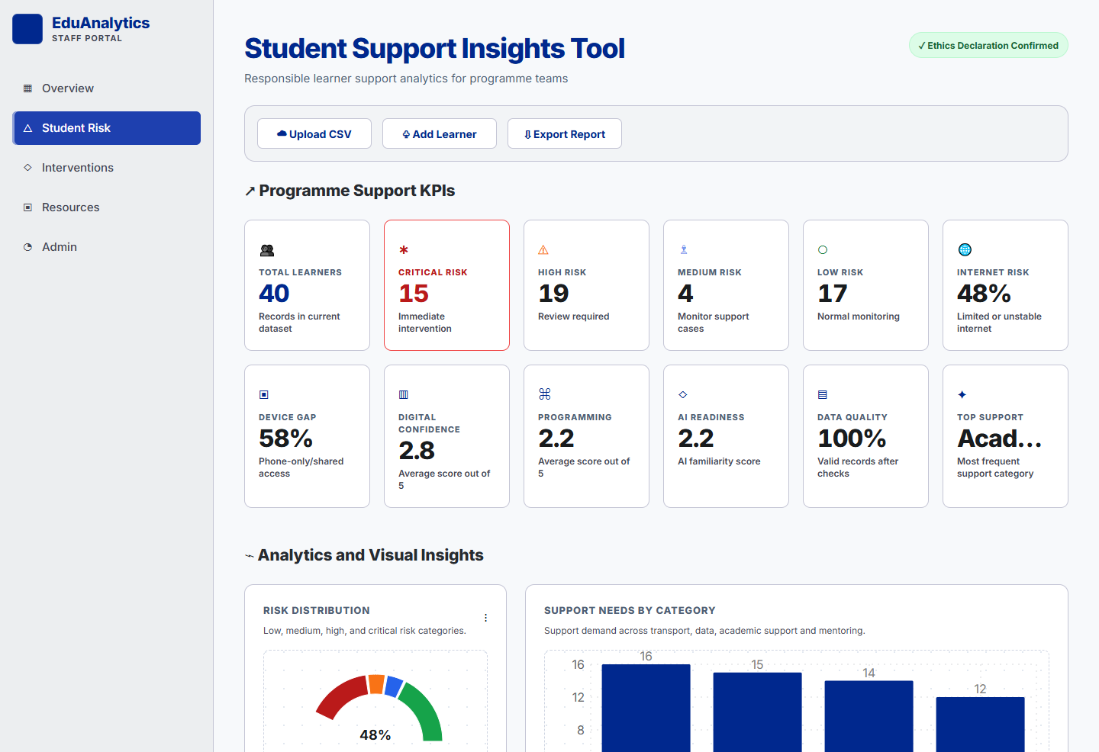
Figure 1: Dashboard overview showing the operational layout and learner support KPI story.

2. Problem Statement and Context
Digital skills programmes depend on timely learner support. Learners may face barriers such as limited data, unstable internet, phone-only learning, transport difficulty, low confidence or limited familiarity with AI tools. When this information sits in spreadsheets or disconnected notes, programme staff may not see risk patterns early enough to act.
The core project question is: How can a programme team use learner data responsibly to identify support needs, prioritise support actions and improve learner success?
Current challenge | Impact on programme delivery | How the prototype responds
Manual learner support review | Staff spend time scanning spreadsheets and may miss early warning signs. | The tool validates data and summarises risk through dashboard KPIs.
Inconsistent support prioritisation | Support decisions can vary depending on who reviews the data. | A transparent scoring model gives consistent risk categories and reason codes.
Limited reporting visibility | Leadership may not see the full pattern of learner needs. | Charts and summaries translate data into management-level insight.
Ethical risk in using learner data | Learners can be unfairly labelled if outputs are treated as final decisions. | Human review, consent wording and non-automation rules are built into the workflow.

3. Stakeholder and User Needs Analysis
The tool is designed primarily for programme staff who need to understand learner support needs quickly and fairly. It also serves leadership, facilitators, mentors and IT support by creating a clearer evidence trail from data capture to support action.
Stakeholder | Need | Design response
Learners | Fair, timely and relevant support without unnecessary exposure of personal data. | Synthetic/anonymised data approach, privacy wording and human review.
Programme staff | A simple way to identify support patterns and prioritise action. | KPI dashboard, risk table, recommendation cards and validation feedback.
Facilitators / mentors | Clear signals about who may need academic or confidence support. | Reason codes and support categories make follow-up easier.
Programme leadership | Management view of support demand, risk and resource needs. | Trends, KPI cards and exportable summaries support reporting.
IT / support administrators | A maintainable prototype with clear setup instructions. | React frontend, ASP.NET Core API, README, environment settings and build evidence.

User Personas
Persona | Primary goal | Success measure
Student Support Officer | Find learners needing urgent support and understand why. | Can filter risk review table and see reason codes.
Programme Manager | Plan support resources using reliable evidence. | Can view top needs, device gaps and internet risk.
Facilitator | Adjust teaching support based on learner readiness. | Can see confidence trends and academic support needs.
Assessor / reviewer | Verify that the assignment evidence is complete. | Can trace every SFIA requirement to evidence files.

4. Current Process and Improved Process
The current process is mostly manual and reactive. The improved process introduces structured data validation, dashboard analysis, risk flagging and staff-reviewed recommendations. This creates a more accountable support process while keeping human judgement in every learner decision.
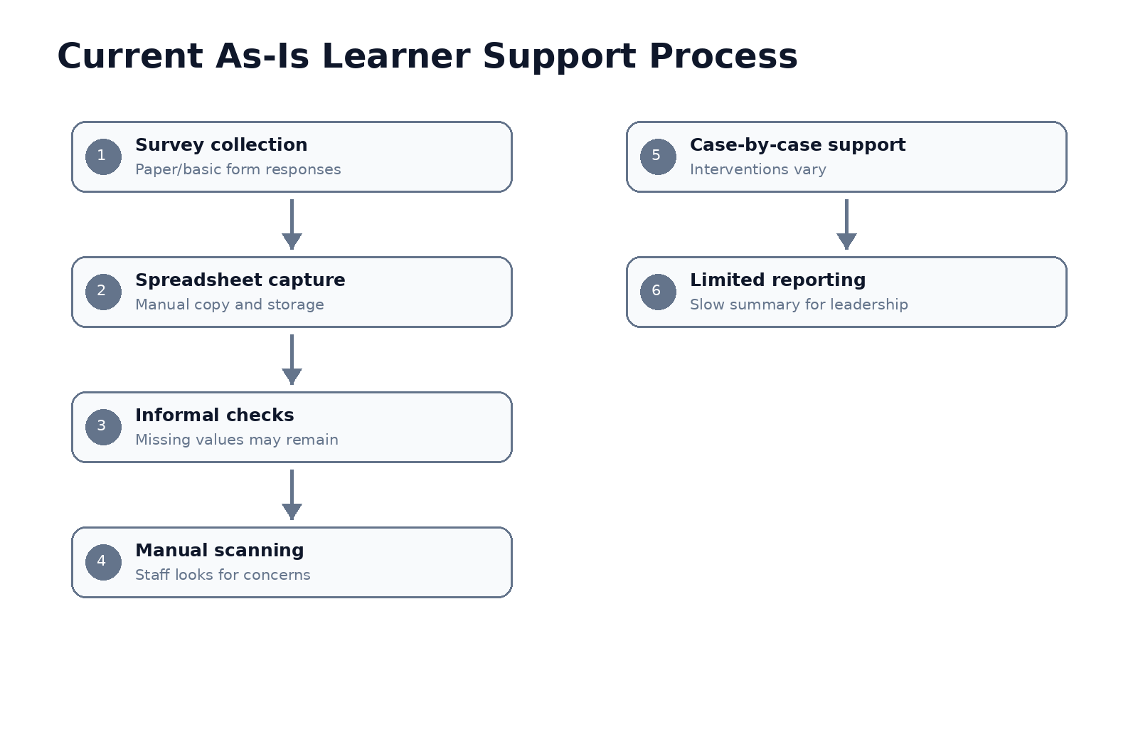
Figure 2: Current as-is process, showing manual review and weak feedback loops.
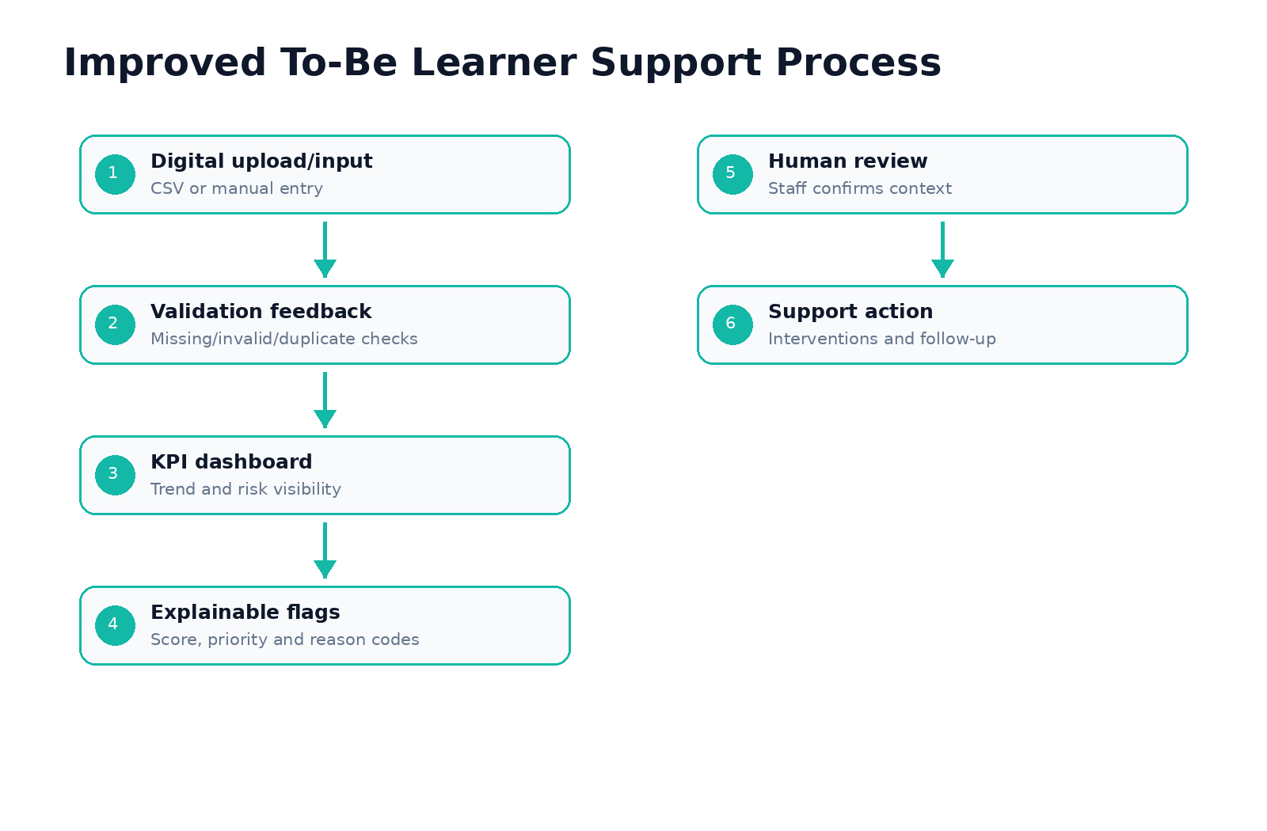
Figure 3: Improved to-be process, showing validation, analysis, risk review and follow-up.

Process Improvement Opportunities
Improvement opportunity | Operational value | Evidence in prototype
Automated validation | Improves data quality before analysis begins. | CSV upload and manual form validation.
Early risk visibility | Supports proactive intervention rather than late response. | Risk score, priority and reason codes.
Clear management reporting | Improves decision-making and resource allocation. | KPI dashboard and five visualisations.
Responsible-use workflow | Prevents automatic labelling or unfair treatment. | Ethics declaration and privacy notice.
Feedback loop | Encourages staff to review, act and monitor outcomes. | To-be process and recommendation cards.

5. Business and Value Model
The value model shows how learner survey data becomes a practical programme management asset. The tool does not only display charts; it supports resource planning, prioritised staff review, targeted intervention and continuous improvement.
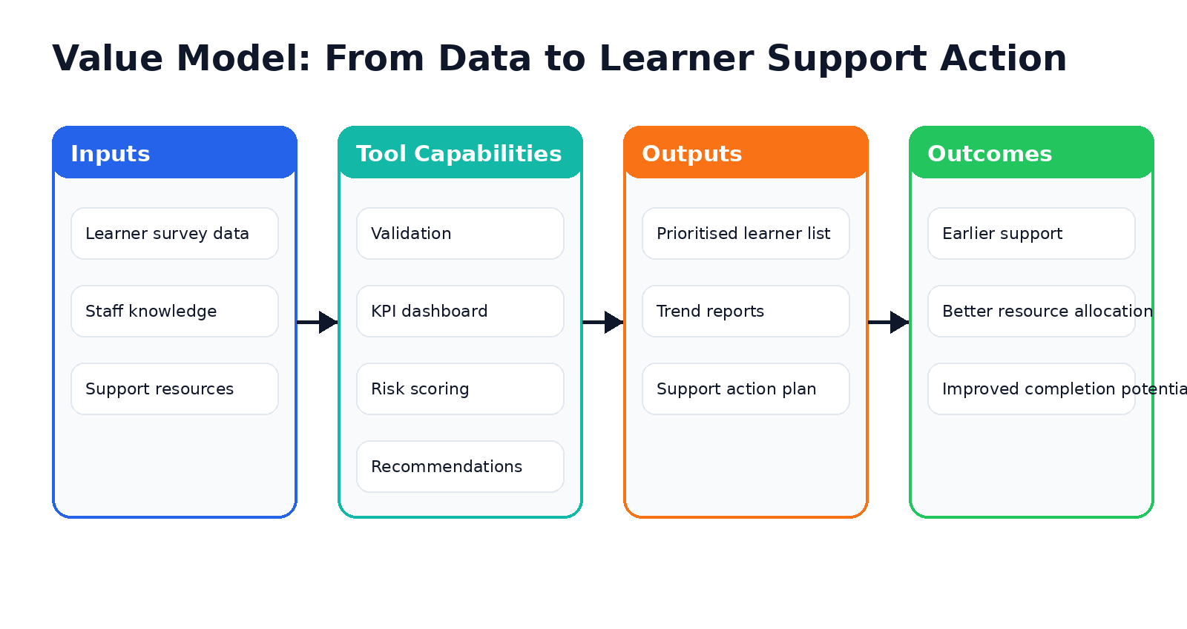
Figure 4: Value model linking data inputs to programme outcomes.
Value area | What the tool improves | Possible indicator
Efficiency | Reduces manual spreadsheet scanning. | Time taken to produce support summary.
Quality | Standardises validation and risk interpretation. | Number of invalid records detected before reporting.
Responsiveness | Highlights high and critical cases early. | Number of flagged learners reviewed weekly.
Resource planning | Shows support needs by category and access barrier. | Allocation of data, device, transport and mentoring support.
Accountability | Provides evidence for decisions and follow-up. | Review notes and exported summaries.

6. Data Description and Data Preparation
The dataset contains 30 synthetic learner records. Synthetic data was used to demonstrate the tool safely without exposing real learner personal information. Each learner record includes access conditions, confidence scores, employment status, support need, attendance risk and a short notes field.
Field | Description | Example
LearnerID | Unique learner reference. | L001
AgeBand | Age group category. | 18-24
Province | Learner area/province. | Western Cape
DeviceAccess | Primary learning device. | Laptop, Shared laptop, Phone only
InternetAccess | Connectivity status. | Reliable, Unstable, Limited
DigitalConfidence | Self-rated digital confidence from 1 to 5. | 4
ProgrammingConfidence | Self-rated programming confidence from 1 to 5. | 3
AIFamiliarity | Self-rated AI familiarity from 1 to 5. | 2
EmploymentStatus | Employment category. | Unemployed
SupportNeed | Primary support need. | Data, Transport, Academic support, Mentoring
AttendanceRisk | Attendance risk category. | Low, Medium, High
Notes | Short context note. | Needs bus pass

Data Preparation and Validation
- Missing value checks for required learner fields.
- Controlled-value validation for age band, device access, internet access and attendance risk.
- Confidence score range validation from 1 to 5.
- Duplicate learner ID detection.
- Quote-aware CSV parsing so commas inside notes do not break import.
- Row-level validation feedback with line numbers and field names.
- Inline validation for manual learner entry.
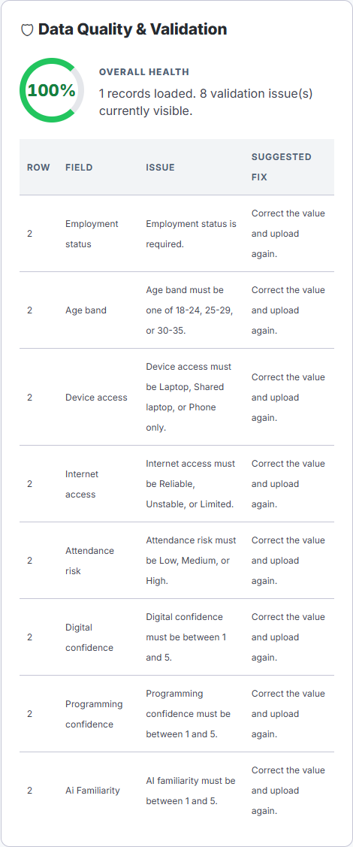
Figure 5: Upload validation evidence showing row-level feedback.

7. Analytics Findings and KPI Dashboard
The dashboard exceeds the minimum visualisation requirement by providing five charts and a richer KPI layer. The analytics are designed for programme staff, not technical users, so labels, colours and helper text focus on operational meaning.
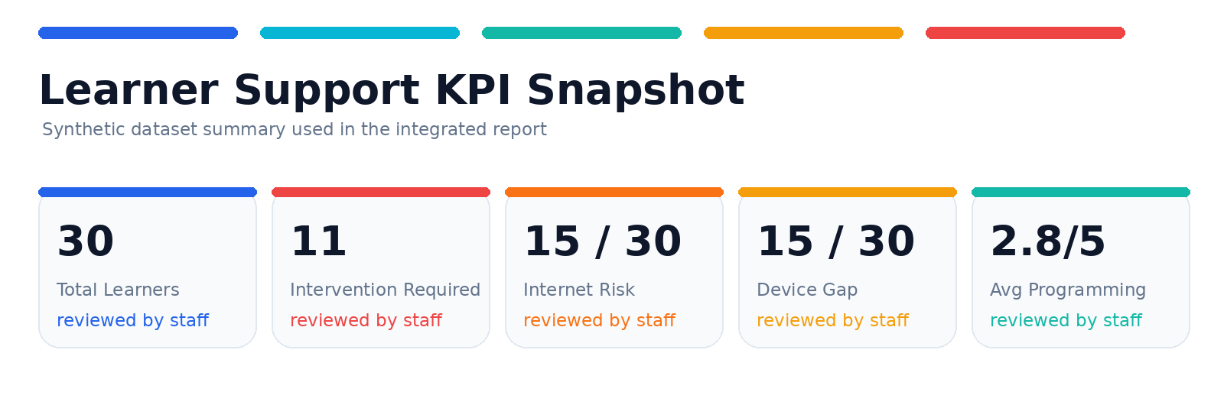
Figure 6: KPI snapshot based on the synthetic learner dataset.

KPI Summary
KPI | Result | Interpretation
Total learners | 30 | Synthetic learner records available for analysis.
Critical risk | 9 | Learners requiring immediate staff review.
High risk | 2 | Learners requiring urgent follow-up.
Medium risk | 4 | Learners needing monitoring and early support.
Low risk | 15 | Learners currently showing lower support risk.
High + critical review group | 11 | Learners requiring priority intervention planning.
Internet risk | 15 learners (50%) | Limited or unstable connectivity affects half the dataset.
Device access gap | 15 learners (50%) | Phone-only or shared laptop access affects half the dataset.
Average digital confidence | 3.2 / 5 | Moderate readiness.
Average programming confidence | 2.8 / 5 | Clear need for coding support.
Average AI familiarity | 2.3 / 5 | Lowest readiness area.
Data quality score | 100% | The synthetic dataset is complete and valid for prototype analysis.

Five Data-Driven Insights
- 11 of 30 learners fall into high or critical review categories, making early support planning a priority.
- 15 learners report limited or unstable internet, which is a major access barrier.
- 15 learners use either a phone only or a shared laptop, showing a significant device access gap.
- Transport and data are the strongest support categories, with 8 transport cases and 8 data cases.
- AI familiarity is the lowest average confidence area at 2.3 out of 5, followed by programming confidence at 2.8 out of 5.

Practical Recommendations
Recommendation | Rationale | Action
Connectivity and device support package | Internet risk and device gaps affect half of the dataset. | Prioritise data vouchers, offline learning packs and device-lending slots.
Targeted attendance support workflow | High and critical learners show combined attendance, access and confidence risk factors. | Assign mentor check-ins, transport follow-up and weekly review meetings.
Confidence-building academic clinics | Programming and AI familiarity are lower than general digital confidence. | Run short practical labs, peer tutoring and beginner-friendly AI/coding sessions.
Resource planning dashboard review | Support needs are concentrated enough to guide planning. | Review KPI dashboard weekly and export summary for programme meetings.

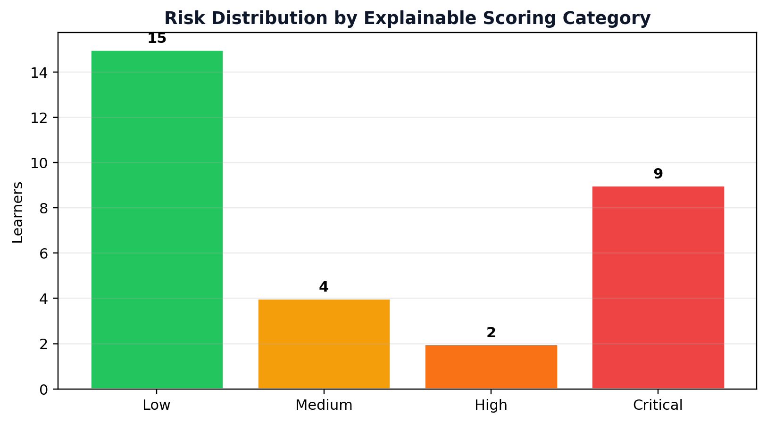
Figure 7: Risk distribution chart.
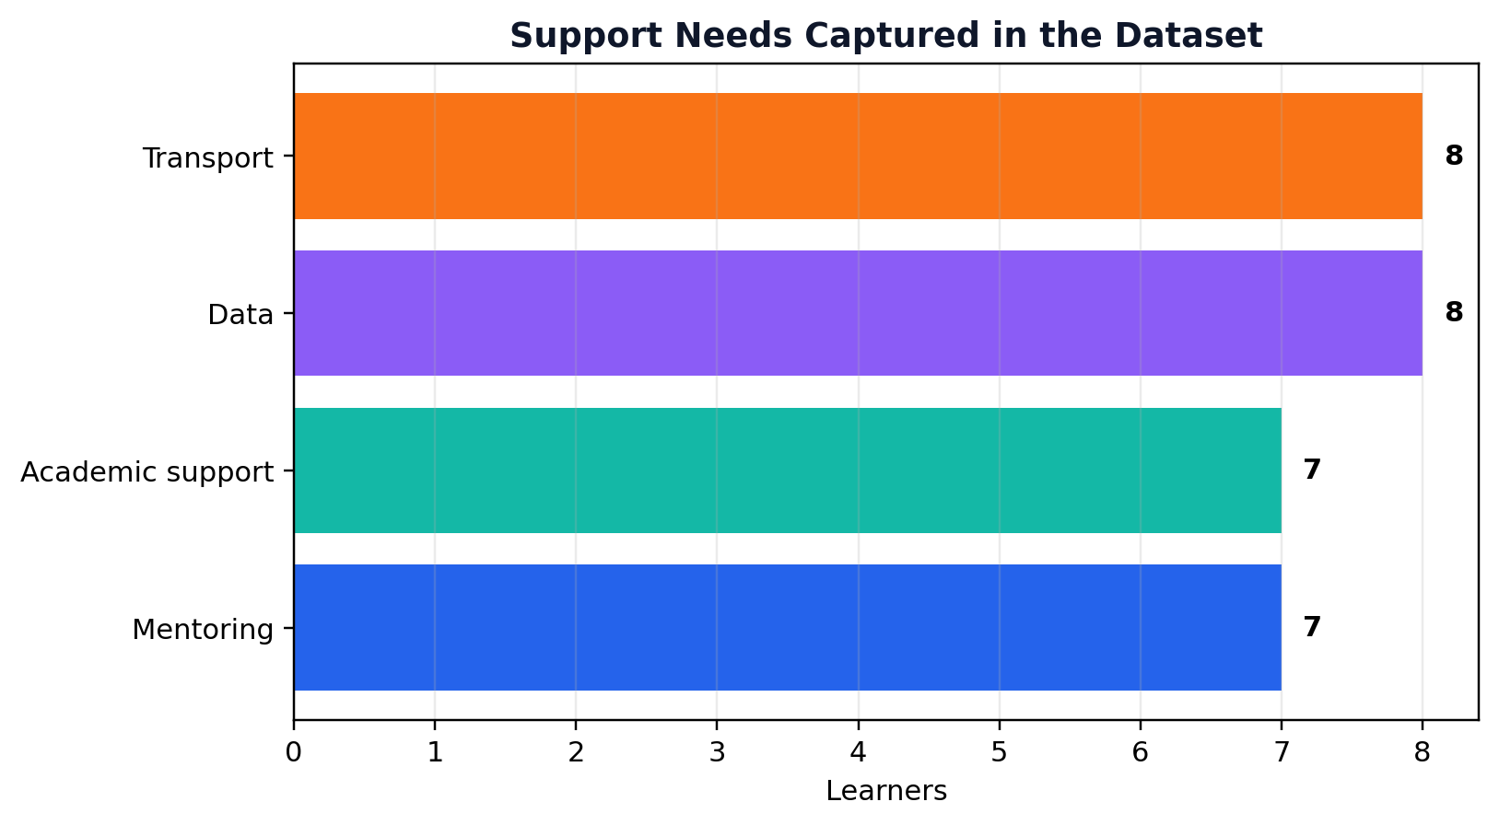
Figure 8: Support needs breakdown.
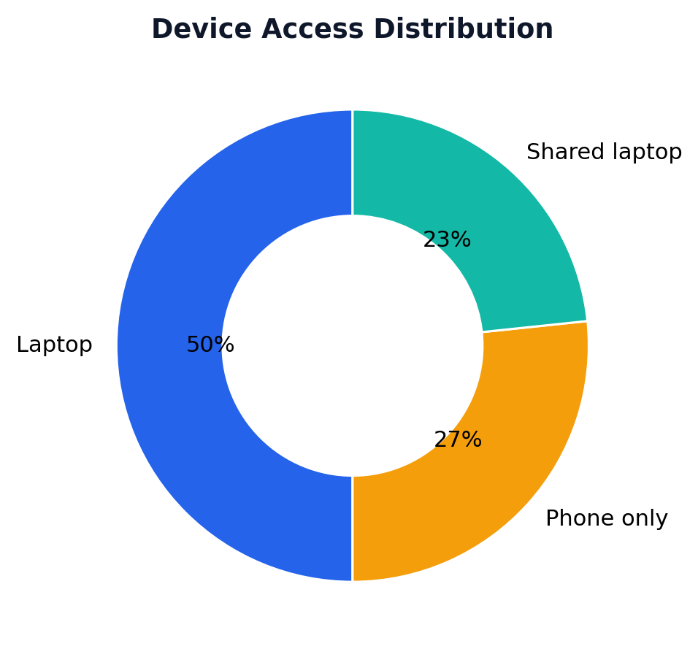
Figure 9: Device access distribution.
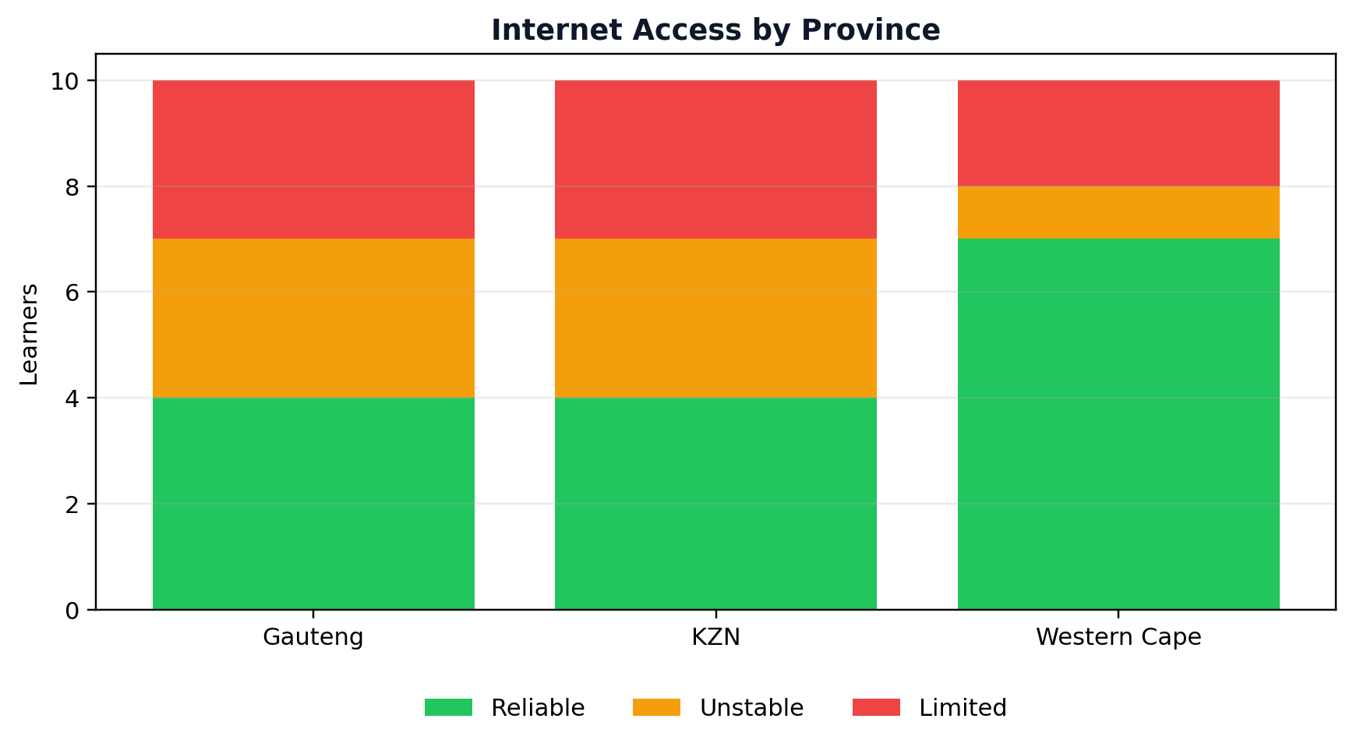
Figure 10: Internet access by province.
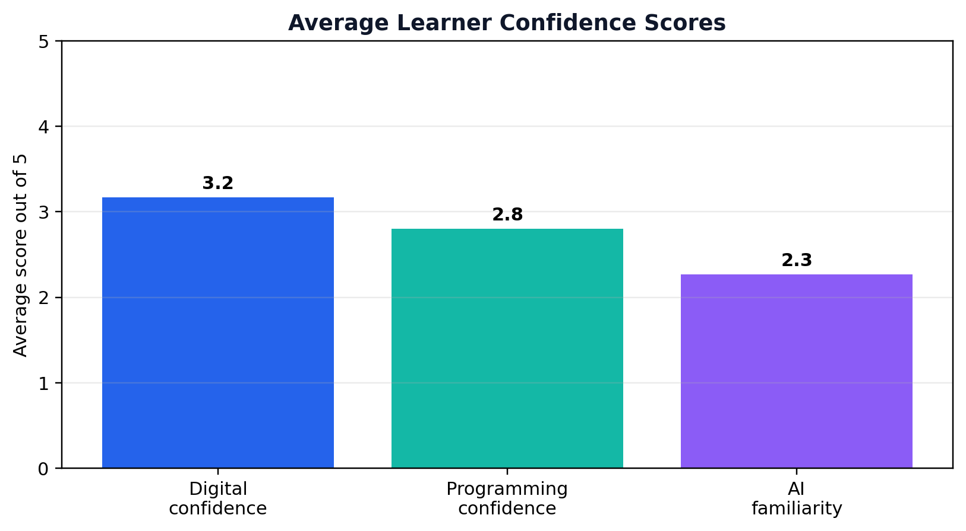
Figure 11: Confidence comparison across digital, programming and AI familiarity.

8. Prototype Description and UX/UI Design
The prototype is a full-stack application using a React + TypeScript frontend and an ASP.NET Core Web API backend. The user interface was designed as an academic intelligence dashboard: clean navigation, strong KPI hierarchy, clear risk badges, chart-first insight layout and a responsible-use layer before sensitive actions.
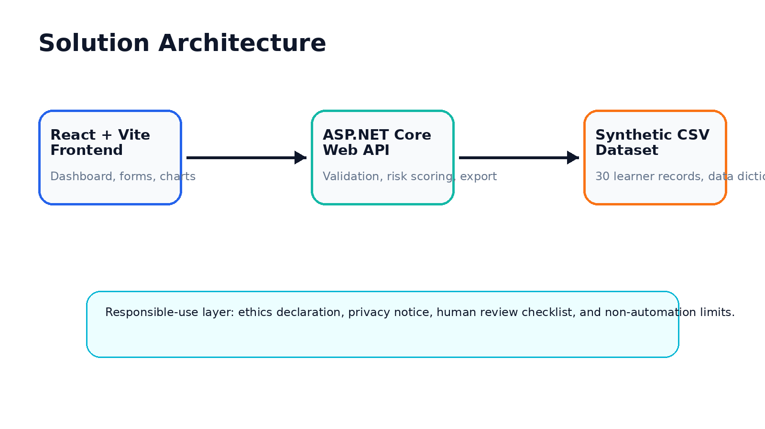
Figure 12: Full-stack solution architecture.
Feature | Implementation evidence | User value
CSV upload | POST /api/learners/upload and upload validation UI. | Fast import of learner survey records.
Manual learner entry | Form with inline validation. | Allows small corrections or direct capture.
Dashboard KPIs | DashboardSummaryDto and frontend KPI cards. | Programme-level decision support.
Five visualisations | Recharts and dashboard aggregates. | Pattern recognition for support planning.
Risk scoring | InsightsService weighted scoring. | Prioritised human review.
Recommendations | Recommendation API and cards. | Practical programme actions.
Ethics declaration | Frontend modal and ethics endpoint. | Reinforces responsible data use.
Export | CSV export endpoint. | Supports reporting and evidence sharing.

UX/UI Design Decisions
- High-level KPI cards appear first because programme staff need a quick operational summary.
- Risk categories use visual priority styling to support fast interpretation.
- Charts are grouped by learner risk, support demand, device access, internet access and confidence trends.
- The risk table exposes reason codes so users can understand why a learner was flagged.
- Ethics and privacy messages are placed inside the workflow rather than hidden in documentation.
- Help and settings views support usability during assessor demonstration.
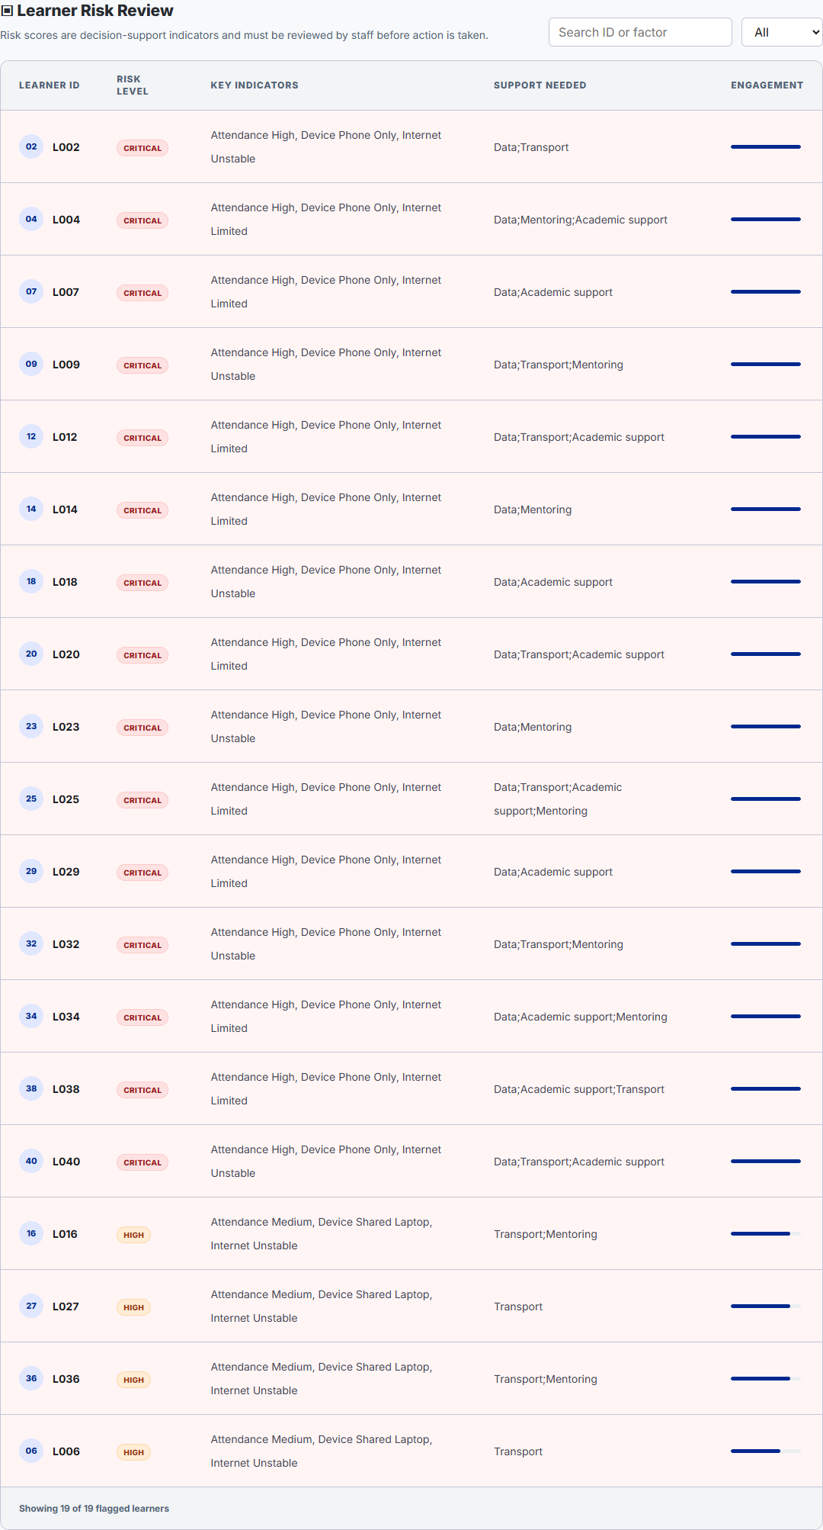
Figure 13: Learner risk review table with score, priority and reason codes.
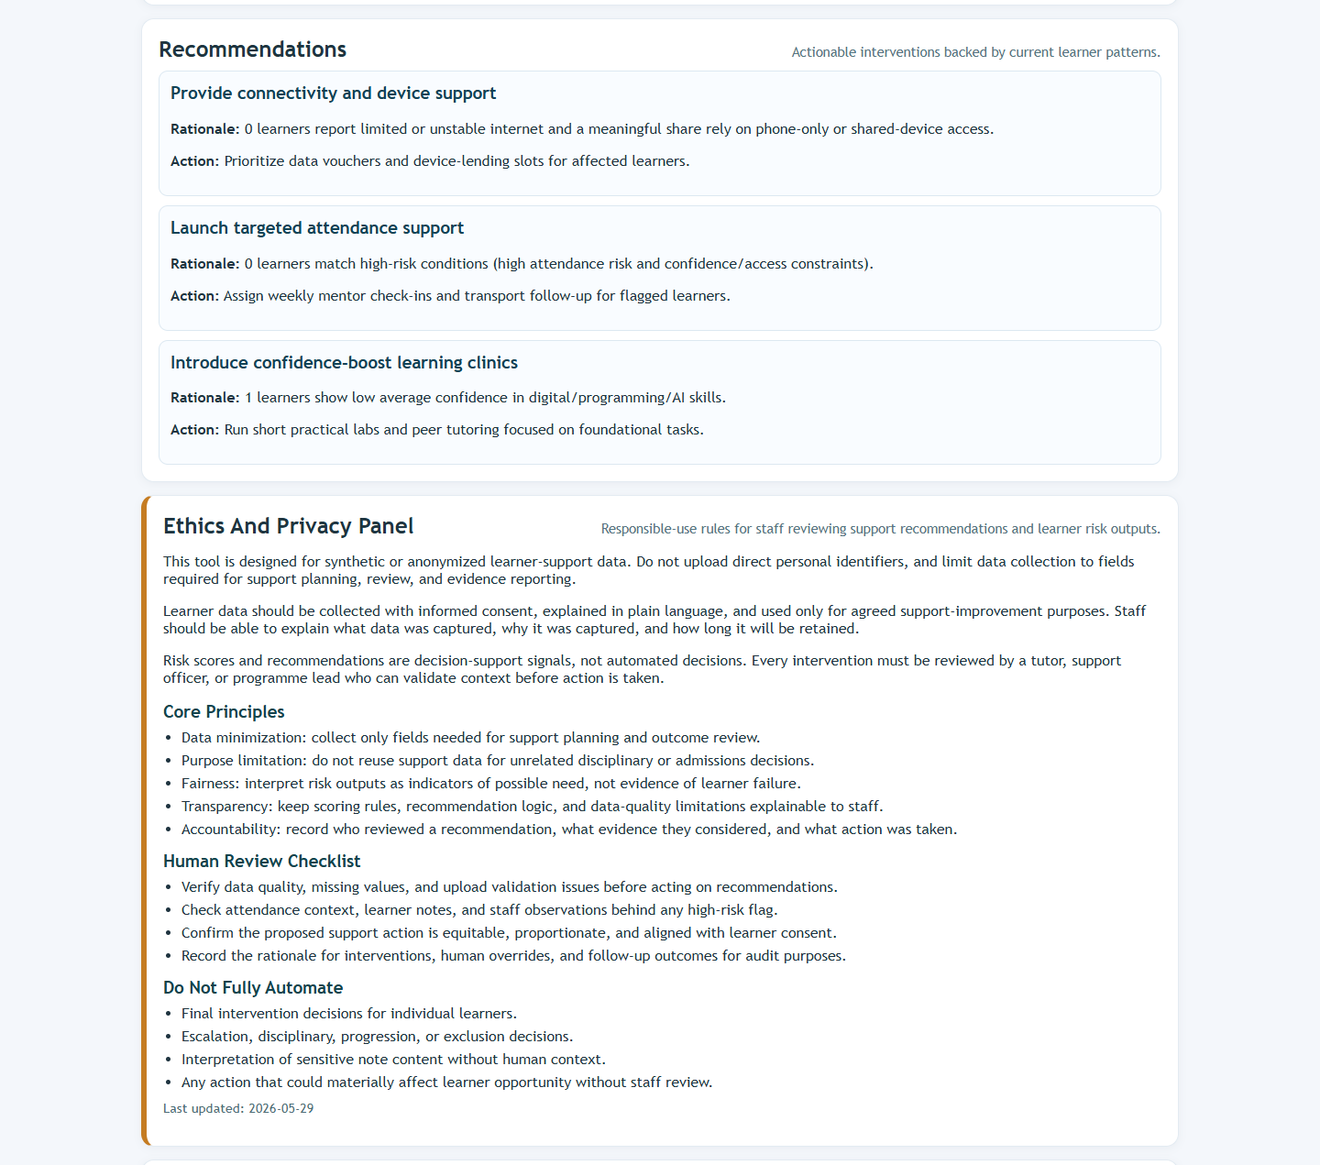
Figure 14: Recommendation and ethics evidence panel.
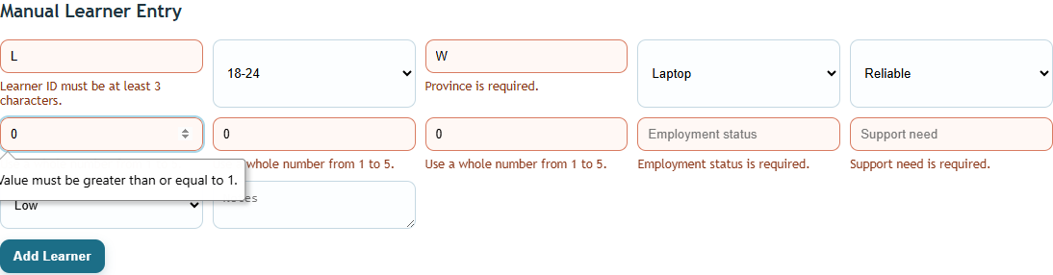
Figure 15: Manual form validation evidence.

9. AI, Data Ethics and Privacy Review
The prototype uses explainable, rule-based decision support. It is AI-enabled in the sense that it interprets support indicators and generates structured recommendations, but it does not make final decisions about learners. This distinction is important because learner support data can influence how staff perceive learners.

Data Sensitivity
The prototype avoids names, identity numbers, phone numbers, home addresses and unnecessary direct identifiers. However, support indicators such as attendance risk, internet access, device access and confidence scores are still sensitive because they can affect learner support decisions.

Responsible-Use Principles
Principle | Application in the prototype
Purpose limitation | Data is used only for learner support planning and programme improvement.
Data minimisation | The dataset avoids direct personal identifiers.
Transparency | Risk reason codes explain why a learner is flagged.
Fairness | Access barriers are treated as resource needs, not learner weakness.
Human review | Staff must review context before acting on flags or recommendations.
Harm prevention | The tool must not be used for exclusion, discipline, funding or progression decisions.
Retention control | Prototype data should be kept only for the assessment period or approved support cycle.
Security | Live deployment would require authentication, access control, audit logging and secure storage.

Human Review Workflow
- Check whether the uploaded learner data is complete and valid.
- Review the learner risk score, support need and reason codes.
- Compare the dashboard signal with facilitator observations and learner context.
- Choose a proportionate support action such as data support, mentoring or academic clinic referral.
- Record the decision and follow-up date for accountability.
- Review whether the support action improved learner participation or confidence.
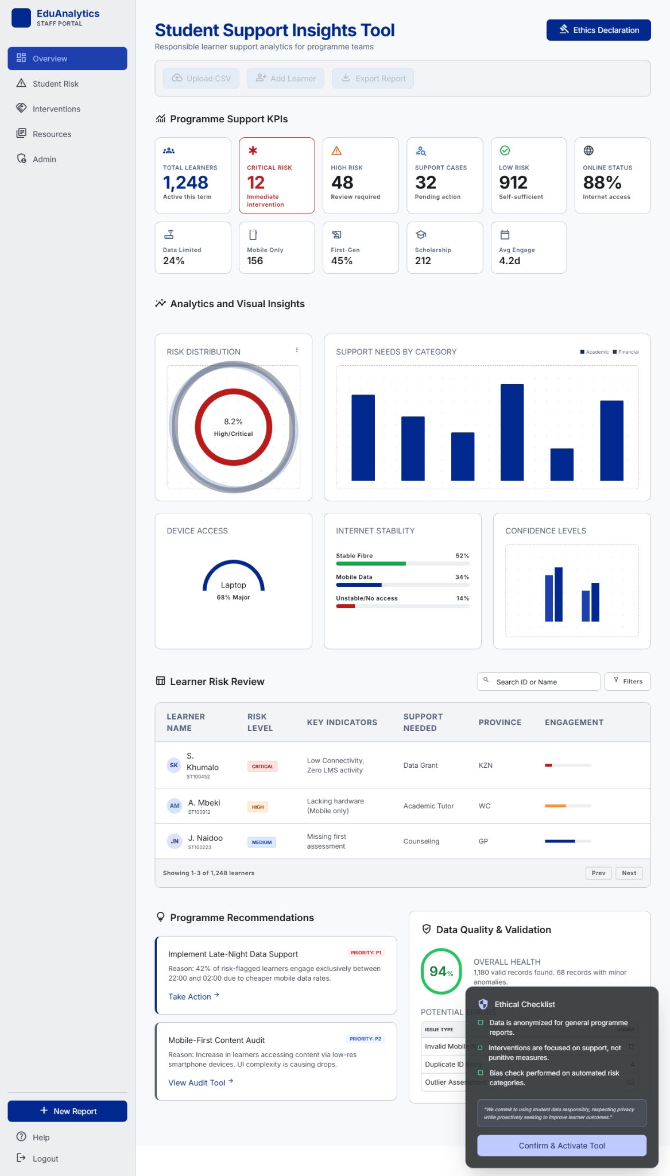
Figure 16: Academic interface reference used to guide the responsible staff-facing design.

10. Methods, Tools and Development Approach
Development followed a staged delivery approach aligned with the assignment plan. The work moved from problem understanding and process modelling into data preparation, prototype build, dashboard development, risk logic, ethics review, testing and evidence packaging.
Area | Tool / method | Purpose
Frontend development | React, TypeScript, Vite | Build a responsive dashboard interface.
Visualisation | Recharts | Render dashboard charts.
Backend development | ASP.NET Core Web API | Provide validation, analytics, risk flags and export endpoints.
Data preparation | CSV dataset and data dictionary | Create safe synthetic learner data.
Version control / workflow | GitHub structure and CI workflow | Support quality gates and reproducible build evidence.
Testing | Manual tests, build tests and API checks | Verify prototype behaviour and evidence readiness.
Documentation | README, user guide, report, evidence folders | Make the submission traceable for assessment.

Development Workflow
- Understand assignment requirements and define a realistic support analytics problem.
- Create a synthetic learner dataset and data dictionary.
- Model the current and improved learner support process.
- Build backend validation, analytics and risk scoring endpoints.
- Develop the frontend dashboard, charts, risk table and forms.
- Add ethics declaration, privacy notice and responsible-use wording.
- Test features, log bugs, improve quality and capture evidence screenshots.
- Prepare the integrated report and map evidence to SFIA skills.

11. Testing, Review and Quality Evidence
Testing evidence covers endpoint availability, dashboard summary contract, transparent risk flags, CSV upload, validation errors, manual learner validation, ethics notice content, frontend type safety, frontend production build and backend release build. Bugs were logged and fixed with evidence of improvement.
Test area | Evidence | Result
Health endpoint | GET /api/health | Passed
Dashboard summary | GET /api/insights/dashboard | Passed
Risk flags | GET /api/insights/risk-flags | Passed
CSV upload happy path | Valid dataset upload | Passed
CSV upload validation | Invalid controlled values and malformed rows | Passed
Manual form validation | Missing or invalid values | Passed
Ethics notice | GET /api/ethics/notice | Passed
Frontend type safety | npm run typecheck | Passed
Frontend production build | npm run build | Passed
Backend release build | dotnet build configuration Release | Passed

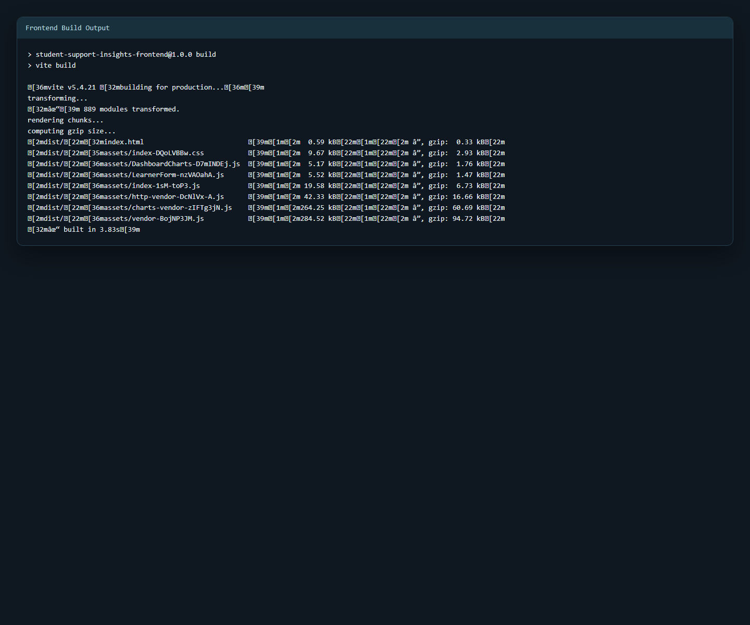
Figure 17: Frontend build evidence.
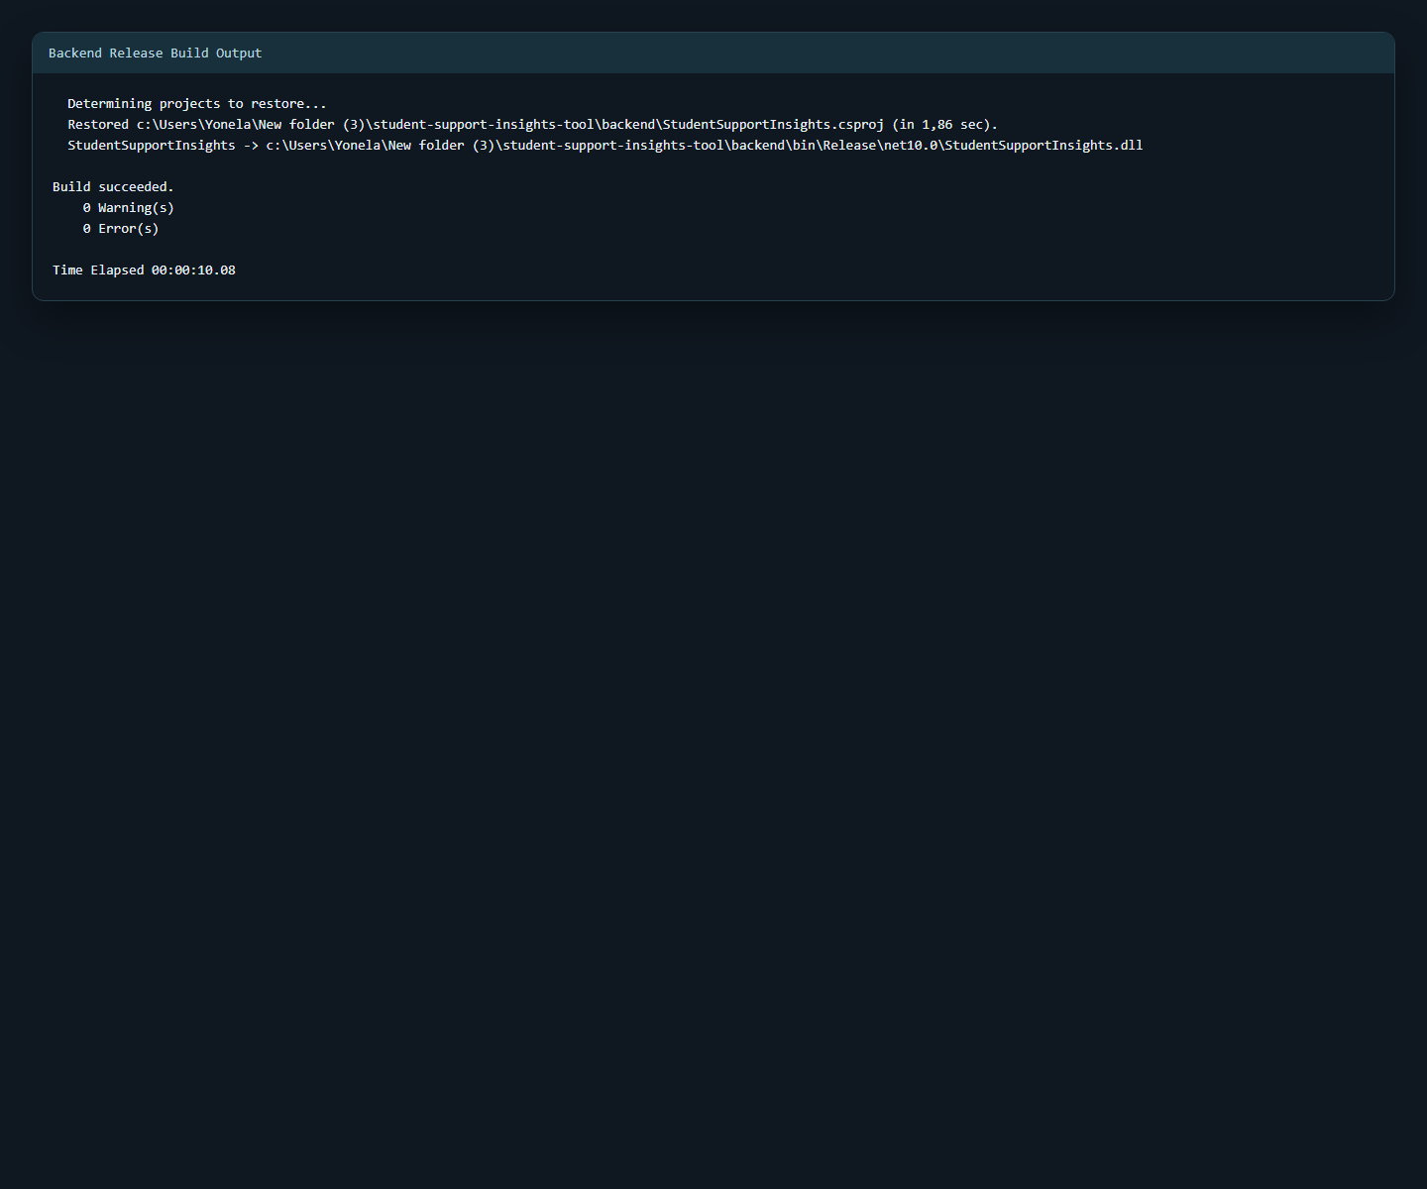
Figure 18: Backend build evidence.

Bug Fix Summary
Bug | Root cause | Fix applied
CSV notes containing commas failed import | Naive comma split broke quoted rows. | Quote-aware CSV parsing and column-count validation.
Risk output was difficult to justify | Risk flags had weak explanation metadata. | Weighted scoring, priority categories and reason codes.
Upload errors lacked field context | Errors were returned as flat strings. | Structured validation errors with line numbers and fields.
Dashboard contract was too limited | Older DTO supported fewer metrics. | Expanded dashboard DTO and richer KPI/charts.

Peer / Stakeholder Review
A review record is included to show that the value model, improved process, dashboard concept and risk/recommendation approach were reviewed. The key review outcome was to strengthen human-review wording and ensure the tool clearly presents risk scores as support signals rather than final decisions.

12. Hosting and Deployment Readiness
The project is prepared for cloud demonstration hosting. A split hosting model is recommended because the frontend is a static React application and the backend is an ASP.NET Core API. The project can be deployed using Azure Static Web Apps and Azure App Service, or using Netlify for the frontend and Railway for the backend.
Hosting option | Frontend | Backend | Best use
Azure option | Azure Static Web Apps | Azure App Service | Best for Microsoft cloud-aligned portfolio evidence.
Alternative option | Netlify | Railway | Fast demonstration hosting with simple GitHub-connected deployment.

Azure Hosting Plan
- Deploy the React/Vite frontend to Azure Static Web Apps.
- Deploy the ASP.NET Core backend to Azure App Service.
- Set VITE_API_BASE_URL to the hosted backend API URL.
- Restrict CORS to the hosted frontend origin.
- Use App Service settings for environment values and API keys.
- Capture hosted dashboard, health check, build and deployment screenshots as evidence.

Hosted Prototype Security Notice
The hosted version should be used with synthetic demonstration data only. If real learner data is ever used, the application must add authentication, role-based access control, protected learner/risk endpoints, audit logging, encrypted storage, retention rules and formal privacy governance.
Endpoint group | Demo status | Production requirement
Health and ethics endpoints | Can remain public. | Monitor availability and keep ethics notice accessible.
Learner, dashboard, risk and export endpoints | Acceptable for synthetic demo only. | Protect with authentication and role-based permissions.
Upload and manual entry endpoints | Should be gated by ethics declaration and API controls. | Require authenticated staff access and audit logging.

13. Reflection and Future Improvements
This project showed that a dashboard is only useful when the data, process and ethical controls around it are strong. The most important design decision was to make the risk model explainable. Instead of hiding the logic, the tool shows scores and reason codes so staff can review the context before taking action.
A key challenge was balancing prototype functionality with assessment evidence. The final submission therefore focuses on traceability: every major assignment requirement links to a section, file or screenshot in the evidence pack. This makes the project easier to assess and easier to improve.

Future Improvements
- Add secure user authentication and role-based access for real deployments.
- Add persistent storage with a controlled retention policy.
- Add intervention tracking so staff can record actions and outcomes.
- Calibrate the scoring model with anonymised historical programme data.
- Add accessibility testing and keyboard navigation evidence.
- Add automated backend unit tests and frontend component tests.
- Add a PDF summary export for management reporting.

14. Evidence Inventory Mapped to SFIA Skills
The evidence inventory shows how the project meets each SFIA capability area in the integrated assignment. This prevents the report from reading as separate tasks and gives the assessor a clear map between skill requirements and project evidence.
SFIA skill | Evidence in project | What it demonstrates
AIDE - AI and Data Ethics | Ethics review, governance checklist, ethics endpoint, privacy panel and human review wording. | Responsible data use, consent, fairness, harm prevention and non-automation boundaries.
BSMO - Business Modelling | Value model, stakeholder needs analysis and review evidence. | Business value, stakeholder alignment and decision-support outcomes.
BPRE - Business Process Improvement | As-is and to-be process models plus workflow explanation. | Process analysis, improvement opportunities and tool placement.
PROG - Programming / Software Development | Frontend, backend, validation, risk scoring, export and API endpoints. | Working prototype and implemented features.
DAAN - Data Analytics | Synthetic dataset, data dictionary, dashboard KPIs, charts, insights and recommendations. | Data preparation, analysis, visualisation and practical recommendations.
METL - Methods and Tools | README, user guide, workflow, CI, test log, bug log and evidence folder. | Structured development method, tool use and quality evidence.

15. Final Submission Checklist
Item | Status | Evidence note
Working prototype | Complete | React frontend + ASP.NET Core backend.
Integrated report | Complete | DOCX/PDF final report.
Synthetic dataset | Complete | 30 learner records.
Data dictionary | Complete | Field definitions and values.
Three or more visualisations | Complete | Five visualisations included.
Five or more insights | Complete | Five key insights in analytics section.
Three or more recommendations | Complete | Connectivity/device, attendance support, clinics and resource review.
As-is and to-be process diagrams | Complete | Included and explained.
Business/value model | Complete | Value model and stakeholder mapping.
AI/data ethics review | Complete | Ethics review, privacy notice and governance checklist.
Testing and bug log | Complete | Test log and bug log included.
README/user guide | Complete | Run commands and user flow documented.
SFIA evidence mapping | Complete | Skill-to-evidence mapping included.
Screenshot evidence | Complete | Dashboard, validation, risk, ethics and build screenshots.

Appendices

Appendix A: Screenshot Evidence
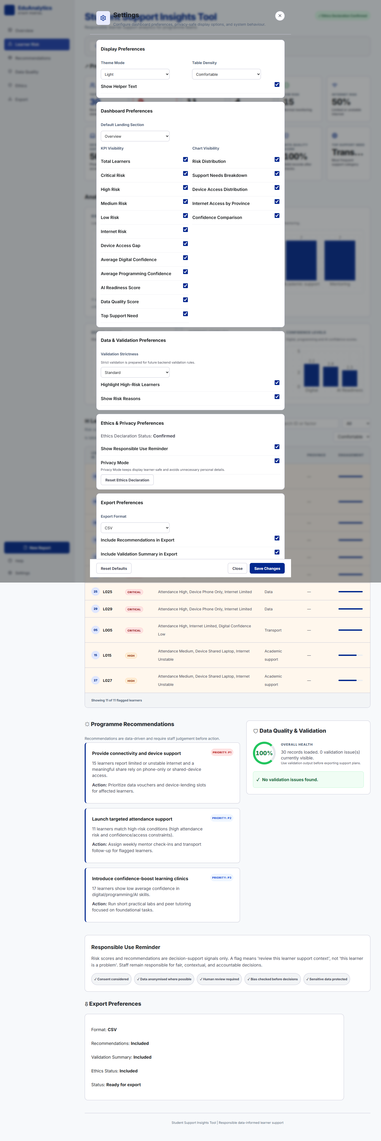
Appendix Figure A1: Settings view evidence.
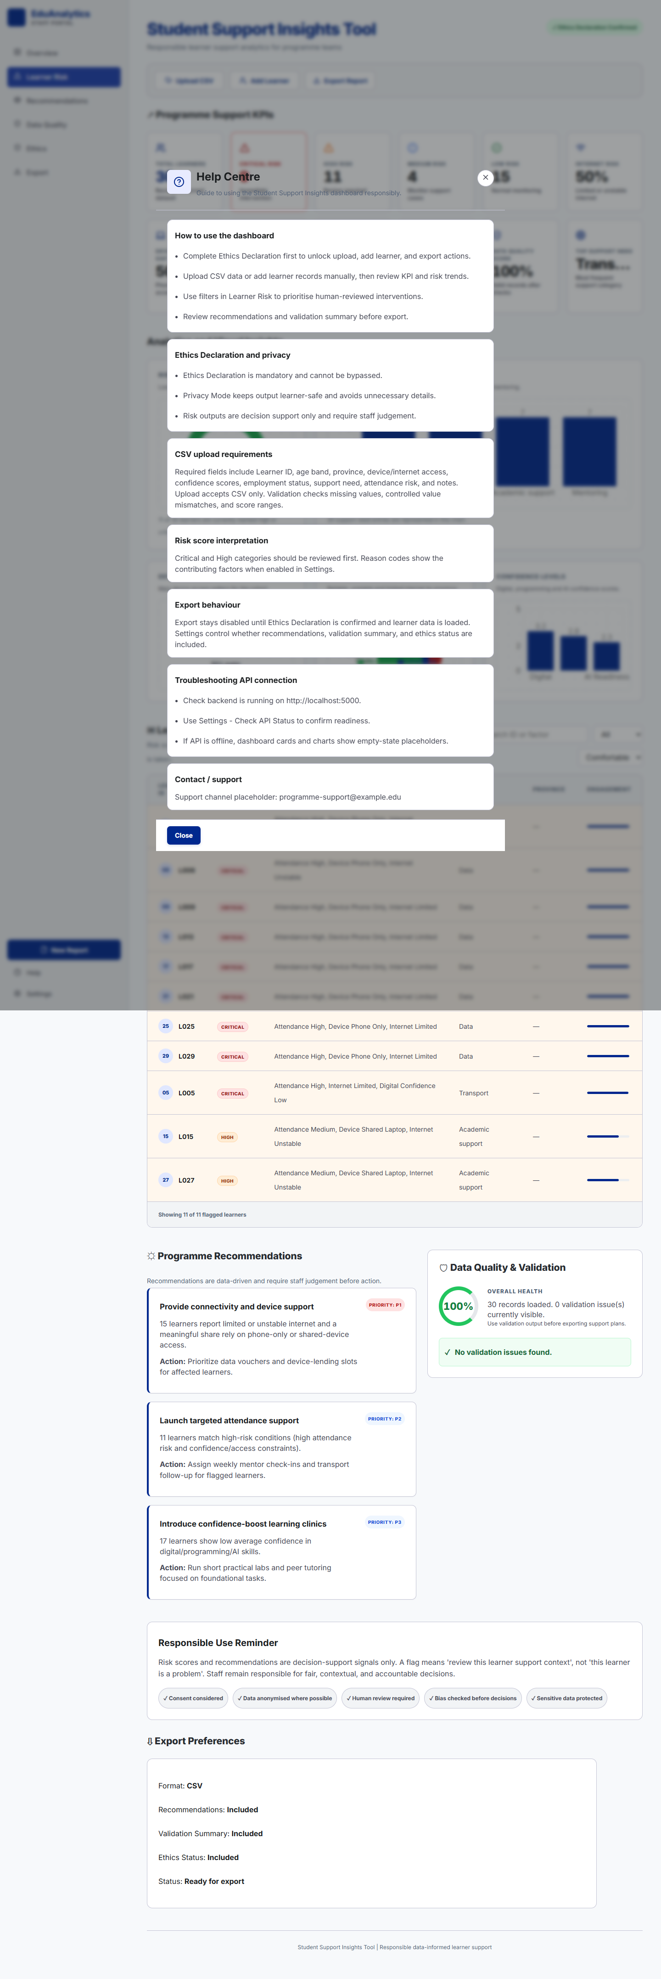
Appendix Figure A2: Help view evidence.

Appendix B: Risk Review Extract
Learner ID | Province | Attendance | Support need | Score | Priority
L002 | Gauteng | High | Data | 100 | Critical
L006 | KZN | High | Data | 100 | Critical
L009 | KZN | High | Data | 100 | Critical
L013 | Western Cape | High | Data | 100 | Critical
L017 | Gauteng | High | Data | 100 | Critical
L021 | KZN | High | Data | 100 | Critical
L025 | Western Cape | High | Data | 100 | Critical
L029 | Gauteng | High | Data | 100 | Critical
L005 | Gauteng | High | Transport | 98 | Critical
L015 | KZN | Medium | Academic support | 75 | High

Appendix C: Improvement Backlog for Future Development
Improvement | Reason | Priority
Secure authentication and role-based access | Required before using real learner data. | High
Protect learner and risk read endpoints | Prevents public exposure of support indicators. | High
Persist intervention follow-up actions | Allows staff to track support outcomes. | Medium
Calibrate risk scoring with approved anonymised data | Improves reliability beyond synthetic data. | Medium
Automated regression tests | Strengthens engineering evidence. | Medium
PDF export of management summary | Improves reporting usefulness. | Low

