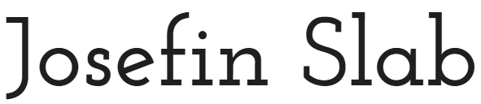



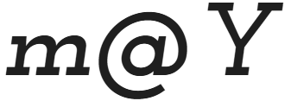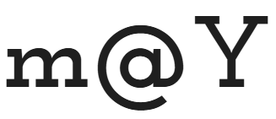

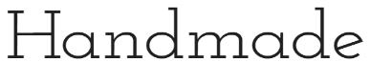





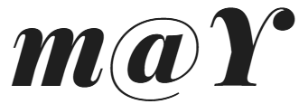

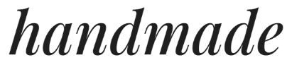

**Y**

**m**

Handmade

Leather

**@**

***Y***

***m***

***@***

Leather

**@**

Handmade

**m**

Handmade

Handmade

Handmade

Handmade

**Y**

**m@**

**Y**

**m@**

**Y**

**m@**

**Y**

Handmade

Handmade

Handmade

Craft

Atelier

Leather