Joint Portal Dynamics on an RNA Neutral Network Improve Prediction of Competing Adaptive Fixations
Ryutaro Yonezu
Independent researcher
Preprint v1.1 - 25 August 2026
Status: preprint; not peer reviewed

Abstract
Models of mutation-limited adaptation can fail when access to competing adaptive phenotypes is structured on the same neutral genotype network. Martin et al. (2024) showed that phenotype arrivals can be bursty and developed a burst-aware approximation for competing peaks, while explicitly identifying dependence between multiple phenotype-introduction processes as a remaining problem. Here we represent neutral motion and all successful adaptive exits as one state-resolved killed continuous-time Markov process. The mathematics is standard; the contribution tested is the joint application to competing phenotype portals on a shared RNA neutral network. In the published focal two-peak RNA system, our ViennaRNA 2.7.2 reconstruction contains 1,937 resident genotypes and 13,355 neutral edges, with 517 portal edges to the frequent adaptive phenotype p1 and 16 to the rarer phenotype p2, and zero portal-genotype overlap. Under N=500, per-site mutation rate 2 x 10^-5, s1=0.005, and six s2 values, we compared three analytic predictions with a direct count-level Wright-Fisher re-execution of 1,000 replicates per condition. Mean absolute error (MAE) was 0.2220 for the simple average-rate independent model, 0.0349 for the Martin et al. burst-aware independent model, and 0.01256 for the joint killed-Markov model. Thus the joint model reduced MAE by 64.0% relative to the stronger burst-aware independent baseline and by 94.3% relative to the average-rate baseline. It was closer than the burst-aware model in 5/6 conditions and closer than the average-rate model in 6/6. The result supports a narrow conclusion: when competing adaptive opportunities are exposed along the same structured neutral trajectory, retaining shared state information can materially improve prediction of the p2-first outcome, benchmarked here by a threshold-based Wright-Fisher takeover proxy, beyond models that combine phenotype-specific marginal statistics independently.
Keywords: genotype-phenotype map; neutral network; portal genotype; Wright-Fisher; killed Markov process; first passage; arrival bias; RNA secondary structure

Plain-language summary
A highly beneficial evolutionary outcome can still be hard to reach if the mutations leading to it are available only from a small and spatially restricted part of genotype space. In the RNA landscape studied here, one adaptive phenotype had 517 one-mutation exits from the resident neutral network, whereas the rarer phenotype had only 16. A simple average-rate model therefore badly overestimated how often strong selection would make the rare phenotype win. A previous burst-aware model improved this substantially but still treats competing phenotype-specific fixation processes independently. Tracking both sets of exits on the same neutral network improved prediction further. In simple terms: evolution depends not only on how attractive a destination is, but also on where the doors are along the path the population is actually walking.

1. Introduction
Evolutionary outcomes depend on both selection among variants and the process by which variants become available. Origin-fixation models formalize this by combining mutation or introduction rates with fixation probabilities [1]. Genotype-phenotype (GP) maps add an important complication: many genotypes can share one phenotype, and neutral movement changes which alternative phenotypes are one mutation away. This can bias evolutionary outcomes toward phenotypes that are easier to encounter [2].
Martin et al. (2024) showed that novel phenotypes can arrive in non-Poissonian bursts when access is restricted to portal genotypes, defined as resident-network genotypes with the target phenotype in their mutational neighborhood [3]. They showed that portal discovery can become rate-limiting and can reduce the influence of fitness differences. They also developed a burst-aware two- and multi-peak approximation based on phenotype-specific fixation-time distributions. Crucially, the multi-phenotype calculation assumes independence between competing introduction/fixation processes; the authors explicitly note that this assumption can fail when access to multiple phenotypes is structured on the same neutral component and identify joint analytical and computational treatment as future work [3].
This open point sits within a much older mathematical and evolutionary framework. Weak-mutation evolution can be represented as a Markov chain on genotypes, and first-passage or waiting-time quantities have been used to describe genotype findability and long-term evolution on arbitrary fitness landscapes [4,5]. Neutral-network topology [6], non-neutral genetic correlations in GP maps [7], and community structure in RNA neutral components [8] are also established. We therefore do not claim a new Markov method or a first demonstration that genotype-space structure constrains adaptation.
Partitioned absorbing-state calculations on genotype landscapes are also established. Rozhoňová et al. (2024) replaced mutations entering a target genotype set by absorbing states, partitioned those states into B1 and B2, and calculated the probability of entering the target set through a specified transition class [9].
The narrower question is whether competing adaptive portal sets should be treated as one state-resolved stochastic process when they are exposed along the same neutral trajectory. We test that question in the focal two-peak RNA system used by Martin et al. and compare a joint killed-Markov predictor with both the simple average-rate model and the stronger published burst-aware independent approximation. The comparison is benchmarked against a direct 1,000-replicate-per-condition Wright-Fisher re-execution under the published population-genetic regime.

2. Model

2.1 Neutral motion and adaptive portals
Let G0 be the neutral component associated with resident phenotype p0. Let Q be the continuous-time generator with equal rate on each available neutral point-mutation edge. For adaptive phenotype pi, let ni(g) be the number of one-mutant edges from resident genotype g to pi. Under the weak-mutation, monomorphic approximation, the successful adaptive exit intensity in neutral-edge time units is
kappa_i(g) = n_i(g) N P_fix(s_i) | (1)
where P_fix(si) = [1 - exp(-2 si)] / [1 - exp(-2 N si)], matching the fixation expression used in the focal published analysis. A common per-edge point-mutation factor multiplies neutral and adaptive transition rates and therefore cancels from competing-exit probabilities after rescaling time.

2.2 Simple average-rate independent model
A simple average-rate treatment replaces genotype-dependent hazards by their neutral-network averages r1 and r2. The p2-first probability is
P_avg(p2 first) = r2 / (r1 + r2) | (2)
This is useful as a transparent baseline but does not account for bursty portal discovery.

2.3 Martin et al. burst-aware independent model
Martin et al. derive phenotype-specific expected fixation times that incorporate portal-limited bursts and a polymorphic correction [3]. We recomputed those fixation times using their public formula and parameters. Their two-peak competition approximation combines the two marginal fixation-time processes independently:
P_burst(p2 first) = 1 / [1 + t2_fix / t1_fix] | (3)
This is the stronger prior analytic comparator for the open dependence question; it already captures much of the portal-limited burst effect and is therefore the primary baseline for assessing the added value of the joint model.

2.4 Joint killed-Markov formulation
Instead of calculating phenotype-specific processes separately, define one killed generator that preserves the resident genotype as shared state:
K = Q - diag(kappa_1 + kappa_2) | (4)
For initial distribution alpha over resident genotypes, standard killed/absorbing Markov theory gives
P_joint(pi first) = alpha^T (-K)^(-1) kappa_i | (5)
E[T_first] = alpha^T (-K)^(-1) 1 | (6)
Equations (4)-(6) are standard [10]. The only modeling change is that exposure to both adaptive phenotypes is conditioned on the same current neutral genotype. Importantly, the focal p1 and p2 portal-genotype sets do not overlap; dependence here arises from a shared neutral trajectory, not from positive portal overlap.

3. Materials and methods

3.1 RNA genotype-phenotype reconstruction
The focal two-peak setting follows Martin et al. [3]. The start sequence was ACCUAAAAAAGG. The resident phenotype p0 was integer 19529749 with dot-bracket structure .(((.....))); p1 was 27262981, ((........)); and p2 was 27918661, ((((...)).)). Folding used ViennaRNA 2.7.2 with RNA.cvar.uniq_ML = 1 and the same near-degenerate-MFE handling reproduced from the public helper code. Martin et al. used ViennaRNA 2.4.14 [3,11]. As a fail-closed compatibility check, the start sequence had to reproduce the published p0 encoding; it did so exactly.
Breadth-first traversal of phenotype-preserving one-mutant neighbors produced one resident neutral component of 1,937 genotypes and 13,355 neutral edges, with mean neutral degree 13.789. All one-mutant neighbors were folded to identify adaptive portal edges. The corresponding resident robustness was rho = 13.789 / 36 = 0.38304.

3.2 Portal statistics
Phenotype p1 was accessible through 517 portal edges and p2 through 16. Portal-genotype overlap was zero. Dividing by 1,937 x 36 possible point substitutions gives mean one-step phenotype probabilities phi1 = 7.414 x 10^-3 and phi2 = 2.294 x 10^-4, closely matching the focal frequencies reported by Martin et al. [3].

3.3 Analytic predictions
All analytic comparisons used N = 500, s1 = 0.005, and s2 in {0.01, 0.02, 0.04, 0.08, 0.16, 0.32}. For the joint model, alpha was uniform over resident genotypes. Because Q uses symmetric equal rates on undirected neutral edges, the uniform distribution is stationary for the corresponding monomorphic substitution process. The simple average-rate prediction used Equation (2). The Martin burst-aware prediction used the published portal-burst fixation-time expression with N = 500, per-site mutation rate u = 2 x 10^-5, sequence length 12, alphabet size 4, rho = 0.38304, phi1, phi2, and the polymorphic correction enabled. The joint probabilities were obtained by sparse linear solves of Equation (5). No parameters were fitted to the Wright-Fisher outcomes.

3.4 Direct Wright-Fisher re-execution
A direct haploid Wright-Fisher re-execution was implemented at genotype-count level under the published regime: N = 500, L = 12, per-site mutation rate u = 2 x 10^-5, s1 = 0.005, and the six s2 values above. Each replicate began from a uniformly sampled resident genotype and was relaxed for 10N = 5,000 generations under resident fitness. Parent sampling was fitness-weighted and multinomial; mutation was applied independently per site. The probability of two or more substitutions in a single offspring was 2.64 x 10^-8 and was retained rather than discarded. The adaptive run ended when p0 fell below 25% of the population, at which point the dominant adaptive phenotype was recorded. One thousand replicates were run per condition with seed 20260823.
Relaxed resident states were reused across s2 values as a common-random-numbers variance-reduction device. This induces cross-condition dependence but leaves each condition's marginal distribution unchanged. The re-execution is a count-level implementation matched to the published update regime, not a byte-for-byte rerun of the authors' software. A final source-code audit confirmed the burn-in transition: in the published implementation, non-p0 mutants produced in the last resident-relaxation generation retain zero fitness and therefore have zero parent weight in the first adaptive generation. The count-level runner removes those zero-weight individuals immediately before that parent draw, which is distribution-equivalent for the ensuing generation.

3.5 Evaluation
For each condition, the empirical outcome was the fraction of 1,000 replicates assigned to p2 when the resident phenotype p0 first fell below 25% of the population. We use this threshold-based takeover outcome as a computational proxy for which adaptive phenotype fixes first. Binomial 95% Wilson intervals are reported. Predictive accuracy is summarized descriptively by mean absolute error (MAE) across the six fixed conditions. Because conditions share pre-relaxed states and there are only six designed parameter settings, no independent-sample significance test is claimed.

4. Results

4.1 State-resolved joint dynamics remain portal-limited as p2 selection increases
The 517-versus-16 portal-edge asymmetry creates a 32.3-fold difference in mean one-step access. Increasing s2 strongly increases the fixation probability of a p2 mutant after it appears, but does not increase the number or location of p2 portals encountered during neutral exploration. Consequently, the average-rate model rises from 0.05765 to 0.59355 across the six conditions, whereas the joint model remains between 0.03970 and 0.05941. The Martin burst-aware independent model partially captures this limitation, rising from 0.04723 to 0.15968.
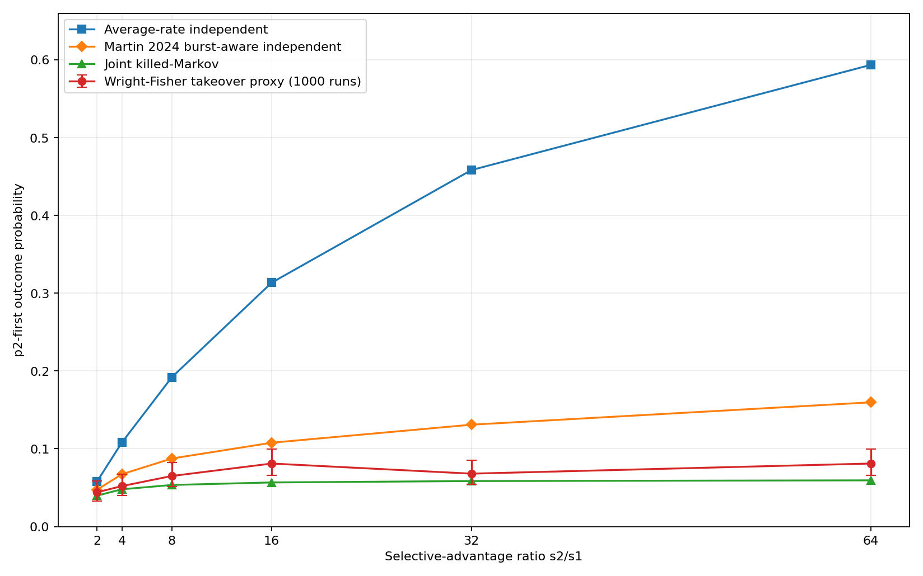
Figure 1. Competing p2-first probabilities. Wright-Fisher points show the threshold-based takeover proxy from 1,000 replicates with 95% Wilson intervals. The simple average-rate independent model increasingly overpredicts p2. The Martin et al. burst-aware independent model captures much of the portal limitation, while the joint killed-Markov model retains the lowest aggregate error.

4.2 Joint dynamics improve on the stronger published burst-aware comparator
Against the direct Wright-Fisher outcomes, MAE was 0.22200 for the average-rate model, 0.03489 for the Martin burst-aware independent model, and 0.01256 for the joint killed-Markov model. Relative to the burst-aware comparator, the joint model reduced MAE by 64.0% (2.78-fold) and was closer in 5/6 conditions; relative to the average-rate model, it reduced MAE by 94.3% (17.7-fold) and was closer in 6/6. Four of six joint predictions fell inside the corresponding 95% Wilson intervals, versus two burst-aware and one average-rate prediction.
s2/s1 | WF | 95% CI | Avg-rate | Burst-aware | Joint | |e| avg | |e| burst | |e| joint | Joint vs burst
2 | 0.044 | [0.033, 0.059] | 0.05765 | 0.04723 | 0.03970 | 0.01365 | 0.00323 | 0.00430 | Burst
4 | 0.052 | [0.040, 0.068] | 0.10805 | 0.06727 | 0.04790 | 0.05605 | 0.01527 | 0.00410 | Joint
8 | 0.065 | [0.051, 0.082] | 0.19193 | 0.08746 | 0.05343 | 0.12693 | 0.02246 | 0.01157 | Joint
16 | 0.081 | [0.066, 0.100] | 0.31355 | 0.10775 | 0.05670 | 0.23255 | 0.02675 | 0.02430 | Joint
32 | 0.068 | [0.054, 0.085] | 0.45829 | 0.13094 | 0.05849 | 0.39029 | 0.06294 | 0.00951 | Joint
64 | 0.081 | [0.066, 0.100] | 0.59355 | 0.15968 | 0.05941 | 0.51255 | 0.07868 | 0.02159 | Joint
Table 1. Threshold-based Wright-Fisher takeover outcome and three analytic predictions. “Burst-aware” is the Martin et al. independent two-peak approximation recomputed from the public formula; errors are absolute deviations from the Wright-Fisher fraction.
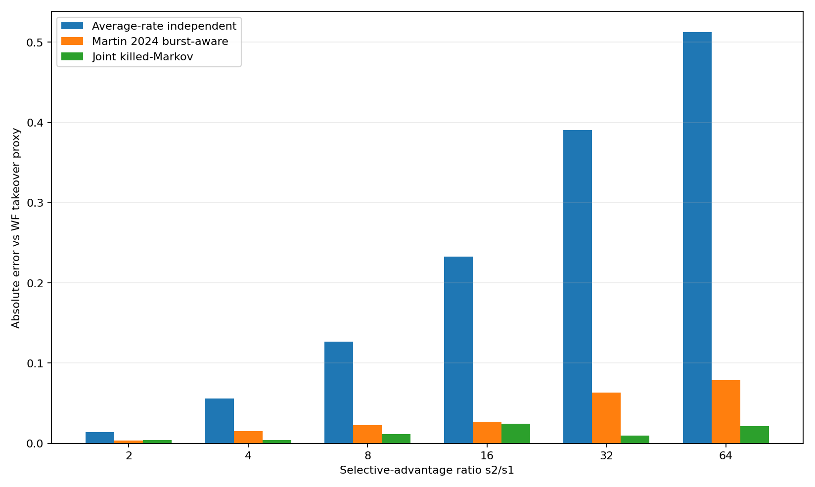
Figure 2. Absolute prediction error by selection ratio. The joint model is not best at s2/s1 = 2, but it is closer than the burst-aware independent model in the other five conditions.

4.3 High selection does not erase access constraints
At s2/s1 = 64, the average-rate model predicts P(p2 first) = 0.59355. The Martin burst-aware independent model predicts 0.15968. The threshold-based Wright-Fisher takeover proxy is 0.081 (95% CI 0.06565-0.09956), while the joint model predicts 0.05941. Thus the published burst correction removes most of the average-rate failure, but a remaining dependence error persists when phenotype-specific outcomes are combined independently. The joint model removes much of that residual by conditioning both adaptive channels on the same neutral genotype state.

5. Discussion

5.1 What is added beyond burst-aware independent modeling
The key comparison is not between the joint model and a naive Poisson model alone. Martin et al. already showed that portal-limited bursts matter and provided a substantially better burst-aware fixation-time approximation. Recomputing that model reduced MAE from 0.22200 to 0.03489 in our benchmark. The present joint formulation reduces the remaining MAE to 0.01256 by retaining which resident genotype is currently occupied while evaluating both adaptive exits. This supports the specific hypothesis that shared-state dependence matters after marginal burst statistics have already been modeled.
The focal portal sets have zero genotype overlap, so the result should not be described as arising from positive overlap between p1 and p2 portals. Instead, the dependence is path-mediated: the same neutral trajectory determines when the population visits regions exposing p1 and regions exposing p2. A phenotype-level factorization loses this ordering and occupancy information.

5.2 Relation to prior work and novelty boundary
The broad foundations are established. First-passage and waiting-time concepts have been applied to genotype findability [4], and Markov-chain methods provide a general weak-mutation framework for long-term evolution on complex fitness landscapes [5]. Neutral-network topology affects evolutionary dynamics [6]. Non-neutral genetic correlations make phenotype access locally heterogeneous [7], and RNA neutral components have hierarchical community structure [8]. Rozhoňová et al. used a genotype-level absorbing Markov construction in which transitions entering a target genotype set were represented by absorbing states partitioned into B1 and B2, allowing the probability of entry through a specified transition class to be calculated [9]. Schaper and Louis established arrival-of-the-frequent effects [2], and related work showed that arrival bias can dominate natural selection in a biomorph GP map [12], while Martin et al. established portal-limited non-Poissonian bursts and their effect on adaptive competition [3]. Standard killed/absorbing Markov theory supplies Equations (4)-(6) [10]. None of these elements, including genotype-level partitioned absorption, is claimed as new.
The narrow residual tested here is the state-resolved joint treatment of multiple competing adaptive portal sets on one shared neutral trajectory, addressing the broader dependence problem that Martin et al. identify as future work. A targeted literature re-audit through 25 August 2026 identified close methodological precedents, including the partitioned absorbing-state calculation of Rozhoňová et al. [9], but did not identify a publication that directly combines the Martin et al. portal-limited multi-phenotype setting with shared resident-genotype state, competing phenotype-specific successful-exit hazards, fixation-order prediction, and quantitative comparison against both the Martin burst-aware independent approximation and a direct threshold-based Wright-Fisher takeover benchmark in the focal RNA two-peak system. This is a to-our-knowledge statement, not proof of absence.

5.3 Limitations
First, the joint model is still an approximation to finite-population Wright-Fisher dynamics. Its MAE of 0.01256 and underprediction at some conditions may reflect transient polymorphism, occupancy of multiple resident genotypes, or differences between continuous-time successful-exit hazards and discrete-generation segregation and fixation. Second, the reconstructed map used ViennaRNA 2.7.2 whereas the original study used 2.4.14. The focal start phenotype matches exactly and the recovered portal frequencies closely match the published values, but a version-matched reconstruction or direct use of an archived original GP-map array would strengthen submission-grade replication. Third, evidence is limited to one focal RNA neutral component and two adaptive phenotypes. Generality across other components, other GP maps, portal overlap patterns, and different mixing regimes remains untested.
Fourth, the direct Wright-Fisher benchmark used one master seed and common pre-relaxed states across s2 conditions. This is appropriate for a paired descriptive comparison but is not a substitute for multiple independent seed blocks if inferential uncertainty across simulation ensembles is desired. Fifth, the repository retains the historical long-run runner and frozen 1000 x 6 reference for auditability, but the refactored repository-native one-command rerun has not yet been independently checked against that frozen reference.

5.4 Testable predictions
The formulation predicts that (i) systems with similar marginal portal frequencies can differ in fixation order when portal placement differs; (ii) the benefit of joint state resolution should shrink as neutral mixing becomes fast relative to adaptive discovery; (iii) the benefit should grow when portal sets occupy distinct or strongly structured network regions; and (iv) for three or more adaptive phenotypes, rearranging relative portal geometry while approximately preserving each phenotype's marginal access statistics should redistribute winner probabilities.

6. Conclusion
Portal-limited bursts already explain why average mutation/fixation rates can overstate the power of selection on structured GP maps. The present result isolates a narrower residual: competing phenotype-specific processes can remain dependent because both are exposed along the same neutral trajectory. In the focal RNA system, the established burst-aware independent approximation achieved MAE 0.03489, whereas the state-resolved joint killed-Markov model achieved 0.01256, a 64.0% reduction, and was closer in 5/6 conditions. The result does not introduce new Markov mathematics or a new general law of evolution. It provides computational evidence that retaining shared neutral-network state can materially improve prediction after known burst effects have already been accounted for.

Data and code availability
The accompanying repository contains the analytic reconstruction code, the historical Wright-Fisher runner used for the frozen 1000 x 6 reference, a repository-native rerun implementation, frozen reference results, figures, prior-art notes, checksums, and reproduction instructions. The public repository URL and archival DOI should be added to the released version metadata.

Reproducibility statement
Frozen reference-run environment: Windows 10 build 19045; Python 3.10.11; NumPy 2.2.6; SciPy 1.15.3; ViennaRNA 2.7.2. The focal neutral component contained 1,937 nodes and 13,355 neutral edges. The Wright-Fisher benchmark used 1,000 replicates for each of six s2 conditions. Frozen numerical results and SHA256 checksums are included in the accompanying repository package.

Acknowledgements
The author thanks the developers and maintainers of ViennaRNA and the authors of Martin et al. (2024) for making their analysis code publicly available.

Competing interests
The author declares no competing interests.

References
[1] McCandlish DM, Stoltzfus A. Modeling evolution using the probability of fixation: history and implications. Q Rev Biol. 2014;89(3):225-252. doi:10.1086/677571.
[2] Schaper S, Louis AA. The arrival of the frequent: how bias in genotype-phenotype maps can steer populations to local optima. PLoS One. 2014;9(2):e86635. doi:10.1371/journal.pone.0086635.
[3] Martin NS, Schaper S, Camargo CQ, Louis AA. Non-Poissonian bursts in the arrival of phenotypic variation can strongly affect the dynamics of adaptation. Mol Biol Evol. 2024;41(6):msae085. doi:10.1093/molbev/msae085.
[4] McCandlish DM. On the findability of genotypes. Evolution. 2013;67(9):2592-2603. doi:10.1111/evo.12128.
[5] McCandlish DM. Long-term evolution on complex fitness landscapes when mutation is weak. Heredity. 2018;121:449-465. doi:10.1038/s41437-018-0142-6.
[6] Aguirre J, Buldu JM, Manrubia SC. Evolutionary dynamics on networks of selectively neutral genotypes: effects of topology and sequence stability. Phys Rev E. 2009;80:066112. doi:10.1103/PhysRevE.80.066112.
[7] Greenbury SF, Schaper S, Ahnert SE, Louis AA. Genetic correlations greatly increase mutational robustness and can both reduce and enhance evolvability. PLoS Comput Biol. 2016;12:e1004773. doi:10.1371/journal.pcbi.1004773.
[8] Weiss M, Ahnert SE. Neutral components show a hierarchical community structure in the genotype-phenotype map of RNA secondary structure. J R Soc Interface. 2020;17:20200608. doi:10.1098/rsif.2020.0608.
[9] Rozhoňová H, Martí-Gómez C, McCandlish DM, Payne JL. Robust genetic codes enhance protein evolvability. PLoS Biol. 2024;22(5):e3002594. doi:10.1371/journal.pbio.3002594.
[10] Norris JR. Markov Chains. Cambridge University Press; 1997.
[11] Lorenz R, Bernhart SH, Hoener zu Siederdissen C, et al. ViennaRNA Package 2.0. Algorithms Mol Biol. 2011;6:26. doi:10.1186/1748-7188-6-26.
[12] Martin NS, Camargo CQ, Louis AA. Bias in the arrival of variation can dominate over natural selection in Richard Dawkins's biomorphs. PLoS Comput Biol. 2024;20:e1011893. doi:10.1371/journal.pcbi.1011893.

