**INTI International College Penang School of Computing**

**3+0 Bachelor of Science (Hons) in Computer Science, in collaboration with Coventry University, UK 3+0 Bachelor of Science (Hons) in Computing, in collaboration with Coventry University, UK**

**Coursework cover sheet**

**Section A - To be completed by the student.**

|  |  |
| --- | --- |
| Full Name: Yong Huey Syh | |
| CU Student ID Number: 14196357 | |
| Semester:1 | |
| Session:  **April 2023** | |
| Lecturer:  **Puteri Nursyawati Azzuri (puteri.azzuri@newinti.edu.my)** | |
| Module Code and Title:  **4067CEM Software Design** | |
| Assignment No. / Title:  **Continuous Assessment** | % of Module Mark:  **50** |
| Hand out Date:  **12 May 2023** | Due Date:  **Task 1: 02 June 2023, by 11.59pm.**  **Task 2: 07 July 2023, by 11.59pm**  **Task 3: 23 June 2023, by 11.59pm.**  **Task 4: 23 June 2023, by 11.59pm.**  **Task 5: 23 June 2023, by 11.59pm.** |
| Penalties: No late work will be accepted. If you are unable to submit coursework on time due  to extenuating circumstances, you may be eligible for an extension. Please consult the lecturer. | |
| Declaration: I/we the undersigned confirm that I/we have read and agree to abide by the University regulations on plagiarism and cheating and Faculty coursework policies and procedures. I/we confirm that this piece of work is my/our own. I/we consent to the appropriate storage of our work for plagiarism checking.  Signature(s): | |

**Section B - To be completed by the module leader**

|  |  |  |
| --- | --- | --- |
| Intended learning outcomes assessed by this work:   1. Understand and apply appropriate concepts, tools, and techniques to each stage of the software development. 2. Understand and apply design patterns to software components in developing new software. 3. Demonstrate an understanding of project planning and working to agreed deadlines, along with professional, interpersonal skills and effective communication required for software production.   5. Demonstrate an awareness of, and ability to apply, social, professional, legal, and ethical standards as documented in relevant laws and professional codes of conduct such as that of  the Malaysian National Computer Confederation. | | |
| Marking scheme | Max | Mark |
| 1. User Story Mapping | 20 |  |
| 2. Setting up a GitHub |  |
| Repository | 10 |
| 3. Creating a Class diagram and |  |
| design pattern selection | 30 |
| 4. Creating a Prototype User |  |
| Interface and Usability Testing | 20 |
| 5. Discuss the ethical issue |  |
| related to the software | 20 |
| Total | 100 |  |

**Task 4: Creating a Prototype User Interface and Usability**

Prototype:

1. Main Page

1. Course Page

1. Financial Page

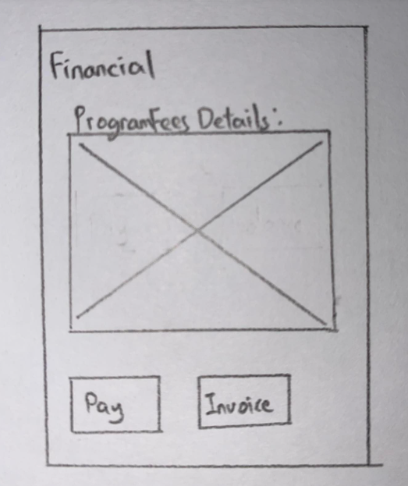

**Usability Questions:**

1. Do you find out any unexpected error?
2. Do you understand the labels and instructions?
3. Do you find out any problem when you doing specific action?
4. Do you satisfy with the response time?
5. Do you get the necessary information you want?
6. Do you consider the software as user-friendly?
7. Is it easy when you navigate the user interface?
8. Were the interactive elements functions well? Such as buttons.
9. Do you enjoy using it? If not, what is the section should be improve?