# **Compare Hotel between San Francisco and Los Angles**

Yongbin Wang

October 23, 2019

## **Introduction**

San Francisco and Los Angles are the major cities from California. For someone who would like to visit San Francisco or Los Angles and stay in a hotel. This capstone project is used to compare the hotels of San Francisco and Los Angles basic on the number of the hotels and rate of the hotels.

**2. Data Description**

This project uses Foursquare location data to get all the hotels’ name and rates that are within 1 mile of San Francisco and Los Angles.

San Francisco:

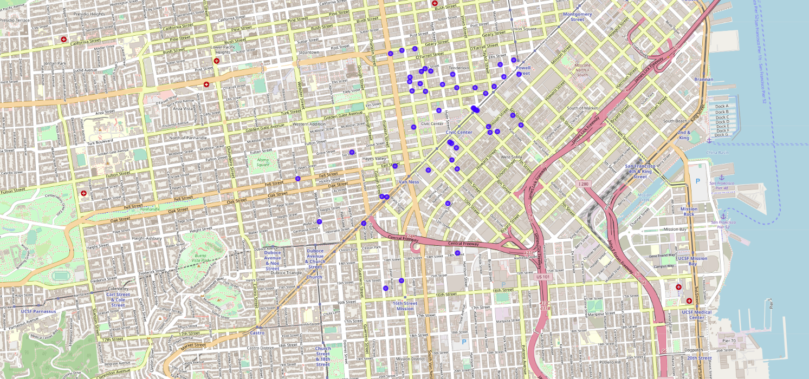

Los Angeles:

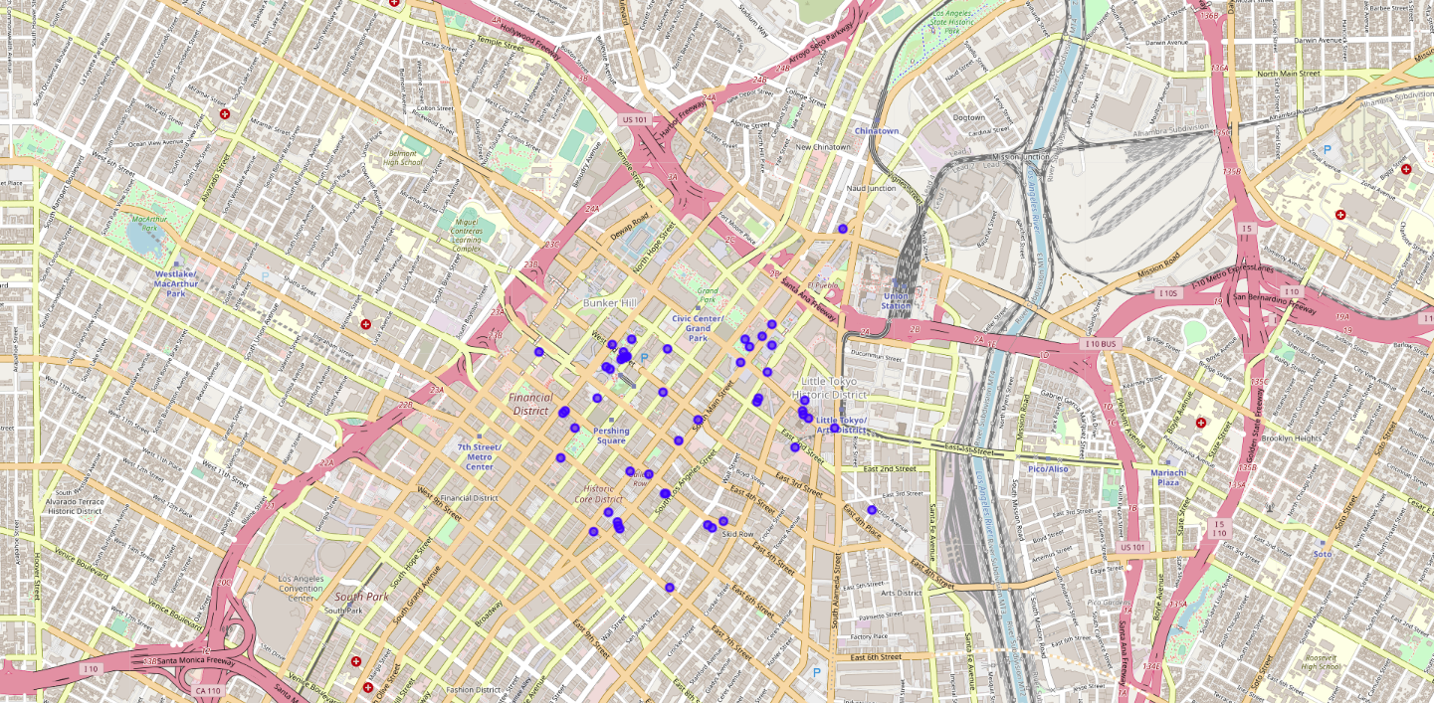

### 3. Methodology

Search San Francisco or Los Angeles’s hotel venues to get the rate of the hotels and store them into dataframe. Use histogram to display the rate of the hotels for users to compare the rate distribution.

## **4. Results and Discussion**

San Francisco has twenty-one hotels that have been rated. Los Angeles has ten hotels that have been rated. San Francisco has six high rated (rate 8.0-9.0) hotels, but the highest rate hotel of Los Angeles is only 8.0. Therefore, San Francisco has more good hotels than Los Angeles.

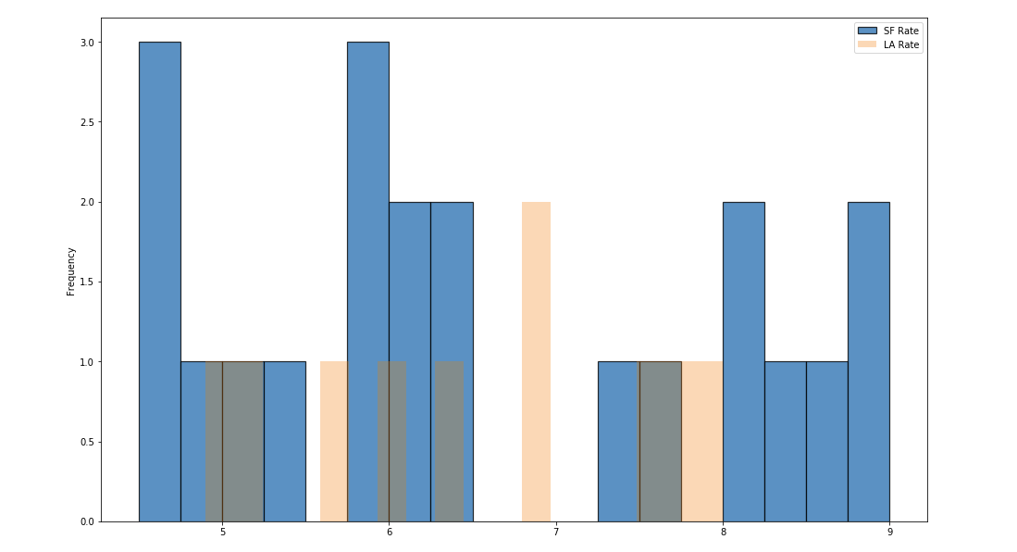

San Francisco doesn’t have any hotels in the rate range: 6.5 to 7.25. The rate distribution of the San Francisco hotels shows either low or kinda high. We can presume the wealth gap between the rich and the poor in San Francisco is large.

## **5. Conclusion**

San Francisco has extreme good and bad hotels. Los Angeles doesn’t have many hotels as San Francisco has, but its hotel rate distribution is evenly good.