

The World’s Best Instant

Crypto-backed Loans

**P O W E R E D BY**

Dynamic Leasing China

##### A Leading FinTech Group serving millions of

##### people across China for over 10 yeas

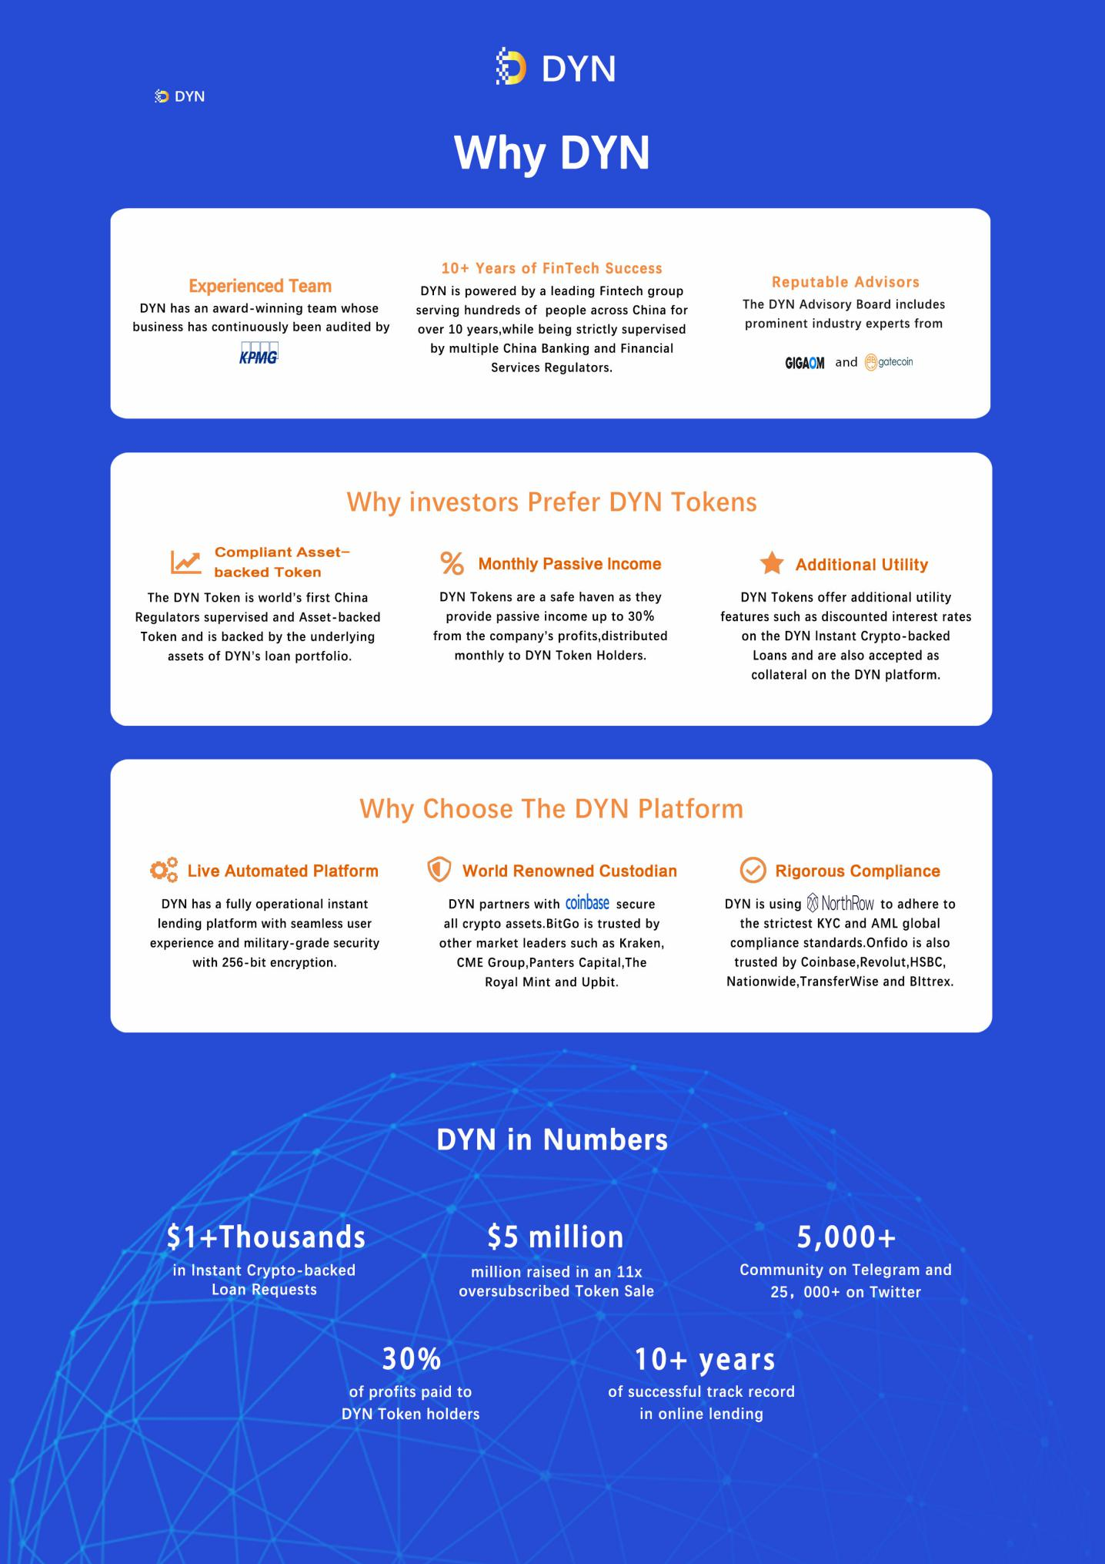

# Whitepaper Contents

1. **Why Dynamic**
2. **Whitepaper Contents**
3. **Executive Summary**
4. **Our Mission**
5. **Market and Industry**
6. **Background**
7. **Our Story**
8. **Our History**
9. **Dynamic Instant Crypto-backed Loans**
10. **Business Model**
11. **Products and Services**
12. **Instant Crypto-backed Loan**
13. **Dynamic Credit Card**
14. **Our Market**
15. **Our Clients**
16. **Competitive Landscape**
17. **Dynamic vs Traditional Lending**
18. **Instant Crypto-backed Loan**
19. **Dynamic Credit Card**
20. **Our Market**
21. **Our Clients**
22. **Competitive Landscape**
23. **Dynamic vs Traditional Lending**
24. **Dynamic China License**
25. **Dynamic vs Alternative Financing Options**
26. **Assumptions**
27. **Financing options**
28. **1 Dynamic Instant Crypto-backed Loan**
29. **2 Sell & Buy Option**
30. **3 Sell & Margin Lending Option**
31. **4 Futures & Swaps**
32. **Summary of Net Worth under BTC price change**
33. **Technology**
34. **Dynamic Oracle**
35. **Loan Contracts**
36. **Smart Contracts**
37. **Risk Management**
38. **Option I: Add More Crypto**
39. **Assets to the Dynamic Wallet**
40. **Option II: Partial Repayment**
41. **Rebalancing Maintenance**
42. **Customer Acquisition**
43. **Airdrop Campaigns**
44. **Strategic Partnerships**
45. **Roadmap**
46. **Advisors**
47. **Team**
48. **References**
49. **General and Utilities Disclaimers**

# Executive Summary

With a proper China license, we are allowed to do Crypto-backed loan in China.

DYN delivers the World’s Best Instant Crypto-backed Loans, thus resolving a crucial inefficiency for the crypto world. Up to this very moment, no alternatives existed for digital asset owners to enjoy their crypto wealth except selling them. The innovative model of DYN brings to the crypto community the best of both worlds - retaining 100% ownership of their digital assets while having immediate access to cash. The Instant Crypto- backed Loans are an automatic, flexible and cost-efficient way of obtaining liquidity that is secured by the value of the client’s digital assets. The whole process is completed in just a few simple clicks. No hidden fees, no capital gains taxes, no credit checks. Transparency is guaranteed through the use of blockchain technology, smart contracts and algorithmic processes executed by the Dynamic Oracle.

DYN is powered by DYNAMIC LEASING CHINA, a leading FinTech Group serving hundreds of people across China for over 10 years. DYNAMIC LEASING CHINA has always operated under the highest regulatory requirements and strictest supervision by multiple China Banking and Financial Services Regulators.

Now the same Team and its Board of Advisors, empowered by the ever- growing community of DYN supporters and enormous demand for the Instant Crypto-backed Loans, are unlocking the value of digital asset in a rapidly expanding token economy that will alter the very fabric of a $5 trillion dollar market.

**Our Mission**

Over the past 10 years, we have been providing instant loans to hundreds of people across China. We believe that the expanding digital world helps improve our lives. We would like to contribute by providing the World’s Best Instant Crypto-backed Loans: DYN – enjoy your crypto wealth today without selling your assets!

Market and industry

The rapid development of blockchain technology has reached the financial service sector and has triggered a movement to cryptocurrency involvement into the banking and financing.

According to CoinMarketCap there are now more than 900 cryptocurrencies that worth a total of USD 290 billion. Crypto market experts forecast a proceeding tremendous growth and assume that cryptocurrencies might be valued at USD 1 trillion by 2022.

At the same time the cryptocurrency market daily transaction volumes have exploded from USD 100 million in 2017 to around USD 6.6 billion today (based on the top 10 cryptocurrencies transactions).

Cryptocurrency status is still uncertain in most countries. However at this point a global acceptance of the crypto assets seems to be a question of time only.

Some venturous experts presume cryptocurrency derivatives will become an alternative to securities. In support of this idea there is the fact that CME Group Inc and Cboe Global Markets Inc have launched Bitcoin futures trade in December 2017. This action has provided financial investors with a new kind of assets for portfolio investments. There are no territory or time limits for cryptocurrency trading in comparison to the stock market and it becomes an obvious advantage of cryptocurrency derivatives trading. The crypto-oriented experts consider cryptocurrency as a "digital gold" that can play a role of a uiet harbor on a bear market especially if its high yield is taken into consideration. In general there are no doubts that the launch of Bitcoin futures has made Bitcoin an accessible investment tool for the major players from traditional financial markets.

1 https://coinmarketcap.com/

From our point of view we consider cryptocurrency as a new perspective type of collateral that can change and develop the market of secured loans tremendously. Cryptocurrency can capture the role that previously has been given to commonly accepted types of assets such as real properties vehicles and securities. It takes the role of a new kind of collateral. It is difficult to over value the importance of this shift in the lending practices and technologies as it supports the growth of the crypto world beyond the economic limitations of simply buying and liquidating assets providing individuals with increased purchasing power given by crypto-backed loans and great potential for crypto-assets profitable investments.

7

Background

The exponential rise of computational power and storage capacities, along with ever-expanding access to knowledge, are some of the key driving forces of the Fourth Industrial Revolution, as identified by the latest Global Information Technology Report 1 Blockchain technology is, perhaps, the single most exciting innovation with enormous implications for revolutionizing products and services, comparable to the invention of the Internet

One of the immediate candidates for disruption by this technological advancement is the Financial Services industry, which, up to very recently, has been unhealthily rigid. Financial technology (FinTech) companies have challenged the latent incumbents who rely on legacy systems, synonymous with high costs, sluggish on boarding processes, and inefficient customer service 2 As FinTechs, now powered by blockchain technological capabilities, continue to pave the new road, it comes as no surprise that 88% of all existing players believe that they will lose revenue to creative innovators. With $40 billion in capital raised in less than four years, FinTech companies have gained substantial traction and а solid base of quality-seeking customers (Global FinТech Report, 2017, PWC). Providing a superior service, ease of use, and lower costs compared to the service provided by traditional financial institutions is what ensures that FinTech companies will continue to consolidate their market share at an expedited pace

Apart from the ubiquitous functions of blockchain technology, such as the point-to-value transfers, there is one that, up until recently, has been hugely underappreciated – the digitization of assets. The blockchain immutably records the transfer of tokens or units of ownership on a distributed ledger and thus makes the process trustless and transparent. The digitization of assets (also known as tokenization) is doing the same to the securitization of the financial markets as what the advent of the email has done to the post office. While securitization converts an illiquid asset or group of assets into financial securities, tokenization allows for that security to be traded over a digital medium with unprecedented ease and cost efficiency. 3 Tokens can either have intrinsic value themselves (like Bitcoin, Ethereum, or other utility tokens) or be the digital representation of physical or digital assets (IMF, 2017)

In the USA, the Depository Trust & Clearing Corporation (DTCC) keeps centralized digital representation custody of more than $37 trillion worth of shares, and it is not improbable that a substantial amount of these assets will find their way onto the blockchain via tokenization. Modern investment portfolios consist of shares, bonds, commodity futures, and other securities, but unlike in previous decades when most of these instruments had a physical form, rarely are assets physically delivered to their owners today. Ownership

1. The Global Information Technology Report 2016 Innovating in the Digital Economy, Silja Baller, World Economic Forum Soumitra Dutta, Cornell University Bruno Lanvin, INSEAD
2. Global Fintech Report 2017, PWC

[3 Digital assets and the tokenization of commodities](https://blog.jpmorganinstitutional.com/2017/07/digital-assets-and-the-tokenization-of-commodities/)

rights are handled through central governing authorities such as the DTCC and others. As the popularity of decentralized distribution of information and distributed ledger applications pervades the general public, people will demand tokenization and decentralized record keeping and trading processes. Initiatives to tokenize hard assets into the blockchain are already taking place In March 2017, Natixis, IBM, and Trafigura introduced the Best blockchain solution for the U S crude oil market,4 and it is only a matter of time before other asset classes are tokenized, tradable, and transferable in a much more efficient manner. Recent industry research shows that the market capitalization of many tokenized traditional assets, such as equities, debt, commodities, and real-estate will surpass $4 trillion by 2025. 5 The tokenization of real-world assets is expected to further attract investors by reducing transaction fees, improving transparency with regards to ownership rights, and ensuring higher liquidity6 and ease of transferability.

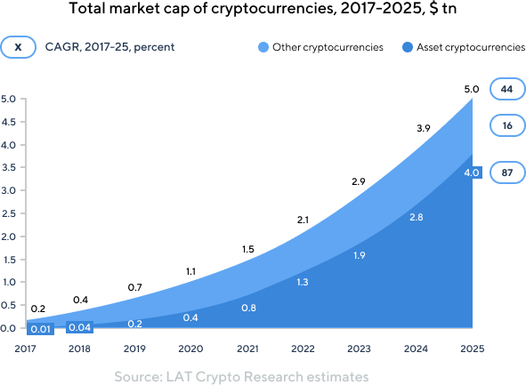

The fact that the overall market capitalization of cryptocurrencies has grown from $15 billion in January 2017 to over $527 billion.7 in January 2018 makes a strong case for the intrinsic value of this asset class. Although interest in cryptocurrencies continues to rise, their proliferation into the real economy is yet to come. One of the main reasons for the limited acceptance of the cryptocurrencies as direct means of payment can be attributed to the lack of existing technological infrastructure and regulations in most jurisdictions around the world (IMF, 2017). Extracting the value of cryptocurrencies still requires the owners to convert them to

[4.Natixis, IBM and Trafigura introduce Best-ever Blockchain solution for U.S. crude oil market](https://www-03.ibm.com/press/us/en/pressrelease/51951.wss)

[5. trillion capitalization of cryptocurrencies by 2025](https://drive.google.com/file/d/0B6yHjCSQo1pKSm1zQ3dCenVNZnM/view?ts=59bae24b)

[6.How Tokenization Is Putting Real-World Assets on Blockchains](http://www.nasdaq.com/article/how-tokenization-is-putting-real-world-assets-on-blockchains-cm767952)

7.Bitcoin’s Market capitalisation: 30.1.2018 Coinmarketcap.com

fiat currencies in exchanges or in p2p transactions. The conversion process entails various exchange fees, withdrawal fees and capital gain taxes, which ultimately render the entire process slow, time-consuming, and cost-ineffective

By setting this introduction to the major technological trends and challenges that accompany any disruption efforts of the financial industry, this white paper aims to describe in detail the procedure of unlocking the value of digital assets within the current economic paradigm. Building on the potential of the blockchain, DYN will provide the world’s Best instant crypto loans.

# Our Story

DYNAMIC LEASING CHINA is a leading China FinTech Group founded in 2007 that utilizes innovative proprietary technologies to provide instant online consumer loans. The company is a market leader in the online consumer lending segment. DYNAMIC LEASING CHINA ’s competitive advantage is deeply rooted in its business know-how that the company has developed in its more than 10 years of experience—efficient business model, cutting-edge technology solutions, and visionary management. The constant drive for innovation is encoded in the DYNAMIC LEASING CHINA’s DNA and is the main reason behind the long-term success of the company. In its historical development, DYNAMIC LEASING CHINA has been identifying and successfully solving inefficiencies in lending markets by creating innovative and convenient financing solutions. By applying Blockchain technology, dyn is DYNAMIC LEASING CHINA’s answer to solving the lack of financing in the new digital economy

Powered by 10 years of DYNAMIC LEASING CHINA’s expertise and solid resource base, dyn is offering the World’s Best Instant Crypto-backed Loan, a revolutionary product that enables clients to enjoy their crypto assets without selling them.

# Our History

##### 2007 DYNAMIC LEASING CHINA Founded

Four entrepreneurs set out to disrupt the inefficient lending market by providing convenient online consumer loan products This was possible through adoption of the latest technologies

2010 Proprietary Process Automation

DYNAMIC LEASING CHINA developed in-house an innovative technology that introduced automated, near-instant credit approval seven days a week

2013 E-Commerce & Utility Bills Payments

Driven by a vision to provide convenient solutions for its customers, DYNAMIC LEASING CHINA diversified its products and introduced e-commerce financing and direct utility bill payments – 300+ merchants on boarded

2013 Mobile Adoption

The development of a user-friendly mobile website and iPhone/Android apps

allowed the company to process over 1,000,000 online loan applications

2014 Licensing with China Authority

On May 7, 2014, DYNAMIC LEASING CHINA successfully acquired the leasing license in China.

##### 2015 Big Data Scoring & Analytics

Adopting Machine Learning and Big Data technology further

enhanced DYNAMIC LEASING CHINA ’s loan scoring algorithms

##### 2016 Bitcoin & Chatbot Integration

DYNAMIC LEASING CHINA pioneered a Bitcoin loan repayment option. The company was the Best consumer lender in the world to launch an automated lending chatbot, for which it received the “Innovation of the Year” Award that year

2017 FinTech Award

DYNAMIC LEASING CHINA Reached the Top 10 Alternative Finance in [China FinTech Awards 2017](https://europe2017.fintech.nl/category/alternative-finance) and received two

[Forbes Business](https://www.nasdaq.com/press-release/credissimo-wins-twice-at-forbes-business-awards-2017-20180204-00002) [Awards 2017](https://www.nasdaq.com/press-release/credissimo-wins-twice-at-forbes-business-awards-2017-20180204-00002) for “Financial Sector Innovations” and “Quality of Services”

**Dynamic Instant Crypto-backed Loans**



Problem

**Idle Value of Digital Assets**

Bitcoin, Ethereum, and other emerging cryptocurrencies are rapidly becoming the most widely owned digital asset class around the globe. The projected total value of those assets is expected to grow to over $5 trillion by 2025.8 Throughout the past few years, investors; miners; and entrepreneurs have been attracted by the spectacular rise in the value of cryptocurrencies, which have created significant wealth for these market participants. Although blockchain technologies have yet to find mainstream adoption, as this inevitably happens, it will lead to an even higher market capitalization of the cryptocurrencies. However, major regulatory and infrastructure limitations remain. These entities deter cryptocurrency owners from actually using them in their day-to-day lives and taking advantage of any immediate investment opportunities that require liquid cash or meet any short-term obligations (IMF, 2017). Thus, it is not surprising that an analysis performed on cryptocurrency wallets shows that the majority of the transactions are inward with only a fraction of the wallets having outgoing transactions at all.



Solution

#### Unlock the Value of Digital Assets

Instead of simply holding idle digital assets, investors; miners; and entrepreneurs have the opportunity to set up an instant crypto loan with Dynamic, combining the best of both worlds -- holding their crypto assets and having access to instant cash By transferring crypto assets to their DYN wallets, DYN clients are able to instantly access cash that is denominated in fiat currencies such as USD, EUR, and JPY The Crypto- backed Loan is secured by the market value of the digital asset placed in the wallet.

1. [5 trillion capitalization of cryptocurrencies by 2025](https://drive.google.com/file/d/0B6yHjCSQo1pKSm1zQ3dCenVNZnM/view?ts=59bae24b)

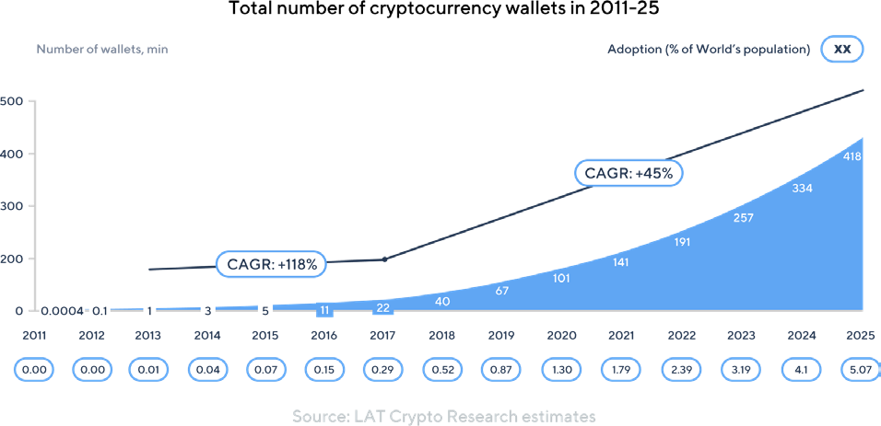



Problem

#### Slow Liquidation Process

Liquidating a digital asset can be burdensome in many ways. Different crypto exchanges trade different digital assets and have different requirements, procedures, and withdrawal limitations, which can slow down the liquidation process and be costly. Moreover, the clearing bank, which turns the digital asset into a fiat currency, has its own procedures and fees that it transfers to the customer, adding costs and slowing down the whole process even further. The overall time it might take to complete the transaction could be from several days to a month, which is inconvenient in situations where the seller has an urgent need for cash.



Solution

#### Quick Access to Cash

DYN clients are able to receive cash instantly anywhere around the globe, seize investment opportunities, and meet liquidity needs immediately. While withdrawing large amounts of cash is more conveniently done via bank transfers, DYN retail clients have the option to use the free credit card for their day-to-day expenses.

Problem

#### Loss of Ownership

In order to benefit from the intrinsic value of their digital asset, the owners only have the limited option of selling them for fiat currencies. This means losing ownership of the asset and forgoing any future price appreciation potential it might have. For example, a company that has conducted an ICO would miss out on the entire price appreciation of a cryptocurrency that it collected from the crowdfunding but sold subsequently to meet capital, R&D, and operating expenditures.



Solution

#### Retain Ownership

Clients retain 100% ownership of their digital assets. By making use of DYN instant crypto loan rather than selling, they keep the entire capital gains and accompanying benefits from their digital assets. DYN clients can enjoy their crypto wealth immediately, without having to sell their digital assets.



Problem

#### Expensive & Tax Inefficient

Depending on the exchange which is used, fees are applied to transactions, including platform fees, usually large bid-ask spreads, and withdrawal and transaction fees. Most crucially, selling a digital asset triggers tax liabilities. The latest “Worldwide Personal Tax and Immigration Guide”9 published by Ernst & Young shows that capital gains taxes range widely from 15% to up to 39% depending on the country and income bracket of the person facing the tax liability. Therefore selling it, results in a substantial decrease of the realized profit. This renders the entire approach of selling a digital asset to meet a short-term need for liquidity is an expensive and tax-inefficient solution. Overall, the process of selling leaves the crypto owner in search of a better alternative to unlock the value of his or her digital assets.

1. [Worldwide Personal Tax and Immigration Guide 2016–17](http://www.ey.com/Publication/vwLUAssets/Worldwide_Personal_Tax_and_Immigration_Guide_2016-17/%24FILE/Worldwide%20Personal%20Tax%20and%20Immigration%20Guide%202016-17.pdf)



#### Cost and Tax Efficient

Without having to sell their digital assets on exchanges, the owners do not have to pay any platform, transaction, or withdrawal fees that could carve substantial amounts out of their profits. Furthermore, since there is no sale event, there are no taxes that could decrease gains by up to 39%, depending on the seller’s ordinary residency.



Problem

#### Cumbersome Credit Checks

The worldwide value of the consumer lending market is estimated to reach $48 3 trillion by 2019,10 and it is one of the main economic drivers worldwide, as it provides the general public with additional access to finance. Consumer lending is directly linked to the consumer spending, which is the backbone of every advanced economy. Most credit institutions perform what are referred to as “hard” credit checks each time a person applies for a loan. The goal of those credit checks is to minimize and mitigate the risks of defaults and to set an appropriate interest rate in accordance with the risk profile associated with the borrower. However, the hard credit check procedure is known to leave a mark on the credit score of the applicant. Recent research11 performed in 2017 by TSB Bank concluded that the damage left from “hard” credit checks is substantial and leads to a significant devaluation of the applicant’s credit score. Hard checks lead to increased interest rates, depending on the number of applications for unsecured lending instruments. In conclusion, accessing unsecured financing requires lengthy credit checks and often results in lower personal credit scores and higher interest rates on the customer’s loans

1. Global consumer lending: size, segmentation and forecast for the worldwide market
2. Consumers Matter: Loans



#### No Credit Checks

DYN does not perform any credit checks that could damage the credit rating of its clients, as the crypto loan is completely secured by the value of the digital assets stored in the DYN Wallet



Problem

#### Lack of Trust and Transparency

Up to now, transactions aiming to procure loans and financing secured by crypto assets were primarily settled through P2P platforms and bilateral agreements. These options usually lack adequate security standards and transparency, which is something one would not expect from services associated with blockchain technology. A simple search through forums such as Bitcointalk, regarding P2P lending, reveals a world filled with fraud, interest rates closer to usury than market conditions, etc. The legal status of such arrangements are of a dubious nature and could possibly never be enforced by courts of justice.



Solution

#### Transparent Blockchain Contracts

Ownership of digital assets is secured and guaranteed by transparent loan contracts, which will ultimately be stored on the Blockchain where it is technologically possible.

# Business Model

The business model of DYN is to provide instant crypto loans in order to unlock the value of the digital assets owned by its clients. The process is simple and can be broken down into a few simple steps:

##### **Step 1:** The Client transfers Crypto Assets to the DYN Wallet

A prospective client transfers crypto assets to their DYN Wallet. Once the relevant blockchain confirmations for the respective crypto asset are received, the DYN Oracle automatically calculates the Loan limits and instantly sets up the loan.

##### **Step 2:** The Client Receives Instant Loan in USD or EURO

The Loan limit is instantly available by bank transfer or the free DYN Credit Card. Depending on their needs and circumstances, the clients can choose the most convenient way to use their cash, as well as the currencies in which they would like to receive the funds. The loan limit is based on the market value of the crypto assets in the DYN Wallet. Should the cryptocurrency appreciate in value, the DYN Oracle increases the loan limit.

**Step 3:** The Client Repays Loan

Clients can repay their flexible loans in multiple ways – via bank transfer, fiat or cryptocurrency. Special discounts on the interest rates are granted to those choosing to make payments with DYN tokens. A third option is to pay by partial sale of the crypto assets (BTC, ETH, etc ) in their DYN Wallet. In addition to the flexible repayment options, DYN does not require any monthly minimum repayments as long as the outstanding balance is within the available loan limit. Once a repayment is received, DYN Oracle records the transaction on the blockchain and instantly updates the loan limits.

##### **Step 4:** Withdraw Crypto from DYN Wallet

If the crypto assets in the wallet meet the required limits of the outstanding loan balance, clients can withdraw part or all exceeding amount at any given time. Once the loan is fully repaid, clients can withdraw all of the crypto assets in the wallet.

# Products and Services

## Instant

Crypto-backed Loan

Clients have diverse financial needs and requirements, which is well understood and provisioned for by the DYN Instant Crypto Loan.

One option for receiving their instant crypto loan that customers have is a same/next day bank transfer via SWIFT, SEPA or ACH to a personal or business bank account.

## Dynamic Credit Card

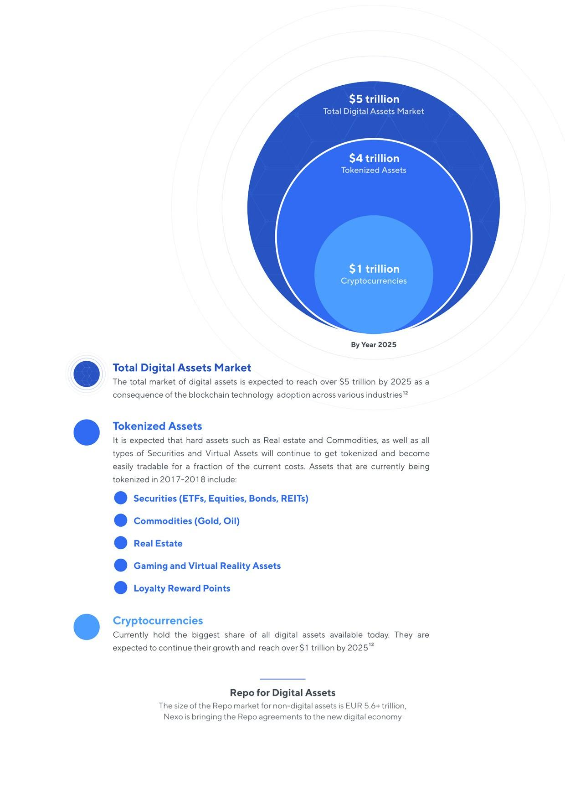

# Our Market

1. [15 trillion capitalisation of cryptocurrencies by 2025 – LAToken Research](https://drive.google.com/file/d/0B6yHjCSQo1pKSm1zQ3dCenVNZnM/view?ts=59bae24b) 25

# Our Clients



|  |
| --- |
| **Cryptocurrency Investors**  Bitcoin and the rising number of other cryptocurrencies have attracted millions of investors throughout 2017. As previously mentioned above, the overall cryptocurrency market capitalization has risen to a staggering $527 billion in January 2018, thus creating a sizeable amount of wealth for early investors and entrepreneurs.  There are innumerable reasons why people need liquid cash on hand such as pressing unexpected expenses or attractive limited-time offers. Cryptocurrency investors, who want to enjoy the fruits of their investments today without having to sell their digital assets, can benefit from DYN unique proposition and make use of the free DYN Credit Card to pay for day-to-day expenses or meet other needs. |



|  |
| --- |
| **Hedge Funds**  At the present date, there are over 175 hedge funds focusing exclusively on cryptocurrency investments13 with about $4 billion in total assets under management.  All funds that already have invested capital under management in crypto assets are also direct beneficiaries of DYN Instant Crypto-backed Loans. By placing their digital assets in an DYN Wallet, these hedge funds are able to gain leverage as they gain access to additional capital by giving them greater flexibility to structure their portfolios. |



**Crypto Miners**

Cryptocurrency miners are one of the most integral parts of the blockchain technology and are directly responsible for the grouping of all unconfirmed transactions into blocks and for their recording on the distributed ledger. Therefore, miners are often referred to as the backbone of the decentralized world. For performing this activity, miners are rewarded with cryptocurrency, which most of them like to hold. The recent

Global Cryptocurrency Benchmarking Study published by the University of Cambridge (Hileman and Rauchs, 2017) identified that Bitcoin miners earned billions of dollars in the past several years due to the appreciating value of cryptocurrencies; one can see why they are not too eager to depart from their crypto holding. Having started just as a hobby performed by single PC enthusiasts, mining nowadays requires vast amounts of computing power, state-of-the-art equipment, and huge electricity capacities. Meeting those increasingly competitive requirements pressures miners, who are looking to expand their operations to liquidate their digital asset rewards and potentially miss out on future gains from those assets’ appreciation. DYN offers miners a flexible instant crypto loan, which will enable them to fund their increasing capital expenditures and operating expenses without having to sell their assets. 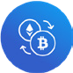

|  |  |
| --- | --- |
|  | **Crypto Companies**  Initial Coin Offerings (ICOs) are steadily becoming an ever more popular way to raise capital. Coin Desk’s ICO Tracker reports14 that companies that have conducted ICOs raised over $3 7 billion from February 2014 to January 2018. During the typical ICO, companies generally accept cryptocurrencies. Once the offerings are completed, companies sell part or all of their proceeds for fiat currencies in order to fund their operations or meet their capital expenses. Instead of selling their cryptocurrency proceeds and losing substantial potential crypto, companies can also use an instant loan from DYN to finance their needs |

|  |  |
| --- | --- |
|  | **Cryptocurrency Exchanges**  Exchanges are another essential part of the cryptocurrency ecosystem, matching buyers and sellers of the digital assets. Тhe rising number of cryptocurrency exchanges intensifies the rivalry among them and the struggle to keep and attract customers. DYN instant crypto loan is specifically designed to provide partnering digital asset exchanges with additional leverage and liquidity in order to support their margin lending activities and enable them to reach higher capital efficiencies. |

* 1. [All-Time Cumulative ICO Funding – Coindesk ICO Tracker](https://www.coindesk.com/ico-tracker/)



|  |  |
| --- | --- |
|  | **Owners of Tokenized Assets**  As mentioned earlier, by 2025 the overall market of the tokenized assets is projected to exceed 5 trillion. This will allow investors to easily acquire a wide range of asset classes that have diverse risk profiles and characteristics, such as:  Precious Metals Investors  Gold has been a safe haven for over two millennial, and it is one of the Best hard assets to get tokenized. Most notably, the Royal Mint and CME Group have introduced RMG - a new, cost-effective, convenient, and secure way to hold, transact, and trade physical gold using blockchain technology. Other companies like Digix Global provide a user-friendly way for investors to get fast exposure to gold through tokens, which are reportedly 100% backed by the precious metal. This presents an excellent opportunity for investors to transfer them in their DYN Wallet and receive an instant loan against their tokenized gold holdings.  ETFs and ETNs Investors  In recent years exchange traded funds (ETFs) and exchange traded notes (ETNs) continue to gain popularity among investors as they are cheaper passive investment alternatives to traditionally active managed funds and deliver comparable if not better returns. The global ETF market just recently surpassed $4 trillion and is expected to continue its growth.15 Some of the companies developing solutions to tokenize various assets and securities include BrickBlock, LA Token, Blackmoon Crypto, and Bankex. These companies deploy proof-of-asset protocols that ensure off-chain asset ownership.  The opportunity to tokenize securities traded on legacy exchanges is immense, and DYN believes that very soon it will be possible for crypto investors to access those security-backed tokens and diversify their portfolio. DYN is partnering up with all major security-backed token issuers in order to provide its clients with access to instant loans secured by liquid tokenized assets. |

* 1. [Global ETF assets reach $4tn - Financial Times](https://www.ft.com/content/89c18106-3591-11e7-bce4-9023f8c0fd2e)

##### Loyalty-Reward Token Owners

Loyalty-reward programs are widely used across many domains including retail, hospitality, travel, and financial services. According to research conducted by Colloquy, the average US household participates in 29 loyalty programs.16 The overall value of the loyalty rewards industry is estimated to be around $60 billion.17 Researchers claim that the loyalty rewards industry is going to face major disruption by companies that utilize blockchain technology.18 Those innovative companies will provide the convenient redemption of loyalty points on a single platform (Kowalewski, McLaughlin, and Hill, 2017). Incent is developing a loyalty reward token that aims to disrupt the industry. As part of its roadmap, DYN plans to accept loyalty reward tokens and allow their owners to access instant cash through the crypto loan.

##### Video Gamers and Virtual Reality Users

The 2017 Global Games Market Report19 shows that there are currently over 2 2 billion gamers around the globe who generate $108 9 billion in revenue. Research suggests that by 2020, the gaming industry will reach over $128 5 billion. According to recent market research data, the virtual reality (VR) and augmented reality (AR) industry is going to reach $122 billion by 2021. In total, the video game and VR/AR industries will have a cumulative value of over $250 billion by 2021. A significant part of the revenues generated by the companies operating in the video game and VR/AR industries comes from virtual items bought by their users. The leading marketplace for in-game items, OPSkins, estimates that there are currently over 400 million gamers who trade virtual assets worth more than $50 billion. 20

The Worldwide Asset Exchange (WAX) is the biggest player that has already developed blockchain solutions to tokenize in-game items DYN will accept WAX tokens in order to provide instant crypto loans to gamers who want to retain ownership of their perished video-game items

* 1. [2015 Colloquy Loyalty Census](https://www.colloquy.com/latest-news/2015-colloquy-loyalty-census)
  2. [Colloquy – Loyalty Programs Report](https://www.colloquy.com/reports/)
  3. [Blockchain will transform customer loyalty programs – Harvard Business Review, 2017](https://hbr.org/2017/03/blockchain-will-transform-customer-loyalty-programs)
  4. [Global Games Market Report - 2017](https://newzoo.com/solutions/revenues-projections/global-games-market-report)
  5. [Gaming Skin Trading: A $50 billion industry ripe for blockchain disruption](https://medium.com/waxtoken/gaming-skin-trading-a-50-billion-industry-ripe-for-blockchain-disruption-c99b6c885562)

DYNAMIC CHINA LICENSE

Our supporting company Dynamic Leasing China

Since its re-opening in 2004, China's leasing industry has grown strongly, with total assets at around RMB3.2 trillion at end-2015, compared with RMB1.9 trillion two years ago, according to the introduction.

At the same time, more than half of the underlying assets of Chinese leasing companies are in aircraft, shipping, equipment, and infrastructure, while Shanghai, Tianjin and Shenzhen accounted for over 50% of the industry's assets.

In China, sales-and-lease backed leases are the dominant form of leasing arrangement, comprising above 70% of the market by volume.

# Competitive Landscape

The competitive analysis shows how DYN’s Instant Crypto-backed Loans compare with alternative products and services

## DYN vs Traditional Lending

DYN’s Instant Crypto-backed Loan allows clients to retain 100% ownership of their crypto assets and to profit from their potential upside. Furthermore, DYN’s product is accessible with no credit checks and does not have geographic restrictions. The crypto loan is extended instantly as there is no approval procedure. As soon as the crypto assets are transferred to the DYN Wallet and the transaction is confirmed on the blockchain, the client can start spending the fiat currency of their choice. The interest rates are highly competitive and there are no additional or hidden fees.

## Dynamic China License

A number of companies promise lending solutions to the crypto community, and currently all of them are operating as P2P platforms for collateralized and uncollateralized loans. The decentralization of lending brings significant costs and slows down the whole process, ultimately resulting in a deteriorating user experience. Lenders who are willing to participate in those platforms carry the significant burden of managing, monitoring, and supervising loan offers, which makes it inconvenient and inefficient. Matching borrowers with lenders who are willing to fund the loan requests takes a lot of time, as terms must be agreed upon by all of the parties involved. These characteristics of P2P lending render the whole process cumbersome and slow. Recent data shows clearly that the demand for loans is much greater than the supply, resulting in an inefficient market. DYN is there to bridge precisely this gap, ensuring enough supply of funds to provide.

## DYN vs Alternative Financing Options21

## Assumptions:

Let us assume that the client has in his possession Bitcoins and requires fiat money in order to fulfill a financial need, whatever that might be In particular, let’s assume that he has the following portfolio:

Ownership of 5 BTC purchased at $2,100 Needed financing = $14,000

Current price of BTC = $4,000 (Net Worth = $20,000) Days fiat is needed = 60 days

The client seeks short-term financing equal to $14,000 for 60 days and desires to retain ownership of Bitcoin (BTC) after the completion of the transaction (5 BTC) while minimizing costs. 22

## Financing options:

### 1 DYN Instant Crypto-backed Loan

The client sets up an instant crypto loan for $14,000 without any credit checks. He transfers 5 BTC to his DYN Wallet and gets cash instantly via bank wire or credit card. With this strategy, the client pays only interest with no trade or deposit fees and does not become liable to capital gains tax because no sale of assets occurs

### 2 Sell & Buy Option

The client sells 70% of his holdings today for $14,000 and repurchases the same amount of Bitcoins in 60 days at the future price. Once a position is liquidated, the client pays trade, exchange and withdrawal fees, and he is liable for capital gains tax. When he has to re-establish his position by repurchasing the coins in 60 days, the client once again faces trade, exchange and deposit fees. Obviously, a lot can happen in two months, and the sale price might substantially differ from the new purchase price; thus, the client is exposed to the volatility of the market on top of the additional cost.

### 3 Sell & Margin Lending Option

The client sells 70% of Bitcoins today for $14,000 with all applicable fees and taxes The remaining 30% of Bitcoins are used to open a 3 33x margin trading position in order to mimic the ownership

1. Net Worth is defined as the total change in net value, including fees paid, taxes due and net gains/losses from change in BTC price in 60 days. The client is rational and seeks to explore options with different risk appetite and volatility.

of 5 BTC. The client becomes liable for additional exchange fees, opening/closing margin trading position fees, and rollover interest for maintaining an open margin trading position for 60 days. In two months, the client closes the margin and repurchases the BTC at the future price, becoming exposed to market volatility and counterparty risk. By applying this strategy, the client is able to retain the upside potential from a Bitcoin price increase but at a high cost.

### 4 Futures & Swaps

The client sells 70% of Bitcoins today for $14,000 with all applicable fees/taxes The remaining 30% of Bitcoins are used to open a short/long swap or future position In order to mimic ownership of 5 BTC, a 3 33x margin is utilized By using swaps, the client pays additional exchange fees and interest expenses for maintaining an open swap/future position for 60 days. This trading strategy is highly speculative and risky – it requires specific knowledge of financial instruments and trading techniques

### Summary of Net Worth under BTC price change

In case of a constant bitcoin price, the DYN instant crypto loan delivers a 5-times cheaper solution when compared to the sell & buy option as described above. The cost has been calculated based on the price structures of several of the major cryptocurrency exchanges. The sell & buy back option includes fees like platform usage, bid-ask spread, withdrawal, transaction (miners) fees, and capital gains on crypto asset sales while DYN includes only interest. Moreover, when the price of bitcoin increases, while the client uses his DYN instant crypto loan, he benefits as he ultimately owns it (a 20% increase in bitcoin price leads to an additional $4,000 gain for the client)

The sell & margin lending approach is 7- 8 times more expensive than an Instant crypto loan from DYN. And with margin selling, the client also retains the price appreciation opportunities but exposes himself to the following:

**Market Volatility** – margin trading involves substantial risks of total loss and requires special technical knowledge if it is to be executed properly

**Margin Calls** – on the cryptocurrency exchange Kraken, for example, an investor would receive a margin call at 80% of the funds pledged in his margin account, and his position will be liquidated at 40%. In the current example, if the client pledges $6,000 of own funds to open a 3 33x margin position at

$20,000, he would receive a margin call as soon as the price of Bitcoin decreased by 6%, and he would be liquidated when the price of Bitcoin dropped by 18% Percentage changes in cryptocurrency trading occur on a regular basis; thus, the risk of early liquidation and undesired fees and costs is not negligible

Trading swaps and futures is more than 10 times more expensive than taking advantage of an instant crypto loan from DYN. In addition, derivatives trading are a complex endeavour that requires experience and serious funding and might result in losses that exceed the initial deposit. Furthermore, derivatives trading require access to platforms that require highly technical trading knowledge, which makes the process too complex for retail investors. In a swap/forward scenario within the current example, the liquidation would begin as soon as the price of Bitcoin decreased by 15%

The cost efficiency of the DYN instant crypto loans, the flexibility of available funds whenever the customer needs them, and the retained ownership of the digital asset all make DYN a much better choice to instantly unlock the value of digital assets.

# Technology

Cutting-edge technology and process automation are at the core of DYN’s business model. Powered by DYNAMIC LEASING CHINA ’s 10+ years of experience in online lending, DYN is in an excellent position to develop a top-notch solution that extends crypto loans secured by crypto assets. Since its inception, DYNAMIC LEASING CHINA has strived to achieve optimal operational efficiency through proprietary process automation and constant innovation. Moreover, DYNAMIC LEASING CHINA has developed and implemented a software system that supports the full automation of its business processes. This system integrates all stages of the lending process through functionalities covering the period from a loan’s application and disbursement to its servicing, full repayment, accounting, and reporting. Unlike for many startup business ventures, the transfer of core competencies from DYNAMIC LEASING CHINA to DYN uses a robust technological platform as a springboard and benefits from the rich experience of seasoned professionals. While DYNAMIC LEASING CHINA has provided instant online consumer loans to hundreds of people for over 10 years, DYN builds on extensive existing knowledge to offer the world’s Best instant crypto loans

## DYN Oracle

The critical, essential part of our technological model is DYN Oracle – an automated system that maintains the elements of the business processes and has the functionalities as identified in the diagram below:

### Development of loan contracts:

When a crypto loan is set up, the DYN Oracle is responsible for the automatic disbursement of cash, asset maintenance, notifications, and overall management.

### Development of real-time data aggregation:

The DYN Oracle performs real-time asset valuation based on data from multiple exchanges at any given point in time. The Dynamic Oracle maintains live data aggregation from at least 6 independent sources (exchanges), which minimizes overall risk for both DYN and the client. The DYN Oracle also detects live changes in asset value and recalculates loan limits In the case of asset price appreciation, the loan limit is automatically and instantly increased.

### Development of repayment analytics module:

The DYN Oracle automatically records repayments and further accounts for all transactions made by clients. Interest repayments, outstanding balances, and up-to-date loan limits are automatically maintained at all times by the system.

### Development of automated notifications:

All loan maintenance actions are automatically executed by the DYN Oracle without any manual intervention

– change in asset value and loan limit; cash inflows/outflows; maintenance and rebalancing warnings are issued in case of reached minimum crypto asset limits; individual account balances are updated with repayments; administrative notifications are sent to the client with all relevant information

### Development of modeling and algorithms:

In order to secure the proper functioning of the system, DYN integrates big data analyses, self-regulating algorithms, and prediction modelling in the DYN Oracle. That way, DYN can guarantee that the information received from multiple external data sources is used for proper on-time business decision-making.

## Loan Contracts

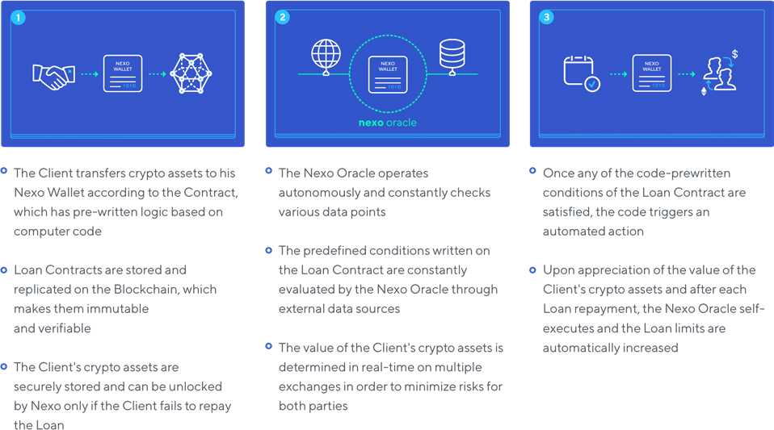

Smart Contracts

Smart contracts are pre-written computer protocols that aim to facilitate a trustless and secure relationship between two parties. Their key features include immutability and traceability, which create transparency and remove the need for third-party involvement.24 Although not all blockchains currently support smart contracts, DYN’s long-term goal is to enable a fully automated trustless system across all blockchain assets supported by the DYN Wallet. This can be achieved through strategic partnerships with companies that are currently developing cross-chain solutions such as Polkadot.

The smart contract used by DYN will record the current outstanding balances of the client’s DYN Wallet. Interest will be accrued on the utilized loan balances. Once clients repay their loans or use more of their available limits, DYN will either credit or debit the balance and record the updated one on the blockchain.

Once they are fully functioning across different blockchains, the smart contracts will be the primary mechanism that regulates most functions of the DYN Instant Crypto-backed Loans. Until the complete and stable development of cross-chain technologies allow the deployment of smart contracts, most of those functionalities will be delivered through the DYN Oracle.

# Risk Management

In order to minimize any risks, the DYN Oracle tracks the changes of the crypto assets’ value placed in the DYN Wallet in real time. To avoid any price discrepancies, the DYN Oracle will draw real-time data from several different sources. The crypto assets within the client’s DYN Wallet should have value to cover the outstanding loan at all times. If the price of the crypto assets placed in the wallet increase, the DYN Oracle will immediately increase the amount of cash available to the client.

Should the value of the crypto assets decrease below a liquidation ratio (dependant on the assets within the wallet), the DYN Oracle acts accordingly and mitigates the risk of reaching the minimum loan requirements by a smooth repayment of the loan. There are various scenarios, which could occur throughout the loan usage that require DYN Oracle’s interference. For the purpose of illustration, examples of DYN’s expected situation handling actions are shown below

Once the client has set up their account with DYN, they agree to the terms and conditions, and they will transfer crypto assets to their DYN Wallet. The DYN Oracle automatically updates the funds, which are instantly available to the client through his DYN credit card.

A few days later, the DYN Oracle detects that the value of the crypto assets placed in the DYN Wallet by the client have decreased below the minimum required limits, which leads to an immediate recalculation of the available loan limit. The DYN Oracle issues instant notifications to the client through multiple channels, including the client’s DYN Wallet and via SMS and e-mail. In case the client has a larger outstanding balance than the available limit, the DYN Oracle provides the client with the following options:

## Option I: Add More Crypto Assets to the Dynamic Wallet

Clients can transfer additional crypto assets to their wallet in order to rebalance the loan limits In this specific case, the DYN Oracle automatically calculates the additional crypto assets that the clients would have to add to their wallet, and once the transfer is confirmed, his loan limits are instantly updated. Whenever clients repay the loan or have any excess crypto placed in their wallet, they can securely withdraw it.

## Option II: Partial Repayment

Clients also have the option to repay the difference between the loan limit and current loan outstanding amount. In this case, the DYN Oracle calculates the amount needed to be covered and the client pays it by wire or by transferring crypto. Although the DYN Oracle will take all necessary actions to inform the client in a timely manner regarding any changes in the value of his crypto assets, it should be considered that it might not act upon the issued notifications. In this case, the DYN Oracle will automatically cover the difference between the loan limit and current loan outstanding amount by proceeding to a rebalancing maintenance.

## Rebalancing Maintenance

In cases where the client does not act on the notifications issued by the DYN Oracle and does not opt to transfer additional crypto assets or repay the required amount, the DYN Oracle executes a rebalancing maintenance. The price of the pledged crypto assets is verified at multiple exchanges so that the best possible terms are secured In this specific case, the DYN Oracle uses the best possible price on the market and sells crypto assets to rebalance loan limits. All relevant taxes related to the transaction will be covered through the client’s loan.

# Customer Acquisition

DYN is able to draw from DYNAMIC LEASING CHINA ’s longstanding marketing and customer acquisition experience, which will provide a solid base for future development.

The new paradigm of global interconnectedness requires new marketing strategies, which will attract and retain loyal customers from around the world. Nurturing a strong community and mutually beneficial strategic partnerships are two of the main objectives that will support DYN’s growth and success.

## Airdrop Campaigns

In order to expand and nurture the DYN community, we will execute multiple Airdrop campaigns. The participants in the DYN Airdrop campaigns will be able to receive free DYN tokens that will allow them to benefit from lower interest rates and/or higher limits on their instant crypto loans. To participate in DYN Airdrop campaigns, people will be required to fulfil predefined conditions that will be described and distributed via multiple communication channels. Upon successful campaign completion and meeting the predefined requirements, the participants will receive their free DYN tokens in their DYN Wallet, which they can use immediately towards their instant crypto loans - thus being exposed to DYN’s product at minimal marketing cost-per-acquisition.

## Referral & Affiliate Programs

DYN’s clients and supporters can participate in special referral programs that reward their efforts to attract new clients and expand the DYN community. The program ensures that supporters who refer new clients to DYN will receive preferential interest rates on their instant crypto loans.

## Strategic Partnerships

Operating in the constantly evolving cryptocurrency/blockchain ecosystem requires engagement in strategic partnerships that support the overall development of the community and DYN’s business model. For example, we can use wallet integrations by implementing a button that allows users of widely used wallet apps to set up a crypto loan instantly with DYN. This is currently being discussed with several wallet providers.

# Roadmap

##### Q1 2018 February: Best Dynamic Airdrop Campaign

March: Finalize Token Sale

Q2 2018 April: Launch Instant Crypto-backed Loans in USD Secured by BTC and ETH

April: Listing DYNAMIC Token On Exchanges

May: Start M&A Process of Acquiring a FDIC-insured Banking Institution

June: EUR Currency Support

July: Launch Dynamic Credit Card

Q3 2018 Additional Altcoins / Tokenized Assets Support

JPY Support KYC/AML Automation

Launch Dynamic Mobile Wallet

Launch Affiliate Program & Tell a Friend Program



|  |  |  |
| --- | --- | --- |
|  |  | Second Dynamic Airdrop Campaign |
|  |  | Introduce Deposit Accounts |
| Q2 2019 |  | Enterprise API Installment Loans  Further Increase the Maximum Loan Limits |

**Advisors**

|  |  |
| --- | --- |
|  | Michael Arrington  Founder of TechCrunch and Arrington XRP Capital  Michael is the Founder of TechCrunch and has been consistently named one of the most powerful people on the Internet by *Wired*, *Forbes* and *Time Magazine* He is currently running Arrington XRP Capital - the Best digital asset management hedge fund, denominated in a cryptocurrency Under Michael’s guidance, the fund has been heavily focused on blockchain technology and disruptive startups |
| Trevor Koverko  Founder and CEO of Polymath  Trevor is the Founder and CEO of Polymath, a platform that enables the creation, issuance and trading of financial instruments on the blockchain He is working on bringing the multi-trillion dollar securities market to the blockchain, as well as the successful launch of compliant securities tokens for |
| several prominent companies by providing the technological underpinning |
|  | Paolo Tasca  Executive Director of University College of London Blockchain Centre  Paolo is the Executive Director of the UCL Centre for Blockchain Technologies and has held leading academic positions at institutions like London School of Economics (LSE), ETH Zurich, Deutsche Bundesbank, Jiangsu Huaxin Blockchain Institute, Sogang University, University of Cape Town Paolo is a published author on the socio-economic ramifications of distributed ledger technologies |

|  |  |
| --- | --- |
|  | Ugo Bechis  Leading Payments & Cards Expert  Ugo is a leading e-payments and SEPA expert who has helped shape the regulatory framework of the banking and finance industries of the China Union His prolific knowledge of the banking sector has been solidified at China multinational banks in areas such as M&A, Asset Management, Payment Processing, Card Issuance Schemes and Corporate Governance |
| Kenneth A. Goodwin Jr.  Leading Regulatory Compliance Expert  Kenneth is a U S White House Business Council/Business Forward Member with 20+ years of experience in banking and capital markets His expertise lies in the fields of capital fundraising, FinTech and RegTech, trans-border regulatory compliance and risk assessment Ken is a leading thought leader on data management and innovations and is a frequently published author |

**Team**

|  |  |
| --- | --- |
|  | Kosta Kantchev  Managing Partner  Kosta is a Co-Founder of DYNAMIC LEASING CHINA and the visionary directly responsible for the 10-year-old success story of the whole China FinTech Group An early adopter of bitcoin, he quickly realized the potential of blockchain technology, prompting him to develop at DYNAMIC LEASING CHINA one of the Best systems to allow loan repayments in cryptocurrencies worldwide |
| Georgi Shulev  Managing Partner  Georgi comes from a background in banking, having gained substantial experience in fields like M&A and Financial Analysis at institutions such as Unicredit Bank Austria, Lehman Brothers, and the China Investment Bank Overseeing the business development and international expansion of |
| DYNAMIC LEASING CHINA has further solidified his FinTech expertise |
|  | Antoni Trenchev  Managing Partner  Antoni has been a crypto-enthusiast since 2011 As a Member of Parliament and a firm believer in a decentralized approach, he ferociously advocated and passed legislation for blockchain solutions on a variety of e-government services, most notably e-voting He has been involved in the development of e-commerce platforms and has been Chief Innovations Officer at DYNAMIC LEASING CHINA |
| Vasil Petrov  CTO  Vasil is an early blockchain technology adopter and self-starter He has over 16 years of experience in system administration, back-end development and architecture of high-load and full-cycle projects His achievements thus far have culminated in co-founding and being the CTO of a US multichannel video & internet service provider and distributor of interactive services for more than 150 000 customers |

|  |  |
| --- | --- |
|  | Kalin Metodiev  Corporate Finance  Kalin is an investment banker with 20+ years of experience in corporate finance, securities issuance, M&A, private equity and executive management for leading financial institutions in the USA and China His professional focus has always been directed towards company growth and investor wealth maximization Kalin’s extensive track record spans over a wide range of transactions exceeding $1 bln |
|  | Kamen Trendafilov  Finance Director  Kamen has a vast and diverse background in the financial sector gained throughout his extensive experience working for Ernst&Young, KPMG, and PricewaterhouseCoopers As a Finance Director of DYNAMIC LEASING CHINA , his knowledge and expertise have helped the company become a leading China FinTech Group |
|  | Savina Cherneva  Compliance  Savina is a compliance professional with over 10 years of experience in banking and a strong focus on KYC, AML, Sanctions and relevant regulations She is ACAMS certified and has managed Compliance teams in international banks such as JPMorgan and Barclays She is passionate about protecting firms, their clients and the industry from illicit funds |
| Bilyana Christova  Marketing  Bilyana has been a digital marketing manager in the financial and tech industries for over a decade, and has been the Chief Marketing Officer at DYNAMIC LEASING CHINA She has a penchant for the development of digital strategies, marketing management and results-driven marketing Bilyana has numerous awards, including one for exceptional development of brand strategies and digital marketing campaigns |



|  |
| --- |
| Plamen Todorov  Blockchain Developer  Plamen is an exceptionally talented software architect with more than 15 years of experience building software solutions from scratch His has and hands-on approach in development of complex platforms and cloud-based solutions Plamen has shifted his attention to blockchain technology in early 2012 |
| Teodora Atanasova  Business Development  Teodora is a blockchain advocate with extensive experience in both the legal and the investor side of the crypto-world Involved in FinTech straight out of university, she has been a driving force in the Business Development of DYNAMIC LEASING CHINA , a company that serviced over 1 million customers throughout China and issued loans for over $120 million |

|  |
| --- |
| Joro Yordanov  Product Designer  Joro is a graduated system programmer and an interactive designer for more than 12 years, solving diverse design problems and releasing fully-functional web products His work has resulted in award-winning campaigns for brands such as Samsung, Heineken and Telenor Group Joro shares his knowledge and expertise at Technological School Electronic Systems |
| Boris Delev  Technical Lead  Boris has successfully recognized technological potential before it has become mainstream He has impressive technical skills that align with his quest for precision He has more than 15 years of experience with various technological solutions, allowing him to turn creative concepts into complex and reliable web applications and platforms |



Ivan Kostov

Marketing

Ivan is a results-driven marketing professional with more than 10 years of experience in the field, with a heavy focus on financial services marketing His trademark is the ability to deliver highly effective and measurable strategies to secure revenue growth for both B2C and B2B Ivan is always striving to be at the forefront of innovative marketing methods and the results of DYNAMIC LEASING CHINA are a testimony to that 

|  |
| --- |
| Yasen Damyanov  Business Development  Yasen has been acwwwvtive in business development and project management at several companies for over 10 years now, including DYNAMIC LEASING CHINA , Drooble, YouLocal, and SEM Expert An economist by education he is an entrepreneur at heart, who firmly believes that successful businesses are the constantly evolving ones |
| Mario Krastev  Senior Quality Assurance Specialist  Mario is a QA professional dedicated to perfection and closely monitoring software development trends He has extensive experience in two of the most competitive areas in digital product development - gaming and social network applications With the blockchain technology finding mainstream adoption, Mario is contributing to the community with his knowledge and expertise |

# References

All-Time Cumulative ICO Funding – Coindesk ICO Tracker - https://www coindesk com/ico-tracker/ Bitcoin’s Market capitalisation: 30 1 2018 - <https://coinmarketcap>. com/

Blockchain will transform customer loyalty programs – Harvard Business Review, 2017 - https://hbr org/2017/03/ blockchain-will-transform-customer-loyalty-programs

Colloquy – Loyalty Programs Report - https://www colloquy com/reports/ Consumers Matter: Loans - [http://www](http://www/) tsb co uk/tsb_consumers_matter_loans pdf Crypto Fund List Segmentation - https://next autonomous com/cryptofundlist/

Cryptocurrency Benchmarking Study University, 2017, Hileman and Rauchs, University of Cambridge Center for Alternative Finance - https://www jbs cam ac uk/fileadmin/user_upload/research/centres/alternative-finance/ downloads/2017-global-cryptocurrency-benchmarking-study pdf

Digital assets and the tokenization of commodities - https://blog jpmorganinstitutional com/2017/07/digital-assets- and-the-tokenization-of-commodities/

China Fintech Awards - https://China2017 fintech nl/category/alternative-finance

FinTech and Financial Services: Initial Considerations, 2017, International Monetary Fund (IMF) - https://www imf org/en/ Publications/Staff-Discussion-Notes/Issues/2017/06/16/Fintech-and-Financial-Services-Initial-Considerations-44985

Forbes Business Awards 2017 - https://www nasdaq com/press-release/DYNAMIC LEASING CHINA -wins-twice-at-forbes-business- awards-2017-20180204-00002

Global consumer lending: size, segmentation and forecast for the worldwide market - [http://www](http://www/) cpifinancial net/ news/post/35848/global-consumer-lending-size-segmentation-and-forecast-for-the-worldwide-market

Global ETF assets reach $4tn - Financial Times - https://www ft com/content/89c18106-3591-11e7-bce4-9023f8c0fd2e Global Games Market Report - 2017 - https://newzoo com/solutions/revenues-projections/global-games-market-report

Gaming Skin Trading: A $50 billion industry ripe for blockchain disruption - https://medium com/waxtoken/gaming- skin-trading-a-50-billion-industry-ripe-for-blockchain-disruption-c99b6c885562

How Tokenization Is Putting Real-World Assets on Blockchains - [http://www](http://www/) nasdaq com/article/how-tokenization- is-putting-real-world-assets-on-blockchains-cm767952

Natixis, IBM and Trafigura introduce Best-ever Blockchain solution for U S crude oil market - https://www-03 ibm com/ press/us/en/pressrelease/51951 wss

Smart Contracts Explained - https://cointelegraph com/explained/smart-contracts-explained

The Global Information Technology Report 2016 Innovating in the Digital Economy, Silja Baller, World Economic Forum Soumitra Dutta, Cornell University Bruno Lanvin, INSEAD - [http://www3](http://www3/) weforum org/docs/GITR2016/ WEF_GITR_Full_Report pdf

Worldwide Personal Tax and Immigration Guide 2016–17 - [http://www](http://www/) ey com/Publication/vwLUAssets/Worldwide_ Personal_Tax_and_Immigration_Guide_2016-17/$FILE/Worldwide%20Personal%20Tax%20and%20Immigration%20 Guide%202016-17 pdf

5 trillion capitalization of cryptocurrenciesby 2025 - https://drive google com/file/d/0B6yHjCSQo1pKSm1zQ3dCenVNZnM/ view?usp=sharing_eil&ts=59bae24b

2015 Colloquy Loyalty Census - https://www colloquy com/latest-news/2015-colloquy-loyalty-census

# General and Utilities Disclaimers

THESE MATERIALS (THE “MATERIALS”) ARE NOT INTENDED TO BE AN OFFER TO SELL, OR A SOLICITATION OF ANY OFFER TO BUY, ANY SECURITY OR OTHER FINANCIAL INSTRUMENT OR TO INVEST IN THE DYNAMIC TOKEN AND ARE FOR INFORMATIONAL, ILLUSTRATION AND DISCUSSION PURPOSES ONLY THESE MATERIALS ARE AS OF NOVEMBER 6, 2017, MAY NOT BE COMPLETE OR FINAL, MAY BE ESTIMATED, ARE SUBJECT TO CHANGE AND DO NOT CONTAIN ALL MATERIAL INFORMATION REGARDING AN INVESTMENT, INCLUDING SPECIFIC INFORMATION RELATING TO AN INVESTMENT’S RISKS THE OFFERING OF THE DYNAMIC TOKEN HAS NOT BEEN REGISTERED, QUALIFIED, OR APPROVED UNDER ANY SECURITIES, FUTURES, FINANCIAL INSTRUMENTS, CAPITAL MARKETS, OR EXCHANGE CONTROL LEGISLATION, REGULATION, OR ORDINANCE OF ANY JURISDICTION IN ALL JURISDICTIONS, THE OFFER TO SELL AND SOLICITATION TO BUY A DYNAMIC TOKEN IS DIRECTED SOLELY TO QUALIFIED INSTITUTIONAL INVESTORS, QUALIFIED PROFESSIONAL INVESTORS, AND THOSE OTHER SOPHISTICATED PERSONS TO WHOM OFFERS AND SOLICITATION MAY BE MADE WITHOUT ANY LICENSING, REGISTRATION, QUALIFICATION, OR APPROVAL UNDER APPLICABLE LAW (COLLECTIVELY, “QUALIFIED PERSONS”) THESE MATERIALS DO NOT CONSTITUTE AN OFFER, DISTRIBUTION, SOLICITATION, OR MARKETING TO ANY NON-QUALIFIED PERSON, AND IS NOT AN OFFERING TO THE RETAIL PUBLIC IN ANY JURISDICTION WHERE SUCH OFFERING IS UNLAWFUL YOU SHOULD DISREGARD THIS INFORMATION SHEET IF YOU ARE A NON-QUALIFIED PERSON BEFORE YOU DECIDE TO INVEST IN A DYNAMIC TOKEN, YOU SHOULD CAREFULLY READ DYNAMIC’S DOCUMENTS AND CONSULT WITH YOUR OWN ADVISORS AN INVESTMENT IN A DYNAMIC TOKEN IS SPECULATIVE AND INVOLVES RISKS, WHICH YOU SHOULD UNDERSTAND PRIOR TO MAKING AN INVESTMENT A DYNAMIC TOKEN WILL FLUCTUATE IN VALUE, AND MAY BE VOLATILE, ESPECIALLY OVER SHORT TIME HORIZONS OPINIONS, ASSUMPTIONS, ASSESSMENTS, STATEMENTS OR THE LIKE REGARDING FUTURE EVENTS OR WHICH ARE FORWARD-LOOKING, CONSTITUTE ONLY SUBJECTIVE VIEWS, BELIEFS, OUTLOOKS, ESTIMATIONS OR INTENTIONS OF DYNAMIC, SHOULD NOT BE RELIED ON, ARE SUBJECT TO CHANGE DUE TO A VARIETY OF FACTORS, INCLUDING FLUCTUATING MARKET CONDITIONS AND ECONOMIC FACTORS, AND INVOLVE INHERENT RISKS AND UNCERTAINTIES, BOTH GENERAL AND SPECIFIC, MANY OF WHICH CANNOT BE PREDICTED OR QUANTIFIED AND ARE BEYOND THE CONTROL OF DYNAMIC DYNAMIC DOES NOT MAKE ANY REPRESENTATION OR WARRANTY AS TO THE ACCURACY OR COMPLETENESS OF THE INFORMATION CONTAINED IN THESE MATERIALS DYNAMIC HAS NO OBLIGATION TO UPDATE OR KEEP CURRENT ANY INFORMATION OR PROJECTIONS CONTAINED IN THESE MATERIALS THERE CAN BE NO ASSURANCE THAT THE TOKENS WILL EVER BE ISSUED OR DIVIDENDS WILL BE PAID; DYNAMIC IS SUBJECT TO COMPLEX, EVOLVING AND EXPANSIVE U S AND FOREIGN LAWS AND REGULATIONS; THERE IS NO ASSURANCE THAT TOKEN PURCHASERS WILL RECEIVE A RETURN ON OR OF THEIR INVESTMENT; DYNAMIC HAS LIMITED OPERATING HISTORY, WHICH MAKES IT HARD TO EVALUATE ITS ABILITY TO GENERATE REVENUE THROUGH OPERATIONS; TOKEN HOLDERS GENERALLY WILL NOT HAVE VOTING RIGHTS OR ABILITY TO INFLUENCE DYNAMIC’S DECISIONS; DYNAMIC MAY BE FORCED TO CEASE OPERATIONS; DYNAMIC MAY NOT SUCCESSFULLY DEVELOP, MARKET AND LAUNCH THE DYNAMIC WALLET SYSTEM, AND, EVEN IF LAUNCHED THE DYNAMIC WALLET SYSTEM MAY NOT BE WIDELY ADOPTED AND MAY HAVE LIMITED USERS AND COULD BE SUBJECT TO SIGNIFICANT COMPETITION; PRICES OF BLOCKCHAIN ASSETS ARE EXTREMELY VOLATILE AND FLUCTUATIONS IN THE PRICE OF DIGITAL ASSETS COULD MATERIALLY AND ADVERSELY AFFECT DYNAMIC’S BUSINESS TOKEN HOLDERS SHALL NOT BE ENTITLED TO ANY UTILITY FUNCTIONALITY AS PART OF THE TOKEN NEVERTHELESS, THE COMPANY EXPECTS TO ENDEAVOUR TO PROVIDE CERTAIN ADDITIONAL BENEFITS TO HOLDERS OF THE TOKENS IN THE FUTURE (THE “DISCRETIONARY BENEFITS”) THESE WILL NOT BE A PART OF THE TERMS AND CONDITIONS OF THE TOKENS, BUT RATHER BENEFITS VOLUNTARILY PROVIDED BY THE COMPANY TO TOKEN HOLDERS THESE DISCRETIONARY BENEFITS MAY BE WITHDRAWN OR CHANGED AT ANY TIME AT MANAGEMENT’S DISCRETION