**Problem 1**

**a.**

drop table problem1;

create table problem1(

Country VARCHAR(10) NOT NULL,

Education VARCHAR(20),

[All Customers] INT NOT NULL,

Female INT NOT NULL,

Male INT NOT NULL

)

INSERT INTO problem1

select geo.EnglishCountryRegionName, cus.EnglishEducation, count(*),count(case when cus.Gender='F' then 1 else NULL end),

count(case when cus.Gender='M' then 1 else NULL end)

from DimCustomer cus

inner join DimGeography geo

on cus.GeographyKey = geo.[GeographyKey]

where geo.EnglishCountryRegionName in ('France', 'Germany')

group by geo.EnglishCountryRegionName, rollup(cus.EnglishEducation);

UPDATE problem1 SET Education= 'All Customers' WHERE Female='893' or Female='874';

select * from problem1 order by Country,Education;

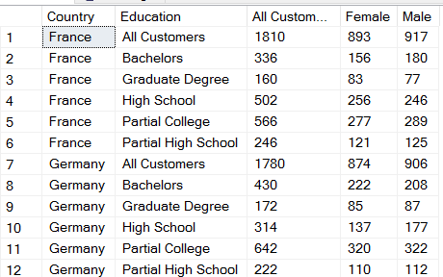

**b.**

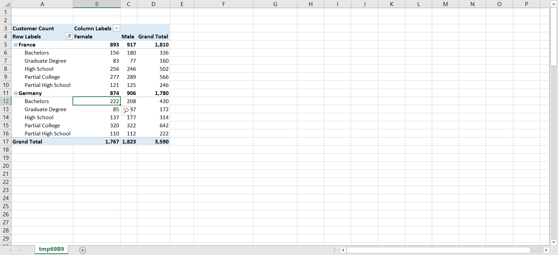

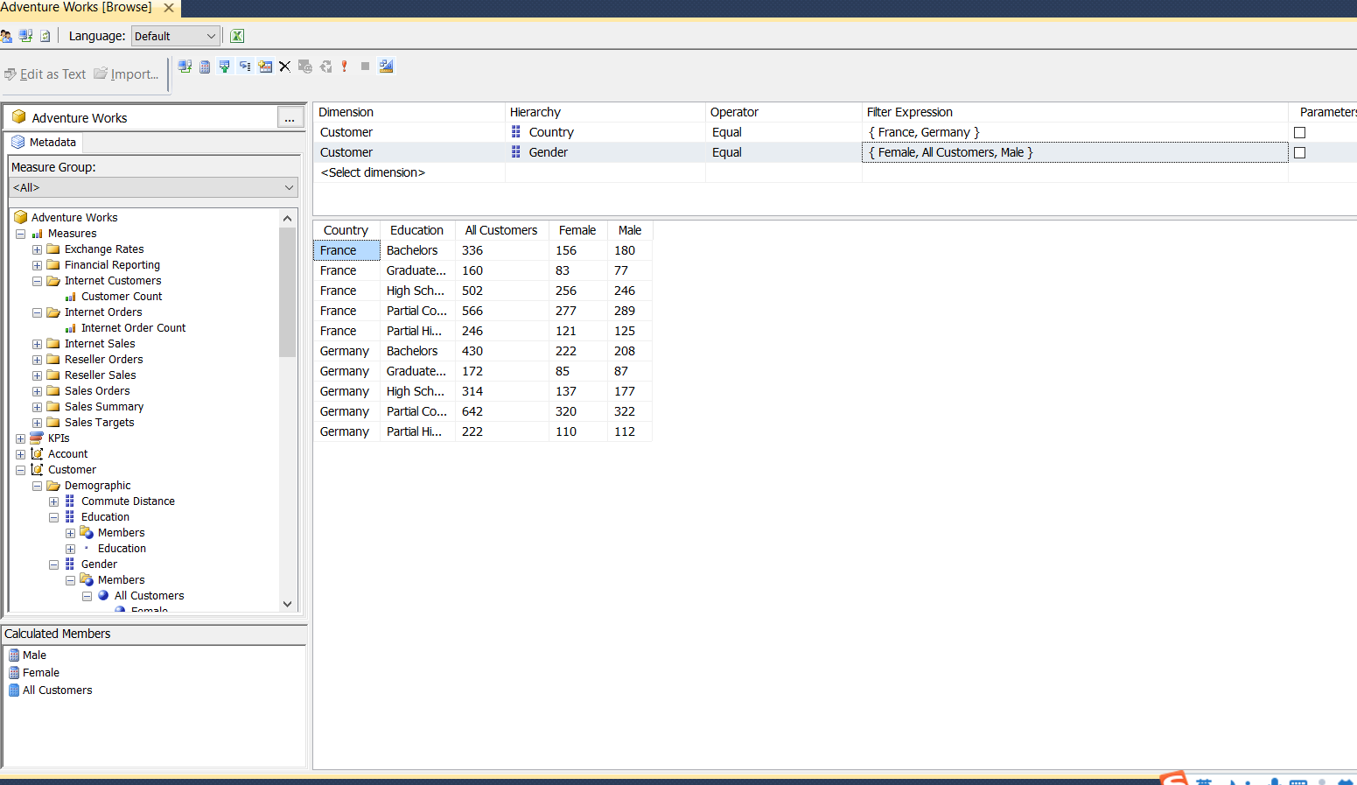

**Problem 2**

SELECT

({[Female],[Male]}) on columns,

({[France],[Germany]},DESCENDANTS([education],1)) on rows

FROM [Adventure Works]

WHERE [Measures].[Customer Count]

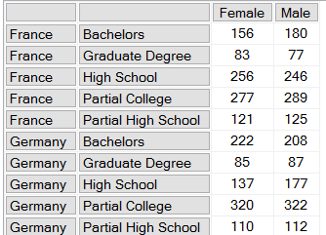

**Problem 3**

SELECT

[Male] on columns,

(Country.members,education.members) on rows

FROM [Adventure Works]

WHERE [Measures].[Customer Count]

The Result shows as follows.

Male

All Customers All Customers 9,351

All Customers Bachelors 2,728

All Customers Graduate Degree 1,578

All Customers High School 1,699

All Customers Partial College 2,522

All Customers Partial High School 824

Australia All Customers 1,814

Australia Bachelors 843

Australia Graduate Degree 152

Australia High School 302

Australia Partial College 373

Australia Partial High School 144

Canada All Customers 804

Canada Bachelors 187

Canada Graduate Degree 171

Canada High School 160

Canada Partial College 187

Canada Partial High School 99

France All Customers 917

France Bachelors 180

France Graduate Degree 77

France High School 246

France Partial College 289

France Partial High School 125

Germany All Customers 906

Germany Bachelors 208

Germany Graduate Degree 87

Germany High School 177

Germany Partial College 322

Germany Partial High School 112

United Kingdom All Customers 979

United Kingdom Bachelors 292

United Kingdom Graduate Degree 131

United Kingdom High School 187

United Kingdom Partial College 254

United Kingdom Partial High School 115

United States All Customers 3,931

United States Bachelors 1,018

United States Graduate Degree 960

United States High School 627

United States Partial College 1,097

United States Partial High School 229

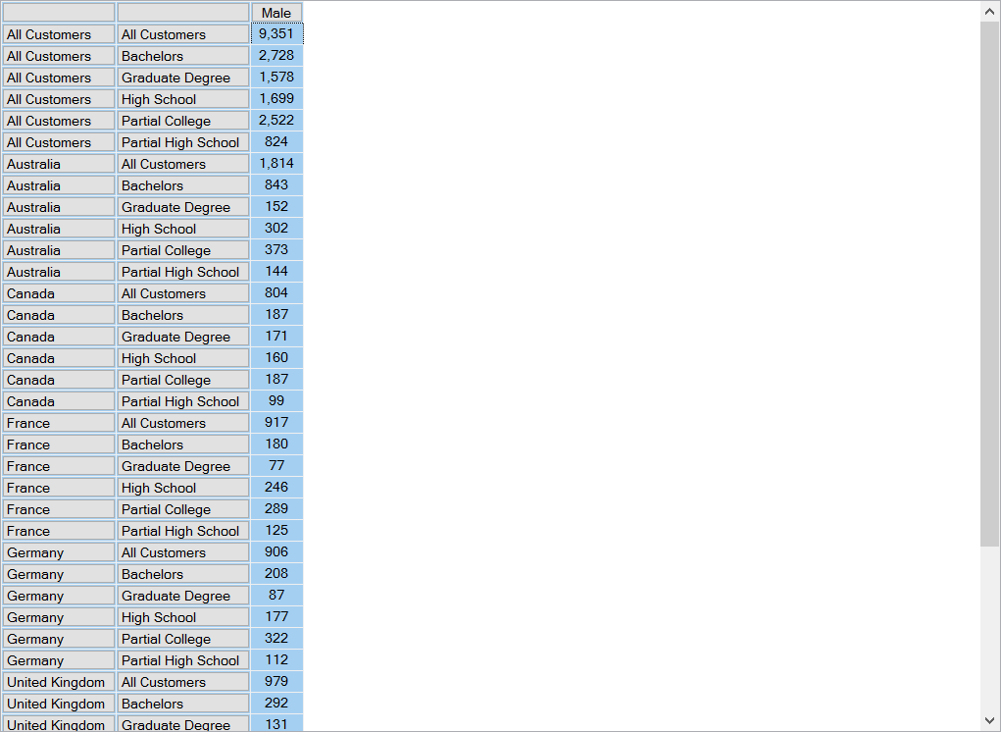

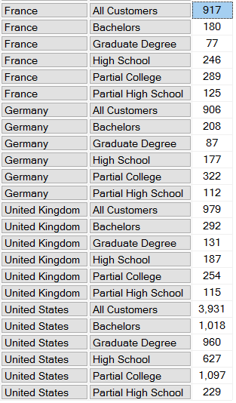

**Problem 4**

WITH MEMBER [Measures].[PercentageMale] AS

'([Gender].[Male],[Measures].[Customer Count])/ ([Gender].[All Customers],[Measures].[Customer Count])',FORMAT_STRING ='#.00%'

SELECT

[Measures].[PercentageMale] on columns,

([Country].members,[Calendar Year].members) on rows

FROM [Adventure Works]

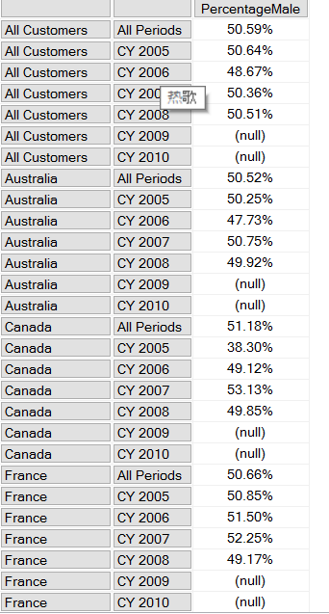

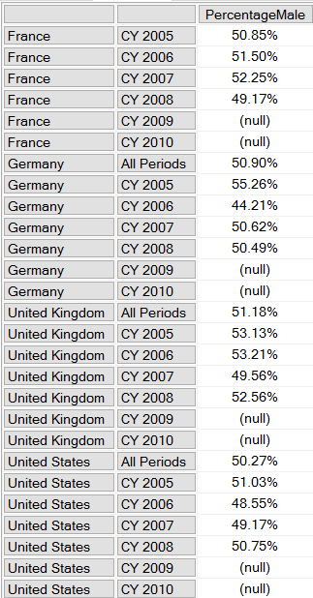

**Problem 5**

SELECT

[Measures].[Internet Sales Amount] on columns,

non empty {[City].members} on rows

FROM [Adventure Works]

WHERE {[France],[Germany]}

