Software Requirements Specification

For

University Communication and Services Portal with Campus Management System and SMS Gateway Integration

Version <2.0>

Group No.: 5 (TT4L)

|  |  |
| --- | --- |
| ANGEL PHOON AN GEE | S-1231302078 |
| MUHAMMAD NABIL NAUFAL BIN MD ZAID | S-1221101160 |
| WAYMAN TAN | S-1211111046 |
| YONG DI LUN | S-1211110326 |

|  |  |
| --- | --- |
|  |  |
|  |  |
|  |  |
|  |  |
| Date: | 18 April 2025 |

Contents

1 Introduction 3

1.1 Purpose 4

1.2 Scope 4

1.3 References 4

1.4 Terms 4

1.5 Abbreviations 4

2 Product Overview 4

2.1 Product Perspective 4

2.2 Product Functions 4

2.3 User Characteristics 4

2.4 Limitations 4

2.5 Assumptions and Dependencies 4

2.6 Apportioning of Requirements 4

2.7 Specified Requirements 4

3 Specific Requirements 4

3.1 External Interfaces 5

3.2 Functions 5

3.3 Usability Requirements 5

3.4 Performance Requirements 5

3.5 Logical Database Requirements 5

3.6 Design Constraints 5

3.7 Standards Compliance 5

3.8 Software System Attributes 5

4 Verification 5

5 Supporting Information 5

6 Index 5

Revisions History

| Version | Primary Author(s) | Description of Version | Date Completed |
| --- | --- | --- | --- |
| 1.0 | Yong Di Lun | Added template for SRS | 2025-04-18 |
| 2.0 | Angel Phoon An Gee, Yong Di Lun | Sections 1.0 to 1.3 written by Angel, checked and edited by Yong Di Lun | 2025-05-12 |

# Introduction

Nowadays, effective communication and streamlined access to information are crucial for institutional success. Hence, the University Communication and Services Portal is designed to bridge the gap between students, lecturers, administrators, and parents. This portal offers real-time access to critical data such as academic performance, attendance records and billing information through a user-friendly interface.

To further enhance responsiveness, the system integrates with an SMS Gateway to enable the delivery of important notifications. Alerts such as low attendance warnings, fee payment reminders and academic progress updates are sent directly to students and parents. This ensures timely information sharing, fosters greater accountability, and strengthens the partnership between the university and its stakeholders. Ultimately, the portal aims to promote transparency, improve communication, and support the academic community.

## Purpose

The purpose of the University Communication and Services Portal is to improve the flow of information between the university and its stakeholders—students, lecturers, administrators, and parents. The portal supports students in managing their academic responsibilities and enables lecturers and administrators to communicate updates efficiently. It also keeps parents informed about their children's academic progress and financial status.

By centralizing access to vital information, the system reduces communication gaps and promotes transparency. Its integration with an SMS Gateway ensures that important messages—such as attendance alerts, fee reminders, and academic updates—are delivered to users in real time, regardless of their location.

This document is intended for all key stakeholders, including students, lecturers, administrators, and parents, as part of a broader effort to foster accountability and create a more organized and responsive educational environment.

## Scope

The University Communication and Services Portal is designed to simplify and enhance access to academic and administrative services. It complements the existing Campus Management System (CMS) by offering a user-friendly interface and essential features for daily operations. The system also integrates with an SMS Gateway to ensure timely communication.

**Supported Role-Based Functionalities:**

* **Students**:
  + View subject details, academic grades, and class schedules.
  + View Notifications and report system issues.
* **Lecturers**:
  + Manage student attendance, grades, and notifications.
  + Monitor student performance and receive alerts for at-risk students.
* **Administrators**:
  + Manage user roles, access logs, fee reports, enrollment statistics, and analytics.
  + Generate system reports.
* **Parents**:
  + Receive SMS updates on attendance, academic performance, and billing.
  + No direct portal access required.

The portal ensures secure, role-based access, protects data confidentiality, and complies with institutional policies.

## Product Overview

The University Communication and Services Portal is a comprehensive, web-based platform designed to unify and streamline communication and services within the university.

**Key Features and Benefits:**

* **Centralized Access**:
  + Real-time access to academic records, attendance, and billing information.
* **Multi-Stakeholder Integration**:
  + Supports students, lecturers, administrators, and parents.
* **Seamless CMS Integration**:
  + Ensures accurate and synchronized data with the existing Campus Management System.
* **SMS Gateway Support**:
  + Sends timely notifications including attendance alerts, fee reminders, and progress summaries.
* **Secure Role-Based Access**:
  + Tailors access and visibility according to user roles to ensure data privacy.
* **Intuitive Interface**:
  + User-friendly design with real-time updates for efficient decision-making.

**Overall Impact:**

* Promotes transparency and accountability.
* Enhances academic monitoring and institutional communication.
* Improves efficiency and stakeholder engagement across the university.

### Product Perspective

The University Communication and Services Portal is an extension of the existing digital infrastructure. Besides, this product also designed to enhance the capabilities of the current Campus Management System (CMS). Rather than replacing existing systems, this portal serves as a communication and service interface to pull data from the CMS and presents it in a user-friendly format for various stakeholders.

This portal acts as a middleware solution which integrates backend systems and frontend user experiences. It leverages existing databases and APIs from the Campus Management System to ensure real-time synchronization of academic records, attendance data and financial information. Additionally, it incorporates an SMS Gateway to enable automated dispatch of important alerts and updates to users.

From a system architecture standpoint, this portal is modular which is designed to support future enhancements such as mobile app integration, multi-language support or the inclusion of new service modules. Overall, the portal is positioned as a bridge between core administrative systems and end users to improve service delivery and communication throughout the university ecosystem.

Additionally, the portal may use SMTP protocol to communicate with an email server, enabling the delivery of email notifications and system alerts. The use of standard communication protocols ensures compatibility, scalability and secure interaction with external systems and services. These interfaces provide transparent, timely and efficient communication within the university ecosystem.

#### Memory Constraints

**Server Side**

* Application server:
  + Minimum of **16 GB RAM** recommended.
  + Supports **concurrent sessions, real-time data retrieval**, and **SMS Gateway communication.**
  + Optimized for **peak usage** (e.g., exam result releases, fee deadlines).
* Database server:
  + Ideally **32 GB RAM or more**.
  + Handles large volumes of **academic, attendance**, and **financial records.**

**Client Side**

* Devices: **Desktops, laptops, tablets, smartphones.**
* Minimum requirement: **2 GB RAM** and **modern web browser**.
* Optimized as a **web-based application** to reduce local resource usage.

**System Optimization**

* Uses **data caching** and **session management**.
* Designed for **consistent performance** and **user satisfaction**.

#### Operations

* 24/7 availability for academic and administrative services
* Hosted on reliable infrastructure (on-premises or cloud-based)
* Routine operations:
  + User authentication
  + Real-time synchronization with Campus Management System
  + Automated SMS notifications based on triggers (e.g., low attendance, fee deadlines)
* Administrator responsibilities:
  + Manage user roles and monitor system performance.
  + Handle data backups and apply security patches or updates.
  + Schedule maintenance tasks (e.g., database optimization, log management) during off-peak hours
* User-facing operations:
  + Login/logout
  + Dashboard navigation
  + Viewing data and managing notifications
  + User-friendly interface requiring minimal training.

#### Site Adaptation Requirements

* Supports deployment on either on-premises servers or cloud infrastructure.
* Hosting environment must provide:
  + Reliable internet connection
  + Adequate power supply
  + Physical or virtual servers with sufficient CPU, memory, and storage
* Software requirements:
  + Compatible operating systems: Linux or Windows Server
  + Relational database: e.g., MySQL
  + Application server: e.g., Node.js or Java
* SMS Gateway integration:
  + Physical: space and network for GSM modems
  + Cloud-based: outbound internet access and API support
* Compatibility with:
  + Existing Campus Management System
  + Authentication infrastructure
  + Network configuration and security policies
* Training for site personnel on:
  + Administration
  + Updates
  + Basic troubleshooting

#### Interface with Services

* Campus Management System:
  + Provides academic, attendance, and billing data.
  + Accessed via direct database connections.
* SMS Gateway:
  + Sends automated messages (e.g., alerts, reminders)
  + Uses standard HTTP communication.
* Authentication and authorization:
  + Integration with Single Sign-On (SSO) systems.
  + Role-based access to portal features and data.
* Additional service interfaces:
  + Email via SMTP for reports and notifications.
  + Payment gateways for student billing.
  + Ensures a fully connected platform to enhance communication and user engagement.

### Product Functions

The **University Communication and Services Portal** provides a comprehensive set of functions that support academic, administrative and communication across the university community. Table below are the descriptions of functions.

|  |  |  |  |
| --- | --- | --- | --- |
| No. | Functions | Description | Accessible Role |
| 1 | View Subject Details | Allows users to access detailed information about subjects | Student |
| 2 | View Academic Grades | Allows students to view their grades | Student |
| 3 | View Class Schedule | Displays the class schedule for the student | Student |
| 4 | View Notification | View notification | Student |
| 5 | Report System Issues | Allows users to report technical problems | Student, Lecturer |
| 6 | Manage Notifications | Enables lecturers and admin automate notifications to students and their parent | Lecturer, Admin |
| 7 | Manage Grades | Allows lecturers to enter or update student grades | Lecturer |
| 8 | Manage Attendance | Enables lecturers to track and record attendance | Lecturer |
| 9 | View Student Progress | Allows lecturers to monitor the academic progress of students | Lecturer |
| 10 | Receive At-Risk Student Alerts | Notifies lecturers about students who may be at academic risk | Lecturer |
| 11 | Manage User Role | Administers user role assignments and permissions | Administrator |
| 12 | Monitor System Access Logs | Tracks and audits system access activity | Administrator |
| 13 | Generate Fee Reports | Creates financial reports related to student fees | Administrator |
| 14 | View Enrollment Statistics | Shows data on student enrollment figures | Administrator |
| 15 | View Advanced Analytics Dashboard | Provides advanced data insights and analysis | Administrator |
| 16 | View System Issue | View system issue report by student or lecturer | Administrator |

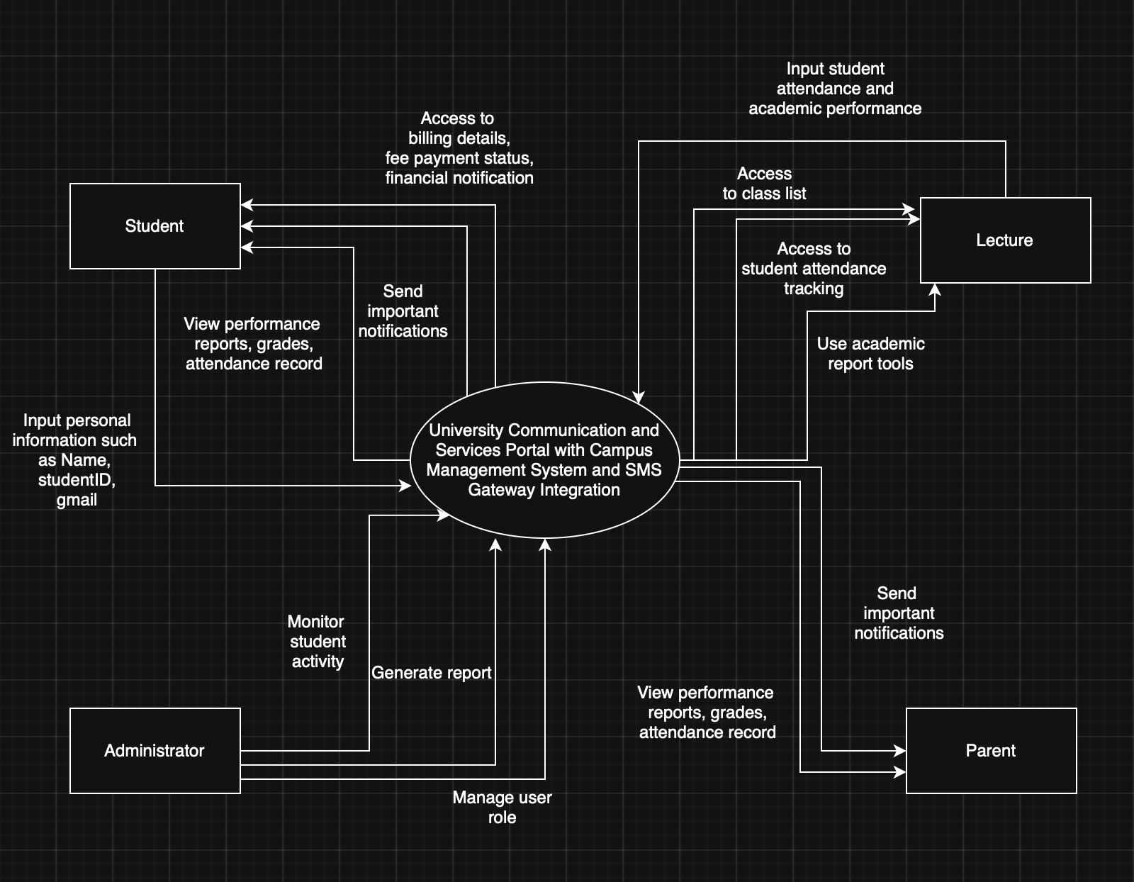

Figure above illustrates the context diagram of University Communication and Services Portal with Campus Management System and SMS Gateway Integration.

Link: <https://app.diagrams.net/#Hangelphoon7%2FSRS%2Fmain%2FUntitled%20Diagram.drawio%23%7B%22pageId%22%3A%22C5RBs43oDa-KdzZeNtuy%22%7D>

### User Characteristics

The University Communication and Services Portal is designed to accommodate a diverse range of users with varying levels of technical proficiency, educational backgrounds, and responsibilities. The primary user groups include students, lecturers, administrators and parents, each with distinct needs and access rights.

|  |  |
| --- | --- |
| Role | Description |
| Student | Students are typically digital natives which familiar with online platforms and mobile devices. They require intuitive access to academic records, attendance information, billing details and notifications. Their interaction with the portal is frequent, particularly during registration periods, assessment times, and fee deadlines. |
| Lecture | Lecturers are academic staff members who use the portal to manage course-related information, view student attendance and monitor academic performance. While many lecturers are comfortable with technology, the portal is designed to support varying levels of digital literacy by offering a clear, user-friendly interface and role-specific features. |
| Administrator | Administrators are responsible for managing system configurations, user accounts, reporting tools and institutional data. This group generally possesses a higher level of technical knowledge and may require access to advanced features such as data exports, user activity logs and system alerts. |
| Parent | Parents represent a user group with potentially limited exposure to educational portals. They primarily use the system to monitor their child’s academic progress, attendance, and financial obligations. To accommodate this, the portal does not include a dedicated interface for parents. Instead, the system delivers well-structured SMS messages containing summarized information, along with attached files when necessary (e.g., grade reports, fee statements). This approach ensures parents receive timely and accessible updates without the need to navigate the system directly. |

### Limitations

* **Dependence on Campus Management System (CMS):**
  + Portal relies heavily on integration with the CMS.
  + Any inaccuracies, downtime, or delays in the CMS affect data quality and timeliness.
  + The portal does not modify or enhance CMS functionality—only retrieves and displays data.
  + Limits flexibility in implementing advanced features.
* **Internet Connectivity Requirements:**
  + As a web-based system, stable internet is required for access and functionality.
  + Users in areas with poor infrastructure or during outages may face accessibility issues.
* **SMS Notification Constraints:**
  + Dependent on external SMS carriers and their availability.
  + Prone to message delivery failures or delays.
  + Limited message length and formatting restrict detailed communication.
* **Security and System Updates:**
  + Role-based access and encryption are in place, but ongoing threats require regular updates and monitoring.
  + Potential vulnerability to common web-based security threats if not maintained properly.
* **Limited Support for Custom Features:**
  + Highly customized workflows and complex reporting are not supported without additional development.
* **Digital Literacy Barriers:**
  + Users with limited technical skills may experience a learning curve when using the system.

## Definitions

# References

# Specific Requirements

## Functions

## Performance Requirements

## Usability Requirements

## Interface Requirements

### System Interfaces

### User Interfaces

### Hardware Interfaces

### Software Interfaces

### Communication Interfaces

### External Interfaces

## Logical Database Requirements

## Design Constraints

## Software System Attributes

## Supporting Information

# Verification

## Verification Approach

## Verification Criteria

# Appendices

## Assumptions and Dependencies

## Acronyms and Abbreviations

## Glossary