Test Summary Report
General Information
Test Report Description | This Test Summary Report provides a summary of findings based on the Test Log and Test Incident Report for the Library Management System.
Version Author | Yong Di Lun | Contact Number | -
Associated test plan reference | LMS_TP_1.0.0
Execution Date | 04/06/2026 to 04/06/2026

Summary
Test Status Report Summary
The status of the test are as follow:
Number of Test Cases Planned to be Completed | Number of Test Cases Remaining to be Executed | Number of Test Cases Completed | Number of Test Cases Passed | Number of Test Cases Failed
68 | 0 | 68 | 40 | 28
Current status of the Test Incident Report are as follow:
New  (new incident introduced in current iteration) | Open  (incident discovered from previous test iteration that still pending to be resolved) | Reject  (incidents that were rejected after investigation because it cannot be categorised as incident) | Resolved  (incidents that have been confirmed resolved) | Deferred  (incidents that have been deferred)
28 | 28 | 0 | 0 | 0
Note: The number of incidents is counted based on Test Incident ID and not based on Test Incident Report ID.

Incident ID | Test Case ID | Severity | Short Description | Status
LMS_TIR_1.0/TIR-001 | TC-02-002 | Fatal | Registered email with wrong password was accepted if this row fails. | Open
LMS_TIR_1.0/TIR-002 | TC-04-003 | Major | Empty name was submitted through the profile update form. | Open
LMS_TIR_1.0/TIR-003 | TC-04-004 | Major | Empty email was submitted through the profile update form. | Open
LMS_TIR_1.0/TIR-004 | TC-05-003 | Minor | Book list displayed title, author, and availability/count. | Open
LMS_TIR_1.0/TIR-005 | TC-05-004 | Fatal | Simulated BookManager.list database failure returned HTTP 500. | Open
LMS_TIR_1.0/TIR-006 | TC-06-005 | Fatal | Simulated BookManager.getBook database failure returned HTTP 500. | Open
LMS_TIR_1.0/TIR-007 | TC-07-002 | Major | Empty search input was submitted from the home search form. | Open
LMS_TIR_1.0/TIR-008 | TC-07-003 | Major | A 60-character keyword was submitted. | Open
LMS_TIR_1.0/TIR-009 | TC-07-006 | Major | Empty search validation message was checked. | Open
LMS_TIR_1.0/TIR-010 | TC-08-003 | Major | A user with five reservations attempted another reservation. | Open
LMS_TIR_1.0/TIR-011 | TC-08-004 | Major | Duplicate reservation route was invoked directly with an authenticated user session. | Open
LMS_TIR_1.0/TIR-012 | TC-08-005 | Major | Reservation limit message was checked after exceeding the limit. | Open
LMS_TIR_1.0/TIR-013 | TC-10-001 | Fatal | Admin Add Book route was submitted with valid data. | Open
LMS_TIR_1.0/TIR-014 | TC-10-009 | Fatal | Database insertion was checked after valid Add Book submission. | Open
LMS_TIR_1.0/TIR-015 | TC-10-003 | Minor | Description field was inspected for required validation. | Open
LMS_TIR_1.0/TIR-016 | TC-10-004 | Major | Quantity field was inspected for a minimum value rule. | Open
LMS_TIR_1.0/TIR-017 | TC-10-006 | Major | Duplicate book handling was checked against the real Add Book route/page. | Open
LMS_TIR_1.0/TIR-018 | TC-10-008 | Minor | Field-specific error message was checked for missing Description. | Open
LMS_TIR_1.0/TIR-019 | TC-11-002 | Fatal | Simulated BookManager.delete failure returned HTTP 500; target book still exists = True. | Open
LMS_TIR_1.0/TIR-020 | TC-11-003 | Major | Delete non-existing book returned HTTP 302. | Open
LMS_TIR_1.0/TIR-021 | TC-11-005 | Minor | Admin delete link was inspected for an explicit confirmation step. | Open
LMS_TIR_1.0/TIR-022 | TC-11-006 | Minor | Cancel deletion flow was checked; no confirmation dialog is implemented. | Open
LMS_TIR_1.0/TIR-023 | TC-11-008 | Fatal | Deletion failure message check used simulated delete failure response HTTP 500. | Open
LMS_TIR_1.0/TIR-024 | TC-12-001 | Fatal | Admin edit route was submitted with valid values. | Open
LMS_TIR_1.0/TIR-025 | TC-12-010 | Fatal | Database was checked after valid edit submission. | Open
LMS_TIR_1.0/TIR-026 | TC-12-002 | Major | Invalid edit Book ID returned HTTP 200. | Open
LMS_TIR_1.0/TIR-027 | TC-12-005 | Major | Quantity field was inspected for a positive/minimum value rule. | Open
LMS_TIR_1.0/TIR-028 | TC-12-007 | Fatal | Description-only edit was submitted through the edit route. | Open

Document references
- LMS_TP_1.0.0
- LMS_TDS_1.0.0
- LMS_TCS_1.0.0
- LMS_TPS_1.0.0
- LMS_TL_1.0.0
- LMS_TIR_1.0.0
Changes from Plans
There has been no change from plan. All 68 planned test cases have been completed. Refer to the charts and coverage table below.

Comprehensiveness assessment
All 68 planned test cases were completed. 40 test cases passed (58.82%) and 28 test cases failed (41.18%). The failed cases resulted in 28 open incidents: 10 fatal, 13 major, and 5 minor defects.

For the schedule adherence, refer to the diagram below:
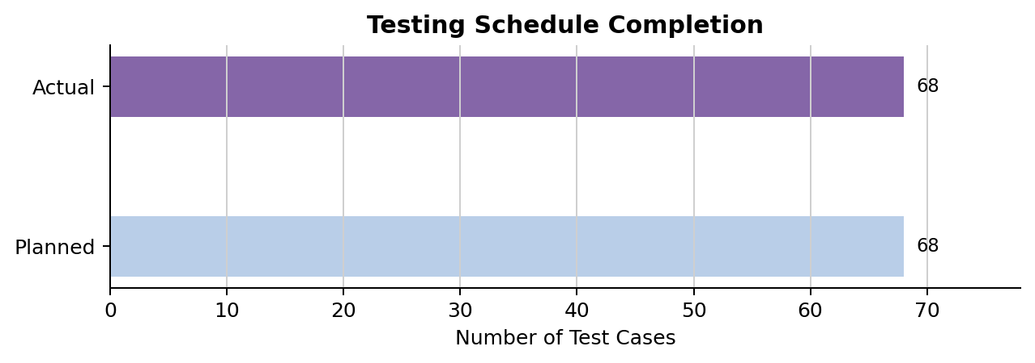
The Test Case coverage is shown as below:
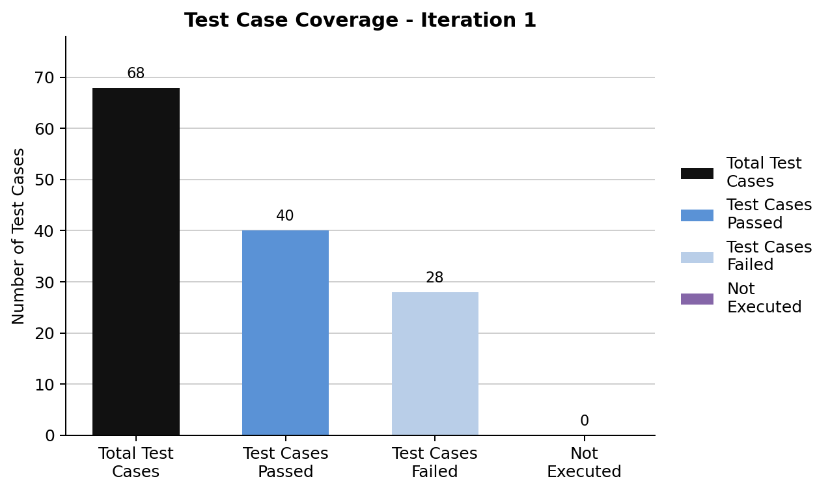
The Test Case result by function is shown as below:
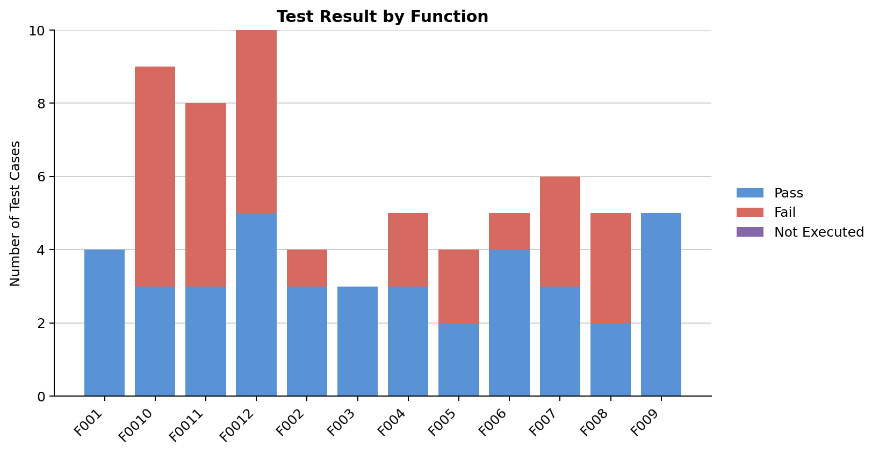
Below are the lists of defects found through testing, by severity:
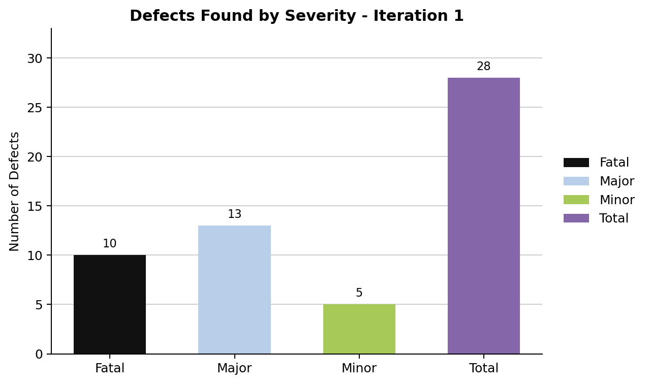
NOTE:
- Incident having critical security, data integrity, or unhandled server-error impact = Fatal defect.
- Incident having important business-rule or validation impact = Major defect.
- Incident having display, message, or procedural impact = Minor defect.

Test Documents | % Completed | Date of Completion
Test Plan | 100 | 04/06/2026
Test Design Specification | 100 | 04/06/2026
Test Case Specification | 100 | 04/06/2026
Test Procedure Specification | 100 | 04/06/2026
Test Log | 100 | 04/06/2026
Test Incident Report | 100 | 04/06/2026
Test Summary Report | 100 | 05/06/2026

Result Summary
The items tested were the Library Management System functional features F001 to F0012.
68 test cases were planned and executed. 40 test cases passed and 28 test cases were recorded with incidents. The pass rate is 58.82%.
10 fatal incidents, 13 major incidents, and 5 minor incidents were found in this test iteration. All incidents remain open and should be corrected by the development team before release.
Rationale for Decisions
Due to the existence of fatal and major defects at the end of the test iteration, the current LMS version is not recommended for release. Fatal defects include authentication, admin book management, update persistence, and unhandled database failure responses.
Conclusion and Recommendation Based on Test Result
Conclusion: The current version of the product is not fit for release until fatal and major defects are fixed.
Recommendation: Fix failed authentication validation, profile/search/reservation rules, admin add/edit/delete flows, and database error handling. After correction, execute regression testing using the same automated test system.

Approvals
Name | Job Title | Signature
Prepared By:  Yong Di Lun | Test Lead  LMS Test Team
Reviewed By:  QA Manager | Quality Assurance Team  LMS Test Team
Reviewed By:  Test Manager | Test Manager  LMS Test Team
Approved By:  Project Manager | Project Manager  LMS Project

