Test Summary Report
General Information
Test Report Description | This Test Summary Report includes LMS functional and non-functional test results.
Version Author | Yong Di Lun | Contact Number | -
Associated test plan reference | LMS_TP_1.0.0
Included NFRs | REQ_Q001, REQ_Q002, REQ_Q003, REQ_Q004

Test Status Report Summary
Planned | Remaining | Completed | Passed | Failed
72 | 0 | 72 | 41 | 31
Current Incident Status: New/Open = 31, Rejected = 0, Resolved = 0, Deferred = 0.
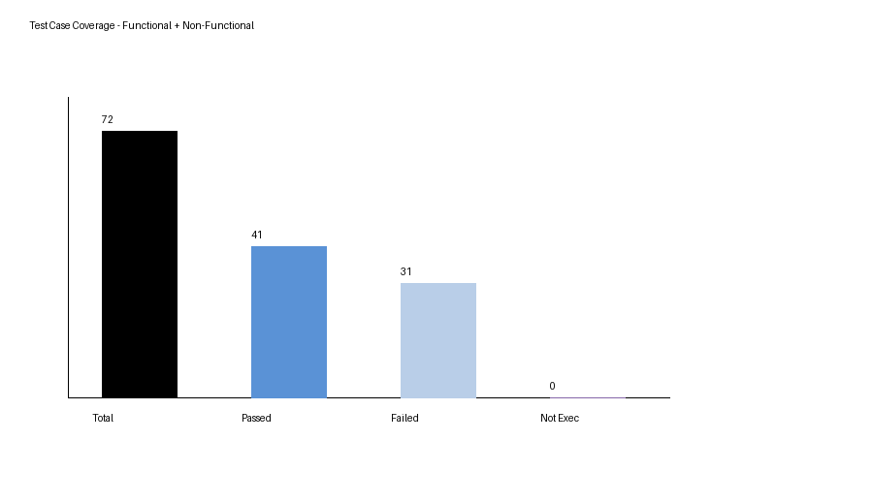
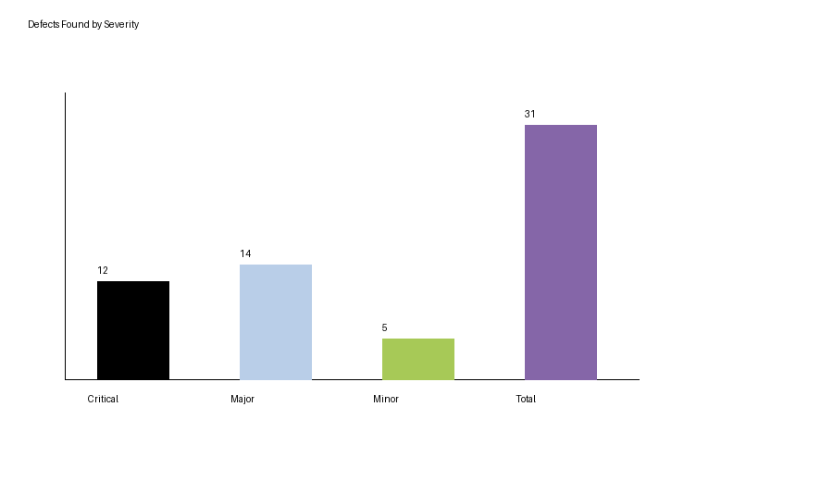
Result Summary: 72 total test cases were completed. 41 passed and 31 failed. The NFR update added 4 test cases, with 1 pass and 3 failures.
Conclusion: The current LMS version is not recommended for release until open functional and non-functional incidents are fixed, especially security and data-integrity defects.

