

**Hystrix: Latency and Fault Tolerance for Distributed Systems**

Hystrix基础

What is Hystrix

Hystrix [hɪst'rɪks] 高起[鱼]鳞癣

## Introduction

Hystrix is a latency(延迟) and fault tolerance(容错) library designed to isolate points of access to remote systems, services and 3rd party libraries, stop cascading failure(雪崩效应) and enable resilience(增强稳定性) in complex distributed systems where failure is inevitable.

## What Is Hystrix?

In a distributed environment, inevitably some of the many service dependencies will fail. Hystrix is a library that helps you control the interactions between these distributed services by adding latency tolerance(延迟容忍) and fault tolerance(错误容忍) logic. Hystrix does this by isolating points of access between the services, stopping cascading failures across them, and providing fallback options, all of which improve your system’s overall resiliency.

当一个应用依赖多个外部服务，一切都正常的情况下，如下图：

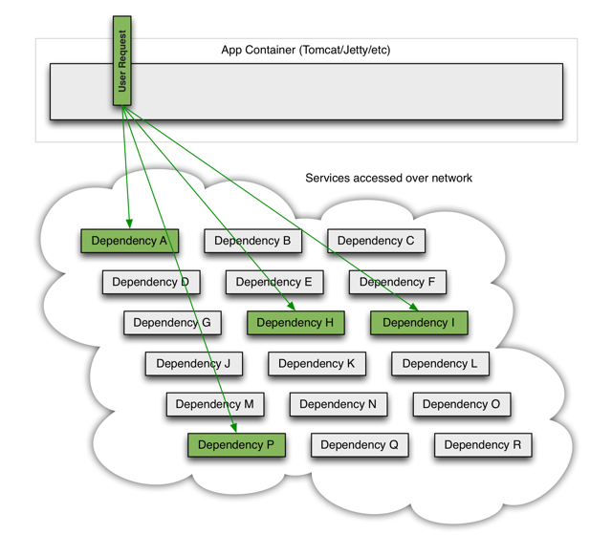

如果其中一个依赖发生延迟，当前请求就会被阻塞

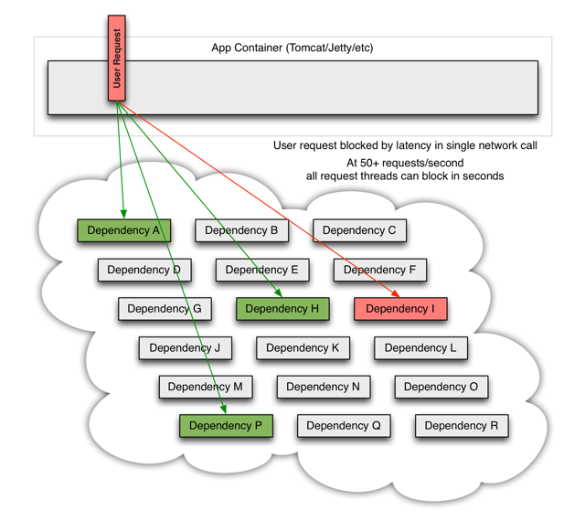

出现这种情况后，如果没有应对措施，后续的请求也会被持续阻塞

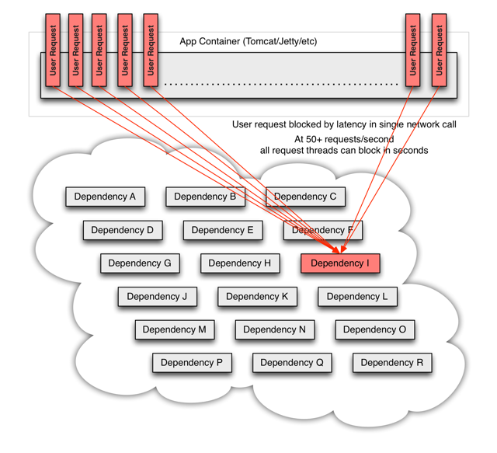

所以，当引入了Hystrix之后，当出现某个依赖高延迟的时候：

