Assignment 1:
Comprehensive Project Management Plan for the Innovation Project

Project Topic:
Spam & Malware Detection System
(CyberShield AI)

Group Name | Group 1
Group Members (Student ID) | Tee Ren Hang (106214467)  Ng Yong Hin (106214441)
Section | C1
Subject | COS30049 – Computing Technology Innovation Project
Lecturer | Mr. Faizal
Word Count | 2641 words (exclude table of contents and references)

Table of Contents
1.0 Project Background and Introduction 1
1.1 Background 1
1.2 Problem Statement 1
1.3 Project Objectives 2
1.4 Scope 2
2.0 Team Introduction 3
3.0 Project Requirements 4
3.1 Functional Requirements 4
3.2 Non-Functional Requirements 4
4.0 Scope Management 5
4.1 Project Scope Statement 5
4.2 Work Breakdown Structure (WBS) 6
4.3 WBS Dictionary 9
5.0 Time Management 10
5.1 Development Schedule 10
5.2 Gantt Chart 11
6.0 Risk Management 12
6.1 Risk Register 12
6.2 Risk Management Plan 13
7.0 Monitor and Control (Change Control) 14
7.1 Progress Monitoring 14
7.2 Change Control Process 14
7.3 Change Log 15
8.0 Closure Plan 16
8.1 Project Acceptance Criteria 16
8.2 Closure Activities 16
9.0 Project Design (UI/UX Prototype) 17
9.1 Design Overview 17
9.2 Prototype Screens 18
9.3 Usability Principles Applied 22
10.0 References 23
11.0 Bibliography 23

1.0 Project Background and Introduction

1.1 Background
The proliferation of digital communication has led to a significant rise in spam messages and malware threats. Cybercriminals exploit email systems, messaging platforms, and file-sharing services to distribute unsolicited content and malicious software that can compromise personal data, financial systems, and organizational infrastructure.

This project, named CyberShield AI, aims to develop a machine learning-based spam and malware detection system that can automatically classify incoming messages and files as either legitimate or harmful. By leveraging pattern recognition and feature extraction techniques, the system will provide real-world cybersecurity value and serve as an interactive platform for users to understand how such models work.

The project is structured in three phases, project management planning and UI/UX prototype design, machine learning model implementation, and web application development and deployment. This document covers Phase 1, establishing the foundation for subsequent development phases.

1.2 Problem Statement
Spam and malware continue to be among the most prevalent and damaging cybersecurity threats facing individuals and organizations today. Traditional rule-based filtering systems struggle to keep pace with the increasingly sophisticated tactics used by attackers, such as polymorphic malware and context-aware phishing emails. There is a clear need for an intelligent, adaptive detection system capable of learning from data patterns to accurately classify and mitigate these threats in real time.

This project addresses this gap by developing a machine learning-powered detection system that analyses text-based communications and identifies spam or malware with high accuracy, providing users with actionable threat insights through an interactive web interface.

1.3 Project Objectives
The project is guided by four primary objectives. First, the team aims to develop and train machine learning models capable of classifying emails and messages as spam, ham, or malware with a minimum accuracy of 95%. Second, the project seeks to build an interactive web application that allows users to input messages and receive instant threat classification results alongside confidence scores. Third, data visualization features will be integrated to provide users with meaningful insights into dataset statistics and model performance metrics. Finally, the interface will be designed in accordance with established UI/UX principles to ensure accessibility and a positive user experience for all users regardless of technical background.

1.4 Scope
The project focuses on text-based spam and malware detection using publicly available datasets. The system will be delivered as a web application supporting manual text/file input by the user. Real-time email server integration, mobile application development, and multi-language support are explicitly out of scope for this project.

2.0 Team Introduction
Name | Role | Responsibilities
  Tee Ren Hang  106214467 | Project Manager, Report Lead, UI/UX Designer | Project background & introduction, problem statement, project objectives & scope, project requirements (FR & NFR), UI/UX prototype design (Figma), usability principles, meeting minutes, contribution form
  Ng Yong Hin  106214441 | Technical Lead, Project Planner | Team introduction, scope management (WBS, WBS Dictionary), time management (Gantt Chart, development schedule), risk management (risk register & plan), monitor & control, closure plan, references& control, closure plan, references

3.0 Project Requirements

3.1 Functional Requirements
The following table outlines the key functional requirements for the CyberShield AI system across all three project phases.

ID | Requirement | Priority | Description
FR-01 | Message Input | High | Users can paste or upload email/message text for analysis
FR-02 | Spam Classification | High | ML model classifies messages as spam or legitimate (ham)
FR-03 | Malware Detection | High | System identifies potential malware threats in messages/attachments
FR-04 | Confidence Score | Medium | Display classification confidence percentage
FR-05 | Data Visualization | Medium | Interactive charts showing dataset statistics and model metrics
FR-06 | Threat History Log | Medium | Display recent scan results and threat history
FR-07 | Real-time Processing | High | Analysis completed within 2 seconds of submission

3.2 Non-Functional Requirements
Non-functional requirements define the quality attributes and constraints of the system.

ID | Requirement | Category | Description
NFR-01 | Response Time | Performance | Classification results returned within 2 seconds
NFR-02 | Accuracy | Quality | Model achieves minimum 95% classification accuracy
NFR-03 | Usability | UX | Interface follows Nielsen's 10 usability heuristics
NFR-04 | Scalability | Architecture | System handles 1000+ concurrent users
NFR-05 | Security | Security | All data encrypted in transit and at rest

4.0 Scope Management

4.1 Project Scope Statement

The project scope encompasses the development of a machine learning-based spam and malware detection system with a web-based interface. The system will process text-based communications (emails and messages), classify them using trained ML models, and present results through an intuitive dashboard with data visualization capabilities.

In Scope: Dataset collection and preprocessing, ML model development (training, tuning, evaluation), web application frontend (React.js with Material UI), backend API for model serving using FastAPI, data visualization dashboard using D3.js, user authentication, and project documentation.

Out of Scope: Mobile application development, real-time email server integration, enterprise-grade deployment infrastructure, and multi-language support beyond English.

4.2 Work Breakdown Structure (WBS)
The WBS decomposes the project into five major phases, each containing sub-tasks assigned to team members.
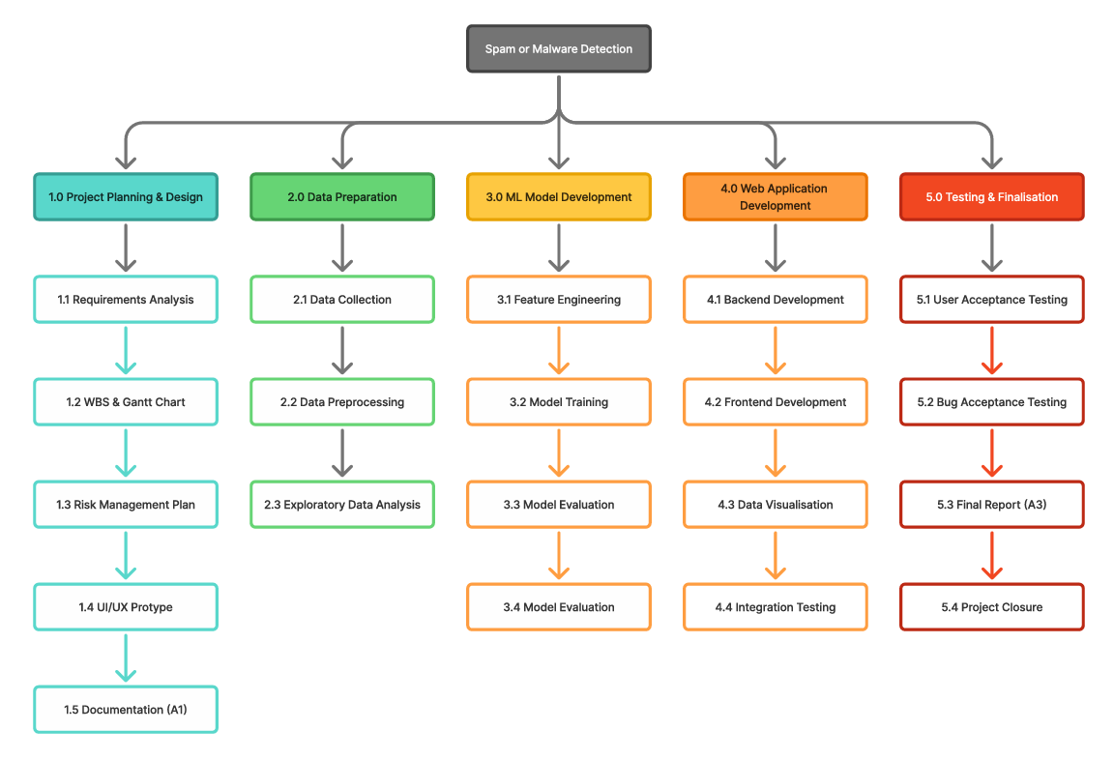
Figure 1: WBS Diagram

WBS ID | Task Name | Description | Assigned To
1.0 | Project Planning & Design | Overall planning, documentation, and prototype design | Both
1.1 | Requirements Analysis | Define functional and non-functional requirements, identify dataset. | Tee Ren Hang
1.2 | WBS & Gantt Chart | Create work breakdown structure and project timeline. | Ng Yong Hin
1.3 | Risk Management Plan | Identify project risks, assess likelihood/impact, define mitigation. | Ng Yong Hin
1.4 | UI/UX Prototype | Design wireframes and prototype using Figma. | Tee Ren Hang
1.5 | Documentation (A1) | Compile and submit Assignment 1 report. | Both
2.0 | Data Preparation | Dataset collection, cleaning, and exploratory analysis | Ng Yong Hin
2.1 | Data Collection | Download and validate UCI SMS Spam dataset. | Ng Yong Hin
2.2 | Data Preprocessing | Clean text, remove stopwords, tokenize, encode labels. | Ng Yong Hin
2.3 | Exploratory Data Analysis | Generate statistical summaries, class distribution plots, word clouds. | Both
3.0 | ML Model Development | Feature engineering, model training, evaluation, and export | Ng Yong Hin
3.1 | Feature Engineering | Apply TF-IDF and BoW vectorization. | Ng Yong Hin
3.2 | Model Training | Train Naive Bayes, SVM, and Random Forest classifiers. | Ng Yong Hin
3.3 | Model Evaluation | Evaluate accuracy, precision, recall, F1; generate confusion matrix. | Ng Yong Hin
3.4 | Model Export | Serialize final model using pickle/joblib for web integration. | Ng Yong Hin
4.0 | Web Application Development | Frontend, backend, data visualization, and integration | Tee Ren Hang
4.1 | Backend Development | Build FastAPI endpoints for model inference. | Tee Ren Hang
4.2 | Frontend Development | Implement React.js with Material UI (MUI) frontend aligned with Figma prototype. | Tee Ren Hang
4.3 | Data Visualization | Integrate D3.js for interactive dataset and model charts. | Tee Ren Hang
4.4 | Integration Testing | Test end-to-end pipeline from user input to classification output. | Both
5.0 | Testing & Finalization | UAT, bug fixing, final report, and project closure | Both
5.1 | User Acceptance Testing | Test usability with sample users; gather feedback. | Both
5.2 | Bug Fixing & Refinement | Address identified issues from testing phase. | Both
5.3 | Final Report (A3) | Compile and submit Assignment 3 documentation. | Both
5.4 | Project Closure | Conduct closure review, archive artefacts, complete contribution forms. | Both

4.3 WBS Dictionary
The WBS Dictionary provides detailed descriptions, deliverables, duration estimates, and dependencies for key work packages.

WBS ID | Task Name | Deliverable | Duration | Dependencies
1.1 | Requirements Analysis | FR & NFR tables in project report | 3 days | Project inception
1.4 | UI/UX Prototype | Figma wireframes (5+ screens) | 1 week | 1.1 complete
2.1 | Data Collection | Downloaded dataset files, validation report | 2 days | Phase 1 complete
2.2 | Data Preprocessing | Cleaned dataset CSV, preprocessing script | 3 days | 2.1 complete
3.2 | Model Training | Trained model files (.pkl), training notebook | 5 days | 3.1 complete
4.2 | Frontend Development | Responsive React web application | 1 week | 4.1 complete
4.4 | Integration Testing | Test report with pass/fail results | 3 days | 4.1, 4.2, 4.3 complete

5.0 Time Management

5.1 Development Schedule
The project follows an iterative development methodology spanning approximately 14 weeks from inception to final delivery. The Gantt chart illustrates the complete timeline with task dependencies and milestones.

Phase | Task | Start Date | End Date | Duration
Phase 1: Project Planning & Design | Project plan, risk assessment, UI prototype | 30 Mar 2026 | 24 Apr 2026 | 4 weeks
Phase 2: Data Preparation | Data collection, data preprocessing | 21 April 2026 | 10 May 2026 | 3 weeks
Phase 3: ML Model Development | Feature engineering, model training | 5 May 2026 | 23 May 2026 | 3 weeks
Phase 4: Web Application Development | Frontend, backend, integration, visualization | 22 May 2026 | 14 Jun 2026 | 3 weeks
Phase 5: Testing & Finalization | Unit, integration, UAT, bug fixes, documentation, deployment, handover | 4 Jun 2026 | 27 Jun 2026 | 3 weeks

5.2 Gantt Chart

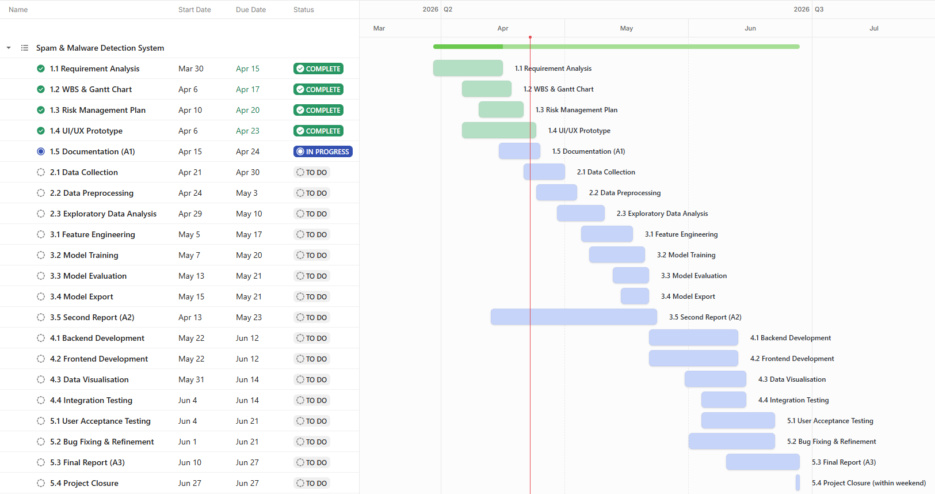
Figure 2: Gantt Chart

6.0 Risk Management

6.1 Risk Register
The following risk register identifies all foreseeable project risks, their likelihood and impact ratings, and proposed mitigation strategies.

Risk ID | Risk Description | Category | Likelihood | Impact | Risk Level | Mitigation Strategy
R-001 | Poor ML model accuracy due to imbalanced dataset | Technical | Medium | High | HIGH | Apply SMOTE oversampling; use stratified cross-validation
R-002 | Team member becoming unresponsive or disengaging from discussions on Discord | Resource | Medium | High | HIGH | Cross-train members; redistribute tasks if needed
R-003 | Scope creep causing timeline overrun | Scope | Medium | High | HIGH | Strict change control process; weekly scope reviews
R-004 | Difficulty integrating ML model with web backend | Technical | Low | Medium | MEDIUM | Prototype integration early in Phase 2; use FastAPI for backend integration
R-005 | UI design does not meet usability expectations | Quality | Low | High | MEDIUM | Follow Nielsen's heuristics; conduct peer review of prototype
R-006 | Communication breakdown within 2-person team | Communication | Medium | High | HIGH | Weekly meetings; use shared project management tools

6.2 Risk Management Plan
Risk management will be conducted on an ongoing basis throughout all project phases. The team will review the risk register at every weekly meeting to assess whether any identified risks have materialized or whether new risks have emerged.

Risk likelihood and impact are rated on a three-point scale (Low / Medium / High). A risk is classified as HIGH if both likelihood and impact are medium or above, MEDIUM if either is low, and LOW if both are low. All High-level risks require an immediate documented mitigation action.

The primary risk owner for all risks is the team collectively, given the two-member team structure. Any risk that materializes and results in a change to the project scope, timeline, or deliverables must be logged in the Change Log (Section 7.3).

7.0 Monitor and Control (Change Control)

7.1 Progress Monitoring
Progress will be monitored through weekly team meetings held every Saturday, where each member reports on completed tasks, upcoming tasks, and any blockers. Progress is tracked against the Gantt Chart baseline. Key performance indicators for monitoring include tasks completed on schedule (target 100%), assignment submission on time, and risk register reviewed at every meeting. Any deviation of more than two days from the planned schedule triggers a re-planning discussion. Meeting minutes will be recorded for every meeting and submitted as part of the assignment deliverables, serving as an audit trail for team communication and decisions.

7.2 Change Control Process
Any proposed change to the project scope, timeline, or deliverables must follow the change control process below. The process begins with identification, where a team member recognizes a need for change and documents it informally. The change is then formally submitted by logging it in the Change Log with a full description, the requestor’s name, and the submission date. During the following team meeting, both members assess the impact of the proposed change on scope, time, and overall quality. A decision is then made, requiring agreement from both team members for the change to be approved; if disagreement persists, the matter is escalated to the lecturer or tutor for resolution. Once approved, the change is implemented by updating the relevant project artefacts including the project plan, WBS, and Gantt Chart accordingly.

7.3 Change Log
Change ID | Description | Requestor | Date Submitted | Impact | Status | Decision
CR-001 | Reassign WBS task 1.3 (Risk Management Plan) from Both to Ng Yong Hin to better reflect actual task ownership and improve clarity of responsibility allocation. | Ng Yong Hin | 06 Apr 2026 | No scope or timeline impact | Approved | Both members; update WBS Assigned To column
CR-002 | Expand Dashboard prototype screen (Section 9.2) to include Spam Cluster Distribution donut chart and Spam Volume Heatmap in addition to the originally planned class distribution pie chart. | Tee Ren Hang | 13 Apr 2026 | Minor scope addition to prototype; no timeline impact | Approved | Both members; update Figma prototype and Section 9.2 description

8.0 Closure Plan

8.1 Project Acceptance Criteria
Criterion | Description | Measurement
Model Accuracy | ML model achieves ≥95% classification accuracy | Accuracy, Precision, Recall, F1-Score on test set
Functional Completeness | All functional requirements (FR-01 to FR-07) implemented | Requirements traceability matrix
Performance | Response time <2 seconds for classification | Load testing results
Code Quality | Clean, documented code passing all tests | Code review, test coverage >80%
Documentation | Complete project documentation and user guide | Deliverables checklist
Deployment | Application deployed and accessible via URL | Deployment verification

8.2 Closure Activities
Project closure includes final deliverables review against acceptance criteria, lessons learned documentation, knowledge transfer to stakeholders, archiving of all project artifacts (code, datasets, models, documentation), individual and team performance evaluation, and final project report submission.

9.0 Project Design (UI/UX Prototype)

9.1 Design Overview
The CyberShield AI web application is designed to provide a clean, intuitive interface that enables users, regardless of technical background to interact with the spam and malware detection models. The design philosophy prioritizes clarity, trust, and efficiency.

The prototype was designed using Figma and consists of five key screens: Home Page, Detection Input Page, Results Page, Data Visualization Dashboard, and Threat History Page. The design adheres to Nielsen's 10 Usability Heuristics and Material Design principles to ensure consistent, accessible, and user-friendly interactions.

As this is a Phase 1 wireframe prototype, the current design uses a monochromatic black-and-white layout to focus on structure, information hierarchy, and interaction flow. Visual styling decisions, including color palette and typography, will be finalized in a later phase of development.

9.2 Prototype Screens

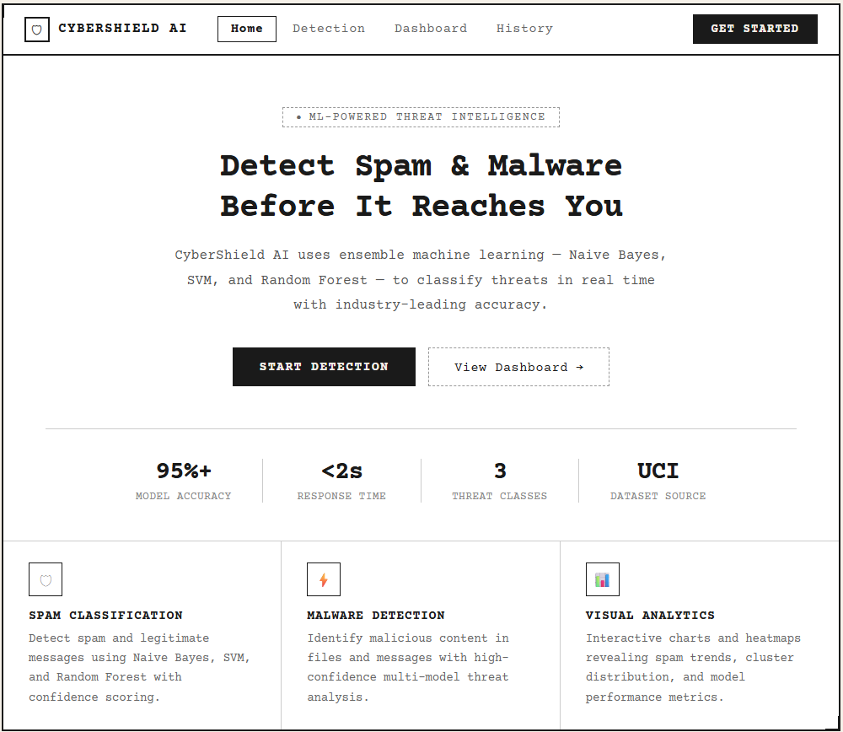
Figure 3: Initial home page design

Home Page: Introduces the CyberShield AI system with a clear call-to-action button directing users to the detection tool. Includes a brief description of the system's capabilities and navigation links.

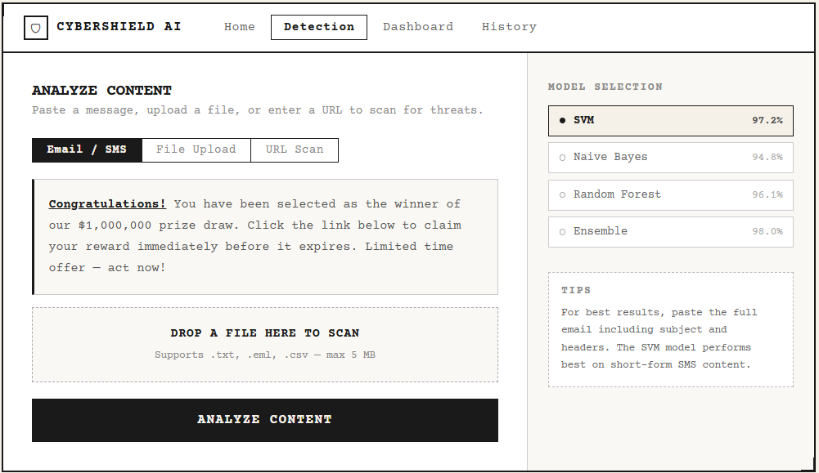
Figure 4: Initial detection input page design

Detection Input Page: Provides a text area for users to paste email or message content, with an option to upload a file. A prominent 'Analyze' button triggers the classification process.

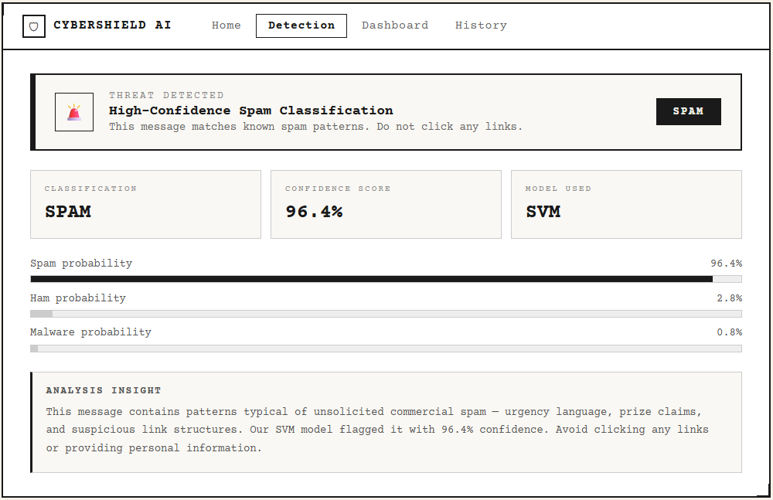
Figure 5: Initial results page design

Results Page: Displays the classification result (Spam / Ham / Malware) with a confidence score percentage, a visual indicator bar, and a brief explanation of what the result means for the user.

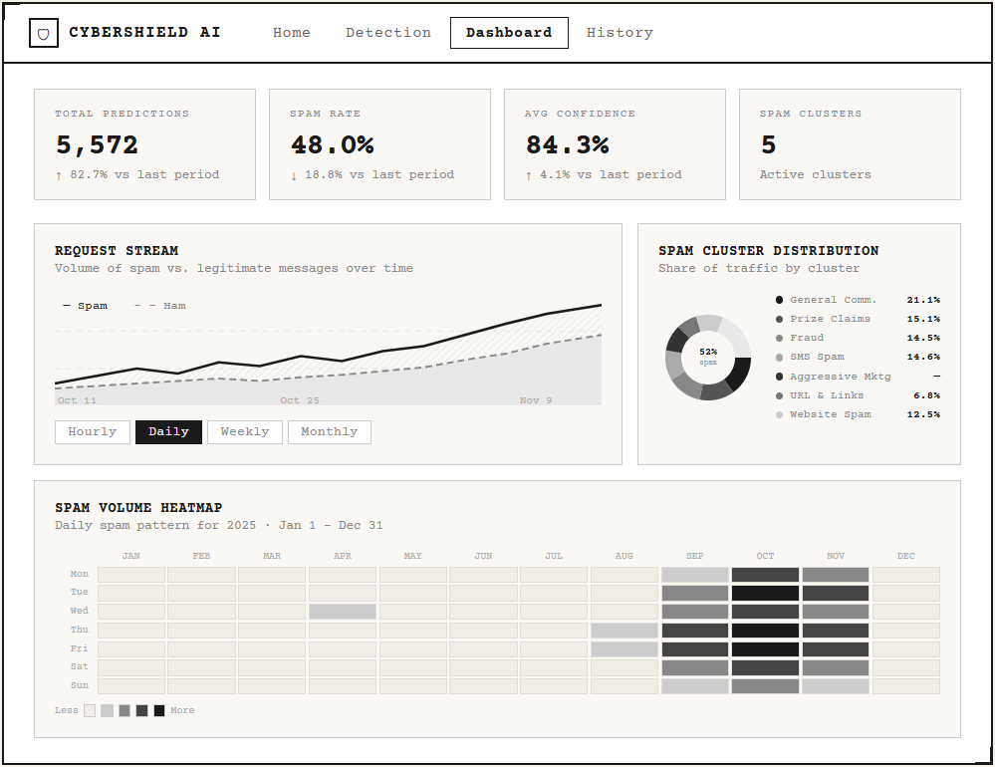
Figure 6: Initial data visualization dashboard page design

Data Visualization Dashboard: Presents interactive charts including class distribution pie chart, model accuracy metrics, and a word cloud of the most common spam keywords. Built using D3.js.

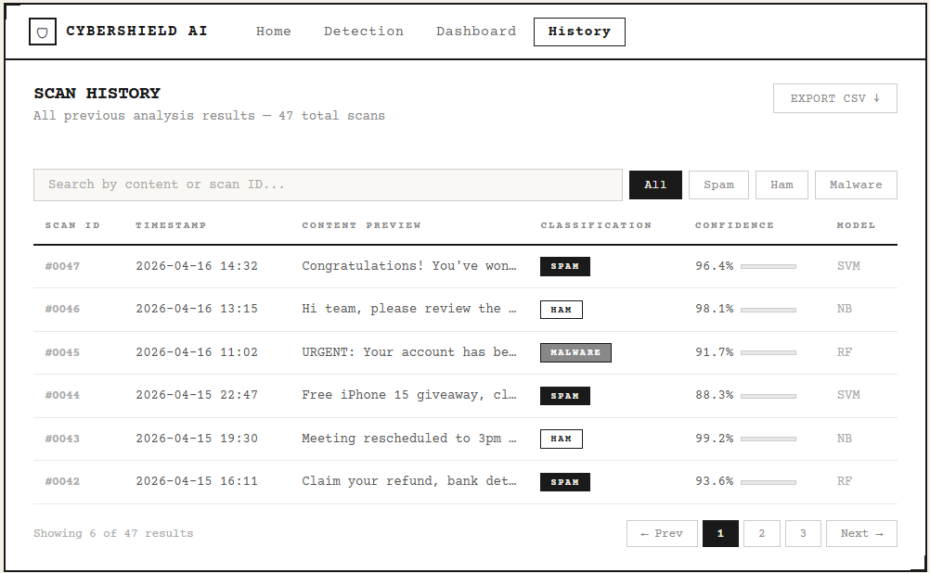
Figure 7: Initial threat history page design

Threat History Page: Shows a table log of the user's previous scan results with timestamps, classification labels, and confidence scores, allowing users to review past activity.

9.3 Usability Principles Applied
The prototype design incorporates seven principles drawn from Nielsen’s 10 Usability Heuristics to ensure a high-quality user experience. Visibility of system status is maintained through a loading spinner and progress indicator that appear during analysis, keeping users continuously informed while the model processes their input. The principle of match between system and real world is applied by using plain, accessible language such as “Spam”, “Safe”, and “Malware” rather than technical classification codes. User control and freedom is supported by allowing users to clear their input, re-submit content, or navigate back to the home page at any point without losing progress. Consistency and standards are upheld through uniform navigation bar layout, button styles, and labelling conventions applied consistently across all screens. Error prevention is addressed at the input stage, where the file upload component validates the format before submission to prevent unsupported file types from being processed. Recognition rather than recall is facilitated by keeping the main navigation and action buttons always visible on screen, so users do not need to remember previous steps to proceed. Finally, the principle of aesthetic and minimalist design is reflected in the layout of each screen, where a single primary action is the focus, avoiding visual clutter and reducing cognitive load for the user.

10.0 References
1. Nielsen, J. (1994). 10 Heuristics for User Interface Design. [online] Nielsen Norman Group. Available at: https://www.nngroup.com/articles/ten-usability-heuristics/.

2. archive.ics.uci.edu. (n.d.). UCI Machine Learning Repository. [online] Available at: https://archive.ics.uci.edu/dataset/228/sms+spam+collection.

3. FastAPI (2023). FastAPI. [online] fastapi.tiangolo.com. Available at: https://fastapi.tiangolo.com/.
‌
4. Meta Open Source (2025). React. [online] react.dev. Available at: https://react.dev/.
‌

11.0 Bibliography
1. Material UI (2024). MUI: The React component library. [online] Available at: https://mui.com/

