Supporting Information

Accelerated degradation of all-solid-state batteries induced through volumetric occupation of the carbon additive in the solid electrolyte domain

Hyun-seung Kim, Sejin Park, Sora Kang, Jae Yup Jung, KyungSu Kim, Ji-Sang Yu, Dongwon Kim, Jong-Won Lee*, Yang-Kook Sun*, Woosuk Cho*
Experimental

Synthesis of the solid electrolyte
An argyrodite-type Li₆PS₅Cl_{0.5}Br_{0.5} solid electrolyte was synthesized in a dry room using a solid-state reaction. Stoichiometric amounts of Li₂S (99.9%, Alfa Aesar), P₂S₅ (99%, Sigma-Aldrich), LiCl (99%, Sigma-Aldrich), and LiBr (99%, Sigma-Aldrich) were mixed. The mixture was uniformly mixed for a solid-state reaction and ground at 350 rpm for 2 hours using a planetary ball mill (Pulverisette 6, Fritsch) after being loaded into a zirconia pot. The as-prepared mixture (30g) was pelletized at 50MPa and heat-treated at 550°C for 6 h under vacuum.

Electrochemical characterization
The cathode composite was prepared by mixing the positive electrode material (LiNi_{0.8}Co_{0.1}Mn_{0.1}O₂, NCM), solid electrolyte (SE, Li₆PS₅Cl_{0.5}Br_{0.5}), and conductive carbon (spherical carbon; Super C, Timcal, carbon fiber; PotenCia, Teijin). The cathode composite (15mg) was tested in wt. ratio of 100-x : x : 3 and 90 : 13-y : y. The composite cathodes were pelletized (diameter: 13 mm) under a pressure of 517 MPa after pelletizing the solid electrolyte (150 mg) using a polyaryletherketone (PAEK) mold. Then the Li-In foil was placed into the anode side (NCM | SE | Li-in). The cell was sealed using a torque of 11 N m. After the application of the external pressure, the electrochemical characterization was tested with various current densities of 0.05 to 2.0 C (1.0 C = 180 mA g⁻¹). Dry-electrodes (NCM : SE : carbon additive : PTFE = 90 : 9 : 1 : 1, where PTFE is polytetrafluoroethylene) were fabricated and tested using Li foil was placed into the negative electrode side. The composite powder was prepared with milling mixer with 20000 RPM, and resultant was further mixed in mortar four times to homogenize the mixture. The mixed powder was kneaded to form the paste, and subsequently calendared to fabricate the dry electrode sheet. The mass loading was 36 mg cm⁻² The cell test was conducted using TOYO galvanostatic cycler (TOSCAT-3100).
DC polarization was conducted to measure the ionic conductivity and electrical conductivity. The solid electrolyte(100 mg)/cathode composite(100 mg)/solid electrolyte(100 mg) stack was pelletized by applying pressure (517 MPa and 103 Mpa), and Li foil was placed on both sides. The cell was tested by applying a constant current to measure the ionic conductivity. To measure the electrical conductivity, the cathode composite (100 mg) was pelletized at 517 MPa, followed by applying a constant voltage.
CC-pulse characterization ^{[1]} was conducted to verify the extent of decomposition of the solid electrolyte. For this purpose, the cells were charged at 0.05 C until reaching each voltage point, followed by rapid charging at 1.0 C, a 10-minute resting period, and rapid discharge at 1.0 C.

Spectroscopic and morphological characterization
XPS was performed to investigate the decomposition of the solid electrolyte after cycling using a Thermo Scientific XPS instrument (Sigma Probe). High-resolution transmission electron microscopy (HR-TEM, JEOL ARM-200F) was used to confirm the interfaces of the three phases (NCM, SE and conductive carbon). Scanning electron microscopy (SEM, JEOL JSM-IT200) was employed to characterize the morphologies.

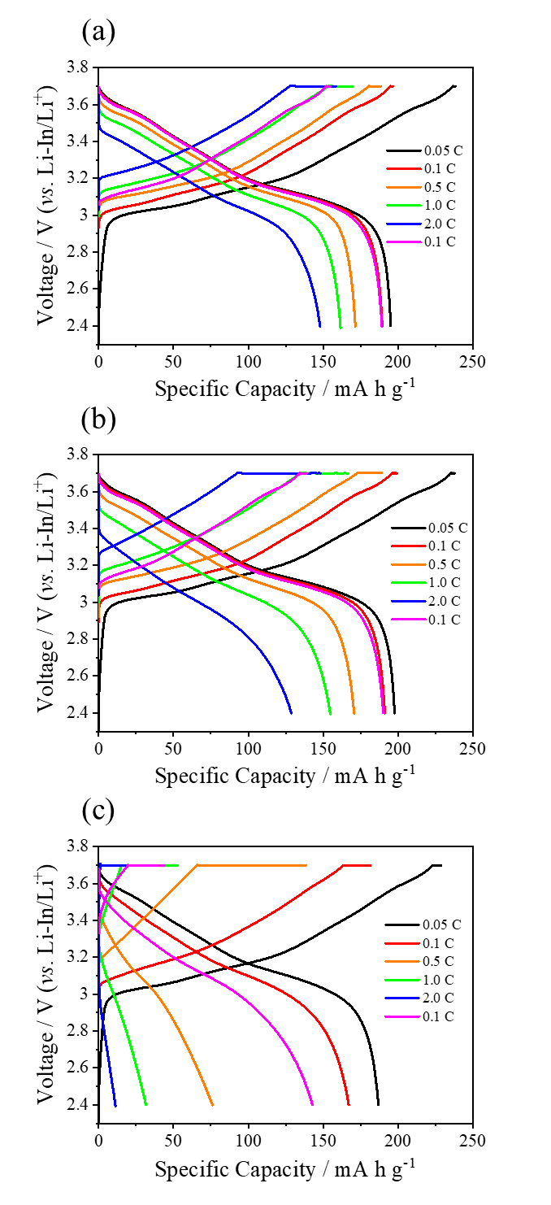
Figure S1. C-rate dependent voltage profiles obtained from (a) 80 wt.%, (b) 85 wt.%, and (c) 90 wt.% of active materials-comprised pellet electrodes

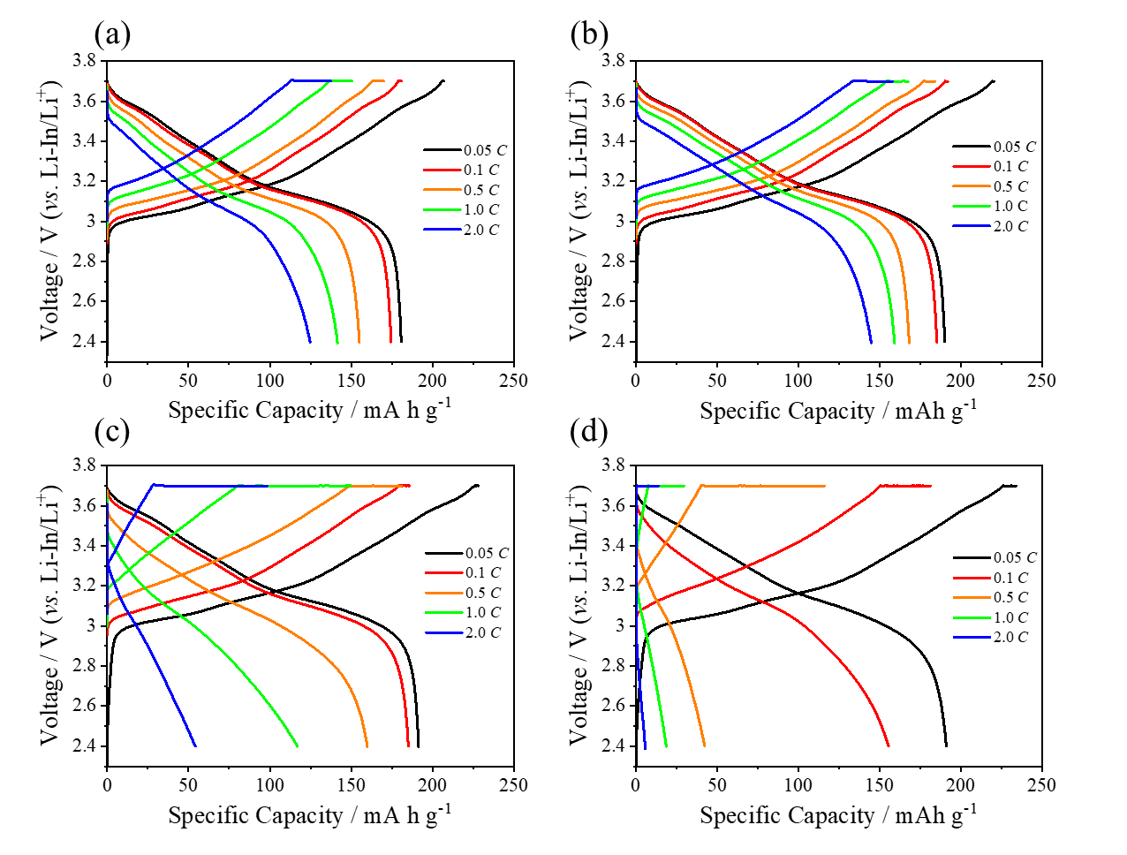
Figure S2. C-rate dependent voltage profiles obtained from (a) 0 wt.%, (b) 1 wt.%, (c) 2 wt.% and (d) 3 wt.% of carbon additive-comprised and 90 wt.% active material incorporated pellet electrodes

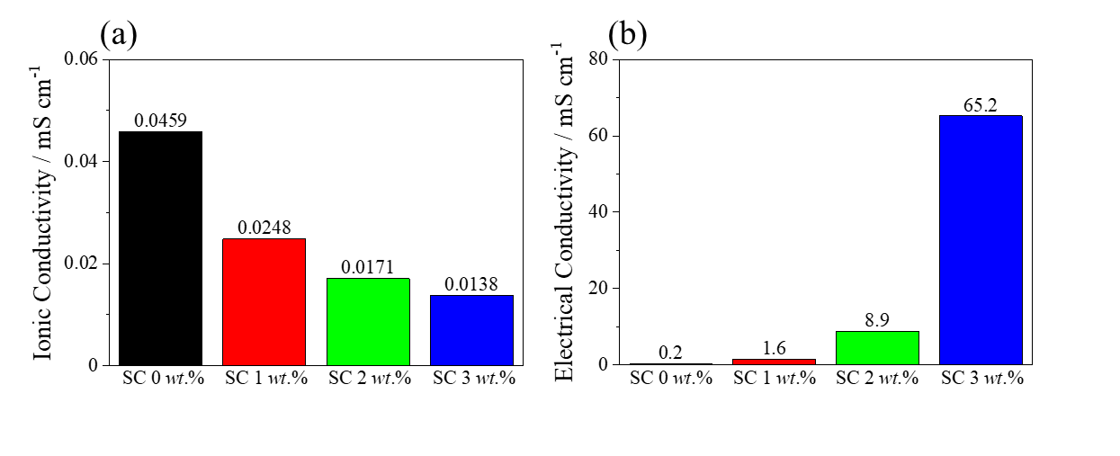
Figure S3. (a) Ionic and (b) electrical conductivity measured from 0 wt.%, 1 wt.%, 2 wt.%, and 3 wt.% of carbon additive-comprised and 90 wt.% active material incorporated pellet electrodes

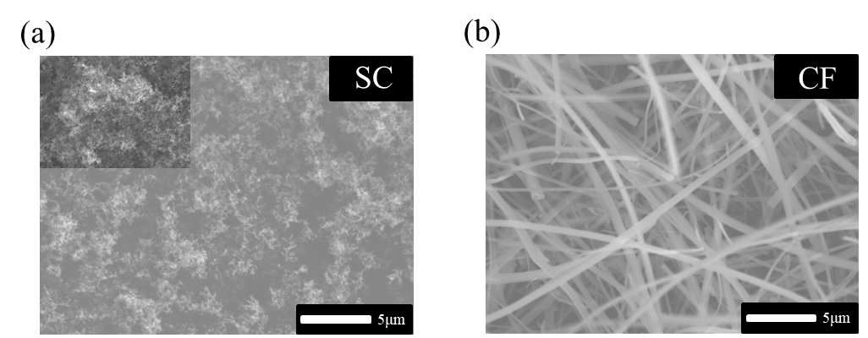

Figure S4. SEM images of (a) SC and (b) CF powder

Figure S5. Cyclic voltammogram recorded from the pellet electrode with (a) the weight ratio of solid electrolyte to carbon additive with 14:1

Figure S6. Cyclic voltammogram obtained from the pellet electrode with BET-based current density

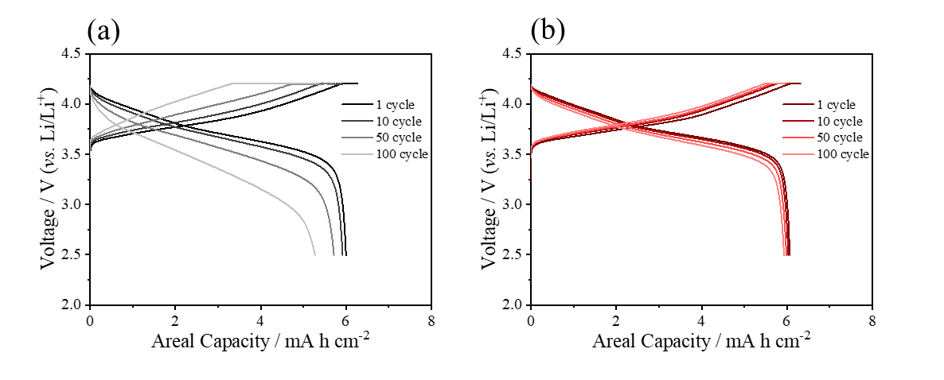
Figure S7. Cycle number-dependent voltage profiles obtained from (a) SC and (b) CF-added dry electrode, respectively

References
[1] a)J. Byun, C. R. Lee, W. Kim, M. A. Lee, H. Y. Jang, C. Hwang, J. H. Song, J.-S. Yu, S. Back, K. J. Kim, H.-s. Kim, Adv. Funct. Mater. 2024, n/a, 2401620; b)H.-s. Kim, T. H. Kim, S. S. Park, M. S. Kang, G. Jeong, ACS Appl. Mater. Interfaces 2021, 13, 44348; c)S. Vignesh, H. S. Che, J. Selvaraj, K. S. Tey, J. Energy Storage 2024, 89, 111656; d)I. M. Monirul, L. Qiu, R. Ruby, J. Energy Storage 2024, 92, 112304.

