Supplementary Information

Conflicting Roles of Conductive Additives in Controlling Cathode Performance in All-Solid-State Batteries

Minhyeong Cho, Jonghyeok Yun, Junhee Kang, Siwon Kim, Jong-Won Lee*

ª Division of Materials Science and Engineering, Hanyang University, 222 Wangsimni-ro, Seongdong-gu, Seoul 04763, Republic of Korea

* Corresponding author.
E-mail addresses: jongwonlee@hanyang.ac.kr (J.-W. Lee)

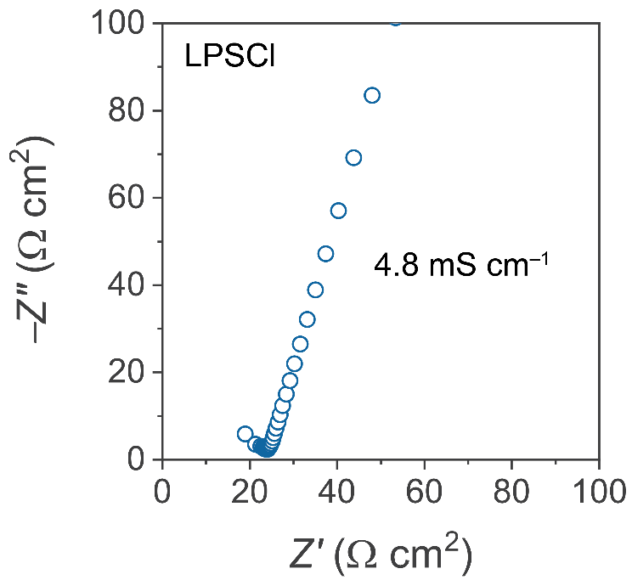
Fig. S1. Nyquist plot of the AC-impedance spectrum for LPSCl.

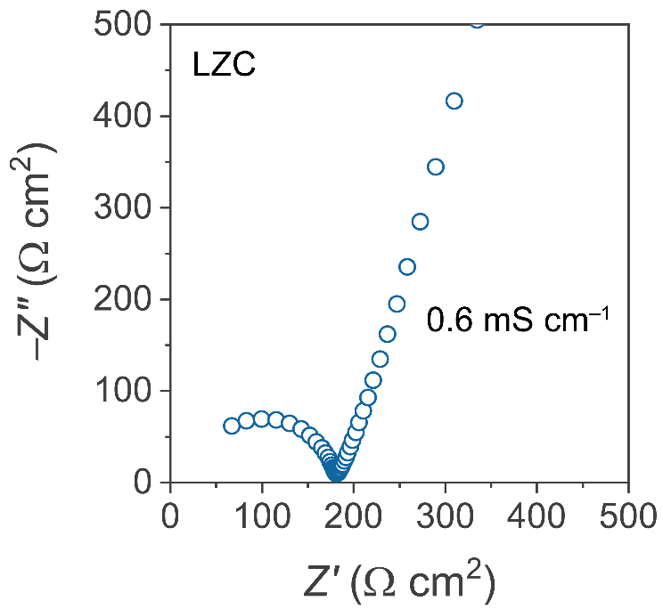
Fig. S2. Nyquist plot of the AC-impedance spectrum for LZC.

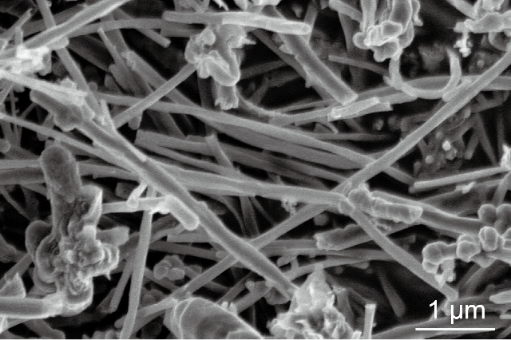
Fig. S3. SEM image of VGCF particles.

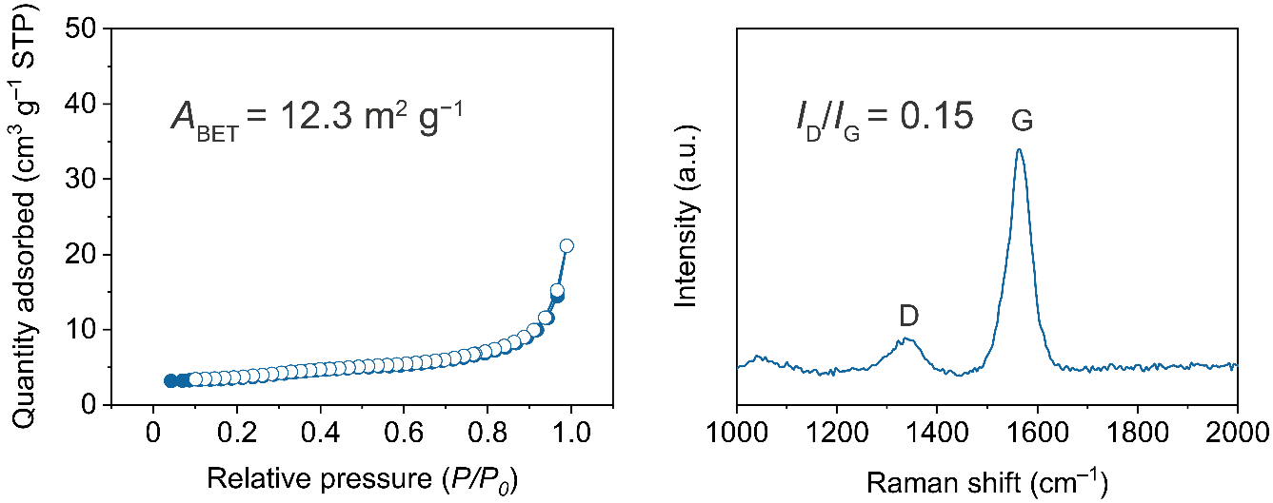

Fig. S4. N₂ adsorption/desorption isotherms of VGCFs.

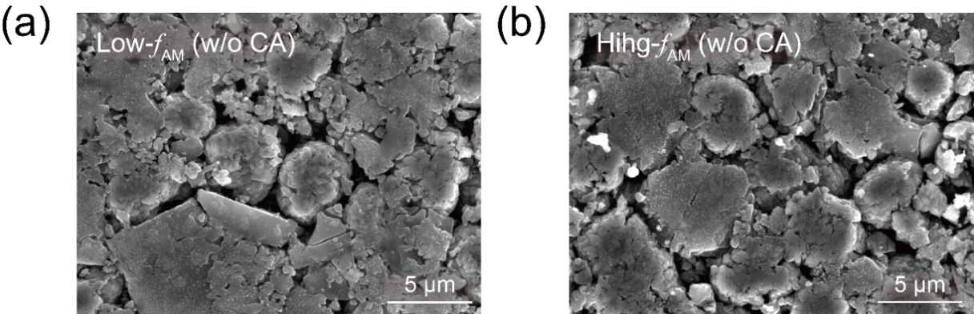
Fig. S5. SEM images for (a) low- and (b) high-f_{AM} electrodes without CAs.

Table S1. Fitted parameters for the pristine and cycled electrodes.

Pristine |  | R₁  (Ω cm) | R_{ion}  (Ω cm²) |  | R_{int}  (Ω cm²) | R_{w}  (Ω cm²) | CPE_{int}
 |  |  |  |  |  |  | C  (mF s^{η−1}cm⁻²) |  | η  (−)
Low-f_{AM} | w/o CA | 891.1 | 64.8 | 145.0 |  | 22.1 | 0.7 | 0.7
 | with CA | 926.0 | 80.9 | 175.2 |  | 18.3 | 1.1 | 0.5
High-f_{AM} | w/o CA | 1742.3 | 318.8 | 241.1 |  | 86.7 | 1.4 | 0.4
 | with CA | 1747.6 | 402.5 | 278.0 |  | 64.5 | 4.8 | 0.7

Cycled |  | R₁  (Ω cm) | R_{ion}  (Ω cm²) |  | R_{int}  (Ω cm²) | R_{w}  (Ω cm²) | CPE_{int}
 |  |  |  |  |  |  | C  (mF s^{η−1}cm⁻²) |  | η  (−)
Low-f_{AM} | w/o CA | 1244.8 | 108.2 | 285.1 |  | 28.7 | 0.7 | 0.7
 | with CA | 1370.2 | 140.1 | 381.0 |  | 27.6 | 1.2 | 0.4
High-f_{AM} | w/o CA | 2227.0 | 416.9 | 490.3 |  | 105.3 | 1.2 | 0.9
 | with CA | 2013.5 | 780.9 | 591.4 |  | 41.9 | 3.6 | 0.7

Table S2. Porosity and tortuosity of composite electrodes.

Sample |  | Porosity | Tortuosity
Low-f_{AM} | w/o CA | 0.14 | 6.47
 | with CA | 0.15 | 7.56
High-f_{AM} | w/o CA | 0.18 | 17.41
 | with CA | 0.19 | 18.34

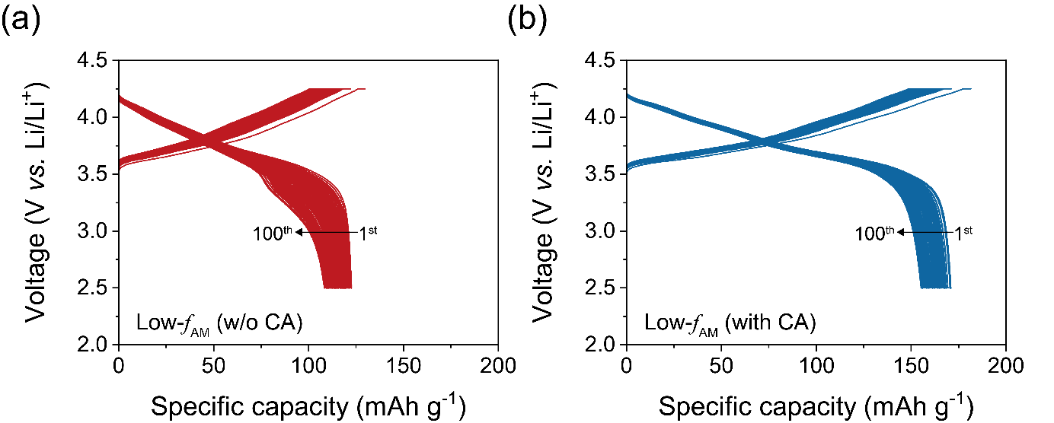
Fig. S6. Voltage profiles of ASSBs with low-f_{AM} electrodes (a) without and (b) with CAs during the cycling test at 0.33C.

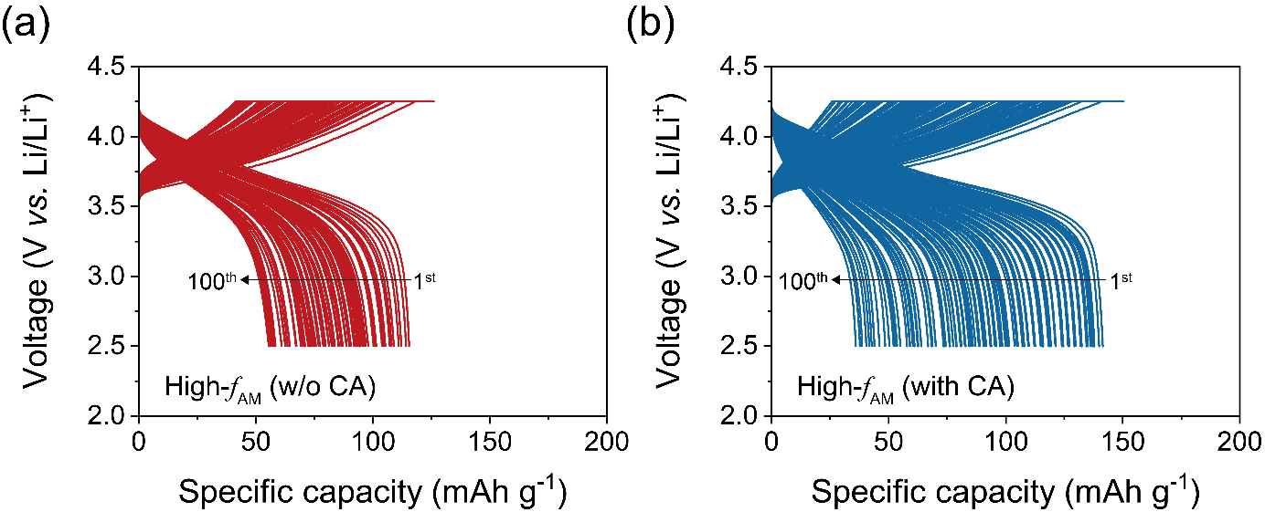
Fig. S7. Voltage profiles of ASSBs with high-f_{AM} electrodes (a) without and (b) with CAs during the cycling test at 0.33C.

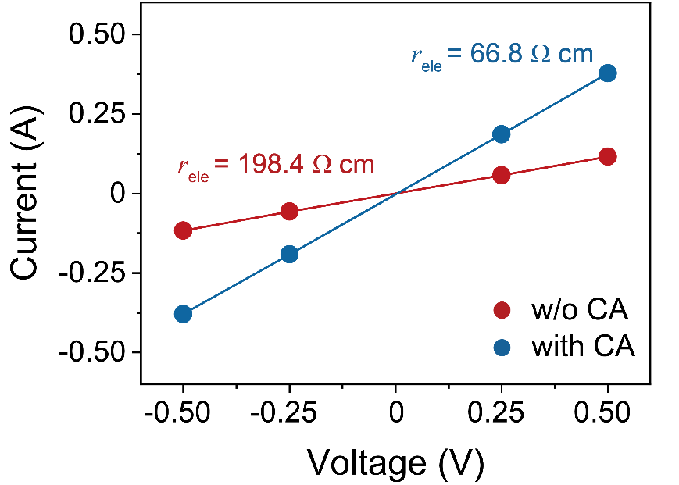

Fig. S8. DC-polarization measurements of high-f_{AM} electrodes with LZC.

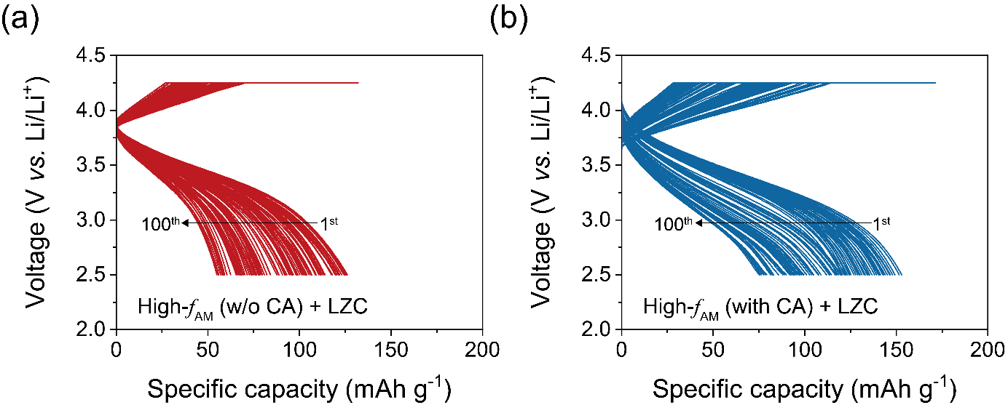
Fig. S9. Voltage profiles of high-f_{AM} electrodes using LZC (a) without and (b) with CAs during the cycling test at 0.33C.

