Supporting Information
Customizing the Morphology and Microstructure of Single-Crystalline Ni-Rich Layered Cathode Materials for All-Solid-State Batteries

Jae Yup Jung, Kyungsu Kim^{b}, Joo Hyeong Suhª, Hyun-Seung Kim^{b}, Min Jae Youª, Kern-Ho Park^{b}, Jun Ho Song^{b}, Ji-Sang Yu^{b}, Jong-Won Lee^{c,*}, Woosuk Cho^{b}* and Min-Sik Park^{a,}*
ªDepartment of Advanced Materials Engineering for Information and Electronics, Kyung Hee University, 1732 Deogyeong-daero, Gj-heung-gu, Yongin 17104, Republic of Korea
^{b}Advanced Batteries Research Center, Korea Electronics Technology Institute, 25, Saenari-ro, Seongnam 13509, Republic of Korea
^{c}Division of Materials Science and Engineering, Hanyang University, 222, Wangsimni-ro, Seongdong-gu, Seoul 04763, Republic of Korea

* Corresponding authors.
E-mail address: cho4153@keti.re.kr (W. Cho), jongwonlee@hanyang.ac.kr (J.-W. Lee), maspark@khu.ac.kr (M.-S. Park)

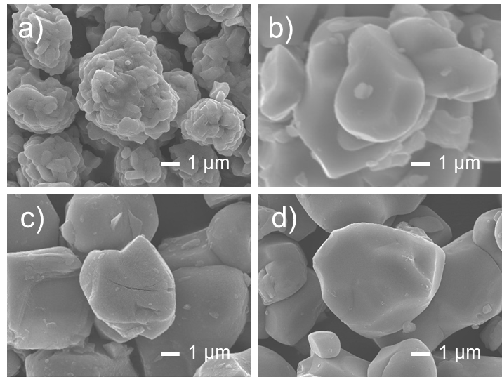
Fig. S1 FE-SEM images: (a) PC-NCM, (b) as-prepared SC-NCM, (c) wet-milled SC-NCM, and (d) SC-NCM.

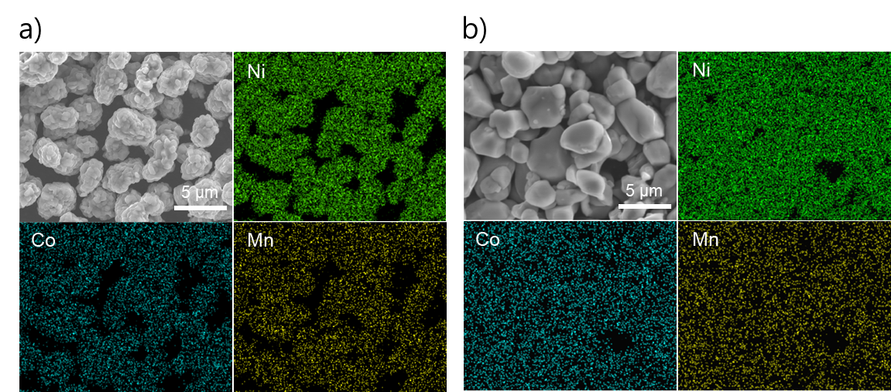
Fig. S2 SEM-EDS mapping results: (a) PC-NCM and (b) SC-NCM.

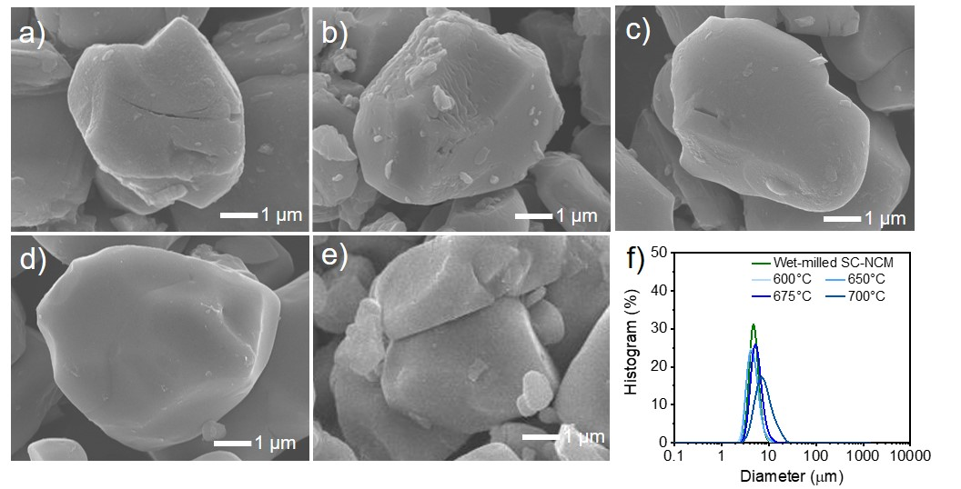Fig. S3 FESEM images and particle size distributions of SC-NCMs during the optimization process: wet-milled SC-NCM (a) before and after post-heat treatment at (b) 600°C, (c) 650°C, (d) 675°C, (e) 700°C, and (f) comparison of particle size distributions.

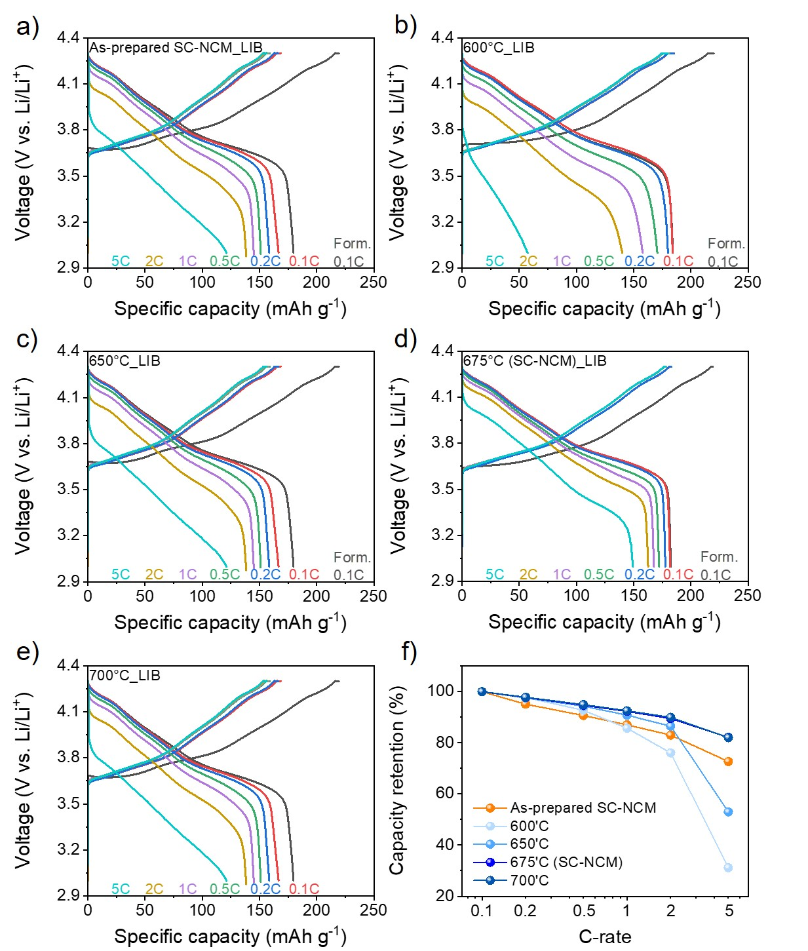Fig. S4 Rate capabilities during the optimization process of NCMs in LIBs: (a) as-prepared SC-NCM and post-heat treated SC-NCM at different temperatures of (b) 600°C, (c) 650°C, (d) 675°C (SC-NCM), (e) 700°C, and (f) comparison on capacity retentions at various C-rates.
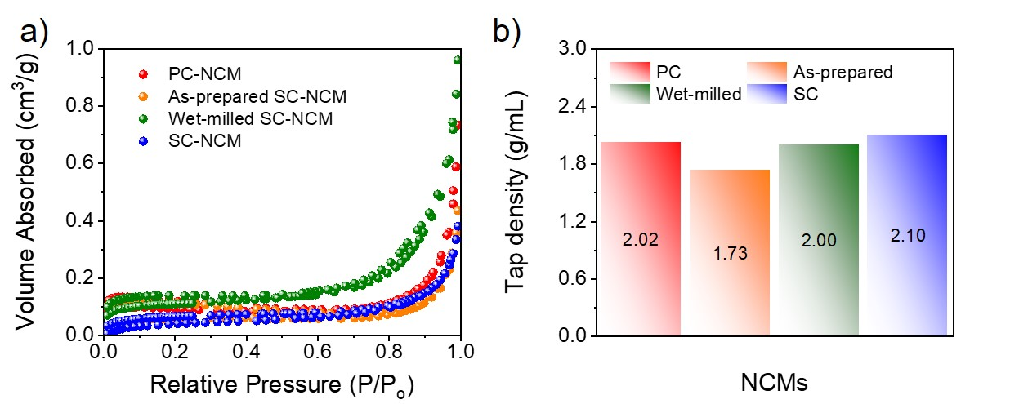
Fig. S5 Analysis of surface area and mechanical density: (a) BET and (b) tap density of NCMs.

Table S1. Lattice parameters: PC-NCM, as-prepared SC-NCM, wet-milled SC-NCM, and SC-NCM.

Sample | c [Å]
PC-NCM | 14.1811
As-prepared SC-NCM | 14.1920
Wet-milled SC-NCM | 14.1920
SC-NCM | 14.1929

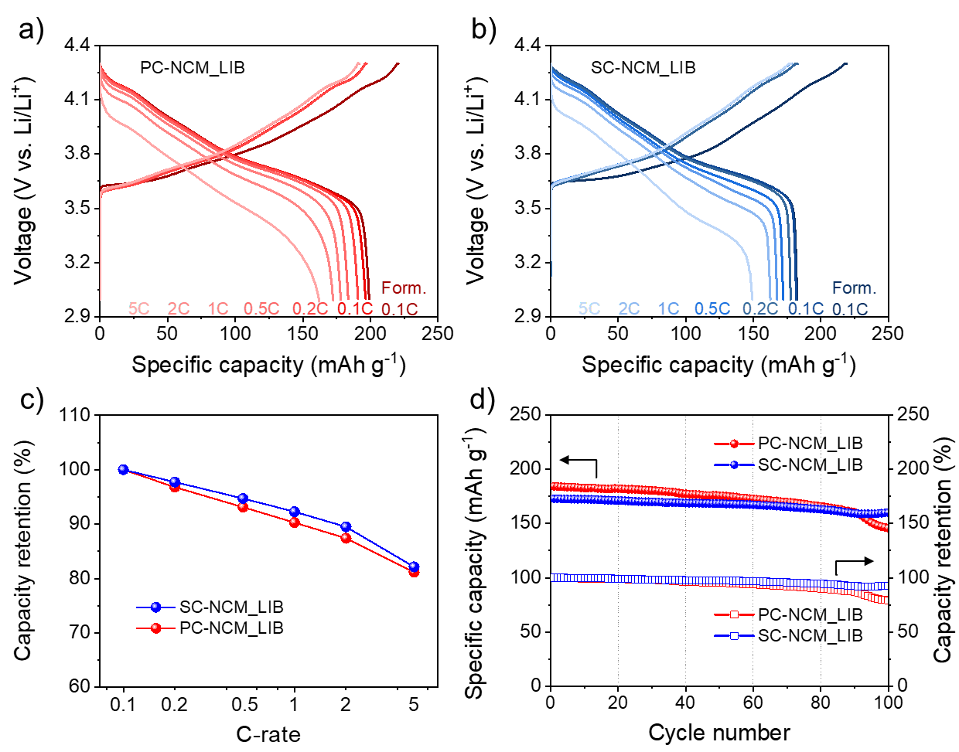Fig. S6 Electrochemical characterization of PC-NCM and SC-NCM for LIBs from 3.0 to 4.3 V vs. Li/Li⁺: voltage profiles of (a) PC-NCM and (b) SC-NCM. And comparison on (c) rate capabilities at various C-rates and (d) cycle performance of PC-NCM and SC-NCM.

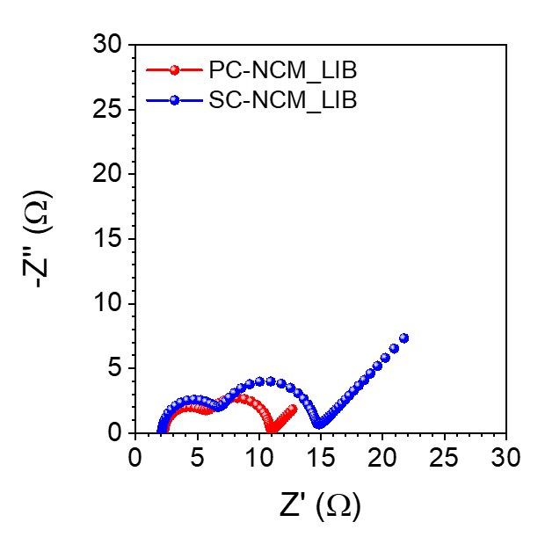
Fig. S7 Nyquist plots of PC-NCM and SC-NCM for LIBs at fully charged state of the first cycle.

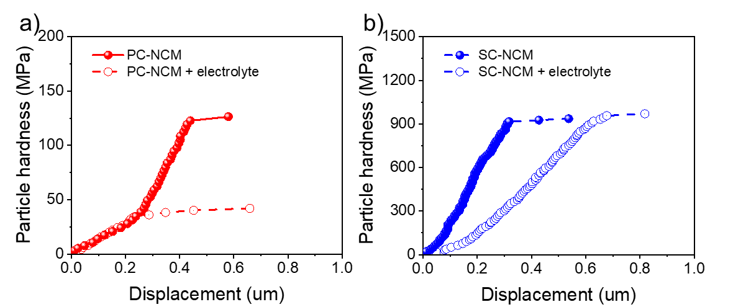
Fig. S8 The particle hardness: (a) PC-NCM and (b) SC-NCM before and after immersion in liquid electrolyte, respectively.

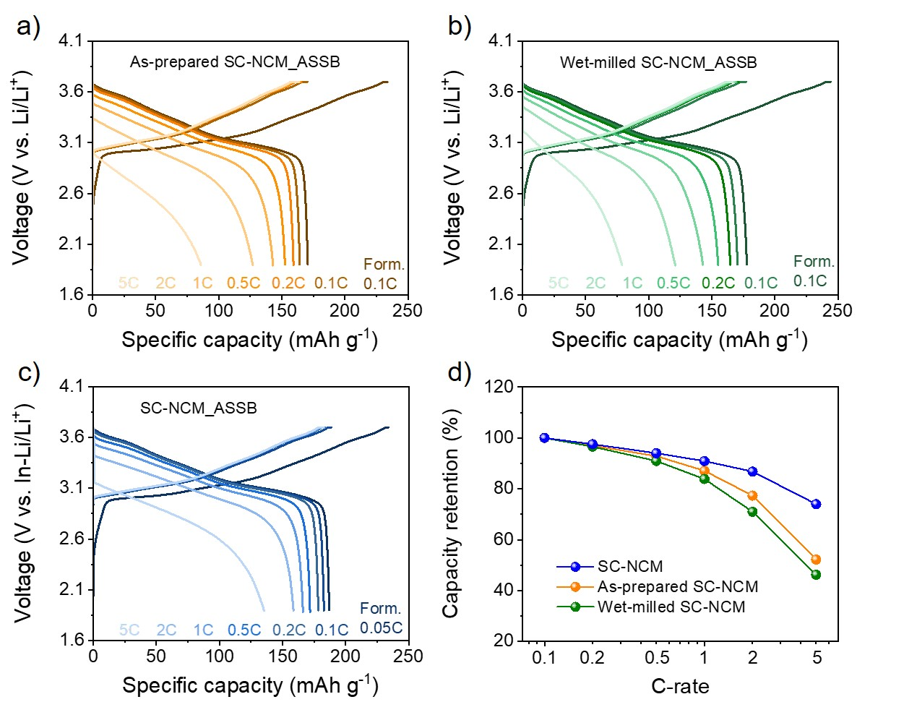
Fig. S9 Rate capabilities during the optimization process of NCMs in ASSBs: Voltage profiles of (a) as-prepared SC-NCM, (b) wet-milled SC-NCM, (c) SC-NCM obtained at optimized temperature of heat treatment, and (d) comparison on capacity retentions at various C-rates.

