Supplementary Materials

Deciphering the critical degradation factors of solid composite electrodes with halide electrolytes: Interfacial reaction versus ionic transport

Supplementary Note 1. The SSRM analysis on the cross-sectional area of composite electrodes
SSRM is a technique for observing spreading resistance profiles on sample surfaces using AFM. Fig. S1 shows a schematic of the experimental setup for SSRM. When a DC bias was applied, electrons passed from the probe tip to the conductive side attached to the sample through the composite electrode at a wide current scale of 10 to 100 mA. The resistivity (ρ_{e}) of each pixel in the SSRM maps was calculated from the measured resistance (R_{e}) using the equation ρ_{e} = 4·r·R_{e}, where r is the probe diameter. In our SSRM measurements, the applied bias was set to +2.5 V, which was sufficient to measure R_{e} while preventing the decomposition of LPSCl in the composite electrode.

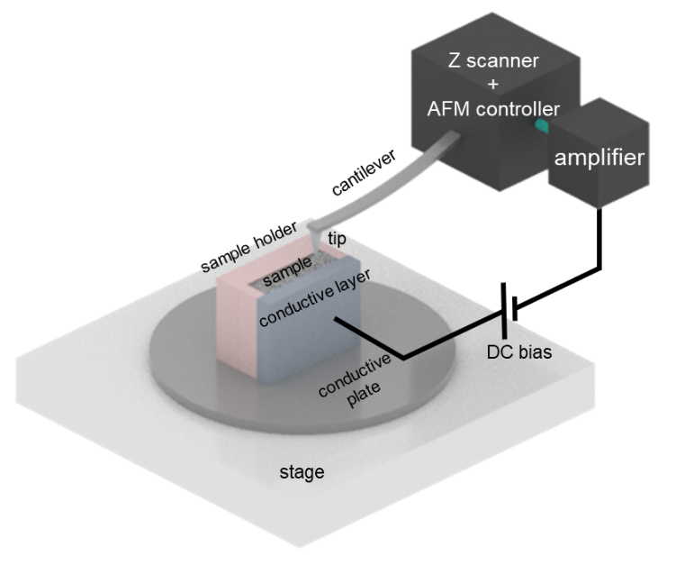

Fig. S1. Schematic of the experiment setup for SSRM on the cross-sectional area of a composite electrode.

Supplementary Note 2. The FS analysis on the cross-sectional area of composite electrodes
The mechanical property mapping was conducted using tapping-mode AFM. The force-distance curves were measured using silicon probes (PPP-NCHR, Park Systems, Co., Ltd.) under dry conditions. After calibrating a probe, topography and corresponding force-distance curves were collected over a 5 μm × 5 μm area with a resolution of 256 × 256 pixels. The force-distance curve provides information on various micromechanical properties, including adhesion between the tip and sample, as well as elastic and plastic deformation energies. To determine the Young’s modulus (E), the retraction curve was analyzed by considering the adhesion force between the tip and sample. To fit the retraction curve, the Derjaguin-Muller-Toporov model was employed:
$$F-F_{adh} = \frac{4}{3}E^{*}\sqrt{{R(d-d_{0})}^{3}}$$
where (F-F_{adh}) represents the force on the tip relative to the adhesion force, R is the tip end radius, and (d-d₀) is the sample deformation. If the Poisson’s ratio (v) of the sample is known, the E value of the sample can be related to E*:
$$E^{*} = {\left[\frac{1-v^{2}}{E}+\frac{1-v_{tip}^{2}}{E_{tip}}\right]}^{-1}$$
where E_{tip} is the tip modulus that is assumed to be infinite, and v_{tip} is the Poisson’s ratio of the tip.

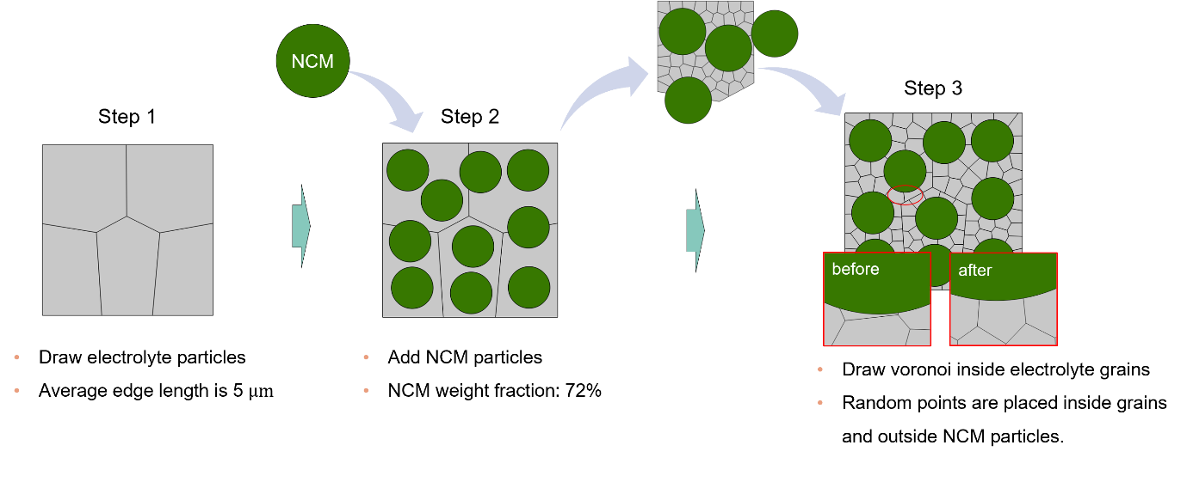
Fig. S2. Simulation geometry of SE grain, NCM particles and virtual crack pathways inside grain. The SE grains were generated by the Voronoi tessellation method and NCM particles were packed to match the volume fractions of SE and NCM. Each grain was discretized to submicron-sized and set to simulate the crack path inside grain particle of SE.

Supplementary Note 3. The crack propagation model

The crack propagation is modeled by employing the cohesive zone model. The cohesive elements have zero thickness, which means that any two adjacent solid objects will be in complete contact. Following the bilinear traction separation law, when the stress caused NCM volume change exceeds strength of the cohesive elements, debonding initiates and propagates. The quadratic nominal stress criterion is adapted for damage initiation, which is given by
$$\left(\frac{〈σ_{n}〉}{σ_{n}^{c}}\right)+ \left(\frac{σ_{s}}{σ_{s}^{c}}\right)=1$$
where $σ_{n}$, $σ_{s}$ denote the normal and shear traction in the cohesive element, respectively;$σ_{s}^{n}$ and $σ_{s}^{c}$ indicate the critical value of normal and shear traction forces, respectively. denote the Macauley bracket, defined as $〈σ_{n}〉=σ_{n}$ for $σ_{n}>0$ and $〈σ_{n}〉=0$ for $σ_{n}≤0$. The mixed mode displacement is defined as
$$d_{m}= \sqrt{{〈d_{n}〉}^{2}+d_{s}^{2}}$$
where $d_{n}$ and $d_{s}$ are the normal and shear relative displacement, respectively. Before damage initiation, a linear relationship between the traction and the relative displacement maintains as
$$σ_{i}=Kd_{i}$$
where $K$ are the stiffness of the cohesive elements and i is index of normal and shear. The mixed mode displacement at which the damage initiates is governed as
$$d_{m0}= \left\{\begin{aligned}d_{n}^{0}d_{s}^{0}\sqrt{\frac{d_{m}^{2}}{{(d_{s}^{0}d_{n})}^{2}+{(d_{n}^{0}d_{s})}^{2}}} d_{n}>0 \\ d_{s}^{0} d_{n}<0\end{aligned}\right.$$
When $d_{m}>d_{m0}$ the stiffness K is subsequently reduced even on the unloading state. Thereby, the traction seperation relations are rewritten as
$$σ_{i}=(1-d)K_{i}d_{i}$$
where d is the debonding index which varies from 0 to 1 based on a damage evolution criterion. For the final failure, we employ the Benzeggagh and Kenane criterion (B-K criterion)
$$G^{c}= G_{n}^{c}+\left(G_{s}^{c}- G_{n}^{c}\right){\left(\frac{G_{s}}{G_{n}+G_{s}}\right)}^{η}$$
where $G_{n}^{c}$ and $G_{s}^{c}$ are the critical fracture energy in the normal and shear direction (the area under the traction separation curve), respectively. $G_{n}$ and $G_{s}$ denote the energy release rate in normal and shear direction, respectively. The failure displacement for each direction is defined as
$$d_{i}^{f}=\frac{2G_{i}^{2}}{σ_{i}^{c}}$$
where i is index of normal and shear. The failure displacement is defined as
$d_{m}^{f}= \left\{\begin{aligned}\frac{2d_{m}^{2}}{d_{m}^{0}K_{n}\left(d_{n}^{2}+d_{s}^{2}\right)}\left[G_{n}^{c}+\left(G_{s}^{c}-G_{n}^{c}\right)\left(\frac{d_{s}^{2}}{d_{n}^{2}+d_{s}^{2}}\right)\right], d_{n}>0 \\ d_{s}^{f}, d_{n}<0 \end{aligned}\right.$
Finally, the damage parameter, d, is calculated as
$$d=\min\left(1,\max\left(0,\frac{d_{m}^{f}\left(d_{m}-d_{m}^{0}\right)}{d_{m}\left(d_{m}^{f}-d_{m}^{0}\right)}\right)\right)$$

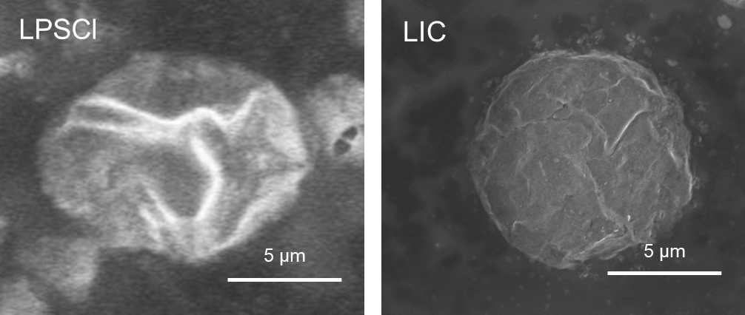

Fig. S3. (a) SEM images of LPSCl and LIC particles.

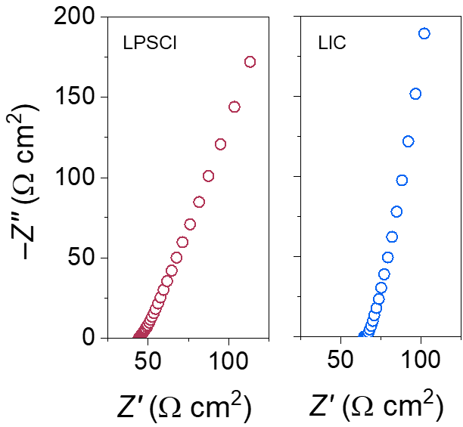

Fig. S4. Nyquist plots of SEs for the measurements of ionic conductivities.

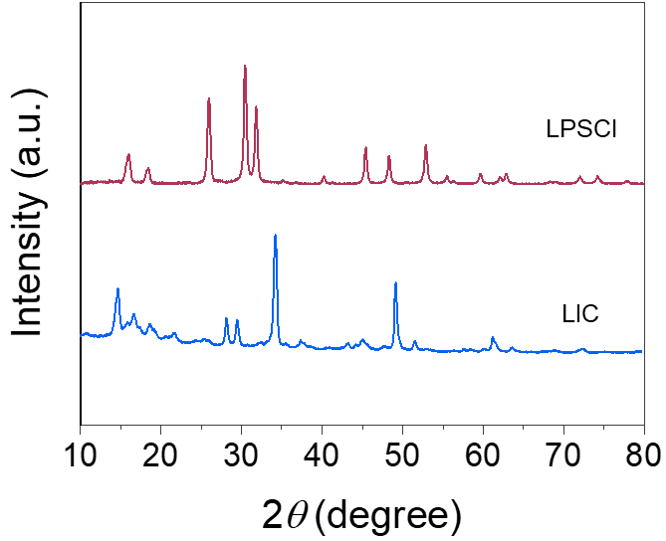

Fig. S5. XRD patterns of LPSCl and LIC powders.

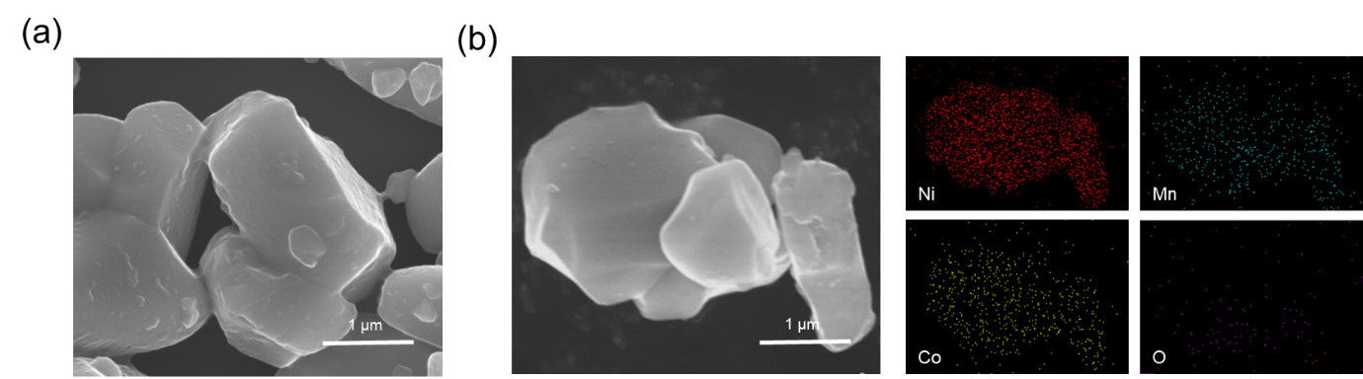

Fig. S6. (a) SEM and (b) EDS mapping images of single-particle NCM.

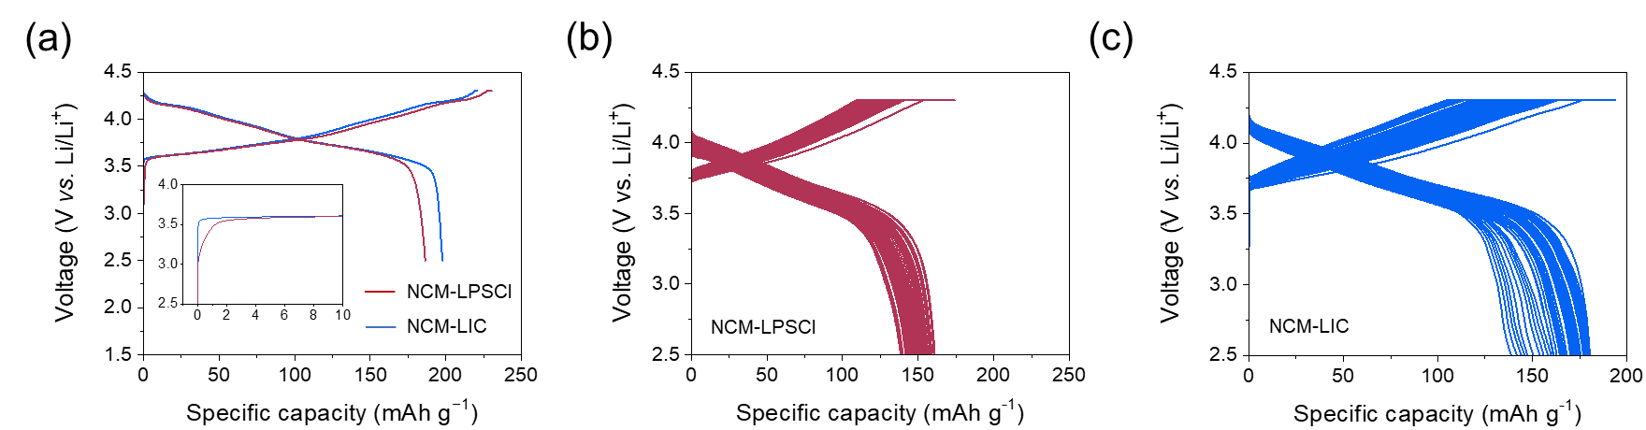

Fig. S7. (a) Voltage profiles of the initial charge-discharge cycle of ASSBs with NCM-LPSCl and NCM-LIC at 0.05C. Voltage profiles of ASSBs with (b) NCM-LPSCl and (c) NCM-LIC recorded during the cycling test at 0.33C.

Table S1. Fitted parameters for the unit cell determined using the TML.
 | R₁  (Ω cm²) | R₂  (Ω cm²) | CPE₂
 |  |  | C  (μF s^{η−1} cm⁻²) | η  (−)
NCM-LPSCl | 21.7 | 2.6 | 189.6 | 0.5
NCM-LIC | 17.8 | 0.007 | 24.2 | 0.9
NCM-LPSCl  (after cycling) | 19.7 | 0.5 | 0.07 | 0.5
NCM-LIC  (after cycling) | 19.0 | 24.9 | 16.5 | 0.8

 | R_{ion}  (Ω cm²) | R_{int}  (Ω cm²) | CPE_{int} |  |  | Z_{w}
 |  |  | C  (μF s^{η−1}cm⁻²) | η  (−) | R_{w}  (Ω cm²) |  | T  (s) | f  (−)
NCM-LPSCl | 126.1 | 341.7 | 96.8 | 0.8 | 14.7 |  | 5.1 | 0.2
NCM-LIC | 302.5 | 65.2 | 257.6 | 0.9 | 30.7 |  | 22.5 | 0.4
NCM-LPSCl  (after cycling) | 155.6 | 982.3 | 98.6 | 0.8 | 11.8 |  | 3002.6 | 0.2
NCM-LIC  (after cycling) | 595.6 | 113.8 | 368.9 | 0.7 | 1017.9 |  | 0.5 | 0.6

Fig. S8. XRD pattern of LIC after 240 h under pressure.

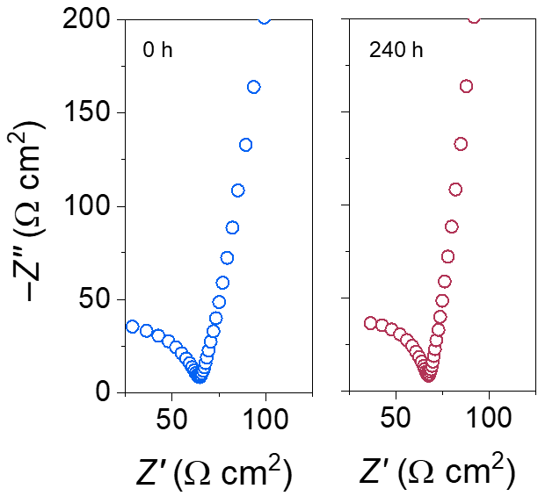

Fig. S9. AC-impedance spectra of LIC before and after 240 h of aging without pressure.

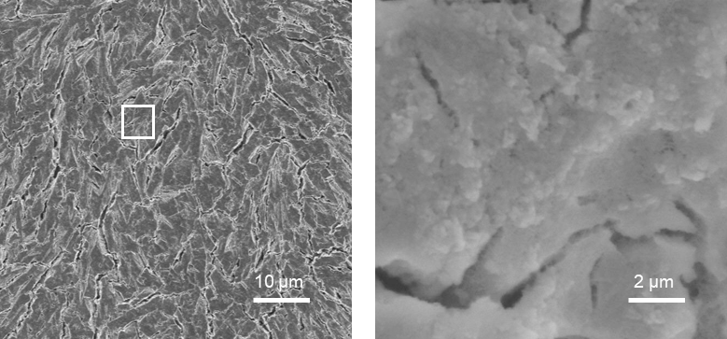

Fig. S10. SEM micrographs of the LIC SE after pressing at 433 MPa.

Fig. S11. The evolution of cracking in LPSCl and LIC SEs versus degree of lithiation, in consideration of elastic-only deformation.

Fig. S12. The evolution of cracking in NCM-LPSCl and NCM-LIC versus degree of lithiation with elastic-plastic and elastic-only deformation, respectively.

