Supplementary Materials

Chemo-mechanical failure of solid composite cathodes accelerated by high-strain anodes in all-solid-state batteries

Supplementary Note 1. Materials characterization
The SEM images of NCA and LTO active materials are shown in Fig. S1. NCA and LTO secondary particles with diameters of ~10 μm consisted of nanoscale aggregates (primary particles). The XRD patterns of NCA and LTO exhibited characteristic features of the layered phase (R$\overline{3}$m) and cubic spinel phase (Fd$\overline{3}$m), respectively [S1,S2] (Fig. S2). LPSCl used for composite cathodes and separator layers was also observed by SEM and XRD, which showed a spherical shape with typical structural features of the argyrodite-type phase (Figs. S3 and S4).

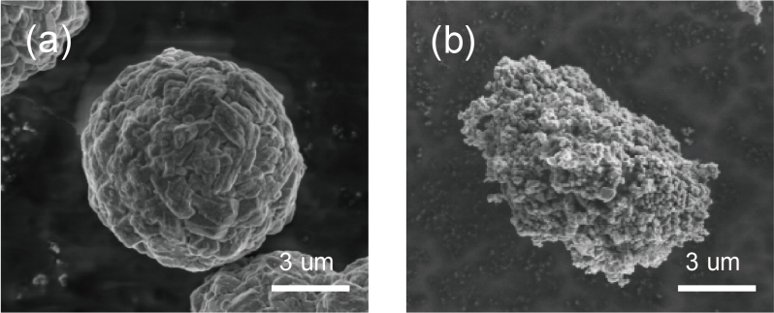

Fig. S1. SEM images of (a) NCA and (b) LTO active material.

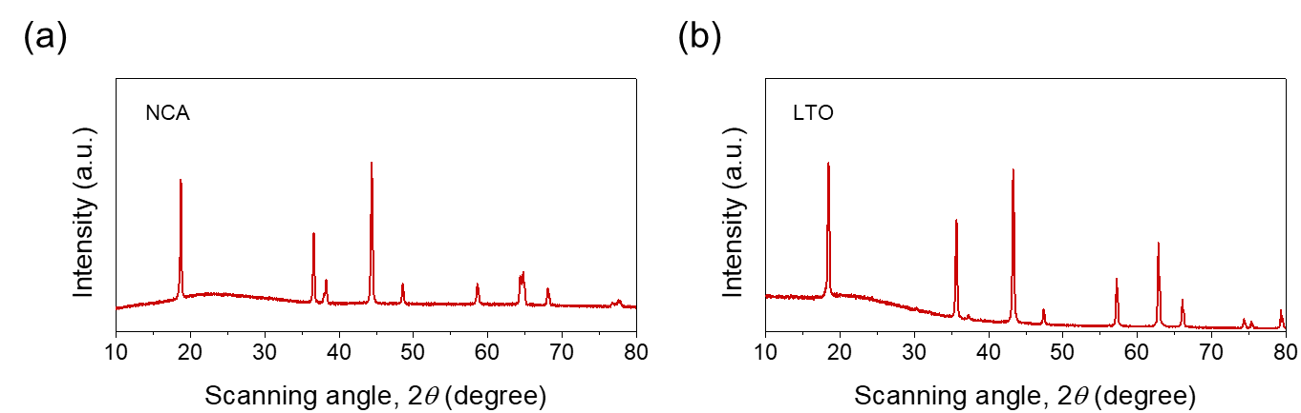

Fig. S2. XRD patterns of (a) NCA and (b) LTO active materials.
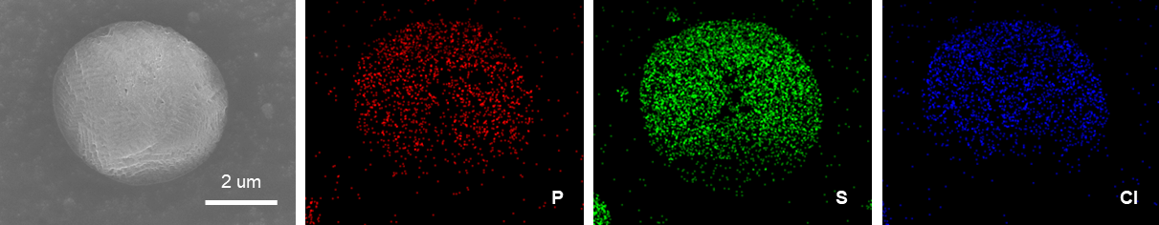

Fig. S3. SEM/EDS images of LPSCl.

Fig. S4. XRD pattern of LPSCl.
Supplementary Note 2. Electrochemical-mechanical modeling
To predict the stress field in a NCA particle during charging with the anode volume change, 2D electrochemical model coupled with mechanics module was constructed, and the simulation was conducted using COMSOL Multiphysics. In the model, the anode volume change was expressed as a constant external pressure in the y-axis direction. We assumed that at the initial state, the NCA particle is fully lithiated (discharged) with a uniform Li concentration throughout its volume. During charging, the local current density (i_{loc}) on the interface between the NCA particle and solid electrolyte is determined by the Butler-Volmer equation as follows:
$$i_{loc}=-i_{0}\left(exp\left(\frac{α_{a}Fη}{RT}\right)-exp\left(\frac{{-(1-α}_{a})Fη}{RT}\right)\right)$$
where i₀ is the exchange current density, α_{a} is the transport coefficient, F is the Faraday constant, and η is the overpotential. R and T are the molar gas constant and the absolute temperature, respectively.
Solid-phase diffusion of intercalated Li in a NCA particle is described by the Fick’s law:
$$\frac{\text{∂}\text{c}}{\text{∂}\text{t}}-\text{D}{\text{ ∇}}^{\text{2}}\text{c}=0$$
where c is the solid-phase concentration of Li in NCA, D is the diffusion coefficient, and t represents the time. The model parameters for electrochemical modeling are summarized in Table S1.
The stress-strain relationship of a linearly elastic material can be written as
$$ε_{ij}^{e}=\frac{1}{E}\left[\left(1+υ\right)σ_{ij}-υσ_{kk}δ_{ij}\right]$$
where $ε_{ij}^{e}$ and $σ_{ij}$ represent strain and stress tensors, respectively. E is the Young’s modulus, υ is the Poisson’s ratio, and δ_{ij} is the Kronecher delta. Therefore, the total strain ($ε_{ij}$) with diffusion-induced strain ($ε_{ij}^{d}$) caused by lithiation/delithiation of NCA can be expressed as
$${ε_{ij} ={ ε}_{ij}^{e}+ ε}_{ij}^{d} = \frac{1}{E}\left[\left(1+υ\right)σ_{ij}-υσ_{kk}δ_{ij}\right]+\frac{Ω}{3}∆c$$
where Ω is the partial molar volume of NCA and c is the Li concentration. To represent the interfacial heterogeneity, the reference exchange current density was reduced for the inactive boundary of the NCA particle. The model geometry is shown in Fig. S5 and boundary conditions in the normal direction are summarized in Table S2, where $n$ is the normal vector, A is the area of the electrode, and a is the active surface area for interfacial reaction. 𝜙_{e}, 𝜙_{s}, and i_{total} represent the electrolyte potential, electric potential in a solid phase, and current density of the cell, respectively. P_{applied} and u denote the applied pressure and displacement field vector.

Parameter [unit] | value
Cell dimension [L×W, μm] |  | 815 × 100
Temperature [K] |  | 298.15
Reference exchange current density [A m⁻²] |  | 10
Reference concentration [mol m⁻³] |  | 48000 [S3]
Radius of the active material [μm] |  | 5
Maximum cell voltage [V] |  | 4.3
Minimum cell voltage [V] |  | 2.5
C-rate |  | 0.33
Electrical conductivity of active material [S m⁻¹] |  | 1 [S4]
Diffusion coefficient of Li in active material [m² s⁻¹] |  | 3 × 10⁻¹⁴ [S4]
Electrolyte conductivity [S m⁻¹] |  | 0.02 [S5]
Table S1. Parameters for electrochemical modeling.

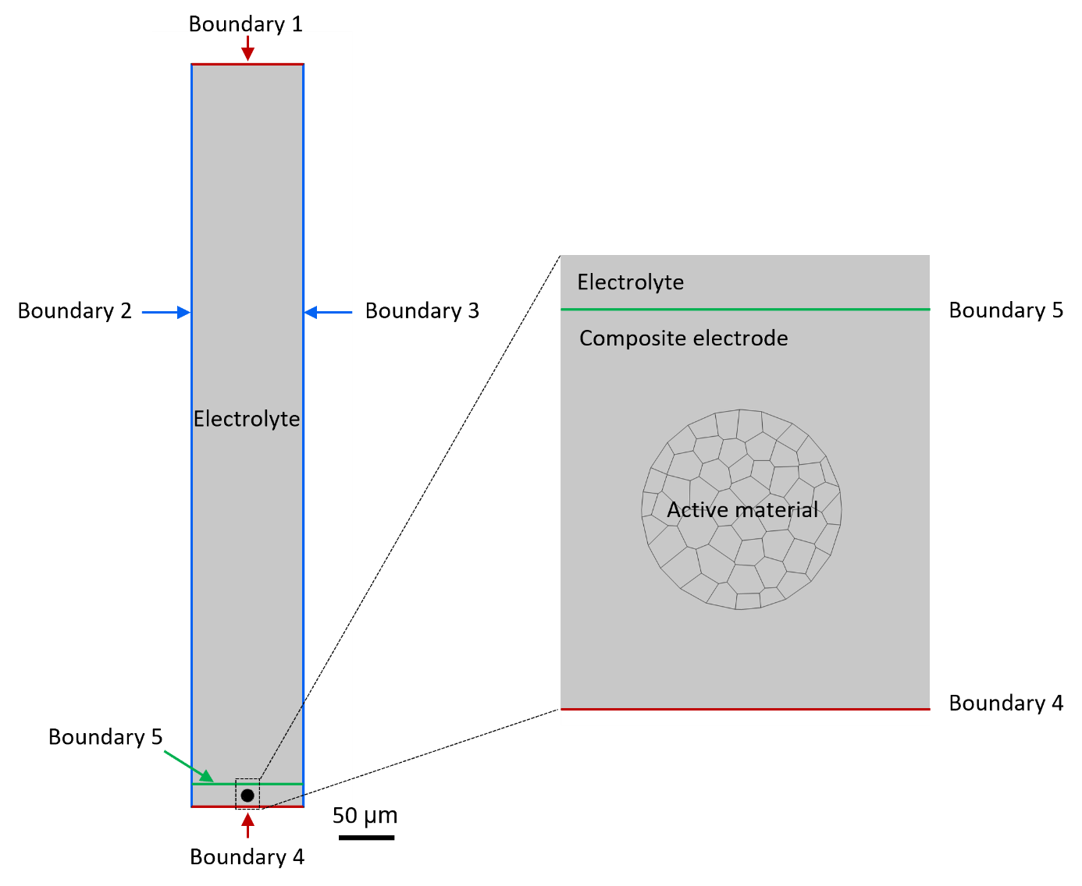

Fig. S5. Geometry for the electrochemical-mechanical modeling

Table S2. Boundary conditions for modeling.
 | Mass conservation | Charge conservation | Solid mechanics
Boundary 1 | $$n∙∇c=0$$ | $n∙{∇ϕ}_{e}=0$,  $$n∙{∇ϕ}_{s}=i_{total}$$  $ϕ_{s}=0$, | $$n∙σ_{yy}=-P_{app}$$
Boundary 2 |  | $${n∙∇ϕ}_{e}=0$$ | $$n∙u=0$$
Boundary 3
Boundary 4 |  | $n∙{∇ϕ}_{e}=0$,  $$n∙{∇ϕ}_{s}=i_{total}$$
Boundary 5 | - | $$n∙{∇ϕ}_{s}=0$$ | -
Electrolyte-active material interface | $$-n∙D∇c=\frac{i_{loc}}{aF}$$ | - | -

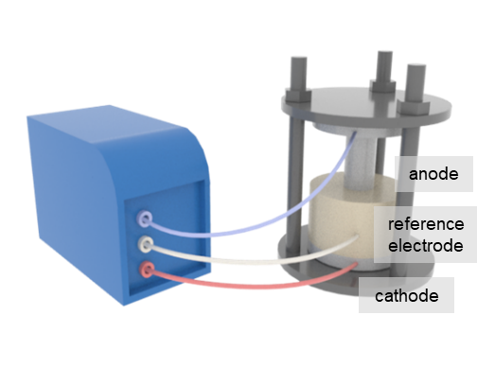

Fig. S6. Schematic of a three-electrode ASSB configuration.
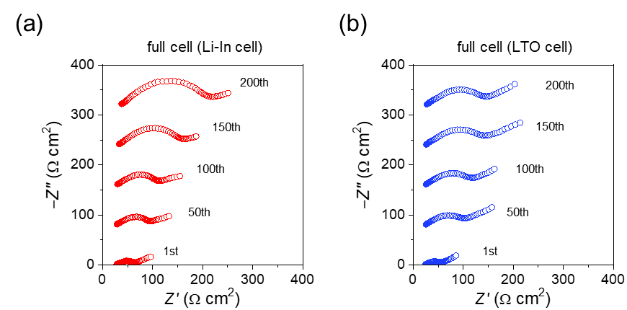

Fig. S7. AC-impedance spectra of full cells with (a) Li-In and (b) LTO anodes.
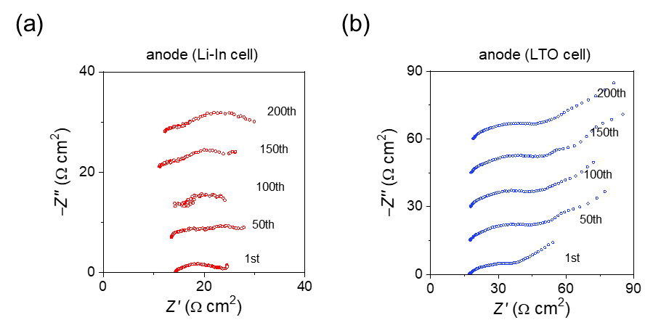

Fig. S8. AC-impedance spectra of anodes in (a) Li-In and (b) LTO cells.

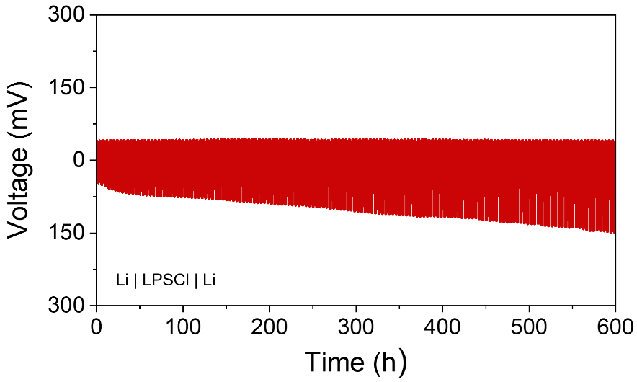

Fig. S9. Cycling performance of the symmetric [Li-In | LPSCl | Li-In] cell cycled at a current density of 0.9 mA cm⁻² with an areal capacity of 1.8 mAh cm⁻². To create the initial, cyclable Li inventory, one electrode was electrochemically lithiated with an areal capacity of 1.8 mAh cm^{–2} and then was used in the symmetric cell, which resulted in the asymmetric polarization curves.
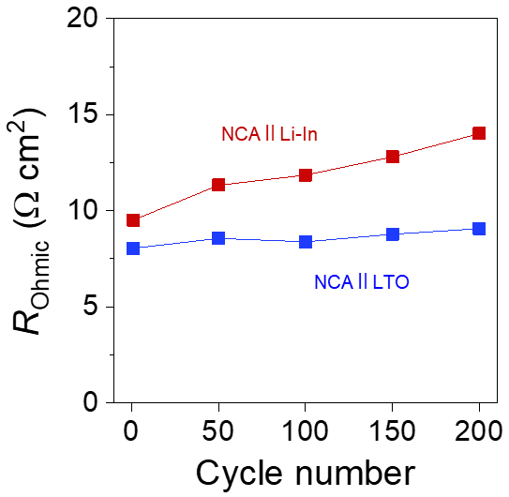

Fig. S10. Ohmic resistance values of Li-In and LTO cells.

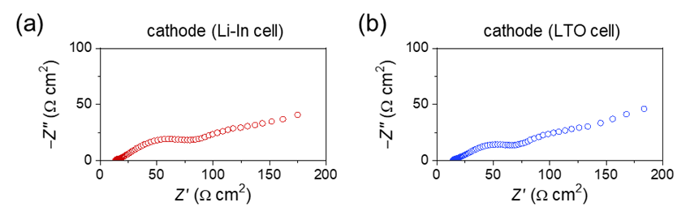

Fig. S11. AC-impedance spectra of cathodes in as-prepared (a) Li-In and (b) LTO cells before the pre-conditioning cycle.
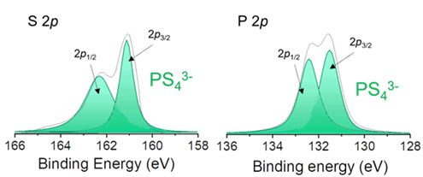

Fig. S12. XPS spectra for S 2p and P 2p core levels obtained from the cathodes before pre-conditioning.

Table S3. Fitted parameters of the EIS spectra obtained from the cathodes of Li-In and LTO cells using the TLM-based equivalent circuit.
Sample | Cycle No. | R_{Ohmic}  (Ω cm²) | R_{ion}  (Ω cm²) | R_{int}  (Ω cm²) | R_{w}  (Ω cm²) | CPE_{int}
 |  |  |  |  |  | C  (μF s^{η−1}cm⁻²) | η  (−)
Li-In cell | 1 | 34.0 | 27.8 | 28.8 | 21.6 | 152.7 | 0.50
 | 50 | 40.8 | 33.4 | 52.0 | 21.8 | 61.8 | 0.62
 | 100 | 46.0 | 37.6 | 65.2 | 24.4 | 50.9 | 0.64
 | 150 | 43.3 | 35.4 | 115.7 | 128.6 | 34.5 | 0.65
 | 200 | 45.4 | 37.2 | 170.4 | 174.5 | 26.4 | 0.65
LTO cell | 1 | 3199.5 | 28.8 | 8.7 | 13.1 | 55.5 | 0.70
 | 50 | 3681.9 | 33.1 | 39.0 | 20.4 | 66.4 | 0.68
 | 100 | 3694.7 | 33.3 | 52.8 | 21.8 | 61.8 | 0.68
 | 150 | 3958.2 | 35.6 | 72.6 | 25.6 | 61.8 | 0.69
 | 200 | 4232.1 | 38.1 | 74.0 | 29.7 | 56.4 | 0.70

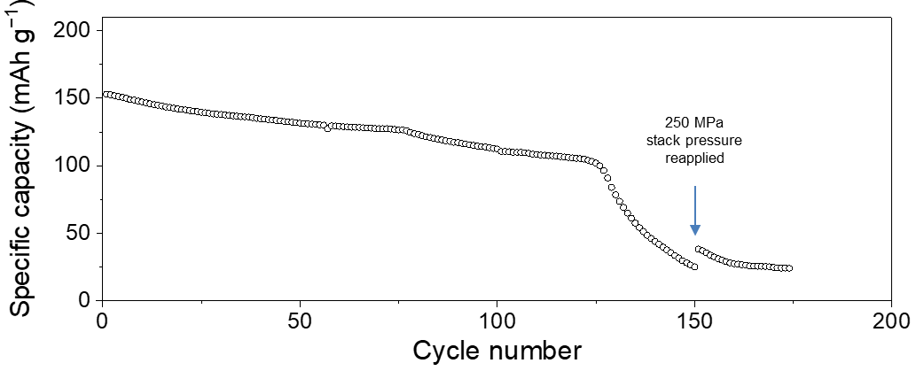

Fig. S13. Discharge capacity retention of the Li-In cell during cycling at a 0.5C rate. A stack pressure of 250 MPa was reapplied after 150 cycles.
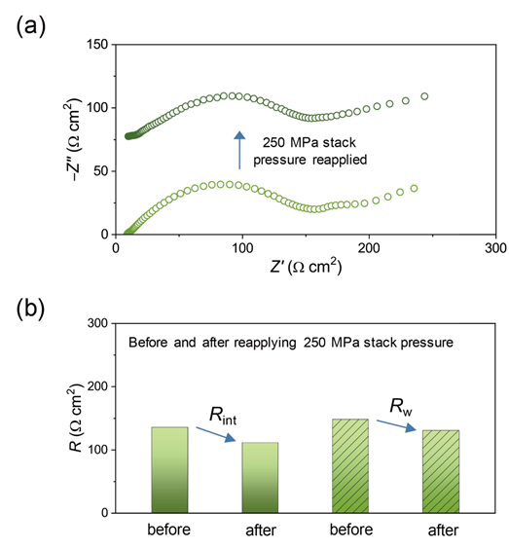

Fig. S14. (a) AC-impedance spectra of the cathode in the Li-In cell before and after reapplying a stack pressure of 250 MPa and (b) the corresponding interfacial and diffusion resistance values.
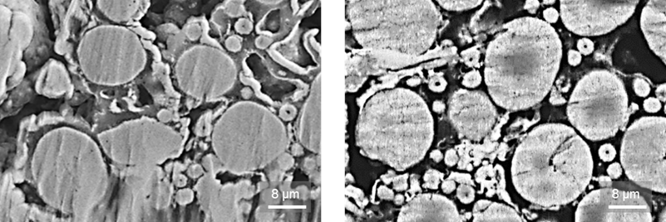

Fig. S15. Cross-sectional SEM images of the cathodes collected after the cell fabrication, demonstrating that NCA particles remained stable without any signs of cracking.
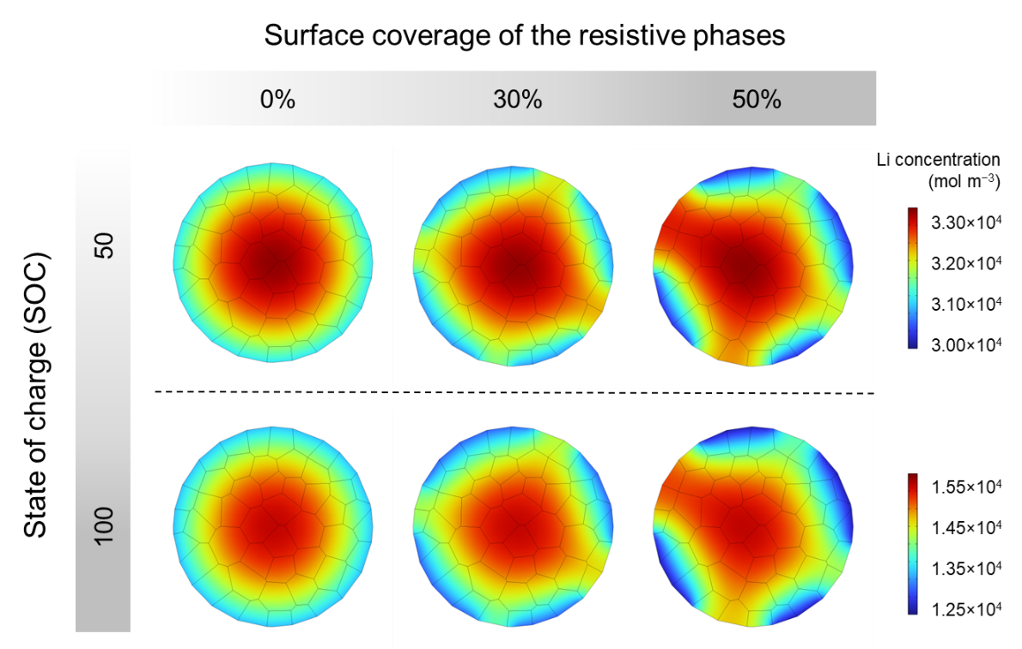
Fig. S16. Distribution of Li concentration upon charging.
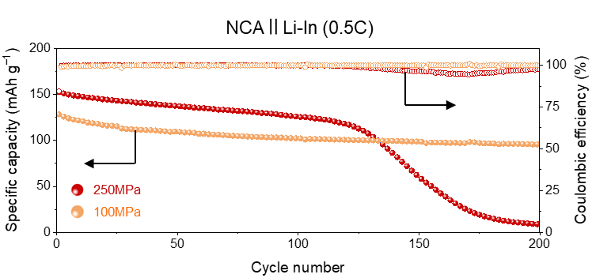
Fig. S17. Cycling performances of the Li-In cells under different stack pressures.

References
[S1] G. Peng, X. Yao, H. Wan, B. Huang, J. Yin, F. Ding, X. Xu, Insights on the fundamental lithium storage behavior of all-solid-state lithium batteries containing the LiNi_{0.8}Co_{0.15}Al_{0.05}O₂ cathode and sulfide electrolyte, J. Power Sources 307 (2016) 724-730, https://doi.org/10.1016/j.jpowsour.2016.01.039
[S2] Q. Cheng, S. Tang, J. Liang, J. Zhao, Q. Lan, C. Liu, Y.-C. Cao, High rate performance of the carbon encapsulated Li₄Ti₅O₁₂ for lithium ion battery, Results Phys. 7 (2017) 810-812, https://doi.org/10.1016/j.rinp.2017.01.040
[S3] N. Nitta, F. Wu, J. T. Lee, G. Yushin, Li-Ion Battery Materials: Present and Future, Materials Today (2015) 18, 252-264, https://doi.org/10.1016/j.mattod.2014.10.040
[S4] R. Amin, D. B. Ravnsbæk, Y.-M. Chiang, Characterization of Electronic and Ionic Transport in Li_{1-x}Ni_{0.8}Co_{0.15}Al_{0.05}O₂ (NCA), J. Electrochem. Soc. (2015) 162, A1163, https://doi.org/10.1149/2.0171507jes
[S5] B. K. Park, H. Kim, K. S. Kim, H.-S. Kim, S. H. Han, J.-S. Yu, H. J. Hah, J. Moon, W. Cho, K. J. Kim, Interface Design Considering Intrinsic Properties of Dielectric Materials to Minimize Space-Charge Layer Effect between Oxide Cathode and Sulfide Solid Electrolyte in All-Solid-State Batteries, Adv. Energy. Mater (2022) 12, 2201208, https://doi.org/10.1002/aenm.202201208

