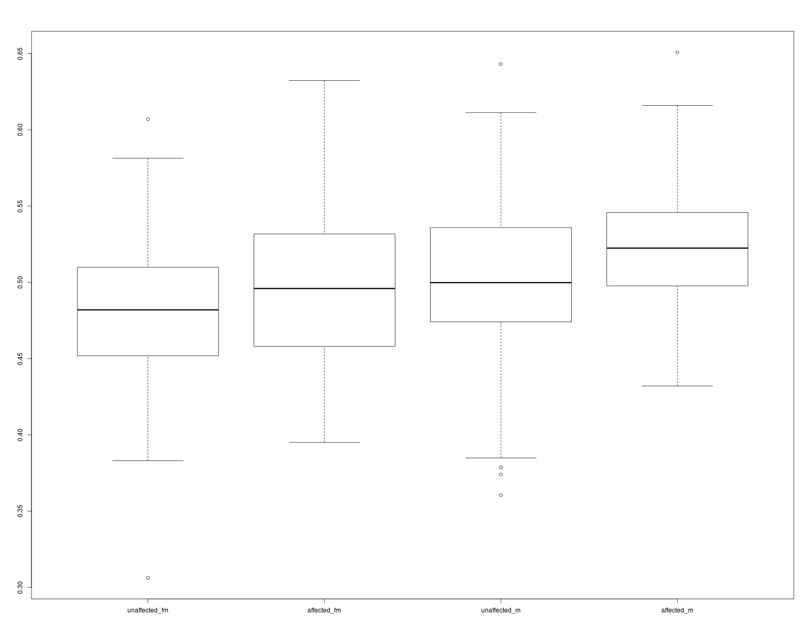
Figure 1. One svm test model prediction of malness(cost = 1,type = 0)

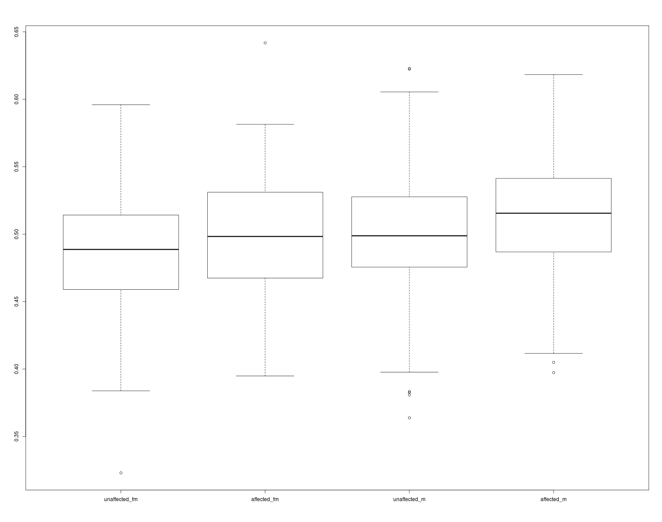
Figure 2 . svm test model of malness after cross-validation (cost = 1 ,type = 0 , accuracy = 61% )

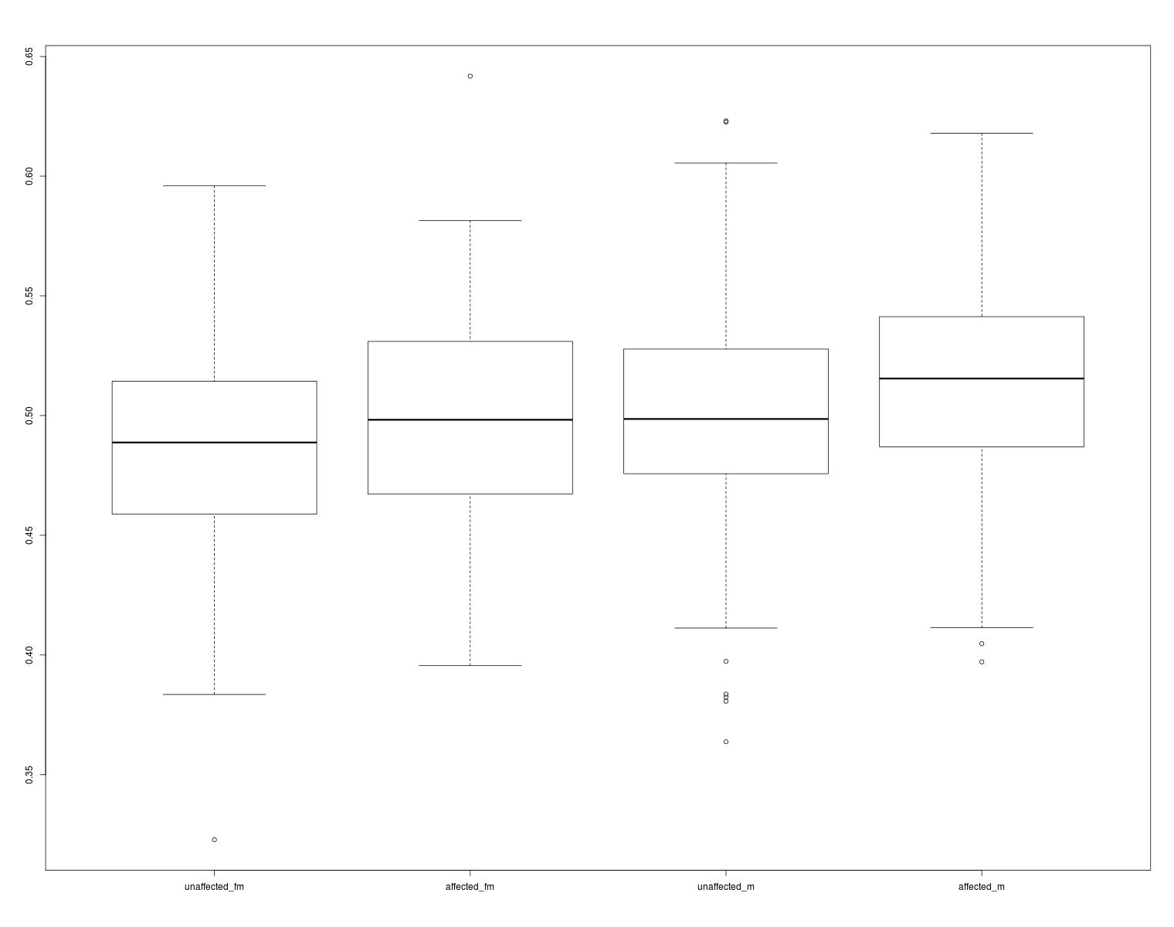
Figure 2 . svm test model of malness after cross-validation (cost = 1 ,type = 7 , accuracy = 61%)
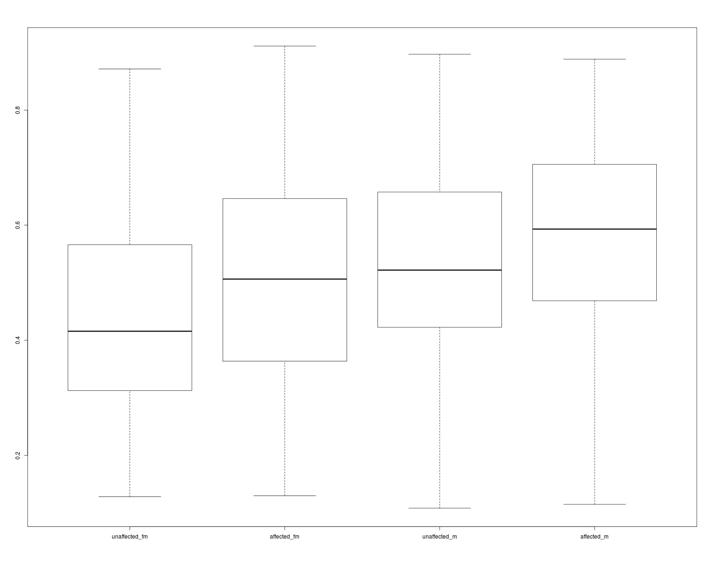
Figure 2 . svm test model of malness after cross-validation (cost = 100 ,type = 7 , accuracy = 65%)

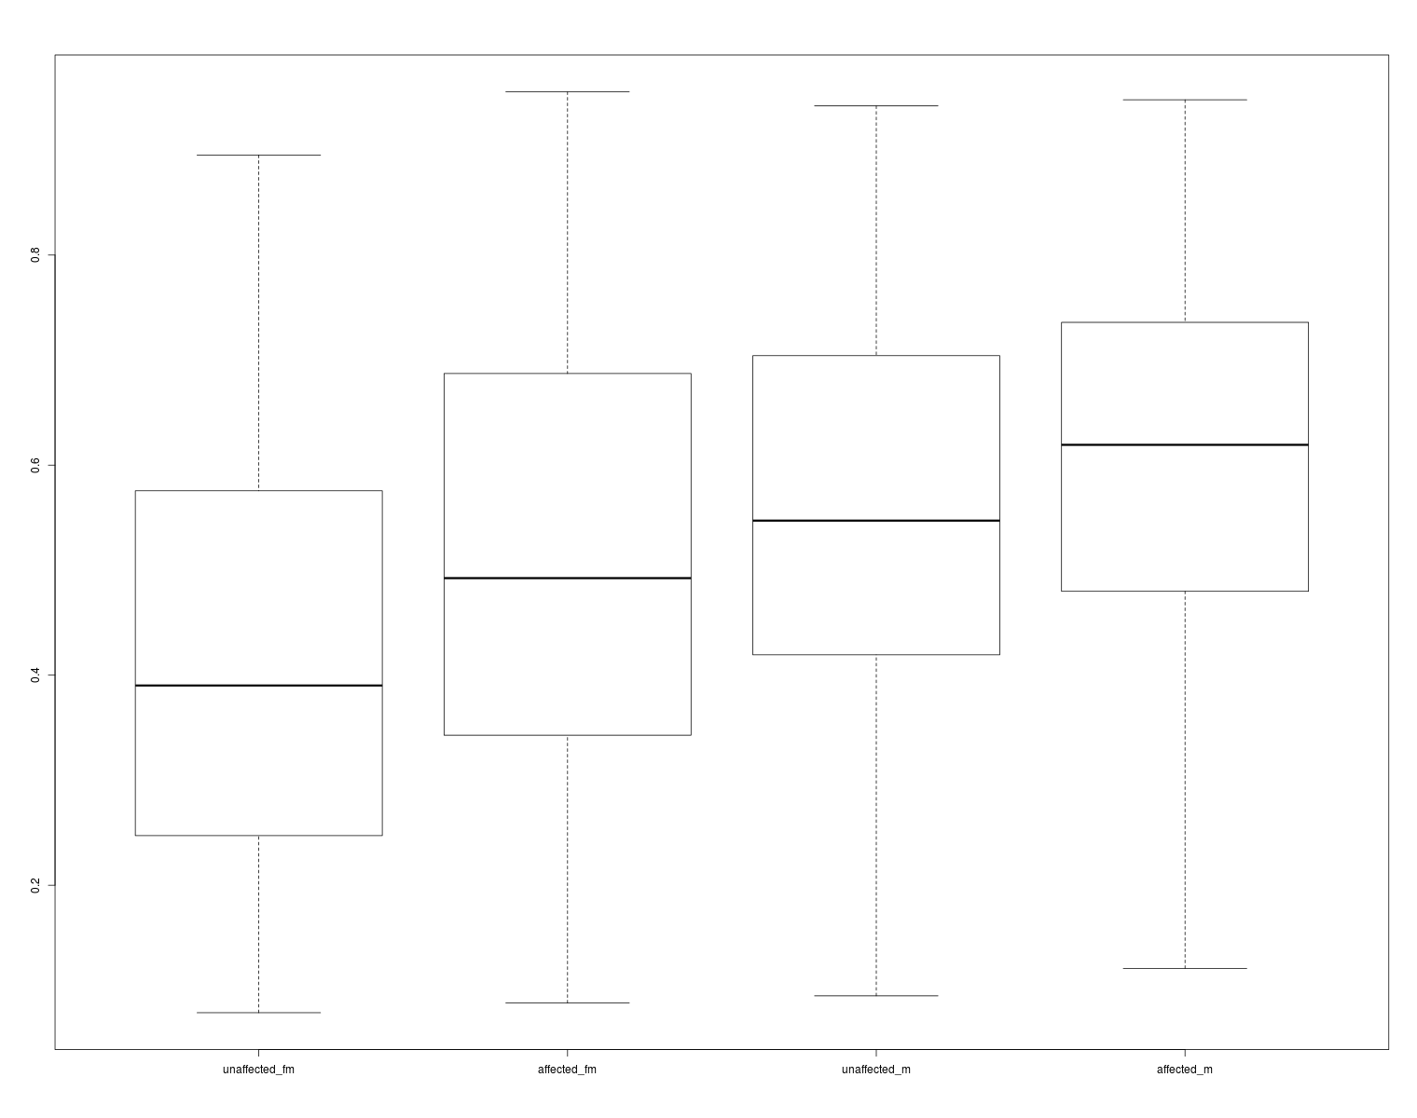
Figure 2 . svm test model of malness after cross-validation (cost = 100 ,type = 6 , accuracy = 68%)

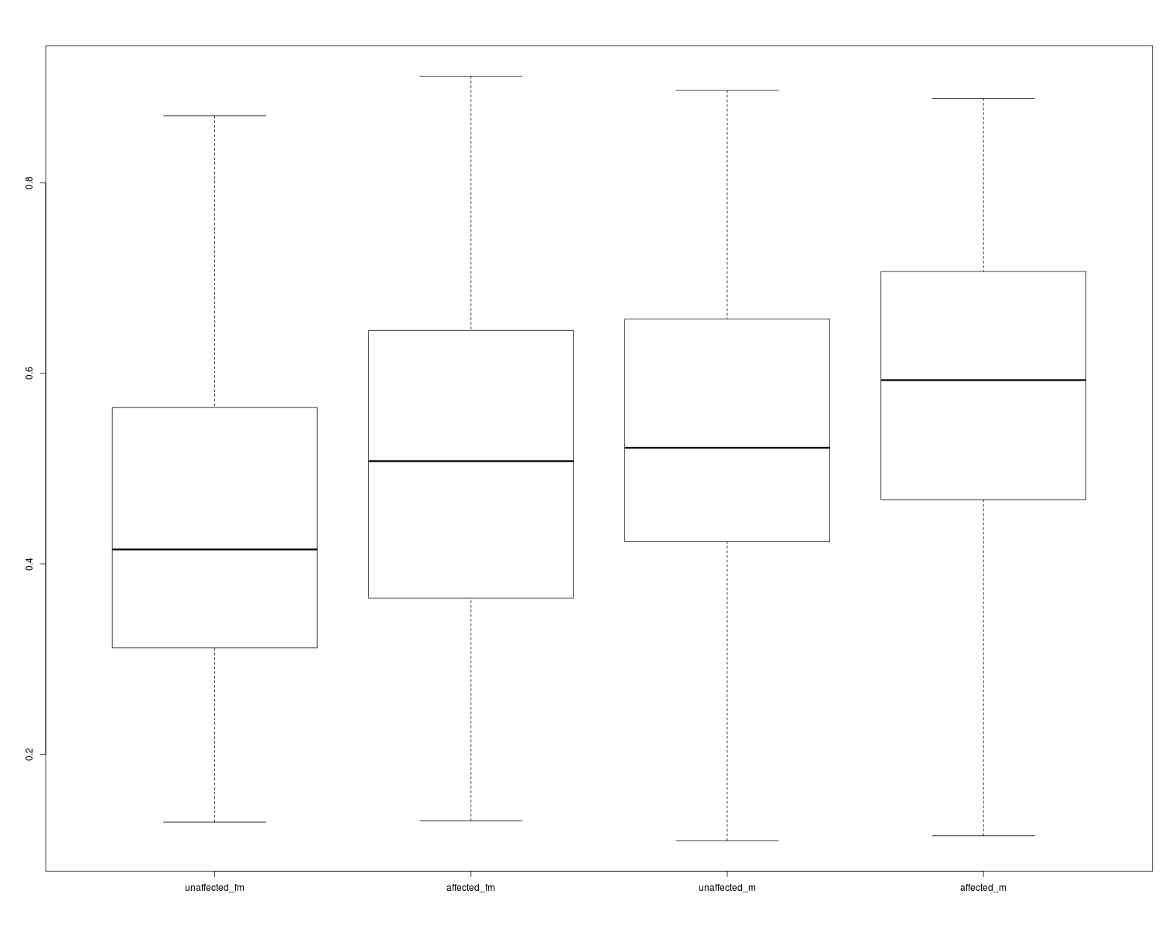
Figure 2 . svm test model of malness after cross-validation (cost = 100 ,type = 0 , accuracy = 65%)

