Biometrics features from face pictures and Kinect records

Yongchao Huang, Brooke Mc Kenna, Kevin Vervier, Jacob Michaelson

In this document, we keep track of progress done on the facial dysmorphism and gait analysis projects. Code examples can be found at http://flamingo.psychiatry.uiowa.edu/redmine/issues/291#change-3018

Introduction

Material and Methods

Pictures used in this study were obtained during devGenes data collection.
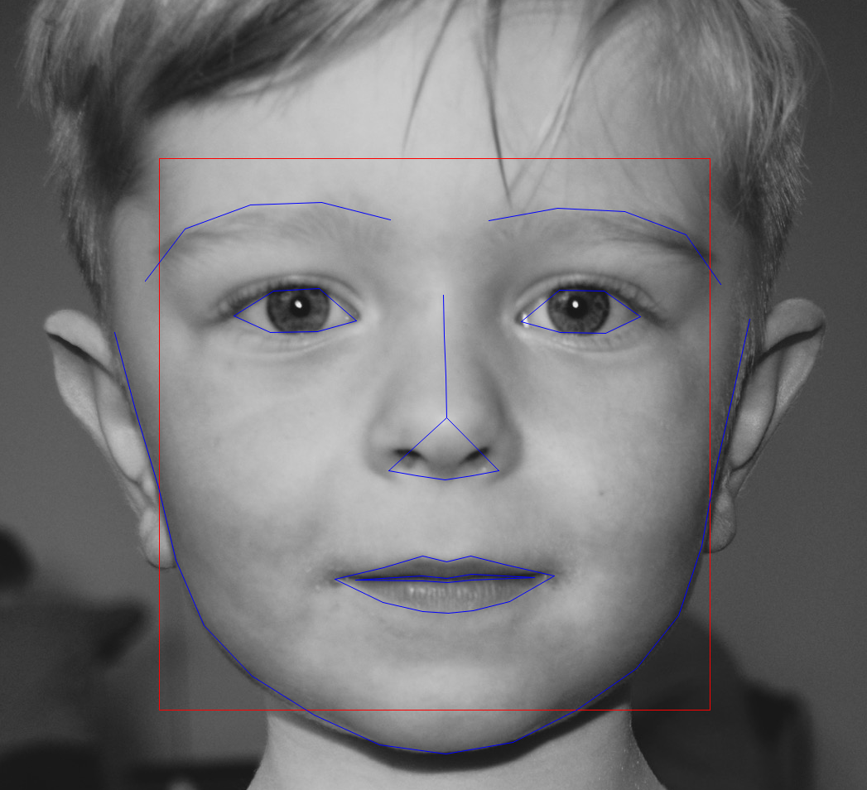
Extracting facial landmarks was performed using 'dlib' library, in particular a modified version of 'face_landmark_features.py'. It relies on a machine learning model (shape_predictor_68_face_landmarks.dat.bz2), and can predict up to 68 key points (see Example). Conversion from dlib output format to csv format was performed using /wdata/rotating_Students/ychuang/src/dlib2csv.R

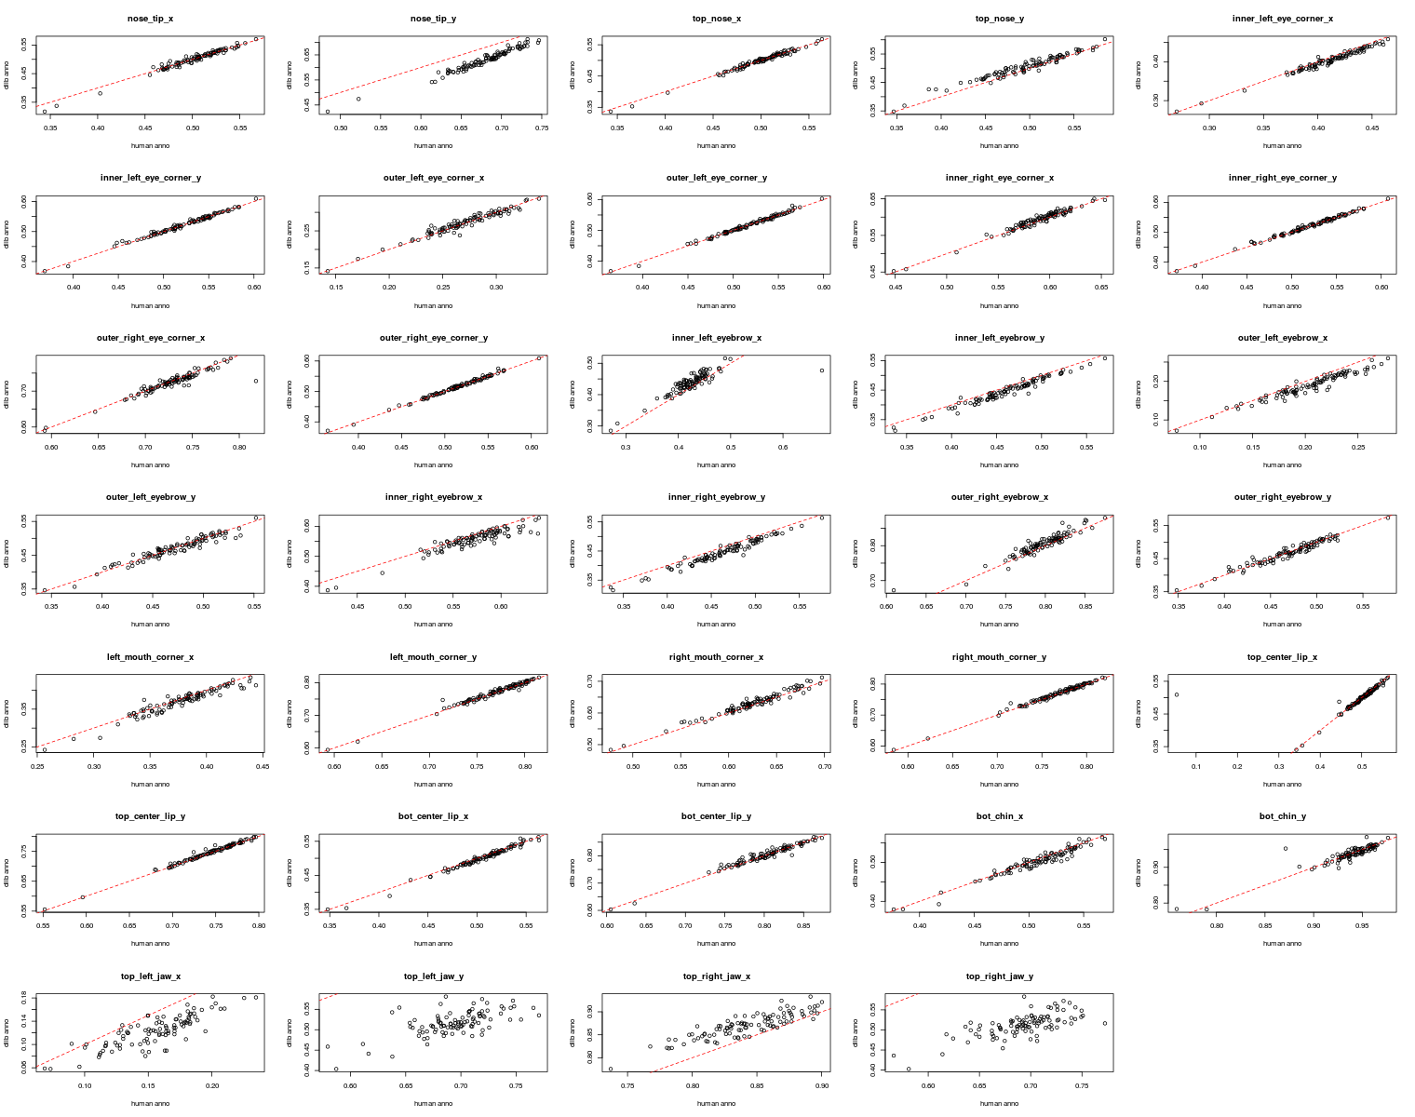
We validated this approach by comparing it with manual annotation on a subset of 99 pictures for 34 facial points, and find a good overlap between dlib and manual annotations (see Fig. 1), except for right and left jaw points.
TODO: reproduce Fig 1. using /wdata/rotating_Students/ychuang/src/01.comparison_dlib_manual.R , there is '…' in the code left as an exercise. Also the method to get the final figure is free, code examples are only here to guide if needed.
Bonus: add actual correlation value + line
It might be because of a lack of children pictures during the dlib model training. In preliminary analysis, we only consider a subset of 24 points given the redundancy of some key points being very close (e.g. eyebrow ones).

Machine Learning approach to predict 'maleness'
Raw training data can be found in /wdata/rotating_Students/ychuang/data/All_final. It consists in 661 pictures with affected individuals and also controls.
A separate set of pictures, based on the most recent pictures, is held out for validation purpose, and will be used only when a final model will be ready.
Sex and age can be found in /wdata/devGenes/...

Jake already trained a random Forest model and got descent results (Fig 2).
TODO: replicate this analysis

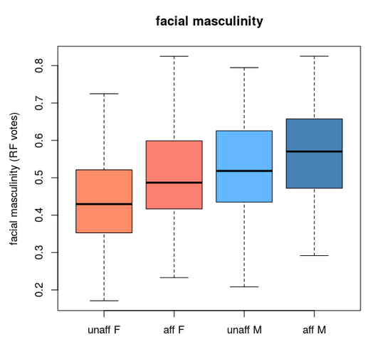
Machine Learning approach to predict affected status
Affected status can be found in /wdata/devGenes/CURRENT DATA/DATASETS/AFFECTED_STATUS_data.csv

Results

Discussion

References

