《Embedded System and Microcomputer Principle》Lab Report
Topic | LED lamp control system
Name | 孙永康 | SID | 11911409
The interrupts code
void HAL_GPIO_EXTI_Callback(uint16_t GPIO_Pin)
{
static unsigned char uRx_Data_1[1024] = {"LED0 is On\r\n"};
static unsigned char uRx_Data_2[1024] = {"LED0 is Off\r\n"};
static unsigned char uRx_Data_3[1024] = {"LED1 is On\r\n"};
static unsigned char uRx_Data_4[1024] = {"LED1 is Off\r\n"};
static unsigned char uLength_on = 12;
static unsigned char uLength_off = 13;
static unsigned int cnt_1 = 0;
static unsigned int cnt_2 = 0;
HAL_Delay(100);
switch (GPIO_Pin)
{
case KEY0_Pin:
if(HAL_GPIO_ReadPin(KEY0_GPIO_Port, KEY0_Pin) == GPIO_PIN_RESET) {
HAL_GPIO_TogglePin(LED0_GPIO_Port, LED0_Pin);
if(cnt_1 == 0)
{
HAL_UART_Transmit(&huart1, uRx_Data_2, uLength_off, 0xffff);
cnt_1 = 1;
}
else
{
HAL_UART_Transmit(&huart1, uRx_Data_1, uLength_on, 0xffff);
cnt_1 = 0;
}
}
break;
case KEY1_Pin:
if(HAL_GPIO_ReadPin(KEY1_GPIO_Port, KEY1_Pin) == GPIO_PIN_RESET) {
HAL_GPIO_TogglePin(LED1_GPIO_Port, LED1_Pin);
if(cnt_2 == 0)
{
HAL_UART_Transmit(&huart1, uRx_Data_4, uLength_off, 0xffff);
cnt_2 = 1;
}
else
{
HAL_UART_Transmit(&huart1, uRx_Data_3, uLength_on, 0xffff);
cnt_2 = 0;
}
}
break;
default:
break;
}
}

void HAL_UART_RxCpltCallback(UART_HandleTypeDef *huart)
{
if(huart->Instance==USART1){
static unsigned char uRx_Data[1024] = {0};
static unsigned char uLength = 0;
if(rxBuffer[0] == '\n'){
HAL_UART_Transmit(&huart1, uRx_Data, uLength, 0xffff);
if (uRx_Data[6] == 'n' && uRx_Data[11] == '0') {
HAL_GPIO_WritePin(LED0_GPIO_Port, LED0_Pin, GPIO_PIN_RESET);
uLength = 0;
}
if (uRx_Data[6] == 'n' && uRx_Data[11] == '1') {
HAL_GPIO_WritePin(LED1_GPIO_Port, LED1_Pin, GPIO_PIN_RESET);
uLength = 0;
}
if (uRx_Data[6] == 'f' && uRx_Data[12] == '0') {
HAL_GPIO_WritePin(LED0_GPIO_Port, LED0_Pin, GPIO_PIN_SET);
uLength = 0;
}
if (uRx_Data[6] == 'f' && uRx_Data[12] == '1') {
HAL_GPIO_WritePin(LED1_GPIO_Port, LED1_Pin, GPIO_PIN_SET);
uLength = 0;
}
uLength = 0;
}else{
uRx_Data[uLength] = rxBuffer[0];
uLength++;
}
}
}
Results (screenshots and hardware photos)
(1) Use KEY0 to control LED0
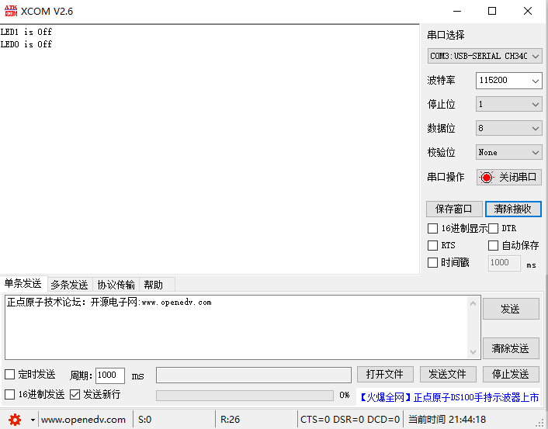
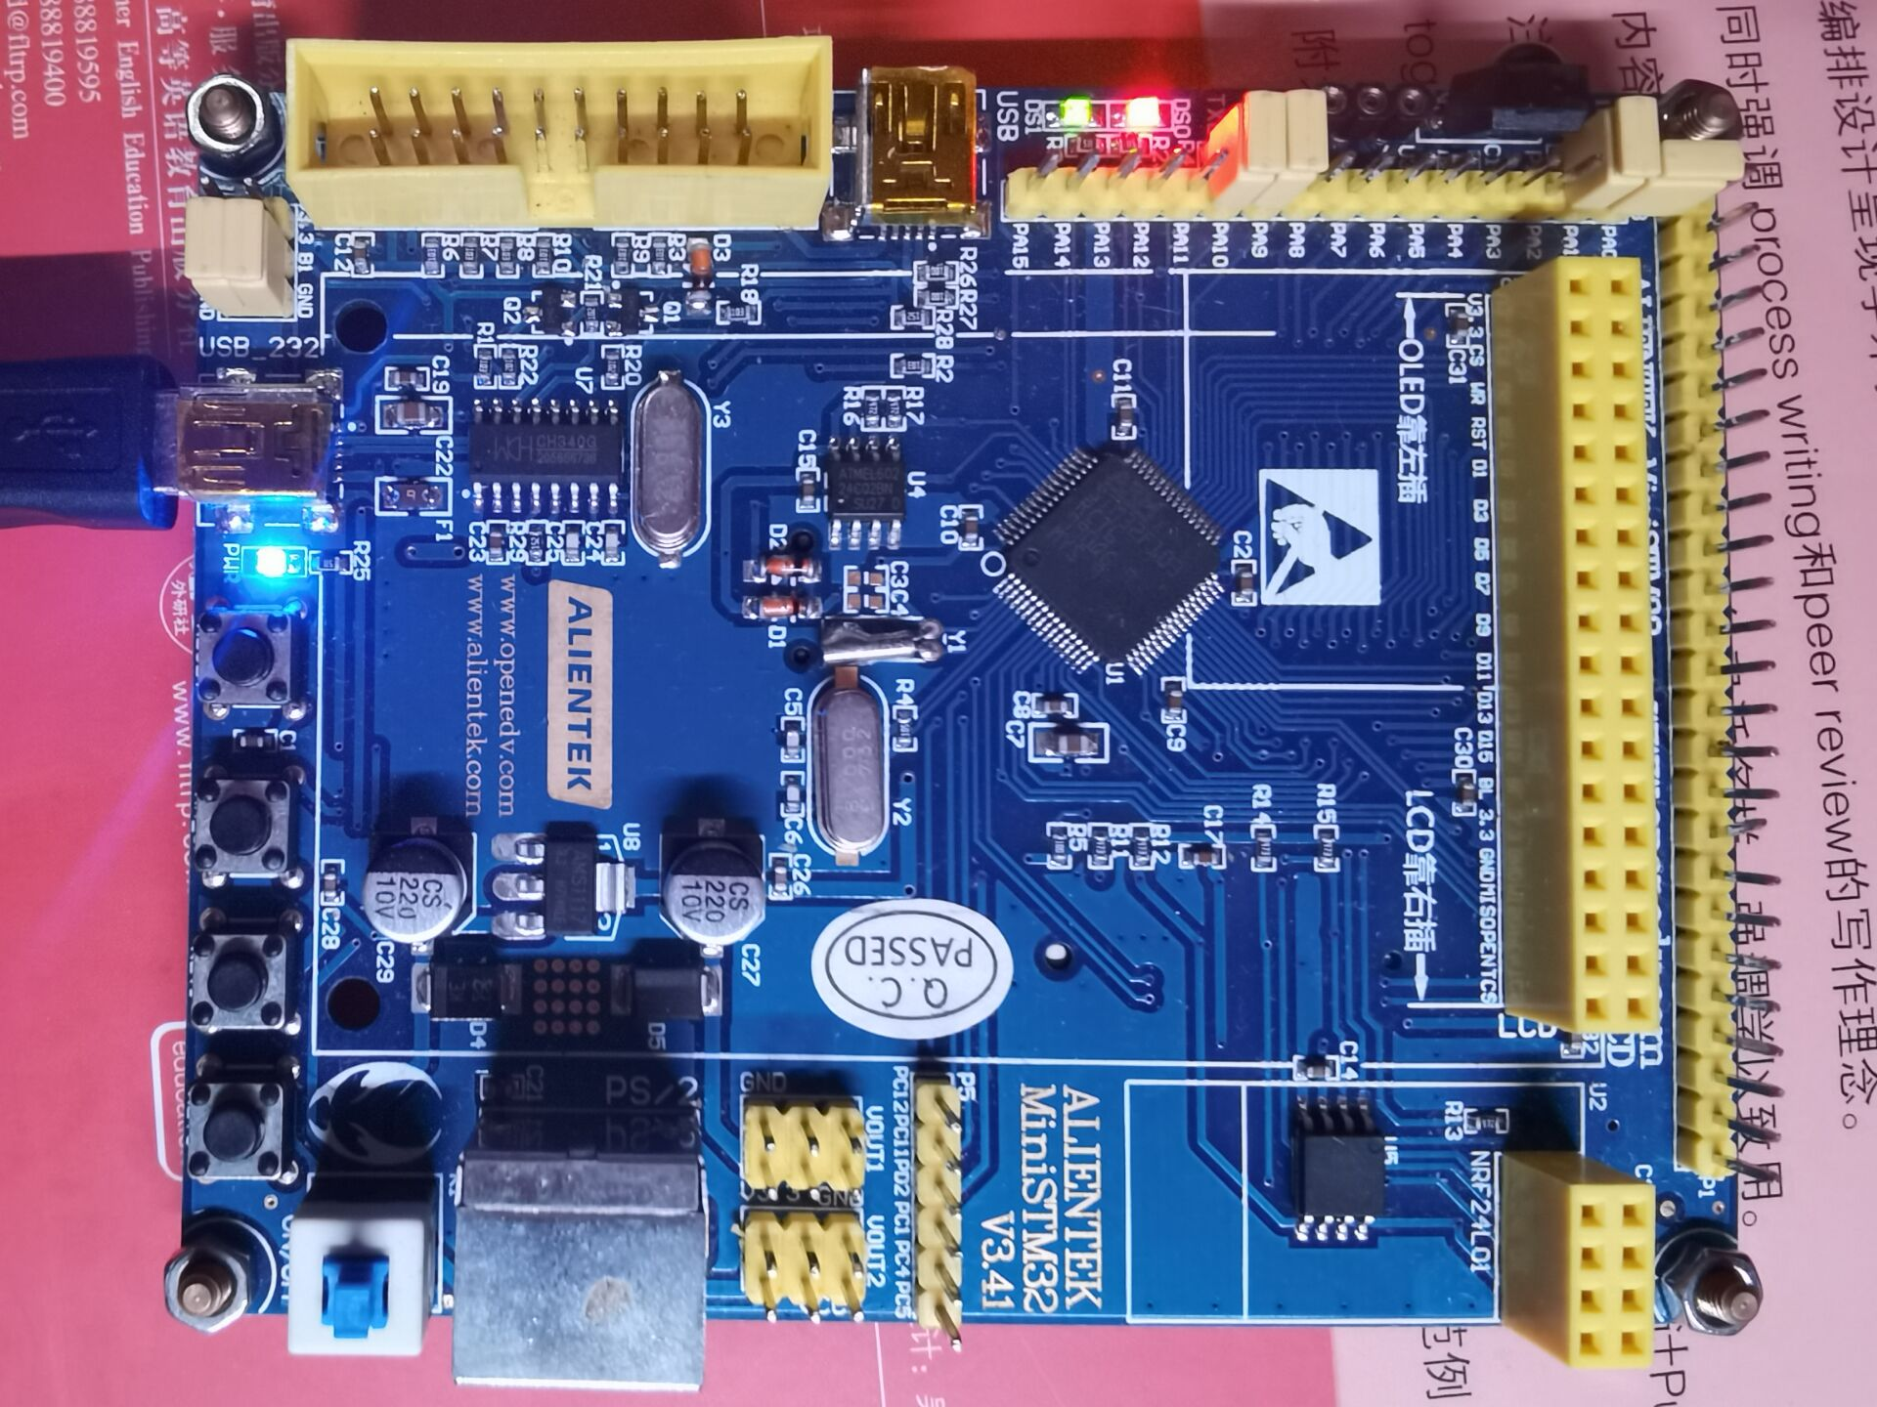
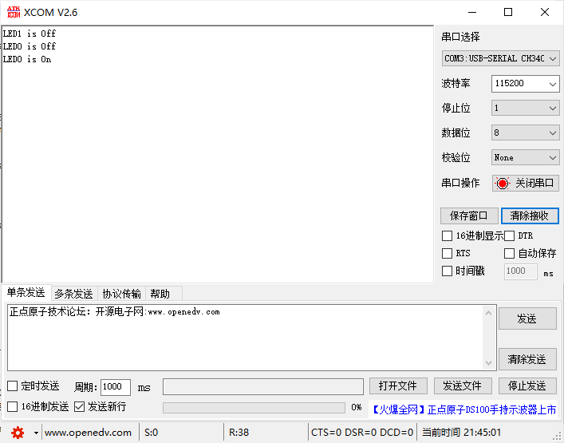
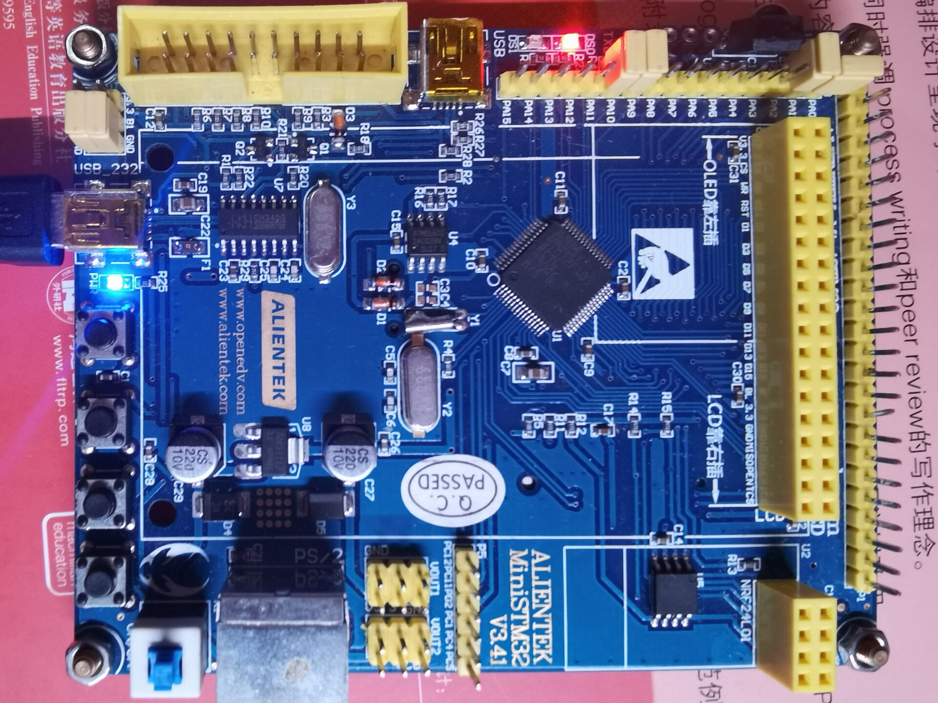
(2) Use KEY1 to control LED1
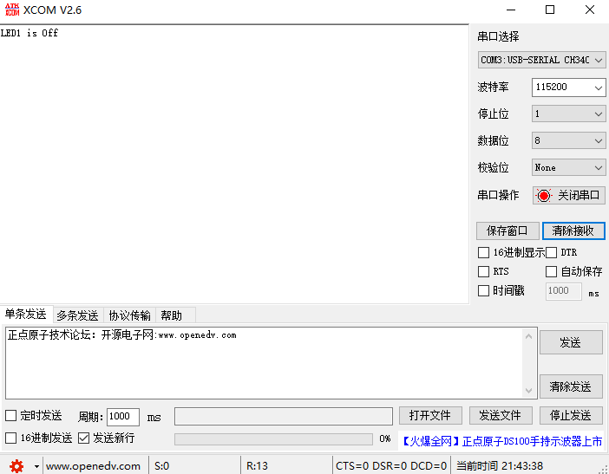

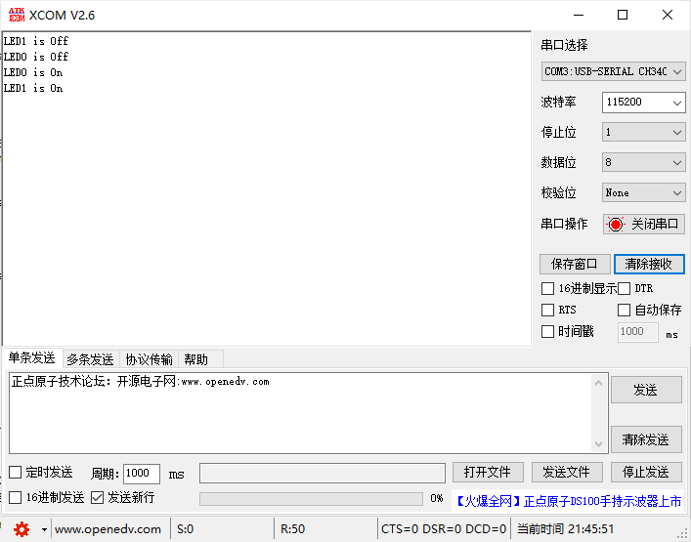
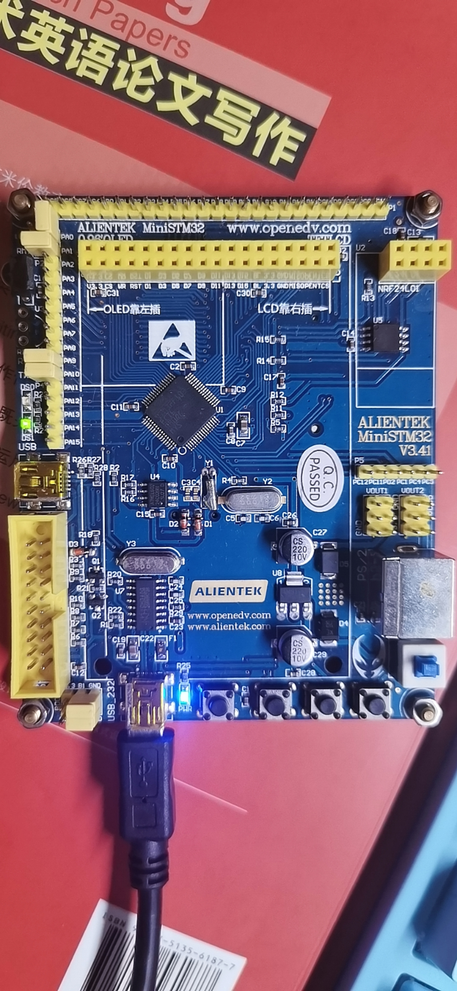
(3) Use command message to control LED0
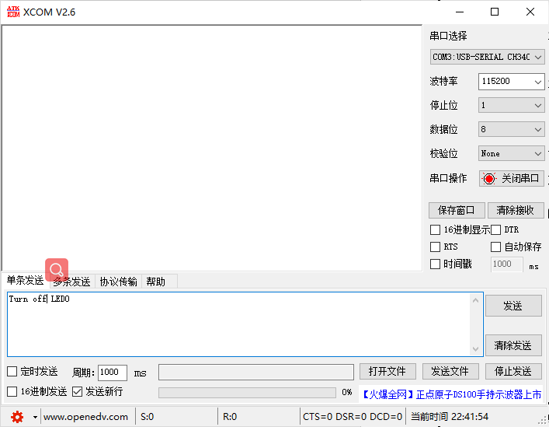
(4) Use command message to control LED1
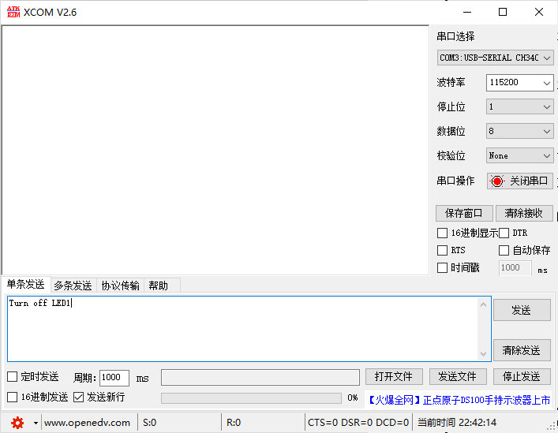
Hardware picture is the same

Problems encountered and solutions
My UART port work not well
I ask for other’s help
Summary & experience

Please only paste the codes you write in the report, do not paste the unnessary HAL API functions!!

