Computer lab 4: Markov Chain Monte Carlo

Yonglin Zhuo(yonzh457)

Assignment 1: Different versions of the Metropolis-Hastings algorithm

a ) The function normm is simulating from a normal with zero mean and unit variance using a Metropolis algorithm with uniform proposal distribution. The exercise is to try the following alpha = 0.1,1 and 200 for 2000 iterations. Present trace plots of line type and histograms with interpretations. Tune the sampler by finding a value of alpha that gives an acceptance probability of 0.3. You have to modify the code in order to save the acceptance rate. Explain the code with comments.

Codes :

normm<-function (Nsim, a)
## Nism is the number if iterations and the a is
## if we choose a = 5.3, it seems the acceptance rate is
## around 0.3
## the parameter of the Proposal distribution g(.|x^t)
## here we choose uniform distribution
{
vec <- vector("numeric", Nsim)
## the vector vec is used to store the simulation result
x <- 0
vec[1] <- x
## innitialzing
accepts = 0
for (i in 2:Nsim) {
innov <- runif(1, -a, a)
Xstar <- x + innov
## sample a candidate value Xstar
## from the proposal distribution
aprob <- min(1, dnorm(Xstar)/dnorm(x))
## computing the Metropolis-Hastings ration
## here we using Metroplolis algorithm
## so g(x|y) = g(y|x)
u <- runif(1)
## ramdom probability that accepts the Xstar
if (u < aprob){
x <- Xstar
accepts <- accepts +1
}
vec[i] <- x
}
print(accepts/Nsim)
return (vec)
}

output <- function(iteration=2000,alpha=5.3){
vec <- normm(iteration,alpha)
h<-hist(vec, xlim = c(-5,5),freq=FALSE,las=1,col=8,xlab="x",
main="Histogram(Alpha = ) with Normal Curve")
curve(dnorm(x, mean=0, sd=1), add=TRUE, col=2, lwd=2)
}

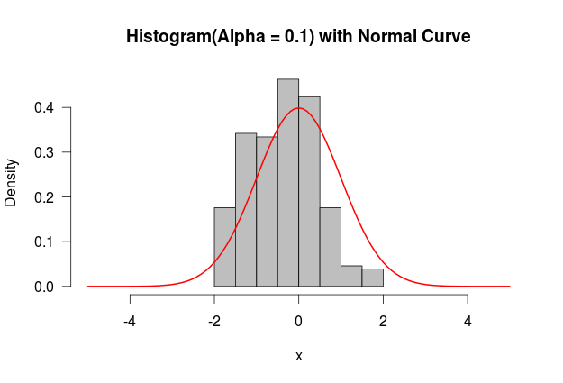
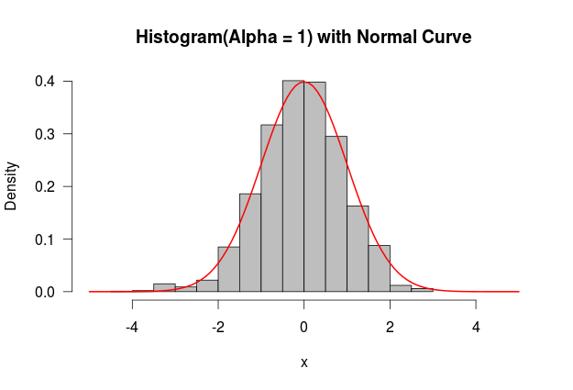
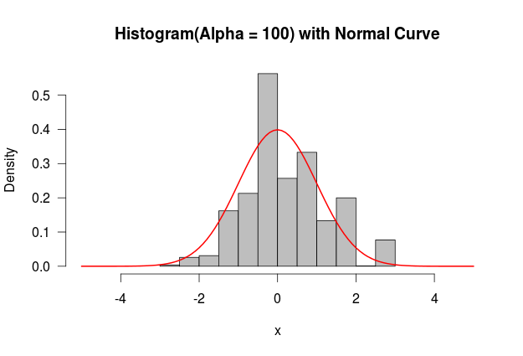

The accept rates for alpha = 0.1, 1, and 100 are 0.9805, 0.7965, and 0.015, respectively. After trying some values of alpha, it is easy to find that the accept value will be around 0.3, if we choose alpha=5.3. As you can see in the following figure that the chain tends to be stationary with the increasing of the iteration. It seems that the simulation is somewhat good.

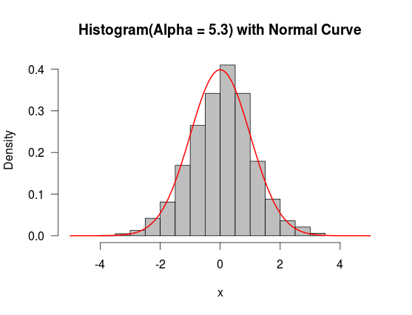

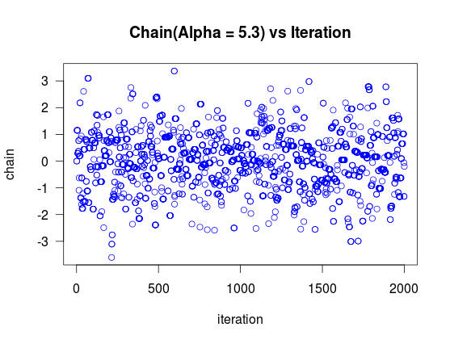

b.) Function gammh is aMetropolis-Hastings independence sampling algorithm with normal proposal distribution with the same mean and variance as the desired gamma. Try a = 0.1, 2 and b = 0.01, 2. Present trace plots and histograms with interpretations. Explain the code with comments.
Codes:
gammh<-function (Nsim, a, b)
## Nism is the number if iterations and a and b are the parameters of the ##Gamma distribution
{
mu <- a/b
## the mean of the proposal distribution
sig <- sqrt(a/(b * b))
## the standard deviation of the proposal distribution
vec <- vector("numeric", Nsim)
x <- a/b
vec[1] <- x
## initializing
accepts = 0
for (i in 2:Nsim) {
can <- rnorm(1, mu, sig)
aprob <- min(1, (dgamma(can, a, b)/dgamma(x, a, b))/(dnorm(can, mu, sig)/dnorm(x,mu, sig)))
## computing the Metropolis-Hastings ratio
## here we use Metropolis-Hastings independence sampling algorithm
## so g(x|y) = g(x)

u <- runif(1)
## ramdom probability that accepts the Xstar
if (u < aprob){
x <- can
}
vec[i] <- x
accepts <- accepts+1
}
accepts
return(vec)
}
output <- function(iteration=2000,a,b){
vec <- gammh(iteration,a,b)
h<-hist(vec,freq=FALSE,las=1,col=8,xlab="x",
main="Histogram(a = 0.1, b = 2) with Gamma Curve")
curve(dgamma(x, shape=0.1, scale=2), add=TRUE, col=2, lwd=2)
return (vec)
}
h = output(2000,0.1,2)
plot(h,las=1,col=4,xlab='iteration',ylab='chain',,
main="Chain(a = 0.01, b = 2) vs Iteration")

The simulation seems not so bad. The chain tends to have a period of 250.

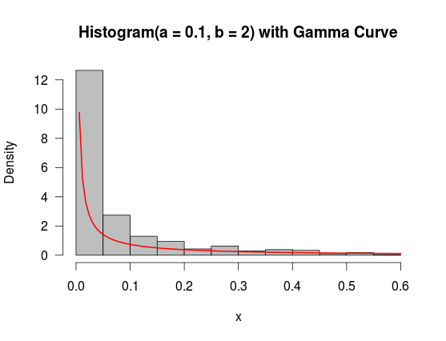

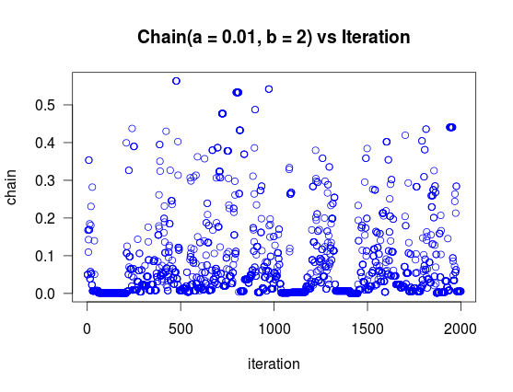

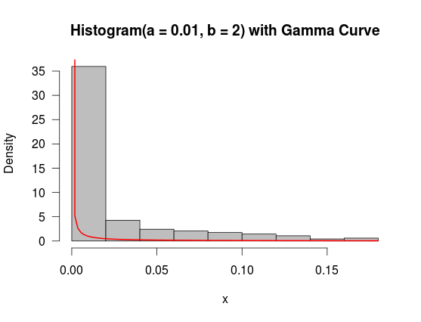

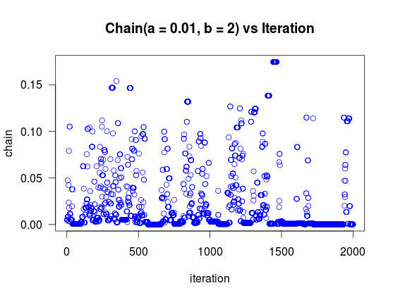

Assignment 2: The Gibbs sampling algorithm for the one-way random effects model

a )Implement R-code for the normal one-way random effects model with k levels. Provide results in Tables with mean, standard deviations and 95% credible intervals for the mean, the random effects and all variances for both your own code and the MCMChregress() analysis

Codes:

library(SuppDists)
data_set <- c(1545,1440,1440,1520,1580,1540,1555,1490,1560,1495,
1595,1550,1605,1510,1560,1445,1440,1595,1465,1545,
1595,1630,1515,1635,1625,1520,1455,1450,1480,1445)
Y <- matrix(data_set,6,5)
#### initialize constants and parameters ####
N <- 10000
## lenght of chain
X <- matrix(0,N,10)
## the chain, a bivariate sample
Y_bar_1 <- mean(Y[1,])
Y_bar_2 <- mean(Y[2,])
Y_bar_3 <- mean(Y[3,])
Y_bar_4 <- mean(Y[4,])
Y_bar_5 <- mean(Y[5,])
Y_bar_6 <- mean(Y[6,])

n_i <- dim(Y)[2]
k <- dim(Y)[1]
n <- k * n_i

a_i <- 0.0001
b_i <- 0.0001

X[1,] <- c(Y_bar_1,Y_bar_2,Y_bar_3,Y_bar_4,Y_bar_5,Y_bar_6,1,1,1,1)

sum_sq = function(vec, c)
{
temp <- (vec - c)^2
sum_sq <- sum(temp)
return (sum_sq)
}

sum_sq_matrix = function(M,c)
{
temp <- 0
for (i in 1:6)
{
temp <- temp + sum_sq(M[i,],c[i])
}

return (temp)
}

#### generate the chain ####
for (i in 2:N){
P <- X[i-1, ]
m <- P[7]*P[8] / (P[8] + n_i*P[9]) + P[9]*n_i*Y_bar_1 / (P[8] + n_i*P[9])
s <- sqrt(P[8]*P[9] / (P[8] + n_i*P[9]))
X[i,1] <- rnorm(1, m, s)
X[i,2:10] <- X[i-1,2:10]

P <- X[i, ]
m <- P[7]*P[8] / (P[8] + n_i*P[9]) + P[9]*n_i*Y_bar_2 / (P[8] + n_i*P[9])
s <- sqrt(P[8]*P[9] / (P[8] + n_i*P[9]))
X[i, 2] <- rnorm(1, m, s)
X[i,3:10] <- X[i-1,3:10]

P <- X[i, ]
m <- P[7]*P[8] / (P[8] + n_i*P[9]) + P[9]*n_i*Y_bar_3 / (P[8] + n_i*P[9])
s <- sqrt(P[8]*P[9] / (P[8] + n_i*P[9]))
X[i, 3] <- rnorm(1, m, s)
X[i,4:10] <- X[i-1,4:10]

P <- X[i, ]
m <- P[7]*P[8] / (P[8] + n_i*P[9]) + P[9]*n_i*Y_bar_4 / (P[8] + n_i*P[9])
s <- sqrt(P[8]*P[9] / (P[8] + n_i*P[9]))
X[i, 4] <- rnorm(1, m, s)
X[i,5:10] <- X[i-1,5:10]

P <- X[i, ]
m <- P[7]*P[8] / (P[8] + n_i*P[9]) + P[9]*n_i*Y_bar_5 / (P[8] + n_i*P[9])
s <- sqrt(P[8]*P[9] / (P[8] + n_i*P[9]))
X[i, 5] <- rnorm(1, m, s)
X[i,6:10] <- X[i-1,6:10]

P <- X[i, ]
m <- P[7]*P[8] / (P[8] + n_i*P[9]) + P[9]*n_i*Y_bar_6 / (P[8] + n_i*P[9])
s <- sqrt(P[8]*P[9] / (P[8] + n_i*P[9]))
X[i, 6] <- rnorm(1, m, s)
X[i,7:10] <- X[i-1,7:10]

P <- X[i, ]
m <- (mean(P[1:6]))*k*P[10] / (P[9] + k*P[10])
s <- sqrt(P[9]*P[10] / (P[9] + k*P[10]))
X[i, 7] <- rnorm(1, m, s)
X[i,8:10] <- X[i-1,8:10]

P <- X[i, ]
m <- 0.5*n + a_i
s <- (0.5*sum_sq_matrix(Y, P[1:6])) + b_i
X[i, 8] <- rinvgamma(1, m, s)
X[i,9:10] <- X[i-1,9:10]

P <- X[i, ]
m <- 0.5*k + a_i
s <- (0.5* n_i *(sum_sq(P[1:6],P[7]))) + b_i
X[i, 9] <- rinvgamma(1, m, s)
X[i,10] <- X[i-1,10]

P <- X[i, ]
m <- 0.5 + a_i
s <- 0.5*P[7]^2 + b_i
X[i, 10] <- rinvgamma(1, m, s)
}

results <- X[1000:10000, ]
theta <- results[,1:6]
par(mfrow= c(3,3))
for(i in 1:3){
title <- paste('Theta', i)
plot(theta[,i], type='l', main = title, ylab='',col=4,las=1)
hist(theta[,i], main = title, prob = TRUE,las=1)
lines(density(theta[,i]),col=4,las=1)
plot(cumsum(theta[,i]) / 1:length(theta[,i]), type = 'l', main = title, ylab = '',las=1,col=4)

}

titles <- c('Mu','Sigma Square','Tau Square','Sigma_mu Square')
par(mfrow= c(2,3))
for(i in 9:10){
title <- titles[i-6]
plot(results[,i], type='l', main = title, ylab='',col=4,las=1)
hist(results[,i], main = title, prob = TRUE,las=1)
lines(density(results[,i]),col=4,las=1)
plot(cumsum(results[,i]) / 1:length(results[,i]), type = 'l', main = title, ylab = '',las=1,col=4)

}

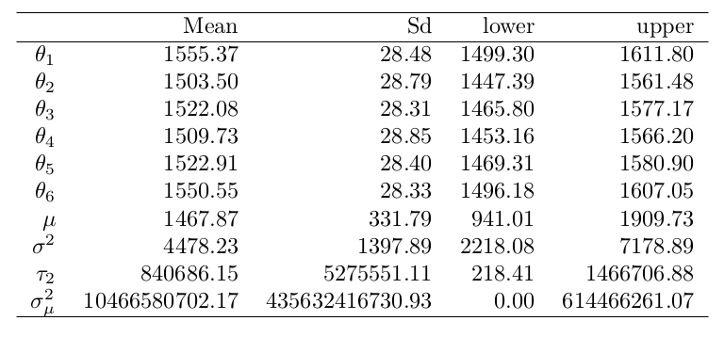
Table 1 mean, standard deviations and
95% credible intervals for the mean
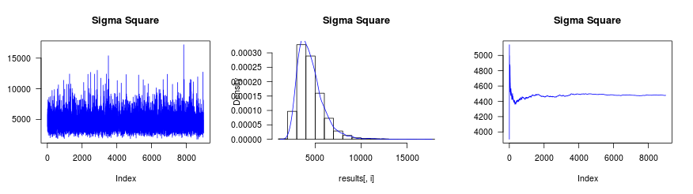
Figure 2 Sigma Square
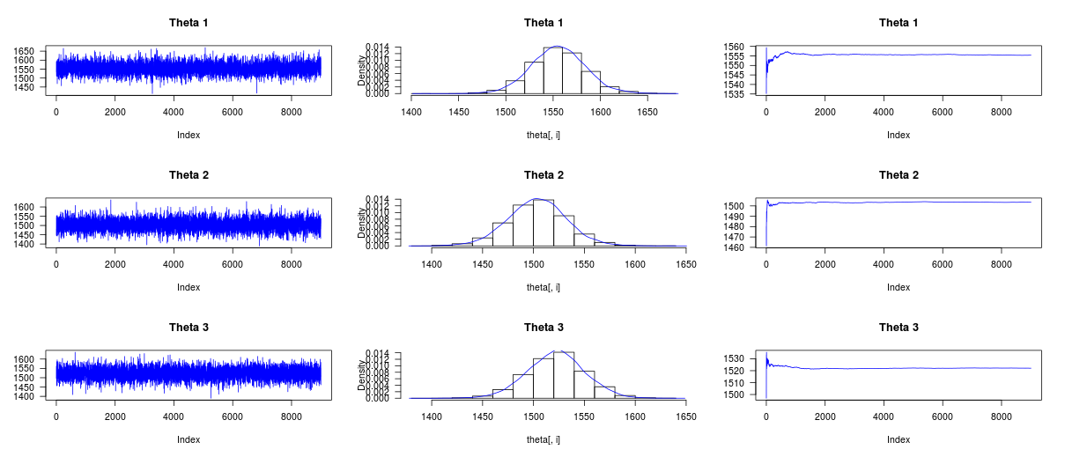
Figure 2 Theta 1 – 3

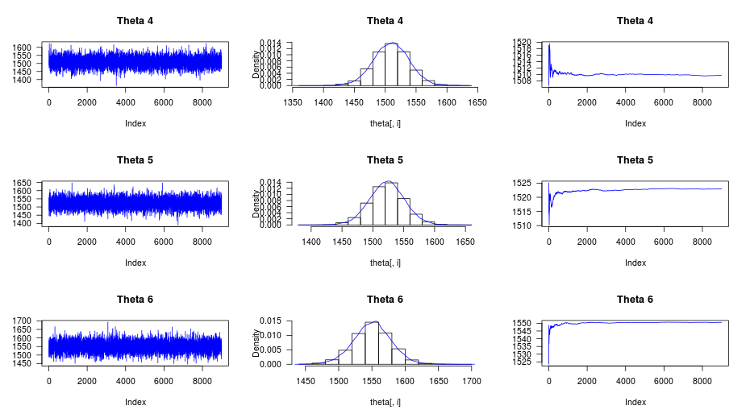
Figure 3 Theta 4 – 6
All the table and Figures above show that our method works very well.

MCMCregress Analysis

Since we can see in the following table the estimates of Theta's are quit close to our own codes, but the Sigma square is quit different.
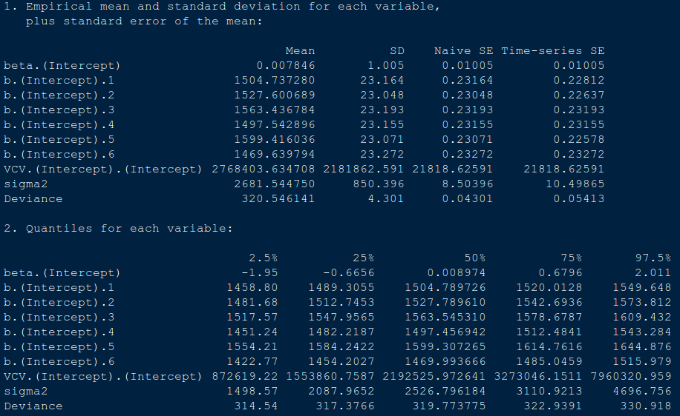
Table 2 MCMCRegress Results

