Tutorial 12 & 13

# Trees

1 . Given a binary tree of size 76, what is the minimum number of levels it can contain? What is the maximum number of levels?

* NOTE: Size of a binary tree is the number of nodes in the tree.]

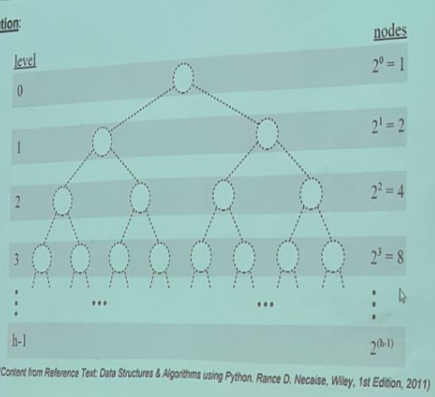

***To determine the minimum number of levels to contain a specific number of nodes, we need to consider the maximum number of nodes at each level since the nodes will have to be organized with each level at full capacity.***

***From the above diagram, we can conclude that minimum number of levels of a binary tree of size [log2 n] + 1. Eg.***

* ***If size of tree is 7, minimum levels is [log2 7] + 1 = 2 + 1 = 3***
* ***If size of tree is 8, minimum levels is [log2 8] + 1 = 3 + 1 = 4***

***Therefore, for a binary tree of size 76, the minimum number of levels is:***

***[log2 76] + 1 = 6 + 1 = 7***

1. What is the maximum number of nodes possible in a binary tree with 5 levels?

***From the above diagram, we can conclude that maximum number of nodes possible in a binary tree occurs when it is a perfect binary tree (a full binary tree in which all the leaf nodes are at the same level).***

***For a binary tree with n levels, the maximum number of nodes is 2^n – 1. Eg***

* ***If number of levels is 3, the maximum number of nodes is 2^3 – 1 = 7***
* ***If number of levels is 4, the maximum number of nodes is 2^4 – 1 = 15***

***Therefore, the maximum number of nodes in a binary tree with 5 levels is:***

* ***2^5 – 1 = 32 – 1 = 31 nodes***

1. Given the following binary trees:

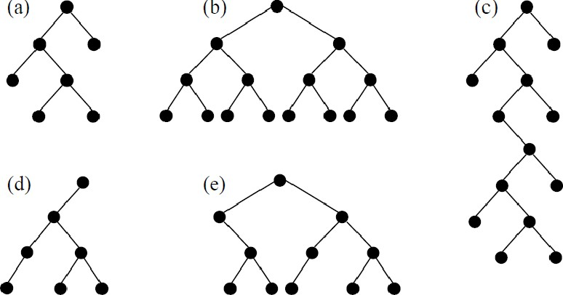

(Content from Reference Text: Data Structures & Algorithms using Python. Rance D. Necaise, Wiley, 1st Edition, 2011)

1. Indicate all the structure properties that apply to each tree: full, perfect and complete.
2. Determine the size of each tree.

[NOTE: Size of a binary tree is the number of nodes in the tree.]

1. Determine the height of each tree.

[NOTE: Height of a binary tree is the maximum depth of any node in the tree.]

1. Determine the width of each tree.

[NOTE: Width of a binary tree is the number of nodes on the level containing the most nodes.]

|  |  |
| --- | --- |
|  | ***Full binary tree***  ***Size: 7***  ***Height: 3***  ***Width: 2*** |
|  | ***Perfect binary tree***  ***Size: 15***  ***Height: 3***  ***Width: 8*** |
|  | ***Binary Tree***  ***Size: 14***  ***Height: 7***  ***Width: 2*** |
|  | ***Binary Tree***  ***Size: 11***  ***Height: 3***  ***Width: 5*** |
|  | ***Binary Tree***  ***Size: 11***  ***Height: 3***  ***Width: 5*** |

4. Consider the following binary tree:

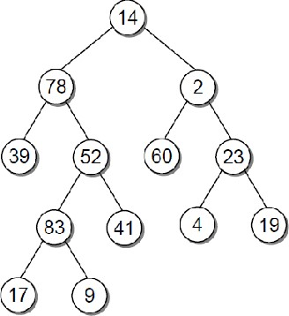

(Content from Reference Text: Data Structures & Algorithms using Python. Rance O Necaise, Wiley, 1st Edition, 2011)

1. Show the order that the nodes will be visited in the following tree traversal methods:
   1. Pre-order traversal

***14 78 39 52 83 17 9 41 2 60 23 4 19***

* 1. In-order traversal

***39 78 17 83 9 52 41 14 60 2 4 23 19***

* 1. Post-order traversal

***39 17 9 83 41 52 78 60 4 19 23 2 14***

* 1. Breadth-first traversal

***14 78 2 39 52 60 23 83 41 4 19 17 9***

1. Identify all of the leaf nodes.

***39 17 9 41 60 4 19***

1. Identify all of the interior nodes.

***14 78 52 83 2 23***

1. List all of the nodes on level 4.

***17 9***

1. List all of the nodes in the path to each of the following nodes:

 83

***14 78 52 83***

* 1. 39

***14 78 39***

## 4

***14 2 23 4***

## 9

***14 78 52 83 9***

1. Consider node 52 and list the node's:

() descendants

***83 17 9 41***

(ii) ancestors

***14 78***

## (iii) siblings

***39***

g. Identify the depth of each of the following nodes:

 78

***Depth = 1***

(ii) 41

***Depth = 3***

(iii) 60

***Depth = 2***

## (iv) 19

***Depth = 3***

5. A binary search tree is created when the numbers are inserted in the following order:

30, 63, 2, 89, 16, 24, 19, 52, 27, 9, 4, 45

Draw the binary search tree.

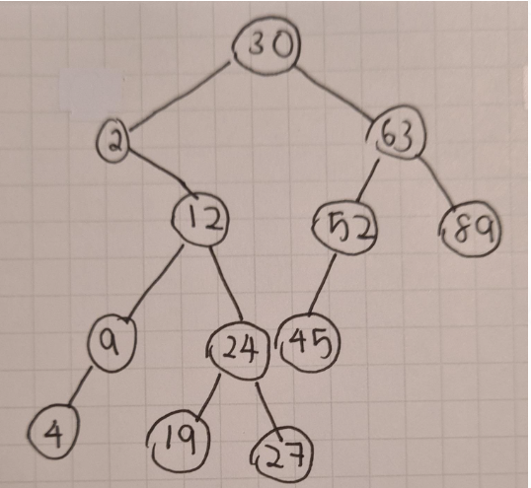

 End of Tutorial